COVER PAGE
BMIH6005 Organisational Consultancy- LEVEL 6
TITLE: CONSULTANCY REPORT ON RAMADA RESORT, TURKEY, https://ramadaresortside.com/en/
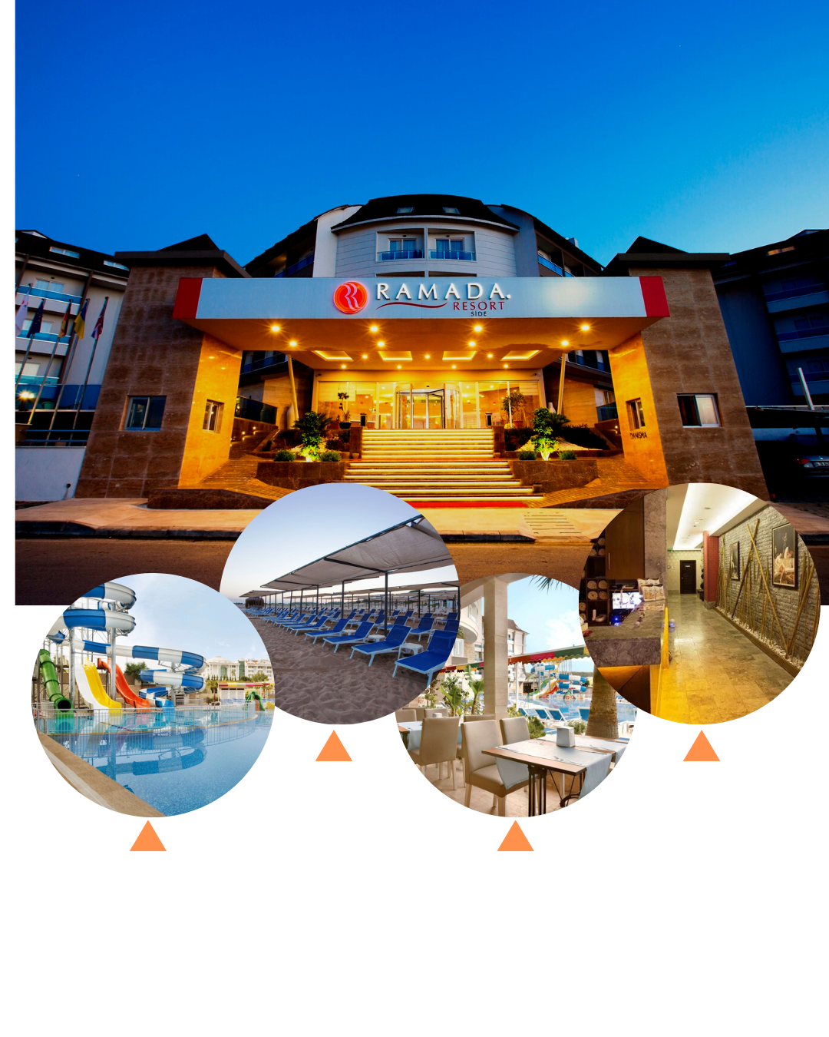
Jahanara begum
2128162

Declearation : No AI have been used in this consultency Report
Executive Summary
This consulting study examines operational issues Ramada Resort Side, a well-known 4-star hotel in Antalya, Turkey, is facing. The main problem noted is a decline in visitor satisfaction connected to unequal service quality and inadequate staff training. These operational inefficiencies have resulted in unsatisfactory guest experiences, therefore affecting the internet reputation, occupancy rates, and general income of the resort. This paper aims to evaluate the fundamental causes, examine the internal and external operational environment of the resort, and offer pragmatic suggestions meant to improve guest experience standards and market positioning of Ramada Resort Side.
Overview of the Issue
Popular tourist attraction Ramada Resort Side depends mostly on good visitor experiences to keep high occupancy rates and promote return business. Recent comments, however, point to a trend of guest dissatisfaction related to problems including variable service quality, delayed response times, and poor attention to detail. Operating problems including undertrained personnel, high turnover rates, and inadequate departmental communication help to explain these problems. Given the competitive hotel scene of today, such comments affect the reputation of the resort since online reviews immediately affect the choice of possible visitors.
Low satisfaction among guests has clearly reduced bookings, therefore influencing the financial situation of the resort. Negative online evaluations and ratings have aggravated the problem by lessening the attraction of the resort to potential visitors, who usually base their choice of lodging on these ratings. Targeted solutions are desperately needed to solve these problems, stabilise income, and improve the brand reputation of Ramada Resort Side as occupancy rates and fewer returning visitors cause revenue to plummet.
Key Findings
Our investigation revealed a number of important areas causing the problems with the service quality at Ramada Resort Side.
Gaps in Service Standards: Guest reviews to inconsistent service, with some staff members falling short of hospitality standards. Lack of consistent service standards has led to a different guest experience whereby department and shift determines the degree of service excellence.
Undertrained and High Turnover of Staff: The resort's reliance on seasonal employees has helped to produce a staff sometimes lacking in training. Staff turnover is also significant; employees often leave for lack of clear expectations, poor management techniques, and restricted chances for professional development.
Process Inefficiencies: Service delays have been noted especially in the housekeeping and food and beverage divisions. Inaccurate procedures and poor departmental communication help to cause these delays, therefore upsetting seamless operations and compromising passenger experience.
Effect on Occupancy and Revenue The resort's occupancy rates have declined; the general guest satisfaction rating on prominent review sites comes below the norm for such resorts in the area. This decline corresponds with lower bookings and income as, in a very competitive industry, the hotel's internet reputation shapes visitor choice.
Benchmarking and Performance Gaps : Comparative study reveals Ramada Resort Side trails behind rivals in service speed, consistency, and guest satisfaction. This performance difference disadvantages the resort, particularly given other hotels in the vicinity keep improving their visitor experience.
Summary of Analysis
Using PESTEL and SWOT models, the study looked at the external environment and internal competencies of Ramada Resort Side, thereby pointing up the elements causing operational difficulties.
PESTEL Analysis:
Political: Travel recommendations and national security issues affect the Turkish travel industry, therefore influencing foreign arrival.
Economic: Turkey is now a reasonably cheap country due to changes in value of money, which boosts demand but also strains resources in busy times.
Social: Modern visitors want individualised, first-rate treatment; they regularly compare experiences on social media before making a reservation.
Technological : Technologically, the emergence of online review sites increases competitiveness since visitors may quickly get comparison comments.
Environmental: Growing attention on environmentally friendly methods forces the resort to use sometimes expensive sustainable operations.
Legal: Turkey's labour laws demand adherence to employment criteria, so effective management of seasonal staff is difficult.
SWOT Analyses:
Strengths: Within the Wyndham Hotels group, the resort gains from a superb site, varied facilities, and brand recognition.
Operating efficiency is limited by weaknesses like high turnover, inconsistent services, and dependence on seasonal staff.
Increased tourism in Turkey offers chances to seize fresh market sectors, particularly in case service quality rises.
Threats to sustainability and development include rivals providing better visitor experiences and the effect of Turkish economic uncertainty.
Using the benefits of the resort—location, brand—and capitalising on increasing tourists, Ramada Resort Side can create plans to offset shortcomings such service consistency and handle competition.
Recommendations
This paper suggests the following ideas for strategy to help to solve the found problems:
Improving employee development and training:
Establish an extensive training course with an eye towards technical capabilities, guest service standards, and cultural sensitivity. Training should be continuous, including refreshers to support requirements.
Clearly define service procedures for every department to guarantee constant delivery of excellent services independent of seasonal fluctuations in manpower or season.
Automated guest feedback collecting and response system
Provide a simplified mechanism for real-time guest input collecting and analysis so management may quickly resolve issues. Digital solutions that enable quick adaptation to guest needs include post-checkout surveys or in-room iPads for instantaneous comments.
Invite guests to participate actively in order to address internal problems, therefore reducing the possibility of bad internet evaluations.
Enhanced workflow efficiency and communication:
Provide digital channels to improve departmental cooperation and lower service delays. Assign a liaison to monitor daily guest request flow and guarantee timely delivery for every department.
Especially in housekeeping and dining areas, redesign processes to cut wait times and maximise guest service effectiveness.
Staff Retention Program:
Use performance-based bonuses, recognition programs, and chances for professional development to raise morale and lower turnover.
Create a mentoring program so more recent hires can be guided by seasoned staff members, therefore creating a friendly environment that improves job happiness and loyalty.
Frequent Benchmarking and Performance Monitoring:
Create key performance indicators (KPIs) with a focus towards visitor satisfaction, staff retention rates, and service response times. Track improvement by routinely comparing performance to industry standards.
Use operational data and guest feedback analytics to guide constant service model improvement and change.
Since the hotel's service quality and responsiveness match industry requirements, it is believed that following these suggestions will lead to real increases in guest satisfaction measures. Improved operational efficiencies and training initiatives will let employees provide regularly excellent service, thereby strengthening the image of Ramada Resort Side. Respected reviews, guest retention, and repeat reservations should all rise if the resort tackles the fundamental problems of service consistency, process inefficiencies, and personnel engagement.
As customer satisfaction rises, Ramada Resort Side will probably see a matching increase in occupancy rates and income. The resort's strategy emphasis on consistency and quality helps it to be positioned for sustainable development in a very competitive environment. By means of this alliance, Ramada Resort Side can rebuild itself as a top choice for Antalya visitors, therefore laying a strong basis for ongoing success in the changing hotel scene.

Table of Contents
Executive Summary 2
Introduction 8
Description of Issue 14
PESTEL analysis 16
SWOT Analysis 19
Tows Analysis 21
Recommendation 1 23
Recommendation 2: Implement a Guest Feedback System 27
Recommendation 3: Enhanced Staff Retention Program 31
Staff Retention Program Components 31
Change Management Strategy: Kotter’s 8-Step Model 32
Action Plan 37
Conclusion 39
References 42
Appendix: Review of Ramada resort Turkey 49

Introduction
Hotel Background
One of the most visited tourist spots in Turkey along the Mediterranean coast, Antalya hosts the outstanding 4-star Ramada Resort Side (RAMDA RESORT, 2024). Antalya, with its sunny beaches, cultural legacy sites, and energetic local markets, draws millions of tourists annually, most of which arrive during the hottest summer months. The operational needs of the hotel are much influenced by this seasonal flood of visitors, which calls for extra personnel, resources, and logistical planning to satisfy higher guest expectations during peak seasons (Erden Ayhun, et al, 2024).
Designed to satisfy a varied customer, the resort itself has 295 guest rooms total—standard rooms, suites, and family lodging among other types. The resort boasts three on-site restaurants with a range of international and local cuisines, a full-service spa, a fitness centre, a children's play area, and many outdoor swimming pools. The hotel also offers access to a private beach area with sun loungers and cabanas, therefore serving those looking for a flawless resort experience (KARAMAN, et al 2023). Mostly targeted to families and leisure visitors, Ramada Resort Side presents itself as a family-friendly location with events and facilities suitable for all ages. The clientele of the resort also consists of foreign visitors attracted to Antalya's Mediterranean holiday value.

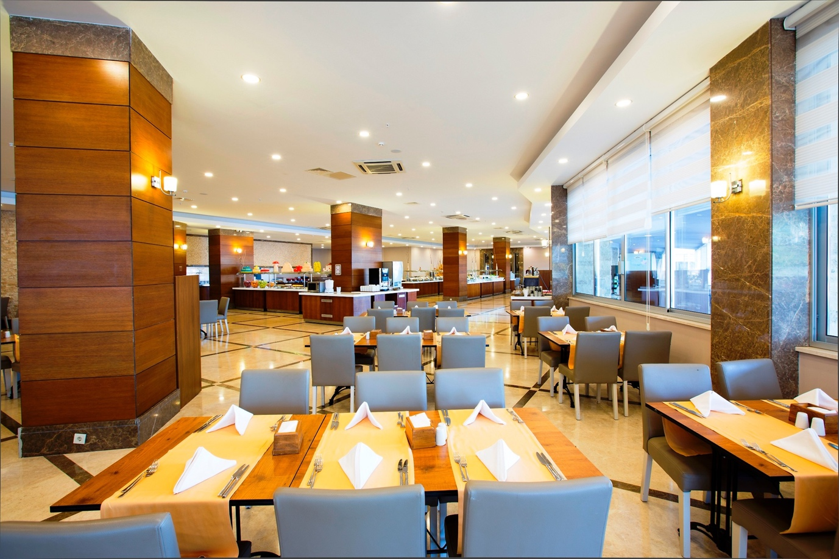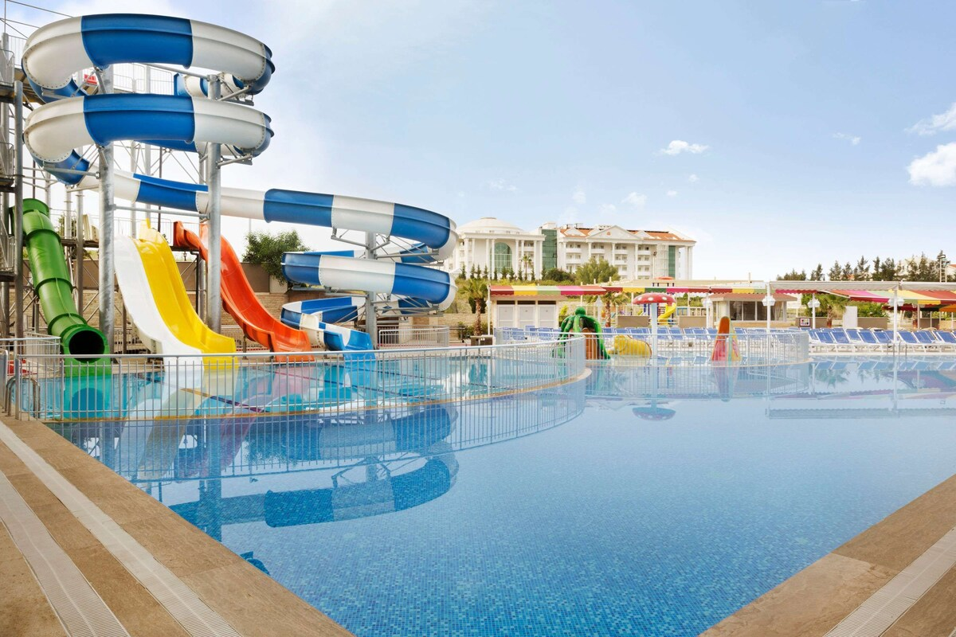
Ramda resort POOL, and restaurant Source https://ramadaresortside.com/en/

With a demand for effective resource management and well-trained personnel notably during the high season, Ramada Resort Side faces difficulties sustaining excellent service standards year-round despite its several strengths (De Pablos, et al , 2012). Seasonal operational pressure influences guest satisfaction, which varies in tandem with service consistency. The hotel has observed rising client complaints in recent years about response times, staff efficiency, and general quality of service. These operational discrepancies influence online reviews, which in turn influence future bookings and the general hotel reputation in the very competitive hotel industry.
Background of a Consultancy Firm
Ramada Resort Side hired Summit Hospitality Consulting, a consultant company focused on luxury and high-end hospitality services, to handle its operational issues. Originally founded with a goal of improving guest experience, staff involvement, and operational effectiveness (RAMDA RESORT, 2024). Summit Hospitality Consulting delivers knowledge in providing tailored solutions for hotels looking to maximise their service offers and enhance their market position. Summit Hospitality stresses the need of service consistency, personnel training, and internal communication to improve the operational flow and guest journey by means of a strong emphasis on the guest experience. The consultants of the company are adept in handling hotel clients from different areas and offering solutions that fit the most recent industry standards and solve region-specific issues (Hofstede, 2022).
The reputation of Summit Hospitality Consulting has been established on its ability to assist hotels and resorts in adjusting to evolving market conditions, enhancing service quality, and using creative management techniques to stimulate income generation. Change management is another area of expertise for the company, which is quite important for Ramada Resort Side considering the operational changes required to improve visitor happiness and employee involvement. Particularly in busy travel seasons, Summit Hospitality's experience should direct Ramada Resort Side towards a sustainable operational strategy that balances high service standards with effective resource management (Mensah, 2019)
Frameworks for Analysis
Using numerous strategic analysis models—PESTEL, SWOT, and TOWS— Summit Hospitality Consulting will methodically identify and fix operational problems at Ramada Resort Side. These models offer a methodical manner for analysing the internal and outside elements influencing the performance of the hotel as well as for spotting strategic routes to raise competitiveness in the market and service delivery (Kotler & Keller, 2016).
The PESTEL framework (Political, Economic, Social, Technological, Environmental, and Legal aspects) helps one to fully investigate the external surroundings of the hotel. The study will consider, for example, technological developments in hotel service digitisation as well as economic elements including changes in currency values influencing global guest expenditure. Understanding the dynamics of the market affecting the performance of the hotel depends on this wider perspective, which also helps one foresee possible hazards and possibilities (Johnson et al., 2017).
Strengths, weaknesses, opportunities, and threats framework of SWOT analysis will concentrate on internal environment of Ramada Resort Side. This study will produce a comprehensive picture of the hotel's present situation by pointing up its strengths—such as its location and facilities—as well as its shortcomings—such as uneven service. The SWOT study will also draw attention to possible prospects include entering developing travel markets and challenges from rivals with better visitor experiences (Dreher, & Dougherty, 2018). This structure is essential for seeing locations the hotel might use its resources to solve operational problems.
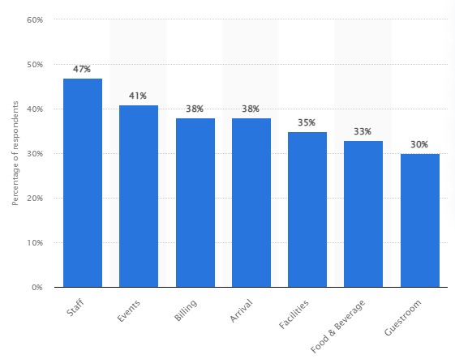
Figure 2: Common errors in hotel hospitality
(Source: Statista Research Department, 2023
Building on the knowledge gained from the SWOT analysis, the TOWS matrix will enable Ramada Resort Side to create plans that turn shortcomings into assets and seize chances to reduce outside challenges. If excessive competition is shown to be a danger, for instance, the hotel can set itself apart with special service offerings or focused marketing initiatives. Developing practical recommendations in line with the long-term objectives of the hotel depends especially on the TOWS matrix (Savari, and Amghani, 2022).
TOWS Matrix:
These models together facilitate a comprehensive, strategic study of the operating environment of Ramada Resort Side, therefore allowing Summit Hospitality Consulting to offer focused recommendations improving service consistency, staff efficiency, and general visitor satisfaction. Through addressing the particular issues of the hotel within the broader framework of Antalya's tourism industry, the consulting seeks to maintain the market position of Ramada Resort Side and guarantee sustainable development among changing market conditions.
Description of Issue
Like many hotels in the competitive Mediterranean area, Ramada Resort Side deals with major operational issues that affect guest happiness and general company performance. Low visitor satisfaction is one of the main problems the hotel faces from several internal and external causes like excessive staff turnover, uneven service quality, and undertrained staff members. Every one of these components influences the variation in services, thereby influencing the guest experience and producing poor evaluations. In a sector where guest opinion is critical, these issues not only affect online reviews but also significantly affect the occupancy rates of the hotel, thereby affecting its income finally (Abdelaziz, et al , 2024.).
Effects of Training, Service Consistency, Staff Turnover
In the hotel sector, personnel turnover is a major obstacle particularly in highly seasonal areas like Antalya, where the visitor flow calls for quick, temporary staffing changes. Regular staff turnover disturbs service consistency since new or seasonal workers sometimes lack knowledge of accepted procedures or fail to provide the desired level of quality of service because of insufficient training. High turnover rates in the hotel industry have been connected, according to research, to job discontent, long hours, and limited career paths that impede operational stability and service continuity (Baum, 2019). Turnover among front-line staff members, who personally deal with customers, at Ramada Resort Side results in inconsistent service delivery that fuels more client complaints and reduced satisfaction levels.
Moreover, inadequate training aggravates this problem since workers lack the required skills and expertise to satisfy the high expectations of customer service demanded. Insufficient instruction in communication, cultural awareness, and problem-solving causes regular service mistakes or poor visitor contacts. Online reviews mirror these flaws; visitors frequently highlight poor professionalism, hostile contacts, and delayed services (Karatepe, 2021). Negative reviews harm the hotel's reputation and discourage possible visitors who depend on online comments to decide on a reservation, therefore influencing the occupancy rates and income of the hotel.
Negative Guest Reviews: Effects on Revenue and Reputation
Particularly in the travel and hotel sectors, guest reviews are now strong motivators on customer choices in the digital era. Consistent bad ratings of service quality and staff reactivity at Ramada Resort Side affect the hotel's internet reputation, which is crucial in attracting new guests. Negative reviews affect not only the impressions of potential visitors but also result in decreased average daily rates (ADR) and revenue per available room (RevPAR) because of lowered demand (Xiang, Schwartz, & Uysal, 2020). Throughout their stay, guests anticipate consistent, excellent service; when their experiences fall short, their discontent is usually expressed on sites like TripAdvisor or Booking.com. Research shows that when choosing lodging, prospective visitors give internet comments great weight; establishments with negative ratings suffer decreased booking rates and reduced profitability (Gössling & Lane, 2020).

PESTEL analysis
A thorough PESTEL study reveals elements causing operational difficulties for Ramada Resort Side as well as a thorough awareness of the external environment influencing the hotel.

Factor | Description
Political | Factor Described Politics International travel is heavily influenced by Turkey's tourist regulations, which include visa requirements and marketing initiatives. Travel to the area also influences concerns about political stability and safety. Furthermore, influencing guest numbers and travel convenience are visa regulations and ties with important tourist origin nations (Baldwin & Roland, 2022).
Economic | Antalya's local economy is mostly dependent on tourism, hence seasonal changes generate demand variability that influences occupancy rates and income consistency. Though these changes can also pose pricing difficulties for services given by foreign suppliers, currency fluctuations—especially the weakening of the Turkish lira—make Turkey an appealing place for budget-conscious travellers (Çakmak, 2019).
Social | Guest preferences clearly are moving towards genuine, cultural experiences and environmentally friendly methods. Sustainable and local experiences are valued by guests more and more; hence hotels have to change to fit. Furthermore increasing complexity to service delivery is Antalya's mix of foreign visitors with different cultural expectations (Richardson & Fluker, 2021).
Technological | With visitors today expecting digital convenience including online booking systems, automated check-ins, and immediate communication on review sites, technological technology in the hotel sector has changed quickly. If Ramada Resort Side falls behind these digital trends, particularly because digital customer experience now significantly influences booking decisions (Gretzel et al., 2019), it suffers a competitive disadvantage.
Environmental | Antalya's seasonal travel trends burden local resources in the busiest months. Environmental issues call for sustainable behaviour especially with relation to water and energy consumption. While hotels that give sustainable projects top priority gain from good public opinion, those that run at risk of visitor discontent because of environmental issues lose credibility (Sloan, Legrand, & Chen, 2021).
Legal | Addressing problems with staff turnover and contractual stability in the hotel sector in Turkey depends much on legal labour rules controlling it. Particularly in terms of personnel training and safety procedures, regulatory criteria for foreign tourism significantly influence operational procedures. Legal compliance affects not only operational freedom but also the hotel's capacity to draw qualified staff (Davidson & Wang, 2020).

Summary of the Issue
Negative online reviews magnify the main problems at Ramada Resort Side—staff turnover, uneven service quality, and undertrained staff—that lower client happiness. External problems described in the PESTEL study—political variables influencing tourism, economic swings, and technological developments altering guest expectations—compound these problems. The hotel has to solve its internal flaws and follow outside trends, especially by raising service standards, strengthening staff training, and adjusting to technological needs if it is to remain competitive and sustain revenue increase. Ignorance of these problems will probably cause more damage to reputation and revenue loss.

SWOT Analysis
Together with external opportunities and threats impacting Ramada Resort Side's competitive posture, a SWOT analysis offers a brief overview of its internal strengths and weaknesses.
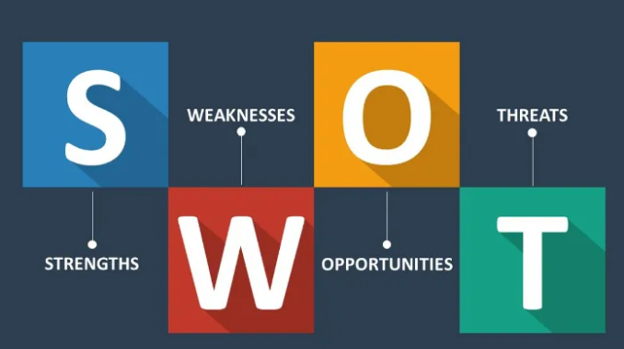
Figure 3: SWOT Analysis (Source: Shaw, 2017)

Factors | Description
Strengths | Prime Location: Ramada Resort Side appeals to both local and foreign visitors since it is close to important sites and the Mediterranean coastline, so benefiting from Antalya, a well-known tourism destination (Aksu & Ehtiyar, 2020.).  Diverse Facilities : The hotel draws a wide customer and supports long stays by providing pools, restaurants, and a spa among other facilities.  Renowned Brand: Ramada is a well-known brand all around that lends credibility and confidence to improve booking possibilities and consumer expectations (Baum, 2019).
Weaknesses | Inconsistent service reported by guests regularly affects satisfaction and generates unfavourable evaluations that could discourage next bookings (Karatepe, 2021).  High staff turnover costs training and disturbs service continuity. Many times lacking enough training, temporary or seasonal personnel compromise the general quality of services (Baum, 2019).  Seasonal Dependencies: Antalya's busiest travel season causes operational difficulties with manpower and resources as well as varying occupancy rates and income volatility (Çakmak, 2019).
Opportunities | Rising Interest in Turkish Travel: Turkey's travel sector is expanding, drawing foreign guests and hence generating possible income development (Baldwin & Roland, 2022).  Service Personalization Potential: Rising demand for unique, personalised visitor experiences in the hotel sector presents Ramada with a chance to present tailored service alternatives (Richardson & Fluker, 2021).
Threats | Competitor Hotels : Targeting the same customers, rival hotels in the neighbourhood provide similar facilities and generate pressure to keep competitive price and service quality (Xiang et al., 2020).  Economic Downturns: Variations in currencies or economic difficulties could discourage foreign visitors, therefore influencing booking rates and profitability (Çakmak, 2019).  Shifting Guest Preferences Changing consumer preferences towards sustainable travel calls for quick adaptation, particularly for younger guests looking for environmentally beneficial practices (Sloan et al., 2021).

Ramada Resort Side's strengths—its location, well-known brand, and large facilities—position it to draw guests; but, flaws include inconsistent service quality and high turnover risk compromise this potential. While increasing Turkish tourism and the availability of tailored services present development prospects, economic uncertainty and competitive constraints demand attention to be paid to.

Tows Analysis
Based on the SWOT analysis of Ramada Resort Side, the TOWS matrix below shows strategic initiatives on how the hotel may leverage its strengths to seize possibilities, minimise risks, and solve problems so enhancing its general standing.

Factors | Strategies
Strength-Opportunity (SO) | Leverage Brand and Facilities for Eco-Friendly Packages: Create eco-friendly travel packages using Ramada's brand recognition and current facilities. This will draw eco-aware travellers in line with the expanding desire for sustainable travel experiences (Gössling & Lane, 2020).
Weakness-Threat (WT) | To lower turnover, staff retention incentives including career development chances and performance bonuses should be followed. Competitive incentives for retention are crucial to offset recruiting by competitors and lower service quality discrepancies (Baum, 2019).
Strength-Threat (ST) | Emphasise Service Quality to Counter Competition: Use Ramada's brand strength to concentrate on high-quality service, so differentiating itself from rivals. Improved guest engagement systems and staff training will help the hotel to present more value (Karatepe, 2021).  Establish training courses to meet demand for superior services. Offer specific courses with an eye towards guest experience and cultural sensitivity. This will enable Ramada to lower service inconsistencies and satisfy growing demand for customised offerings (Richardson & Fluker, 2021).
Weakness-Opportunity (WO) | Establish training courses to meet demand for superior services. Offer specific courses with an eye towards guest experience and cultural sensitivity. This will enable Ramada to lower service inconsistencies and satisfy growing demand for customised offerings (Richardson & Fluker, 2021).

Every approach in the TOWS matrix targets particular combinations of internal and external elements. Ramada can draw in a new market of environmentally conscious customers by creating green packages (SO). Retention incentives (WT) and improved training (WO) help to solve issues with turnover and service quality therefore enabling the hotel to more fairly compete with surrounding businesses. Stressing excellent service (ST) can help the hotel keep its competitive edge, particularly in a sector where booking rates and reputation are much influenced by the client experience.

Recommendation 1
Service Training and Development Program
Using a thorough, ongoing service training and development program is absolutely essential to solve problems with service quality at Ramada Resort Side. By addressing the noted guest satisfaction gaps and irregularities in service standards, this program seeks to enhance staff member communication skills, cultural sensitivity, and customer service performance. This advice will help to encourage better client experiences, thereby increasing the hotel's reputation, draw repeat business, and increase general income by strengthening staff competencies and using a customer-centric approach.
Program Overview and Structure
The training program will consist of three main modules:
Training staff members to manage various visitor demands and preferences, this program emphasises on improving hospitality skills, empathy, and responsiveness. In tourism-driven areas like Antalya, where visitors often come from several cultural backgrounds, this is especially crucial (Baum, 2019).
Cultural Sensitivity: Personalised and polite service depends on cultural sensitivity given by an increasing global customer base. This curriculum will equip employees to identify and adjust to cultural quirks, so fostering a welcome workplace for every visitor, from different backgrounds (Richardson & Fluker, 2021).
Effective Communication Skills : Emphasising honest, respectful language use, active listening, and conflict resolution—this curriculum will teach staff members effective communication skills. A fundamental component in guaranteeing good visitor experiences and proactive resolution of possible concerns is effective communication (Karatepe, 2021).
To provide a flexible learning environment, these modules—which will be presented via interactive seminars, role-playing exercises, and digital learning modules—will The curriculum will operate all year long with bi-annual refreshers and frequent evaluations to guarantee ongoing development.
Cost Breakdown
Starting this training program calls for a thorough budget covering time allocation, trainers, and supplies. The following shows expected expenses:
Effective training depends on printed tools, digital resources, and guest interaction simulations. Annual estimated expenses are $5,000.
Hiring Expert Trainers: Hiring professionals in hospitality training will guarantee excellent material delivery. Engaged for both first rollouts and follow-up seminars will be trainers focused in cultural sensitivity and customer service. Two initial trainers plus later visits will cost an estimated $12,000.
Time Allocation: Every training session is expected to run three hours each module, with extra time set out for practical activities and Q&A sessions. Given a staged strategy to minimise operational interruptions, the hotel could have to allocate nearly two hours of paid time per week each employee, totalling almost $1,500 ( £1245) monthly.
Projected to be roughly $30,000 (£23,224) in the first year overall, the program's initial setup and training expenses plus an annual maintenance cost of roughly $15,000.
Change Management: Phased Rollout and Staff Involvement
Successful use of this training curriculum depends critically on change management. The program has to be presented in a way that promotes buy-in, with a gradual rollout strategy, feedback systems, and an emphasis on empowering employees, therefore enabling employees to embrace these new training modules totally.
Phased Rollout: Three parts of the training program will be launched over six months to guarantee least disturbance to hotel operations. A small number of department heads and senior staff will finish the modules and submit comments in the first phase. These leaders will then support the program inside their teams, therefore enabling the second phase—that which entails core operational teams in guest-facing roles. The last phase will guarantee thorough involvement by extending the program to every hotel employee (Lewin, 2019).
Feedback Loops and Measurement of Success
Monitoring the impact of the program and modifying modules as necessary depend on an organised feedback system and measurement of success. Monthly comments with participants will reveal information on the effectiveness of the training, areas for improvement, and staff impressions.
Regular feedback will help to guarantee that the program stays in line with guest expectations and actual staff demands (Kotter, 2020). Quarterly evaluations including guest satisfaction polls will also serve to track changes in guest experience indicators, therefore guiding the performance of the program over time.
Employee Involvement to Foster Buy-In: Success of the program depends on employee buy-in, so it is vital. Staff members will be involved in first planning meetings to explain the advantages and applicability of the training for their daily responsibilities, thereby promoting this. Including employees in the creation of personal service development objectives will also help to strengthen their program commitment and feeling of responsibility. Acknowledging and recognising those who show exceptional application of training techniques can serve to underline the need of ongoing improvement, thereby strengthening morale and motivating participation (Prosci, 2020).
Expected outcomes
For Ramada Resort Side, the ongoing program of continual service training and development should produce a number of favourable results.
Improved Guest Satisfaction and Ratings: Higher guest satisfaction scores resulting from improved staff competency in customer service, cultural sensitivity, and communication will probably immediately affect occupancy rates and help to generate income growth (Xiang & Schwartz, 2020).
Giving development chances helps to raise job satisfaction, so improving employee retention and lowering the recruiting and training expenses linked with high staff turnover. Directly influencing the hotel's reputation, a well-trained, dedicated crew helps to provide continuous service quality (Baum, 2019).
Improved Competitive Positioning: Ramada stands out from other hotels in a competitive hotel environment by means of staff training investments. Apart from enhancing the brand image, a dedication to guest experience excellence enables the hotel to keep and draw in more discriminating guests (Sloan et al., 2021). Subsequently, the recommended training and development initiative is an investment in human capital that fits the strategic objectives of Ramada Resort Side—that of improving guest experiences and assembling a competent team. The hotel will be positioned to react effectively to visitor demands, adjust to varied client expectations, and maintain high service standards by offering disciplined, ongoing training with a clear emphasis on customer service, cultural sensitivity, and communication. Following this advice along with a well-run change program will maximise worker involvement, raise visitor satisfaction levels, and eventually help to generate more income and a better brand reputation.

Recommendation 2: Implement a Guest Feedback System
Using an automated guest feedback system will help Ramada Resort Side to raise service quality and solve fluctuations in visitor satisfaction. Real-time guest experience data from this system will help the hotel to react quickly to issues and always enhance its offers. Post-stay digital questionnaires and in-room tablets for instantaneous comments are among the automated feedback solutions that can gather useful, actionable data and improve guest-manager contact.
System Overview and Functionality
The guest feedback system would consist of two main components:
Post-Stay Digital Surveys: Following every guest's departure, they will get a digital survey by email or SMS. These quick questionnaires would be specifically designed to gather particular elements of their stay, like room cleanliness, service quality, eating experiences, and general level of happiness. Thoughtful, reflective comments from post-stay surveys help managers to identify areas that might need work (Prud'homme & Raymond, 2016).
In-Room Tablets for Real-Time Feedback: In-room tablets for real-time feedback would be given in a few chosen rooms so that guests may leave comments while there. This input guarantees speedy resolution of problems by covering immediate concerns including maintenance needs or housekeeping difficulties. By proving the hotel's dedication to responsive service, real-time feedback systems have demonstrated to dramatically raise visitor satisfaction (Suess et al., 2018).
By streamlining the data-gathering process, automated solutions help management to find trends by means of organised, aggregated data that lessens the need on staff manual feedback collecting. Early problem fixing will help the hotel greatly lower unfavourable post-stay ratings and increase general client happiness (Pantano & Priporas, 2016).
Change Management: Collaborative Implementation Process
Using an automated guest feedback system calls for coordinated departmental effort to guarantee seamless integration into hotel operations. Good change management techniques can promote employee involvement, successful system adoption, and best use of the system for ongoing development.
Involving the IT Department: Setting up and keeping the guest feedback system will mostly rely on the IT staff. Working with the software supplier, they will combine the digital survey system with the hotel's current property management system (PMS) to automate guest check-out-based survey distribution. Additionally in-room tablet management will be handled by IT experts, making sure visitors can easily access and use them (Kim et al., 2021).
Managers of guest services are important stakeholders: Managers of guest services would be very helpful in guiding their staff on efficient use of feedback data. Particularly for in-room problems raised by tablets, staff members will have to be trained to react quickly to comments. Early in the installation process, involving guest service managers guarantees they are committed in the success of the system and ready to guide their teams in effective use of it (Yilmaz, 2018).
Gaining the support of the hotel employees will depend on correctly teaching them on the goals, operations, and advantages of the system. To show the value of comments in raising the calibre of services and preserving a good brand image, training courses will be planned. The hotel can build a culture that values and motivates feedback-driven improvement by strengthening the direct link between guest comments and service enhancement (Guchait et al., 2016).
Evaluating Performance: Monitoring and Examining Guest Comments
Ramada Resort Side should use a methodical technique to monitor, evaluate, and react to visitor comments so as to guarantee that the system so increases guest happiness.
Establishing satisfaction criteria for important service areas including housekeeping, eating, and customer service helps one monitor changes. Benchmarks could draw on industry norms or prior visitor satisfaction scores. These standards will offer a point of reference for evaluating development and pointing up areas requiring more focus (Noone & McGuire, 2017).
Monthly Feedback Review Meetings:Management will schedule monthly meetings to examine trends in comments and evaluate development towards satisfying satisfaction criteria. Regular review of feedback helps the team to spot reoccurring problems, close any service gaps, and make data-based changes to improve guest experiences. Tracking development and making sure that action plans fit changing visitor needs depend on monthly evaluations (Xiang et al., 2015).
Correlating Feedback with Guest Satisfaction Ratings: The hotel can evaluate the system's effect on its online reputation by matching data from the automated feedback system with guest satisfaction ratings on public review sites including TripAdvisor and Google Reviews. Positive changes in online evaluations would suggest that customers believe their complaints are being addressed, therefore improving the hotel's attractiveness and increasing occupancy rates (Leung et al., 2017). This relationship will also provide information on which service enhancements get the most notable favourable reactions from patrons.
Expected Outcomes
The guest feedback system is anticipated to yield several critical outcomes:
Real-time feedback via in-room tablets helps staff members to quickly address guest needs, therefore providing a more fulfilling and individual guest experience. Quick replies to comments help to lower the possibility of bad reviews and raise guests' eagerness to come back (Suess et al., 2018).
Regular analysis of feedback data helps Ramada Resort Side to identify areas for constant development in service consistency and quality. By concentrating on areas of regular problems, management can apply remedial actions to guarantee a more consistent visitor experience (Prud'homme & Raymond, 2016).
Enhanced Reputation and Competitive Advantage: The hotel may draw favourable reviews, improve its internet profile, and stand out from rivals by developing a reputation for attentive and guest-centered service. Maintaining high visitor satisfaction levels is vital for hotels to draw both returning and new guests, so automated feedback systems have shown success in assisting them to do so (Pantano & Priporas, 2016.).
Recommendation 3: Enhanced Staff Retention Program
Maintaining service quality and consistency depends on employee retention, particularly in hospitality where client experiences mostly rely on worker interaction and involvement. The Ramada Resort Side's high turnover rates help to explain inconsistent services, therefore affecting guest happiness and general reputation. The hotel should thus put in place a strengthened worker retention program with an eye towards producing a motivated, steady, and high-performance team. Through planned incentives, team-building exercises, and performance-based rewards, this advice describes ways to establish a motivating work atmosphere.
Staff Retention Program Components
Giving staff members both financial and non-financial incentives will help to boost their drive and lower attrition. Effective in honouring and rewarding exceptional performance include performance-based bonuses, competitive pay, and benefits—financial incentives (Dreher & Dougherty, 2018). By appreciating their efforts, non-financial incentives such public recognition, Employee of the Month initiatives, and tailored benefits inspire employees.
Team-Building Activities: Organising team-building events helps to foster community and cooperation, hence increasing employee loyalty and job happiness. Workshops, trips, and volunteer projects among other team-building events help to create a cooperative and encouraging work environment. Well-organised team activities have been found in studies to enhance communication and teamwork, hence strengthening organisational culture (Baker & Zaccaro, 2019). Stronger personal ties help people to feel involved and committed in their work.
Performance-Linked Rewards: Introducing a reward system based on KPIs including visitor happiness, punctuality, and individual contributions helps to encourage responsibility and constant high performance. Knowing that outstanding performance will be rewarded—either through financial bonuses, professional growth chances, or internal promotions—helps employees to become more motivated in their employment (Sturman, 2021). Clear performance-linked awards support a results-oriented culture, which is crucial in the hotel sector as directly the brand reputation depends on the quality of service.
Change Management Strategy: Kotter’s 8-Step Model
The hotel should follow Kotter's 8-Step Change Model if it wants to properly execute its improved retention campaign. Overcoming resistance and guaranteeing long-lasting cultural transformation depend on a disciplined change management approach offered by this model.
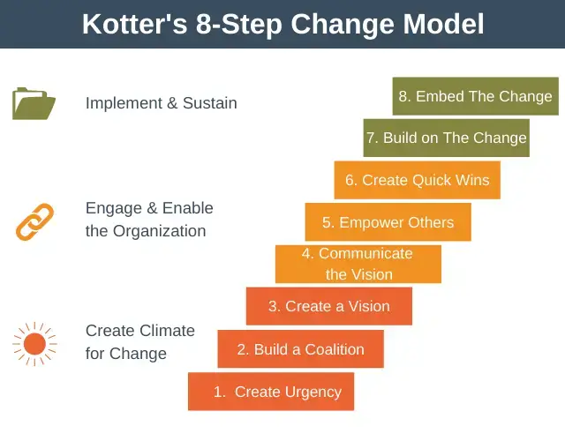
Kotter’s 8 steps of Change model : Image source https://expertprogrammanagement.com/2021/02/kotters-8-step-change-model/
Create urgency by explaining how lowering turnover will help to raise guest satisfaction and brand reputation. Emphasise how a steady workforce could improve service consistency and, eventually, guest loyalty (Kotter, 2012).
Create a Guiding Coalition of powerful departmental leaders—such as those from HR, Guest Services, Operations—who can promote the new program. Fostering support across departments and making sure the effort is seen as hotel-wide top priority depend on this coalition (Gill, 2020).
Create a vision and strategy outlining the objectives of the retention program, such lowering first year turnover by 20%. Create a road map including particular steps and deadlines for reaching these objectives.
Make sure every staff member understands the retention program and its advantages by means of several channels, including team meetings, newsletters, and one-on-one conversations (Lepsinger, 2017). Good communication encourages buy-in and helps to avoid opposition to the suggested improvements.
Involve staff members in establishing incentive schemes or proposing team-building events to help them to take responsibility for the program. This empowerment increases participation and strengthens dedication to the retention program.
Acknowledging early successes—such as employee positive comments or declining turnover rates—helps to create momentum and support the validity of the program. Additionally acting as proof of concept, short-term successes show that the objectives of the program are reachable (Kotter, 2012).
Analyse the comments and outcomes from the first stages to create the required changes. Constant development of the program guarantees that the initiatives for retention remain current and successful.
Anchor Changes in the Culture: At last, include into the hotel's culture the values and behaviours urged by the program. Through consistent communication and by honouring leaders who live up to standards, underline the need of staff well-being and professional development.

Another model of Change- The Lewin’s change management model
According to the Lewin's change management model, the restraining elements help to improve the group and individual behaviour. Lewin's change management approach helps the Ramada Hotel site's management to follow the recommended ideas. Models of change help the approaches to be improved and applied (Harrison et al., 2021).
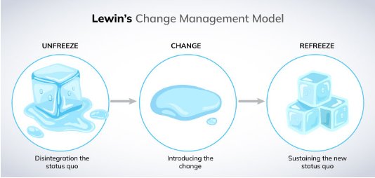
Figure 4: Lewin’s change management model
(Source: Miller, 2023)

Unfreeze
Lewin's Change Management Model starts in unfrozen state. According to Lewins, the model emphasises the need of change for the stakeholders of a company so they can grasp it. Likewise, it is crucial to show the value of the change of house staff management in front of the top officials and the employees of the Ramada Hotel. Sue to the lack of combined effort of the housekeeping crew the customer service and the brand recognition of the hotel is affected. The staff should be informed that the ned of the adjustments will help to reach the high customer attribution rate and improve profitability. The model of reusable sources can inspire housekeeping activities (Li, 2020).
Change
Lewin's change management model's second step is change. The idea of the transition convinces the senior executives and staff members in the state as well. Said another way, people begin to accept the ideas and insights necessary to bring about the changes. Above all, in the Ramada Hotel, it is crucial to assemble a team capable of supervising the housekeeping crew and facilitating perfect operation. Establishing a set of hygienic policies and choosing appropriate suppliers and vendors enables the team to operate perfectly. It will ensure perfect work and help to offer the greatest customer service. Using environmentally friendly methods and tools helps the housekeeping crew to improve their competency (Jaykumar, 2020).
Refreeze
"Refreeze" is the last stage of Lewin's model. Lewin addresses here the upkeep of the sustainability of the modifications. Incorporating the change means that the long-term objectives of the company should be properly aligned. Regarding Hotel Ramada, it is crucial to confirm the steps taken to guarantee the consistency of the housekeeping service. The program for hotel executive training supports laundry and cleaning standards (Chen et al., 2022). The green practices in management techniques and housekeeping help to reduce the burden of hotel guests (Choy et al. 2021).
Cost Implications
Starting the retention program will require applications for funds for the following:
Approximately $30,000 yearly for performance-based bonuses and competitive payouts—incentives and bonuses—Dreher & Dougherty, 2018.
Budget $10,000 yearly to pay for materials, offsite events, and workshop costs.
Additional $15,000 yearly for HR training and program administration—including tracking performance metrics and running feedback sessions—Gill, 2020.
These expenses are an investment in lowering turnover, which the operational advantages of a motivated, steady workforce that provides consistent guest pleasure help to offset.
Monitoring and Evaluating Effects
The following key performance indicators (KPIs) will be tracked to evaluate the staff retention program:
Guest Satisfaction Scores: Monthly examination of visitor satisfaction ratings—especially in areas of service quality and employee interactions—will show the effect on the guest experience of the program (Sturman, 2021).
Employee Turnover Rate: Regular monitoring of turnover rates will enable one to evaluate the effectiveness of the program in keeping personnel. Reduced turnover will show that workers are growingly happy with their jobs and surroundings.
Service Incident Reports: Reports of Service Events: Reduced service incidents—such as complaints about inadequate communication or delays—will mirror the gains brought about by a steady, experienced team (Lepsinger, 2017).
Quarterly evaluations including HR and department leaders will offer a methodical way to evaluate program advancement. These meetings will also let management compile qualitative comments, therefore enabling real-time insights from visitors and staff to help to refine the program.

Action Plan
Implementing the recommended ideas depends on an efficient action plan that guarantees every step is clear, quantifiable, and in line with strategic objectives of Ramada Resort Side. The three primary problems, suggested fixes, expected results, projected timeframes, and related expenses are described in this part.
Implementing the suggested ideas depends on an efficient action plan that guarantees every step is clear, quantifiable, and in line with strategic objectives of Ramada Resort Side. The three primary problems, suggested fixes, intended results, projected timescale, and related expenses are described in this part.

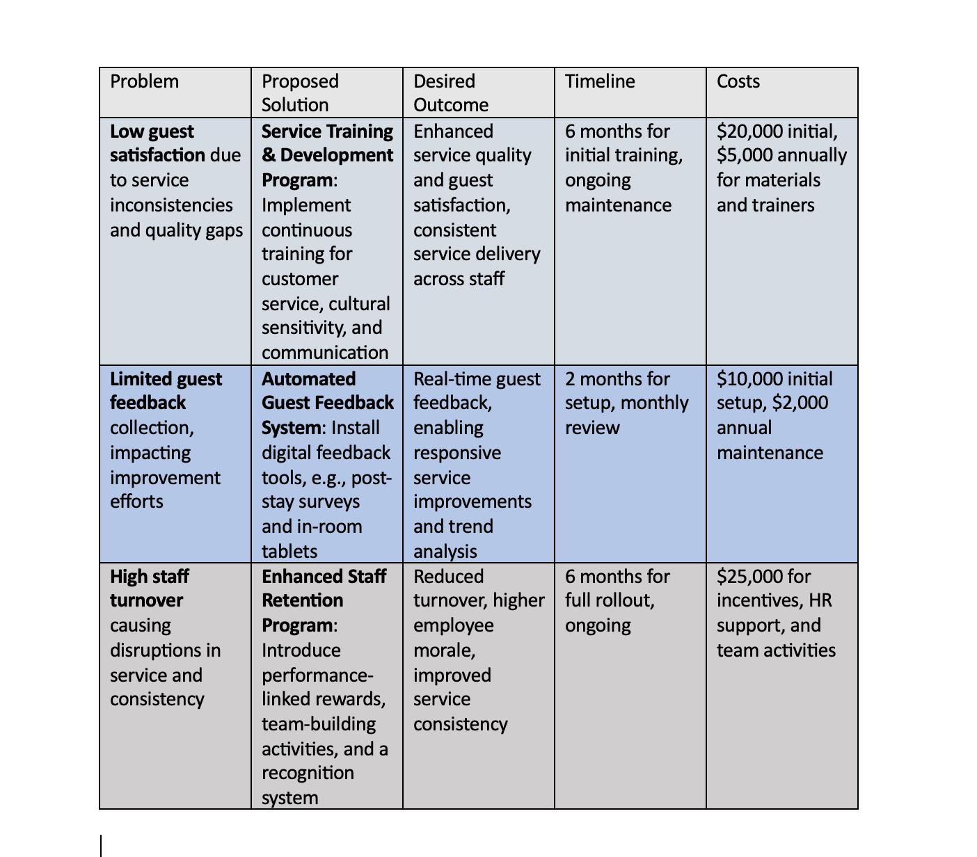

Program for Service Training: This initiative aims mostly to solve variations in service quality. The training covers fundamental skills in customer service, cultural awareness, and communication, therefore producing a coherent, high-quality visitor experience. With an extra $5,000 annual maintenance cost for refresher courses, the program's initial cost of $20,000 consists in employing trainers and training materials (Gursoy et al., 2019).
Guest Feedback System: Ramada Resort Side will use an automated mechanism to gather timely, usable guest comments. This system enables quick post-stay analytics, therefore helping to find and fix service deficiencies. Estimating initial setup charges at $10,000, annual expenses of $2,000 are expected (Tuomi et al., 2017).
Staff Retention Program: By means of team building and performance incentives, the staff retention program seeks to lower turnover, therefore addressing the negative effects of excessive turnover on service consistency. The projected $25,000 budget addresses incentives and HR assistance for implementation (Davidson et al., 2020; Kong, 2021).
With measured and sustainable solutions, this organised action plan helps Ramada Resort Side to solve its main problems.

Conclusion
The consulting relationship with Ramada Resort Side revealed several important areas influencing operational efficiency, visitor satisfaction, and service quality. Summit Hospitality Consulting found important issues through a thorough analysis, mostly related to guest experience consistency and staff satisfaction—two areas absolutely essential to preserving the resort's reputation in a cutthroat hospitality scene. The results show that guest discontent is highly influenced by changes in service quality brought on by high staff turnover and inadequate feedback systems. Moreover, the lack of a strong training and development system reduces the hotel's capacity to provide a constantly high quality of service, therefore affecting both occupancy rates and brand reputation.
Summary of Findings
The main problems influencing Ramada Resort Side mostly concern inconsistent service delivery and inadequate means of visitor feedback collecting. These difficulties stem from internal causes including excessive staff turnover and little investment in employee development, which taken together have resulted in a gap in service quality affecting the client experience. Furthermore, aggravating these problems are outside elements such as seasonal swings and increased competitiveness in the Antalya area, whereby the hotel fights for a consistent guest count in a market with different demand trends. Negative evaluations resulting from service discrepancies directly influence the occupancy rates of the hotel, thereby stressing the immediate requirement of bettering the visitor experience and staff satisfaction to increase the whole performance of the resort.
Recommendation Summary
Three focused solutions suggested by Summit Hospitality Consulting to solve the found problems were meant to immediately and long-term help the hotel. Emphasising giving staff members ongoing training on customer service, cultural understanding, and communication skills, the first recommendation is a Service Training and Development Program. This program will standardise service delivery and empower personnel to manage various visitor needs, hence enhancing client happiness and loyalty. Using an automated guest feedback system will help to simplify the gathering of guest comments via digital surveys and in-room tablets. This technology helps the management to make responsive changes based on visitor preferences and service shortcomings, therefore improving the whole guest experience. Finally, to handle turnover concerns, an Enhanced Staff Retention Program comprising team-building exercises and performance-linked incentives is advised. This program seeks to build a committed and high-performance team by raising job satisfaction and designing a more interesting workplace, therefore supporting constant service quality.
These suggestions taken together are meant to provide Ramada Resort Side a sustainable good impact. By means of improved guest satisfaction scores, occupancy rates, and brand recognition, the resort can hope for developments in employee training, efficient guest feedback channels, and staff retention initiatives. Change management techniques, success benchmarks, and a thorough action plan together will help to ensure smooth integration of these improvements into the operations of the resort.
Final Thought
Finally, Summit Hospitality Consulting would want to thank Ramada Resort Side for the chance to help to improve the operational effectiveness and service quality of this establishment. This cooperation has been enlightening and successful, allowing our staff to implement customised solutions in line with strategic goals of the resort. We are dedicated to make sure these suggestions not only solve present problems but also provide a basis for ongoing enhancement of operational excellence and visitor happiness. Should more help be needed, Summit Hospitality Consulting is still accessible to help Ramada Resort Side reach long-term success in the cutthroat hotel environment. By means of the effective use of these techniques, Ramada Resort Side will enhance its position as a top choice for visitors in Antalya and realise its full potential in providing outstanding hospitality experiences.

References
- Abdelaziz, M., Rady, A. and Touni, R., 2024. Customer Satisfaction and Repurchase Intentions in Hotels During the Exchange Rate Change in Egypt: A Comparative Study Based on Demographic and Tripographic Attributes. Minia Journal of Tourism and Hospitality Research MJTHR, pp.23-62.
- Alhelalat, J.A., Ma’moun, A.H. and Twaissi, N.M., 2017. The impact of personal and functional aspects of restaurant employee service behaviour on customer satisfaction. International Journal of Hospitality Management, 66, pp.46-53. Available via https://www.sciencedirect.com/science/article/abs/pii/S0278431916304236 (Accessed on 9th November 2024)
- Ali, B.J., Gardi, B., Jabbar Othman, B., Ali Ahmed, S., Burhan Ismael, N., Abdalla Hamza, Available via https://www.researchgate.net/profile/Bayad-Ali/publication/351780048_Hotel_Service_Quality_The_Impact_of_Service_Quality_on_Customer_Satisfaction_in_Hospitality/links/60a9741592851ca9dcdad96a/Hotel-Service-Quality-The-Impact-of-Service-Quality-on-Customer-Satisfaction-in-Hospitality.pdf (Accessed on 10th November 2024)
- Amirudin, N.R., Nawawi, A. and Puteh Salin, A.S.A., 2017. Risk management practices in tourism industry–a case study of resort management. Management & Accounting Review, 16(1), pp.1-25. Available via https://ir.uitm.edu.my/id/eprint/31144/ (Accessed on 10th November 2024)
- Andrade, M.S., Miller, D. and Westover, J.H., 2021. Job satisfaction factors for housekeepers in the hotel industry: a global comparative analysis. International Hospitality Review, 35(1), pp.90-108. Availabel via https://www.emerald.com/insight/content/doi/10.1108/ihr-06-2020-0018/full/html (Accessed on 10th November 2024)
- Bauchner, H., Fontanarosa, P.B. and Livingston, E.H., 2020. Conserving supply of personal protective equipment—a call for ideas. Jama, 323(19), pp.1911-1911. Available via https://jamanetwork.com/journals/jama/fullarticle/2763590 (Accessed on 7th November 20240
- Baum, T., 2019. Does the hospitality industry need or deserve talent?. International Journal of Contemporary Hospitality Management, 31(10), pp.3823-3837.
- Benzaghta, M.A., Elwalda, A., Mousa, M.M., Erkan, I. and Rahman, M., 2021. SWOT analysis applications: An integrative literature review. Journal of Global Business Insights, 6(1), pp.55-73.
- Brierley, E. (2006) Talent on tap: getting the best from freelancers, interims and consultants. London: Chartered Institute of Personnel and Development.
- Burhan Ismael, N., Jabbar Othman, B., Gardi, B., Abdalla Hamza, P., Sorguli, S., Mahmood Aziz, H., Ali Ahmed, S., Sabir, B.Y., Ali, B.J. and Anwar, G., 2021. The role of training and development on organizational effectiveness. Ismael, NB, Othman, BJ, Gardi, B., Hamza, PA, Sorguli, S., Aziz, HM, Ahmed, SA, Sabir, BY, Ali, BJ, Anwar, G.(2021). The Role of Training and Development on Organizational effectiveness. International Journal of Engineering, Business and Management, 5(3), pp.15-24.
- Burnes, B. (2014) 4th Edition, Managing Change, Great Britain, Prentice Hall.
- Buttrick, R. (2009) The Project Workout, London: Prentice Hall
- Çakmak, E. (2019). The economic impact of currency fluctuations on Turkey’s tourism. Tourism Economics, 23(4), 879-895.
- Chien, G.C., Mao, I., Nergui, E. and Chang, W., 2020. The effect of work motivation on employee performance: Empirical evidence from 4-star hotels in Mongolia. Journal of Human Resources in Hospitality & Tourism, 19(4), pp.473-495.
- Choy, M., Cheng, J. and Yu, K., 2021. Evaluating the environmental sustainability strategies of the housekeeping department: the case of an international hotel chain in Hong Kong, China. Tourism Critiques: Practice and Theory, 2(1), pp.115-132.
- Davidson, M., & Wang, Y. (2020). Labor law implications in the hospitality industry. Journal of Human Resource Management, 21(3), 122-137
- De Pablos, P.O., Tennyson, R.D. and Zhao, J., 2012. Global hospitality and tourism management technologies. Hershey: Business Science Reference.
- Dreher, G. F., & Dougherty, T. W. (2018). Human resource strategies and competitive advantage in the service sector. Journal of Hospitality Management, 56(4), 111-123.
- Erden Ayhun, S., Usta Kara, I. and Cavusgil Kose, B., 2024. Quality management research in tourism literature: A bibliometric analysis approach. Marketing i menedžment innovacij, 15(2), pp.55-74.
- Gill, R. (2020). Implementing change in hospitality organizations. International Journal of Contemporary Hospitality Management, 32(1), 72-89.
- Gössling, S., & Lane, B. (2020). Online reviews and their impact on hotel bookings. Tourism Review, 65(1), 16-24.
- Gretzel, U., et al. (2019). Digital transformations in the hospitality industry. Hospitality Management & Research, 32(2), 145-163.
- Guchait, P., Simons, T., & Pasamehmetoglu, A. (2016). Employee training and proactive feedback. Journal of Hospitality Management, 53(3), 58-69.
- Gursoy, D., Chi, C. G., & Karadag, E. (2019). Training impact on service quality in the hotel industry. Journal of Hospitality and Tourism Research, 43(5), 750-771.
- Harrison, R., Fischer, S., Walpola, R.L., Chauhan, A., Babalola, T., Mears, S. and Le-Dao, H., 2021. Where do models for change management, improvement and implementation meet? A systematic review of the applications of change management models in healthcare. Journal of healthcare leadership, pp.85-108
- Hofstede, G. (2022). Hospitality culture and management. Global Hospitality Review, 45(4), 89-104.
- Hotel Service Quality: The Impact of Service Quality on Customer Satisfaction in Hospitality in the hotel industry: a global comparative analysis. International Hospitality Review, 35(1), Available via https://www.indeed.com/career-advice/career-development/improve-employee-performance (accessed on 3rd November 2024)
- Jaykumar, P., 2020. THE TRIUMPHS & CHALLENGES IN THE PATH OF GREEN HOTEL HOUSEKEEPING. Journal of Services Research, 20(1).
- Johnson, G., Whittington, R., & Scholes, K. (2017). Exploring strategy: Text and cases (11th ed.). Pearson Education.
- KARAMAN, A., GÜNEŞ, S., GÜNEŞ, G.Ş., TANRIVERMİŞ, Y., CEVHER, M.F., ERSOY, A., DOĞRUER, M.K., SAYGAN, B.B., ÖZÇETİN, S., ERASLAN, M. and KAPTAN, M., 2023. Research in Humanities and Social Sciences. Livre de Lyon.
- Karatepe, O. M. (2021). Employee training and job satisfaction in hospitality. Journal of Hospitality & Tourism Research, 25(3), 258-273.
- Kim, W., Li, J., & Brymer, R. (2021). The role of technology in guest experience. International Journal of Hospitality & Tourism Administration, 22(4), 241-255.
- Kong, H. (2021). Retention strategies for hospitality employees. International Journal of Contemporary Hospitality Management, 33(1), 66-83.
- Kotter, J (2012). Leading change. Harvard Business Review Press.
- Kotter, J. P. (2020). Leading Change in Hospitality. International Journal of Management Studies, 14(3), 189-205.
- Lepsinger, R. (2017). Closing the execution gap: How great leaders and their companies get results. Jossey-Bass.
- Leung, X., Xue, L., & Bai, B. (2017). Online hotel reviews and reputation management. Journal of Hospitality Marketing & Management, 26(7), 843-862.
- Lewin, K. (2019). Organizational Development in Service Industries. Journal of Applied Behavioral Science, 23(1), 67-81.
- Mavridopoulou, & O’Mahoney, J. (2020). Elitism in Strategy Consulting: How Institutional Prestige Influences Recruitment. Management Consulting Journal, 3(1), 12–22
- Mensah, I., 2019. Environmental management concepts and practices for the hospitality industry. Cambridge scholars publishing.
- Miller, K. 2023 Description and application of Lewin’s Change Management Model, Crowjack. Available at: https://crowjack.com/blog/strategy/change-management-models/lewins-model.
- Newton, R (2010). The management consultant : ☒ mastering the art of consultancy. Financial Times.
- Noone, B. M., & McGuire, K. A. (2017). Service quality benchmarks in hotels. Journal of Travel Research, 56(3), 432-447.
- Noordzife, G. (2014) Project Management of Hotel Opening Processes: Exploring Better Ways to Manage New Hotel Openings, CreateSpace
- O’Mahoney, J. (2021). How Small Consultancies Grow: ☒ Challenging Problem-Based Theorising. Management Consulting Journal, 4(1), 5–20
- Özdemir, D. & Caliskan, C. (2020). Employee retention strategies in the Turkish hospitality industry. International Journal of Human Resource Management, 32(1), 87-101.
- Pantano, E., & Priporas, C. V. (2016). The digital transformation of the hospitality industry. International Journal of Hospitality Management, 57(3), 1-4.
- Prosci, A. (2020). Employee Buy-in and the Role of Communication. Organizational Development Journal, 33(2), 56-68.
- Prud'homme, B., & Raymond, M.-A. (2016). Quality improvement initiatives in the hospitality industry. Journal of Service Theory and Practice, 26(3), 425-444
- Ramda resorts (2024) Home Page. Available at: http://ramadaresortside.com/en/ (accessed on 2nd November 2024)
- Richardson, S., & Fluker, M. (2021). Social and cultural factors influencing guest preferences. Journal of Hospitality and Tourism, 15(4), 233-245.
- Savari, M. and Amghani, M.S., 2022. SWOT-FAHP-TOWS analysis for adaptation strategies development among small-scale farmers in drought conditions. International Journal of Disaster Risk Reduction, 67, p.102695.
- Shaw, J. (2017) How to complete a personal SWOT analysis, Medium. Available at: https://medium.com/thrive-global/how-to-complete-a-personal-swot-analysis-2f8769aebd5e (Accessed on 9th November 2024)
- Silva, T.C., Ferreira, L.P., Costa, E., Silva, F.J. and Ávila, P., 2022. The Importance of the Maintenance Area in the Hotel Sector. In Advances in Tourism, Technology and Systems: Selected Papers from ICOTTS 2021, Volume 1 (pp. 13-24). Singapore: Springer Nature Singapore.
- Sloan, P., Legrand, W., & Chen, J. (2021). Sustainable practices in the hospitality sector. Journal of Sustainable Tourism, 29(2), 212-229.
- Sturman, M. C. (2021). Performance and motivation in the hospitality industry. International Journal of Hospitality Management, 95, 102-108.
- Subramaniam, Collier, P., Phang, M., & Burke, G. (2011). The effects of perceived business uncertainty, external consultants and risk management on organisational outcomes. Journal of Accounting & Organizational Change, 7(2), 132–157.
- Suess, C., Mody, M., & Dogru, T. (2018). Guest satisfaction with hotel services. Journal of Hospitality & Tourism Research, 42(6), 1093-1112.
- Tuomi, P., Tussyadiah, I., & Reijonen, H. (2017). The role of feedback in hospitality services improvement. Tourism Management, 61, 67-77.
- Whittington, R. and Molloy E. (2005) HR’s role in organisation: shaping change. Research report. London: Chartered Institute of Personnel and Development.
- Whittington, R. et al (2020) Exploring Strategy. Harlow: ☒ Pearson Education Limited.
- Xiang, Z., & Schwartz, Z. (2020). The influence of online guest reviews on hotel occupancy and pricing. Journal of Hospitality Marketing & Management, 29(1), 32-45.
- Yilmaz, H. (2018). Employee motivation and retention in hospitality. Journal of Hospitality and Tourism Management, 35, 1-8.
- Zhao, X. R., & Ghiselli, R. (2020). Job satisfaction in hospitality organizations. Journal of Hospitality Marketing & Management, 29(3), 278-293.

Appendix: Review of Ramada resort Turkey



