Report:Academic Report
TO:UWTSD From:Yasmeen Begum (2119725) Date:1stFebruary2022 Subject: Academic and employability skill BMSW4001 BIRMINGHAM
Lecturer: ABDI RAHMAM

Table of content

Introduction 3

Description 4 Feelings 5

Experience 6

Evaluation 13

Presentation feedback form 14

Conclusion 15

PDP Plan 16

References 17

Introduction

For my reflective journal I will be exploring my experiences by using the Gibbs model of reflection.as there are many more models we can use, Era model, Driscol's what's model and many more, but for this report I have used Gibbs. In this model of reflection there are 6 key aspects to explore. These aspects being description, feelings, evaluation, analysis, conclusion, and action plan. According to (Adean I.S ,Febriani 2020) they say it is compulsory for the students to make reflections of literary works. Using this model, I will be reflecting on my experiences during the write up of report one and my experience whilst working as a group for a group presentation.

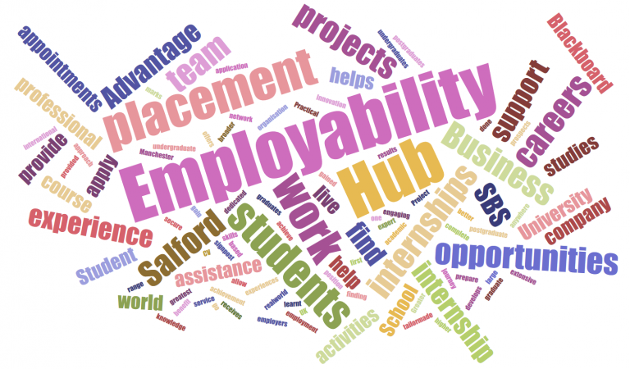

DISCRIPTION
Week 1. Induction I learnt What does this module mean. The meaning of academic and employability. What the main overview of the module would be over the weeks ahead. Giving us a schedule and an idea of what we be learning in weeks to come.

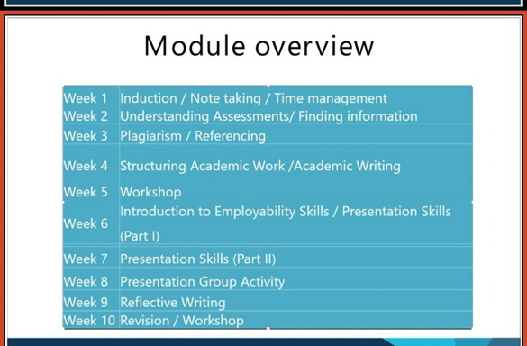

FEELINGS
I found taking notes was easy and helped me better to remember stuff. It helped me to write this report.as I had notes written down. Because with having things going on outside university, you forget what you have learned. I experienced that note taking really did help me.im glad I did.
Taking notes is important as you can go back and read what you might have forgot in the past. Note taking is a good practice of recording information. Our work memory is different than others. Taking notes sometimes helps you better than just remembering it, as our capacity of memory can only hold up certain amount of information.
This module has helped to learn about What is the meaning of academic and employability skills. How Employability skills can be defined as the transferable skills needed by an individual to make them employable. Alongside with good technical understanding and subject of knowledge, so employers can often outline a set of skills that they want from an employee.
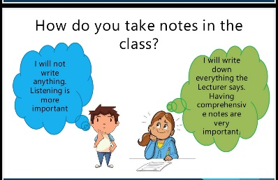

I also learned how to time management. For me time management really helped as it let me manage university work and life outside. Meaning with family and my job.it allowed me to keep control of my social activities.it also helped me to prioritise and complete with my assessments deadlines.it helped me to have a routine which also helped me with my mental health. And I had to do what would make my life easy for myself. Feeling less stress and being more able to concentrate on my studies.
Having a strategy like the pomodoro technique really helped aswel.it helped me feeling less anxious when we were explained how to use the technique. Below is a demonstration of how to use the pomodoro technique. Which I learnt while in week 1 of our module. If I did not have this technique. I do not know if would of be able to work around work, university, and family,

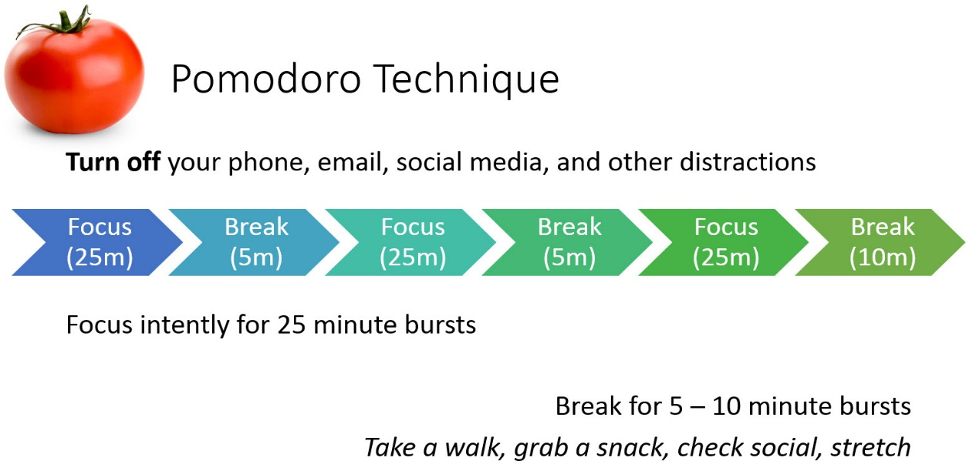
.

WEEK 2: I was explained how to understand assignments and finding information. Which for me is still a struggle as its all new for me. I learned that there are two types of assignments. Which are formative assessment and summative assessment. Having to understand the two difference is not easy and will take time for me as. I take time to understand the concept of things. This was where we were explained how to do task1.task 1 was where we were given a question on how we would motivate staff in the workplace. We had to write up 2000 words and we had to also reference it. we had to search resource and information out there. I never have done an assignment before.so for me it was a struggle and still is.as I find it a struggle to understand concept of things.so I planned my time for me to start my report, but I know for next time where I have gone wrong and can-do things different.as you will learn new things as you go along.
So, this is the different between them, which will help me to understand.
FORMATIVE ASSESSMENT: 1, class tasks help you to consolidate and develop your learning. 2, class tasks demonstrate to your lecturer whether you understand key concepts.

SUMMATIVE ASSESSMENT: 1, mid-term assignments and end of term assignments allow your lecturer to assess your ability to meet the learning outcomes for the module.
2, these tasks allow you to receive grading and feedback which aid you to progress through your course.
Finding information:
Where do we find and begin researching? I learned how to search information. How There are many resources we can use but it knowing what resources are then fictionally. I learned. There are also 2 types of sources one which is primary, and one is secondary.
So, I learned that primary meant information I gathered or searched on my own Knowlagent. And secondary was what is already out there. Where others have searched and owned it,
Primary source. Primary is your own research, your own information first-hand evidence.
Secondary source. Secondary is someone else finding. Anything that describes, anything like books, articles. existing research. Information which is out there.
Then I learned then we have quantitative data and qualitative date.
I did not even know there was such data out there which is highly used.it explained to me what the difference was between them both and how people would use them to search information. I learned how we can use quantitative data in graphs, charts. Large sample size information. maths, statistics analysis. which can be done by questionnaire, face to face interviews. I never knew how to create a chart or graphs before which I do know. Which I am proud off. Even know how to crate them. Which I never knew before.
Where I have learned that qualitative data is based on variety of formats, including written words, audio clips, and video.

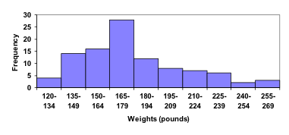
This Photo by Unknown Author is licensed under CC BY-SA
I also learned what the CRAAP TEST ment.as I have never heard of it before. Which helps with all types of information is available out there and making sure how we search it currently. this is what craap means and helps you to understand.

Currency: the timeliness of the information
- When was the information published or posted?
- Has the information been revised or updated?
- Is the information current or out of date for your topic?
- Are the links functional?
Relevance: the importance of the information for your needs
- Does the information relate to your topic or answer your question?
- Who is the intended audience?
- Is the information at an appropriate level (i.e. not too elementary or advanced for your needs)?
- Have you looked at a variety of sources before determining this is one you will use?
- Would you be comfortable using this source for a research paper?
Authority: the source of the information
- Who is the author/publisher/source/sponsor?
- Are the author's credentials or organizational affiliations given?
- What are the author's credentials or organizational affiliations given?
- What are the author's qualifications to write on the topic?
- Is there contact information, such as a publisher or e-mail address?
- Does the URL reveal anything about the author or source?
  - examples:
.com (commercial), .edu (educational), .gov (U.S. government)
    - .org (non-profit organization), or
    - .net (network)

Accuracy: the reliability, truthfulness, and correctness of the content
- Where does the information come from?
- Is the information supported by evidence?
- Has the information been reviewed or refereed?
- Can you verify any of the information in another source or from personal knowledge?
- Does the language or tone seem biased and free of emotion?
- Are there spelling, grammar, or other typographical errors?
Purpose: the reason the information exists
- What is the purpose of the information? to inform? teach? sell? entertain? persuade?
- Do the authors/sponsors make their intentions or purpose clear?
- Is the information fact? opinion? propaganda?
- Does the point of view appear objective and impartial?
- Are there political, ideological, cultural, religious, institutional, or personal biases?

Then we were explained how to do Referencing in our reports. I never even knew what referencing meant until I was taught. referencing is also a Secondary source as it is information we have searched up. Which is also called Harvard Referencing. referencing is when we use someone else work. But we must be careful of what we can use as it is a copy write and ethically wrong to use someone’s work and claim it as your own. We must ethically make sure we do the right thing by referencing our work. From various sources, we must always reference any research we use from library books to articles. If we are using from a book making sure we write the Arthur of the book and title. Where articles we must quote name of the person and year the article was written.as we cannot use information which is already owned by someone else.to be honest I struggled with understanding referencing, where meaning which format to use and how. But there are loads of videos on YouTube which has helped me.

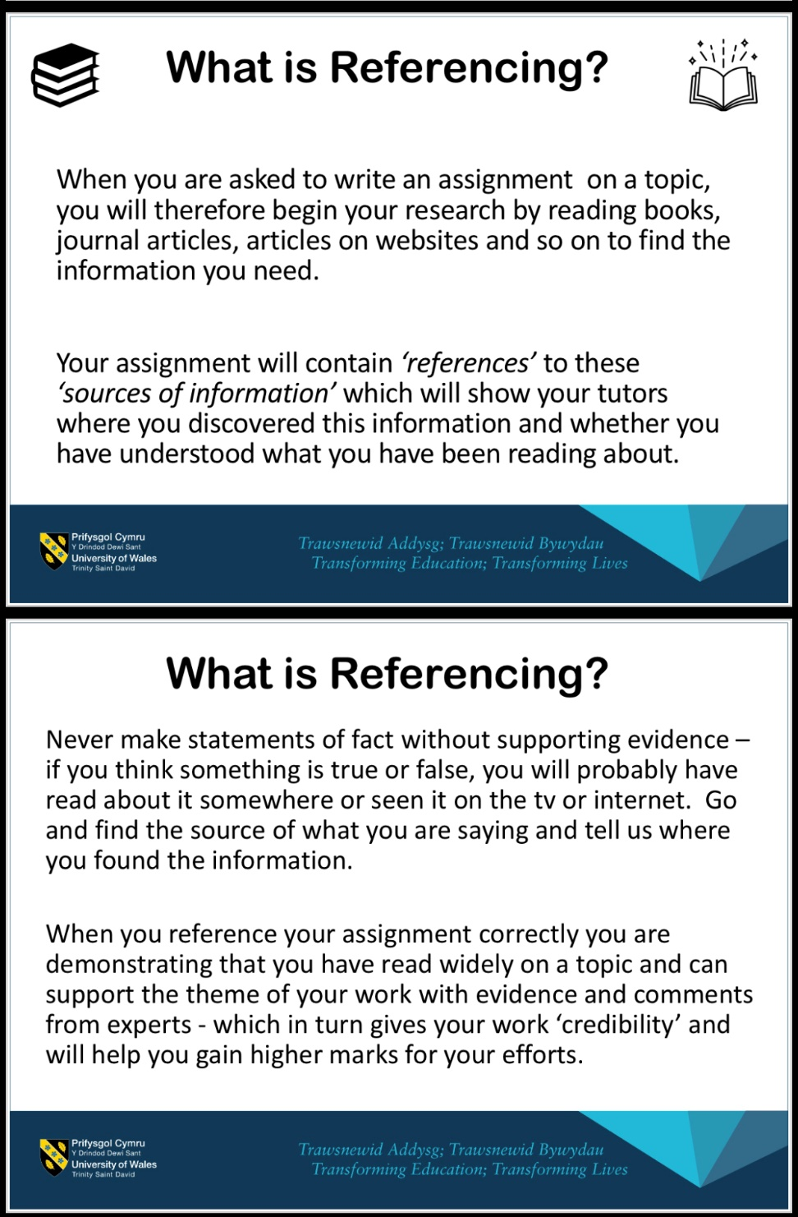

Which then came in about learning about Plagiarism.
Which also means claiming something. which is not yours, taking someone’s else work or ideas and passing them of as well your own. Which ethically and by law is wrong. There are people out there who will get others to do their assignments and essay for them. But there think there playing clever but because of today's technology it is easy to pick up if anyone has copied anyone’s work. Below I have attached a video for people to understand more about what plagiarism is.

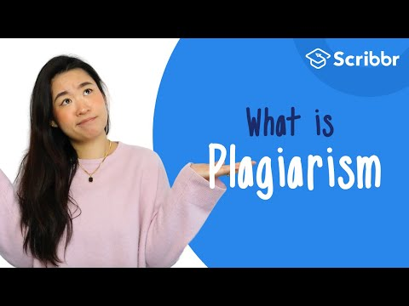
https://youtu.be/Uk1pq8sb-eo

Then came understanding the difference between a report and essays. There are 2 main types of assessments which are REPORT AND EASSY. once you get to understand them it be easy to do.to be honest it is still hard for me to figure it out. But searching the information about what is the differences does help.
The differences between reports and essays are.
REPORTS HAVE A TABLE OF CONTECTS | EASSYS DON’T HAVE A TABLE OF CONTENTS.
REPORTS ARE DIVIDED INTO HEADED AND NUMBERED SECTIONS AND SOMETIMES SUB-SECTIONS | EASSYS ARE NOT DIVIDED IN TO SECTION BUT YOU MAY HAVE SEPARATE HEADED APPENDICES.
REPORTS OFTEN ORIGINATE FROM OUTSIDE ACADEMIC SUBJECTS AND ARE TYPICALLY USED IN THE WORLD OF WORK. | EASSYS ORIGNATE IN ACADEMIC SETTINGS, INCLUDING PRACTISE-BASED SUBJECTS.
REPORTS OFTEN PRESENTS DATA AND FINDINGS THAT YOU HAVE COLLECTED YOURSELF, EXAMPLE THROUGH A SURVEY, EXPERIMENT OR CASE STUDY.SOME REPORTS FOCUS ON APPLYING THEORY TO YOUR FIELD OF WORK. | EASSYS USUALLY FOCUS ON ANALYSING OR EVALUATING THEORIES, PAST RESERCH BY OTHER PEOPLE, AND IDEAS.THEY MAY INCLUDE APPLYING THEORY TO PRACTICE IF YOU ARE IN A PRACTISE-BASED FIELD.
A REPORT USUALLY CONTAINS TABLES, CHARTS AND DIAGRAMS. | EASSYS DON’T INCLUDE TABLES, CHARTS, OR DIAGRAMS
REPORTS USUALLY INCLUDE DESCRIOTIONS OF METHODS USED | EASSYS DON’T USUALLY REFER TO THE METHODS YOU USED TO ARRIVE AT YOUR CONCLUSIONS
THE DISCUSSION IN A REPORT OFTEN COMMENTS ON HOW THE REPORT RESERCH COULD BE IMPROVED AND EXTENDED, AND MAY EVALUATE THE METHODS AND PROCESSES USED. | EASSYS DON’T USUALLY REFLECT ON PROCESS OF RESERCHING AND WRITING THE EASSY ITSELF.
REPORTS SOMETIMES INCLUDE RECOMMENDATIONS. | EASSYS DON’T INCLUDE RECOMMENDATIONS

Evaluation
Then we learned about what is a presentation. I learned that presentation can be done signally or as a group. I learnt that Individual presentation is your own research, your own planning. And how you can work independently. Where group presentation is you work as a group. The group itself then will do research together and plan together then will also present the work. I enjoyed my experience as working as a group. We had been given the task to present a presentation of an advert of a job description. there were four of us in a group. Where we choose a group leader. Who we thought would be a good leader? Because she was confident enough and knew what needed to be done. The group leader decided what job advert we were going to choose. We all got together and gathered information regarding the job advert. Everyone had their part of research to do. We used PowerPoint to present our presentation. On the day of presentation, I was unconfident to present in front of the class, as I speak to quick but on the day, I learned to just take it easy and slow. According to (Levi, 2022) “that presentations give some students anxiety arises from fear.so that’s why students might reorganize that worry.by separate ways to present presentations by body language. such as standing upsetting arranging themselves behind a table or would walk and talk " then were given feedback from other groups. Which was good to have as it helps us to improve. so, I have learned what to do next time when presenting. I have attached our feedback form below .that’s where we started to learn about employability skills. That what is employability skills. Employability skills are what employees seek when someone goes for an interview or applies for an employment. What kind of skills you can give towards there company? How would their benefit from you? It is what employees seek.s.so we worked as a group to search what job we would advertise. The benefits. Its description. working as groups less stressful. You get to share the project. You also work as a team.

Conclusion
So out of this module and tasks I have learned a lot. I have learned just even the basics which I never knew. I left school at the age of 11.i did not return to any form of education. So, coming back into education at the age of 42 was a big struggle and stressful. But I thought let me give it a go. For me to even learn how to use word. Was a struggle. Having to understand the concept of what we have been taught is hard. But this module has given me a wonderful experience and opportunities. I have now learned to write up a report. How to be a part of a team for presentations’ we reference our work. How to be careful about what we submit and how we search our information.no one said it be easy. But I still have a lot of way to go. there is a lot I could have done and need to do. I need to take it easy and plan better for next time. Need to ask more for help if I struggle. The main thing is kept on practing.as practice makes it better.

Personal Target | How will I achieve this? | How will this improve my academic or employability prospects? | How will I know that I have achieved this? | When will I achieve this by?
1.Understanding how to do Assignments | By practising more. understanding them | It will help me to make sure that I am doing my assignments in the right format. | By completing them and redoing them if incorrect. as practise makes it better | As soon as possible.
2.Reserch information for assignments. | Will read more. Watch videos to understand how to make sure that I am researching the correct information | It will help gathering the right information, which is needed. | By getting it checked regularly by my lecture. | As soon as possible.
3.Understanding the concept of modules | Will ask for help when needed. | It will help me to understand more widely. | By making sure by asking staff. | When required

Refences
Adreani, I.S., Febri ani, R.B. and Syafryadin, S. (2020). USING GIBBS’ REFLECTIVE CYCLE IN MAKING REFLECTIONS OF LITERARY ANALYSIS. Indonesian EFL Journal, [online] 6(2), p.139. Available at:

Levi (2022). Helping Students Overcome Presentation Anxiety. inside higher ed. 23 Mar.

https://journal.uniku.ac.id/index.php/IEFLJ/article/view/3382/2034.

Gibbs, G. (1998) Learning By Doing : A guide to teaching and learning methods, Oxford: Further Education Unit, Oxford Polytechnic

What is plagiarism? | Scriber (2020). What is plagiarism? | Scriber. [online] YouTube. Available at: What is plagiarism? | Scribbr 🎓
.

