
Project Management plan of a Restaurant Extension
(BMSW5104)

Lahin Miah
Student ID: 1817205
Submission date: 23/07/2021
Contents
1.0 Introduction 3
2.0 Project B: Restaurant Extension 3
2.1 Outline of the project 3
2.2 Analysis of stakeholder 4
2.3 Work Breakdown Structure 5
2.4 Consideration of resources 7
2.5 Project schedule 8
2.6 Risk assessment 9
3.0 Conclusion 12
4.0 References 13

1.0 Introduction
Building project plan is not an easy task as an individual or an organization has to consider so many aspects because the plan has to be perfect and contain a cost analysis, breakdown of the processes, schedule and finally reduce the risk of failure (Wysocki et al, 2015). This study will contain such a project plan for a restaurant which is trying to extend their dining space by joining the outside terrace with the dining space and build a decently large dining space which will contain a large number of customers. So, first there will be a brief discussion on the project outline and then a stakeholder analysis of the restaurant, a work breakdown structure containing a hierarchy of activities, allocation of resources or an overview of the total cost, project schedule using Gantt chart and finally there will be a risk assessment to figure out the probability of the success of the project plan.

2.0 Project B: Restaurant Extension

2.1 scope of the project
The project will be on an extension of a restaurant and for the sake of the study we will choose a restaurant called Sticky Walnut which is a popular medium size restaurant in UK. The restaurant is thinking about extending the space that they have right now and they are thinking about using the outside terrace as a regular space because that terrace comes into use only in summer and they are trying to utilize everything they have (Van Aartsengel and Kurtoglu, 2013). Which is why it is mandatory for the restaurant to extend the area and using the outside terrace as a regular dining area by combining it with the regular space can be a great idea. The restaurant Sticky Walnut can even embrace another step which is to build another floor above the restaurant which would certainly provide them so much extra space but in this case, they need to consider the capital resources that they have. But in this project management plan, there will be development of a plan for the restaurant to extend their dining area by combining it with the outside terrace. The iron triangle also known to people as triple constraint are the budget, scope and schedule of a project management plan (Adams, 2011). Where the schedule is in the top corner of the triangle and other two are on the rest two corners. This project also has an iron triangle where we will have to work with these three factors.

2.2 Analysis of stakeholder
Stakeholders are the entities which are either impacted by the organization or affect the organization in managing planning or executing. There are basically two types of stakeholders which are internal and external (Varvasovszky and Brugha, 2010).
A Quad chart consists of a two-by-two matrix where there are four sections which is a kind of form of technical documentation that is used describe and invention or an innovation and, in this case, we will analyze stakeholders of a company (Goodpaster, 2011). Quad chart can be an illustration, writing or a photograph, here a table will be used.
Quad Chart of stakeholder analysis
Purpose | Customers
- The project is being done to analyze the stakeholders to figure out an approach which will enable the restaurant owners to extend their business successfully.  - The reason behind analysing the stakeholders is to develop a sustainable plan which will enable the people in management to embrace the best decisions (Frost, 2012).  - The result from these initiatives would be an extension of the restaurant without any mess and trying to reach and serve the maximum number of customers that the restaurant can. | - The project is basically to serve a large number of customers inside the dining area as the area outside is unused most of the time and only used in summer.  - The owners and some employees will be benefited as well as the customers because customers will get more space and will be able to use the place for different occasions and some employees will get the chance of developing some skills for themselves (Stamey and Honeycutt, 2005).  - It will involve the decisions of the owners as well as the other stakeholders of the restaurant like its managers and HR professionals.
Desired end results | Measures of success
- The goal is to extend the restaurant and reach as many potential customers as possible and hire some skilled candidates in the process (Goodpaster, 2011).  - The project will be successful because the company is following systemic procedures and an effective scheme. | - The plan will be finished upon completion of the extension and when the restaurant will be able to provide or serve for a larger number of customers (Kieweg, 2019).  - Measuring the number of customers and customer satisfaction can be an easy way to measure the success of the plan.

Internal stakeholders of the restaurant
The chosen company is a medium sized restaurant business which is why they have a total of 20 employees and two managers. Out of 20, 15 of the employees are on contract and the others are part time workers who are mostly students. The two managers work on two shifts and they monitor the operations and customer services because restaurant business in dependent on it. There are two owners of a restaurant as they started as partners. These stakeholders have direct influence on both the performance and sustainability of the restaurant and as the restaurant is extending, they certainly will require more staffs (Brugha and Varvasovszky, 2010). While recruiting, they need to select the candidates with potential and skills to work towards assuring best customer service. They need to recruit candidates with better communication and time management skills. They can even hire a good HR manager at first to develop some competencies among both the new and old employees of the restaurant and build a better workforce.
External stakeholders of the restaurant
Customers are the primary external stakeholders who have to largest impact on a restaurant business and these hospitality services basically runs on customer services. Approximately 200 to 300 customers visit the restaurant every day from morning to late night and the restaurant will be expecting 300 to 400 customers at least in a day after the extension. The restaurant gets their supply daily in the morning from a local firm and buy other commodities from local markets and after the extension they will create a contract with another firm and receive the raw materials from two trusted firms (Goodpaster, 2016). The restaurant has some regular or in other words loyal customers who visit the restaurant daily and even bring friends and family with them which is why they always try to provide a quiet place for them to have a good time and extending the dining area will be much better for those type of customers. They are also targeting the customers who look for a quiet place to have a meal and work. The suppliers are also happy as they get paid in time and deliver quality raw materials for the restaurant. There are no shareholders or creditors of the restaurant and they always try to strictly follow the rules and legislations made by the government and food inspection services in UK (Leach, 2014).
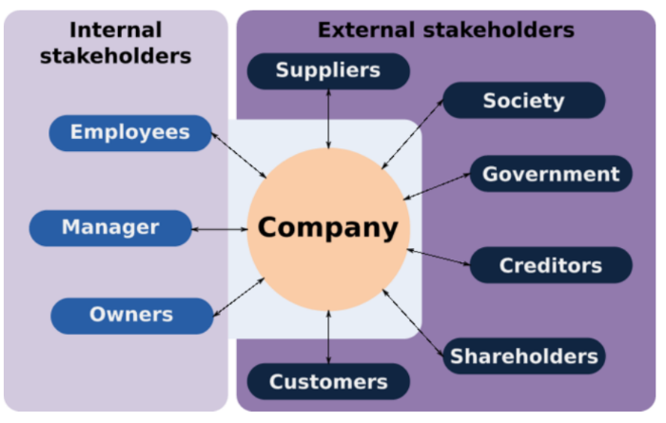
Fig: Internal and External Stakeholders

2.3 Work Breakdown Structure
There are four stages of the work breakdown structure discussed here which are the top level, controls account, work packages and activities. Here the top level contains only the title which is the project plan: Restaurant extension and the controls account consists of two things which are planning and measuring cost. The planning part includes all critical processes and the measuring cost part includes the cost of those planning parts. The activities in the planning and measuring part can be divided into certain packages like decorations and staff management. The final detailed part is the activities section of the WBS framework where there are details of which things are required and their exact amount (Globerson, 2014). So, let’s discuss the wo controls account in details.

Planning: The planning part consist of the largest number of activities and also holds more significance in successfully executing the plan. It contains,
- Buying accessories like new tables and chairs, paints and brushes, decorating staffs like sculptures or flower cards, new lights, kitchen accessories as the restaurant will be expecting more customers and a chef, new dresses for new recruitments and so on.
- Professionals from real estate has to be informed to smash the wall and merge it with the outside terrace and also build a roof over the terrace and wall around it (Brotherton et al, 2008). This would require hiring quite a lot of staff and cost the restaurant as well as take a lot of time.
- Professionals who handle the decorations of place like restaurants, wedding or houses will be hired to decorate the new place according to the old dining area but if it does not suit with it then maybe a different design would be more appropriate (Devi, and Reddy, 2012). This will depend on how the new space looks.
- New staffs have to be hired to assure better customer service and so that the customers will not have to wait for a long time to get a decent meal. As they are expecting a 25 to 30% increase in customers, they will have to hire 4 new waiters and chef.
- Finally, they have to arrange an inauguration ceremony which has to be large to catch the attention of as many potential customers as possible and invite people too while maintaining social distancing which should not be an issue to the extension.
Measuring cost: The cost of the total plan has to be divided into these sectors of activities such as building the space, decoration and staff hiring. There will also a cost of inauguration ceremony and all of these costs will be within the budget of the restaurant that is how much the owners want to spend on the extension. Thus, if the cost will be divided as required in all the sectors then the project plan will definitely be cost effective.

2.4 Consideration of resources
Capital resources is one of the major aspects in business and as the restaurant is extending, they will need money and manpower to do that. They may even need to redecorate some of the dining areas because they are thinking about using the outside terrace as a regular area that is build a roof there and the merge the dining area with that new area. The restaurant will have to go through a large cost but they will be able to serve more customers due to more space and also will be able to maintain social distance due to covid-19 pandemic (Wei et al, 2012). The restaurant has 20 staffs right now out of whom they have 4 chefs, 2 cleaners, 2 managers and 14 waiters and waitresses. But as they are extending, they will require some more waiters and they need to hire at least five waiters or waitresses with minimum skills and they need to hire part time workers as they are on a small budget.
They have to think about the decoration as people look for a good interior in restaurants and as they are breaking a wall and merging the terrace with the dining area, they have painted that side of the wall similar to the other side of the dining area and they can even make it a bit more gorgeous with lighting. So, if we divide the cost into different processes,
Processes | Costs
Breaking the wall between terrace and dining area to merge them together | £1000
Building a roof over the terrace and walls around it | £4000
Painting the wall and redecorating the terrace area | £250
Hiring new staffs | £750
Making clothes for the new staffs | £200
Buying tables, chairs and kitchen accessories | £400
Inauguration ceremony | £700
Total Expenditures | £7,300

The total expenditure for the restaurant in extending will be approximately 7,300 pounds and if they get about 30% more customers due to the extension, then will certainly not have to go through a hard time (Padilla, and Carr, 2011). Their customers will definitely appreciate the extra space.

2.5 Project schedule
The project has to be finished within a certain amount of time because if it will take more than the estimated time then the cost will rise and the plan would certainly not be cost efficient. That is why building a project schedule is mandatory and what better way to represent that other than using a Gannt chart(Maylor, 2011). The project will be finished after approximately three months or 14 weeks from the starting point. The steps of the plan are building a scheme, measuring the costs, buying the accessories needed for redecoration, contracting real estate agencies to smash the wall and build a roof over the terrace, hiring people involved with redecorations, hiring new staffs and finally arrange an inauguration ceremony. And all of these procedures have to be done within the 14 weeks.
Gantt chart
 | Week 1&2 | Week 3&4 | Week 5&6 | Week 7&8 | Week 9&10 | Week 11&12 | Week 13&14
Creating scheme & measuring costs
Buying the accessories needed
Contacting real estate agencies
Merging the terrace and dining area
Hiring people related to redecorating
Hiring new staffs
Arranging inauguration ceremony

2.6 Risk assessment
Risk assessment is basically examining the probability of reaching the outcomes of a project plan or achieving the goals and objectives of it. Identifying the risks are the primary step and their impact of whether that is qualitative or quantitative. And the final step is to embrace measures which would help to face or eliminate the risks of the project plan. There are four steps of risk assessment which will be used in this project management plan which are risk identification, risk evaluation, risk mitigation and contingency plan.
Risk identification: Risk checklists can be used to identify the risks and some organizations use their experience from previous plans to contemplate the risks but here in this case it is the first project planning which is why they have to explore and measure different aspects like technical, cost, schedule, political, environmental and people (Dikmen et al, 2008). The risk breakdown structure framework can be formed in order to measure the risks for the company.
Areas of risk | Identifying the risk
Technical | Issues in the planning or execution of the plan
Cost | Overall cost may rise due to inefficiency or issues in the schedule or even in the cost management.
Schedule | If the schedule is not tight, it will cause extra cost for the restaurant and the inauguration will also be late.
Political | Political issues may include lockdown which can happen if there is an increment in the covid-19 disease and if governments legislate any other policies after the pandemic.
Environmental | Environmental issues include factors like fear of public due to the covid-19 which may decrease the number of customers for the restaurant.
People | People include both employees and customers and issues can come from both of them. Employees may not be as dedicated or motivated as they were before pandemic or issues with the recruitment or talent management. Right set of customers also has to be reached.

Risk evaluation: Evaluation of the risk can be divided into a two-by-two matrix where the entries will be high impact and likely to occur, low impact and likely to occur, high impact but unlikely to occur and low impact but unlikely to occur. The first one that is high impact and likely to occur is in the cost of the project and there is a high risk of increasing cost if there is a total lockdown or any of the workers get affected by covid-19 then the whole team would have to be quarantined (Nieto-Morote and Ruz-Vila, 2011). Another high impact is the political risk but it unlikely to occur in the current condition. Issues in the schedule can also have a high impact as it may increase the cost but it is also not likely to occur that much. People revolving around the restaurant will have a low impact but likely to occur.
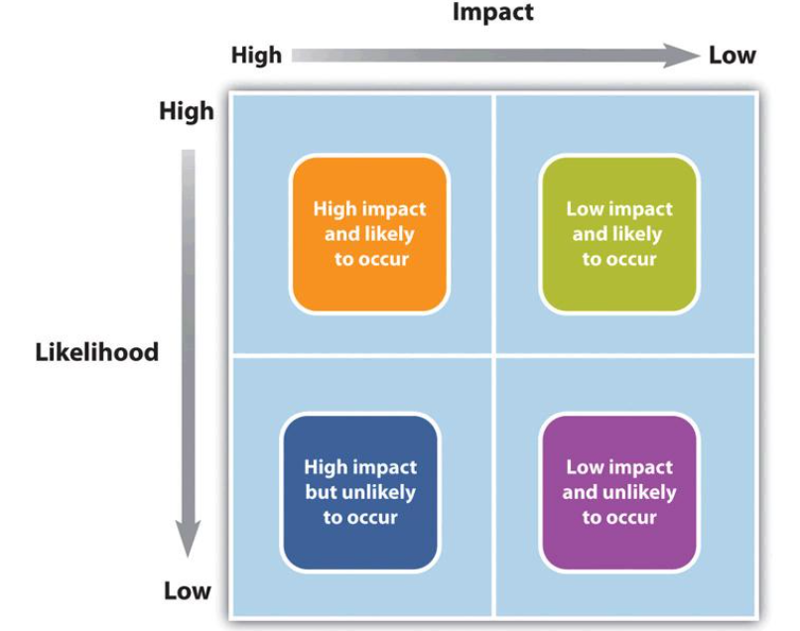
Fig: Risk evaluation
Risk mitigation: Risk mitigation can be done through one of the four steps which are risk avoidance, risk sharing, risk reduction and risk transfer. An alternative strategy is the best option to avoid the risks and this strategy has to have a higher probability of success but the downside of it is that it may have a higher cost which is certainly not the way to embrace for the company. Risk sharing is basically sharing the risk with partners and the restaurant has only two owners but they can sell some shares in public which would not be good for the restaurant business (Maylor, 2011). Risk reduction is to invest on funds which would collaborate in reducing the risks and the restaurant can certainly follow the process. Finally risk transferring is basically taking the help of an insurance company who will bear the loss of the risks and as the restaurant has an insurance, they certainly can go through the process.
Contingency Plan: A contingency plan is like a backup plan for a project which is used when there is a huge amount of risk in the original plan but in this case the risk is at a tolerable amount which is why there was no need of a contingency plan because building another plan would have taken more time which would certainly not be beneficial for the company.
So, it can be concluded that the project plan discussed here may have a risk but with proper execution and management, the plan has the potential to become successful and the restaurant will become sustainable and profitable in a short period.

3.0 Conclusion
The study discussed a project management plan for a restaurant extension in details and tried to be as specific as possible. Through the report there was discussions on the stakeholder analysis which was primarily internal and external and there was discussion of how these stakeholders will be managed during the extension. Then there was a work breakdown structure which demonstrated hierarchy of activities and their order so that it would be easier to comprehend which activities have to be done first (John Wiley & Sons, 2011). The next one was resource analysis and this is an essential part which contains the information of the costs related to the activities of the plan and the total cost of extension was 7,300 pounds which was within the budget of the company. The next part was project schedule which is also necessary because if the project would consume more time, then it would cost the restaurant both literally and figuratively. The project schedule was demonstrated using a Gantt Chart and finally the last part was risk assessment of the project plan where all the aspects were analyzed thoroughly and found out that there was no need of a contingency plan as the risk was either inevitable or not have a huge impact (Chapman and Ward, 2016). So, the project plan has the potential to be successful.

4.0 References
Adams, G., 2011. The iron triangle. Transaction Publishers.
Brotherton, S.A., Fried, R.T. and Norman, E.S., 2008. Applying the work breakdown structure to the project management lifecycle. In PMI Global Congress Proceedings (pp. 1-15).
Brugha, R. and Varvasovszky, Z., 2010. Stakeholder analysis: a review. Health policy and planning, 15(3), pp.239-246.
Chapman, C. and Ward, S., 2016. Project risk management: processes, techniques and insights. John Wiley.
Devi, T.R. and Reddy, V.S., 2012. Work breakdown structure of the project. Int J Eng Res Appl, 2(2), pp.683-686.
Dikmen, I., Birgonul, M.T., Anac, C., Tah, J.H.M. and Aouad, G., 2008. Learning from risks: A tool for post-project risk assessment. Automation in construction, 18(1), pp.42-50.
Frost, E., 2012. So What’sa Quad Chart, Exactly?: Exercises in Genre. GRASSROOTS WRITING RESEARCH JOURNAL, p.113.
Globerson, S., 2014. Impact of various work-breakdown structures on project conceptualization. International Journal of Project Management, 12(3), pp.165-171.
Goodpaster, K.E., 2011. Business ethics and stakeholder analysis. Business ethics quarterly, pp.53-73.
Goodpaster, K.E., 2016. Business ethics and stakeholder analysis. In The Corporation and Its Stakeholders (pp. 103-124). University of Toronto Press.
John Wiley & Sons, Inc.. Wysocki, R.K., 2011. Effective project management: traditional, agile, extreme. John Wiley & Sons.
Kieweg, S., 2019. SPARC V&V Quad Chart (No. SAND2019-7395PE). Sandia National Lab.(SNL-NM), Albuquerque, NM (United States).
Leach, L.P., 2014. Critical chain project management. Artech House.
Maylor, H., 2011. Beyond the Gantt chart:: Project management moving on. European management journal, 19(1), pp.92-100.
Nieto-Morote, A. and Ruz-Vila, F., 2011. A fuzzy approach to construction project risk assessment. International Journal of Project Management, 29(2), pp.220-231.
Padilla, E.M. and Carr, R.I., 2011. Resource strategies for dynamic project management. Journal of construction engineering and management, 117(2), pp.279-293.
Stamey, J. and Honeycutt, T., 2005. Quad charts in software project management. Journal of Computing Sciences in Colleges, 21(2), pp.322-327.
Van Aartsengel, A. and Kurtoglu, S., 2013. Develop Project Management Plan. In Handbook on Continuous Improvement Transformation (pp. 57-63). Springer, Berlin, Heidelberg.
Varvasovszky, Z. and Brugha, R., 2010. A stakeholder analysis. Health policy and planning, 15(3), pp.338-345.
Varvasovszky, Z. and Brugha, R., 2010. A stakeholder analysis. Health policy and planning, 15(3), pp.338-345.
Wei, C.C., Liu, P.H. and Tsai, Y.C., 2012. Resource-constrained project management using enhanced theory of constraint. International Journal of Project Management, 20(7), pp.561-567.
Wysocki, R.K., Beck Jr, R. and Crane, D.B., 2015. Effective project management: how to plan, manage, and deliver projects on time and within budget.

