DS 1 Assignment William

Screenshot/Photo 1

GEMINI
This is an AI application, which I frequently use in my daily life to research, find information on tasks, and it also very helpful in work-related projects.
One of the most important applications that helps my digital life .

Screenshot/Photo 2
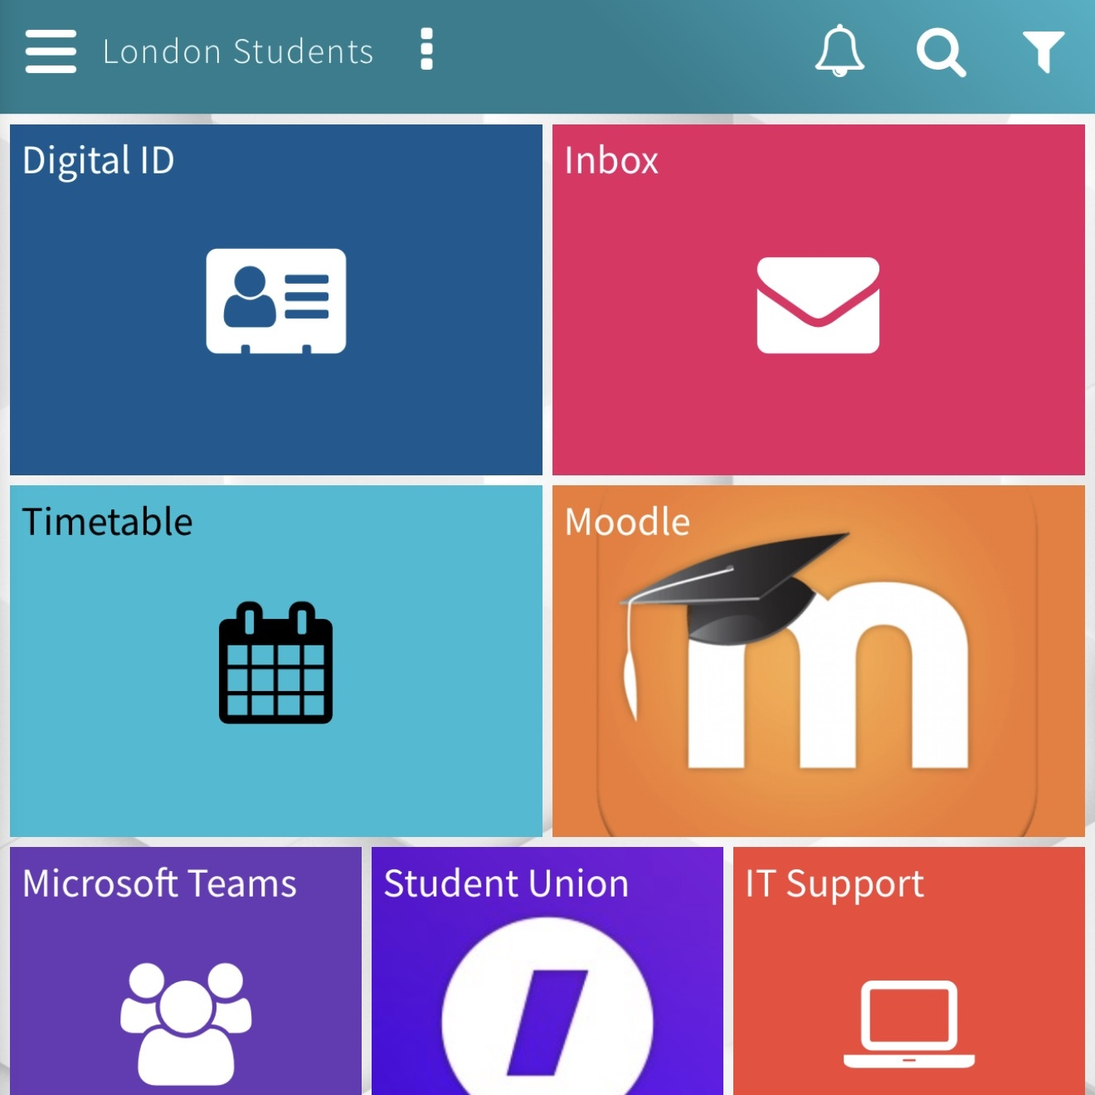
UWTSD HUB
This is my university application, which makes checking of my school timetable and school modules very effective and handy. This application also helps me keep track of modules needed for the academic semester.
This tool helps me stay on top of my university classes.

Screenshot/Photo 3

OUTLOOK
This application helps me keep track of my university emails. It helps me stay in touch with the university’s information for its students.
A very useful tool that helps me manage my university emails.

Screenshot/Photo 4

ONEDRIVE
This tool is essential, and it helps me in manage my university assignments and academics by allowing me to create folders and allocate each folder to a specific course.
This is an essential tool that helps my digital life at university.

Screenshot/Photo 5

WHATSAPP
This is a social application, which helps me keep in touch with my school colleagues through texts, calls, and online gatherings to discuss school or course matters.
This demonstrates how I maintain communication and build relationships outside of formal lectures.

Screenshot/Photo 6
[Insert Photo/Screenshot below]

[Write what this shows of your digital life]

My Short Reflection
- I use digital tools to communicate with my school and work colleagues.
- I feel confident when I use digital tools in my studies as it gives me information from a wider source.
- I want to improve productivity and planning, and this is why I use calendars, task listings and digital notes in organizing my daily life.
- I often use tools like WhatsApp and Facebook to keep in touch with my colleagues.
- Digital skills are important for me because they make life easier in terms of researching and finding information.
- I hope this module will help me understand the use and importance of digital tools.

