Boycho Nikolov
Student ID: 2115531

Data Analysis & Visualisation (ACCB4002_LON)
Assessment 2 Database Analysis and Design
Module code: ACCB4002
Boycho Nikolov
2115531@student.uwtsd.ac.uk

Contents
Introduction: 2
Task: 3
Observations: 5
Hypothesis 6
Null hypothesis: 8
What is a null hypothesis? 8
Factors affecting this hypothesis: 9
Mean: 9
Variance: 11
Assumption: 11
Frequency: 11
Conclusion: 13
Bibliography 14

Introduction:

In this report will be explain how the skills was improved during to the course.
Statistics is the power knowledge of skills to collecting, organize, presenting, analyze, and interpreting data to make more effective decisions.
In this report will explain how is develop during the course knowledge and skills required to perform basic statistical analysis of experimental data.
It will be report with infographics and power of the Statistic how could be accepted or neither denied the hypothesis.

Infographics is a way to learn and demonstrate an ability to represent data, to extract information from it.

Task:

As the figure below shows they are two sample of data for students score.
This the visualisation of the data given to us.
The graphs show us the variation of the scores achieved by student before using the app and after using the app.
As you could see the score after using the app is greater than the score before using the app.

Into the table could be seen the data added in two groups, this mean its two sample to analyse

Best score before using app | Best score after using app
12 | 14
9 | 9
8 | 10
9 | 11
12 | 15
14 | 15
15 | 15
17 | 10
18 | 20
15 | 20
14 | 18
14 | 16
14 | 17
12 | 14
10 | 20
11 | 15
8 | 4
7 | 10
6 | 11
6 | 19
5 | 16
17 | 17
19 | 19
20 | 18
17 | 20
16 | 19
17 | 20
12 | 14
13 | 14
11 | 13
12 | 12
6 | 9
8 | 20
10 | 17
15 | 17
17 | 17
17 | 19
18 | 20
12 | 13
17 | 15

As could see here in the table is the result of calculation of the data, using formula to make t-test for data and analyse
Using mathematics, the t-test takes a sample from each of the two samples and organize the ready to read and analyse data by assuming a null hypothesis that the two means are equal.
In this Base and the formulas, the results are calculated and compared against the normal values and could be assumed null hypothesis is accepted or rejected.

 | Best score before using app | Best score after using app
Mean | 12.75 | 15.3
Variance | 16.80769231 | 15.29230769
Observations | 40 | 40
Pearson Correlation | 0.530985814
Hypothesized Mean Difference | 0
df | 39
t Stat | -4.153849425
P(T<=t) one-tail | 8.62016E-05
t Critical one-tail | 1.684875122
P(T<=t) two-tail | 0.000172403
t Critical two-tail | 2.02269092

This table represent all the values needed to analyse the data.

Observations:

This is the number of observations in each sample. Both samples have 40 observations.
- Sample 1 Observations: 40
- Sample 2 Observations: 40

Hypothesis

Below is the graph could see the result of calculation of the data with two unpaired samples.
On the base of this figures will analyse and made hypothesis as the task is given.
The hypothesis is done based of the data of two independent scores achieved from children in a local primary school.

This is the summary report for data given to us for score before using the app

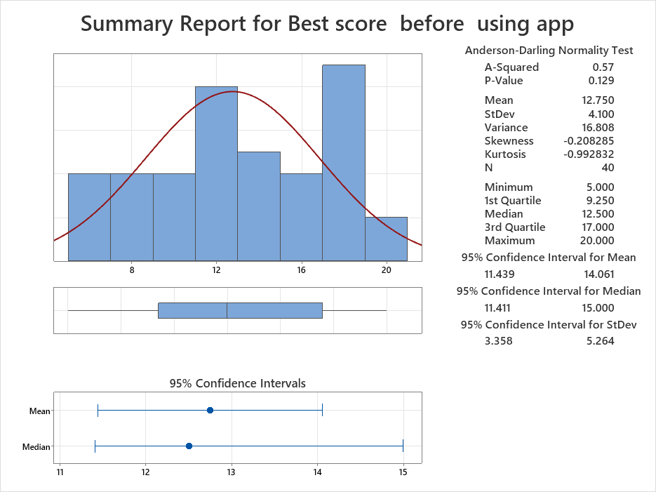

This is the summary report for data given to us for score before using the app

This is the summary report for data given to us for score before using the app

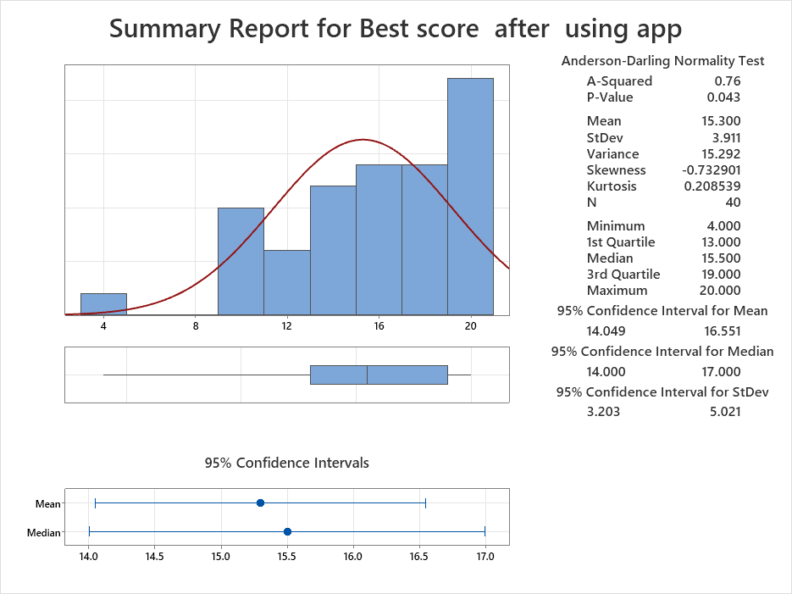

Null hypothesis:

In this part is represented question What is a null hypothesis?
A null hypothesis is a hypothesis that assume that is no significant difference in a group of represented data.
Null Hypothesis is used to give the acceptability of a hypothesis using samples of given data.

As the task is given the report will represent and test three levels:
Here could see Hypothesis based of the result of calculation of data before using the app:
Here is the hypothesis for the result of data calculation of the score achieved from students before using the app:
- 0.10
- If The number of P-value is greater than 0.10, so that mean is not failed to reject that null hypothesis.

2. If The number of T -stat 4.12 is greater than t Critical two-tail 2.02, so that mean is the hypothesis could not be rejected.

- 0.05
If The number of P-value is not greater then 0.05, so that mean is failed to reject that null hypothesis.

- 0.01

If The number of P-value is not greater then 0.01, so that mean is failed to reject that null hypothesis.

Here is the hypothesis for the result of data calculation of the score achieved from students after using the app:
- 0.10
- If the number of P-value is not greater than 0.10, so that mean is failed to reject that null hypothesis.
- The number of T -stat 4.12 is greater than t Critical two-tail 2.02, so that mean is the hypothesis could not be rejected that null hypothesis.

- 0.05
If The number of P-value is not greater then 0.05, so that mean is failed to reject that null hypothesis.

- 0.01

If The number of P-value is greater then 0.01, so that mean is not failed to reject that null hypothesis.

Factors affecting this hypothesis:

1.The effect Size of the sample:
Factors mean difference between the accurate value and the value represented in the null hypothesis.
the greater the sample size, the greater the power of the test
2.Levels of Significance:
The seriousness level of a hypothesis is the value of error probability, and its normally set at 5%. This mean, the research could have less than 5% chance of occurring below the null hypothesis to be considered statistically done.
Significance level is correlated with value: increasing the significance will increases chances to prove this hypothesis.
When is decreased the serious level, the test becomes less easy to detecting true effects. [1]

Mean:

The mean of a data represent average. To calculate the mean, input all the numbers in a data set and then divide by total number of instances in the given data value.
This is the mean for each sample. The mean pre-test score is 12.75 and the mean post-test score is 15.3.
In the figure could be seen the score of the students Before using the app and how they did
Comparable the average of the data, the score achieved before using the app which is 12.75., it is smaller than average of the score after using the app, which is 15.3.

After using the app comparable to the average which is 15.3.
As could see most of the children’s have high score and bigger average after using the app.

Variance:

This is the variance for each sample. The variance of the before using the app is 16.80 and the variance for the after using the app is 15.29.
The number of the value of the variance is show us there are no significant difference between those two variances.
Whoever the data showed that the score after using the app is greater the score after using the app.

Assumption:

For more confident and accurate result should made another test called Levine’s test.
The figure represents the results for the t-test that the test is not assume equal variances.

No evidence that either sample 1 for using app before and sample 2 for data using app after having any departure from normality

Calculating Z-score,
(a) it is authorising researchers to calculate the probability of a value materialize within a standard normal distribution.
(b) and accept to compare two scores that are from different samples (this mean may got different means and standard deviations).

Could be Assumed that every of the following numbered statements is in error. Each represent a researcher’s conclusions, but the researcher has been mistaken.

Frequency:

In the graph below is showed Frequency of the score before using the app.
As could see the most often score is 17 achieved from 7 students.

At the graph below is calculated frequency of the score after using app.

In the graph below is showed Frequency of the score before using the app.
As could see the most often score is 20 achieved from 7 students.
The children with score 19 also increase from 1 to 4.
Whoever the low less result of 5 is the same for both, only 1 achieved 5.

Conclusion:

In this course is learned how to calculate t-test and data given to us, making the hypothesis and assumptions, based on the graphs.
A t test is a type of statistical knowledge that is used to compare the data of two groups. It is one of the most important used statistical hypothesis tests in our course. [2]
Learning how to run T-test is the part of the statics and is powerful tool.
Important part of education is to learn variety of techniques used to represent different types of data calculations.
Knowledge to Demonstrate an ability to rearrange data in order to extract information from it is significant part of the of statistic.

