A Simple Responsive Layout

When we develop for the web, we should remember that a percentage of the audience will be viewing via mobile phone. For this reason, many big websites have implemented “responsive” code. This means that the layout of the page will vary, depending on which device is used to view it. This can be achieved by careful coding.

An example is shown below:

<!DOCTYPE html>
<html lang="en-us">
<head>
<style>
.car {
float: left;
width: 300px;
height: 300px;
margin: 5px;
padding: 15px;
border: 1px solid black;
}
</style>
</head>
<body>

<h1>Simple Responsive Layout</h1>

<div class="car">
<h2>Micra</h2>
<p>The Nissan Micra is an excellent car.</p>
<p>It can be 3 door or 5 door and its top speed is 80mph</p>
</div>

<div class="car">
<h2>Mini</h2>
<p>The Mini was first released in the 1960s</p>
<p>It is one of the smallest cars on the road</p>
</div>

<div class="car">
<h2>Ferrari</h2>
<p>The Ferrari is a very fast car.</p>
<p>It is used a lot in Formula 1 racing</p>
</div>

</body>
</html>

When we view the above HTML/CSS code in a standard browser on a desktop or laptop machine, we see the following:

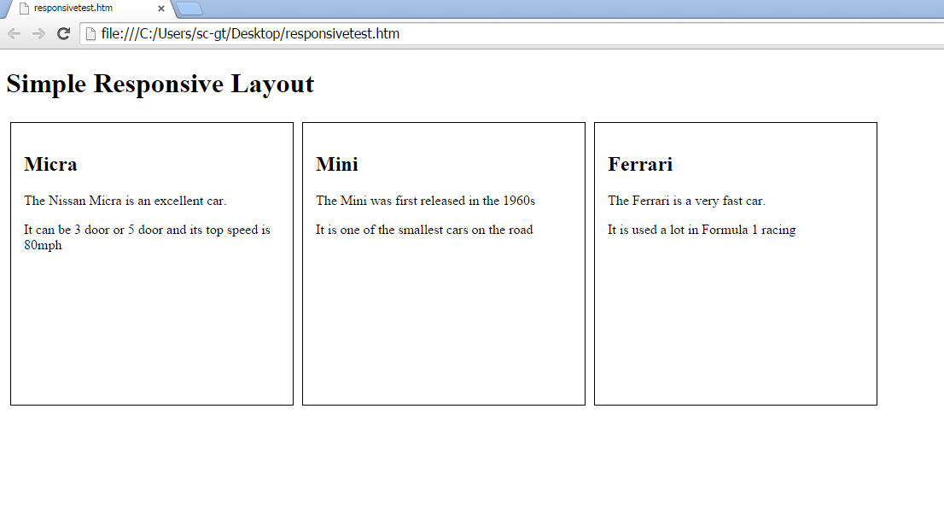

When we view this on a smaller screen, the page responds to the size available:

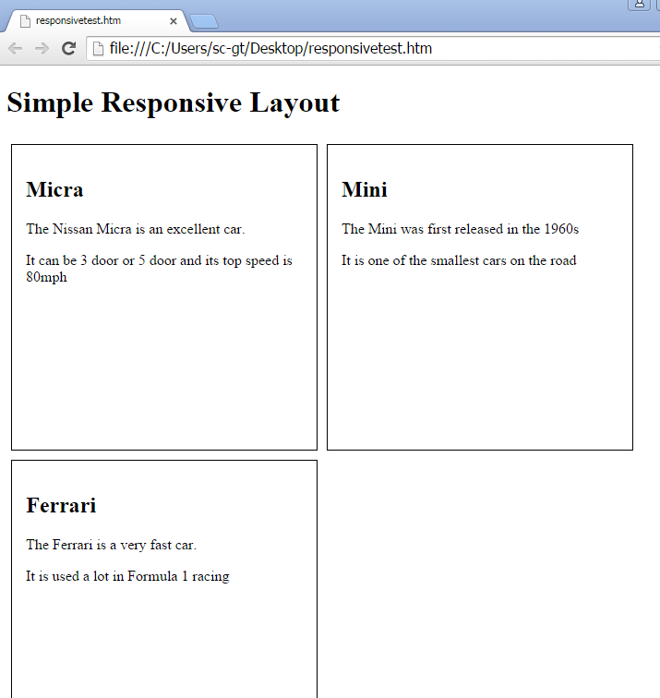

As you can see, the box containing the data on the “Ferrari” is now positioned underneath.

If we are viewing in mobile phone size, once again, the page again responds to the size available:

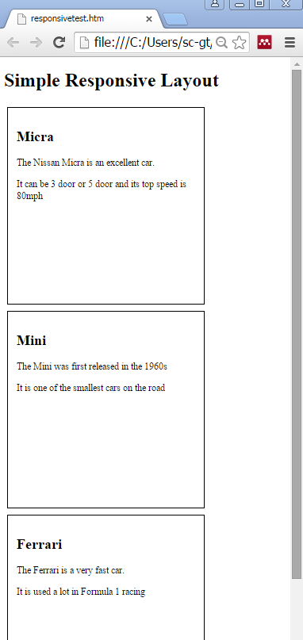

Responsive webpage design is a complex area of coding. There are some utilities that can help with responsive design. One of the most well-known of these is Bootstrap.

http://getbootstrap.com

