University of Wales Trinity Saint David
Wales Institute of Science and Art
Engine Performance Characteristics
ACHA4012 Motorsport Technology
James Greenhill-Upward
2005245
26/03/2023

Contents
- Introduction Pg. 3
- Equipment and Methodology Pg. 4
- Results Pg. 5
- Graphs Pg. 6
- Conclusion Pg. 7
- References Pg. 8
- Introduction
This document will cover the Engine Performance Characteristics of a Naturally aspirated Spark Ignition engine.
The aim of this test is to create a set of data points with the engine dynamometer and with these data points the students must calculate the data for Power, Torque, Specific Fuel Consumption, Brake Mean Effective Pressure and Overall Thermal Efficiency.
The students were provided the Lambda, Fuel Flow Rate, Dyno Speed, Load readings and a handout with the formulas needed to calculate the data needed. They must be able to use those data sets to then collate the data for power, torque and specific fuel consumption against engine speed into a set of graphs. Using those graphs they must then research how they may have gotten that data and elaborate on what the data means and how it can be justified.
- Equipment and Methodology
The engine in question is a Honda D16 1.6 litre single overhead camshaft from a Honda CR-X and the dynamometer is a Schenck WS230, the crankshaft of the engine is bolted directly to the dynamometer. (UWTSD 1 ,2020). The engine speed can be controlled by the dynamometer by a magnetic field that increases he amount of load on the engine.
There are three different ways to perform these dynamometer tests, Manual operation which involves having control over both the engine speed by applying throttle to the engine and the load generated through the dynamometer by adjusting the power of the magnetic field. Using this method, you can simulate the engine being put under specific amounts of load at a particular throttle percentage e.g., 100 nm of load against 50% throttle input. This is useful as you would be able to assess how an engine responds or copes with those certain parameters.
Test sequencing is an automated version of manual operation, this is done by filling out the parameters that you would want the engine to be evaluated at and the dynamometer will run a test program that would run through all of those details.
Finally there is the peak curve test which differs from a manual operation and test sequencing as it provides a graph and data table. There are two kinds of this test, there is a step test and a sweep test. A step test works by inputting a range of engine speed and the intervals data needs to be measured at and then as the test runs the dynamometer will pause at each interval for a set range of time to accurately gather data as the engine is running. After this cycle is complete you can set the engine speed, throttle position and how long it will take from the end of the cycle to the complete end of the test. Steps tests are an excellent way of getting accurate data as the engine is held long enough for the sensors to gather data however this also increases the cycle time and could lead to overheating of the engine. (UWTSD 2, 2020)
A sweep test is test that allows the engine to roll through a interval of engine speeds set by the tester uninterrupted before coming to a stop after its completed its cycle. Much like a step test you can set the intervals of which the data in recorded, for example every 100rpm, and the data will be logged without the engine being held at that speed for any period of time. The benefit of completely a sweep test is that a cycle can be performed quickly which could be scene as vital in a motorsport environment but because the engine speed is always increasing the data recorded is not as accurate as it might be with a step test.
The data gathered for this document was recorded during a single sweep test.
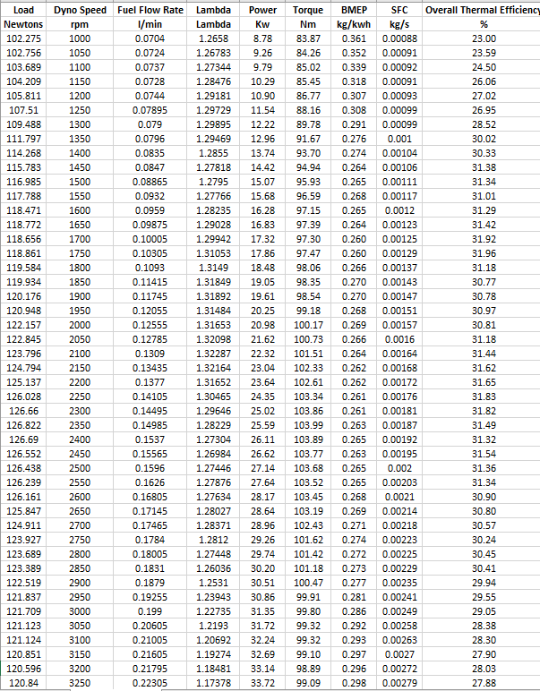
- Results
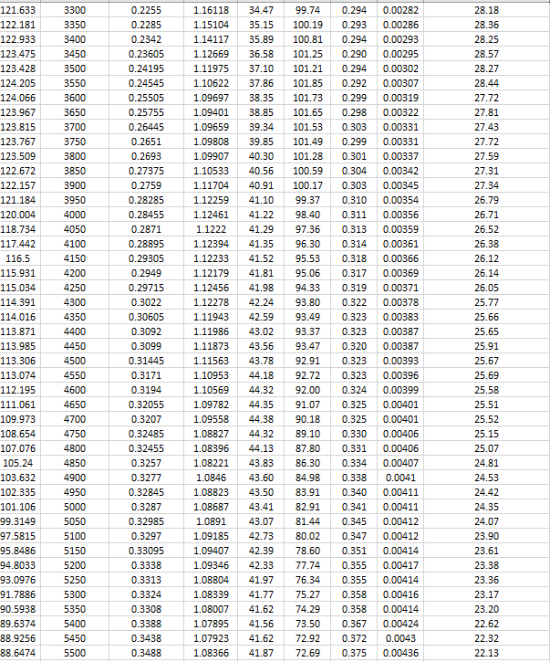
Figure 1 Data sheet showing results 1000-3250rpm
Figure 2 Data sheet showing results from 3300-5500rpm
Figure 3
Figure 4 Data sheet showing results 1000-3250rpm
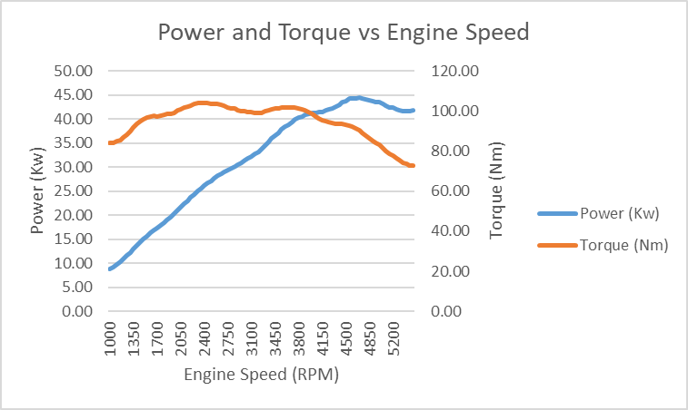
- Graphs
Figure 5 Power/Torque vs Engine Speed Graph
When comparing the power produced and the engine speed this graph shows a typical power output for a naturally aspirated engine. Given that this engine is naturally aspirated and has no form of forced induction there is no way to create a higher air/fuel ratio. At low rpms there is less air and fuel being used in the combustion process which means a low power output and then at higher rpms, with a higher air/fuel ratio, the engine can produce more power (Sundar, S.A. 2016). The max power created during this procedure was 44.38 kilowatts at 4700rpm.
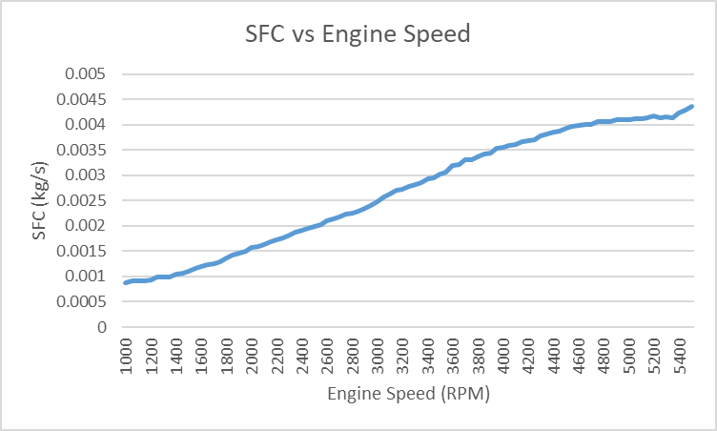
The torque curve is also affected by the air fuel ratio of an engine but as pointed out in the video provided by UWTSD, the torque curve is usually flatter for a naturally aspirated engine. This data could be the result of there being engine wear, fuelling issues or perhaps a problem with the air supply which could affect the air fuel ratio at the point of combustion in the engine. The peak torque was 104 newton metres at 2350rpm.
In this graph, showing the relationship between specific fuel consumption and engine speed, the consumption is shown increase in correlation with the engine speed. A lower SFC value means that less fuel is being used to generate power. For example the SFC value at 2000rpm is 0.00157kg/s when the engine is producing 20.98kw whereas at 4000rpm it is at 0.00356kg/s and producing 41.22kw. A 126.7% increase in consumption but a 96.5% increase in power. This means that the engine is losing overall efficiency in its combustion process at higher rpms which could be linked to the air/fuel ratio, much like power and torque, is being limited by the area of the combustion chamber. As shown in Analysis of fuel pressure on the performance of motorcycle engine with ethanol fuel, the amount of fuel pressure in an engine can directly correlate between the power, torque and SFC. A higher fuel pressure can contribute to a higher power and torque figure but also the fuel consumption whereas the vice versa is true with a lower fuel pressure. It could mean that the engine can not get the fuel pressure it needs to maintain that ratio of Power to SFC.
Figure 6 Specific Fuel Consumption vs Engine Speed graph

- Conclusion
With this procedure complete, the results have been calculated using the appropriate formulae and then been documented to show graphical data. To conclude the results returned have been less than satisfactory.
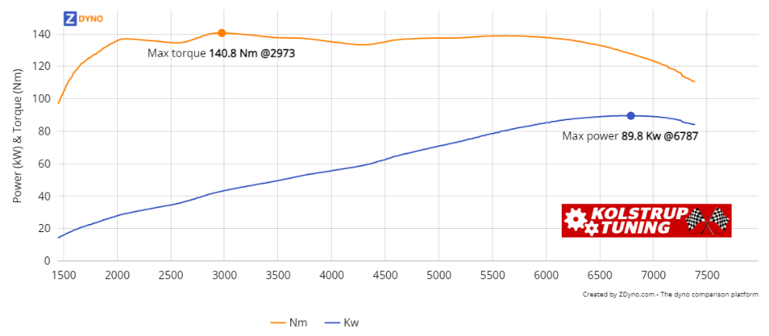
The power and torque figures were lower than expected, as can be seen in Figure 7, the peak torque is 140.8nm at 2973 compared to 104nm at 2350rpm and the highest power figure between 1500 and 5500rpm is 78.74kw at 5500rpm compared to 44.38kw at 4700rpm. However this is not a truly direct comparison, the dynamometer graph shown in Figure 5 is with the engine itself in an engine dynamometer whereas the graph shown in Figure 7 is from a fully assembled vehicle on a rolling road dynamometer with a full exhaust system, engine management and drivetrain.
Figure 7 Vehicle Dynamometer Graph of Honda CRX with a D16 engine (ZDyno)
To evaluate this assessment could have been made more accurate if there was more data collected, a single data set is an informative beginning but with additional runs and data acquired data can be taken as an average instead of an absolute which would show any inaccuracies and smooth them out if possible. A sweep test was used to collect the data which was effective way of collecting data but is not as accurate as a step test which could make up for any inaccuracies that might have occurred but would have also taken more time to complete which is not always available.
Given the data and the formulae provided, the author is content with their calculations for all the necessary figures and data points that were needed are accurate. They made to get assistance and sought out guidance if they had a problem understanding how to correct the calculations and how each data point could be used effectively.
- References
- Parkers (n.d.). Honda CRX Convertible 1.6 ESi 2d specs & dimensions | www.parkers.co.uk [online] Available at: https://www.parkers.co.uk/honda/crx/convertible-1992/16-esi-2d/specs/.

- Sundar, S.A (2016). Why is it that the output torque of an engine starts reducing after reaching a peak, even though the RPM is increasing? [online] Available at: https://qr.ae/przmO5
- UWTSD 1 (2020). Engine Dynamometer Overview. [online] Available at: https://youtu.be/-WajOAp2LUE.

- UWTSD 2 (2020). Engine Dynamometer testing. [online] Available at: https://youtu.be/VD9OPoaAcJU.

- ZDyno (n.d.). Find a vehicle to compare with HONDA CRX AS 1,6 1991. [online] ZDyno. Available at: https://zdyno.com/compare?dynoFiles=8276.

- Irawan, B., Winoko, Y.A., Puspitasari, E. and Dwiyono, T. (2021). Analysis of fuel pressure on the performance of motorcycle engine with ethanol fuel. IOP Conference Series: Materials Science and Engineering, 1073(1) https://doi.org/10.1088/1757-899x/1073/1/012081.

