Module Title: Design Thinking and Innovation
Module Code: LCLM 6002
Lecturer’s Name: Akash Puranik
Student Name: Hind Elgasmi
Student Number: -2310059
Assignment Title: Innovation & Customer Journey
Table of Content
- Introduction
- Key Consumer and Industry Trends Affecting Unite Students
2.1 Evolving Consumer Trends
2.2 Prevailing Industry Trends
2.3 Synthesis: The Strategic Imperative for Innovation
- Part 1: Analysis of Organisational Innovation and Customer Journey
3.1 Innovation Ambition Matrix Analysis
3.1.1 Core Innovations
3.1.2 Adjacent Innovations
3.1.3 Transformational Innovations
3.2 Current Customer Journey Mapping
3.3 Critical Analysis Linking Journey Pain Points to Innovation Gaps
- Part 2: Proposed Digital Transformation Initiative
4.1 Initiative Overview: The Smart Student Living Platform
4.2 The Enhanced, Future-State Customer Journey
4.3 Key Features and Strategic Rationale
4.3.1 AI-Powered Personalisation Engine
4.3.2 Predictive Maintenance and Smart Building Module
4.3.3 Immersive Digital Discovery Suite
4.3.4 Integrated Community & Automation Hub
4.4 Phased Implementation and Change Management
4.5 Measuring Impact and Success: A Balanced Scorecard
- Conclusion 6. References
Introduction
Unite Students stands as a titan in the United Kingdom's purpose-built student accommodation (PBSA) sector. Founded in 1991, the organisation has meticulously expanded its portfolio to become the UK's largest provider, operating a formidable estate of over 130 properties that deliver in excess of 70,000 bed spaces across key university cities such as London, Manchester, Birmingham, and Bristol (Unite Group plc, 2023). Its operational philosophy transcends the traditional landlord-tenant dynamic; its core mission is actively to enhance the student experience by providing safe, high-quality, and supportive accommodation that caters to both the academic imperatives and social well-being of its residents. The company’s value proposition is strategically augmented by integrating a suite of amenities—including communal study areas, fitness facilities, and sophisticated digital platforms for tenancy management—which collectively position it as a dominant and influential player within an intensely competitive and rapidly evolving market.
The selection of Unite Students for this critical analysis is driven by its profound strategic relevance to the themes of innovation and digital transformation. Firstly, the PBSA sector is currently navigating a period of significant flux, characterised by volatile international student enrolment patterns, acute cost-of-living pressures impacting student affordability, and an inexorable rise in student expectations for digital-first, flexible, and personalised services (Savills, 2023). Secondly, Unite’s end-to-end customer journey—spanning from initial research and booking through to move-out and feedback—is distinctly defined and readily measurable. This clarity makes it an exemplary case study for a granular analysis of customer experience pain points and for identifying tangible, high-impact opportunities for digital enhancement. This portfolio will, therefore, undertake a rigorous assessment of Unite Students' current innovation strategy and customer experience by deploying the analytical frameworks of the Innovation Ambition Matrix and Customer Journey Mapping. The insights gleaned from this diagnostic exercise will form the foundation for a proposed, comprehensive digital transformation initiative—the conceptualisation of an AI-powered Smart Student Living Platform. This initiative is designed to decisively address the identified strategic gaps, elevate student satisfaction to new heights, and future-proof Unite's competitive advantage within the dynamic and demanding UK higher education landscape.
Key Consumer and Industry Trends Affecting Unite Students
The UK student accommodation sector operates as a barometer for broader demographic, economic, and technological shifts. A nuanced understanding of these trends is not merely beneficial but essential for contextualising Unite Students' strategic posture and for pinpointing its core innovation imperatives in the coming years.
Evolving Consumer Trends
The contemporary student is a digitally native, value-conscious consumer who approaches the choice of accommodation with high expectations for their living environment, viewing it as an integral component of their overall university experience. Several key trends are shaping their demands:
The Non-Negotiable Expectation of Digital Convenience: As members of Generation Z, today's students have been raised in a digitally saturated world. Their baseline expectation is for seamless, mobile-first digital interactions across all touchpoints. This encompasses everything from the initial property search and booking process to real-time communication with management, self-service portals for reporting maintenance issues and managing payments, and even app-based control over their immediate living environment, such as heating and lighting (Euromonitor International, 2024). The quality of the digital experience is no longer a value-added bonus but a fundamental prerequisite that directly influences their choice of provider.

The Growing Demand for Flexibility and Autonomy: The legacy of the COVID-19 pandemic, coupled with the diverse needs of a modern student body that includes a significant proportion of international students and postgraduates, has fundamentally altered expectations around tenancy agreements. There is a marked and growing demand for greater flexibility. Students actively seek shorter, more adaptable contract lengths, options for room swaps to accommodate changing circumstances, and tenancy agreements that align with non-standard academic calendars or placement years. This trend reflects a desire for autonomy and a reluctance to be locked into rigid, long-term financial commitments.
Wellbeing, Community, and the 'Experience Economy': Students are increasingly making accommodation decisions based on a property's ability to actively foster personal wellbeing and a genuine sense of belonging. The availability, quality, and design of social spaces, organised events, and dedicated study facilities are now critical decision-making factors, often outweighing the specific physical attributes of the bedroom itself. Accommodation is viewed as a key platform for social integration and building support networks, particularly during the potentially daunting first year of university.
Heightened Sustainability Consciousness: Environmental and social governance (ESG) considerations are exercising a growing influence over student choices. A progressively environmentally aware student population demonstrates a preference for providers that can demonstrate an authentic and tangible commitment to sustainability. This is evidenced through investments in energy-efficient building designs, robust recycling and waste-reduction schemes, and ethical sourcing policies. Aligning their consumption with their personal values is increasingly important, allowing them to support brands that reflect their ethical stance (Knight Frank, 2023).
Prevailing Industry Trends
Concurrently, the PBSA market itself is characterised by intense competition, consolidation, and rapid technological adoption, creating a challenging operational environment for all providers.
Accelerated Technological Integration and the Rise of Smart Buildings: Leading PBSA providers are increasingly making strategic investments in smart building technologies and data-driven services. The integration of Internet of Things (IoT) sensors for monitoring energy and water usage, alongside AI-driven platforms for predictive maintenance and space utilisation, is becoming more common. This technological arms race is fundamentally shifting the basis of competition away from traditional factors like location and price alone, towards a new paradigm where superior service quality, operational efficiency, and technological sophistication are key differentiators.
The Permanent Legacy of the COVID-19 Pandemic: The pandemic acted as a forced accelerant for digital adoption across industries, and PBSA was no exception. Digital tools such as virtual viewings, contactless check-in processes, and fully digital payment systems, which were initially implemented as temporary crisis measures, have now been permanently embedded into student expectations. Providers who fail to maintain and advance these digital capabilities risk being perceived as outdated and unresponsive to student needs.
Rising Competition and Market Saturation in Key Hubs: The market continues to face sustained pressure from a variety of fronts, including new entrant PBSA providers, sophisticated university-private partnerships, and the emergent growth of co-living models that also target the student demographic. In an increasingly crowded marketplace, differentiation through a superior, seamless customer experience and genuine innovation is paramount for maintaining premium occupancy rates and justifying rental prices.
Acute Economic and Cost-of-Living Pressures: The ongoing cost-of-living crisis has made students more financially cautious and price-sensitive than ever before. While PBSA represents a premium product compared to the private rental sector, providers must now demonstrably articulate clear value for money. This is achieved not only through the physical product but through exceptional service quality, inclusive amenities, and a visible commitment to financial flexibility and support, ensuring their value proposition remains compelling in a constrained economic climate.
Synthesis: The Strategic Imperative for Innovation
Collectively, these intersecting consumer and industry trends illuminate a strategic crossroads for Unite Students. To maintain its market leadership and ensure long-term resilience, the company must proactively transition from its established role as an efficient operator of high-quality property assets to becoming a provider of an intelligent, deeply personalised, and seamlessly integrated student living experience. The following analysis will critically evaluate how well its current innovation portfolio is configured to meet this formidable challenge and where the most significant opportunities for transformational change reside.
Part 1: Analysis of Organisational Innovation and Customer Journey
Innovation Ambition Matrix Analysis
The Innovation Ambition Matrix, as developed by Nagji and Tuff (2008), provides a powerful strategic lens to evaluate the balance, ambition, and strategic focus of Unite Students' current innovation portfolio. It categorises innovation into three distinct horizons—Core, Adjacent, and Transformational—each with differing levels of risk and potential reward.
Core Innovations: Defending the Base Core innovations involve incremental, sustainable improvements to existing products, services, and internal processes. They are designed to enhance the current business model without fundamentally altering its underlying structure or value proposition.
Examples at Unite Students: These include the continuous refinement of the online booking and administration system, ensuring a user-friendly website for browsing properties, checking availability, and managing tenancy agreements. The development and maintenance of self-service digital portals and the resident app for reporting maintenance, paying rent, and communicating with property teams is another key Core activity. Furthermore, ongoing amenity upgrades—such as enhancing communal spaces, gyms, and Wi-Fi infrastructure—represent incremental improvements that bolster the overall value proposition.
Critical Analysis: Unite Students demonstrates a strong and commendable focus on Core innovations, which is essential for defending its existing market position and ensuring day-to-day operational reliability and customer satisfaction. These efforts optimise efficiency, reduce costs, and maintain competitiveness on essential service parameters. However, a strategic over-reliance on these incremental improvements carries a significant risk: it can lead to Unite being perceived as a commodity provider in a market where basic digital services are now considered table stakes. While Core innovations protect the status quo, they offer diminishing returns in terms of meaningful competitive differentiation and are insufficient to create a sustainable market advantage in the face of disruptive new entrants or business models.
Adjacent Innovations: Expanding the Perimeter Adjacent innovations involve venturing into new but related domains, markets, or customer segments by leveraging and stretching the organisation's existing capabilities, assets, and brand reputation.
Examples at Unite Students: Key adjacent moves include forming deep strategic university partnerships for guaranteed accommodation slots and nomination agreements, which effectively embeds Unite within institutional pathways and secures a predictable, high-volume demand stream. Initiatives focused on digital community engagement—using apps and social media to promote events and foster resident interaction—represent an expansion of Unite's role from a transactional landlord to a proactive community facilitator. The experimentation with more flexible tenancy options is a direct, market-responsive adjacent innovation that appeals to the growing international and postgraduate segments.
Critical Analysis: These adjacent moves are strategically astute and represent a logical, relatively low-risk form of growth by leveraging Unite's formidable core assets and established market reputation. They are effective for protecting and marginally expanding market share. However, the critical weakness is that these strategies are largely reactive to observable market pressures and are, for the most part, being replicated by Unite's key competitors. While they prevent Unite from falling behind, they are unlikely to create a sustained, uncontested market advantage or "blue ocean" of new demand (Kim & Mauborgne, 2015). They represent playing the existing game better, rather than changing the game entirely.
Transformational Innovations: Securing the Future Transformational innovations are the high-risk, high-reward initiatives that have the potential to fundamentally reshape the company's business model, create entirely new value propositions, or redefine the standards of the entire market.
Examples at Unite Students: An analysis of Unite's public strategy, annual reports, and investor presentations suggests that activities in this horizon are currently in a nascent or conceptual stage. Potential areas that would qualify as Transformational include the large-scale deployment of AI-driven hyper-personalisation of the entire student journey, from room-matching to wellbeing support; the comprehensive integration of IoT for smart building management leading to fully predictive operational models; and the pioneering use of Virtual and Augmented Reality (VR/AR) for creating truly immersive remote property exploration and community engagement experiences.
Critical Analysis: This identified gap in Unite's current portfolio regarding commercialised, large-scale Transformational innovations represents a profound strategic vulnerability. Given the powerful consumer trend towards hyper-personalisation and the industry trend towards smart, data-driven building integration, this apparent lack of significant investment in transformative technology could, in the medium term, allow more agile or technologically bold competitors to redefine market standards and erode Unite's leadership position. The company's evident focus on Core and Adjacent innovations, while prudent for managing short-term risk and delivering steady returns, may paradoxically be leaving it poorly prepared for a future where data, AI, and seamless digital integration are central to service delivery and competitive advantage. The strategic question is whether Unite is optimising for the present at the potential expense of the future.
Current Customer Journey Mapping
To move from the strategic portfolio level to the tangible customer experience, the technique of customer journey mapping is indispensable. It tracks a customer's entire end-to-end process across all interactions and channels (Lemon and Verhoef, 2016), providing a granular view of where value is created, where critical friction points occur, and where targeted digital innovation could deliver the most significant improvements. For Unite Students, the journey of a typical resident can be mapped across six key stages,
Table 1: Current Customer Journey Map for Unite Students

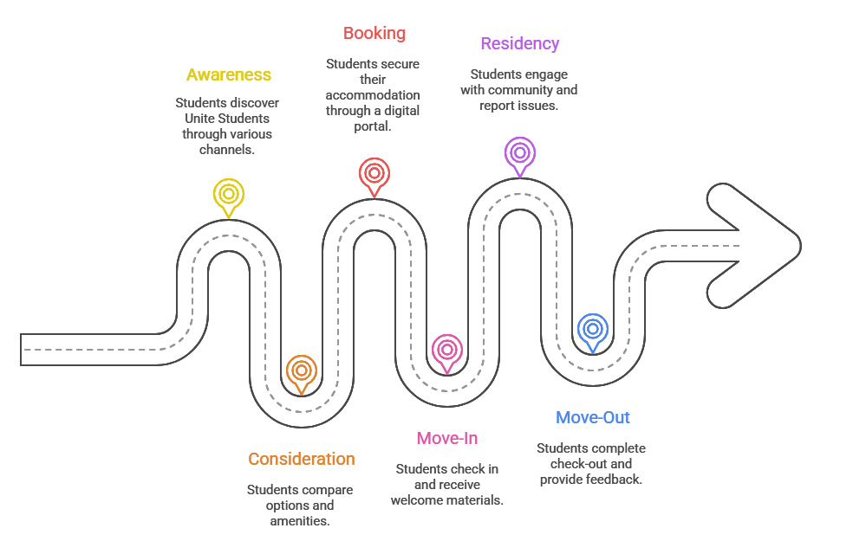

Critical Analysis Linking Journey Pain Points to Innovation Gaps
The journey map illuminates several critical friction points that directly correlate with the gaps identified in the Innovation Ambition Matrix, creating a compelling case for targeted intervention.
The Consideration & Booking Gap: From Generic Discovery to Guided Personalisation. The pain points of "information overload" and "perceived contract rigidity" are direct symptoms of a Core innovation approach that relies on providing standardised, one-to-many information. The digital platform functions as a passive repository rather than an active guide, leading to student anxiety and decision paralysis. This presents a clear Transformational opportunity for an AI-powered recommendation engine that acts as a personalised concierge, offering tailored property suggestions based on a sophisticated analysis of user preferences, academic schedule, and social habits, thereby transforming a stressful process into a curated experience.
The Residency Chasm: From Reactive Operations to Proactive Living. The most significant operational and experiential failure is the "slow or reactive maintenance" cycle, a classic Core operational deficiency that directly and negatively impacts daily student satisfaction. Compounding this is the "lack of personalisation" in services and community engagement, which represents a missed Adjacent opportunity to deepen emotional connection and loyalty. This cluster of issues presents the most potent opportunity for a Transformational initiative. Integrating a network of IoT sensors to enable predictive maintenance and deploying AI to curate hyper-personalised content and community connections would simultaneously achieve a step-change in operational efficiency and a dramatic elevation of the customer experience, addressing both pain points with a single, cohesive technological platform.
The Operational Friction in Move-In/Out: Enhancing Core Processes. The "peak-time stress" during move-in and the "lack of deposit transparency" during move-out are primarily inefficiencies in Core processes. While not requiring transformational change, they can be effectively smoothed through Adjacent digital solutions such as app-based check-in scheduling and a fully transparent, real-time digital deposit tracker. These solutions would significantly improve clarity, reduce administrative burden, and bookend the customer journey with positive digital interactions.
Part 2: Proposed Digital Transformation Initiative
Initiative Overview: The "Smart Student Living Platform"
Based on the critical diagnostic gaps identified in Part 1, this proposal recommends the strategic development and phased implementation of an integrated AI-powered Smart Student Living Platform. This initiative is conceived not as a simple incremental upgrade to existing systems, but as a Transformational corporate programme designed to catalyse a fundamental shift in Unite Students' strategic identity: from a reactive manager of accommodation assets to a proactive, intelligent, and indispensable partner in the student living experience.
The platform's primary objective is to decisively address the three key strategic weaknesses revealed by the prior analysis:
The generic, inefficient, and sometimes overwhelming nature of the current customer journey.
The reactive and costly operational model, most acutely observed in the maintenance cycle.
The relative lack of a deeply personalised, engaging, and community-focused digital experience that fosters long-term loyalty.
This platform will serve as a centralised digital nervous system for Unite's operations, leveraging data and AI to create a virtuous cycle of continuous improvement, where operational data enhances the student experience, and student engagement data, in turn, informs more efficient operations.
The Enhanced, Future-State Customer Journey
The implementation of the Smart Student Living Platform would fundamentally re-engineer and elevate the student experience at every touchpoint.
Table 2: Enhanced Customer Journey Map with the Smart Student Living Platform
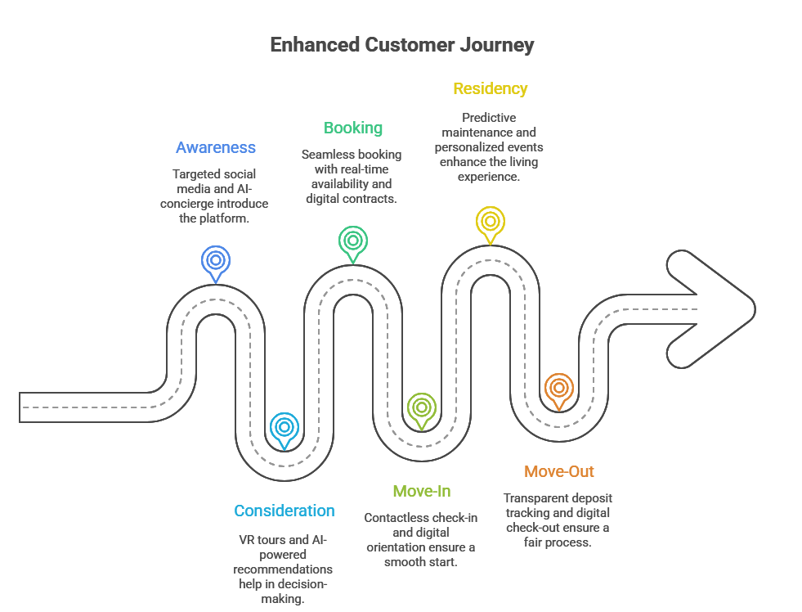

Key Features and Strategic Rationale
The platform's features have been meticulously designed as direct, tactical responses to the analysed pain points, with a clear alignment to the three horizons of innovation.
AI-Powered Personalisation Engine (A Transformational Response to Generic Discovery)
Feature: A sophisticated machine learning algorithm that analyses a combination of stated preferences (e.g., budget, desired location, noise tolerance, social vs. quiet living) and, with explicit user consent, anonymised and aggregated behavioural data. This system provides highly personalised room and flatmate matches, curates event and activity recommendations, and delivers tailored wellbeing and academic support content.
Strategic Rationale: This directly and decisively tackles the pain points of "information overload" in the consideration stage and "lack of personalisation" during residency. It moves the digital experience from a one-size-fits-all Core service to a Transformational value proposition that significantly increases conversion rates, enhances resident satisfaction, and builds profound brand loyalty by making each student feel uniquely understood.
Predictive Maintenance and Smart Building Module (A Transformational Overhaul of Core Operations)
Feature: The strategic integration of a network of IoT sensors throughout a building's infrastructure to continuously monitor the health of key equipment (e.g., boilers, ventilation), environmental conditions (temperature, humidity), and patterns of usage. AI algorithms analyse this data stream to predict failures with high accuracy, automatically generating pre-emptive work orders for the facilities team before the student is even aware of a problem.
Strategic Rationale: This is the cornerstone of operational transformation. It directly solves the major pain point of "slow or reactive maintenance," which is the single biggest driver of daily dissatisfaction. It transforms a Core operational area from a cost centre reacting to problems into a Transformational capability that proactively ensures comfort, significantly reduces emergency repair costs, minimises resident disruption, and extends the lifecycle of capital assets.
Immersive Digital Discovery Suite (A Transformational Tool for Market Differentiation)
Feature: High-fidelity, 360-degree VR tours of all room types and communal areas, accessible from any device. Augmented Reality (AR) tools that allow a student to use their phone camera to visualise how their own furniture might fit into a room or how it could be laid out.
Strategic Rationale: This Transformational feature directly mitigates the risk and uncertainty for international and remote students during the critical consideration phase. It builds immense confidence in the booking decision, reduces the likelihood of post-arrival disappointment, and serves as a powerful marketing and competitive differentiation tool that can command a premium and secure bookings much earlier in the cycle.
Integrated Community & Automation Hub (An Adjacent Innovation for Engagement and Efficiency)
Feature: A rich social layer fully integrated into the main app, allowing residents to create profiles, connect with neighbours, form interest-based groups (e.g., "Chess Club," "Med Students"), and manage all tenancy administration. This is supported by an advanced AI chatbot handling routine queries about rent, rules, and processes 24/7.
Strategic Rationale: This Adjacent innovation actively strengthens community ties and improves operational efficiency by automating responses to a high volume of routine enquiries. It creates a "stickier" and more satisfying resident experience that encourages long-term retention, while simultaneously freeing up on-site staff to focus on complex, high-value interactions and community building, thus enhancing their roles.
Phased Implementation and Change Management
A strategic initiative of this scale and complexity necessitates a phased, agile rollout to prudently manage risk, validate investment, and ensure organisational readiness.
Phase 1: Pilot and Prove (Months 1-18): Focus on the Predictive Maintenance Module and the Automation Hub (advanced chatbot) in 3-5 select, newer properties. This phase targets the most acute operational pain point (maintenance) and demonstrates a clear, quick return on investment (ROI) through reduced repair costs and improved satisfaction scores, building internal momentum for the wider programme.
Phase 2: Scale and Integrate (Months 19-36): The wider roll-out of the AI Personalisation Engine and Community Features across the majority of the portfolio. This phase requires a major focus on robust data governance, cybersecurity, and comprehensive change management programmes for staff, whose roles will evolve towards more analytical and resident-engagement focused activities.
Phase 3: Lead and Innovate (Months 37+): The full deployment of the Immersive Digital Discovery Suite and the continuous refinement of all AI models based on the vast datasets collected. This phase is where Unite Students would establish itself as the undisputed digital innovator and thought leader in the global PBSA sector, potentially licensing the platform technology to other providers.
Key risks, such as data privacy concerns, potential for digital exclusion, and internal cultural resistance, must be proactively managed. Mitigation strategies include implementing transparent opt-in/opt-out consent models, maintaining and enhancing non-digital service channels for inclusivity, and executing a thorough internal communication and upskilling programme to foster a culture of innovation and digital fluency across the organisation.
Measuring Impact and Success: A Balanced Scorecard
The success of the Smart Student Living Platform will be rigorously measured by a balanced scorecard of Key Performance Indicators (KPIs), each directly linked to the strategic objectives and pain points it is designed to address.
Strategic Pillar | Key Performance Indicator (KPI) | Baseline & Target | Data Source
Student Experience | Net Promoter Score (NPS) / Student Satisfaction | Target: +10-15 points from a defined baseline. | Post-stay surveys; in-app feedback.
 | Satisfaction with Personalisation (Metric) | Target: 25% increase in students rating personalisation as "Excellent". | Specific survey question.
Operational Efficiency | Reduction in Reactive Maintenance Tickets | Target: 30-40% decrease in volume. | Maintenance management software.
 | Average Maintenance Resolution Time | Target: 40-50% reduction in mean time to resolve. | Maintenance management software.
Business Performance | Occupancy Rate | Target: Sustain >98% in a competitive market. | Central booking system data.
 | Student Retention / Repeat Booking Rate | Target: 15-20% increase in returning residents. | Year-on-year booking analysis.
Digital Engagement | Monthly Active App Users (MAU) | Target: >85% of all residents. | App analytics platform.
Financial & Sustainability | Operational Cost per Bed Space | Target: 5-7% reduction through efficiency gains. | Financial reporting systems.
 | Energy and Water Consumption | Target: 8-10% reduction via smart building controls. | Utility smart meter data.

Conclusion
This portfolio has provided a rigorous and critical analysis of Unite Students' strategic position within the complex and evolving UK PBSA sector. The application of the Innovation Ambition Matrix has revealed a company with a robust and well-executed foundation in Core innovations and a strategic, logical foray into Adjacent growth areas. However, it has also uncovered a significant and potentially consequential gap in Transformational ambition. This current innovation profile, while ensuring short-term stability and predictable returns, exposes Unite to a considerable long-term strategic risk. This is because the dominant consumer and industry trends are increasingly favouring providers that can deliver intelligent, personalised, and proactive digital services, a realm unlocked by Transformational investments.
The subsequent customer journey mapping crystallised this strategic gap into a set of tangible, impactful student pain points, particularly around the generic and often stressful discovery process, the reactive and dissatisfying maintenance cycle, and the overall lack of personalised engagement throughout the academic year. The proposed AI-powered Smart Student Living Platform is presented as a direct, coherent, and strategic response designed to bridge this gap decisively. It is a consciously Transformational initiative that reimagines the student experience from a linear, transactional process into a dynamic, responsive, and personalised journey, while simultaneously driving unprecedented levels of operational efficiency through the pervasive use of data, AI, and automation.
By adopting a carefully structured, phased implementation strategy and adhering to a rigorous framework of KPIs, Unite Students can systematically de-risk this transformation and capture value at each stage of the journey. This digital transformation is, in its essence, far more than a simple IT upgrade; it represents a fundamental strategic realignment of the entire business model. It presents a generational opportunity for Unite Students to cement its market leadership not just through the sheer scale and quality of its physical portfolio, but through the superior intelligence, responsiveness, and quality of the experience it provides. In doing so, Unite can ensure its continued resilience, profitability, and competitiveness for the future, solidifying its role not just as a place for students to live, but as a foundational partner in their success and well-being.

References
Euromonitor International. (2024). Digital Consumer in the United Kingdom. [Online] Available at: Euromonitor Passport. [Accessed 26 October 2025].

Kim, W. C. & Mauborgne, R. (2015). Blue Ocean Strategy, Expanded Edition: How to Create Uncontested Market Space and Make the Competition Irrelevant. Boston: Harvard Business Review Press.

Knight Frank. (2023). UK Student Accommodation Market Report 2023. [Online] Available at: https://www.knightfrank.co.uk/research/reports/uk-student-accommodation-market-report-2023 [Accessed 26 October 2025].

Lemon, K. N. and Verhoef, P. C. (2016). 'Understanding Customer Experience Throughout the Customer Journey', Journal of Marketing, 80(6), pp. 69-96.

Nagji, B. and Tuff, G. (2008). 'Managing Your Innovation Portfolio', Harvard Business Review, 86(5), pp. 68-74.

Savills. (2023). Spotlight: UK Purpose-Built Student Accommodation. [Online] Available at: https://www.savills.co.uk/research_articles/229130/331128-0 [Accessed 26 October 2025].
Unite Group plc. (2023). Annual Report and Accounts 2023. [Online] Available at: https://www.unite-group.co.uk/investors/reports-and-presentations [Accessed 26 October 2025].

