Module Name: Managing Projects in The Organisation

Module Code: BMSW 5004

Student Name: Nadeem Arif

Student: ID 1711109

Lecturer: Paul Ranson

Introduction
This report will focus on how Rock Solid will carry out the task of assisting Vintners Antiques in relocating from their shop premises in Shirley, to a Warehouse on Stratford Road, Sparkbrook. Rock-Solid specialise in Project Planning, Removals and Management Services.
The Vintners are a unique niche antique business. There are currently four employees and the owner who is the 3rd generation family owner. This is a reputable family business that has strong links with its local community as well as a larger section of the market due to its excellent service over several years.
Vintners have been able to maintain their excellent reputation due to their high standards of quality and service as a result of their knowledge and expertise of this niche market; Vintners Antiques now feel it is the right time to expand the business and capture a larger market. In order to achieve this, Vintners have appointed Rock Solid to assist in the relocation of their business. Rock Solid will take it upon themselves to relocate Vintners to their new premises by reducing costs, time and inconvenience as much as practically possible.
Potential Risks
Any project, whether small or large, has its fair share of risks which can potentially derail the whole project and impact the overall completion of the project. This section of the report will highlight some of the most common risks associated with project management.
Cost
This is a common risk which typically occurs when the scope and cost estimation has not been accurate, this can lead to an escalation in costs and result in losses to the company. To avoid this, there are tools such as the ‘Delphi Method’ which can be used to determine a more accurate cost estimation.
“The Delphi method is a forecasting process framework based on the results of multiple rounds of questionnaires sent to a panel of experts. Several rounds of questionnaires are sent out to the group of experts, and the anonymous responses are aggregated and shared with the group after each round. The experts can adjust their answers in subsequent rounds, based on how they interpret the "group response" that has been provided to them.” (A. Twin, 2020)
Time
Time keeping is essential in everyday life and none more so than in business. To be successful in life, one must realise the value of time and appreciate the fact that time does not wait for anyone and is therefore very important that one must respect time. It is very important for Rock Solid to complete the project by the estimated time of completion, delays can have negative effects for the Vintners and their reputation as a trustworthy local community-based business.
“Timekeeping is an essential part of the work process for companies across many different fields these days. There is a multitude of different ways you can adapt it to serve different purposes – depending on your professional field, company culture, and your team’s overall goals. Here at actiTIME, for example, using a timekeeping tool has allowed us to optimize and improve our workflow in several key areas. With access to detailed time records, project planning is no longer a guessing game for our team leads – with actual data on how long it takes our people to complete specific tasks, estimating their work on future projects is significantly less challenging.” (actiTime,2019)
Scope
In the world of Project Management, scope is to have the ability to recognize the functionality and the features of the project, and the scope of work necessary to complete the project. Scope is also all about meeting the needs of the client by identifying their needs and expectations and by trying your best to fulfil the client’s needs and expectations.
Scope is when the assigned tasks are carried out to the client’s expectations and within the timeframe and cost agreed upon. If things go wrong, then we as the project management company will be expected to juggle things around to make ends meet. According to the PMBOK: "Managing project scope is primarily concerned with defining and controlling what is and is not included in the project.” (Wrike,2020)
It is very important for Rock Solid to work out the timescale and price accurately in order to provide Vintners with a relatively accurate timescale and price. If the tasks start to take longer than expected or the price starts to go up, that can potentially damage the project and have a negative effect on the client’s business.
The more complex the project, the greater the need for perfect planning and communication between the team involved to ensure there are no problems. For Rock Solid to carry out this project successfully, we must ensure that every task is completed on time and within budget.
Tools & Techniques
To complete a project successfully, we must use the right tools and techniques to get the best results. There are several tools available to use for project management, these tools help you to work out the complexity and price for the whole project.
Steering Group
A steering group is made up of a group of people who will oversee the project, this group will make key decisions regarding the project. To organise a steering group, there is no fixed technique as different managements will be structured differently and the cultures will be varied. “Their main function is to oversee and facilitate the Management Standards project, acting as a project management group or board. Key activities include:
- project naming
- project management
- planning
- securing and managing resources
- marketing
- managing communications
- monitoring progress
- approving action plans
- generating and approving management reports.” (HSE,2020)

Sponsors
The sponsors for this project are the individuals providing the finances for this project, in the case of Vintners, its Doreen who is the sponsor for this project. Doreen will be responsible for agreeing to Rock Solid’s quotation and giving the go ahead and provide the finances for the removal project. “A sponsor can refer to a range of individuals or entities that support the goals and objectives of some individual or company. Sponsors, for instance, invest in private companies, create demand for publicly traded securities, underwrite mutual fund shares for public offerings, issue exchange traded funds (ETFs), offer platforms for benefits, and so on.” (J. Chen,2020)

User stories

User stories are usually a short and brief sentence describing the user’s desires, usually told by a person from experience expecting or desiring new capabilities into their system. “User stories are short, simple descriptions of a feature told from the perspective of the person who desires the new capability, usually a user or customer of the system. They typically follow a simple template:
As a < type of user >, I want < some goal > so that < some reason >.
User stories are often written on index cards or sticky notes, stored in a shoe box, and arranged on walls or tables to facilitate planning and discussion. As such, they strongly shift the focus from writing about features to discussing them. In fact, these discussions are more important than whatever text is written.” (Mountain Goat Software,2020)
Vintners User Stories
Rock Solid listened to the Vintners management and staff user stories to determine the best way forward in their quest for relocation, Rock Solid then resorted to using sticky notes with brief messages to differentiate between the needs and wants and were able to put forward suggestions by prioritising the needs and requests.
Delphi Method
The Delphi technique was developed by ancient Greeks which, gained fame in the 1950s as a result of an experiment carried out by Professor Marcos Du Sauty. Although this method originated from common people and butchers having to guess the weight of a cow just by looking at it, the guesses were generally wayward and many were a long way off the actual weight, but once the average was worked out, the average guess was very close to the actual weight. Similarly, Professor Sauty carried out an experiment on guessing the number of jellybeans in a jar, even after the wild guesses which were mainly way off the actual number, the average guess was surprisingly very close. Rock Solid have made use of this technique by gathering the expertise and opinions from their appointed steering group to produce a quotation for the project, which will be relatively accurate in terms of pricing and estimated completion of the project.
“The Delphi Technique is a method used to estimate the likelihood and outcome of future events. A group of expert’s exchange views, and each independently gives estimates and assumptions to a facilitator who reviews the data and issues a summary report.” (D. Haughy,2020)
Gantt Chart
The Gantt chart is used to inform the Project Manager and the client of the progress of the project. The chart is also very useful to track delays which can have knock on effect on various tasks within the project. For example, if a task can only begin after a certain task has been completed, the chart will inform of the delay and make the project manager aware, subsequently, the necessary actions can be taken to bring the project back into the original timeframe and/or notify the clients of the changes.
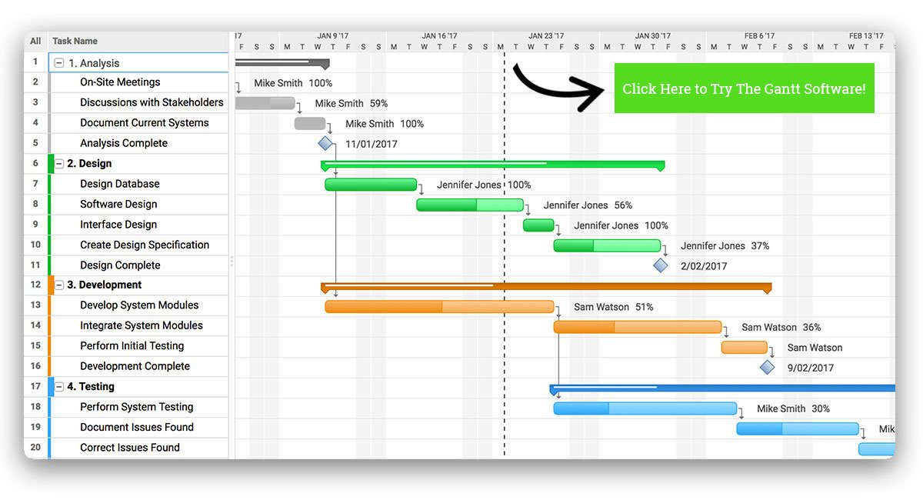
“Many people have never heard of a Gantt. Simply put, a Gantt chart is a visual view of tasks scheduled over time. Gantt charts are used for planning projects of all sizes and they are a useful way of showing what work is scheduled to be done on a specific day. They also help you view the start and end dates of a project in one simple view. On a Gantt chart you can easily see:
- The start date of the project
- What the project tasks are
- Who is working on each task?
- When tasks start and finish
- How long each task will take
- How tasks group together, overlap and link with each other
- The finish date of the project.” (Project Manager, 2020)
Communication with Stakeholders
It is very important to be in continual communication with everyone involved such as, stake holders and the individuals carrying out the tasks. Rock Solid will communicate regularly throughout the project by, having early morning brief stand-up meetings where the colleagues inform of their progress or the lack of progress due to unforeseen circumstance, use a daily updated Gantt chart, by being up to date with the user stories and making sure the requirements are fulfilled according to their priority.
Self-Development, Future Recommendation and Personal Reflection
This Module has been an amazing learning curve for me. From the very first lesson, the practical activity we took part in, the Lego house building was amazing to say the least, it was very realistic of a real building project. I quickly learned that we must build a prototype before going in to mass production, such mistakes can be very costly and potentially ruin the whole project. Throughout the module, I learned to focus on tasks very carefully and the practical activities made everything a lot easier to understand and carry forward into a potential career in project management.
In the future, if I was given a project to manage, I will most certainly be using the techniques and methods I have learned about throughout this module, such as, Delphi Method, User Stories and Gantt Chart.

References
- actiTime. 2020. Timekeeping: A Robust Tool to Improve Efficiency. [Online]. Available at: What Is Time Keeping and Why Is It Important? (actitime.com). Accessed 8th December 2020
- Delphi Technique a Step-by-Step Guide (projectsmart.co.uk). Accessed 09th December 2020
- HSE.2020. Steering Group: What are the key activities of a steering group? [Online]. Available at: Prepare the organisation - Steering groups (hse.gov.uk).Accessed 09th December 2020
- Investopedia. 2020. Delphi Method: What is Delphi Method? [Online]. Available at: Delphi Method Definition (investopedia.com). Accessed 08th December 2020
- Investopedia. 2020. Sponsor: What is a sponsor? [Online]. Available at: Sponsor Definition (investopedia.com). Accessed 09th December 2020
- Mountain Goat Software.2020. User Story: What is a User Story? Available at: User Stories and User Story Examples by Mike Cohn (mountaingoatsoftware.com). Accessed 09th December 2020
- Project Manager.2020. What Is Gantt Chart? [Online]. Available at: Gantt Chart: The Ultimate Guide (with Examples) - ProjectManager.com. Accessed 09th December 2020
- Project Smart.2020. DELPHI TECHNIQUE A STEP-BY-STEP GUIDE. [Online]. Available at:
- Wrike.2020. What Is Project Scope Management? [Online]. Available at: What is Scope in Project Management? (wrike.com). Accessed 08th December 2020

