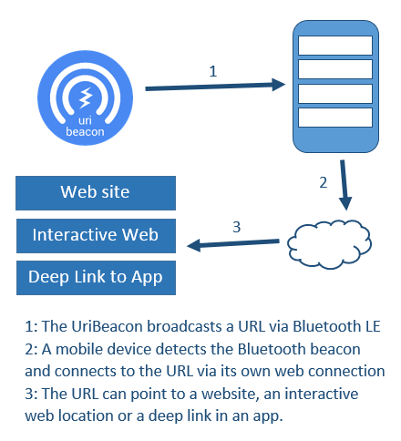


Methodology
Several locations will be equipped with BLE learning beacons that allowed students to access materials safety sheets, kiln programming manuals and videos showing how to operate equipment safety (all have to have live safety briefings before being allowed to use the equipment). The students will also be briefed about the beacons and supported in learning to access them through a focussed seminar session. Usage of the web resources will be monitored using Google Analytics as direct arrivals at the web pages.
Aims & Objectives
The aim of the project is to investigate the use of Physical Web technology to provide users of the Glass Workshops with easily accessible Health & Safety materials via the following objectives:
  - To produce high-quality Health & Safety materials that can easily be accessed using mobile devices
  - To use UriBeacons to point users towards those materials
  - To record the usage of, and user responses to, such materials

LEARNING BEACONS – USING THE INTERNET OF THINGS TO DELIVER HEALTH AND SAFETY MATERIALS IN STUDENT WORKSHOPS
N. Whitehead
University of Wales Trinity St. David (UNITED KINGDOM)
nicola.whitehead@uwtsd.ac.uk

Just-in-place learning
The learner is presented with multimedia demonstrations (i.e. mentoring) when it is needed in the workshop location where the student is working. This provides context-based learning outside of normal teaching hours, allowing the user access to resources that can be played on handheld devices. This is not simply just-in-time learning but the localized nature of the learning beacons allows us to extend this paradigm to ‘just-in-place’ learning – rather than accessing a large site of all available material the student is only presented with materials relevant to their location, i.e. the local workshops, as suggested by Mathew [2].
References
- A.P. Mathew, “Just in Place Learning: A Novel Framework for Employing Information in “Place” for Urban Learning Environments”, in ACADIA 10: LIFE in:formation, On Responsive Information and Variations in Architecture [Proceedings of the 30th Annual Conference of the Association for Computer Aided Design in Architecture (ACADIA)] pp. 73-80, 2010.
- Google, "Physical Web," GitHub, Accessed 13th October 2017, Retrieved from https://google.github.io/physical-web/

The Physical Web
Launched by Google in 2014, the Physical Web [1] is an IoT project that aims to provide location-based information through Open Source technologies using Bluetooth Low Energy (BLE) beacons. The Learning Beacon project uses Eddystone beacons placed in each of the glass workshops. The technology is inexpensive and does not need any specialised wifi infrastructure. The beacons can be wall-mounted; their batteries can last for up to a year and are easy to replace.

Abstract
Health and safety is an important part of student education within a wide range of both engineering and applied art fields. The introduction of Internet of Things (IoT) technologies mean that it is possible to provide highly-localised health and safety information as well as short instructional videos detailing the safe operation of workshop equipment using mobile technology.
Each workshop will be equipped with a Bluetooth LE (BLE) “learning beacon” that points mobile devices towards web pages. Students can download the Physical Web app on their mobile device and then use it to access the web page pointed to by the local beacon. The content can be easily updated so teaching staff can maintain the content and add and remove teaching materials as appropriate.
Use of the materials will be monitored using Google Analytics to see how often the web pages are accessed and which pages are accessed most often.

