Sonic The Hedgehog 2
Name: Sêren Williams
Student ID: 2501567
Module Name: Game Design and History
Assignment Title: Retrofitting Existing Games: Creating a Game Design Document
Lecturer: Richard Morgan
Date: 15/01/2026

INTENDED PLATFORMS | Sonic 2 will be intended for the SEGA Genesis/Mega Drive platforms.

TARGET AGE / DEMOGRAPHIC OF PLAYERS
Sonic 2 is targeted at children and teenagers ages 8-16 with fast paced, arcade style gameplay and colourful characters that also appeal to speedrunning and action focused players.

INTENDED PEGI / ESRB RATING
Sonic 2 is rated PEGI 7 as it complies with the PEGI ratings requirements.

CONTRIBUTING TEAM MEMBER: | Sêren Williams

SECTION 2: GAME OUTLINE

GAME STORY SUMMARY
Sonic 2 will continue from the end of the original Sonic game where Dr. Robotnik (Dr. Eggman) returns to take revenge on Sonic. This time, Dr Eggman plans to harness the power of the Chaos Emeralds to build his ultimate weapon call the Death Egg, a huge space station. Dr. Eggman invades West Side Island to capture innocent animals and turning them into robots to power his machines. Sonic’s mission is to stop him once again. Along the way Sonic meets Tails (Miles Tails Prower) who eventually becomes Sonic’s loyal partner. Sonic and Tails race across diverse zones and levels, collecting Chaos Emeralds and dismantling Dr. Eggmans operation. Despite their efforts, Dr. Eggman manages to launch the Death Egg into space. In the final battles, sonic confronts Eggman inside the Death Egg and defeats him causing the station to crash. Although Eggman escapes, his plans are foiled and Sonic and Tails emerge as heroes ready for their next adventure.

GAME FLOW
Sonic 2 is a 2D scroller game where the player speeds through themed zones, each split into two acts. Gameplay focuses on speed, jumping from platform to platform depends on the players reflexes. Players collect rings which can be used for protection and points. Special Stages are accessed by collecting rings and jumping into star posts to earn chaos emeralds. Each zone ends with a boss fight with Dr. Eggman.

CONTRIBUTING TEAM MEMBER: | Sêren Williams

SECTION 3: MAIN CHARACTER(S)
& PLAYER CONTROLS

CHARACTER APPEARANCE
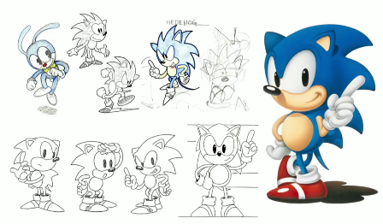
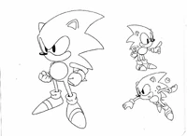
Sonic
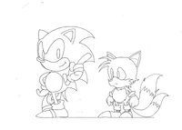

Tails
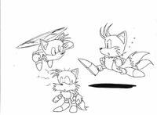
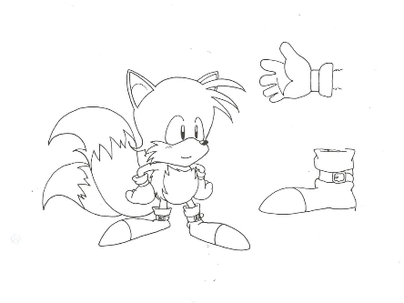
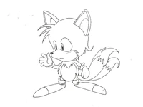


Dr. Eggman
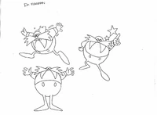
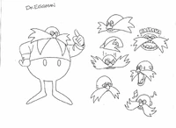

CHARACTER DOSSIER / DETAILS
NAME: | Sonic the Hedgehog
GENDER: | Male
SPECIES: | Hedgehog
AGE: | Teenager (15)
FACTION: | Good/Heroic, Defender of freedom and nature
KNOWN ASSOCIATES: | Tails (Sonics partener and friend)  Dr. Eggman (Antagonist)

CHARACTER’S BACKSTORY
Sonic is a fast-running blue hedgehog who arrives on West Side Island to stop Dr. Eggman from capturing the animals and using the Chaos Emeralds to power the Death Egg. His personality is confident, brave, heroic and rebellious. Sonic’s personality is reflected in the gameplay which emphasises speed and quick reflexes. He attacks by jumping and curling into a spin and the introduction of the Spin dash allows him to build speed instantly which reinforces his aggressive playstyle. The game supports multiple styles of play including high-speed running, precise platforming, exploration for secrets and special stages and skill-based mastery. All of which tie directly to Sonic’s abilities and character.

CHARACTER CONTROLS / PLAYER CONTROLS
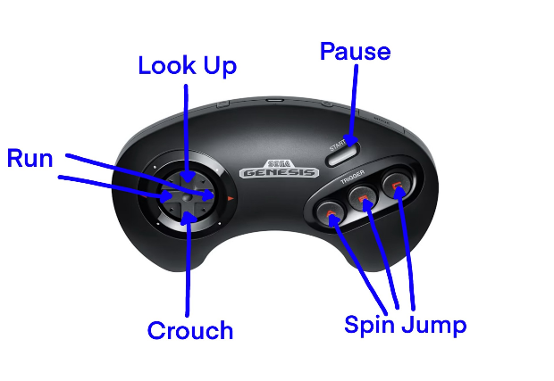
Both controls for Sonic and Tails

Spin Jump = A/B/C
Spin Attack = Move + Crouch
Spin Dash = Crouch + A/B/C

CHARACTER DOSSIER / DETAILS
NAME: | Miles Tails Prower
GENDER: | Male
SPECIES: | 2 Tailed Fox
AGE: | 8 years old
FACTION: | Good, hero, ally of Sonic
KNOWN ASSOCIATES: | Sonic loyal partner  Dr. Eggman (Antagonist)

CHARACTER’S BACKSTORY
Tails is a young two tailed fox who joins Sonic on West Side Island to help stop Dr. Eggman’s invasion. He is kind, loyal and intelligent but shy. Tails acts as a supportive companion rather than a leader, which is reflected in his gameplay role. He can jump, spin, attack enemies and use his twin tails to fly for short periods. This helps with platforming, recovery and exploration of the game. Tails supports all styles of play in the game, including high-speed movement, platforming, exploration of hidden routes, Special Stages, and cooperative and casual play making the game more accessible for less experienced players.

CHARACTER DOSSIER / DETAILS
NAME: | Dr. Eggman (Ivo Robotnik)
GENDER: | Male
SPECIES: | Egg shaped man
AGE: | 50
FACTION: | Bad, antagonist, evil
KNOWN ASSOCIATES: | Sonics rivalry  Tails,

CHARACTER’S BACKSTORY
Dr. Eggman is a brilliant but arrogant scientist who returns after his pervious defeat to conquer the world by capturing animals, collecting the Chaos Emeralds and powering his space station, the Death Egg. He is egotistical, ruthless and obsessed with control, which is reflected in gameplay through his constant interference and escalating boss encounters. Eggman does not use speed or platforming himself, instead he challenges the player though mechanical weapons, traps and vehicles such as the Egg Mobile and Death Egg machinery. His role supports every style of play by forcing fast reflexes during speed focused sections, precise timing in platforming, careful pattern recognition in boss fights and strategic movement making him the driving force behind the game’s challenge and progression.

CONTRIBUTING TEAM MEMBER: | Sêren Williams

SECTION 4: GAMEPLAY

SEQUENCE OF PLAY
We present the sequence of play as a clear, level-based structure rather than separate story chapters. The game is divided into zones each usually made up of two acts with a boss fight against Dr. Eggman at the end to give players a strong sense of progression and payoff. We use large, memorable set pieces to keep players engaged and excited such as high-speed loops and slopes in Emerald Hill Zone, the rising chemical traps and tube slides in Chemical Plant Zone, the aerial plane sequence in Sky Chase Zone and the high-pressure final battles abroad the Death Egg. These moments showcase speed and skill.

UNIQUE SELLING POINTS (USPs)
Main selling points focus on fast, momentum-based platforming that rewards speed, skill and exploration within the same levels. The introduction of the Spin Dash allows players to build speed instantly which improves game flow and control while the addition of Tails supports cooperative player, accessibility and vertical exploration through flight. Large set pieces help each zone feel exciting and distinct, reinforcing the game’s high-energy identity. The game also includes unique minigames such as 3D half-pipe Special Stages for collecting Chaos Emeralds and a competitive two-player mode both of which increase replay ability and appeal to arcade style and social players.

PLATFORM-SPECIFIC FEATURES
The battery backed cartridge to save player progress, allowing continuation from later zones. Sonic 2 will be designed around the Gensis controller only, therefor using the D-pad movement and buttons for jumping and charging the Spin Dash. The Sega Genesis will support 2 player competitive mofe with a vertically split screen for simultaneous racing. Bright sprites, backgrounds and smooth animation will be tailored to the console’s graphical capabilities.

CONTRIBUTING TEAM MEMBER: | Sêren Williams

SECTION 5: GAME WORLD

GAME WORLD
Emerald Hill Zone

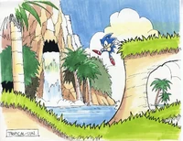
It’s a bright and colourful area of rolling hills, waterfalls and loops that introduces the player to Sonic’s speed, jumping and Spin Dash. Players encounter simple enemies, different paths and hidden areas with upbeat music and energetic visuals for a fun and adventurous mood.

Chemical Plant Zone
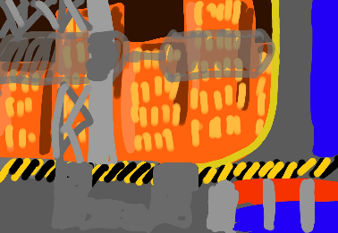
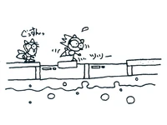
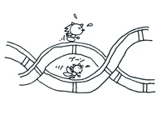
Players navigate through a hazardous, industrial world filled with pipes, rising chemical pools, conveyor platforms and robotic enemies.


Sky Chase Zone
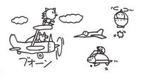

Death Egg
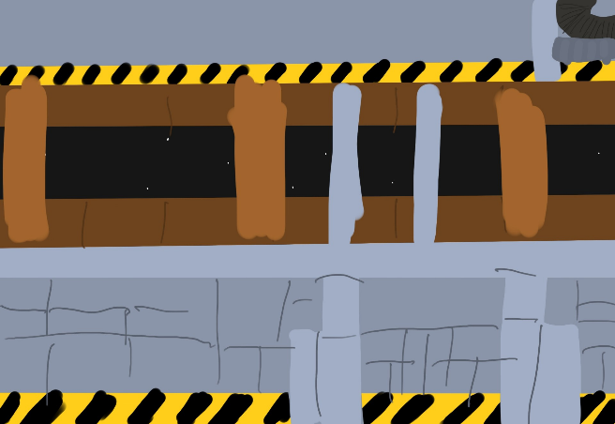

Special Stages
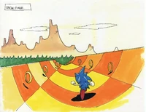

LOCATION DETAILS
NAME: | Emerald Hill Zone
WHAT DOES IT LOOK LIKE? | Green Hills, Palm Trees, waterfalls, checkerboard cliffs, green, oasis, natural
WHAT MOOD IS BEING INVOKED IN THIS LOCATION? | Bright, energetic, welcoming, happy
WHAT KIND OF MUSIC WILL BE USED FOR THIS LOCATION? | Upbeat, melodic, adventurous, quest-y
HOW ARE THE LOCATIONS CONNECTED IN THE GAME WORLD? | Introducing the islands natural state, an entry point into the game, setting the tone

LOCATION DETAILS
NAME: | Chemical Plant Zone
WHAT DOES IT LOOK LIKE? | Industrial, factories, pipes, neon chemicals, danger, rising liquid traps
WHAT MOOD IS BEING INVOKED IN THIS LOCATION? | Tense, hazardous, mechanical, dangerous, toxic,
WHAT KIND OF MUSIC WILL BE USED FOR THIS LOCATION? | Fat, tense, rhythmic, slightly chaotic
HOW ARE THE LOCATIONS CONNECTED IN THE GAME WORLD? | Grounds the game world by making Eggman’s presence feel real and invasive

LOCATION DETAILS
NAME: | Sky Chase Zone
WHAT DOES IT LOOK LIKE? | Clouds, open skies, tornado plane, blue, clear
WHAT MOOD IS BEING INVOKED IN THIS LOCATION? | Hopeful, adventurous, cinematic, ambition
WHAT KIND OF MUSIC WILL BE USED FOR THIS LOCATION? | Light, heroic, uplifting, confident, hope
HOW ARE THE LOCATIONS CONNECTED IN THE GAME WORLD? | Bridge between locations, enforcing the ideas that the player is being chased by Eggman

LOCATION DETAILS
NAME: | Death Egg
WHAT DOES IT LOOK LIKE? | Cold metal interiors, dark, space backdrop, industrial, intense
WHAT MOOD IS BEING INVOKED IN THIS LOCATION? | Intense, isolated, dangerous, climactic, the final showdown
WHAT KIND OF MUSIC WILL BE USED FOR THIS LOCATION? | Tense, finale, ending, scary
HOW ARE THE LOCATIONS CONNECTED IN THE GAME WORLD? | Comes after the sky chase zone, the end zone, the final showdown, final threat in the story, defeating Eggman

LOCATION DETAILS
NAME: | Special Stages
WHAT DOES IT LOOK LIKE? | 3D half pipe floating in a void, bright, checkerboard patters, rings, bombs,
WHAT MOOD IS BEING INVOKED IN THIS LOCATION? | High energy, tense, exhilarating, exciting, bright
WHAT KIND OF MUSIC WILL BE USED FOR THIS LOCATION? | Fast, electric, driving, high, happy, exciting
HOW ARE THE LOCATIONS CONNECTED IN THE GAME WORLD? | When a player earns 50 rings after completing a zone, it takes the player to the special stage where they can collect chaos emeralds, linking to the story where the player must get the emeralds before Eggman does

GAME FLOW

CONTRIBUTING TEAM MEMBER: | Sêren Williams

SECTION 6: GAME EXPERIENCE

GAME EXPERIENCE
The theme of sonic, will be a thrilling, energetic and adventurous game with a strong emphasis on speed and excitement. The game will present as a light hearted and playful tone using colourful and vibrant visuals, upbeat music and character designs will have a fantasy feel, while still delivering moments of tension and challenge through having fast gameplay and boss encounters. The experience will feel fun and empowering with high energy, encouraging players to feel confident and skill as they race through the world.

HOW IS THIS FEELING GOING TO BE PRESENTED TO THE PLAYER?
The experience will be delivered by focusing on the speed, momentum and flow of each level. The levels will be built with slopes, loops and the use of the new spin dash movement to make players feel fast and powerful and constantly moving forward. Bright and colourful visuals create a playful and energetic atmosphere. By balancing the high-speed sections with moments of precision platforming maintains tension without overwhelming the player. Boss encounters and escalating hazards are used to heighten urgency and reward skill ensuring the overall experience is thrilling and engaging.

ARE THERE ANY SPECIAL MODES OR INTERFACES FOR GAMEPLAY?
There will be special stages available in the game. If a player earns at least 50 rings in each zone, they will be taken to a special stage where they are able to get extra rings, power ups and other goodies. In the stages there will be rings to collect to earn chaos emeralds, chaos emeralds are collected at the end of the stage, bombs cause the player to lose rings when running into one therefore increasing the risk, ring clusters tests the players reflexes by testing their steering and timing.

WHAT DOES THE PLAYER FIRST SEE WHEN THEY START THE GAME?
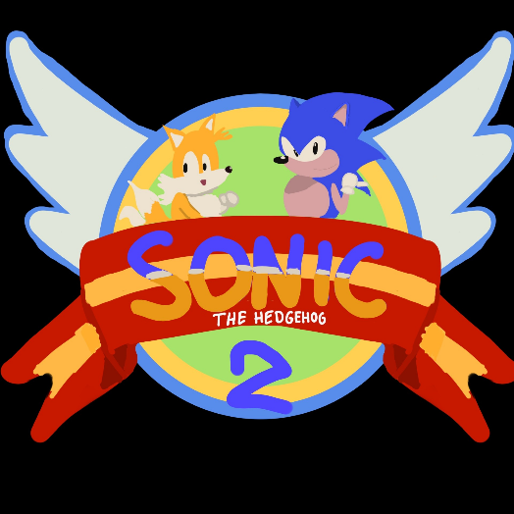

When the player starts the game up, they are met with the opening screen of Sonic 2, it will consist the title “Sonic the Hedgehog 2” along with Sonic and tails behind the title. It will be very colourful and vibrant with energetic exciting and adventurous music in the back.

WHAT EMOTIONS ARE MEANT TO BE INVOKED BY THE GAME?
Because each zone and scene is themed, there will be different emotions invoked throughout. In the more colourful and exciting scenes it will invoke feelings like excitement, thrill, confidence, empowerment, curiosity and discovery whereas in the more industrial and intense scenes it’ll invoke feelings of tension, focus, relief and achievement and they defeat each level.

HOW ARE MUSIC AND SOUND GOING TO BE USED?
The music and sound will strongly reinforce speed, mood and player emotion, fast and upbeat tracks will be used in most zones to create adrenaline rushes and make players feel confident and heroic as they maintain momentum. Clear, responsive sound effects give instead feedback with ring sounds rewarding success and sharp damage cues signalling danger. More mechanical and intense music is used during boss fights, industrial areas and the Death Egg scene to increase tension and urgency. IN the Special stages, the music will feel electric to heighten focus and pressure.

HOW DOES THE PLAYER NAVIGATE THE SHELL MENUS/ SCREENS OF THE GAME?
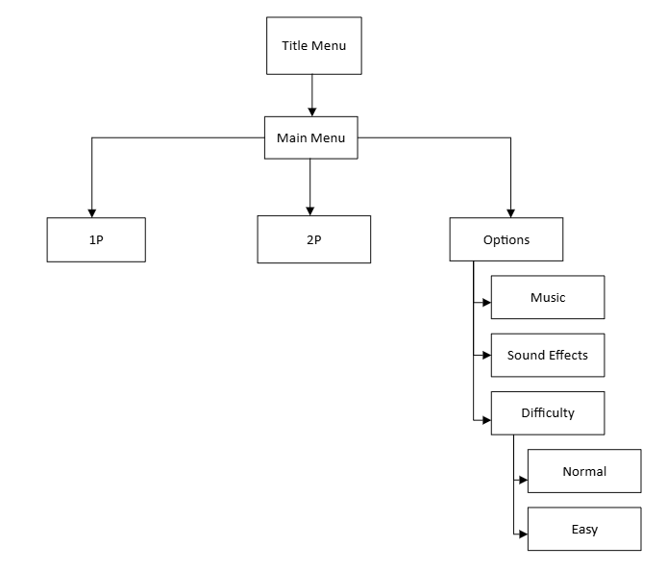

CONTRIBUTING TEAM MEMBER: | Sêren Williams

SECTION 7: GAMEPLAY MECHANICS

GAMEPLAY MECHANICS
MECHANIC: Spin Dash, Rolling/Spin Attack, Tails

HAZARD: Spikes, Bottomless Pits, Lava, Fire, Crushing Blocks/Platforms, Water, Badniks, Boss Machines

POWER-UP: Ring Monitor, Shield, Invincibility, Speed Shoes, 1-Up, Rings, Special Stages

MECHANIC DETAILS
NAME: | Spin Dash
WHAT DOES IT LOOK LIKE? | Sonic crouches and rapidly revs in place, blue blur animation
EFFECT ON PLAYER: | Allows instant high-speed launch from a standstill, breaks enemies and monitors
WHEN WILL IT FEATURE IN THE GAME? | Anytime

MECHANIC DETAILS
NAME: | Rolling/Spin Attack
WHAT DOES IT LOOK LIKE? | Sonic curls into a blue ball while moving
EFFECT ON PLAYER: | Destroys enemies, activates certain objects, protects from some hazards
WHEN WILL IT FEATURE IN THE GAME? | Anytime

MECHANIC DETAILS
NAME: | Tails
WHAT DOES IT LOOK LIKE? | Orange two tailed fox who follows Sonic
EFFECT ON PLAYER: | Can defeat enemies, collect rings, take hits instead of Sonic
WHEN WILL IT FEATURE IN THE GAME? | Anytime (1P Only)

HAZARD DETAILS
NAME: | Spikes
WHAT DOES IT LOOK LIKE? | Rows of sharp grey spikes on floors, walls or ceilings
EFFECT ON PLAYER: | Causes damage unless invincible or rolling at speed
WHEN WILL IT FEATURE IN THE GAME? | Appears in Emerald Hill Zone and throughout

HAZARD DETAILS
NAME: | Bottomless Pits
WHAT DOES IT LOOK LIKE? | Gaps in terrain leading off screen
EFFECT ON PLAYER: | Instant death, regardless of rings
WHEN WILL IT FEATURE IN THE GAME? | Throughout the game, increasingly frequent in later zones

HAZARD DETAILS
NAME: | Lava/Fire
WHAT DOES IT LOOK LIKE? | Animated red, orange liquid or fire jets
EFFECT ON PLAYER: | Damage on contact, lava can instantly kill if submerged
WHEN WILL IT FEATURE IN THE GAME? | Prominent in industrial zones

HAZARD DETAILS
NAME: | Crushing Block/Platforms
WHAT DOES IT LOOK LIKE? | Large moving blocks or pistons
EFFECT ON PLAYER: | Instant death if crushed
WHEN WILL IT FEATURE IN THE GAME? | Mostly in mid or late game

HAZARD DETAILS
NAME: | Water
WHAT DOES IT LOOK LIKE? | Submerged sections with bubbles
EFFECT ON PLAYER: | Limited air, drowning after countdown
WHEN WILL IT FEATURE IN THE GAME? | Chemical Plant Zone and later

HAZARD DETAILS
NAME: | Badniks
WHAT DOES IT LOOK LIKE? | Robotic animals (crabs, monkeys, wasps)
EFFECT ON PLAYER: | Damage on contact unless attacked
WHEN WILL IT FEATURE IN THE GAME? | Entire game, each animal unique to zone

HAZARD DETAILS
NAME: | Boss Machines
WHAT DOES IT LOOK LIKE? | Egg shaped hovercraft with zone themed weapons
EFFECT ON PLAYER: | Blocks progression until defeated
WHEN WILL IT FEATURE IN THE GAME? | End of every zone

POWER-UP DETAILS
NAME: | Ring Monitor
WHAT DOES IT LOOK LIKE? | Tv monitor with gold ring icon
EFFECT ON PLAYER: | +10 rings
WHEN WILL IT FEATURE IN THE GAME? | Entire game

POWER-UP DETAILS
NAME: | Shield
WHAT DOES IT LOOK LIKE? | Blue shimmering bubble around Sonic
EFFECT ON PLAYER: | Absorbs one hit without losing rings
WHEN WILL IT FEATURE IN THE GAME? | Early and mid-game zones

POWER-UP DETAILS
NAME: | Invincibility
WHAT DOES IT LOOK LIKE? | Sonic flashes with rainbow colours
EFFECT ON PLAYER: | Temporary immunity, defeats enemies on contact
WHEN WILL IT FEATURE IN THE GAME? | All Zones, in risky or rewarding paths

POWER-UP DETAILS
NAME: | Speed Shoes
WHAT DOES IT LOOK LIKE? | Red trainer icon
EFFECT ON PLAYER: | Increases movement speed temporarily
WHEN WILL IT FEATURE IN THE GAME? | Entire game, often before fast sections

POWER-UP DETAILS
NAME: | 1-Up
WHAT DOES IT LOOK LIKE? | Sonic’s face icon
EFFECT ON PLAYER: | Grants and extra life
WHEN WILL IT FEATURE IN THE GAME? | Rare, hidden or reward-based placements

POWER-UP DETAILS
NAME: | Rings
WHAT DOES IT LOOK LIKE? | Floating Golden Rings
EFFECT ON PLAYER: | Protection from death, 100 rings = 1-Up
WHEN WILL IT FEATURE IN THE GAME? | Core Mechanic entire game

POWER-UP DETAILS
NAME: | Special Stages
WHAT DOES IT LOOK LIKE? | Half-pipe running stage with rings and bombs
EFFECT ON PLAYER: | Collecting enough rings grants a Chaos Emerald
WHEN WILL IT FEATURE IN THE GAME? | Accessed from checkpoints with 50+ rings

COLLECTIBLE ITEMS
Rings, Chaos Emeralds, Extra Lives, Score,

COLLECTIBLE DETAILS
NAME: | Rings
WHAT DOES IT LOOK LIKE? | Floating golden rings, circulated and slightly tilted
BENEFIT FOR PLAYER: | Acts as a health buffer, player survives damage if holding at least one ring  100 rings = 1 extra life  50 rings required to access special stages after every zone
WHEN WILL IT FEATURE IN THE GAME? | Present in every level, from start to finish
CAN IT BE USED AS CURRENCY? | No
WILL IT EARN PLAYERS AN ACHIEVEMENT? | No, but able to unlock content

COLLECTIBLE DETAILS
NAME: | Chaos Emeralds
WHAT DOES IT LOOK LIKE? | Large, faceted gemstones, different colours, obtained in special stages
BENEFIT FOR PLAYER: | Collecting all results in the best ending (defeating Dr Eggmans Death Egg)
WHEN WILL IT FEATURE IN THE GAME? | Accessible throughput the game via special stages  Completion matters at the end of final boss
CAN IT BE USED AS CURRENCY? | No
WILL IT EARN PLAYERS AN ACHIEVEMENT? | No, but unlocks best ending

COLLECTIBLE DETAILS
NAME: | Score/Points
WHAT DOES IT LOOK LIKE? | Numerical score displayed at the top of the screen
BENEFIT FOR PLAYER: | Score goes up by defeating enemies, collecting rings and finishing levels quickly  High scores grant extra lives at thresholds
WHEN WILL IT FEATURE IN THE GAME? | Entire game
CAN IT BE USED AS CURRENCY? | No
WILL IT EARN PLAYERS AN ACHIEVEMENT? | No

COLLECTIBLE DETAILS
NAME: | Extra Lives (1-Ups)
WHAT DOES IT LOOK LIKE? | Monitor with Sonic’s face on it
BENEFIT FOR PLAYER: | Increases number of retries before game over
WHEN WILL IT FEATURE IN THE GAME? | Hidden or reward based throughout all zones of the game
CAN IT BE USED AS CURRENCY? | No
WILL IT EARN PLAYERS AN ACHIEVEMENT? | No

CONTRIBUTING TEAM MEMBER: | Sêren Williams

SECTION 8: ENEMIES

LIST OF ENEMIES
General Enemies
Coconuts – Monkey
Buzz Bomber – Wasp
Masher – Piranha
Crabmeat – Crab
Grounder – Drilling Robot
Balkiry – Bird/ Eagle Plane
Nebula – Flying sphere
Turtloids – Turtle riding turtle

ENEMY DETAILS
NAME: | Coconuts
WHAT DOES IT LOOK LIKE? | Monkey Robot sitting in palm trees
ATTACKS: | Throws coconuts downward
WHEN WILL IT FEATURE IN THE GAME? | Emerald Hill Zone
HOW DOES THE PLAYER DEFEAT IT? | Jump or roll attack
WHAT DOES THE PLAYER EARN FOR DEFEATING THEM? | 100 points + freed animal

ENEMY DETAILS
NAME: | Buzz Bomber
WHAT DOES IT LOOK LIKE? | Yellow and Black robotic wasp
ATTACKS: | Fires projectile while hovering
WHEN WILL IT FEATURE IN THE GAME? | Emerald Hill Zone, Later zones
HOW DOES THE PLAYER DEFEAT IT? | Jump, roll or spin attack
WHAT DOES THE PLAYER EARN FOR DEFEATING THEM? | 100 points + freed animal

ENEMY DETAILS
NAME: | Masher
WHAT DOES IT LOOK LIKE? | Robotic piranha fish
ATTACKS: | Jumps vertically from water
WHEN WILL IT FEATURE IN THE GAME? | Emerald Hill Zone
HOW DOES THE PLAYER DEFEAT IT? | Jump attack
WHAT DOES THE PLAYER EARN FOR DEFEATING THEM? | 100 points + freed animal

ENEMY DETAILS
NAME: | Crabmeat
WHAT DOES IT LOOK LIKE? | Red robotic crab
ATTACKS: | Shoots projectiles sideways
WHEN WILL IT FEATURE IN THE GAME? | Chemical Plant Zone
HOW DOES THE PLAYER DEFEAT IT? | Jump or Roll
WHAT DOES THE PLAYER EARN FOR DEFEATING THEM? | 100 points + freed animal

ENEMY DETAILS
NAME: | Grounder
WHAT DOES IT LOOK LIKE? | Red mole robot with drill nose and hands
ATTACKS: | Burrows underground and drills up from ground
WHEN WILL IT FEATURE IN THE GAME? | Chemical Plant Zone
HOW DOES THE PLAYER DEFEAT IT? | Jump when Exposed
WHAT DOES THE PLAYER EARN FOR DEFEATING THEM? | 100 Points + freed animal
ENEMY DETAILS
NAME: | Balkiry
WHAT DOES IT LOOK LIKE? | Jet shaped, eagle robot
ATTACKS: | Flies horizontally, drops bombs
WHEN WILL IT FEATURE IN THE GAME? | Sky Chase Zones
HOW DOES THE PLAYER DEFEAT IT? | Jumping into it
WHAT DOES THE PLAYER EARN FOR DEFEATING THEM? | 100 Points

ENEMY DETAILS
NAME: | Turtloid
WHAT DOES IT LOOK LIKE? | Turtle robot that gets flown by a smaller turtle robot
ATTACKS: | Fires missiles
WHEN WILL IT FEATURE IN THE GAME? | Sky Chase Zones
HOW DOES THE PLAYER DEFEAT IT? | Jump Attack
WHAT DOES THE PLAYER EARN FOR DEFEATING THEM? | 100 points

ENEMY DETAILS
NAME: | Nebula
WHAT DOES IT LOOK LIKE? | Floating orb robot
ATTACKS: | Electric bursts
WHEN WILL IT FEATURE IN THE GAME? | Sky Chase Zones
HOW DOES THE PLAYER DEFEAT IT? | Jump Attack
WHAT DOES THE PLAYER EARN FOR DEFEATING THEM? | 100 points

LIST OF BOSS CHARACTERS
Bosses – Dr. Eggmans (Dr. Robotnik) Machines
Emerald Hill Boss – Wrecking Ball
Chemical Plant Boss – Capsule
Death Egg Robot – Giant Robotnik Mech

BOSS CHARACTER DETAILS
NAME: | Emerald Hill Boss
WHAT DOES IT LOOK LIKE? | Dr. Eggman/Robotnik in his egg mobile attached to a large spiked wrecking ball that swings beneath him.
ATTACKS: | Swings the spiked ball back and forth, moves horizontally to control the ball’s arc
WHEN WILL IT FEATURE IN THE GAME? | End of Emerald Hill Zone
HOW DOES THE PLAYER DEFEAT IT? | Jump into Robotnik’s egg mobile 8 times, avoid the wrecking ball while timing jumps
WHAT DOES THE PLAYER EARN FOR DEFEATING THEM? | Completion of zone, progression to next zone, no points or items awarded

BOSS CHARACTER DETAILS
NAME: | Chemical Plant Boss
WHAT DOES IT LOOK LIKE? | Dr. Eggman/Robotnik in his egg mobile hovering above two rising platforms surrounded by toxic chemical liquid
ATTACKS: | Drops blocks onto the platforms, platforms skin when stood on, increasing risk of drowning, indirect environmental pressure rather than direct attacks
WHEN WILL IT FEATURE IN THE GAME? | End of Chemical Plant Zone
HOW DOES THE PLAYER DEFEAT IT? | Jump into Robotnik’s egg mobile 8 times, balance on moving platforms while avoid chemical liquid
WHAT DOES THE PLAYER EARN FOR DEFEATING THEM? | Completion of zone, progression to next zone, no points or items awarded
BOSS CHARACTER DETAILS
NAME: | Death Egg Boss
WHAT DOES IT LOOK LIKE? | A giant robot version of Dr Robotnik with massive arms and legs, piloted from inside
ATTACKS: | Stomps the ground, walks toward the player, uses swinging arms to strike Sonic
WHEN WILL IT FEATURE IN THE GAME? | Death Egg Zone, Finale
HOW DOES THE PLAYER DEFEAT IT? | Hit the robot’s cockpit 12 times, if hit, instant death, needs precise timing and pattern recognition
WHAT DOES THE PLAYER EARN FOR DEFEATING THEM? | Completion of zone, progression to next zone, no points or items awarded, best ending if all chaos emeralds are collected, regular ending if not.

CONTRIBUTING TEAM MEMBER: | Sêren Williams

SECTION 9: CUTSCENES

CUTSCENES
Ending Cutscene
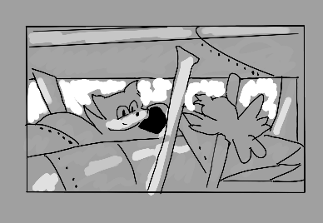
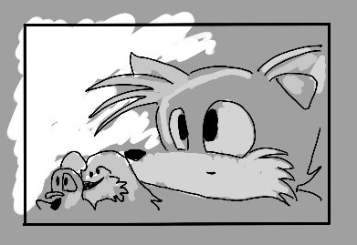
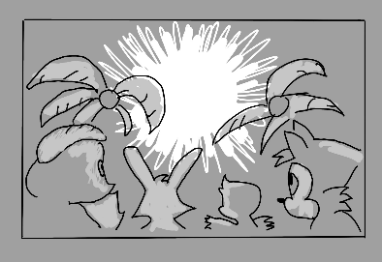




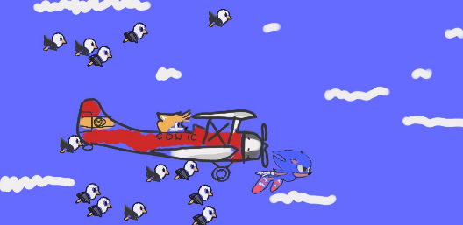

CUTSCENE DETAILS (use this table for each unique cutscene you include)
VISUAL STYLE: | Same 16 bit style all throughout the game, clean, bright and cartoon style
BRIEF DESCRIPTION OF SCENE: | Heroic, ending music plays. A black and white screenshot showing the death egg exploding after sonic destroying the Death Egg Final Boss. Sonic flies out of the death egg while tails watches form the bottom with the freed animals. Tails gets into the plane and flies up.  Cuts to a coloured scene where sonic is falling from the air and flying while tails is flying with sonic in his plane and birds fly with them, . Then birds fly away and then tails turns the plane around and sonic follows and then sonic and tails are facing the screen. Screen goes dark and cuts to the credits.
WHEN WILL IT FEATURE IN THE GAME? | Ending of the game
PURPOSE: | Gives a heroic ending for the player so they feel accomplished.

CONTRIBUTING TEAM MEMBER: | Sêren Williams

SECTION 10: BONUS MATERIALS

BONUS MATERIALS
Chaos Emeralds (Alternate Ending)
Chaos emeralds are used to unlock the better ending. To unlock it the player must collect all emeralds.

Super Sonic
This transforms sonic into supersonic. It allows the player to have faster speed, invincibility and it has a new visual form. The player must collect all 7 Chaos emeralds and have at least 50+ rings during gameplay.

Multiplayer Mode
2 player mode is available where the second player can play as tails. It splits the screen and unlocks exclusive stages that are available for 2 people. It is played in split screen where the players are in a self-contained racetrack, and the goal is to get to the end first.

REPLAY VALUE
Chaos Emeralds (Alternate Ending)
Players are encouraged to replay levels to find special stage entrances and master the half pipe special stages to unlock each chaos emerald. Therefore, them having to replay each level until they unlock the emeralds. This also encourages mastery of the game, creates a clear best ending goal and adds narrative without altering the main game.

Super Sonic
Because the player unlocks this after defeating Dr. Robotnik, it allows the player to experience the game again but with the super sonic form, where everything is faster and at a higher speed. It also allows the player to use abilities unavailable on the first run. It lets players revisit the content in a new way.

Multiplayer Mode
Infinite replayability with multiplayer as it brings competition, skill improvement and social play. Each level will vary based on player skill and strategy. This works as it doesn’t rely on unlocking or having to progress to play.

CONTRIBUTING TEAM MEMBER: | Sêren Williams

