

BMMB 7003 – Dissertation
UNIVERSITY OF WALES TRINITY SAINT DAVID
STUDENT NAME: Aditya Mohod
STUDENT ID: 2503557
September 2025 - 2026

EXAMINING THE RELATIONSHIP BETWEEN WORK-LIFE BALANCE POLICIES AND EMPLOYEE RETENTION AMONG FEMALE IT PROFESSIONALS IN THE UK TECHNOLOGY FIRMS

Abstract
The purpose of this current research is to learn how work-life policies and retention among women in the IT industry in technology organizations in the UK are interconnected. The research is based on the flexible working practices, hybrid working, maternity and parental support, workload management, organisational culture and impacts of career progression on the intention to stay among employees. The study adopted a mixed methods research design that has a pragmatic philosophy and deductive method. A total of 150 female professionals from IT sector were sampled to fill a structured questionnaire, and 10 respondents were sampled and interviewed with semi-structured questions. The quantitative data analysis involved descriptive statistics, correlation, regression and Cronbach alpha and the qualitative data analysis involved thematic analysis as suggested by Braun and Clarke.
The findings are presented and suggest that the respondents generally had a positive attitude towards work-life balance policies, particularly flexible working and hybrid working. Results of regression analysis gave an R value of 0.674 and an R-squared value of 0.455 which means that 45.5% of the variation in the dependent variable was explained by the independent variables in the model. The internal consistency was also high (.877) using the Cronbach’s alpha. The qualitative data was condensed into four main themes; Hybrid and Flexible Working Conditions, Stress and Workload Management, Gender Bias and Organisational Culture and Retention and Career Progression Opportunities. Participants noted flexibility as a means of helping them to balance their personal and professional life as well as enhance their intention to stay. A high workload, unrealistic deadlines, inequitable promotion opportunities, gender bias and limited career development are some of the factors which may lower organisational commitment, however.
In general, the research indicates that overall work-life balance policies positively impact turnover intention and intention to stay when there is management support, work is not excessively stressful, there is equitable career development, and the organization has an encompassed culture. The findings can be applied to technology firms that are seeking to improve the retention of women in IT-related jobs.

DECLARATION

This work has not previously been accepted in substance for any degree and is not being concurrently submitted in candidature for any degree.
Signed ......Aditya Mohod............
Date .....24/09/2026..........

STATEMENT 1
This work is the result of my own investigations, except where otherwise stated.
Other sources are acknowledged by footnotes giving explicit references. A bibliography is appended.
Signed ......Aditya Mohod............
Date .....24/09/2026..........

STATEMENT 2
I hereby give consent for my work, if accepted, to be available for photocopying and for inter-library loan, and for the title and summary to be made available to outside organisations.
Signed ......Aditya Mohod............
Date ....24/09/2026..........

Table of Contents
DECLARATION 4
Chapter 1: Introduction 12
1.1 Introduction 12
1.2 Background 12
1.3 Research Rationale 14
1.4 Research Aim and Objectives 16
1.5 Research Questions 17
1.6 Significance of the study 17
1.7 Scope of the Study 18
1.8 Structure of the Study 19
1.9 Chapter Summary 19
Chapter 2: Literature Review 20
2.1 Introduction 20
2.2 Concept of Work-Life Balance 20
2.3 Work-Life Balance Policies 21
2.4 Employee Perceptions of Work-Life Balance Policies 22
2.5 Employee Retention 23
2.6 Relationship Between Work-Life Balance and Employee Retention 23
2.7 Female IT Professionals and Workplace Challenges 24
2.8 Factors Influencing Retention Decisions Among Female IT Professionals 25
2.9 Employee Perceptions of Work-Life Balance Policies 26
2.10 Theoretical Framework 27
2.11 Research Gap 29
2.12 Chapter Conclusion 29
Chapter 3: Methodology 29
3.1 Introduction 29
3.2 Research Onion Framework 30
3.3 Research Philosophy (Research Onion Layer 1) 30
3.3.1 Pragmatism Philosophy 30
3.4 Research Approach (Research Onion Layer 2) 31
3.4.1 Deductive Approach 31
3.5 Research Methodological Choice (Research Onion Layer 3) 31
3.5.1 Mixed Methods Research 31
3.6 Research Strategy (Research Onion Layer 4) 32
3.6.1 Survey Strategy 32
3.6.2 Semi-Structured Interview Strategy 33
3.7 Time Horizon (Research Onion Layer 5) 33
3.7.1 Cross-Sectional Research 33
3.8 Research Techniques and Procedures 33
3.8.1 Target Population 33
3.8.2 Sampling Technique 34
3.8.3 Data Collection Methods 35
3.9 Measurement of Variables 36
3.10 Data Analysis Techniques 36
3.10.1 Quantitative Data Analysis 36
3.10.2 Qualitative Data Analysis 37
3.11 Reliability and Validity / Trustworthiness 37
3.12 Ethical Considerations 38
3.13 Chapter Summary 38
Chapter 4: Findings 39
4.1 Introduction 39
4.2 Findings from Statistical Tests 39
4.2.1 Frequency 39
4.2.2 Descriptive Statistics 46
4.2.3 Correlation Test 48
4.2.4 Regression Test 50
4.2.5 Cronbach's Alpha Test 51
4.3 Findings from Braun and Clarke's Thematic Analysis 51
4.3.1 Theme 1: Hybrid and flexible working conditions 51
4.3.2 Theme 2: Stress and workload management 53
4.3.3 Theme 3: Gender bias and organisational culture 55
4.3.4 Theme 4: Retention and career progression opportunities 57
4.4 Summary 58
Chapter 5: Discussion 59
5.1 Introduction 59
5.2 Analysis of the findings 59
5.3 Similarities and Dissimilarities between Findings and Literature 61
5.4 Chapter Summary 62
Chapter 6: Conclusion and Recommendations 64
6.1 Concluding the Discussion 64
6.2 Linking with Objectives 64
6.3 Limitations of the Research 66
6.4 Recommendations 67
6.4.1 Recommendations for Organisations 67
6.4.2 Recommendations for Research 68
6.5 Contribution of the Research 69
Reference List 70
Appendices 79
Appendix 1: Questions 79
Appendix 2: Interview Transcript 82

List of Figures
Figure 1.2.1: Growth of UK technology sector 10
Figure 1.2.2: Remote working statistics in the UK 12
Figure 1.3: Employee retention intention among male and female employees 13
Figure 1.6: Portraying the significance of the study 16
Figure 1.8: Research structure 17
Figure 2.1: Theoretical Framework 26
Figure 2.2: Conceptual Framework 27
Figure 3.1: Research Onion Framework 29
Figure 3.2: Mixed Methods Research 32
Figure 3.3: Thematic Analysis 37
Figure 4.2.1.1: Age Group 39
Figure 4.2.1.2: Work Experience of Participants 40
Figure 4.2.1.3: Flexible Work Arrangement 41
Figure 4.2.1.4: Flexible Work Arrangement Promotes Commitment 41
Figure 4.2.1.5: Hybrid Work Helps in Achieving Life Goals 42
Figure 4.2.1.6: Hybrid Working Model’s Impact 43
Figure 4.2.1.7: Reasonable Policies for Mothers 43
Figure 4.2.1.8: Impact of Responsible Work Policies for Moms 44
Figure 4.2.1.9: Work-life Policies Help in Workload Management 44
Figure 4.2.1.10: Work-Life Balance Promotes Time Management 45
Figure 4.2.1.11: Work-life Balance in Organisations 46
Figure 4.2.1.12: Impact of Work-Life Balance Policies on Employee Commitment 46
Figure 4.2.2: The results of descriptive statistics 48
Figure 4.2.3: The result of correlation test 49
Figure 4.2.4: The result of regression test 50
Figure 4.2.5: The result of Cronbach's Alpha test 51

List of Tables
Table 3.1: Measurement of Variables 36

Chapter 1: Introduction

1.1 Introduction
Work life balance policies are increasingly becoming a crucial feature of Information Technology (IT) organisations because it provides employees with the freedom to manage work and their lives. Having the ability to keep preserving this balance can have a good effect on employees' choices to stay in an organisation. Good work-life balance is a priority in the UK IT industry, as employee well-being is increasingly becoming a priority. This chapter provides the background, the aim and the research questions. Lastly, the overall structure of the study is presented.

1.2 Background
The international technology sector has grown significantly in the past few decades. UK is no exception to this, as it has undergone profound growth in recent years.
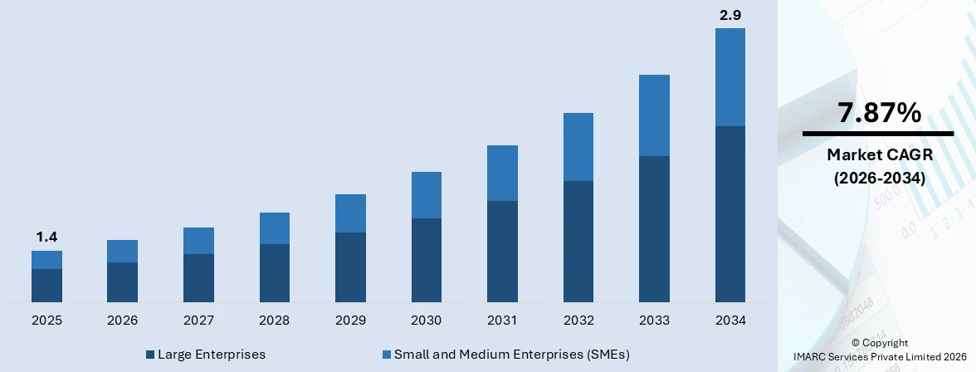

Figure 1.2.1: Growth of UK technology sector
(Source: imarcgroup.com, 2026)
As shown in figure 1.2.1, the overall technology market in the UK in 2025 is estimated to be USD 1.4 trillion. The industry will also record a CAGR of 7.8% to 2034, which will bring the market size to USD 2.9 trillion at the end of 2026 (imarcgroup.com). As per the opinions of Ullah and Azeem (2024), employee retention has become one of the most important factors in today’s competitive international corporate environment. Organisations have understood the necessity of retaining their skilled employees not only to save costs but also to drive innovation. Despite this recognised importance of employee retention, UK technology firms have found it challenging to retain female employees.
Poor work-life balance is a major contributor to this low retention rate among female IT professionals. According to Zuhriatusobah et al. (2023), work-life balance refers to a concept that supports employees' efforts to balance their professional responsibilities and other vital work in their personal lives. Nowadays, most employees demand work-life balance, especially female employees. Based on The Guardian report, work-life balance is the top priority for UK workers when choosing companies to work for that also accounts for 83% (Partridge, 2025). The majority of workers are female, who demand work-life balance to manage their personal responsibilities at the same time. This is echoed by Soliman (2025) who indicated that 67% of female workers want to work hybrid, and 58% indicated that hybrid working freed them up to other personal working.
Compared to the time pressure is another issue that can lead to fatigue for women in the IT field, according to Muhl and Korunka (2026). There are some good answers to this, one of which is that women are expected to be good providers at work and good housekeepers. By avoiding work stress and overworking, workers can prevent stress and burnout. According to Zahra et al. (2026) when there is no work-life balance policy, it causes employee discontentment which impacts them to withdraw from the organisations. Hence, the attitudes of the staff towards good work-life balance will be expected to impact their intent to stay/leave in the organization. Staff will be more inclined to remain with their employer if they feel their employer cares for them, and provides them with any help and support they need to maintain a balance between work and personal life. The flipside of the coin is that when the staffs members feel that the employer is not taking into account their personal accountability and wellbeing, they tend to quit their job.

Hybrid and remote work have become major strategies implemented by IT organisations across the UK to offer a good work-life balance to their employees.
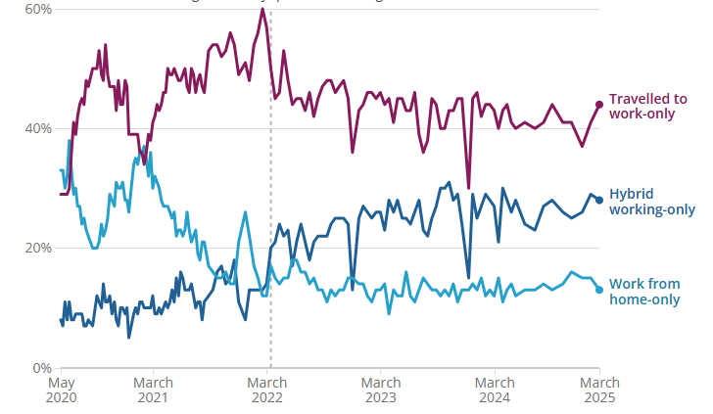

Figure 1.2.2: Remote working statistics in the UK
(Source: ONS, 2026)
Figure 1.2.2 shows the percentage of people in the UK who work remotely. Approximately a quarter of employees have a hybrid work setup and one fifth work at home exclusively (ONS, 2026). Moreover, women employees have a higher propensity to work outside the office compared to men employees. Female employees in this sector encounter some unique challenges that cannot be understood from general employees' perspectives and requires a separate study.

1.3 Research Rationale
What is the issue?
The main problem is poor work-life balance that reduces retention rates, especially among female IT professionals. As discussed by Priyanka, Ms and Chand, Khem (2022), female employees face the issue of poor work-life balance in today’s business environment. It can be seen that employees who are married or have children usually look for a company that has flexible work-life policies (Weng et al., 2023). However, in most of the cases, they become disappointed as they do not find flexible working conditions that would help them to perform their personal responsibilities effectively. In some cases, although the employees offer flexible work-life balance options like hybrid working conditions, the working hours get longer. It is discussed that teleworking conditions often disrupt an individual’s balance between professional and personal work commitments (Berger Ploszaj et al., 2025). Hybrid working conditions do not necessarily suggest the reduction in work pressure. Often women workers are offered the chance to work under hybrid arrangements, with the same level of stress. This may also have an impact on job satisfaction and may eventually lead to staff members leaving their organisation which means that the staff retention rates are low.
Why is it an issue?
The issue is connected with the technology businesses absence of effective work-life balance policies.
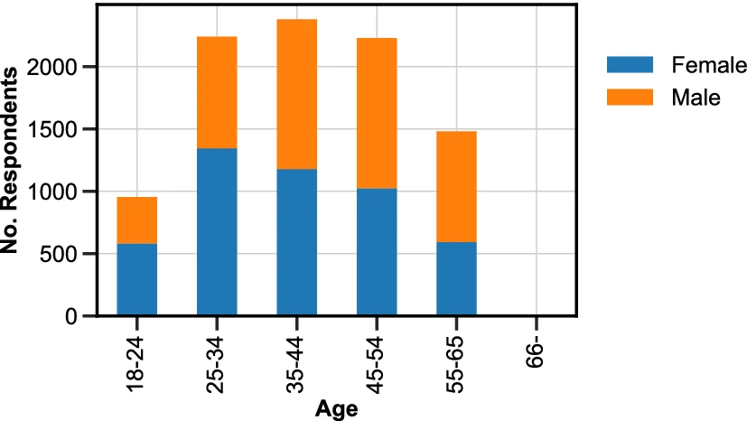

Figure 1.3: Employee retention intention among male and female employees
(Source: Lazzari et al., 2022)
It is found from Figure 1.3 that retention intention is comparatively higher among female professionals than male professionals (Lazzari et al., 2022). For instance, approximately 1400 male and 2200 female employees between 25 and 34 years old leave their organisations. It is also observed that the prevalence of retention rate is lower among female employees whose age is between 35 and 44 years. This is further supported by Bhakuni (2025), stating that although the female participation rate in the labour market is impressive, their retention rate is poor. Thus, it is evident that most of the employers cannot be able to retain their female employees due to their poor retention strategies.

Why is it an issue now?
Poor employee retention is an issue now as it increases the total recruitment costs of a company. A company also needs to train their new employees, which increases its training costs as well. New employees cannot perform like experienced, skilled employees, which leads to the reduction of organisational performance and productivity. The reduction of the women workforce further reduces organisational diversity. As per the opinions of Nweiser and Dajnoki (2022), workforce diversity is crucial in today’s globalised business environment that enhance organisational profitability. It also helps the company to maintain a positive reputation in the international market.
What does the research shed light on?
This study contributes to the knowledge field regarding the impact that work-life balance policies have on decisions related to retention amongst women in the information technology sector in UK technology companies. It highlights the importance of flexible and hybrid working, maternity, workload, organisational culture, career progression. The results also indicate that work-life balance policies might not be adequate as other variables such as stress, gender discrimination and unequal career chances can influence an employee to remain in the company. As a whole the study provides a relevant view of issues related to staff retention.

1.4 Research Aim and Objectives
Research Aim
The study aims to examine the association between employee retention and work-life balance among female IT professionals in technology firms in the UK.
Research Objectives
- To analyse employee perceptions of work-life balance among IT professionals in UK technology firms.
- To assess the factors that influence female IT professionals' retention decisions.
- To evaluate the relationship between work-life balance and employee retention in technology firms in the UK.
- To explore the challenges encountered by female IT professionals in their workplace in the UK.

1.5 Research Questions
- How employees perceive work-life balance among IT professionals in UK technology firms?
- What factors influence female IT professionals' retention decisions?
- How is employee retention in UK technology firms influenced by work-life balance?
- What are the challenges encountered by female IT professionals in their workplace in the UK?

1.6 Significance of the study

Contribution to academic literature

Organisational contribution

Contribution to IT professionals

Figure 1.6: Portraying the significance of the study
(Source: Self-Created)
The above figure 1.6 portrays the significance of this study, that are discussed in the following.
Contribution to academic literature
The present research has dealt with primary basis of academic growth. Suprayitno (2024) has discussed how relation of work-life balance policies with employee retention rates. However, this has been discussed in terms of all employees' perceptions. It does not specifically emphasise female employees. Some of the studies, like Hur (2022), focus on female employees' perceptions and the reasons behind their low retention rate. It does not make any country or sector-specific discussion. By addressing the gaps in existing literature, the study will make a major contribution to academia. It will enrich existing bodies of literature, which will further allow future researchers to gather valuable information and make their studies easier.

Organisational contribution
This research can also improve organisational productivity and performance by making the understood about the importance of work-life balance. According to a report by the UK government, gender diversity is comparatively lower in the UK’s tech companies, with women accounting for 21% share (Department for Science, Innovation & Technology, 2025). Lack of diversity disrupts innovation and organisational performance, which will be resolved with this study. Companies will be able to implement better work-life balance strategies by evaluating the effectiveness of current strategies and the unique challenges faced by female IT professionals. This will enable the researcher to make a prominent contribution to organisational practice and improve productivity by retaining female talent.
Contribution to IT professionals
Female employees often face challenges in balancing their professional duties and personal commitments (Tokbaeva and Achtenhagen, 2023). The study intends to portray the concerns of women that will be used by employers to understand the gaps in existing policies and ensure a high retention rate. It is evident that when their perceptions reach organisations, the policymakers will try to address this issue by redeveloping their policies. In this way, the IT professionals, especially the female employees, will benefit from this particular study.

1.7 Scope of the Study
Geographical Scope
UK is the primary geographical location and it is evident that workplace culture, organisational policies, and structure change based on the geographic locations. Therefore, by emphasising the UK’s technological organisations, the study can depict the country’s unique workplace culture and policies, especially in the technology sector.
Methodological Scope
The research has employed mixed method that combines both primary quantitative and qualitative methods. In the context of primary quantitative data, surveys and statistical analyses are going to be conducted. The study will follow interviews under the primary qualitative method. This methodological combination confirms the validity and reliability of this study.

1.8 Structure of the Study
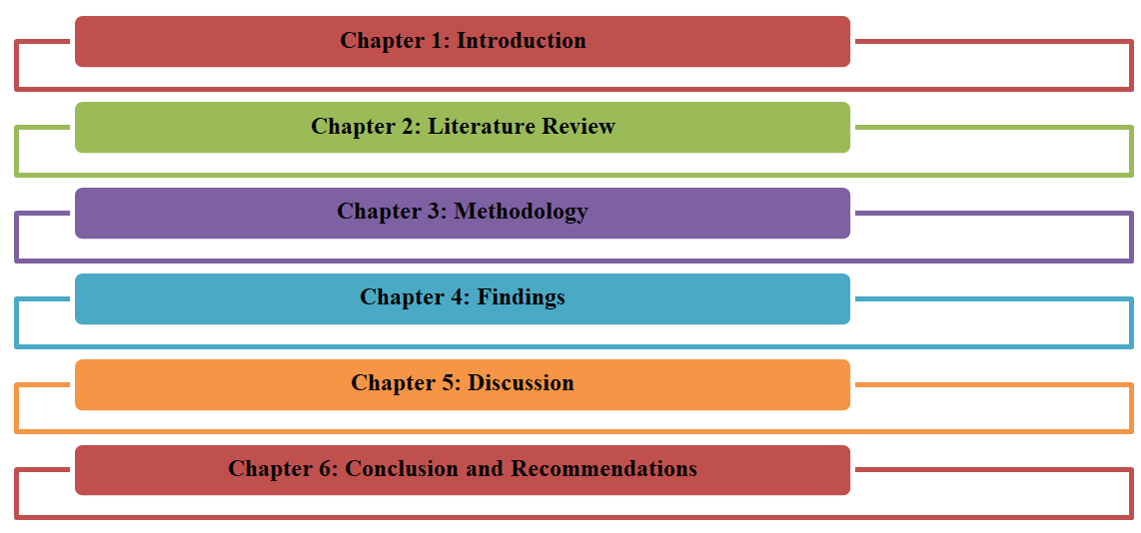

Figure 1.8: Research structure
(Source: Self-Created)

1.9 Chapter Summary
Overall, the chapter has revealed that the issue of retaining women in the UK tech industry is a massive organisational issue, and may cost the organisation, both in terms of recruiting and functioning. When there is high staff turnover in tech firms, additional funds will have to be used to hire, replace and train employees. Other factors that have been highlighted in the chapter include the fact that retaining employees is important to the innovation, productivity and overall performance of the organization. The technology forms of the UK are unable to retain their employees, which negatively impacts their organisational performance. This creates the urgency of conducting this research. Besides, a gap in the existing literature has further influenced it. It can also be seen from the discussion that the study has major significance in academic and practical organisational contexts. The scope of this study is constrained to methodological and geographic scopes.

Chapter 2: Literature Review

2.1 Introduction
The chapter will highlight some of the major workplace issues encountered by women, such as work-family conflict, unequal caregiving roles, fewer career advancement opportunities, gender biases, and workplace discrimination and how these affect employee retention. Suggested empirical research and theoretical views, such as Spillover Theory, Social Exchange Theory, and Two-Factor Theory by Herzberg, will be discussed in the chapter as well.

2.2 Concept of Work-Life Balance
According to modern literature, work-life balance does not mean an equal amount of time spent at work and at home, but it suggests the possibility of an individual performing tasks at work and at home without any difficulties. However, it remains controversial whether flexible working practices have a positive impact on work-life balance or not. Shirmohammadi et al. (2022) say the remote and flexible work options can positively impact autonomy and work-life integration because they provide employees with greater control over their time. They also find that this arrangement may cause an increase in work intensification, causing boundary blurring and work-family conflict when the demands of the organisation are kept fixed.
Likewise, Bloom et al. (2024) offer evidence that hybrid working can have a positive impact on workers' wellbeing. These can also help to boost staff retention, especially with women and those who have long commutes. The results are aligned with the positive results of flexible working arrangements, yet in conflict with other studies that have suggested a negative impact of frequent digital communication and from working from home. Women in tech are particularly in need of a healthy work-life balance as women have historically been overworked with care-giving and household duties. The lack of equal participation of women in household and care duties may play a major role in impacting their capacity to enjoy a good work-life balance (Shockley et al., 2021; Wang et al., 2021).
In technology, work-life balance is a growing matter strategic concern, especially for jobs in the field of information technology. According to Young et al. (2023), work-life balance can affect the occupational satisfaction and organisational commitment among IT workers. Therefore, more companies are striving towards ensuring a healthy work-life balance among employees.

2.3 Work-Life Balance Policies
Numerous firms have started to focus on creating policies that promote work-life balance, their aim being to gain more knowledge about the challenges they encounter when working with employees and the importance of keeping them healthy and happy. parental leave, flexible working and hybrid working is the three key pillars of this policies. There are some conflicting studies of the impact of these policies, however. Employee retention could also be positively influenced by flexible working options since it may provide the employees with a stronger sense of autonomy in their working, as Panda and Sahoo (2021) suggest. Similarly, the employee- organisation relationships can be enhanced and developed trust when the organisation can provide them with sufficient flexibilities in work (Suprayitno, 2024). This in turn can help to improve retention of female employees.
Shirmohammadi et al. (2022) found that remote working has led to work-life interference, as neither the performance expectations of the employers nor the work pressure is reduced in this format. This means that the availability of policy may not be as important as whether the employees are enjoying a real work-life balance or not; organisational culture may play a bigger role.
Other more recent evidence also shows that family support is important to aid in the retention of female professionals at work. The authors of Akhter and Mahmud (2024) argue that the long hours may cause women to experience issues at the workplace including work and family conflict. As a result, these pressures could impact their capacity or willingness to stay in their job. In conclusion, the finding that the effort of organisation as regards the work life balance and support to Family aspect is extremely important associated factors as far as retaining women in IT industry is concerned. There is also some literature to indicate that many organisations are investing in flex at work but not gender inequalities in the wider world.
In addition, organisational support programmes and employee wellbeing programmes have become significant elements of the work-life balance strategies. Ramasamy et al. (2025) argue that inclusive, diverse and supportive positive organisational climates are key to employee engagement and retention. e.

2.4 Employee Perceptions of Work-Life Balance Policies
The long working hours, insufficient time to work on the projects and the rapidly evolving technologies may present employees with a significant challenge to achieve a healthy work-life balance (Young et al., 2023). These pressures may lead to an extent of disillusionment with their job, and staff turnover by organisations in case these pressures are not successfully dealt with. Salary and promotion opportunities have been found to be an important element of employee retention in the past but recent research has begun to pay more attention to work-life balancing as an influence on whether employees want to stay in the organization or quit, particularly in the case of women ( Zumrah et al., 2022).
Panda and Sahoo (2021) have found that two out of 5 studies show the work-familiyalife balance of working employees related to their propensity to remain with the organisations. Similarly, Bloom et al. (2024) discovered that hybrid working set-ups need not affect the organisational performance but may also result in reduced employee turnover (Khan et al. 2023). The present results are another sign that having the right kind of work-life balance policies can have a direct impact on retention results.
In their argument, Ramasamy et al. (2025) stated that various organisational variables affect retention, such as workforce diversity, quality and leadership style. The findings of the literature argue that a company cannot retain employees only with good work-life balance policies if other conditions are not addressed. Therefore, companies need to focus on building a strong organisational culture that values diversity and inclusion along with developing work-life balance strategies.
Females are also facing serious challenges in retaining practitioners in the field particularly gender related experience at workplace, in the IT sector. Young et al. (2023) concluded that for women workers, balancing work and life could be more significant since they have to handle both the responsibilities of childcare and workplace discrimination. Similarly, Shah et al (2025) record extremely low tolerance of organizational practices which enable women to enjoy career development without necessarily having to shoulder the family related responsibilities.

2.5 Employee Retention
Employee retention saves organisational resources related to recruitment and training, which they can further use in other segments to improve organisational performance. Thus, employee retention has become a major concern in today’s organisations. However, the literature gives conflicting details on what the major influencing factors on retention are. Research conducted by Bolt et al. (2022) demonstrated that high-performance human resource practices such as career development, supportive leadership and employee engagement methods are effective for employee retention.
Conversely, Sang (2025) argues that employee retention is a multidimensional process where organisational and personal forces influence employees to stay in the organisation, implying that there is no single organisational practice that can be used to explain employee retention. The difference in these perceptions shows the organisation's need to have a complete picture in which the work-life balance programs are combined with larger organisational support systems. This is especially essential for female IT professionals since work-life balance is not the only factor that can affect their retention decisions, but equal career opportunities and growth also play a vital role (Sumanararathna and Samarakoon, 2019). So, the existing literature suggests that employee retention is a complex phenomenon predetermined by the combination of organisational, professional and individual factors and is not a direct result of a certain retention strategy.

2.6 Relationship Between Work-Life Balance and Employee Retention
Rani and Priya (2022) also discuss that employee turnover has been reduced, with employee satisfaction and employee productivity also positively impacted by hybrid working. The findings indicate that flexible working could be a big component of the support that employees need in order to remain in their organisations. Correspondingly, Panda and Sahoo (2021) had already determined that work-life balance has a positive effect on retention based on the psychological empowerment of the employees, and that implies that they will be ready to stay in organisations that are trustworthy and flexible.
The effectiveness of work-life balance is often questioned, as some of the studies have argued that it is not only adequate to retain employees in an organisation. Ramasamy et al. (2025) outline that organisational climate and workforce diversity are more influential in employee retention as compared to flexible working arrangements. This finding is unlike other sources that have put flexibility on the centre stage of the retention mechanism. On the same note, Shirmohammadi et al. (2022) have found that remote working can decrease turnover intentions in favourable organisational settings. These contradictory results indicate that there is an indirect effect of work-life balance policies that is mediated by certain factors, including organisational support, wellbeing and job satisfaction (Bahar et al., 2022). On the other hand, Young et al. (2023) believe that the opportunities for career advancement and professional recognition impact the levels of occupational commitment as well. Hence, it can be said that although effective work-life balance needs to be the main priority of an IT organisation, they need to also emphasise offering equal career opportunities and creating a positive organisational culture.
Job satisfaction is another aspect that has been identified to be a major predictor to the intentions of employees to stay in the workplace. According to Bloom et al. (2024), enhancing work-life balance has a beneficial impact on employees' satisfaction. This increase in satisfaction may be short-lived however, if the work load and stresses experienced at work are problematic, then this can be a short-term comfort, as highlighted by Wang et al (2021). Therefore, the work-life and employee turnover were investigated to achieve positive outcomes and it was not necessarily and robust (Suprayitno, 2024).

2.7 Female IT Professionals and Workplace Challenges
Some sources indicate that although there is a growing concern about gender diversity, women continue to be underrepresented in most technical jobs in the UK. Researchers have given their opinions about the major contributors to female attrition are. According to Young et al. (2023), some of the most important occupational conditions that lessen the occupational commitment of female professionals in the IT sector are the workloads and lack of work-life balance. Gifford (2022), on the other hand, suggests that structural gender inequalities, such as excluding women from career growth and promotional opportunities, create dissatisfaction among them and contribute to poor employee retention rate. This opposition implies that the issues of female retention cannot be viewed only in terms of work-life balance issues, but should be researched in the context of the broader organisational and cultural aspects (Shockley et al., 2017).
Women workers often have challenges to combine their family and work duties. The inequitable distribution of household work creates a much greater work-family conflict for women, and may have negative consequences on employee health and career stability (Shockley et al., 2021). The same applies to greater flexibility to work - these types of working do not always result in a reduced number of responsibilities on a carer, family member or work load in the professional sphere (Wang 2021). These results dispute previous beliefs stating that flexible work arrangements have an automatic positive effect on employee experiences. Flexibility will be more autocratic, yet it can be associated with role overlap and burnout. Consequently, the new study is slowly but surely demonstrating that the performance of any work-life balance program lies in how organisations manage their workload expectations and not only the issue of offering flexible work approaches (Sumanarathna and Samarakoon, 2019).
Career progression barriers are also issues that would assist in retaining female IT professionals. Guardian community team (2025) found that women are yet to see their way up to the top of the leadership ladder as compared to their male counterparts despite their equal performance. On the other hand, Begeny et al. (2020) say that organisational stereotypes regarding technical competence are often barriers to career progression compared to formal promotion systems. This difference matters since it implies that the issue of retention is not only related to the policy constraints but also to the organisational cultures that still uphold the masculine career norms (Sang, 2025).

2.8 Factors Influencing Retention Decisions Among Female IT Professionals
Equal opportunity for career development is of paramount importance. Nair et al. (2021) discovered that the lack of promotion opportunities is a key factor that makes women leave organisations. On the other hand, Sam et al. (2024) say that occupational commitment is enhanced when employees have a sense of evident professional growth opportunities.
It has received a great academic interest in quality leadership and managerial support. Gifford (2022) also discovered that the importance of supportive leadership leads a company to maintain transparency and fairness. According to Young et al. (2023), employee satisfaction and retention are low where organisational cultures encourage gender stereotypes. Further, the importance of compensation, rewards and workplace culture have also been highlighted in the existing literature. Although the classical theories of retention focus on monetary rewards, Ramasamy et al. (2025) show that inclusive workplace cultures have a more impactful influence on retention as compared to compensation.
However, Xu (2022) discovered that family needs still remain a larger factor in determining the career choice of women than men. Hence, it is evident that effective work culture, gender equality, and career opportunities would be in vain if work-life balance opportunities are not offered to female IT professionals. Conversely, Begeny et al. (2020) note that the preference for work-life integration has significant differences among different individuals, and it follows that a certain organisational policy might not meet the needs of every employee.

2.9 Employee Perceptions of Work-Life Balance Policies
According to Bloom et al. (2024), employees have a positive attitude towards hybrid working arrangements due to their flexibility. But Shirmohammadi et al. (2022) reported that hybrid work blurs the boundaries between work and family life for the growing expectations of availability from the parts of the employers.
Shah et al. (2025) discovered that female workers who feel that the organisation is genuinely concerned with the welfare of its staff are more contented with their occupation and devoted to the organisation. Further, career sustainability highly depends on work-life balance perceptions. The findings of Young et al. (2023) suggest that employees who experience organisational support are more engaged with their professional duty. Nair et al. (2021) stated that women continue to believe that there is still a huge gap in work-life balance in spite of the availability of flexible working options.
The consistency of application of policies across the departments and groups of employees is also a factor in employee perceptions. The policies can be viewed as unfair or unpredictable to workers when there are differences between teams or when the level of discretion is high. It can cause a fall in trust in the organisation even if there are formal policies in place that are supportive. It is thus crucial that the policy should be put into practice and not merely being in place.
The other important one is the level and type of employee control of their working arrangements. Where feasible, employees will be more accepting towards any change in their work schedules, make their own appointments or work at home where necessary. This autonomy will aid in minimizing work and personal life conflicts, and may lead to an increased degree of overall motivation. Conversely, policies that are limited and complicated to access may seem like symbolic than supportive.
Communication also impacts employee perceptions. The confidence in work-life balance arrangements will be increased by good communication on the eligibility, expectations and support available. When the staff expectations are clear and the management is responsive to the needs of the staff, it may be more comfortable to the staff. Hence, it is more likely that positive perceptions will be propagated in workplaces with flexible, available and consistent work-life balance policies and where work and personal needs are valued in the workplace culture.

2.10 Theoretical Framework
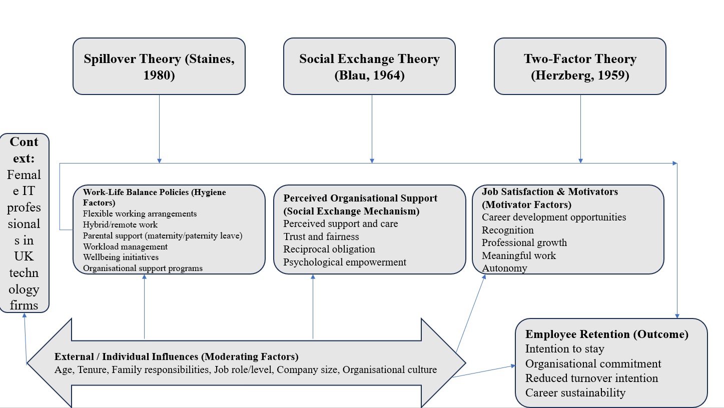

Figure 2.1: Theoretical Framework
Source: Self-developed
One of the theories is the Spillover Theory that suggests that experiences in one aspect of the life of a person may spill over to another aspect of his life and affect his experience or performance. Too many demands, for instance, can have a negative effect on family life; it can cause stress, employee dissatisfaction and decrease employee well-being. But, supportive work-life balance policies can positively spill-over by helping employees be supportive of their personal and work lives (Audretsch et al., 2025). Such favourable outcomes can consequently translate into an increased commitment to the organisation and reduced turnover.
Another reason for employee retention is the Social Exchange Theory of employee retention. According to this theory, employees who believe that organisational support is achieved via flexible working arrangements, parental leave, and wellbeing programs. For instance, when female employees get these benefits, they feel compelled to return the favour to the company by being loyal, committed and working in the organisation. Recent research has suggested that the organisational support score is the lowest among companies which has low retention rate (Wallenburg and Handfield, 2022). This suggests a mutual relationship between employee retention and organisational support.
The Two-Factor Theory of Herzberg divides the factors into hygiene and motivator factors. The hygiene factors may also include work-life balance policies, flexibility of working arrangements, and supportive organisational practices since they will reduce dissatisfaction. Meanwhile, the motivator factors, such as career advancement, recognition and professional development, may be implemented in the meantime, which will result in an increase in satisfaction and retention (Ibrahim et al., 2023).
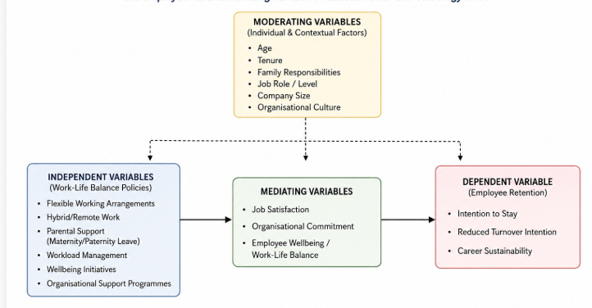

Figure 2.2: Conceptual Framework
Source: Self-developed
The conceptual model combines these theories by hypothesising that work-life balance policies have an impact on employee retention. The flexible working arrangements, hybrid work, parental support and organisational wellbeing initiatives are the independent variables, and employee retention is the dependent variable.

2.11 Research Gap
The issue, though, is being discussed whether work-life balance policies can be considered to have a distinct effect on the explanation of employee retention results. The factors highlighted below are thought to be more significant in determining a person's decision to stay on with an organisation in the studies cited above: Opportunities to, and support in, career development and leadership; organisational culture; and workplace flexibility (some studies).
A significant limitation of the previous studies is that they have dealt with large groups of employees as opposed to female IT professionals. Besides, much of the available evidence is not UK-based, such as Asian and North American studies, and this limits its extension to UK technology firms. Even the current literature is inclined to consider work-life balance or retention separately (as opposed to considering them through the lens of interdependence between them) (Rani and Priya, 2022). Moreover, little research has been done that has utilised a mixed-methods approach to quantitative and qualitative relationships.

2.12 Chapter Conclusion
In this chapter, the literature on work-life balance, employee retention and experiences of female IT professionals has been discussed critically. The analysis has identified necessary concepts, theoretical stances, research and findings gaps.

Chapter 3: Methodology

3.1 Introduction
The methodology chapter is crucial, which helps to explain a researcher about how data were collected and analysed for the research. The methodologies were chosen according to the objective and aim of the research.

3.2 Research Onion Framework
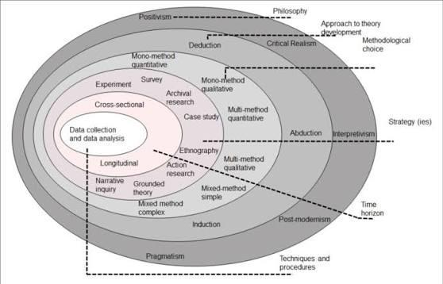

Figure 3.1: Research Onion Framework
Source: Saunders et al., 2019
The model developed by Saunders et al. (2003) is the Research Onion that has gained popularity as a research design organization. The model is made up of 6 layers i.e. research philosophy, research approach, method, research strategy, time horizon and research techniques and procedures as represented in the above figure. The framework is used to provide methodological decisions made by researchers with structure and transparency. This transparency can help to build up the credibility and reliability of the research in total as each methodological choice will be linked to the aims and objectives of the research.

3.3 Research Philosophy (Research Onion Layer 1)

3.3.1 Pragmatism Philosophy
This study employed the pragmatism research philosophy, as the researcher did not want to limit the research philosophy to either interpretivism or positivism. By combining this particular philosophy, the researcher includes both the strengths of positivism and interpretivism.
Justification
Mixed methods research requires both objective and subjective knowledge (Saunders et al. 2003). Thus, employing pragmatism philosophy is essential that includes both objectivity (positivism) as well as subjectivism (interpretivism). This philosophical approach allows researchers to draw findings both from observation of statistical results as well as human experiences. It helps in reviewing topics through both qualitative and quantitative approaches. This suggests an in-depth evaluation of empirical as well as theoretical data. Thus, pragmatism seemed suitable as it enabled the merging of quantitative and qualitative evidence into solving the research problems in a suitable manner (Creswell and Clark, 2017). Considering all these benefits, the researcher has employed pragmatism research philosophy.

3.4 Research Approach (Research Onion Layer 2)

3.4.1 Deductive Approach
The study followed deductive approach that starts with a theory and leads towards the development of hypotheses.
Justification:
It is a significant research approach that is applied to evaluate quantitative data such as responses from surveys in order to get significant details regarding research topic. The data that has been obtained through survey responses and would be further supported by qualitative data (interviews). The synthesis of both methods has helped in gaining a detailed understanding of the importance of work-life balance among female employees in technological firms in the UK (Sharma et al., 2023). It has allowed researcher to review different theories related to employee satisfaction and the working structure of organisations. Theories used for the study were Staines' Spillover Theory, Blau's Social Exchange Theory and Herzberg's Two-Factor Theory. The results of statistical tests conducted on survey results would lead the researcher to test the assumptions made in the mentioned theories.

3.5 Research Methodological Choice (Research Onion Layer 3)

3.5.1 Mixed Methods Research
Study was a mix of quantitative and qualitative research approaches as the quantitative as well as qualitative methods of data collection were used.
Justification
A mixed methods approach would enable the researcher to have an insight into the research problem in both quantitative and qualitative horizons, and it will help to gain a deeper insight into the topic. Thus, the quantitative and quantitative evidence will provide for a general and in-depth interpretation of the research problem. Qualitative interviews were employed to explore in greater detail the experiences of these participants and their organisation's practice. Both of these were employed, and they helped with methodological triangulation and methodological validity/credibility of findings (Creswell and Creswell, 2017). Both approaches have provided significant support in understanding the importance of work-life balance within female IT professionals in the UK.
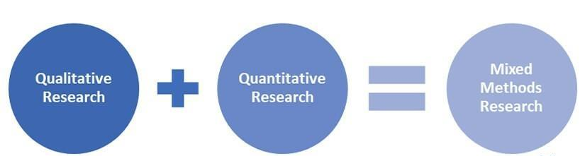

Figure 3.2: Mixed Methods Research
Source: Self-developed

3.6 Research Strategy (Research Onion Layer 4)

3.6.1 Survey Strategy
The technique for quantitative part of the study was a survey and the data was collected from an online questionnaire that was developed on Google Forms. The systematic elicitation of the views of the participants on the work-life balance in a contemporary organisational environment was done through a closed-ended questionnaire (Taheri and Okumus, 2024). It is on the basis of this that the researcher used a closed form of question that would give structured and similar responses. The questionnaire also contained a five point Likert scale that was to be used to determine the level of agreement/ disagreement that the participants had with the statements contained in the survey.

3.6.2 Semi-Structured Interview Strategy
A semi-structured interviewing technique was used to conduct interviews with the female managers (IT and HR) in the virtual environment of Zoom. The data were gathered by using open-ended questions (excluding the survey questions) also provided information regarding the work-life balance and organisational practices in their organisations, adding to the information provided through the survey (Bryman, 2016).

3.7 Time Horizon (Research Onion Layer 5)

3.7.1 Cross-Sectional Research
It was conducted in a cross-sectional time horizon in which data were collected once (the dissertation) during months 4-6. A cross sectional design was considered appropriate as the researcher willing to determine the existing perceptions of the policies that support work-life balance and their connection with work-related outcomes of retention within the timeframe of the available research. According to Saunders et al (2003) the cross-sectional study is appropriate for the researcher's desire to study a specific phenomenon at one specific time.

3.8 Research Techniques and Procedures

3.8.1 Target Population
The target audience was female IT staff working in technology businesses throughout the United Kingdom and HR managers tasked with creating and executing work-life balance policies and programs, such as flexible working, hybrid working, maternity support and workload management. The main focus of the study was on female IT professionals, as they were the ones who had first-hand experience of the work-life balance practices implemented in the organisation and their impact on retention. HR managers were involved to provide the organisation with a view on developing and implementing these policies. The inclusion criteria were: being aged 18 or older, employed in a technology organisation in the UK and having 1 year or more of professional experience in technology. HR Managers had to be directly involved in employee well-being and/or work-life balance. The criteria chosen allowed the participants to provide relevant and reliable information for the research, which was being used to fulfil the aims of the research (Saunders et al., 2003).

3.8.2 Sampling Technique
Quantitative Sampling
Purposive sampling and snowball sampling were used in the quantitative phase. Using purposive sampling enabled those who fulfilled the set criteria and had first-hand knowledge of policies relating to work-life balance in technology companies in the UK to be identified as the respondents for the study. To create a comprehensive sampling frame of female IT practitioners, snowball sampling was then adopted – initial respondents recommended other IT practitioners who satisfied the criteria that were in their professional network. The use of this combination of sampling techniques made participants more easily accessible and ensured that the respondents were pertinent to the research goals. Saunders et al. (2003) believed that 150 female IT professionals were sufficient and meaningful to be used for descriptive statistics, correlation analysis and multiple regression analysis, as well as for statistical power to interpret the results. The selection of this sample size is sufficient to understand the perspective of female employees, as it suggests a standard sample size has been chosen for careful observation.
Qualitative Sampling
In the qualitative phase, purposive sampling was employed to discover and choose those who have a great deal of information and experience about the work-life balance (WL) practices in the organisation. The 10 participants (IT professionals and HR managers) were selected for a semi-structured interview. The small sample size allowed the researcher to collect rich, detailed and information-rich data that could be explored in detail and gain insight into the experiences of the participants. A purposive sampling method was used in this study and is not a statistically representative sampling method, but rather is a sampling technique that emphasises information richness (Creswell and Creswell, 2017). The use of this sampling technique is significant, especially in qualitative research. This is because it is very important to select the sample size very carefully in this type of research, where the depth and authenticity of data are important for critical review of the research topic. However, there is also a limitation of purposive sampling, as it might lead to the development of bias within the study, as the author might only focus on addressing the research objective rather than making findings authentic for future academic researchers.

3.8.3 Data Collection Methods
Questionnaire
The main data were quantitative data obtained using a structured online questionnaire, which was developed using Google Forms. The online version enabled the data to be collected efficiently from the respondents across a variety of geographical areas in the United Kingdom, and also minimised the time and administrative burden. Most of the questions were evaluated using a 5-point Likert scale, and closed-ended and multiple-choice questions were used to collect demographic data. The questions were standardised to ensure uniformity of responses and to make it possible to compare the responses of each of the participants with those of others. In addition, Google Forms also generated an automatic spreadsheet of the responses which could easily be exported to SPSS for further statistical analysis (Saunders et al., 2003).
Semi-Structured Interviews
Semi-structured interviews were used to gather qualitative data using Zoom technology. The interviews lasted about 40-60 minutes in order to allow the participants an adequate amount of time to provide their stories in detail. The open-ended questions used to create the interview schedule focused on: work-life balance experiences, organisational support experiences, career development experiences, workplace issues, flexible working experiences, maternity support experiences, workload and staff retention experiences. The semi-structured approach allowed for consistency of the interviews, but allowed for exploration of areas of interest that arose. This latter method, along with the quantitative findings, gave context to the quantitative findings and helped with triangulation of the methods (Hair et al., 2019).

3.9 Measurement of Variables
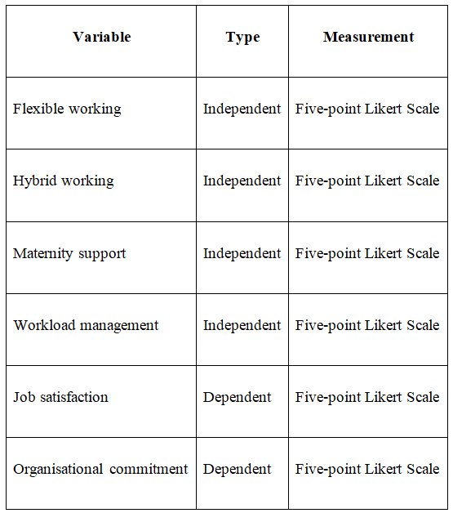

Table 3.1: Measurement of Variables
Source: Self-developed

3.10 Data Analysis Techniques

3.10.1 Quantitative Data Analysis
The data have been analysed in a quantitative manner using IBM SPSS Statistics. All responses were coded and edited for missing data, data entry errors and incomplete responses. Frequencies, percentages, means, and standard deviations were used to describe the demographic information and participants' perceptions of the work-life balance policies. Pearson correlation was then used to see the direction and strength of the relationships between the independent and dependent variables (Field, 2024). Finally, four flexible working variables in the current study flexible working, hybrid working, maternity support and workload management were included in multiple regression analysis to study the percentage of variance of the three employee retention outcomes (satisfaction with the job, commitment to the organisation and intention to stay) explained by the flexible working variables.

3.10.2 Qualitative Data Analysis
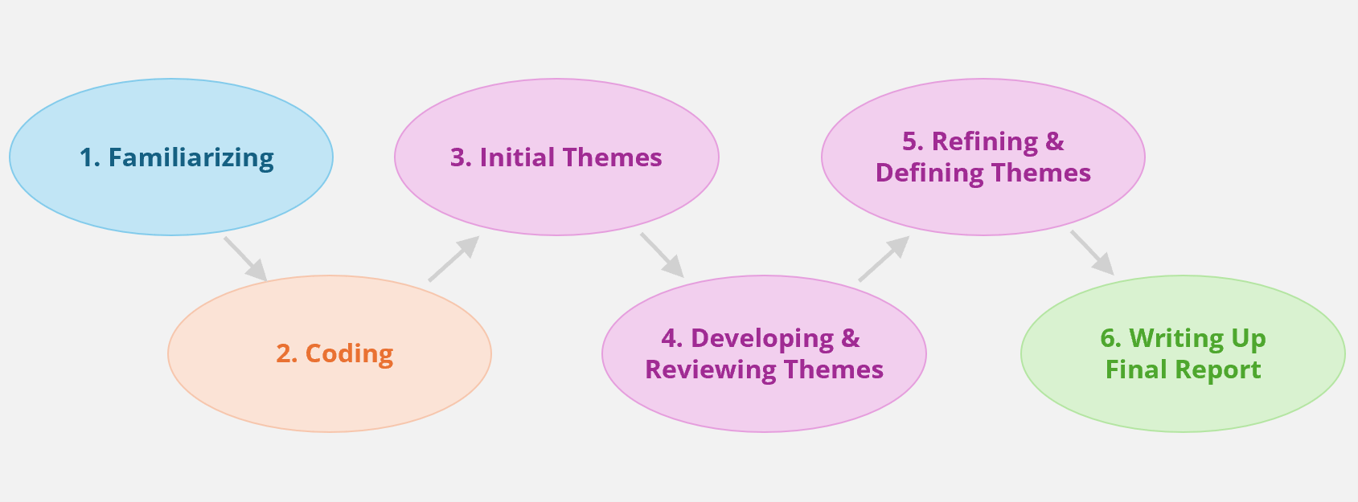

Figure 3.3: Thematic Analysis
Source: Self-developed
The information obtained from the qualitative interviews was later manually analysed following the six stages of the thematic analysis method (Braun and Clarke, 2006). The transcripts of interviews were read several times to familiarise oneself with the data. Meaningful sentences were then provided with initial codes, and these were then grouped into broader categories. Later, the possible themes were grouped into code groups, and themes were discussed and edited into logical and consistent themes. Each theme was then matched, and a suitable name was chosen for each theme and finally put in the overall analytical report.

3.11 Reliability and Validity / Trustworthiness
Cronbach's alpha coefficient was used to determine the reliability of the questionnaire. A cut-off point of above 0.70 was deemed acceptable as the cut-off point of internal consistency. One of the most commonly used homogeneity indices to establish the homogeneity of the measurement items in a quantitative study is Cronbachs alpha. Construct validity was treated by using measurement scales which were developed from previous studies.

3.12 Ethical Considerations
All work was done ethically and with appropriate ethics committee approval at the University. This study was carried out on the basis of ethical principles of the university and the General Data Protection Regulation (GDPR). The nature of the study was explained to participants, informed consent was obtained, and participants were able to leave if they wished. Confidentiality and anonymity were maintained, except when the participant permitted interview recordings; electronic data were kept on devices with a password and destroyed at the end of the University's retention period (Bayramova and Edwards, 2026).

3.13 Chapter Summary
In this chapter, the research philosophy employed was a deductive approach. Mixed methods design, research strategy employed, sampling technique, data collection technique, data analysis technique, reliability, validity and ethical issues were discussed. These methodological options were found to be a good basis for this study.

Chapter 4: Findings

4.1 Introduction
Work-life balance policy is necessary because it can ensure consistent motivation or work satisfaction among employees, which positively impacts employee retention rates. Therefore, the main focus of this chapter is to clearly represent the impact of work-life balance policies on employee retention. In order to test the theoretical assumptions, various statistical tests such as descriptive statistics, correlation, regression, Cronbach's alpha, and frequency will be performed based on the survey results. Further, interviews will also be conducted based on the results of thematic analysis.

4.2 Findings from Statistical Tests

4.2.1 Frequency
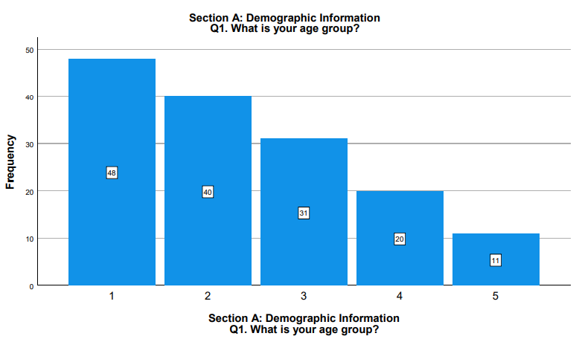

Figure 4.2.1.1: Age Group
The age distribution of the respondents' 150 is shown in Fig. 4.2.1.1. Age group 18-25 years and age group 26-35 years have their proportion of respondents as 48% and 40% respectively. A further 31% are 36 to 45 years and 20% are 46 to 55 years.
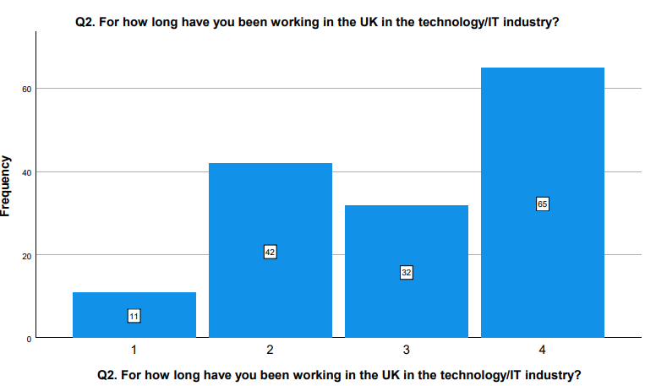

Figure 4.2.1.2: Work Experience of Participants
The above Figure 4.2.1.2 shows that, among 150 respondents, 42% of participants have 4 to 6 years of work experience within the IT industry. Further, 65% of participants have more than 10 years of experience. It can be seen from this information, it is clear that participants have enough experience to explain the significance of work-life balance policies within the organisational culture.
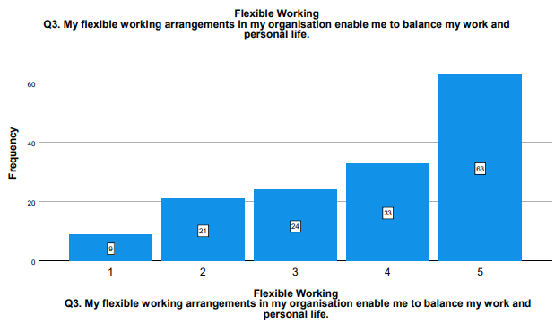

Figure 4.2.1.3: Flexible Work Arrangement
Figure 4.2.1.3 shows that 33% to 63% strongly agree that flex options help them to balance their work and personal life. The result corroborates with Panda and Sahoo (2021) who pointed out that flexible work arrangement can have positive effect on psychological empowerment and work productivity of employees. But one in five of these respondents is not in agreement with this statement.
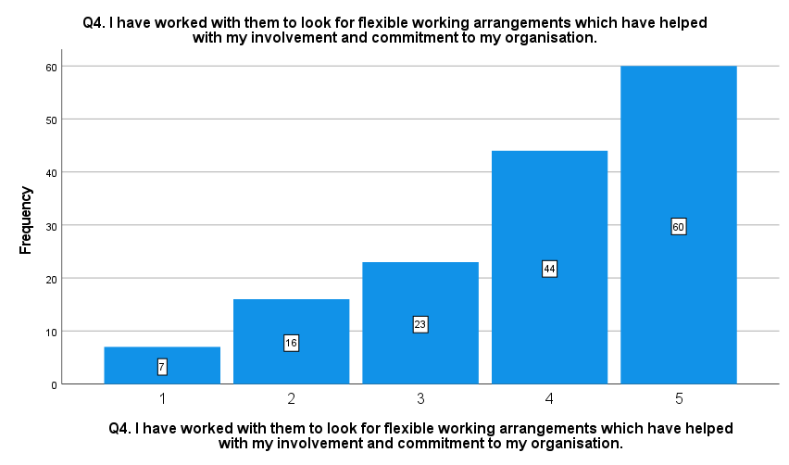

Figure 4.2.1.4: Flexible Work Arrangement Promotes Commitment
Figure 4.2.1.4 showed that 44% - 60% of the respondents stated that flexible working has made them more involved with their organisations. In that aspect, Ramasamy et al. (2025) agrees flexible work can possibly play a role in creating a positive work environment that can be linked to enhanced employee engagement. However 16% of the respondents disagreed.
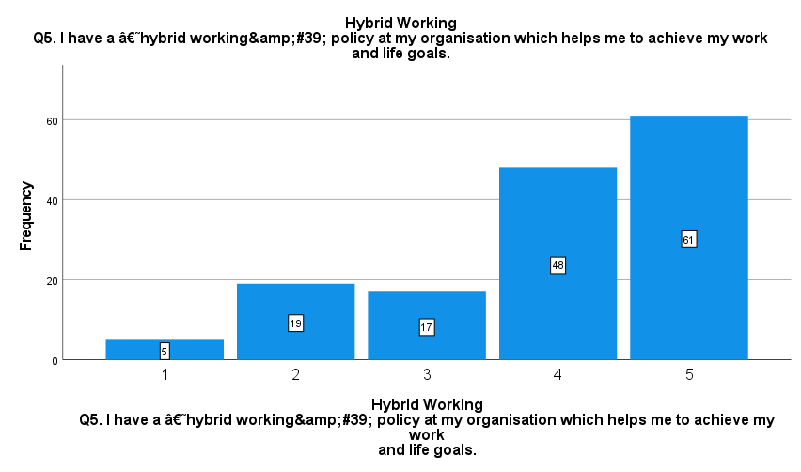

Figure 4.2.1.5: Hybrid Work Helps in Achieving Life Goals
Regarding the question of whether hybrid work helps in achieving life goals, Figure 4.2.1.5 highlights that 48% to 61% of participants agree that the hybrid work model helps in achieving life goals. Bloom et al. (2024) also demonstrate that hybrid working arrangements positively contribute towards the high retention. However, 19% of participants disagree with it.
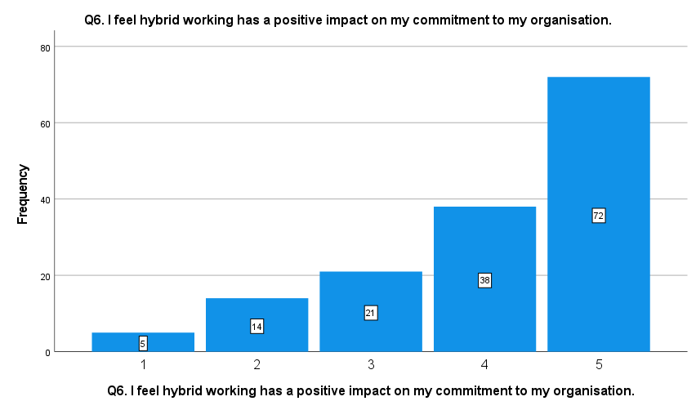

Figure 4.2.1.6: Hybrid Working Model’s Impact
Most of the respondents (72) who answered the question on commitment of the organisation stated that their commitment to the organisation has gone up since adopting a hybrid working model with 36% of them disagreeing. Ramasamy et al. (2025), also mention that hybrid working models can help achieve increased diversity and equality of the workforce.
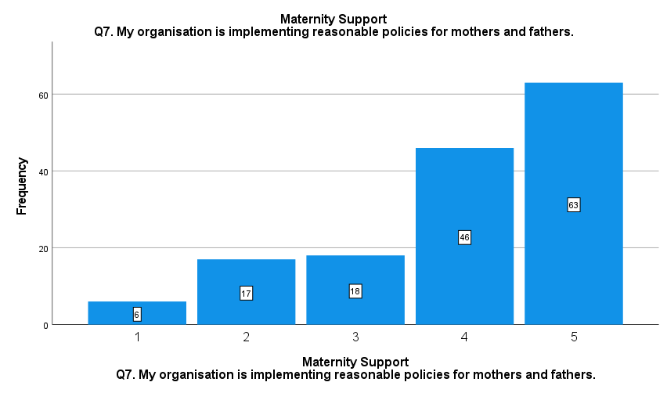

Figure 4.2.1.7: Reasonable Policies for Mothers
The results also show that 46 to 63 percent of respondents say that their companies have implemented "reasonable" workplace policies for mothers. But 17% of the respondents do not agree with this statement.
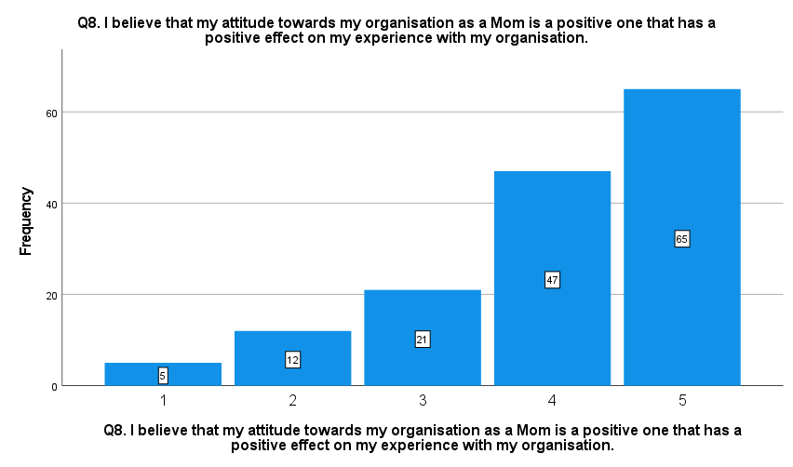

Figure 4.2.1.8: Impact of Responsible Work Policies for Moms
Based on the results shown in figure 4.2.1.8, it can be inferred that 47% to 65% of the respondents think that the responsible workplace policies has direct positive impact on employee attitudes. In comparison, 12% of the respondents are opposed to this statement.
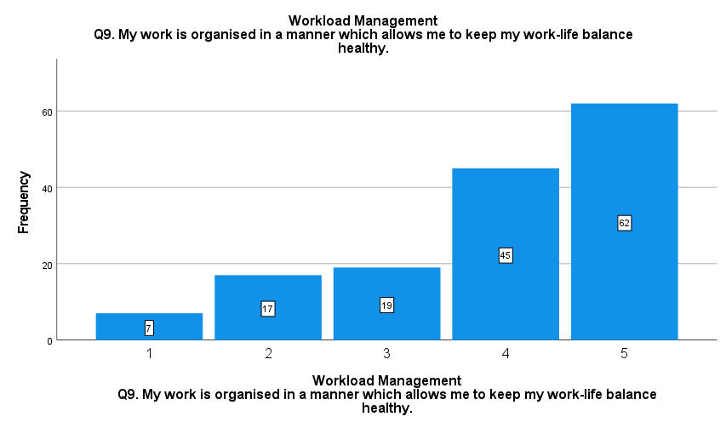

Figure 4.2.1.9: Work-life Policies Help in Workload Management
As illustrated in Figure 4.2.1.9, 45% - 62% of the respondents think that work-life balance policies are adequate for managing and reducing workload within the organisation. But 17% did not agree that work-life balance policies can help to reduce workload.
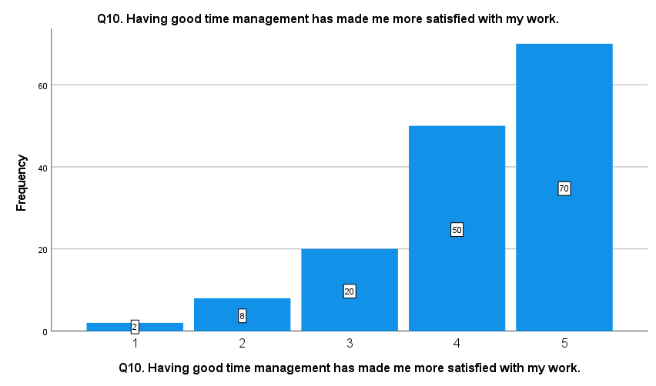

Figure 4.2.1.10: Work-Life Balance Promotes Time Management
It is found from the above figure that 70% strongly agree and 50% agree that good time management practice is important as it contributes to their job satisfaction. However, the above result also indicates that 8% of participants disagree.
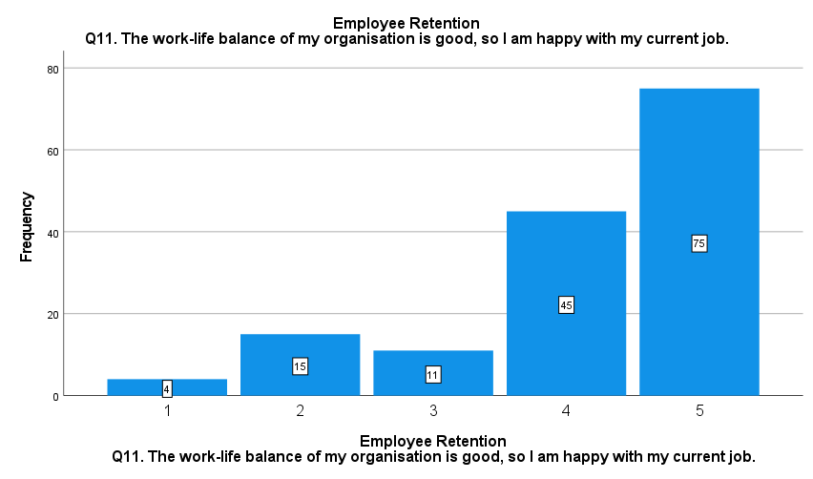

Figure 4.2.1.11: Work-life Balance in Organisations
It can be seen from Figure 4.2.1.11 that most of the participants, 75%, strongly agree that they are happy with their current job as it offers good work-life balance opportunities. 45% of the participants have also agreed on this matter. However, only 15% of participants disagree that their organisations do not offer good work-life balance.
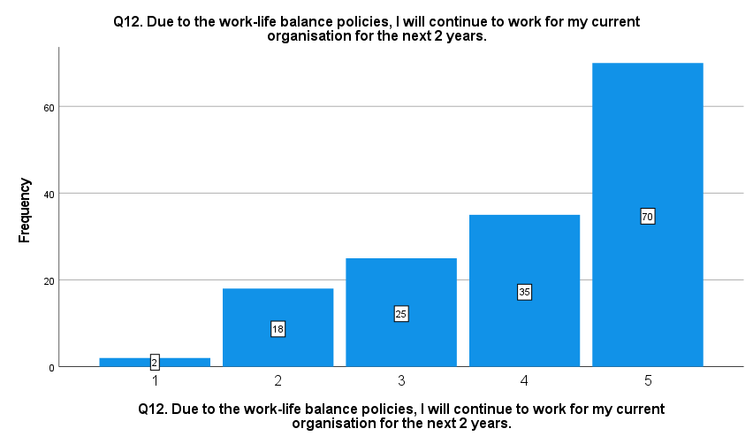

Figure 4.2.1.12: Impact of Work-Life Balance Policies on Employee Commitment
The above Figure 4.2.1.12 indicates that 35% to 70% of participants agree that, due to sufficient work-life balance policies, participants will stay within their organisation for the next 2 years. However, 18% of participants disagreed that they will not stay within their organisation for the next 2 years.

4.2.2 Descriptive Statistics
According to Siregar (2025), descriptive statistics are used to present and summarise the dataset. The measures of descriptive statistics include standard deviation, mean, and median.
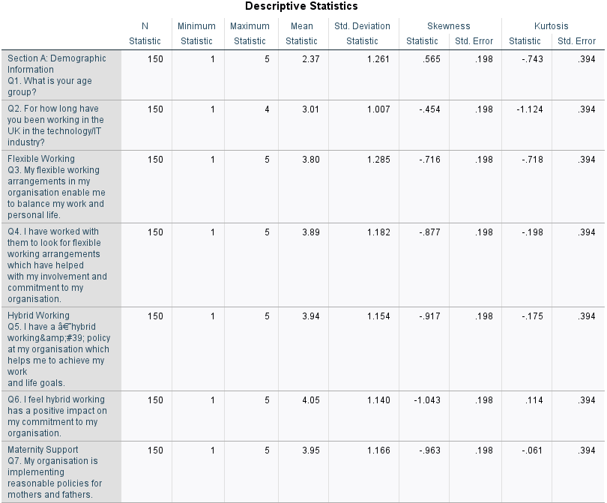
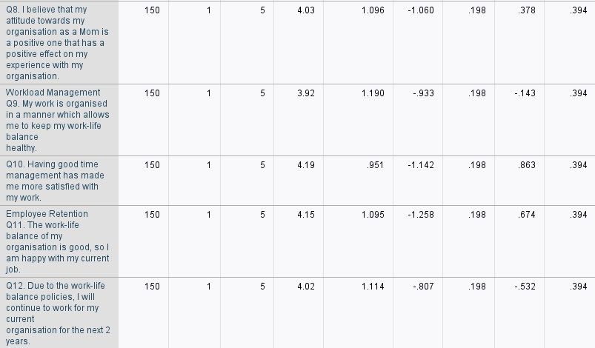

Figure 4.2.2: The results of descriptive statistics
The descriptive statistics indicated in Figure 4.2.2 reveal that the total number of the participants was 150 (N=150). The average scores were between 3.01 and 4.19, which means that on the whole, the employees have a positive attitude to work-life balance. The results also show that the satisfaction with time management and flexible working arrangements imply a score of 4.19 and 3.80 respectively. These results suggest that those organisational practices that provide greater flexibility in terms of time and the manner in which they work are some of the practices that are significant to the respondent.
. These high mean scores suggest that the female employees in the UK’s technology organisations are satisfied with time management and flexible working condition offer by their companies. The mean score of work-life balance is 4.15, which indicates that female IT professionals are happy with their work-life balance. Further, the mean score of 4.02 for good work-life balance and employee retention denotes that, due to good work-life balance, female IT professionals want to stay in their companies for the next 2 years. The Standard Deviation (SD) score of work-life balance perception and employee retention is 1.095 and 1.114, respectively, which suggests diversification in employee perception.

4.2.3 Correlation Test
It is argued that the correlation test helps to explain the relationship between two or more variables (Ali Abd Al-Hameed, 2022). In this case, the correlation between work-life balance and retention rate is portrayed with this particular test.
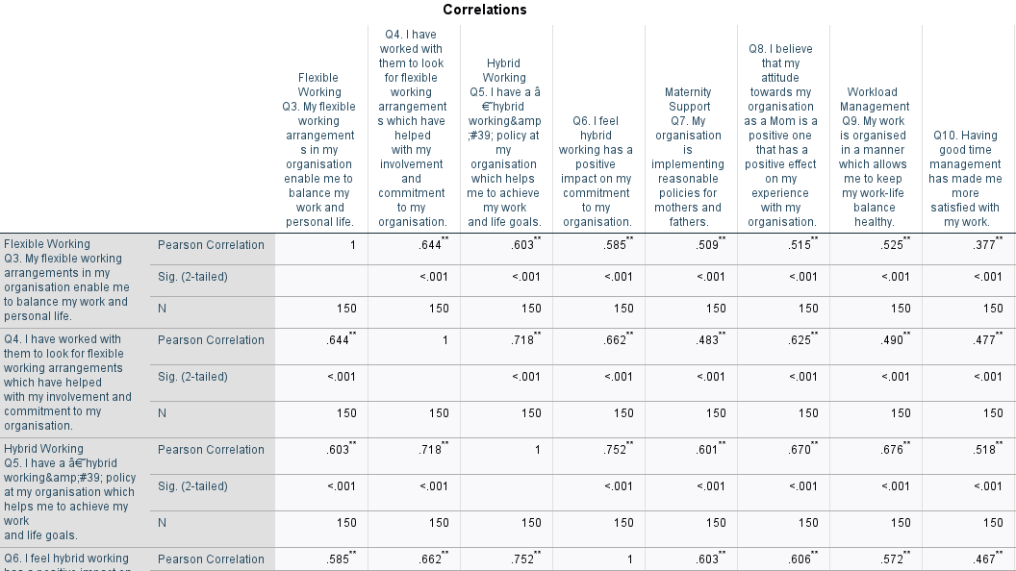
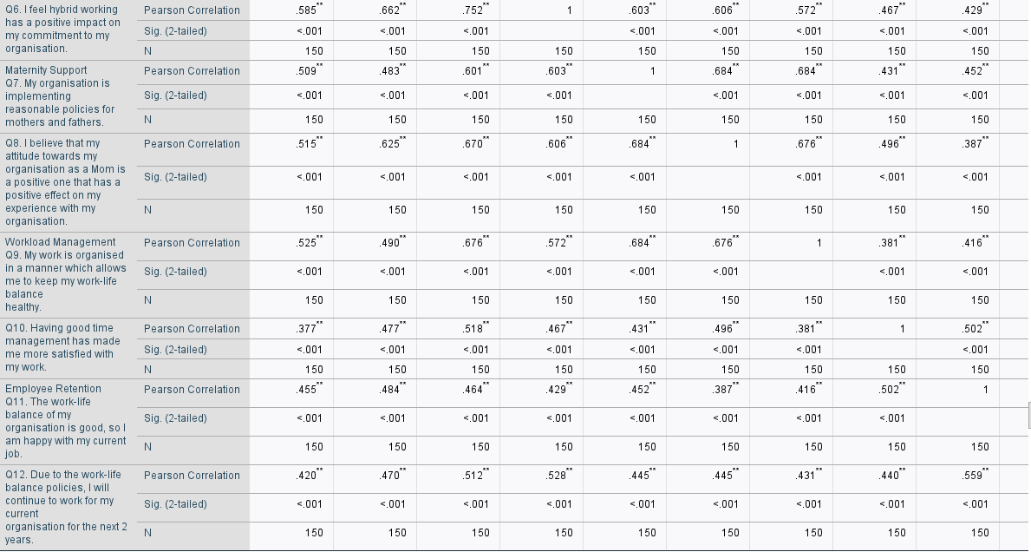

Figure 4.2.3: The result of correlation test
It is found from Figure 4.2.3 that most of the variables are positively correlated. For instance, the correlation between flexible working and hybrid working is .603. This indicates a moderate positive correlation. It means that female employees think that hybrid work arrangements offer flexibility in their work. This test also confirms that a positive connection is found between maternity leave and flexible working arrangements. On the other hand, work-life balance is also positively correlated with maternity support, which results in .445. It is also obtained from the above figure that the correlation between workload management and hybrid working arrangement is .676. It also depicts that flexible working conditions improve employee retention, resulting in .455. On the other hand, a positive correlation of 0.509 is observed between maternity support and flexible working. It signifies the fact that maternity support improves work flexibility. Moreover, the correlation analysis highlights a positive correlation between workload management and employee retention.

4.2.4 Regression Test
This is one of the most significant statistical tests that helps to understand the relationship between independent and dependent variables.
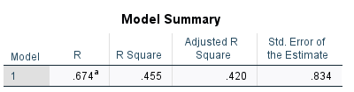
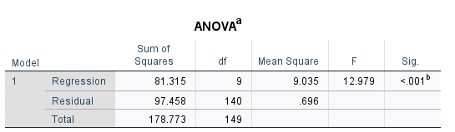

Figure 4.2.4: The result of regression test
Figure 4.2.4 presents an R value of 0.674 and an R-squared value of 0.455. This implies that the independent variables used in the model account for about 45.5% of the variation of employee retention. This can be attributed to factors including maternity leave and flexible working hours, in particular. Further, the value of adjusted R-squared is .420, and the STD error value is .834. Therefore, it can be stated that the results of this test are reliable as well as accurate. It is also obtained from the results of the ANOVA test that the p-value is .001, which is <0.05. This means that the test is statistically significant and the predictors create a positive impact on the employee retention rate.

4.2.5 Cronbach's Alpha Test
This test holds relevant importance for measuring internal consistency within datasets of survey. This means the standard value of this test provides support to maintain the reliability of datasets that are used in statistical tests.
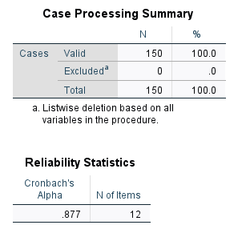

Figure 4.2.5: The result of Cronbach's Alpha test
As shown in Figure 4.2.5, the Cronbach's alpha value of the instrument is .877 which is greater than the acceptable value of .70. As a rule, the Cronbachs alpha value that will indicate acceptable internal consistency will be over 0.70. Hence, the value arrived at in this study indicates that the data collected in this study has a high level of reliability to support the quantitative obtained in the study.

4.3 Findings from Braun and Clarke's Thematic Analysis

4.3.1 Theme 1: Hybrid and flexible working conditions
Familiarisation
As the interview transcript was read several times, it was identified that both the IT professional and HR managers mentioned flexibility and hybrid work arrangements. It is revealed that while some of the organisations provide flexible working conditions to their employees, many have restricted this.

Coding
The key codes that have been generated include flexible work arrangements, hybrid working conditions, department-specific hybrid work, and several others.
Initial theme
There was a positive attitude towards flexible and hybrid working. Flexible and remote working has been a key to staying in the organisation as it has helped them care for their children and home, said IT Professional 5. It implies that retention and the work-life balance could be enhanced through flexible working.”
Develop and review the theme
In this stage, the theme has been reviewed, and it is noticed that flexible work is missing, which is one of the most important codes found in the interview. Therefore, this keyword is also added to the theme.
Refine the theme
Finally, by refining, the theme has been refined, and the name of the final theme is “hybrid and flexible working conditions”.
Final report
It is obtained from the interview results that most of the technology companies in the UK offer hybrid working facilities to their employees. For instance, the first participant stated that “Yes, my organisation has undertaken certain steps to facilitate work-life balance”. The second participant said that “Yes, work-life balance is slightly improved as my organisation has recently introduced hybrid working option; now we need to come to the office on 2 days a week and the rest of the days we can work from home.” As discussed by Sun et al. (2025), hybrid work has a significant impact on employee performance, engagement, and work motivation to the employees. The hybrid working condition is well-aligned with the needs of female employees, as they need to balance both their professional and personal responsibilities, unlike most of the male employees in companies. Only some of the companies do not provide such opportunities to their employees, which makes them feel stressed and frustrated. It also makes them think about leaving the organisations. This is backed up by a report by the United Nations (UN) which has reported that 52% of women want flexibility in their employment (unwomen.org, 2025). The evidence combined with the findings of the interviews indicates that the flexible and hybrid working practices are perceived as advantageous to the women since they allow them to have greater control over balancing between working and personal life.
A lack of supportive leave policies can affect gender equality, where maternity and parental leave policies are concerned, and can make women more likely to manage childcare responsibilities on top of other commitments and can tempt them to leave their organisation in case of their absence. Bhakuni (2025) also cites housework and caregiving duties among other family reasons as the biggest deterrent of women in dual careers. These pressures are also one of the factors that the authors give as the reasons why women leave the workforce. This was also found through the interviews with the final participant of the interview, a technology IT professional, indicating that flexibility was one of the main factors that caused the exit of women in technology. “ I think that one of the most prominent reasons for women leaving tech companies is that they do not think that they will be able to manage their professional and personal responsibilities.” It can be stated from this discussion that employee retention is largely impacted by flexible and hybrid work conditions. However, the third IT professional also stated that their company does not have any flexible working arrangements. Hence, it can be said that some tech companies in the UK need to focus on improving flexibility, like providing hybrid work facilities, to encourage females to come and stay in this field.

4.3.2 Theme 2: Stress and workload management
Familiarisation
The analysis revealed that the IT practitioners and HR managers also consider workload to be a significant issue that is detrimental to employee health. Increased workload was linked to increased stress and burnout and therefore demonstrates that workload management is a problem in organisations. Knowledge of the interview data enabled stress and workload management to be a key theme of the qualitative analysis. Too much work was cited as a big stressor. IT Professional 1 said that “high workload influences me to leave the organisation”. This implies that workload cannot be effectively managed when flexible working is used.

Coding
The coding generated from the interview encompasses workload, burnout, unrealistic deadlines, well-being, workload management, and mental health support.
Initial theme
Based on the coding, an initial theme has been generated about the relationship between poor workload management and mental illness.
Develop and review the theme
The themes have been reviewed to make necessary changes. It was found that the amount of stress employees encounter due to high workload, or poor workload management, is being ignored in the theme.
Refine the theme
The final theme is workload management and stress. It is the most suitable theme drawn from interview findings that appropriately reflects how workload management is directly associated with stress.
Final report
Most of the interviewees have highlighted the problems of increasing workload in their organisations, which often cause burnout and reduce their productivity. “The flexible working condition, like hybrid work, makes me remain in the organisation. But high workload influences me to leave the organisation”, IT professional 1. “...They often feel stressed and burnout due to a high workload”, HR manager 2. As per the opinions of Fauziatunnisa et al. (2025), high workload increases the pressure on employees, which further lead the increase in stress and a reduction in their performance and motivation. It is also reported that workload is the major issue behind employee stress, and 875,000 Britons in the UK face the issue of work-related stress, anxiety, and depression in 2021 (Statista, 2025). The reflection of this argument is also witnessed in the statements of the interviewees. For instance, all the HR managers and IT professionals have acknowledged that workload is the major source of employee stress that needs to be managed appropriately. Except for the second IT professional, all the other IT professionals and HR managers stated that their organisations do not have a strong workload management initiative and employee management programs. It can be seen from the interview that only the second IT professional has stated that their organisation has initiated an employee well-being program through mental health support initiatives and others.
According to International Labour Law, protecting and promoting mental health at the workplace is one of the fundamental things in an organisation (ilo.org, 2026). Despite the importance of mental health support programmes highlighted in International Labour Law, only some of the tech companies in the UK have implemented this in their organisation, which is evident from the interview data. The flexible and hybrid working conditions are not sufficient to retain employees. Hence, it can be stated from these findings that the technology companies in the country need to focus on improving the workload management approach to enhance retention. “We are thinking of introducing such mental health support and well-being programs for them”, HR manager 2. The first step to managing workload effectively is to set realistic deadlines since it has been identified as a major issue in the UK’s technology companies. Most of the interviewees have expressed that their managers set unrealistic deadlines, which become difficult for them to meet, which makes them think about leaving their organisation. Moreover, by initiating these, organisations can become able to strengthen their workload management and reduce stress and employee burnout rates.

4.3.3 Theme 3: Gender bias and organisational culture
Familiarisation
The first step of Braun and Clarke's thematic analysis method is to become familiar with the theme. Therefore, by reading the interview transcript, it is evident that organisational culture and gender bias are the most prominent issues in the UK’s technology companies.
Coding
Codes that have been found after thoroughly reading the interview transcript involve promotional bias, gender pay gap, lack of diversity in leadership, and poor mentorship.
Initial theme
The initial theme that is developed with keywords is pay gap, promotional bias and its implications on employee retention.
Develop and review the theme
The review of the theme led to an improvement in the initial theme and the development of a new theme. By reviewing the theme, it was identified that organisational culture, which is one of the most important aspects, remains excluded from the theme. Gender inequality was also an issue. HR Manager 2 mentioned that "mostly given to men, even though some women genuinely work hard.” This will also imply that in case one group has unequal opportunities, it might demotivate and have an implication on retention.
Refine the theme
The refinement of the theme leads to the rise of a new theme. The new theme is organisational culture and gender bias.
Final report
The gaps in the major policies in the present policies of the organisations were also identified in the interviews. A number of IT professionals and HR managers mentioned that their company also provided an opportunity to work flexibly but not necessarily provided to female workers as compared to male workers. This lack of equality was noted as a problem by the participants and they felt this may lead them to think about leaving their organisations. Wang (2024) reports one of the greatest organisational challenges of the world is gender bias, which impacts approximately 2.4 billion women who are not treated equally. This is reflected in the interview results as some female interviewees complain that they have fewer promotions and advancement opportunities which would lead to their decreasing commitment and levels of motivation towards the organisation. Personal as well as work related issues are noticed in tech organisation, one participant said that in the organisation they are facing gender pay gap, biased decisions etc. especially for women.
Further data also indicates there is still a gender bias. The survey revealed that 26.9 of the overall 361 participants do not believe in women participation in team building and 15.3 said women were bad entrepreneurs (Koch et al., 2025). This kind of attitude can lead to unequal opportunities for women and can, therefore, impact on their decision to exit the organisation.
Even the interview transcripts offer valuable insights into the dissatisfaction of IT workers with the inequitable promotion and career advancement opportunities. This can result in an adverse culture for the organisation, and ultimately, in a poorer rate of female workforce retention. Almerri (2023) notes organisational culture is a crucial aspect in organisational values and employee performance. An ineffective organisational culture may facilitate occurrence of problems such as bullying, harassment, discrimination and unequal treatment in the work place. Therefore, a negative organisational atmosphere can have a negative impact on employee morale as well as lower retention. Around 32.4% of women are said to leave their organisations due to toxic work culture as per shrm.org (2024). Thus, the function of technology organisations within the UK should enhance in the area of developing inclusive organisational culture and reducing gender bias.

4.3.4 Theme 4: Retention and career progression opportunities
Familiarisation
The interview transcript has been read thoroughly to familiarise with initial codes and themes. It is noted that most of the female IT professionals and HR managers have emphasised career progression opportunities, as they stated that it is important to stay in an organisation in the long run. A high degree of correlation was also found between career promotion and long-term retention. According to IT Professional 2, “in the long run, it is career growth, opportunities, and fair promotion that matter the most.” This implies that fair job promotion and career development related policies should be in existence in order to facilitate work-life balance policies.
Coding
The initial codes that have been obtained from the interview transcript encompass mentorship, leadership, career pathway, opportunities, and career progression.
Initial theme
The initial theme that has been generated from the keywords is leadership opportunity and employee leadership.
Develop and review the theme
After a close review of the theme, it is understood that the entire career progression opportunity cannot be explained if only leadership become the focus of the theme.
Refine the theme
The final theme is career progression opportunities and retention, which leads to sufficient explanation of how this factor impacts employee retention in the tech companies of the UK.
Final report
Career development opportunities and work-life balance are the two major determinants of employee retention in an organisation (Shah et al., 2023). It is identified in the interview transcript that one HR manager expressed her concern that most of the leadership roles are dominated by men, and women get limited opportunities, which reduces employee retention. This interview argument suggests that a lack of equal career progression opportunities is the main reason for the low retention rate among female employees in the UK’s tech organisations. It is further informed that women in the UK are going through promotional burnout, and approximately 54% of women have lost hope of getting promoted (peoplemanagement.co.uk, 2026). The report also suggests that women in the UK workplace stated that they do not get motivated by promotional opportunities.
The findings of the interview transcript indicate that organisational culture is one of the major factors in this aspect. Therefore, it can be stated from this discussion that a lack of equal career progression opportunities is one of the most significant challenges in the UK’s tech companies, which makes them likely to leave their organisations. Hence, it can be stated that tech companies in the country need to be more focused on maintaining equal career progression opportunities so that female employees do not feel excluded. In order to restore the confidence of the women and motivate them, organisations can arrange recognition programs and try to make them feel included.

4.4 Summary
It can be stated from the discussion that work-life balance policies involve multiple factors, such as maternity leave policy, hybrid and flexible work arrangements, career progression opportunities, and many others. It is found that the retention rate is lower among female employees. Braun and Clarke's thematic analysis method, along with the quantitative method, has been used to strengthen the reliability of the findings. It is found from quantitative findings that employee retention is associated with work-life balance. Employees with high work-life balance successfully remain in organisations.

Chapter 5: Discussion

5.1 Introduction
The UK workers employed in tech companies are under pressure due to the fast changing technology. Women workers can find these pressures especially difficult to handle when they have to balance work pressures and household and family duties. It is even more crucial that technology companies reinvent and enhance their work-life balance policies to make their workers healthier and women stay at work. In this chapter, the analysis of findings from Chapter 4 is discussed. The discussion of both quantitative and qualitative findings helps to understand a significant connection between work-life balance policies and employee retention among female IT professionals in the UK. Alternatively, the analysis of existing literature and findings can help to understand its similarities as well as dissimilarities for further evaluation of this research topic.

5.2 Analysis of the findings
Perception of employees related to work-life balance
Work-life balance has become one of the most relevant concepts for employees, ensuring mental satisfaction within them. It is an equilibrium that allows individuals to maintain a balance between their private and work life. It has become a significant factor for employees working within technology firms during COVID-19. During this time, employees have to work from home to manage diverse commitments related to their work (Patanjali and Bhatta, 2025). The results of the mean value of flexible working arrangements in descriptive statistics indicate that participants feel positive towards the implementation of flexible working arrangements. It further supports the discussion of the literature review, which argues that when employees are provided with flexible work arrangements, their performance is enhanced. This holds relevant importance for them in increasing their involvement with organisations. It has become clearer through findings from qualitative approach. The reports of the United Nations indicate that 52% of women prefer flexibility within their jobs. This is because it provides support to them in maintaining a good balance between their personal and work life through a systematic approach (unwomen.org, 2025). It proves the argument of Spillover Theory, which suggests that the performance of an employee in one aspect impacts their performance to other. For instance, when an employee feels that they can manage their personal commitments, their performance in the professional domain would automatically improve.
The findings of the correlation analysis further indicate that there is a positive correlation between work-life balance and hybrid working structure 0.676. It indicates that the development of hybrid working structure is significant for organisations. It helps in maintaining a good balance between female employees’ work and personal life in technological firms in the UK. This provides them with relevant support after the birth of a child. During this phase, it becomes difficult for every female working professional to handle their domestic work along with their professional lives. In this respect, organisational policies for flexible working arrangements provide strong support to such female in managing both their work and home.
Analysing factors that impact the retention of female IT professionals
There are different factors that influence the retention of female IT professionals in technological firms in the UK. These factors are culture of workplace, family dynamics, and individuals' career growth. Workplace environments that contain comparative individualism, gender pay gaps, lack of equality in achieving career opportunities impact employee retention. This supports the theoretical assumption of the Two-Factor Theory, which suggests that hygiene factors (pay and equity), along with motivators (career progression opportunity) help the employees to remain in a company. In consideration of these issues, the survey results highlight that over 60% participants among 150 have believes that due to effective work-life balance policies are necessary. It is further argued in the literature review section that effective work-life balance policy is essential to improve employee satisfaction and their retention rate. Other major factors encourage employees to stay within the organisation for a long time. The policies for maintaining work-life balance have a significant impact on employees by promoting remote working options and hybrid work scheduling (Eng et al., 2024).
Connection between work-life balance and employee retention
There is a significant connection between work-life balance and retention of employees in technological firms in the UK. The maintenance of work-life balance provides mental support to female IT professionals. It also helps them develop a positive perspective related to organisational dynamics. The findings of correlation analysis indicate that there is a positive connection between work-life balance and positive attitudes of working mothers towards organisations (0.367). This means organisational policies related to work-life balance provide significant support to such mothers in managing their aspirations for handling work and personal life together (Dzingwa and Terblanche, 2024). As a result, it creates a positive perception among such female working professionals towards organisational dynamics.
The results of regression analysis also support maintaining a connection between work-life balance and retention of employees. It can be seen from the literature review section that Panda and Sahoo (2021) have highlighted the positive relationship between work-life balance and retention strategy. The same result is also found in the statistical test, from which it can be said that the statistical test result support literary argument. It has been found that organisational support for maternity leave, flexible and hybrid working arrangements helps to create a positive impact upon female IT professionals. The findings from qualitative data also indicate that retention of employees is positively impacted through flexible working arrangements. This addresses the principles of Social Exchange Theory, which suggests that employees put effort when their expectations are addressed. In this context, employees become likely to stay in the organisation when they are provided flexible work opportunities and work-life balance opportunities. The data found from interviews indicates that many participants have indicated that managers set unrealistic deadlines for them. Almost 32.4% of women leave organisations because of a toxic working culture of organisations (shrm.org, 2024). This means it is very important for organisations to develop diverse opportunities for their employees to influence them to stay within job roles on a long-term basis. Managers play a very significant role in this context to have a positive influence on them for staying within firms. Therefore, retention of employees significantly depends upon managerial support of HR.

5.3 Similarities and Dissimilarities between Findings and Literature
The similarities and differences between the results of the statistical test and the literature are discussed below.
Similarities
One of the most prominent similarities is that both statistical tests and the literature suggest that flexible working is positively associated with employee retention rate. It can be seen from the argument of Loh and Cheng (2024) that flexible work arrangements are a major driver to improve employee retention and job satisfaction, especially among IT organisations. It is further discussed by Dale et al. (2024) that hybrid work arrangements tend to reduce the likelihood of employees leaving their organisation. This reflection is also evident among the interview findings, as most of the participants said that flexible working arrangements improve their work-life balance and lead them to remain in their companies. Maternity support helps to maintain retention of female employees in organisations. As per the opinions of Johnson et al. (2026), the absence of maternity leave leads many employees to leave the company. The interview results also support this insight, and thus it can be said that companies with high maternity support have high employee retention ability. Apart from that, literature, interview results, and statistical test results show that good workload management reduces stress among the employees. The stress reduction further contributes to a high employee retention rate.
Dissimilarities
The interview findings reveal that most of the employees are satisfied with their work-life balance policies. However, Asfahani et al. (2024) stated that most of the female employees are going through stress due to poor work-life balance. Therefore, it can be said that the argument of the literature contradicts the interview findings. The findings of the statistical test result further reinforce the result of the interview, as it also acknowledged that female IT professionals in the UK are happy with their work-life balance policy, which further positively impacts their retention decision. The analysis of the literature review shows that employees are more likely to stay within those organisations which provide assistance for their care and well-being (Shah et al. 2025). However, findings have demonstrated that the employee retention rate decreases when employees experience any gender bias, a lack of equal career opportunities, and a lack of opportunities for personal and professional life balance. In survey result indicates that over 60% of participants believe that work-life balance policies promote flexible work opportunities for female employees. However, Sang (2025) indicates that work-life balance policies do not contain any gender bise it promotes parental support for both mothers and fathers. The statistical results show that most female employees are stifled by the maternity leave policies. However, the literature offers a contradictory insight, stating that female employees demand sufficient maternity leave. Hence, it can be said from the discussion that in many cases, the literature argument contradicts the findings.

5.4 Chapter Summary
Overall, the chapter has critically analyzed both quantitative and qualitative data to arrive at an overall picture of the interrelation between work-life balance and employee retention in technology companies in the UK. The results show that technology companies have been increasingly implementing various initiatives to help their female employees balance their work and other responsibilities. All this can help in enhancing employee attitudes towards their employers, and even towards the wellbeing and flexibility of their employees. Therefore, the discussion indicates that technology organizations should be more concerned about formulating relevant policies on work-life balance to ensure the policies are executed effectively to retain the same employee rate.

Chapter 6: Conclusion and Recommendations

6.1 Concluding the Discussion
Work-life balance within an organisation is the most important factor within an organisational culture because it helps employees to be motivated and positively contribute towards the organisational growth. Throughout the entire research, it has been easier to identify that the success of an organisation is dependent on the employees and their skills to propose innovative ideas that can help the business to make its own identity within its operating industry. Therefore, in this research, a mixed-methods approach has been utilised to gather specific information about how work-life balance policies affect employee retention. The main reason behind utilising mixed-method research in this study because it can enrich findings by including both statistical data as well as qualitative insights. The findings significantly confirm that some formal initiatives such as flexible schedules, hybrid work, and parental leave play an important role in ensuring the long term retention of employees. However, from the literature, it has also been clear that work-life balance does not indicate spending equal time on work and family. Work-life balance policies mainly allow employees to flexibly meet responsibilities at work and at home.
Work-life balance policies give the workers more flexibility in terms of work and time. The work in the technology industry may demand high requirements which can negatively influence the retention of women who may be unable to work, take care of themselves and their families. Hybrid work has been identified as part of work-life balance policies to overcome the difficulties of these. These arrangements can help to boost job satisfaction, autonomy, productivity and employee empowerment. The survey findings also show that more than 60% of the respondents are satisfied with the work culture of their organisations after implementing work-life balance policies. But, for every upside, there is also a downside: there is an increased risk of technological overload which can affect the work health of employees working digitally and hybrid. The general results of this research reveal that good work-life balance policies may have a positive impact on the willingness of the employees to remain in the organisations and retention.

6.2 Linking with Objectives
Objective 1: Employee perceptions of work-life balance among IT professionals in UK technology firms
In the UK, there are excessively high stress levels among the IT professionals in their technology organisations and there are long hours. This has led to an increasing need of a healthy working life balance in this sector. It is worth noting that, in survey result 4.2.1.3 over 60% of respondents strongly agrees that they can have a more effective work/life, with enough flexibility in work arrangements. This finding aligns with literature review in 2.6 above where Panda and Sahoo (2021) have found that the flexible work schedule enables employees to get empowered and boost their willingness to remain in their organizations. However, a report published by CIPD found that 93% of employees mainly feel that, within the hybrid working model, employees are required to work through digital technologies, but it extends their working hours into their personal lives (cipd.org, 2020). Therefore, continuous working through digital technologies also generates a direct negative impact on employees' mental health conditions (Malik et al., 2025). As in literature review section 2.5, Sang (2025) argues that the reduction of employee retention is effectively dependent on organisational and personal factors because if an organisation promotes flexible work arrangements but forces employees to work during their personal time, then employees will feel demotivated and take the initiative to leave the organisation.
Objective 2: Factors that influence female IT professionals' retention decisions
IT industry is one of the most recognisable industries that experiences the lowest retention rate. The organisation retention decision of employees, specifically female employees heavily influenced by work-life balance policies, promotion within organisational, equal career growth, and flexibility in work time balance. Flexible work arrangement facilities help employees to creatively meet responsibilities at home and in the organisation. Therefore, the survey results in 4.2.1.4, 4.2.1.5, 4.2.1.6, and 4.2.1.7 highlight that over 60% of participants agree that their motivation to work within the organisation is mainly driven by the facility of work-life balance, sufficient implication of working flexibility for moms, as well as allowing for work start and end time selection. In terms of female IT professionals, work-life balance policies and retention intention have a positive association, as shown by regression and correlation statistics. Most importantly, the 4.3.3 thematic analysis indicates that the intention of organisational retention is primarily driven among 2.4 billion women due to gender bias in career opportunities within organisational culture (Wang, 2024).
Objective 3: The relationship between employee retention in technology firms in the UK
In consideration of the association between employee retention and work-life flexibility within the IT sector, it has been easier to highlight that both regression and correlation tests indicate a positive association, as the p-value was lower than the ideal value of 0.05. Therefore, the thematic analysis section 4.3.1 indicates that female IT professionals are required to focus on family responsibilities; for this reason, they primarily priories to join those organisations who are promotes work-life balance policies. Through this information, it has been easier to highlight that the survey results in 4.2.1.12 indicate that, due to positive work-life balance facilities, over 60% of female employees are focused on staying within their organisation for the next two years. Moreover, the literature review section 2.8, Ramasamy et al. (2025), indicates that inclusive workforce culture is the more impactful force that positively contributes towards employee retention rates.
Objective 4: Challenges encountered by female IT professionals in their workplace in the UK
Female IT professionals within the UK experience some major workplace challenges; including gender pay gaps, work stress and burnout, and lack of early management promotion. Therefore, within the IT sector of the UK, several participants have experienced issues regarding bias in achieving equal work opportunities. In consideration of this information, the survey results highlight that over 60% of participants believe that work-life balance policies have the significant ability to promote equal job opportunities. The literature review section 2.9 Shah et al. (2025) highlights that female workers who feel that organisations genuinely care for their welfare are more likely to stay within that organisation and positively contribute towards the organisation’s growth or success.

6.3 Limitations of the Research
This research also has some potential limitations that need to be acknowledged to maintain transparency of this study. The first limitation visible within this research is that it only discusses the subjective nature of work-life balance policies and their benefits. However, this research has not discussed the negative impacts of work-life balance policies and how it works within an organisation. Secondly, the entire research has also discussed how work-life balance policies help to ensure employee retention, but the research does not provide any recommendations about how organisations can implement work-life balance policies such as flexible work arrangements and hybrid working models. Thirdly, in this research, it has been stated that flexible work arrangements and hybrid working model mainly adopted by organisations during the COVID-19 pandemic. However, here, a comparison between the implications of work-life balance policies after and before on employee productivity and commitment has not been mentioned. Lastly, in this research, specific information about the impact of work-life balance policies on employees has been gathered through utilising mixed-method here both primary quantitative and qualitative methods have been involved. However, if the research focuses on a single data collection method, then it can gather more sufficient information and ensure the empirical reliability of the collected information. These are some specific limitations that were visualised within this research, and these gaps are required to be met in future research.

6.4 Recommendations

6.4.1 Recommendations for Organisations
In terms of ensure the successful implication of work-life balance policies within the organisational culture, businesses are required to focus on some potential areas that have been discussed below in the form of recommendations.
1. Build Flexible and Remote Work Policies: In order to implement work-life balance policies within the organisational culture, organisations are required to allow employees to choose their own work start and end times to maintain their personal needs and productivity (Abubaker, 2022). Organisations are also required to adopt hybrid or remote work options, but businesses are also required to maintain a clear formal structure about who can work remotely. Moreover, the promotion of compressed workweek and job-sharing models can be beneficial for organisations because it can help to reduce the workload for employees (Buberwa, 2026).
2. Establish Communication and Time Boundaries: Under the remote or hybrid working structure, employees are required to answer or submit their official work through technological connectivity such as email (Ngonini, 2025). However, it can increase the technological load among employees; to reduce this issue, organisations are required to create an offline window where employees are not expected to read or answer any work emails. Organisations are also required to design some specific days with zero internal meetings because it can help employees to focus deeply on their work (Barber et al., 2023).
3. Train and Lead Through Supportive Management: In an organisational culture, higher authorities such as leaders, managers, and supervisors are required to handle or observe different employees' needs as well as expectations; for this reason, work burnout is easily visible among them (Noor et al., 2025). However, to ensure a high retention rate, businesses are required to encourage employees to prioritise their own off-hours and well-being. Regularly taking anonymous employee feedback regarding workload can be beneficial for organisations because it can help in adopting appropriate policies to ensure the satisfaction level of employees (Shynu et al., 2023).
4. Provide Tangible Wellness and Family Support: According to World Economic Forum data, it has been found that around 83% of female employees have demonstrated that they prioritise work-life balance (Guardian community team, 2025). Due to this reason, organisations are required to promote a hybrid working model where female workers can do their work at anytime and anywhere. Moreover, because of the high workload, multiple employees can experience depression and stress; for this reason, organisations are required to organise dedicated mental health days as well as counselling employees confidentially under Employee Assistance Programs (EAPs) (Masejane et al., 2025).

6.4.2 Recommendations for Research
In the context of recommending suggestions for future research, it has been easier to highlight that, in the future, the entire research needs to focus not only on explaining challenges that organisations can experience without implementing work-life balance policies but also on representing how businesses can adopt work-life balance policies within their organisational culture. In the future, the research is also required to focus on a single data collection method to determine the impact of work-life balance policies because it can reduce the complexities within data representation. In the future, a clear focus needs to be made based on representing the comparison between the differences before and after the use of work-life balance policies on employees and how it positively contributes to the employee turnover.
Further research will be potential to explore experiences in other technology companies and other positions and stages of careers to determine if there are any differences between experiences across each of these contexts. A longitudinal design type of study could be particularly valuable as it would allow the researchers to track the attitude, intention to stay and to work-life balance of the employees over time. The findings of the study could also be extrapolated to other, larger and more diverse samples to increase the representativeness of the findings and minimise the dangers of overgeneralisation. There were opportunities to focus more on areas of organisational culture, leadership support, gender equality and gender opportunity and promotion as these have the potential to impact the effectiveness of the work-life balance policy. The experiences of female workers can also be compared to the experiences of male workers – to determine if there is any potential gender difference(s). There is also an opportunity to further investigate the impact of digital working practices on staff wellbeing and how this affects the work-life balance and retention, both positively and negatively.

6.5 Contribution of the Research
The entire research positively contributes to different organisations by providing clear information about how different organisations can adopt work-life balance policies to improve retention rates. Throughout this research, it has been found that through sufficient work-life balance policies such as hybrid working models and flexible work arrangements, organisations will be able to ensure employees’ work commitments. As survey result 4.2.1.12 highlights, due to work-life balance policies, 35% to 70% of participants will stay within their organisation for the next two years. The main reason behind this consideration is that over 50% of survey participants among 150 agreed that work-life balance policies allow them to ensure a balance between their personal and professional lives. Moreover, through these policies, employees can be empowered, manage their time, and achieve their personal goals. The entire research has also provided clear knowledge towards organisations and their human resource department to implement appropriate work-life balance policies; they are required to understand the needs or expectations of employees from the organisation. Businesses are also required to introduce flexible working structures and promote a supportive leadership structure where employees can confidently share their own creative ideas for business growth.

Reference List
Abubaker, M., Luobbad, M., Qasem, I. and Adam-Bagley, C., 2022. Work–life-balance policies for women and men in an islamic culture: A culture-centred and religious research perspective. Businesses, 2(3), pp.319-338.
Akhter, M. and Mahmud, S., 2024. Family Supportâ€“A Critical Factor to Reduce Work Stress and Facilitate Work Life Balance for Female Employees of Banking Sectors in Bangladesh. International Journal of Latest Technology in Engineering, Management & Applied Science, 13(12), pp.96-105.
Alabi, O. and Bukola, T., (2023). Introduction to descriptive statistics. In Recent advances in biostatistics. IntechOpen.
Ali Abd Al-Hameed, K., (2022). Spearman's correlation coefficient in statistical analysis. International Journal of Nonlinear Analysis and Applications, 13(1), pp.3249-3255.
Almerri, H.S.H., (2023). Investigating the impact of organizational culture on employee retention: Moderating role of employee engagement. Journal of System and Management Sciences, 13(4), pp.488-507.
Asfahani, A.M., Eskandarany, A., Dahlan, D.A., Ullah, Z., Khan, H. and Naheed, R., (2023). Empowering women in Saudi workforce: HR, job satisfaction, and policies for work–life balance. Sustainability, 16(20), p.8826.
Audretsch, D., Belitski, M. and Fiedler, A., (2025). The knowledge spillover theory of entrepreneurship and innovation: Taking stock and new directions. The Journal of Technology Transfer, pp.1-24.
Bahar, A.M., Islam, M.A., Hamzah, A., Islam, S.N. and Reaz, M.D., (2022). The efficacy of work-life balance for young employee retention: a validated retention model for small private industries. International Journal of Process Management and Benchmarking, 12(3), pp.367-394.
Barber, L.K., Kuykendall, L.E. and Santuzzi, A.M., (2023). How managers can reduce “always on” work stress in teams: An optimal work availability framework. Organizational Dynamics, 52(3), p.100992.
Bayramova, A. and Edwards, D.J., (2026). A study of objectivity and subjectivity in research methodology selection. Quality & Quantity, 60(2), pp.5905-5931.
Begeny, C.T., Ryan, M.K., Moss-Racusin, C.A. and Ravetz, G., 2020. In some professions, women have become well represented, yet gender bias persists—Perpetuated by those who think it is not happening. Science advances, 6(26), p.eaba7814.
Berger Ploszaj, H.H., Rocha Fernandes, B.H., Camou Viacava, J.J. and Nassar Cardoso, A., (2025). Understanding the associations between “work from home”, job satisfaction, work-life balance, stress, and gender in an organizational context of remote work. Discover Psychology, 5(1), p.24.
Bhakuni, S., (2025). Breaking barriers: Reducing women employees’ turnover through inclusive organisational practices. Journal of Gender, Culture and Society, 5(1), pp.20-32.
Bloom, N., Han, R. and Liang, J., (2023). Hybrid working from home improves retention without damaging performance. Nature, 630(8018), pp.920-925.
Bolt, E.E.T., Winterton, J. and Cafferkey, K., (2022). A century of labour turnover research: A systematic literature review. International journal of management reviews, 24(4), pp.555-576.
Braun, V. and Clarke, V., (2006). Using thematic analysis in psychology. Qualitative research in psychology, 3(2), pp.77-101.
Bryman, A., 2016. Social research methods. Oxford university press.
Buberwa, E., (2026). Job sharing practices and organisational performance in higher education.
cipd.org, (2020). Workplace technology: the employee experience. Available at: https://www.cipd.org/globalassets/media/knowledge/knowledge-hub/reports/workplace-technology-2_tcm18-80853.pdf [Accessed on: 14th September 2026]
Creswell, J.W. and Clark, V.L.P., 2017. Designing and conducting mixed methods research. Sage publications.
Dale, G., Wilson, H. and Tucker, M., (2023). What is healthy hybrid work? Exploring employee perceptions on well-being and hybrid work arrangements. International journal of workplace health management, 17(4), pp.335-352.
Dzingwa, N. and Terblanche, N., (2023). Coaching to support work-life balance of women in leadership positions. SA Journal of Human Resource Management, 22, p.2509.
Eng, I., Tjernberg, M. and Champoux-Larsson, M.F., (2023). Hybrid workers describe aspects that promote effectiveness, work engagement, work-life balance, and health. Cogent Psychology, 11(1), p.2362535.
Fauziatunnisa, A., Susita, D. and Sariwulan, R.T., (2025). Workload and work-life balance influences job satisfaction through turnover intention in employment companies (No. hal-05336218).
Field, A., (2023). Discovering statistics using IBM SPSS statistics. Sage publications limited.
Gifford, J., (2022). Remote working: unprecedented increase and a developing research agenda. Human Resource Development International, 25(2), pp.105-113.
Department for Science, Innovation & Technology, (2025), Diversity in UK Tech: executive summary. Available at: https://www.gov.uk/government/publications/diversity-in-uk-tech/diversity-in-uk-tech-executive-summary [Accessed on 14 September 2026].
Guardian community team, 2025. UK women in tech: we would like to hear from you. https://www.theguardian.com/technology/2025/oct/21/uk-women-in-tech-we-would-like-to-hear-from-you
Hair, J.F., Black, W.C., Babin, B.J. and Anderson, R.E., 2019. Multivariate data analysis.
Hur, Y., (2022). Exploring effective ways to reduce turnover intention among female employees: The case of US federal employees. Journal of Public and Nonprofit Affairs, 8(3), pp.302-322.
Ibrahim, I.W., Ghazali, I.M., Syed, S.A., Abdullah, N.H.R., Hamid, M.H.A. and Aisyah, S.H., (2023). Exploring motivation for learning using Hertzberg’s two factor theory. International Journal of Academic Research in Business and Social Sciences, 13(3), pp.1065-1083.
ilo.org (2022). Mental health at work. Available at: https://www.ilo.org/sites/default/files/wcmsp5/groups/public/@ed_protect/@protrav/@safework/documents/publication/wcms_856976.pdf [Accessed on 6 August 2026].
imarcgroup.com, (2026). UK Technology Market Size, Share, Trends and Forecast by Technology Type, Enterprise Size, Deployment Mode, Industry Vertical, and Region, 2026-2034. Available at: https://www.imarcgroup.com/uk-technology-market [Accessed on 14 September 2026].
Inel, O., Draws, T. and Aroyo, L., (2023), November. Collect, measure, repeat: Reliability factors for responsible AI data collection. In Proceedings of the AAAI Conference on Human Computation and Crowdsourcing (Vol. 11, pp. 51-64).
Johnson, E., Kosiol, J. and Elder, E., (2026). Returning to Work After Maternity Leave: A Qualitative Study of Nurses' Experiences and Factors Influencing Their Retention. Nursing Open, 13(6), p.e70654.
Khan, D.Z.U., Alam, N., Badar, A. and Ahmad, D.M.B., (2023). Impact of employee turnover on organizational profit with moderating role of recruitment. Bulletin of Business and Economics (BBE), 12(3), pp.169-176.
Koch, L.H., Berger, E.S. and Kuckertz, A., (2025). Gender bias and discrimination towards women entrepreneurs by venture capitalists–a randomized response survey. Venture Capital, pp.1-27.
Lazzari, M., Alvarez, J.M. and Ruggieri, S., (2022). Predicting and explaining employee turnover intention. International Journal of Data Science and Analytics, 14(3), pp.279-292.
Loh, C.W. and Cheng, M.L., (2023). The role of flexible work arrangements in enhancing employee well-being and productivity: A study on SDG 8 implementation in tech companies. Journal of Business and Social Sciences, 2024(18), pp.1-9.
Malik, M.J.N., Ali, M., Malik, A. and Malik, S., (2025). Twin threats in digital workplace: Technostress and work intensification in a dual-path moderated mediation model of employee health. International Journal of Environmental Research and Public Health, 22(12), p.1856.
Masejane, T.P., Ukpere, W.I. and Monyei, F.E., (2025). Curbing Occupational Stress: The Role of Employee Assistance Programmes. Annals of Spiru Haret University. Economic Series, 25(2), pp.161-181.
Mühl, A. and Korunka, C., (2023). You get what you expect: assessing the effect of a compressed work schedule on time pressure, fatigue, perceived productivity, and work-life balance. European Journal of Work and Organizational Psychology, 33(5), pp.703-711.
Nair, S.L.S., Aston, J. and Kozlovski, E., (2021). The role of work-life balance in the retention of female employees in the IT industry: Responses from the South Indian SME software sector. International Journal of Applied Business and Management Studies, 6(1), pp.18-33.
Ngonini, X., (2025). Exploring Hybrid Work Dynamics in Public Organizations: Remote Work and Blended Office-Home Arrangements. In A Review of People Oriented Leadership-Evolving Approaches to Work, Culture, and Management. IntechOpen.
Noor, S., Aslam, A. and Md Isa, F., (2025). Causes of occupational stress and burnout amongst administrative staff in public universities: case of Pakistan. Journal of Applied Research in Higher Education, 17(4), pp.1275-1293.
Nweiser, M. and Dajnoki, K., (2022). The importance of workforce diversity management as a global imperative–a systematic review. Oradea Journal of Business and Economics, 7(2).
Office for National Statistics (ONS), (2026). Who has access to hybrid work in Great Britain? Available at: https://www.ons.gov.uk/employmentandlabourmarket/peopleinwork/employmentandemployeetypes/articles/whohasaccesstohybridworkingreatbritain/2025-06-11 [Accessed on 14 September 2026].
Panda, A. and Sahoo, C.K., (2021). Work–life balance, retention of professionals and psychological empowerment: an empirical validation. European Journal of Management Studies, 26(2-3), pp.103-123.
Patanjali, S. and Bhatta, N.M.K., (2025). Work from home during the pandemic: The impact of organizational factors on the productivity of employees in the IT industry. Vision, 29(3), pp.326-338.
peoplemanagement.co.uk, (2026). UK women face ‘promotion burnout’ amid workplace inequalities, research finds. Available at: https://www.peoplemanagement.co.uk/article/1950760/uk-women-face-promotion-burnout-amid-workplace-inequalities-research-finds [Accessed on 6 August 2026].
Priyanka, Ms and Chand, Khem. 2022. A WORK LIFE BALANCE OF FEMALE EMPLOYEES: A LITERATURE REVIEW. 21. 2022.
Ramasamy, I., Natarajan, S. and Mittal, A., (2025). Impact of Workforce Diversity on Employee Retention and Engagement: Mediating Role of Organizational Climate. Sage Open, 15(4), p.21582440251383043.
Rani, T.J. and Priya, D.V.K., (2022). The role of human Resource Policies on work life balance among information technology sector of women professionals. Journal of Information and Organizational Sciences, 46(1), pp.255-266.
Sam, B., Lavanya, M.G., Srinivasu, M.P., Venkataswamy, M.G., Choudary, M.S.K. and Avala, M.C., (2023). Work-life balance, job satisfaction, and employee retention: A triangular approach. Corrosion Management ISSN: 1355-5243, 34(1), pp.276-286.
Sang, W., (2025). Employee Retention Dynamics: A Systematic Review Mapping the Knowledge Evolution of Embeddedness Theory in Human Resource Management (1995–2025). Administrative Sciences, 15(12), p.499.
Saunders, M., Lewis, P. and Thornhill, A., (2003). Research methods forbusiness students. Essex: Prentice Hall: Financial Times.
Shah, A., Shahnawaz, A. and bin Tahir, S.M.M., (2023). Exploring the Impact of Career Growth Opportunities and Work-Life Balance on Employee Retention. RADS Journal of Business Management, 5(2), pp.180-195.
Shah, C., Raval, A., Bhatia, M. and Thanki, S., (2025). Work-life balance among working women: A study with reference to service industry. NMIMS Management Review, 33(1), pp.55-64.
Sharma, L.R., Bidari, S., Bidari, D., Neupane, S. and Sapkota, R., (2023). Exploring the mixed methods research design: types, purposes, strengths, challenges, and criticisms. Global Academic Journal of Linguistics and Literature, 5(1), pp.3-12.
Shirmohammadi, M., Au, W.C. and Beigi, M., (2022). Remote work and work-life balance: Lessons learned from the covid-19 pandemic and suggestions for HRD practitioners. Human Resource Development International, 25(2), pp.163-181.
Shockley, K.M., Clark, M.A., Dodd, H. and King, E.B., (2021). Work-family strategies during COVID-19: Examining gender dynamics among dual-earner couples with young children. Journal of Applied Psychology, 106(1), p.15.
Shockley, K.M., Smith, C.R. and Knudsen, E.A., (2017). The impact of work–life balance on employee retention. The Wiley Blackwell handbook of the psychology of recruitment, selection and employee retention, pp.513-543.
shrm.org (2024). Future of Talent Retention: Understanding Why Employees Leave and Why They Stay. Available at: https://www.shrm.org/in/executive-network/insights/future-of-talent-retention-report-why-employees-leave [Accessed on 6 August 2026].
Shynu, T., Rajest, S.S. and Regin, R., (2023). Effect of working environmental employee satisfaction on organizational performance. Central Asian journal of mathematical theory and computer sciences, 4(1), pp.29-48.
Siregar, T., (2025). Descriptive statistics: Concepts, data collection methods, and sampling techniques in quantitative research. Jurnal Aplikasi Matematika Dan Statistik, pp.1-43.
Soliman, I. (2025). Majority of women say hybrid work boosts their career progression, study shows.
Statista (2025), Stress in the UK - statistics & facts. Available at: https://www.statista.com/topics/6735/stress-in-the-uk/?srsltid=AfmBOop7zPloFPVFJg0VmoaMvzi4UJLJBkpOTMgTQnWE_nTJ70EAkYoh#topicOverview [Accessed on 6 August 2026].
Sumanarathna, B. and Samarakoon, S.M.A.K., 2019. The effect of work-life balance policies on the retention intention of executive women employee in information technology (IT) industry in Sri Lanka. Kelaniya Journal of Human Resource Management, 14(1).
Sun, M., Kraus, T., Pauli, R. and Garus, C., (2025). Changing sense of place in hybrid work environments: A systematic review of place identity and employee well-being. Wellbeing, Space and Society, 8, p.100236.
Suprayitno, D., (2023). Assessing the effect of compensation packages, work-life balance policies, and career development opportunities on employee retention: A case study of MSME employee. International Journal of Business, Law, and Education, 5(2), pp.1592-1561.
Taheri, B. and Okumus, F., (2023). Conducting mixed methods research. International Journal of Contemporary Hospitality Management, 36(3), pp.995-1004.
Partridge, J., (2025). Work-life balance more important than pay for employees worldwide. Available at: https://www.theguardian.com/business/2025/jan/21/work-life-balance-pay-workers-covid-pandemic [Accessed on 14 September 2026].
Tokbaeva, D. and Achtenhagen, L., (2023). Career resilience of female professionals in the male‐dominated IT industry in Sweden: Toward a process perspective. Gender, Work & Organization, 30(1), pp.223-262.
Ullah, S. and Azeem, S., (2023). Effect of Employee Retention in the IT Industry. Global Management Sciences Review, 9, pp.83-89.
unwomen.org (2025). Your gender equality checklist: Flex work, equal pay, fair tech. Available at: https://www.unwomen.org/en/articles/explainer/your-gender-equality-checklist-flex-work-equal-pay-fair-tech [Accessed on 6 August 2026].
Wallenburg, C.M. and Handfield, R., (2022). Social exchange theory. In Handbook of theories for purchasing, supply chain and management research (pp. 267-282). Edward Elgar Publishing.
Wang, B., Liu, Y., Qian, J. and Parker, S.K., (2021). Achieving effective remote working during the COVID‐19 pandemic: A work design perspective. Applied psychology, 70(1), pp.16-59.
Wang, S., (2023). Gender bias in the workplace: Definition, forms, influence and solutions. In SHS Web of conferences (Vol. 193, p. 02017). EDP Sciences.
Weng, T.C., Shen, Y.H. and Kan, T.T., (2023). Talent sustainability and development: How talent management affects employees’ intention to stay through work engagement and perceived organizational support with the moderating role of work–life balance. Sustainability, 15(18), p.13508.
Xu, Y.J., (2022). Attrition of women in STEM: Examining job/major congruence in the career choices of college graduates. Journal of Career Development, 44(1), pp.3-19.
YAU, N. K. (2023). THE IMPACT OF JOB SATISFACTION, ORGANISATIONAL COMMITMENT, WORK-LIFE BALANCE AND PAY AND REWARD TOWARDS EMPLOYEES’TURNOVER INTENTION. Sky Ng.
Young, D.K., McLeod, A.J. and Carpenter, D., (2023). Examining the influence of occupational characteristics, gender and work-life balance on IT professionals' occupational satisfaction and occupational commitment. Information Technology & People, 36(3), pp.1270-1297.
Zahra, Y., Handoyo, S. and Fajrianthi, F., (2026). Factors influencing employee intention to quit and stay: a scoping review and insights for future research. Cogent Business & Management, 13(1), p.2644675.
Zuhriatusobah, J., Yudha, E.K., Rahayu, Y. and Achmad, W., (2023). Work Life Balance Strategy to Improve Employee Performance at PT. XYZ. Central European Management Journal, 31(2).
Zumrah, A.R., Nizah, M.A.M. and Jalil, N., (2022). Impact of work-life balance on employee retention: Home mortgage as moderator. Global Business and Management Research, 14(3s), pp.595-600.

Appendices

Appendix 1: Questions
A. Semi-Structured Interview Questions
Target Participants: Female IT professionals and HR managers
- Are there any examples of your organisation doing anything around work-life balance (e.g. flexible working/hybrid working, maternity support, workload)?
- How have these work-life balance policies affected your choice of staying or going from your current organisation?
- What do you think are the most important personal and work-related issues that will affect the recruitment and retention of women in UK tech companies?
- Do you believe that long-term employment and career progression of women in the IT sector is being enhanced by effective work-life balance policies in your organisation?
- What is the best way to make work/life balance policies more effective in helping to reduce staff turnover and to stop the attrition of female IT workers in tech companies in the UK?
B. Survey Questionnaire (Five-Point Likert Scale)
Scale
1 = Strongly Disagree
2 = Disagree
3 = Neutral
4 = Agree
5 = Strongly Agree
B. Appendix : Survey Questions
Section A: Demographic Information
Q1. What is your age group?
Q2. For how long have you been working in the UK in the technology/IT industry?
Flexible Working
Q3. My flexible working arrangements in my organisation enable me to balance my work and
personal life.
Q4. I have worked with them to look for flexible working arrangements which have helped
with my involvement and commitment to my organisation.
Hybrid Working
Q5. I have a hybrid working policy at my organisation which helps me to achieve my work
and life goals.
Q6. I feel hybrid working has a positive impact on my commitment to my organisation.
Maternity Support
Q7. My organisation is implementing reasonable policies for mothers and fathers.
Q8. I believe that my attitude towards my organisation as a Mom is a positive one that has a
positive effect on my experience with my organisation.
Workload Management
Q9. My work is organised in a manner which allows me to keep my work-life balance
healthy.
Q10. Having good time management has made me more satisfied with my work.
Employee Retention
Q11. The work-life balance of my organisation is good, so I am happy with my current job.
Q12. Due to the work-life balance policies, I will continue to work for my current
organisation for the next 2 years."

Appendix 2: Interview Transcript
Participant 1: HR manager 1
1. Are there any examples of your organisation doing anything around work-life balance (e.g. flexible working/hybrid working, maternity support, workload)? | Yes, my organisation has undertaken certain steps to facilitate work-life balance. Mmmm… for instance we have introduced a hybrid work arrangement so that employees can work flexibly. It improves work-life balance in our organisations. It has become especially beneficial for those employees who stay in distant areas and have family responsibilities. Our organisations also provide maternity leave and parental leave.
2. How have these work-life balance policies affected your choice of staying or going from your current organisation? | I always wanted to work for a company that prioritises employee well-being since it aligned with my personal values. It is not only beneficial for the employees but also helps me to get a good working-life balance and thus influence my choice of staying in the organisation.
3. What do you think are the most important personal and work-related issues that will affect the recruitment and retention of women in UK tech companies? | In personal level, I think children and family responsibilities reduce concentration and affect recruitment and retention. On a professional level, it is always organisational culture that becomes a barrier to retaining employees in the organisation.
4. Do you believe that long-term employment and career progression of women in the IT sector is being enhanced by effective work-life balance policies in your organisation? | Obviously, it has helped the women to be employed. For instance, women employees now do not need to leave their jobs to raise their children in the initial days. They can apply for maternal leave in such a situation that allows them to remain in their jobs. However, I think that more improvements can be made when women employees get the same opportunities as male employees.
5. What is the best way to make work/life balance policies more effective in helping to reduce staff turnover and to stop the attrition of female IT workers in tech companies in the UK? | I think practical implementation of the policies is required rather than emphasising the improvement of formal policies. In many cases, the structured and formal policies are not maintained, which increase the attrition rate of female employees.

Participant 2: IT professional 1
1. Are there any examples of your organisation doing anything around work-life balance (e.g. flexible working/hybrid working, maternity support, workload)? | Yes, work-life balance is slightly improve as my organisation has recently introduced hybrid working option, now we need to come at office on 2 days a week and the rest of the days we can work from home. Although maternity support is provided in our organisation, it requires improvement as this is not as good as that of other tech companies. I also think that workload management requires improvement in our company.
2. How have these work-life balance policies affected your choice of staying or going from your current organisation? | The flexible working condition like hybrid work, make me remain in the organisation. But high workload influences me to leave the organisation. If such workload continues with unrealistic deadlines, I will probably leave the organisation.
3. What do you think are the most important personal and work-related issues that will affect the recruitment and retention of women in UK tech companies? | Many women struggle to continue their jobs and manage family responsibilities and home chores. The demanding working responsibilities and managing home chores and responsibilities often become challenging for women, which pushes them to leave their jobs. Many times, the gender pay gap make the women feel undervalued and hinders retention.
4. Do you believe that long-term employment and career progression of women in the IT sector is being enhanced by effective work-life balance policies in your organisation? | Umm… yes, but in some cases only. In my organisation, the promotional strategy is full of bias. I mean, only those who can put more butter get a promotion. Those who genuinely do hard work do not get any opportunities. Their works often remain unseen and undervalued. Thus, although temporary improvement has been made in many aspects, the condition is still the same.
5. What is the best way to make work/life balance policies more effective in helping to reduce staff turnover and to stop the attrition of female IT workers in tech companies in the UK? | I think that organisational policies regarding workload management require enhancement. The managers need to be more supportive and inclusivity needs to be integrated in the organisational policies.

Participant 3: IT professional 2
1. Are there any examples of your organisation doing anything around work-life balance (e.g. flexible working/hybrid working, maternity support, workload)? | No, my organisation does not have flexible working conditions. It has not introduced any work-from-home options, although we have raised this concern in a meeting. The maternity and parental leave policies are also not that effective. Suppose we have 8 weeks of parental leave, which is not sufficient at all. One positive thing I would like to add is that our organisation has recently started providing mental health support through workshops.
2. How have these work-life balance policies affected your choice of staying or going from your current organisation? | I won’t deny that mental health support programs help manage workload-related stress. However, it sometimes seems like a vain thing. However, lack of flexibility has really made it difficult for me to sustain in the organisation. The only reason I have stayed in the company is to gather some experience.
3. What do you think are the most important personal and work-related issues that will affect the recruitment and retention of women in UK tech companies? | Responsibilities towards children are one of the most prominent factors, since I think that many female employees face the challenge to balance their caregiving roles and maintaining job responsibilities. Baked career progression is one of the major issues. I can say this from my personal experience. I often see that men get favours and higher payments than women.
4. Do you believe that long-term employment and career progression of women in the IT sector is being enhanced by effective work-life balance policies in your organisation? | I do not think so. Consuming the service that is offered by my organisation is also helpful in the short term. But in the long run, it is career growth, opportunities, and fair promotion that matter the most. The work-life balance also creates improvements so that women can manage both their professional and personal life responsibilities.
5. What is the best way to make work/life balance policies more effective in helping to reduce staff turnover and to stop the attrition of female IT workers in tech companies in the UK? | The best way for me to make work-life balance policies more effective is to practically implement the formal policy. In many cases, expectations that have been made of employees are not realistic at all. More training and work can be organised to support women. Most importantly, transparent and fair career progression opportunities are required.

Participant 4: HR manager 2
1. Are there any examples of your organisation doing anything around work-life balance (e.g. flexible working/hybrid working, maternity support, workload)? | We have introduced hybrid policy in our organisation, but it is not aligned with employee demand. Employees from some of the departments are allowed to do hybrid work once or twice a week. It depends on the departments that they are working in. However, many employees do not get the opportunity to work from home for their job role. We have standard parental and maternity leaves. However, one of the drawbacks is that we do not have any mental health support programs for our employees. They often feel stressed and burnout due to a high workload. We are thinking of introducing such mental health support and well-being programs for them.
2. How have these work-life balance policies affected your choice of staying or going from your current organisation? | In my position, I get the opportunity to do hybrid work twice a week, which helps me to balance my personal and professional life. To be honest, this flexible work arrangement positively influenced my decision to stay in the organisation. However, one major problem I would like to mention is inconsistency. Policies change randomly and frequently. This create uncertainties and ambiguity among the employees.
3. What do you think are the most important personal and work-related issues that will affect the recruitment and retention of women in UK tech companies? | I think that children related responsibilities in personal life and organisational culture in professional life are the most prominent issues. I have noticed that in my organisation, the leadership roles are mostly given to men, even though some women genuinely work hard. This sometimes impacts retention as it is obvious that when employees do not feel valued, they are not likely to continue their jobs in the organisation.
4. Do you believe that long-term employment and career progression of women in the IT sector is being enhanced by effective work-life balance policies in your organisation? | Yes, I think that parental and maternity support, along with flexible working, make the female workers think about long -term employment in their organisations. However, I have myself seen some bias in promotional strategy. It is mostly given to those who are more visible than those who do more hard work.
5. What is the best way to make work/life balance policies more effective in helping to reduce staff turnover and to stop the attrition of female IT workers in tech companies in the UK? | I think improvement of policies is required in certain cases. For instance, workplace management needs to be integrated in policy, and mental health and well-being programs can be introduced.

Participant 5: IT Professional 3
1. Are there any examples of your organisation doing anything around work-life balance (e.g. flexible working/hybrid working, maternity support, workload)? | No, my current working organisation doesn't have any work-life balance policy, as any staff get sick and requires the organisation to work from home process they don't give the opportunity towards the employee.
2. How have these work-life balance policies affected your choice of staying or going from your current organisation? | My current working organisation don’t have any work-life balance policy, which effectively demotivates employees to work for the organisation.
3. What do you think are the most important personal and work-related issues that will affect the recruitment and retention of women in UK tech companies? | In my opinion, I can say that my current working organisation does not have a work-life balance policy. Therefore, this is the main reason that different professionals within my current working organisation have experienced significant demotivation, which also has a negative impact on their work productivity. Due to this reason, I can say that in future I will not stay within this organisation.
4. Do you believe that long-term employment and career progression of women in the IT sector is being enhanced by effective work-life balance policies in your organisation? | In my opinion, I can say that yes, in recent times the establishment of work-life balance policy within the different tech sector was increased in a systematic way, which is the major reason behind the increasing number of women professionals within this industry.
5. What is the best way to make work/life balance policies more effective in helping to reduce staff turnover and to stop the attrition of female IT workers in tech companies in the UK? | In my opinion, I can say that to effectively reduce the employee turnover rate within the organisational culture, a realistic work-life balance is necessary. In addition, within the organisation, the significant establishment of a flexible work schedule is important.

Participant 6: HR manager 3
1. Are there any examples of your organisation doing anything around work-life balance (e.g. flexible working/hybrid working, maternity support, workload)? | Yes, my organisation fully believes in maintaining work-life balance because it not only helps to ensure an increasing employee retention rate but also gearsets positive impact on organisational productivity. For example, my organisation provide facility towards female workers to work from home, which is mainly considered as a flexible or hybrid working policy.
2. How have these work-life balance policies affected your choice of staying or going from your current organisation? | Regarding this question, I can say that as my organisation promotes work from home policy, it helps me to spend some time with my family or close ones without impacting my professional work. Therefore, this is the main thing that motivates me to stay within my current working organisation.
3. What do you think are the most important personal and work-related issues that will affect the recruitment and retention of women in UK tech companies? | Yes, I believe that through effective work-life balance policies, it has been easier to motivate professionals to work for the organisation with a motivated mindset. Moreover, the positive mindset also generates high motivation towards professionals to increase organisational productivity. In my opinion, different organisations have different situations, but in the UK, tech organisations for women professionals can experience the issue of high workload and working shifts. Moreover, within a tech organisation, the competition is very high, and every day for professionals starts with a different challenge that creates workload for professionals.
4. Do you believe that long-term employment and career progression of women in the IT sector is being enhanced by effective work-life balance policies in your organisation? | In my opinion, to ensure work-life balance and ensure the reduction of turnover rates, the establishment of hybrid working and workload reduction policies is best. In addition, within an organisation, observing the workload of professionals is very important as it can positively contribute towards a professional’s work motivation.
5. What is the best way to make work/life balance policies more effective in helping to reduce staff turnover and to stop the attrition of female IT workers in tech companies in the UK? | An organisation can also creatively increase the level of options for employees because it can help professionals to reduce their workload.

Participant 7: HR Manager 4
1. Are there any examples of your organisation doing anything around work-life balance (e.g. flexible working/hybrid working, maternity support, workload)? | Yes, in my current working organisation, different types of work-life balance policies are available that help different professionals specify female able to increase their motivation. For example, my organisation provides core working hours such as 8 hours a day. Therefore, in my organisation, employees are also able to creatively adjust their start and end working hours. My organisation also significantly offers a full 26 days' pay offer.
2. How have these work-life balance policies affected your choice of staying or going from your current organisation? | As an HR manager, I can also say that through the hybrid and flexible working schedules for professionals, it has been easier to motivate them. Therefore, these work-life balance policies also motivated me to mindfully stay within my current working organisation.
3. What do you think are the most important personal and work-related issues that will affect the recruitment and retention of women in UK tech companies? | The key issues that female employees within a tech organisation experience are both personal and work-related issues. For example, within the UK, child care is very costly, that gearsets direct negative impact on their personal life. As well as is professional context work-lead issues are major as in the tech organisation bro culture is highly visible. Due to this reason, in this kind of organisation, female mentorship within technical roles is very limited. Therefore, these are the main things that create the systematic gender pay gap.
4. Do you believe that long-term employment and career progression of women in the IT sector is being enhanced by effective work-life balance policies in your organisation? | Yes, I strongly believe that work-life balance policies can improve the long-term progression among professionals. However, work-life balance policies such as flexible work schedules can help women employees to be satisfied within the working culture. On the other hand, career progression only improves within an organisation when employees get good career opportunities offered by the organisation.
5. What is the best way to make work/life balance policies more effective in helping to reduce staff turnover and to stop the attrition of female IT workers in tech companies in the UK? | The most effective approach that organisations can adopt to increase the work-life balance approach within the organisation is individualised flexibility and organising various line-manager training.

Participant 8: IT Professional 4
1. Are there any examples of your organisation doing anything around work-life balance (e.g. flexible working/hybrid working, maternity support, workload)? | Yes, in my working organisation, some effective work-life balance policies are available that help employees to creatively ensure their motivation for work. For example, in our organisation, female employees who are returning mothers can work for 80% hours for the first two months, but they get 100% pay. In addition, in my working organisation quarterly a workload audits have been conducted by utilising the capacity tracking tools to reduce the risk of burnout. Therefore, these policies also help in reducing the significant risk of increasing employee turnover.
2. How have these work-life balance policies affected your choice of staying or going from your current organisation? | As per my perspective, I can say that work-life balance policies such as flexible work schedules and hybrid working facilities effectively help me to achieve my personal and professional goals. Moreover, due to these, I was able to spend some time with my family members without impacting my work, which also positively contributed towards my personal life.
3. What do you think are the most important personal and work-related issues that will affect the recruitment and retention of women in UK tech companies? | In a tech organisation, both personal and work-related issues are visible, specifically for women, as within the organisation they experience gender pay gaps, biased decisions, etc. Moreover, in terms of personal issues, women are required to equally balance both personal and professional life, but when they need to give a little more attention towards personal life, then it impacts their professional life.
4. Do you believe that long-term employment and career progression of women in the IT sector is being enhanced by effective work-life balance policies in your organisation? | Yes, I believe that long-term employment and career progression of woman enhanced by effective work-life balance policies offered by organisations. Although work-life balance is effective, but we cannot sustain if equal opportunities and career progression opportunities are not provided to us. Therefore, I think these need to be emphasised while designing organisational policies.
5. What is the best way to make work/life balance policies more effective in helping to reduce staff turnover and to stop the attrition of female IT workers in tech companies in the UK? | As per my opinion, the implication of flexible working schedules and employees’ control over work start and end times will be beneficial.

Participant 10: IT professional 5
1. Are there any examples of your organisation doing anything around work-life balance (e.g. flexible working/hybrid working, maternity support, workload)? | We have a flexible working policy, allowing us autonomy to decide on our start and finish times. This is effective for us who have multiple family responsibilities to follow. It also increases productivity as we can work when we feel energetic and productive. We are also encouraged to come to the office for only two days a week. The rest of the days, we have the autonomy to work from home. We have good parental and maternity leave policies, which help us maintain our parental responsibilities appropriately. However, workload is still one of the major challenges, and I feel that the company needs to emphasise more on creating a supportive environment.
2. How have these work-life balance policies affected your choice of staying or going from your current organisation? | In my case, these largely influence in my decision to stay in the organisation. One of the major reasons behind my stay in the organisation includes the flexible and remote working conditions. I think that I won’t be able to get this opportunity in many tech companies of UK. I can easily take a break to pick up my child from school and do the work when I get free from my home chores. Our company only emphasise on doing the task properly. This kind of flexibility strengthens my trust in the organisation and influences my decision to stay in it.
3. What do you think are the most important personal and work-related issues that will affect the recruitment and retention of women in UK tech companies? | I think that one of the most prominent reasons for women leaving tech companies is that they do not think that they will be able to manage their professional and personal responsibilities. It increases the turnover rate, and at the same time, many women do not come into this profession for the same reason, which also impacts recruitment.
4. Do you believe that long-term employment and career progression of women in the IT sector is being enhanced by effective work-life balance policies in your organisation? | Yes, work-life balance obviously matter, and it indeed improves long-term employment rate and career prospects. When women see that they can manage their professional and personal responsibilities, they become likely to stay in the company. But at the same time, career progression depends on fair opportunity and recognition.
5. What is the best way to make work/life balance policies more effective in helping to reduce staff turnover and to stop the attrition of female IT workers in tech companies in the UK? | From my perspective, the practical integration of formal policies into organisational culture is the best way to reduce turnover rate. For example, career prerecession opportunity need to be aligned with work-life balance. Otherwise, women just feel excluded from promotion and other such opportunities, just to use work-life balance conditions.

