
Skills for the Workplace
Module Assignment Submission
Student Name: | Nancy Amitocan
Student Number: | 1711048
Module No: | BMSK4002
Module Title: | Effective team working and Communication

Date of Submission: 26/08/2019

Table of Contents
Introduction 3
Communication and its Process 4
Different communication model 5
Conflicts and its relationship with communication 6
Important factors of communication 7
Teamwork 8
Importance of Teamwork 9
Findings and Analysis 9
Recommendations for improvements 10
Conclusion 11
Reference 12

Introduction
We are living in the science and technology which is making is connected to every corner of the world. No matter what the situation is, we can easily communicate with any person in terms of personal and professional life (Johnson, 2000). We all know that communication is the most important part of any organization. For completing the different task of daily life, we need to communicate with external or internal people at the workplace. Written communication is the most important and used way that almost every organization follows. The team working means making a good collaboration of the team at the workplace, that helps to complete any tough task within the shortest possible of time. In this report, I am going to describe one of my friends named Justina who is currently working in a Management consultant firm. To perform daily activities, she must need to make a proper team working and effective communication. She expresses the different experience of her workplace regarding the importance of commutation and team working for increasing performance. For consulting and managing customers, it’s really important to gather different way of communication.

Communication and its Process
It’s important to make the communication effective and efficient so that everyone in the workplace can perform better. There is a different process of communication that Justina has shared with me. Verbal and written are the process of communication that Justina’s office used. Verbal is also recognized as the non-formal way of communication and written in the formal way of communication that helps to maintain proper documentation. Below are some of the process that she experiences at her workplace:
E-mail: It’s the most used way of communication at Justina’s workplace that helps to contact different clients, stakeholders, shareholders, suppliers or internal part as well. This is a part of written communication that helps to keep all things on track and can be used at any time. Clear meaning with formal and accurate sentences is used in the email that Justina uses regularly.
Memos: For different purchase, service provider, documentation and many other purposes, Justina used to prepare memos. This is the formal documentation method that helps to make proper accountability for her workplace.
Report: Report is the written process that helps to make an analysis on the different situation (Bell, 2005). Justina has to prepare a different report based on overall performance, annual accounts, customer analysis, and many other things.
Informal or verbal communication: Justina also shared some internal communication method, which is also considered as informal or verbal communication. This type of communication helps to maintain proper understating in the different complex situation. Here are these:
- Face to face
- Gesture
- Posture
- Eye contact
- Expression

Different communication model
There are different models of communication that Justina used at her workplace. These models are helping to evaluate the process of communication and its modification. Here are different models that Justina experienced:
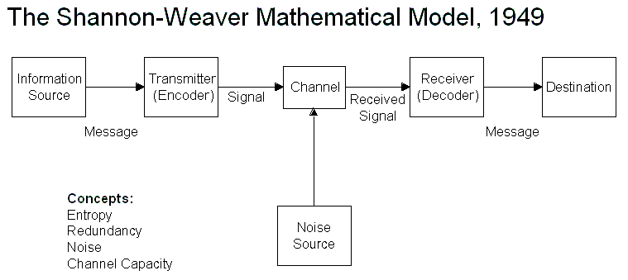
Figure: The Shannon-Weaver model (Cottrell, 2011)
Shannon-Weaver model: This model mainly follows the different transitions process of communication and first came in 1949 (Cottrell, 2011). It has information source, a transmitter that encodes the information after than through in a channel it transmits and decodes, then finally it goes to the destination.
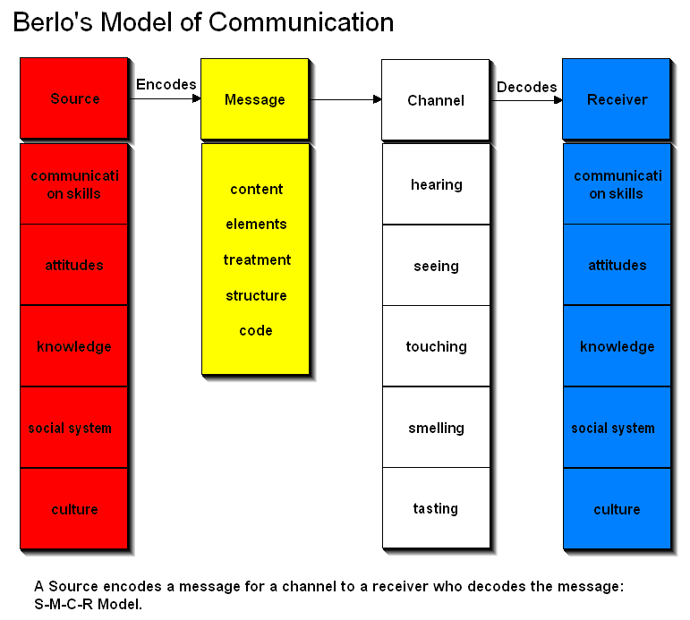
Figure: Berlo’s Model (Hoechsmann, 2012)
Berlo’s Model: This model is the most used model in this modern world and in Justina’s workplace she also follows this model. This model has a long method that provides all the way of communication. It has a sender that sends a message through different media. After that in a channel all the message is processed by hearing, seeing, touching, smelling, and testing. Finally, the receiver receives the message as per sender sends it (Hoechsmann, 2012).

Conflicts and its relationship with communication
Conflicts and communication are mostly linked with each other. Proper communication can help to remove all the conflicts from the organization and everyone can work with better motivation and speed. Justina experienced some conflicts in her work as well due to lack of communication and that made some trouble while working. She also expressed her feelings about some people at the workplace who mainly wants to make conflict while working. Here are some expressed that she shared:
Working Structure: In the workplace, there is a different type of people work and a different person has different mentality or thinking. It’s obvious that working structure won’t match with another person. There are some people at Justina's workplace who intentionally wanted to make issues with her regarding the working structure. Some don’t want to understand what she really wants to express and make different meaning. The passing of wrong information created serious issues for others and made a bad impression while working.
Organization evaluation: There is some communication problem at Justina’s workplace as well. Information was mostly leaked by other competitors due to the bad impact of communication (Stewart, 2017). Some people use social networking in the workplace and they pass different information that are others plus point. Higher level managers are also don’t want to make proper communication and that made some conflicts in the workplace.
Personal analysis: Justina always wanted to remove all the conflict from her workplace and she tries to maintain a better relationship with each other. There are some people as well who used to discuss her viewpoint maintain the friendly environment and remove all the conflict.

Important factors of communication
Communication is really important for personal and professional life. It helps to maintain better networking and creates better opportunities easily. Justina expressed her feelings regarding the importance of communication and she really got lots of help due to the better way of communication. Justina used to maintain a better relationship with all so that she can maintain a social relationship as well. Without proper communication working with a different level of people is really tough to handle. Here are some points based on her experience:
- Communication helps to build a strong network that is helpful in terms of better career development.
- For maintaining the situation better and friendly communication is the obvious thing.
- Communication helps to make the best decision based on the overall strategical analysis.
- Communication makes the best solution within the shortest possible time.
- It helps to maintain bonding with everyone and removes all the conflict.
- Communication helps to build up different ideas that can beat other competitors.
- Efficient communication reduces the different costs of the organization and increases the development.
- Written communication maintains the documentation that can solve any issues in the future.
- The proper way of communication helps to motive different employees that increase the working performance.

Teamwork
Another thing that Justina shared with me is about teamwork. Team working builds up with the proper way of communication and helps to solve any work by shortest possible time. Team working maintains the better environment in the workplace. Team working is all about working as a team where certain tasks are solved by different people and the overall result impacts on the whole team, the result is good or bad it evaluates the overall performance of every member.
Justina used to work as a team in the different situation at her workplace where she must need to contribute on her part and make a decision as a team whenever they face any trouble. As a team, Justina used to work on a different project and all the works are divided into different parts that are solved by other team members. The team is usually formed by more than two people. While working as a team, there must need to follow the proper way of communication. Here are certain things that Justina shared that as the process of communication that are important for teamworking:
Source: From where the information is collected and how the instructions are following are really big factors. This is the part of communication and important factors of the team working as well. Finding out the authentic source helps to get proper information that performs better in team working.
Channel: This is another important factor of communication that helps to pass the information to the receiver (Morgan, 2016). Information is passed through a channel where different types of way of communication are needed. It can be verbal, oral, written, nonverbal, or any kind of informal way of communication.
Encoding and decoding: encoding and decoding is the transition process of communication where the message is transmitted in the channel. There are different types of information needs to be passed while working for the teamwork and all these are passed in the encoding and decoding process.
Feedback and Receiver: Collecting feedback regarding the information is important in teamwork. While working as a team, Justina used to collect feedback from the customers, employees or other people as a media of research collection. Feedback helps to make the best decision based on the information they used to collect. Feedback maintains the authenticity of the information based on its positive or negative situation. The receiver receives the information and provides the feedback based on her perception or thinking (Hersey, 2015).

Importance of Teamwork
There are certainly important factors in the team working that Justina shared with me. It really helps her a lot to solve any tough issues shortly and perform better at her workplace. Here are some important factors in the team working that she shared:
- Teamworking helps to resolve any issues or fulfill project within shortest possible time
- It helps to find out the different solution from a different perspective and make the best decision based on these.
- Using the proper way of communication teamworking maintains a better relationship at the workplace.
- Finds out easy and cost-effective decision that is important for the workplace.
- It opens the door to work on the different field and get better ideas that remove the limitations.
- Enhances the personal development skill that is related to the professional skills as well.

Findings and Analysis
Based on the findings of Justina’s workplace I have made some analysis on this. But its clear that communication is really important for personal and professional life that opens the door to success. Here are below findings and analysis:
- Communication helps to maintain a better relationship with the different type of people and increases the network building opportunity.
- Communication removes the conflicts from the organization and gives a better environment.
- Team working is the efficient part of communication that helps to solve any issues easily.
- Communication helps to handle the different tough situation with proper planning and management techniques.
- Communication gives proper motivation to the employees that are important for team working as well.

Recommendations for improvements
Based on the findings and analysis, I have made some recommendations and improvements as well. All these are related to Justina’s experience on her workplace and work-related issues with the best suggestion. Here are some recommendations for the improvements in communication skill and performance:
- Use the best way of communication that helps to motivate and get the idea easily.
- Proper use of the word is really important to the use of the proper word is mandatory.
- At the workplace, passing the right information is a must.
- Motivate others so that there won’t happen any conflict in the workplace.
- Maintain a friendly relationship all so that team working gets extra advantages.
- Employees who are trying to make conflicts must need to be fired or give penalties

Conclusion
Justina shared all her experience based on her work life and it's clear that teamwork and communication are an essential part of the workplace. Communication helps to connect people and maintain better understand that removes all the conflict. It's really important to maintain conflicts management as well otherwise there can happen harmful thing in the workplace. Effective and efficient communication helps to remove all the conflicts and keeps a friendly situation at the workplace.

Reference
Bell, J. (2005) Doing your research project: A guide for first-time researchers in social science, education, and health. 4th edn. Maidenhead, England: Open University Press.
Cottrell, S. (2011) Critical thinking skills: Developing effective analysis and argument (Palgrave study skills). 2nd edn. Basingstoke: Palgrave Macmillan.
Hoechsmann, M. (2012) Media literacies: a critical introduction. Malden, MA., Wiley- Blackwell.
Hersey, J. (2015). The Importance of Managerial Communication. The Bulletin of the Association for Business Communication, 51(3), pp.25-26.
Johnson, D.E. (2000) Management of organizational behavior: Leading human resources. 8th edn. United Kingdom: Prentice Hall
Morgan, P. (2016). The Business Student’s Guide to Study and Employability. Sage Publications.
Stewart L.P. (2017). Certificate in Higher Education: Skills for the Workplace Student Yearbook. Sage Publications.

