Judit Varga
2411527
School of Applied Computing
Assignment 2
html and css web development
Table of Contents
Introduction 2
Abstract 2
Requirements 2
Implementation 3
‘Home’ 3
‘History’ 4
‘Varieties’ 5
‘Recipe’ 6
‘Tiramisù mistakes’ 7
Website evaluation 8
Usability 8
Accessibility 8
Search Engine Optimization 9
Evaluation of TiramiSite 10
Usefulness (usability and utility): 10
Search Engine Optimisation (SEO): 11
Descriptive titles: 11
Image Optimization: 11
Heading Tags: 12
Accessibility: 12
References 13
Appendices 15
Appendix 1 Text listing of ‘Home’ (index.html) 15
Appendix 2. Text listing of ‘History’ (history.html) 16
Appendix 3. Text listing of ‘Varieties’ (varieties.html) 18
Appendix 4. Text listing of ‘Recipe’ (recipe.html) 19
Appendix 5. Text listing of ‘Tiramisù mistakes’ (mistakes.html) 21
Appendix 6. Text listing of Stylesheet (styles.css) 23

Introduction

Abstract
This report describes Tiramisite.
Firstly, it briefly introduces the website; its aims, content and audience.
Then snippets of each page of the site are included, followed by validation results of the HTML of my homepage and my styles.css. The evaluation of TiramiSite makes up the bulk of the present report: the concepts of usability, accessibility and search engine optimisation are discussed in preparation for the assessment of TiramiSite from these perspectives. References and Appendices have been affixed.

Requirements
This assignment is dedicated to my favourite dessert, Tiramisù. There are three aims to ‘TiramiSite’: to provide a brief introduction into why Tiramisù has become a globally famous dessert, to reveal the gravest mistake chefs around the world make in daily creating it, and to deter future Tiramisù makers from reaching for cream.
The second page of TiramiSite touches upon the historical ambiguities concerning the origin of Tiramisù, explaining three of the many existing legends. After that there is ‘Varieties’, which shows different ways of flavouring Tiramisù.
The next page, ‘Recipe’ is dedicated to making Tiramisù: there is a list of ingredients, a method of creating and assembling Tiramisù, and a video showing a popular Italian chef making it.
The most important page of TiramiSite is the last one, ‘Tiramisù mistakes’, which lists the most common but overlooked mistakes people make when creating the dessert. TiramiSite, therefore, consists of 5 pages: Home, History, Varieties, Recipe and Tiramisù mistakes. The intended audience is the general public, and in particular people with an interest in Italy, Italian desserts, and those curious about the right way of making authentic Tiramisù.

Implementation

‘Home’

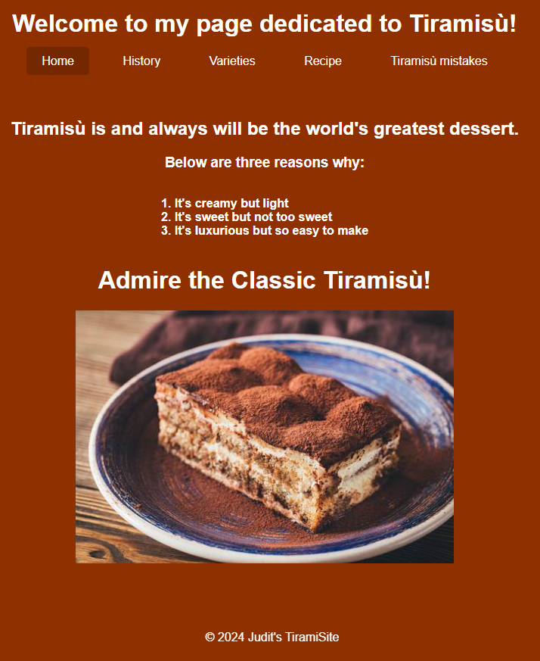

Figure 1. Homepage

‘History’
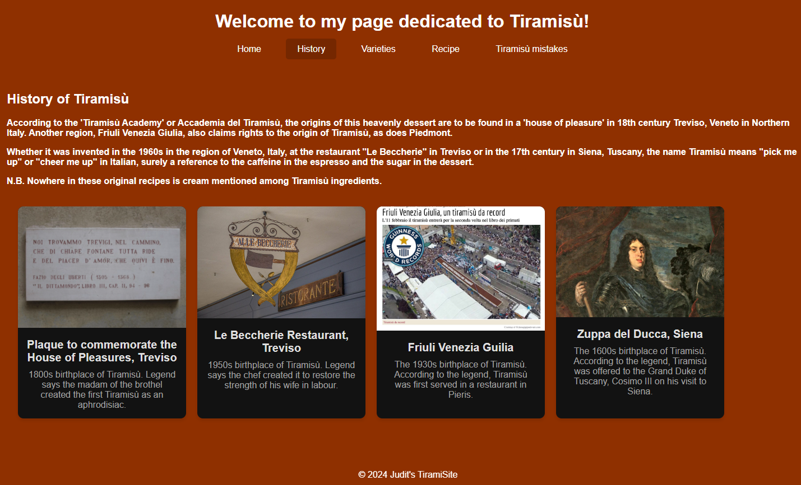
Figure 2. ‘History’

‘Varieties’

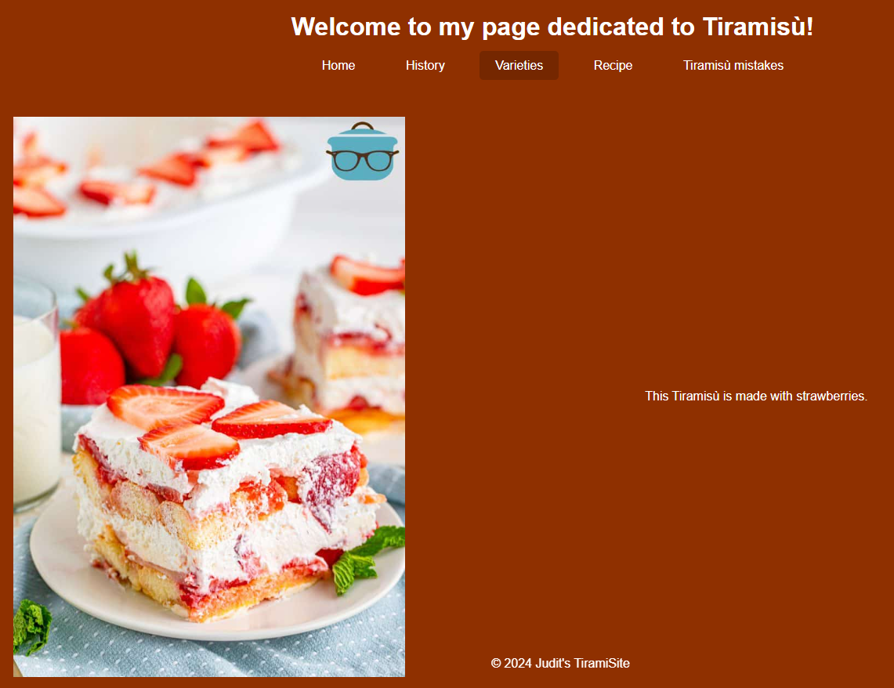
Figure 3. ‘Varieties’

‘Recipe’

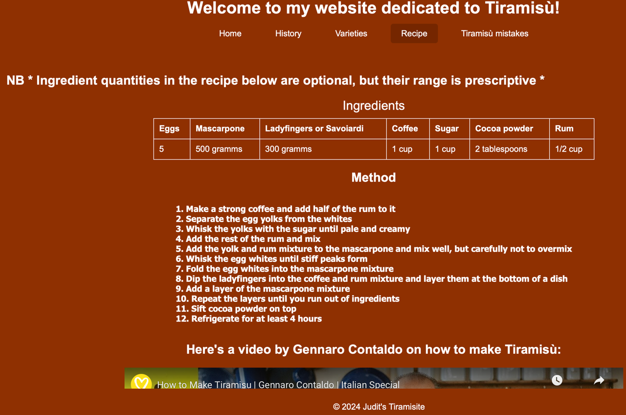
Figure 4. ‘Recipe’

‘Tiramisù mistakes’

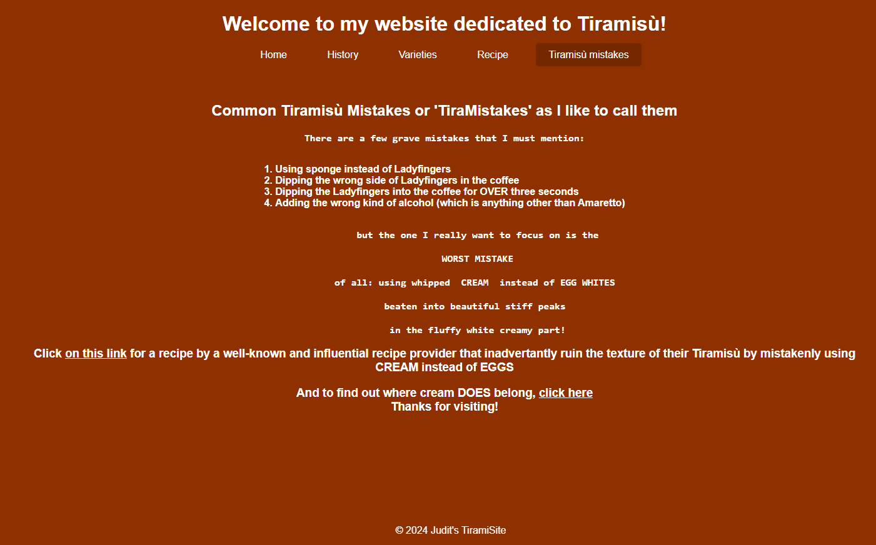
Figure 5. ‘Tiramisù mistakes’

HTML validation by http://validator.w3.org/ showed open </p> tags on some of the pages; these have been resolved by removing the opening tag.
CSS validation by http://jigsaw.w3.org/css-validator/ found no errors, as shown by Figure 6. :
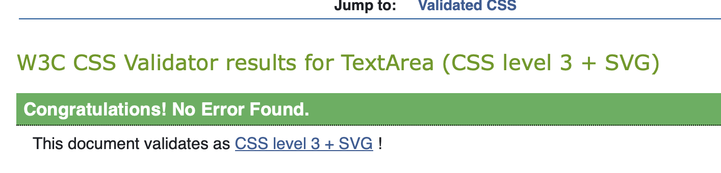
Figure 6. CSS validation: no errors

Website evaluation

Usability
Website usability is a key quality assurance for the ease of users to interact with a website. According to Cappel and Huang (2007), building on Nielsen’s definition from 2000, usability encompasses several attributes, including learnability, efficiency, and user satisfaction. Learnability involves the ease with which users can carry out tasks during their first visit to a website, efficiency targets the speed with which these tasks are completed. User satisfaction evaluates the aesthetic appeal of the website, which plays a critical role in determining user engagement and retention. Usability considers website presentation, navigation, and functionality. Features such as underlined links, breadcrumb trails to guide users back to the home screen, and integrated site search functionality are common design conventions that promote usability by ensuring an intuitive and seamless user experience [1].
Belanche et al. (2012) mentions in addition to this a ‘sense of control’ that users need to have over their activities and location within the website [2].
Duckett (2008) highlights the fact that although usability and accessibility are related, they are also distinct web design considerations. While usability is concerned with ensuring users can navigate a site and achieve their goals efficiently, accessibility focuses on making websites usable by as many people as possible, particularly those with disabilities. Accessibility features, such as adjustable text size and compatibility with screen readers, are designed to accommodate users with visual impairments or difficulties using a mouse. These features align with general legal and ethical commitments to inclusivity, and usability and accessibility together has the potential to create a functional, inclusive and responsive online environment, catering for the needs of diverse users [3].

Accessibility
Chadli et al. highlight the role of the World Wide Web Consortium (W3C) in advancing web inclusivity through the development of standards such as the Web Content Accessibility Guidelines (WCAG) [4]. These guidelines are rooted in the four principles of accessibility: perceivability, operability, understandability, and robustness (P.O.U.R.) [5]. These four principles ensure that web content is presented in perceivable ways (e.g., text alternatives for images), interfaces are operable through various input methods, content and functionality are understandable, and resources are robust enough to work across diverse devices and assistive technologies [5].
Chadli et al. compare free and open-source Web Accessibility Evaluation Tools (WAETs) from the W3C’s official list in their study, and they examine these tools’ effectiveness against WCAG 2.1 standards. They use the Coverage Error Ratio (CER) metric to assess tool performance in detecting accessibility violations. Their analysis reveals that even those with higher CER scores fail to comprehensively address all types of violations. The authors conclude that the lack of holistic evaluation impacts the utility of currently available tools for ensuring compliance with WCAG standards [4].
All related studies emphasise that web accessibility is a critical aspect of digital inclusivity, particularly for individuals with disabilities (PwDs). Jordanoski et al. argue that the Convention on the Rights of Persons with Disabilities (2006) recognizes access to Information and Communication Technologies (ICTs) as a fundamental human right [6]. Yet, the authors claim, many websites remain partially or entirely inaccessible, and there still is a need for rigorous accessibility measures. Jordanoski et al. discuss these challenges in the context of government websites across different income countries, showing that disparities in web accessibility persist particularly in low-income regions [6].
Similarly to Chadli et al. and Jordanoski et al., Boyalakuntla et al. also reinforce the significance of accessibility in enhancing web usability. The authors note that most existing evaluation tools focus on WCAG 2.0 compliance, and demonstrate that there is limited support for WCAG 2.1 and none for WCAG 2.2. To address these gaps, they propose WAccess, a tool designed to evaluate accessibility comprehensively across WCAG 2.0, 2.1, and 2.2 guidelines. They claim that WAccess provides a robust framework for developers to meet evolving standards, improving web accessibility practices [7].

Search Engine Optimization
Search Engine Optimization (SEO) is an essential strategy to enhance the visibility and ranking of websites on search engines, so as to attract site visitors. The two primary categories of SEO strategies are On-page and Off-page optimization, each with distinct approaches.
On-page optimization focuses on elements directly within the website, such as title tags, meta descriptions, sitemaps, and hyperlinking. These elements help search engines understand and rank the content effectively [8]. For example, reducing image sizes improves page load times, which contributes to better rankings. Mulyandi et al. add to this that SEO also involves understanding how users search for information, and is also to do with search engine algorithms [8].
Roumeliotis et al. explain that on-page SEO affects a website's source code, and might involve developers adding the following:
- Descriptive Titles: Concise and keyword-focused for better relevance.
- SEO-Friendly URLs: Readable, structured URLs aiding users and search engines.
- Image Optimization: Compressing files and using ALT tags for accessibility.
- Meta Tags: Informative descriptions and keywords aligning with content.
- Heading Tags: Structured use of H1-H6 to emphasize key content.
- Minified Resources: Optimizing HTML, CSS, and JavaScript for faster load times.
- Mobile Friendliness: Ensuring responsive designs for a seamless user experience.
- Structured Data: Implementing Schema.org standards for rich snippets in SERPs [9].
Off-page optimization, on the other hand, emphasizes building backlinks through methods like social bookmarking, blog posting, and directory submissions [9]. Backlinks from credible sources signal a website's authority and popularity, further enhancing its ranking on search engines [9].
A study by Sharma et al. explains that modern SEO strategies use Google Analytics and website audits to monitor and improve performance. The authors claim that regular audits are necessary to identify optimization opportunities, and to make sure that strategies such as keyword targeting and page interlinking remain effective. Also, modern, dynamic SEO requires consistent code updates to align with search engine algorithm changes. In terms of Off-page optimisation, engaging with social media platforms and forums can amplify a website's reach, as user interactions on these platforms generate valuable backlinks and traffic [10].

Evaluation of TiramiSite

Usefulness (usability and utility):
The site contains a horizontal navigation panel that clearly displays on each site the available pages. To make it easier for users to understand and control where they are on the site, I’ve added an active link functionality which highlights current site. One key element that I’ll include in the future is search functionality that allows users to locate the most quickly the information they are looking for. The ‘Tiramisu mistakes’ page I’ve included links to expedite information location. Because Tiramisite is static implementation based on HTML and CSS, content is delivered mainly by well displayed text. I ensured proper heading nesting, which supports each page’s logical flow: <h1> tags are the highest level and within these are lower heading levels. To introduce variety to textual media, I’ve included images and videos.
Regarding usability (look and feel and ease of use), I ensured consistent colour scheme: background is the same on all pages, and text colour is also consistent throughout. I chose the orange as a warm colour that evokes and sits between the yellow of the yolk and the brown of the coffee and the creamy white of the mascarpone of tiramisu. I kept line spacing, font, font-size consistent and classically simple to allow for quick scanning for information. The navigation pane is consistent throughout as well in terms of styling and follows a logical sequence: ‘Home’ contains a ‘hook’ or a catchy phrase to grab users’ attention, this is followed by ‘History’, because the word ‘classic’ in the image caption invokes the idea of the past times. The next in the navigation sequence is ‘Recipe’, and that follows the logical flow initiated by references to ingredients and the various creation histories of the dessert on the previous page. The names of the five sites within the webpage a clear, descriptive of content, short and simple for easy consumption.

In the future, I will enable interactivity with Javascript such as buttons and forms for users to leave feedback, request and post recipes.

Another future improvement is to ensure that the first and last images on the ‘Varieties’ page are the same height as the two images between. I suspected that the reason for them displaying like this is that .item img class height was set to 100%, so I changed that to 50% but didn’t get the expected change. I’ll need to investigate this further.
Finally, I’ll ensure that I resize all website images in the future. I used GIMP to remove an undesired file type off ZuppaDelDucca.jpg, and had a change to significantly reduce its size, but had not done the same on all the images for lack of time.

Search Engine Optimisation (SEO):

Descriptive titles:
Descriptive titles, such as page titles ‘History’, ‘Recipe’, and ‘Tiramisu mistakes’ have been used in the navigation panel on each page. The word ‘Tiramisù’, the focal topic of my site occurs over 20 times on the five pages. It is because this high number counterbalances the loss of SEO technique in naming my site other than ‘Tiramisù’ that I’ve decided to keep the sitename as a word-play based on the concurrence of ‘s’ in ‘Tiramisù’ and ‘site’. Also, this exaggerated symphony is to indicate to users that Tiramisite’s overt prejudice against cream is not to be taken too seriously.
I’ve ensured readable, structured URLs, such as
file:///Users/juditvarga/Downloads/TiramisuSite/index.html
or
file:///Users/juditvarga/Downloads/TiramisuSite/mistakes.html

Image Optimization:
Alt tags have been applied to my images both for search engine data crawling and for accessibility [11]. The following example is from Index.html, and defines the image of ‘Classic Tiramisù’:
<img src="images/OSK.jfif" alt="tiramisu picture">

Other examples are of the four card images on the ‘History’ page, history.html:

Card 1 image: <img src="images/houseofpleasures.jpg" alt="image brothel" class="card-img">
Card 2 image: <img src="images/beccherieTreviso.jpg" alt="image restaurant" class="card-img">
Card 3 image: <img src="images/FriuliTiramisu.jpg" alt="image tiramisù" class="card-img">
Card 4 image: <img src="images/ZuppaDelDucca.jpg.webp" alt="image Duke" class="card-img">

A further example of the combined gain of media optimisation and accessibility is the use of the <title> attribute on the <iframe> on ‘Recipe’ page in recipes.html:
<iframe
class="video-frame"
src="https://www.youtube.com/embed/HykFyrhuyMk"
title="How to Make Tiramisu | Gennaro Contaldo | Italian Special"
allow="accelerometer; autoplay; clipboard-write; encrypted-media; gyroscope; picture-in-picture; web-share"
referrerpolicy="strict-origin-when-cross-origin">
</iframe>

Heading Tags:
I used headings in a structured way to emphasize key content:
There is <h1> text in the header of each page:

<header>
<h1>Welcome to my page dedicated to Tiramisu!</h1>

Followed by <h2> in the <main> section. The below example is from recipes.html:
<main>
<h2> NB * Ingredient quantities in the recipe below are optional, but their range is prescriptive * </h2>

I’ve ensured responsive designs for a seamless and pleasant user experience, for instance, the .video-frame class in the CSS for the above <iframe> is set to width=100%. Similarly, the width of .item class on line 173 in styles.css is set to 100% to ensure that .item scales with the size of its parent, which in the present case is <main>.

Accessibility:
I used aXe: The Accessibility Engine browser extension to scan each page of TiramiSite for issues, and it has come up with fails on nested heading levels and colour contrast on the hyperlinks on ‘Tiramisu mistakes’ page, which I’ve addressed and there should be no fails now.
TiramiSite adheres to the four main principles of web accessibility:
- Perceivability, which ensures the presence of alternative text for non-text web content, that text is readable against its background, and using clear and descriptive labels for form elements [12]. As explained above, I’ve provided alt text for all images on TiramiSite and title attribute for iframe on Recipe page.
- Operability, a concept that ensures that users are able to effectively interact with web content, regardless of their abilities or disabilities [13]. In the case of TiramiSite, I ensure ease of navigation, I’ve not included interactive multimedia content which might constitute a barrier for assistive technology users, and I ensured that colour contrast is set to the ratios specified in WCAG 2.1.
- Understandability highlights the importance of using simple and clear language, and the benefit of presenting information in a clearly structured, straightforward way. This principle involves avoiding jargon, idioms, and ambiguous terms that may confuse users, particularly those with cognitive disabilities [14].
- Robustness principle ensures that web content be interpreted reliably by all user agents, particularly by assistive technologies [15]. A study by [16] showed that the integration and semantic annotation of mathematical content allows better access for users with visual impairment. Robustness in Tiramisite is ensured, for instance, by semantic elements such as <nav> and <header> on each page, and <table> and <caption>, in particular, on ‘Recipe’. Here is an example of the use of semantic element in the html in recipe.html:
<table>
<caption>Ingredients</caption>
<thead>

References
- D. Cappel and Z. Huang, “Website usability from Nielsen's perspective,” Proc. Research in Web Usability, 2007.
- D. Belanche, L. V. Casaló, and M. Guinalíu, “Website usability, consumer satisfaction and the intention to use a website: The moderating effect of perceived risk,” Journal of Retailing and Consumer Services, vol. 19, no. 1, pp. 124–132, 2012, doi: 10.1016/j.jretconser.2011.11.001.
- J. Duckett, Beginning Web Programming with HTML, XHTML, and CSS, 2nd ed., Wiley Pub., 2008. Available: http://www.books24x7.com/marc.asp?bookid=25220.
- F. E. Chadli, D. Gretete, and A. Moumen, “Comparison of Free and Open Source WCAG Accessibility Evaluation Tools,” Proc. 6th Int. Conf. Networking, Intelligent Systems & Security (NISS '23), ACM, New York, NY, USA, 2023, pp. 1–6. https://doi.org/10.1145/3607720.3607722.
- “Four Principles of Accessibility,” W3C, available at https://www.w3.org/WAI/standards-guidelines/wcag/.
- Z. Jordanoski et al., "The challenge of web accessibility: an evaluation of selected government websites and service portals of high, middle and low-income countries," Proc. 16th Int. Conf. Theory Pract. Electronic Governance, pp. 101–110, 2023.
- K. Boyalakuntla, A. S. M. Venigalla, and S. Chimalakonda, “WAccess -- A Web Accessibility Tool based on WCAG 2.2, 2.1 and 2.0 Guidelines,” arXiv (Cornell University), 2021. doi: 10.48550/arxiv.2107.06799.
- M. R. Mulyandi, N. Septiani, M. Yusup, M. H. R. Chakim, and Nursohit, “Optimizing SEO (Search Engine Optimization) Implementation on a Website Content Management System,” 2022 IEEE Creative Communication and Innovative Technology (ICCIT), Tangerang, Indonesia, 2022, pp. 1–6, doi: 10.1109/ICCIT55355.2022.10118592.
- K. I. Roumeliotis, N. D. Tselikas, and D. K. Nasiopoulos, “Airlines’ Sustainability Study Based on Search Engine Optimization Techniques and Technologies,” Sustainability, vol. 14, no. 18, pp. 11225-, 2022, doi: 10.3390/su141811225.
- S. Sharma, S. P. Panda, and S. Verma, “Role and Analysis of Various SEO Strategies to Improve Website Ranking,” 2022 International Conference on Machine Learning, Big Data, Cloud and Parallel Computing (COM-IT-CON), Faridabad, India, 2022, pp. 639–648, doi: 10.1109/COM-IT-CON54601.2022.9850597.
- M. Daruka and M. Damle, “Boosting D2C (Direct-to-Consumer) Websites with Search Engine Optimisation (SEO),” in 2023 Somaiya International Conference on Technology and Information Management (SICTIM), IEEE, 2023, pp. 84–89. doi: 10.1109/SICTIM56495.2023.10104723.
- M. A. D. Cahyono and I. Inawati, “Analysis of Online Accessibility of Public Access Catalogue on Slims and Inlislite Applications Based on WCAG 2.0,” Edulib (Online), vol. 12, no. 2, pp. 172–190, 2022, doi: 10.17509/edulib.v12i2.51377.
- S. L. Byerley and M. Beth Chambers, “Accessibility and usability of Web-based library databases for non-visual users,” Library hi tech, vol. 20, no. 2, pp. 169–178, 2002, doi: 10.1108/07378830220432534.
- D. M. Raymaker, S. K. Kapp, K. E. McDonald, M. Weiner, E. Ashkenazy, and C. Nicolaidis, “Development of the AASPIRE Web Accessibility Guidelines for Autistic Web Users,” Autism in adulthood, vol. 1, no. 2, pp. 146–157, 2019, doi: 10.1089/aut.2018.0020.
- J. A. Riano Herrera and J. A. Ballesteros Ricaurte, “Web accessibility: Study web accessibility in public places of the Colombian State,” in 2015 Latin American Computing Conference (CLEI), IEEE, 2015, pp. 1–7. doi: 10.1109/CLEI.2015.7360037.
- J. Stegmüller and M. Schubotz, “WikiTexVC: MediaWiki’s native LaTeX to MathML converter for Wikipedia,” arXiv.org, 2024.

Appendices

Appendix 1 Text listing of ‘Home’ (index.html)
<!DOCTYPE html>
<html lang="en">
<head>
<meta charset="UTF-8">
<meta name="viewport" content="width=device-width, initial-scale=1.0">
<title>Tiramisite</title>
<link rel="stylesheet" href="styles.css">
</head>
<body>
<header>
<h1>Welcome to my page dedicated to Tiramisù!</h1>
<nav>
<ul>
<li><a href="index.html" class="nav-link active">Home</a></li>
<li><a href="history.html" class="nav-link">History</a></li>
<li><a href="varieties.html" class="nav-link">Varieties</a></li>
<li><a href="recipe.html" class="nav-link">Recipe</a></li>
<li><a href="mistakes.html" class="nav-link">Tiramisù mistakes</a></li>
</ul>
</nav>
</header>
<main>
<div class="main-container">
<h2>Tiramisù is and always will be the world's greatest dessert.</h2>
<h3>Below are three reasons why:</h3>
<ol>
<li>It's creamy but light</li>
<li>It's sweet but not too sweet</li>
<li>It's luxurious but so easy to make</li>
</ol>
<h1>Admire the Classic Tiramisù!</h1>
<img src="images/OSK.jfif" alt="tiramisu picture">
</div>
</main>
<footer>
<p>&copy; 2024 Judit's TiramiSite</p>
</footer>
</body>
</html>

Appendix 2. Text listing of ‘History’ (history.html)

<!DOCTYPE html>
<html lang="en">
<head>
<meta charset="UTF-8">
<meta name="viewport" content="width=device-width, initial-scale=1.0">
<title>Tiramisite</title>
<link rel="stylesheet" href="styles.css">
</head>
<body>
<header>
<h1>Welcome to my page dedicated to Tiramisù!</h1>
<nav>
<ul>
<li><a href="index.html" class="nav-link">Home</a></li>
<li><a href="history.html" class="nav-link active">History</a></li>
<li><a href="varieties.html" class="nav-link">Varieties</a></li>
<li><a href="recipe.html" class="nav-link">Recipe</a></li>
<li><a href="mistakes.html" class="nav-link">Tiramisù mistakes</a></li>
</ul>
</nav>
</header>
<main>
<div class="main-container">
<div class="content">
<h2>History of Tiramisù</h2>
<p>
According to the 'Tiramisù Academy' or Accademia del Tiramisù, the origins of this heavenly dessert are to be found in a 'house of pleasure' in 18th century Treviso, Veneto in Northern Italy. Another region, Friuli Venezia Giulia, also claims rights to the origin of Tiramisù, as does Piedmont.
</p>
<p>
Whether it was invented in the 1960s in the region of Veneto, Italy, at the restaurant "Le Beccherie" in Treviso or in the 17th century in Siena, Tuscany, the name Tiramisù means "pick me up" or "cheer me up" in Italian, surely a reference to the caffeine in the espresso and the sugar in the dessert.</p>
<p> N.B. Nowhere in these original recipes is cream mentioned among Tiramisù ingredients.</p>
</p>
<p>

</p>
</div>
</div>
<div class="card-container">
<div class="card">
<img src="images/houseofpleasures.jpg" alt="image brothel" class="card-img">
<div class="card-text">
<h3>Plaque to commemorate the House of Pleasures, Treviso</h3>
<p>1800s birthplace of Tiramisù. Legend says the madam of the brothel created the first Tiramisù as an aphrodisiac.</p>
</div>
</div>
<div class="card">
<img src="images/beccherieTreviso.jpg" alt="image restaurant" class="card-img">
<div class="card-text">
<h3>Le Beccherie Restaurant, Treviso</h3>
<p>1950s birthplace of Tiramisù. Legend says the chef created it to restore the strength of his wife in labour.</p>
</div>
</div>
<div class="card">
<img src="images/FriuliTiramisu.jpg" alt="image tiramisù" class="card-img">
<div class="card-text">
<h3>Friuli Venezia Guilia</h3>
<p>The 1930s birthplace of Tiramisù. According to the legend, Tiramisù was first served in a restaurant in Pieris.</p>
</div>
</div>
<div class="card">
<img src="images/ZuppaDelDucca.jpg" alt="image Duke" class="card-img">
<div class="card-text">
<h3 lang="it">Zuppa del Ducca, Siena</h3>
<p>The 1600s birthplace of Tiramisù. According to the legend, Tiramisù was offered to the Grand Duke of Tuscany, Cosimo III on his visit to Siena.</p>
</div>
</div>

</div>

</main>
<footer>
<p>&copy; 2024 Judit's TiramiSite</p>
</footer>
</body>
</html>

Appendix 3. Text listing of ‘Varieties’ (varieties.html)

<!DOCTYPE html>
<html lang="en">
<head>
<meta charset="UTF-8">
<meta name="viewport" content="width=device-width, initial-scale=1.0">
<title>Tiramisite</title>
<link rel="stylesheet" href="styles.css">
</head>
<body>
<header>
<h1>Welcome to my page dedicated to Tiramisù!</h1>
<nav>
<ul>
<li><a href="index.html" class="nav-link">Home</a></li>
<li><a href="history.html" class="nav-link">History</a></li>
<li><a href="varieties.html" class="nav-link active">Varieties</a></li>
<li><a href="recipe.html" class="nav-link">Recipe</a></li>
<li><a href="mistakes.html" class="nav-link">Tiramisù mistakes</a></li>
</ul>
</nav>
</header>
<main>
<div class="item">
<img src="images/StrobeTiramis.jpg" alt="strobe tiramisu image">
<p>This Tiramisù is made with strawberries.</p>
</div>
<div class="item">
<img src="images/veganTiramisu.jpg" alt="Sample image">
<p>This is a vegan Tiramisù, made with coconut cream and no eggs.</p>
</div>
<div class="item">
<img src="images/PistachioTiramisu.jpg" alt="PistachioTiramisu image">
<p>Tiramisù made with pistachios.</p>
</div>
<div class="item">
<img src="images/raspberryTiramisu.jpg" alt="raspberryTiramisu image">
<p>This variation is with raspberries and cream.</p>
</div>
</main>
<footer>
<p>&copy; 2024 Judit's TiramiSite</p>
</footer>
</body>
</html>

Appendix 4. Text listing of ‘Recipe’ (recipe.html)

<!DOCTYPE html>
<html lang="en">
<head>
<meta charset="UTF-8">
<meta name="viewport" content="width=device-width, initial-scale=1.0">
<title>Tiramisite</title>
<link rel="stylesheet" href="styles.css">
</head>
<body>
<header>
<h1>Welcome to my website dedicated to Tiramisù!</h1>
<nav>
<ul>
<li><a href="index.html" class="nav-link">Home</a></li>
<li><a href="history.html" class="nav-link">History</a></li>
<li><a href="varieties.html" class="nav-link">Varieties</a></li>
<li><a href="recipe.html" class="nav-link active">Recipe</a></li>
<li><a href="mistakes.html" class="nav-link">Tiramisù mistakes</a></li>
</ul>
</nav>
</header>
<main>
<h2> NB * Ingredient quantities in the recipe below are optional, but their range is prescriptive * </h2>
<table>
<caption>Ingredients</caption>
<thead>
<tr>
<th>Eggs</th>
<th>Mascarpone</th>
<th>Ladyfingers or Savoiardi</th>
<th>Coffee</th>
<th>Sugar</th>
<th>Cocoa powder</th>
<th>Rum</th>
</tr>
</thead>
<tbody>
<tr>
<td>5</td>
<td>500 gramms</td>
<td>300 gramms</td>
<td>1 cup</td>
<td>1 cup</td>
<td>2 tablespoons</td>
<td>1/2 cup</td>
</tr>
</tbody>
</table>
<div class="main-container">
<h2>Method</h2>
<ol>
<li>Make a strong coffee and add half of the rum to it</li>
<li>Separate the egg yolks from the whites</li>
<li>Whisk the yolks with the sugar until pale and creamy</li>
<li>Add the rest of the rum and mix</li>
<li>Add the yolk and rum mixture to the mascarpone and mix well, but carefully not to overmix</li>
<li>Whisk the egg whites until stiff peaks form</li>
<li>Fold the egg whites into the mascarpone mixture</li>
<li>Dip the ladyfingers into the coffee and rum mixture and layer them at the bottom of a dish</li>
<li>Add a layer of the mascarpone mixture</li>
<li>Repeat the layers until you run out of ingredients</li>
<li>Sift cocoa powder on top</li>
<li>Refrigerate for at least 4 hours</li>
</ol>
<h2>Here's a video by Gennaro Contaldo on how to make Tiramisù:</h2>
<iframe
class="video-frame"
src="https://www.youtube.com/embed/HykFyrhuyMk"
title="How to Make Tiramisu | Gennaro Contaldo | Italian Special"
allow="accelerometer; autoplay; clipboard-write; encrypted-media; gyroscope; picture-in-picture; web-share"
referrerpolicy="strict-origin-when-cross-origin">
</iframe>
</div>
</main>
<footer>
<p>&copy; 2024 Judit's TiramiSite</p>
</footer>
</body>
</html>

Appendix 5. Text listing of ‘Tiramisù mistakes’ (mistakes.html)

<!DOCTYPE html>
<html lang="en">
<head>
<meta charset="UTF-8">
<meta name="viewport" content="width=device-width, initial-scale=1.0">
<title>TiramiSite</title>
<link rel="stylesheet" href="styles.css">
</head>
<body>
<header>
<h1>Welcome to my website dedicated to Tiramisù!</h1>
<nav>
<ul>
<li><a href="index.html" class="nav-link">Home</a></li>
<li><a href="history.html" class="nav-link">History</a></li>
<li><a href="varieties.html" class="nav-link">Varieties</a></li>
<li><a href="recipe.html" class="nav-link">Recipe</a></li>
<li><a href="mistakes.html" class="nav-link active">Tiramisù mistakes</a></li>
</ul>
</nav>
</header>
<main>
<div class="main-container">
<h2>Common Tiramisù Mistakes or 'TiraMistakes' as I like to call them</h2>
<pre>There are a few grave mistakes that I must mention:</pre>
<ol>
<li>Using sponge instead of Ladyfingers</li>
<li>Dipping the wrong side of Ladyfingers in the coffee</li>
<li>Dipping the Ladyfingers into the coffee for OVER three seconds</li>
<li>Adding the wrong kind of alcohol (which is anything other than Amaretto)</li>
</ol>
<pre>
but the one I really want to focus on is the

WORST MISTAKE

of all: using whipped CREAM instead of EGG WHITES

beaten into beautiful stiff peaks

in the fluffy white creamy part!</pre>
<h3>Click <a href="https://www.bbcgoodfood.com/recipes/best-ever-tiramisu" target="_blank" style="color: white;">on this link</a> for a recipe by a well-known and influential recipe provider that inadvertently ruin the texture of their Tiramisù by mistakenly using<br> CREAM instead of EGGS</h3>
<h3>And to find out where cream DOES belong, <a href="images/strawberriesandCream.jpg" target="_blank" style="color: white">click here</a>
<br>
Thanks for visiting!
</h3>
</div>
</main>
<footer>
<p>&copy; 2024 Judit's TiramiSite</p>
</footer>
</body>
</html>

Appendix 6. Text listing of Stylesheet (styles.css)

body {
font-family: Arial, sans-serif;
background-color: #8F3000;
color: #333;
margin: 0;
padding: 0;
}

nav ul {
list-style-type: none;
padding: 0;
}
nav ul li {
display: inline;
margin: 0 10px;
}
nav ul li a {
padding: 10px 20px;
color: white;
text-decoration: none;
background-color: #8F3000;
border-radius: 5px;
font-size: 16px;
transition: background-color 0.3s;
cursor: pointer;
}

nav ul li a:hover {
background-color: #752700;
}

/* Focus effect for keyboard navigation */
nav ul li a:focus {
outline: 2px solid #752700;
}

nav ul li a.active {
background-color: #752700; /* Darker shade of green for active link */
}
header {
background-color : #8F3000;
color: white;
padding: 10px;
text-align: center;
}

main {
background-color: #8F3000;
color: white;
font-family: Arial, sans-serif;
text-align: left;
padding: 20px;
gap: 20px;
}

table {
width: 60%;
margin: 20px auto; /* Center the table horizontally */
border-collapse: collapse; /* Remove space between borders */
font-family: Arial, sans-serif;
}

th {
color: white;
padding: 10px; /* Padding inside the header cells */
text-align: left;
}

td {
padding: 10px; /* Padding inside the data cells */
text-align: left; /* Align text to the left */
}

caption {
color: white;
font-size: 1.5em;
margin-bottom: 10px;
}
th, td {
border: 1px solid;
}

footer{
color : white;
text-align : center;
padding : 10px;
position : fixed;
bottom : 0;
width : 100%;
}

img {
width: 100%; /* Makes the image responsive */
max-width: 500px; /* Ensures it doesn't exceed a specific size */
height: auto; /* Maintains aspect ratio */
}

.main-container {
text-align: center;
font-family: Arial, Helvetica, sans-serif;
font-size: 16px;
font-weight: bold;
}

.main-container ol {
list-style-position: inside; /*numbers inside the list item */
padding-left: 0; /* Removes default padding */
text-align: center;
display: inline-block; /* Centers the entire ordered list */
}
.main-container ol li {
text-align: left;
}

.content { /*container for text above cards*/
font-family: Arial, sans-serif;
color: white;
text-align: left;
z-index: 2; /* Ensure the text is on top of the image */
}

.card-container {
display: flex; /* Flexbox for horizontal alignment */
gap: 20px; /* Space between cards */
padding: 20px;
}

/* Individual Card */
.card {
background-color: white;
border-radius: 10px;
box-shadow: 0 4px 6px rgba(0, 0, 0, 0.1);
overflow: hidden;
width: 300px;
text-align: center;
}

/* Card Image */
.card-img {
width: 100%;
height: auto;
}

/* Card Text */
.card-text {
padding: 15px;
color: #333;
}

.card-text h3 {
margin: 0 0 10px;
font-size: 1.25rem;
}

.card-text p {
margin: 0;
font-size: 1rem;
color: #666;
}

.item {
display: flex;
justify-content: space-between;
align-items: center;
width: 100%;
height: 50%;
padding: 10px;
}

.item img {
width: 50%;
height: 50%;
object-fit: cover; /* Ensures the image fits the area without distortion */
}

.item p {
flex-grow: 1; /* Text takes the remaining space */
font-size: 16px;
margin: 0;
justify-content: center; /* Center the text horizontally */
text-align: center;
padding: 10px;
}

.video-frame {
width: 100%; /* Make the iframe responsive */
max-width: 950px; /* Limit maximum width */
aspect-ratio: 16 / 9;
border: none;
display: block; /* Ensure it's treated like a block element */
margin: 0 auto; /* Center the iframe */
}

