Module: Developing Relationships and Workplace Achievements
Student Name:Iulian Melinte
Student ID: 2113144

Table of Contents
1. Introduction 3
2. Knowledge, skills and behaviour required by HR professionals. 4
3. Knowledge, skills and behaviour required by HR professionals contd. 5
4. Knowledge, skills and behaviour required by HR professionals contd. 6
5. Personal Skills SWOT Analysis 7
6. Personal Skills SWOT Analysis contd. 8
7. Potential benefits of an effective training and development program for myself and AstraZeneca. 9
8. Potential benefits of an effective training and development program for myself and AstraZeneca contd. 10
9. Conclusion 11
References 12

1. Introduction
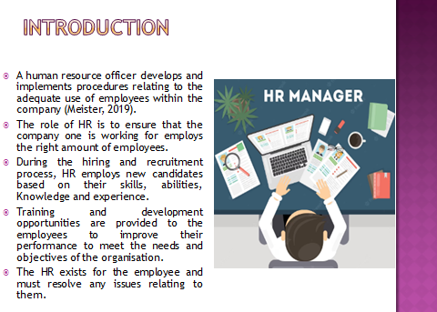
Speaker’s Note: A human resource officer develops and implements procedures relating to the adequate use of employees within the company (Meister, 2019). The role is to ensure that the company one is working for employs the right amount of employees in terms of skills, abilities and experience, and training and development opportunities are provided to the employees to improve their performance to meet the needs and objectives of the organisation. The HR exists for the employee and must resolve any issues relating to them.

2. Knowledge, skills and behaviour required by HR professionals.
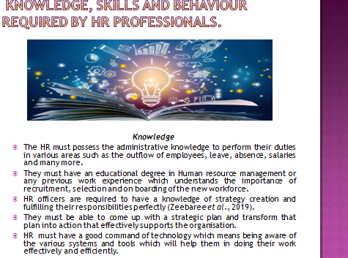
Speaker’s Note: Knowledge: The HR must possess the administrative knowledge to perform their duties in various areas such as the outflow of employees, leave, absence, salaries and many more. They must have an educational degree in Human resource management or any previous work experience which understands the importance of recruitment, selection and onboarding of the new workforce. HR officers are required to have a knowledge of strategy creation and fulfilling their responsibilities perfectly (Zeebaree et al., 2019). They must be able to come up with a strategic plan and transform that plan into action that effectively supports the organisation. In today’s world, every HR must have a good command of the technology which means being aware of the various systems and tools which will help them in doing their work effectively and efficiently.

3. Knowledge, skills and behaviour required by HR professionals contd.
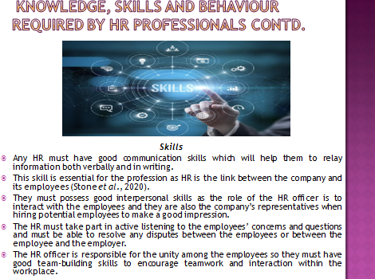
Speaker’s Note: Skills: Any HR must have good communication skills which will help them to relay information both verbally and in writing. This skill is essential for the profession as HR is the link between the company and its employees (Stone et al., 2020). They must possess good interpersonal skills as the role of the HR officer is to interact with the employees and they are also the company’s representatives when hiring potential employees to make a good impression. The HR must take part in active listening to the employees’ concerns and questions and must be able to resolve any disputes between the employees or between the employee and the employer. The HR officer is responsible for the unity among the employees so they must have good team-building skills to encourage teamwork and interaction within the workplace.

4. Knowledge, skills and behaviour required by HR professionals contd.
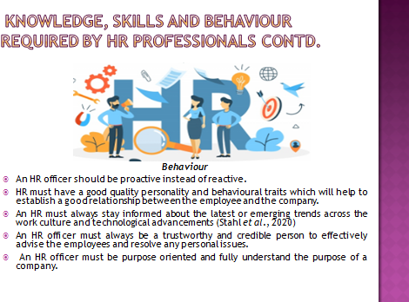
Speaker’s Note: Behaviour: In this profession, HR should be proactive instead of reactive so the HR must have a good quality personality and behavioural traits which will help to establish a good relationship between the employee and the company. An HR must always stay informed about the latest or emerging trends across the work culture and technological advancements (Stahl et al., 2020). An HR officer must always be a trustworthy and credible person to effectively advise the employees and resolve any personal issues. An HR officer must be purpose oriented and fully understand the purpose of a company.

5. Personal Skills SWOT Analysis
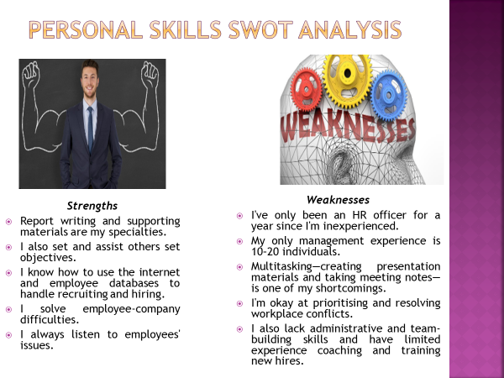
Speaker’s Note: Strengths: One of my biggest strengths is my communication skills such as writing reports and producing materials for supporting the report. I am also very good at setting goals for myself and helping the other employees develop their goals. I have profound knowledge of information technology such as the use of the internet and using employees' databases to manage their recruitment and hiring processes. Problem-solving and resolving any issue between the employees and the company is my forte as I’m empathetic and actively listening to the problems and concerns of the employees.
Weaknesses: As an HR officer, I lack experience in this role so I’ve only worked for more than a year in this position and I’ve only managed between 10 to 20 people at one time. Another one of my weaknesses is multitasking which involves coming up with various materials for the presentation and taking notes from the meeting while managing priorities and solving disputes between the employees. I also lack certain abilities such as team building and administrative knowledge and have little experience advising employees while providing training sessions for new employees.

6. Personal Skills SWOT Analysis contd.
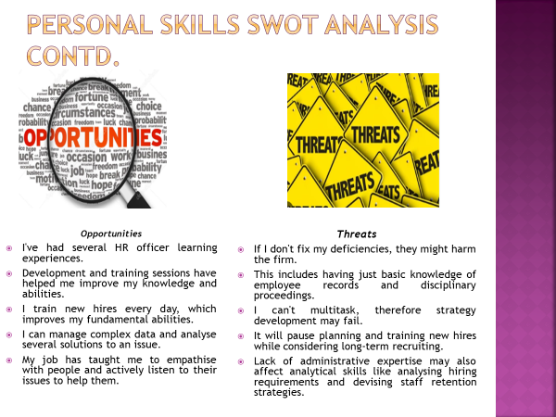
Speaker’s Note: Opportunities: As an HR officer I’ve been provided with many learning opportunities in this profession. I’ve been able to work on myself through various development and training sessions which have helped me to level up my knowledge and skills. I meet new talents every day during the hiring process and providing them with training sessions in turn helps me with my own basic skills. I’ve learned to handle complicated data and make particular use of information to analyse more than just one solution to resolve a problem. Through this profession, I’ve learned to be empathic towards others' problems and actively listen to their concerns and questions to help them resolve them.
Threats: Some of the weaknesses which I possess could produce threats to the operations of the company if I don’t work on them such as administering and maintaining employees' records while taking disciplinary actions. I am not able to multi-task in between various activities which in turn could cause several malfunctions in developing strategies which consider planning and providing training for the new employees while taking into consideration of long-term employee recruitment. The lack of administrative knowledge could also impact the overall analytical capabilities such as analysing and anticipating hiring needs and developing employee retention strategies.

7. Potential benefits of an effective training and development program for myself and AstraZeneca.
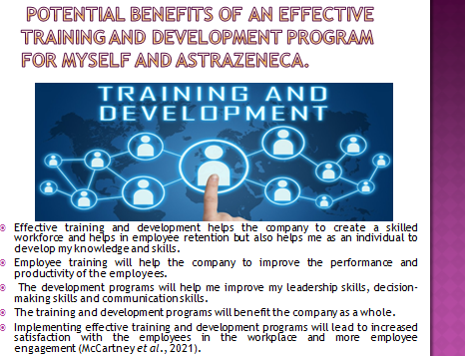
Speaker’s Note: The training and development program is beneficial for both me and the company which i work for as it not only helps the company to create a skilled workforce and helps in employee retention but also helps me as an individual to develop my knowledge and skills. The employee training will help the company to improve the performance and productivity of the employees and the development programs will help me improve my leadership skills, decision-making skills and communication skills which in turn will benefit the company as a whole. Implementing effective training and development programs will lead to increased satisfaction with the employees in the workplace and more employee engagement (McCartney et al., 2021).

8. Potential benefits of an effective training and development program for myself and AstraZeneca contd.
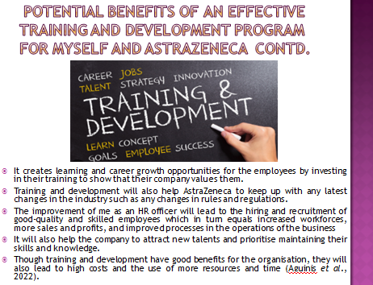
Speaker’s Note: It creates learning and career growth opportunities for the employees by investing in their training to show that their company values them. Training and development will also help AstraZeneca to keep up with any latest changes in the industry such as any changes in rules and regulations. The improvement of me as an HR officer will lead to the hiring and recruitment of good-quality and skilled employees which in turn equals increased workforces, more sales and profits, and improved processes in the operations of the business. It will also help the company to attract new talents and prioritise maintaining their skills and knowledge. Though training and development have good benefits for the organisation, they will also lead to high costs and the use of more resources and time (Aguinis et al., 2022).

9. Conclusion
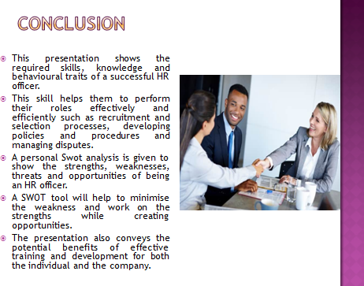
Speaker’s Note: To conclude, this presentation shows the required skills, knowledge and behavioural traits of a successful HR officer. This skill helps them to perform their roles effectively and efficiently such as recruitment and selection processes, developing policies and procedures and managing disputes. A personal Swot analysis is given to show the strengths, weaknesses, threats and opportunities of being an HR officer. Lastly, it conveys the potential benefits of effective training and development for both the individual and the company.

References
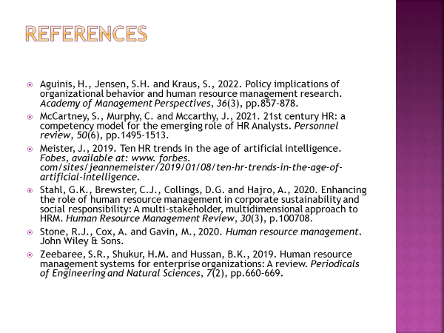
Aguinis, H., Jensen, S.H. and Kraus, S., 2022. Policy implications of organizational behavior and human resource management research. Academy of Management Perspectives, 36(3), pp.857-878.
McCartney, S., Murphy, C. and Mccarthy, J., 2021. 21st century HR: a competency model for the emerging role of HR Analysts. Personnel review, 50(6), pp.1495-1513.
Meister, J., 2019. Ten HR trends in the age of artificial intelligence. Fobes, available at: www. forbes. com/sites/jeannemeister/2019/01/08/ten-hr-trends-in-the-age-of-artificial-intelligence.
Stahl, G.K., Brewster, C.J., Collings, D.G. and Hajro, A., 2020. Enhancing the role of human resource management in corporate sustainability and social responsibility: A multi-stakeholder, multidimensional approach to HRM. Human Resource Management Review, 30(3), p.100708.
Stone, R.J., Cox, A. and Gavin, M., 2020. Human resource management. John Wiley & Sons.
Zeebaree, S.R., Shukur, H.M. and Hussan, B.K., 2019. Human resource management systems for enterprise organizations: A review. Periodicals of Engineering and Natural Sciences, 7(2), pp.660-669.

