BMSP7003D: Embedding Sustainability within Organisations
Assignment Title: FatFace Sustainability Plan
Lecturer: Dr Roisin Mullins
Student: Peter Todorov
Student ID Number: 1705088

Introduction

This report will investigate FatFace and its sustainability initiatives that have been put into place and will compare them to other organisations sustainability initiatives that have been put in to place. After comparing the initiatives recommendations will be given on what FatFace can implement into their organisation over a short, medium and long term time frame. These recommendations will give FatFace a bigger advantage over other businesses due to the implementation of becoming net zero in the businesses from previous initiatives and the implementation of new initiatives. Data will be analysed from other businesses and then compared to FatFace to show how it is doing on various aspects of the business and what can be improved upon through the recommendations.

Transport

FatFace currently owns five company vehicles that includes two diesel vans, two diesel cars and one petrol/hybrid car (FatFace, 2023). Their emissions output for these vehicles when compared from 2022 to 2023 are as follows for cars average diesel (miles) in 2022 it was 8.09 tCO2e and in 2023 it was 5.42 tCO2e which is a decrease of -2.67 from the previous year, cars average petrol (miles) in 2022 there was 0.99 tCO2e and in 2023 it was 2.66 tCO2e which is an increase of 1.66 tCO2e from the previous year and for cars average hybrid (miles) it was 0.90 tCO2e and in 2023 it was 0.41 tCO2e which is a decrease of -0.49 of tCO2e from the previous year (FatFace, 2023). The usage of employee vehicles (Grey Fleet) in the FatFace organisation has been tracked with 71.33 tCO2e being emitted in 2022 and in 2023 it was 93.46 tCO2e so it increased by 22.13 tCO2e in just one year (FatFace, 2023). The grey fleet usage is a part of the carbon output that may be under presented in terms of milage and tCO2e that are produced from the vehicles used so further investigation or tracking into the vehicles that are used and the miles that are undertaken to ensure that the figures that are being reported in the future are correct so positive changes can be made.

For deliveries that are not to their stores FatFace use Evri that deliver to either customers home or to Evri parcel shops or lockers (FatFace, No Date). Although in FatFace’s GHG emissions summary it does not give the tCO2e from their home delivery service and as it is unlikely that it is included in the grey fleet mileage figure as it should only include employee vehicles milage. If FatFace are able to get figures and statistics to include in their GHG emissions summary, then it will give a more accurate look at their carbon emissions. Another statistic that would be valuable for the GHG emissions summary is how many of the home delievies that are successful and unsuccessful. With statistics on the home delivery tCO2e and successful and unsuccessful home deliveries it could give a percentage figure for which FatFace may look to improve. Research conducted by Brown & Guiffrida (2014) looked at carbon emissions for deliveries when compared to customer pickup for the last mile. They found that offering delivery for fewer customers than the break even number will mean that higher carbon emissions will be produced when compared to if the purchases had been picked up by the customers themselves (Brown & Guiffrida, 2014). To ensure that the overall carbon output is reduced whilst upholding a 95% service level, the customer numbers who require delivery needs to be between the break even point and the maximum customer numbers (Brown & Guiffrida, 2014).

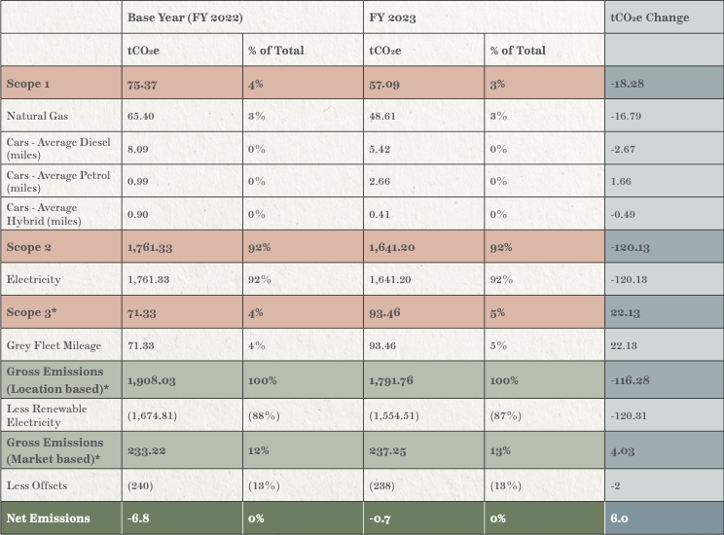FatFace GHG Emissions Summary (FatFace, 2024)

When comparing the carbon emissions output for Primark against Primark and the Post Office it shows that FatFace has made a positive change to reduce their carbon emissions although there is still work to be done. For scope 1 FatFace has reduced their tCO2e by -18.2% from 2023 to 2022 with Primark since 2018/2019 has increased by 12% despite the size difference of the two companies Primark has not been able to reduce their carbon emissions slightly when FatFace has made a significant difference to do so.

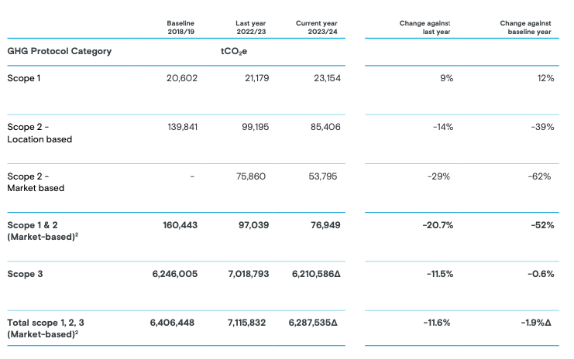
Primark GHG Emissions Summary (Primark, 2024)

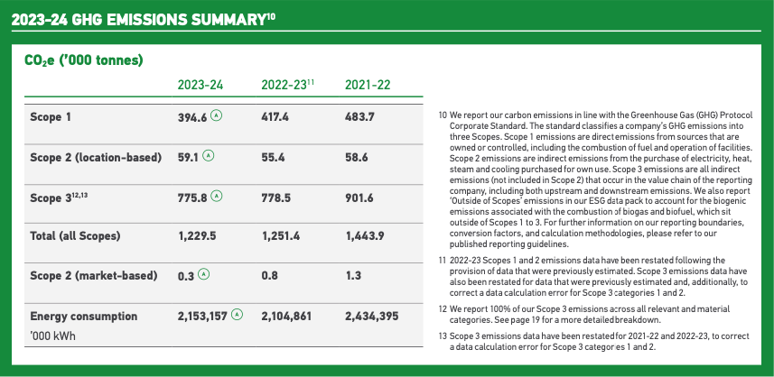
Post Office 2023-2024 GHG Emissions Summary (Post Office, 2024).

Product Sourcing

The products that are sourced for FatFace are mostly sourced in countries that are based in Asia and China producing 57% of products created and with the UK manufacturing 2% of all the products that are created despite FatFace being the home base for the business. These levels of products that are produced in Asia will have a negative effect on the emissions and scope levels for FatFace and them looking to become net zero in scope three. Moving production to countries that are closer to the UK may result in the cost of the products increasing but will show to their customers that they are looking forwards in terms of sustainability and their impact on the environment from the products that they produce.

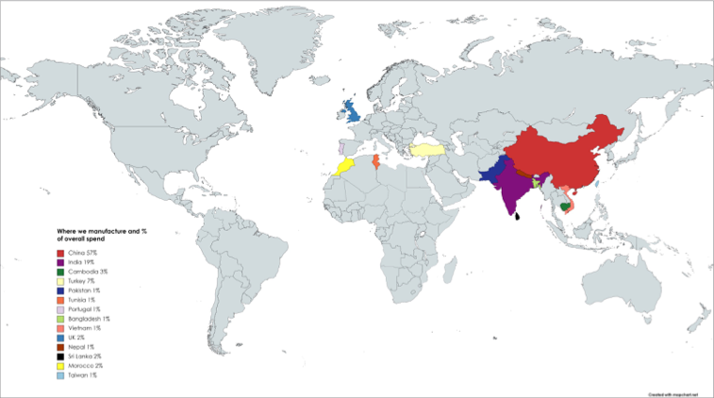
FatFace Product Sourcing By Country (FatFace, 2024)

Marketing

The marketing that FatFace is undertaking includes advertising the sustainable initiatives that are currently being undertaken. The reasoning for this is that Changing Markets Foundation found that 59% of claims that were made by companies from either the UK or Europe were either unsubstantiated or misleading to the consumers (Changing Markets Foundation, 2021). Additionally, they also found that nearly 50 major fashion brands had no strong promise in ending their usage to materials that are fossil fuel based (Changing Markets Foundation, 2021). This shows that despite the claims of being sustainable the majority do not follow through and actions must be shown to the public to ensure they are acting correctly. The actions that FatFace have undertaken to show that they are embracing sustainability, and the circular economy are in store clothing collection for recycling and reuse in 2018, achieving 100% responsibly sourced cotton for their products and achieving net zero for their operations in the UK (FatFace, 2024). To ensure that they are marketing themselves correctly FatFace have an ethical marketing policy that was established in May 2022 so that customers understand their commitment to sustainability and ethical marketing (FatFace, 2024). This is done through the usage of third party independent certification standards to ensure that all of the claims made by FatFace are correct and truthful (FatFace, 2024). Doing this can allow customers to have faith in the brand as any claims made by FatFace are accurate and factual.

Circular Economy

FatFace can move towards being a part of the circular economy through the recommendations that will be given which will allow for them to use the materials required for the business to have multiple lifetimes of usage. The recommendations such as clothing repair workshop will allow for clothing that has or has not been purchased from there to be given a new lease of life.

Research by Uribe-Toril et al., (2022) found that businesses that incorporated the circular economy in to their business practices are highly likely to continue throughout long periods of time. This shows that people would rather support businesses that are embracing sustainability and the circular economy than businesses that are not. By supporting businesses that have the circular economy as a important aspect it will allow for their continuing growth in sustainability as they can continue to invest in these aspects of the business.

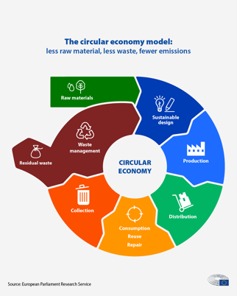
Circular Economy Model (European Parliament, 2023)

Recommendations

Recommendations
Short term (1 year) | Medium term (3 year) | Long term (5 year)
Implement a clothing repair workshops inside stores (low cost) | Implement car electric charging points at all stores (medium/high cost) | Assist employees in purchasing electric cars for grey fleet usage (high cost)

Short Term

Primark has been offering repair workshops for free in a large number of their stores as they aim to educate the public on how to care, repair and upcycle their clothing, Primark also offer online tutorials for people who are not able to attend the in store workshops (Primark, 2024). The workshops aim to inspire the people attending to customise, mend, embryoid or upcycle their clothing to extend the life of it (Primark, 2024). FatFace currently works with the Clothes Doctor where customer can send in clothing that either needs repairing or altering (Clothes Doctor, 2024). For this to happen an online form needs to be completed with a price given and then the clothing has to be sent off for the repair or alteration to happen. An alternative that FatFace can look to implement could be holding repair workshops similarly to Primark in their stores instead of customers sending the products away. Holding the workshops in their stores will allow for the wait time for customers to potentially be drastically reduced and the carbon emissions will be reduced too as clothing will not have to travel vast distances to be repaired. Another benefit for FatFace is that in store workshops may convince customers to purchase new items as they would be in store and may see new products that they would like to purchase that they would not have seen if they had posted the items instead. The potential cost for the workshops to the customer may be for the materials used, a set fee no matter the repair or alteration cost or no cost at all due to the fact that customers will be more likely to purchase new clothing.

Medium Term

FatFace should encourage employees that use their cars for their work to purchase either a hybrid or an electric vehicle so that it can allow for the tCO2e can be reduced for scope three for FatFace. As FatFace is already net zero in scope 1 and two reducing the carbon emissions for scope 3 will benefit the organisation in the future as it will have a better start when it aims to include scope 3 in their targets. FatFace has already started to install EV charging stations at two of their biggest stores so increasing the number of stores at which they have been installed at can lead to their usage by either their employee or customers who are visiting the stores (FatFace, 2024). Increasing the number of stores that have electric charging points will show not only to customers but also employees that they are moving towards becoming as net zero as possible. Research by Zhou et al., (2022) on electric charging points for vehicles investigated the charging points in Ireland; with the total number of charging points, demand to charge at each point and the likelihood of charging each day. It was discovered that when the number of vehicles using a single charging point increases by 5% the cost of construction for that point increases by 8% (Zhou et al., 2022). If the number of vehicles using a single charging point decreases by 5% then the cost of construction for that point decreases by 4% (Zhou et al., 2022). So, the cost for FatFace installing electric vehicle charging points will depend on their location as certain locations will be more busier than others so an investigation will need to be done to determine the overall cost. To offset the cost of installing the charging points payment to charge your vehicle can be implemented with differing prices for peak and off peak times. Doing this will incentivise customers to come outside of their normal hours and habits which can boost trade for the business in hours where they may traditionally struggle.

Long Term

With the addition of electric charging points at all of their stores the next step for FatFace would be assisting their employees in the purchasing of electric vehicles for the usage in the business and outside the business. This can be done by a step by step basis by starting with senior management who mostly use their personal car in the business for travel to various aspects of it. Doing this will allow for the tCO2e from grey fleet usage to come down significantly as it will benefit the employees and the business as the cost of traditional fuels continue to rise. The cost of this will be significant for the business but will be beneficial for it in the long term as both employees and the business may be relucent to purchase a vehicle that they may not have the full usage of. Finding a balance of contributions from both the business and employees will be key and if both want to contribute a certain percentage the limit on how much is spent in total. An analysis of which vehicles that would be most viable to change in reducing the tCO2e that comes from the grey fleet usage with starting with the vehicles that are the most emitters and working the way until all of the vehicles are changed.

Conclusion

The recommendations given in this report will give FatFace a greater boost when compared to other businesses in becoming a part of the circular economy. These recommendations have been given to allow FatFace to make the biggest impact possible for the organisation in the short, medium and long term. After each recommendation has been implemented there should be an analysis conducted to discover the effectiveness of the recommendation implementation to see what changes can be done in the future when looking to implement similar recommendations in to the organisation. After each analysis is completed, it may result in the other recommendations that have been given altering to become more realistic in achieving in the time frame given although the original recommendation may still be a target but at a later date.

Word Count: 2260

Reference List

Brown, J. R., & Guiffrida, A. L. (2014). Carbon emissions comparison of last mile delivery versus customer pickup. International Journal of Logistics Research and Applications, 17(6), 503-521.

Changing Markets Foundation. (2021). Fashion industry addicted to greenwashing and fossil-fuel based synthetics. Retrieved from: https://changingmarkets.org/wp-content/uploads/2021/06/SYNTHETICS-ANONYMOUS-PRESS-RELEASE-UK.pdf

Clothes Doctor. (2024). FatFace Services. Retrieved from: https://clothes-doctor.com/pages/fatface-services

European Parliament. (2023). Circular Economy: Definition, Importance and Benefits. Retrieved from: https://www.europarl.europa.eu/topics/en/article/20151201STO05603/circular-economy-definition-importance-and-benefits

FatFace. (2023). Our Environmental, Social And Governance Impact Report: June 2022 – May 2023: Retrieved from: https://xcdn.next.co.uk/pdfs/fatface/FatFace-ESG-Report.pdf

FatFace. (No Date). What Are My Delivery Options?. Retrieved from: https://help.fatface.com/hc/en-gb/articles/24627040674321-What-are-my-delivery-options

Royal Mail. (2024). ESG Report 2023-24. Retrieved from: https://www.royalmail.com/sites/royalmail.com/files/2024-06/Royal_Mail_ESG_Report_2023-24.pdf

Primark. (2024). Sustainability and Ethics Progress Report 2023/24. Retrieved from: https://primark.a.bigcontent.io/v1/static/Primark-Sustainability-and-Ethics-Progress-Report-2023-2024

Uribe-Toril, J., Ruiz-Real, J. L., Galindo Durán, A. C., Torres Arriaza, J. A., & de Pablo Valenciano, J. (2022). The Circular Economy and retail: using Deep Learning to predict business survival. Environmental Sciences Europe, 34(1), 2.

Zhou, G., Zhu, Z., & Luo, S. (2022). Location optimization of electric vehicle charging stations: Based on cost model and genetic algorithm. Energy, 247, 123437.

