

University of Wales Trinity Saint Davids
Ordnance, Munitions and Explosives Principals

Academic Year 2025

Eryn Legg

The importance of critical diameters and densities in relation to TNT, a secondary explosive, and Lead Azide, a primary explosive.

Supervisor: Dr Gareth Collett CBE

This thesis is submitted in partial fulfilment of the requirements for the degree of Ordnance, Munitions and Explosives BEng

© UWTSD 2025. All rights reserved. No part of this publication may be reproduced without the written permission of the copyright owner.

Academic integrity declaration
I declare that:
- the thesis submitted has been written by me alone.
- the thesis submitted has not been previously submitted to this university or any other.
- that all content, including primary and/or secondary data, is true to the best of my knowledge.
- that all quotations and references have been duly acknowledged according to the requirements of academic research.
I understand that to knowingly submit work in violation of the above statement will be considered by examiners as academic misconduct.

Abstract
Confinement and unconfinement of Lead Azide is important in design due to confinement offering safe handling and storage as well as minimising storage requirements however the immediate detonation after ignition means for little to no effect of ranging critical densities and diameters. The density of Lead Azide has a low variation due to the materials ability to be Dead Pressed which thus allows for minimal design variation of the critical diameter.
Confinement and unconfinement of TNT is important due to TNT being a secondary explosive. Where confinement offers advantages, such as increasing the temperature and pressure internally, the material can be under and over confined either resulting in confinement failure or energy absorption/waste. There is a greater critical diameter variation due to TNT’s vast manufacturing techniques all resulting in a vast ranging density which can cause detonation.

Keywords:
TNT
Lead Azide
Confined
Unconfined

Table of Contents
Academic integrity declaration i
Abstract ii
Keywords: ii
List of Figures iv
List of Tables v
List of Abbreviations vi
1 Literature review and information summarisation of Lead Azide's critical diameter and density 7
1.1 Primary understanding of Lead Azide and properties 7
1.1.1 Influence of critical diameter of Lead Azide and following detonation transition 7
1.1.2 Influence of critical density of Lead Azide and following detonation transition 7
1.2 Comparison of unconfined and confinement of Lead Azide design in reference to critical diameters and density 8
1.2.1 The importance of stimulus applied to Lead Azide and interaction with confinement 8
1.3 Theorisation of the effect of alterations of critical diameters and industry benefits 8
2 Literature review and information summarisation of TNT 's critical diameter and density 9
2.1 Primary understanding of TNT and properties 9
2.1.1 Influence of critical diameter of TNT and following detonation transition 9
2.1.2 Influence of critical density of TNT and following detonation transition 9
2.2 Comparison of unconfined and confinement of TNT design in reference to critical diameters and density 9
2.2.1 Velocity of detonation theoretically achieved from minimum to maximum density 10
2.3 Theorisation of the effect of alterations of critical diameters and industry benefits 11
3 Summarisation and overall comparison of both secondary and primary explosives 11
3.1 Visual Comparison of the densities, diameters, and velocities that can achieve successful detonation with TNT and Lead Azide 12
References 14

List of Figures
Figure 1; Density increase of pressed TNT and following mathematical effect on Detonation Velocity

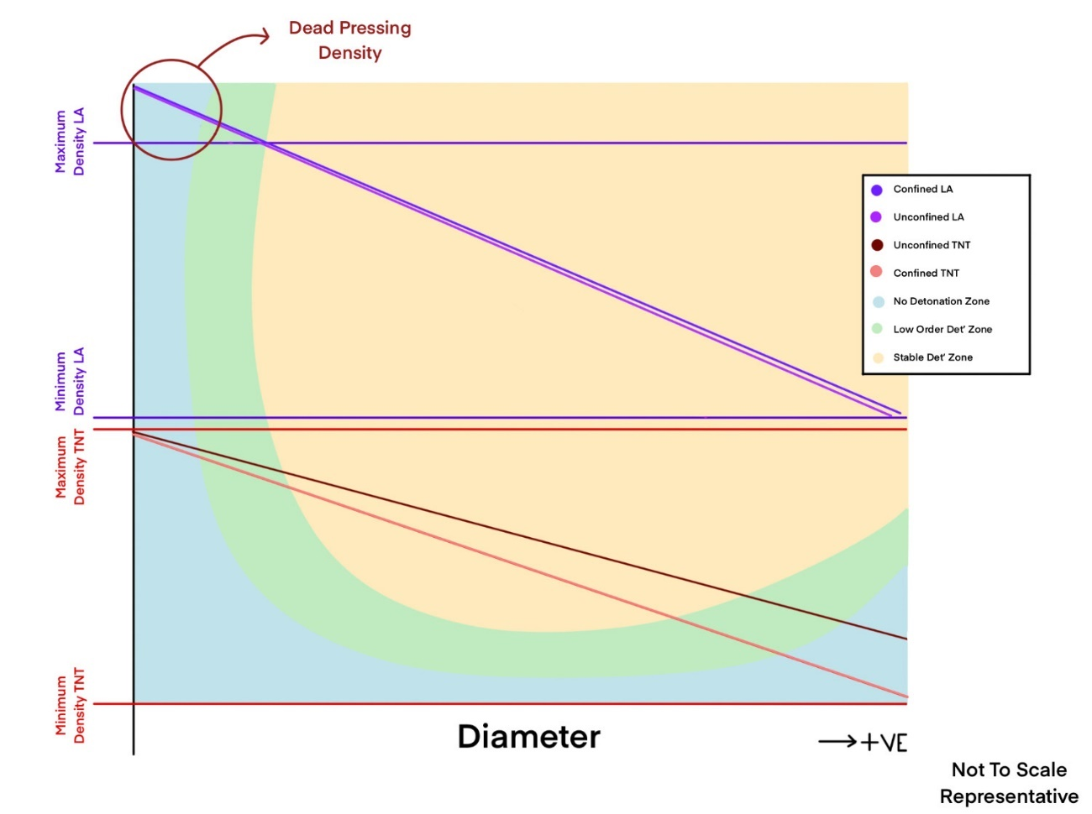
Figure 2 – Representative Figure Demonstrating TNT and Lead Azide’s density difference and diameter change based on confinement

List of Tables
Table 1; Calculated values of Density and Velocity with velocity converted to m/s for clarity

List of Abbreviations
ESD | Electro-Static Discharge
TDM | Theoretical maximum density
STD | Shock-to-Detonation transition
TNT | 2,4,6-trinitrotoluene

Literature review and information summarisation of Lead Azide's critical diameter and density

Primary understanding of Lead Azide and properties

Critical Diamer is commonly defined as; the minimum diameter needed to sustain stable detonation of an energetic material [2]. This diameter can be formed in either a confined vessel or an unconfined vessel, both of which determine the substances rate of reaction, velocity achieved, total substance used and material efficiency.

Critical density is defined commonly as; the minimum density required to sustain a detonation of a substance [2]. The density of a material can be affected by impurities of substance, manufacturing quality, manufacturing techniques and storage/handling techniques. The critical density is affected by the molecular makeup of the material.

Lead Azide is a highly sensitive, primary explosive which has applications in detonators and procession caps. Lead Azide is toxic and a carcinogen meaning specialised handling, storage and trackability is required.

Influence of critical diameter of Lead Azide and following detonation transition
The influence of critical diameter of Lead Azide is; under the general understanding that as you decrease the critical diameter of an energetic, the reactivity and sensitivity increases. Lead Azide specifically has a comparatively small critical diameter, a factor which is determined by the charge density and crystal size, from 0.01mm to 0.1mm. [5] Due to the minor diameter, this greatly effects the detonation transition as, although variant with what stimuli is used, the deflagration to detonation transition is practically immediate.

Influence of critical density of Lead Azide and following detonation transition
As Lead Azide is a primary explosive, ‘Dead Pressing’ can occur where the density is so great the material will not ignite due to the interactions between the tightly packed crystalised structures. However [6], Lead Azide is not easily Dead Pressed instead, it is more common to occur in peroxides.
If the Lead Azide has a density below the critical density for that diameter, propagation can occur inefficiently, resulting on a slower detonation transition (depending on the ignition method) and further detonation velocity.
An important aspect of understanding density is manufacturing error in the form of voids, temperature fluctuations, the assumption of a complete homogenous fill, and impurities of the material. All these must be considered of the material as they can affect the overall density.

Comparison of unconfined and confinement of Lead Azide design in reference to critical diameters and density
Confinement of a primary explosive affects the initiation efficiency however, in Lead Azide it is observed that due to the instantaneous detonation after ignition, the effect of confinement and confinement design variations has minimal affect and variation regardless of critical density and diameter. Furthermore, even the increased density of the confining material [7], usually would affect chance of detonation but does not with Lead Azide.
This conversely means that unconfined design of Lead Azide does not influence the critical diameter and density however due to Lead Azide high sensitivity, confinement offers other advantages such as storage safety and handling.

The importance of stimulus applied to Lead Azide and interaction with confinement
Contextually, the stimulus applied to Lead Azide is critical in the understanding of the critical density and diameter as different stimulus will cause different detonation effect. The four variants are heat, friction, ESD or spark.
Heat can cause rapid decomposition to deflagration as Lead Azide is thermally unstable, this will release energy and gas [10]. Shock alternatively has a similar effect of immediate detonation as the crystal structure compresses causing high-energy regions [11]. Friction, usually produced via mechanical rubbing, has the effect of initiation as localised heat and pressure can break down the chemical bonds in the azide [10]. Finally, ESD, meaning Electro-Static Discharge, interacts by a static spark delivers localised energy causing a chain reaction between the crystals [10].
Stimulus applied can also be influenced by the confinement of the material, contextually Lead Azide, undergoes deflagration to detonation transition is practically immediate with a comparatively low explosion heat temperature, making confinement and unconfinement have minimal effect.
Stimuli is crucial as Primary explosives are used to ignite secondary, due to secondary explosives being far less sensitive and therefore requiring far more stimuli, usually in the form of a shock wave, to cause successful ignition and detonation. Shock waves cause internal friction, increase pressure and temperature and adiabatic heating.

Theorisation of the effect of alterations of critical diameters and industry benefits
Due to Lead Azide having minimal variation regardless of its confinement, this allows for vast creative design options, the length, geometry, mass and other factors can be altered whilst still able to reach maximum detonation velocity.
An important considering however, due to lead being toxic, the use is heavily restricted to protect the British countryside and therefore the design has been phased out. [8]

Literature review and information summarisation of TNT 's critical diameter and density

Primary understanding of TNT and properties
TNT is a secondary explosive, known to be chemically stable and relatively insensitive compared to many other high explosives [11], has been used in both civil and defence industries. Since the 1890s, the material has been used in artillery as its incredibly low sensitivity meant safe storage and transport of the munitions was now possible.
The density of TNT at room temperature, 20ͦC, when pressed is 1.62 g/cc with a critical diameter that ranges depending on the manufacturing technic for example, a diameter of 2.62±0.56 mm when pressed or a diameter of 14.6±2.0 mm when creaming and casting [12], This results in an average detonation velocity of 6,900 m/s, the density and diameter greatly influencing these properties as density increases so does the detonation velocity.

Influence of critical diameter of TNT and following detonation transition
The influence of critical diameter of TNT is that TNT has a comparatively high critical diameter comparatively to other secondary explosives, this effects the design configurations as the TNT requires a large diameter charge or booster to achieve complete detonation. [13]

Influence of critical density of TNT and following detonation transition
The influence of critical density of TNT is as density increases the critical diameter decreases, this can allow for more ranging designs [14]. This higher density also results in an increased detonation velocity and shock propagation efficiency.
Unlike with primary explosives, TNT cannot be Dead Pressed and therefore the maximum density is due to the homogenous nature, mixed chemical compositions, and manufacturing technics and what is appropriate for the design and usage of the material at the time.

Comparison of unconfined and confinement of TNT design in reference to critical diameters and density
Confinement of a secondary explosive is expected to have the effect of peak pressure experienced externally increases, delays expansion, allows for fragmentation, alters local pressure and causes greater structural damage to the munitions. In TNT it is observed that when in confinement, TNT can sustain detonation at a smaller critical diameter [14], there is a direct negative correlation between strength of confinement and critical diameter, whereas strength increases, critical diameter decreases.
Confinement of TNT also results in a lower critical density where the lower shock impedance and slower reaction-zone [15] can be countered by the confinement increasing pressure and temperature behind the shock.
Unconfined designing of TNT usually results in the TNT needing to be closer to the ideal crystalline density as the material is comparatively insensitive and non-ideal, making its critical density and diameter greater than its confined counterpart.
In design confinement is more suited for munition and ordnance design as confinement offers higher temperature and pressure of the material through detonation resulting in a faster and more efficient end result. Over confinement can occur where energy becomes wasted due to being used on the destruction of the confinement, under confinement occurs when the material cannot sufficiently store the increasing temperature and pressure.

Velocity of detonation theoretically achieved from minimum to maximum density
The velocity of detonation is determined on several factors, including density. There are three primary ways to find this value; experimentation, calculation and simulation. When looking at the calculation side there are multiple factors which include error [15], such as critical diameter, confinement, temperature, humidity, initiation method and manufacturing method.
The density of TNT is greatly varied, pressed offering a density of as low as 1.35 g/cm³ and up to 1.6 g/cm³. When looking at pressed TNT the minimum velocity and theoretical maximum can be calculated by;
When 0.9 < Pa < 1.534
D = 1.873 + 3.187 Pa
When Pa > 1.534
D = 6.762 + 3.187(Pa – 1.534) – 25.1(Pa – 1.534)² + 115.056 (Pa – 1534)³
Where D = Detonation Velocity in mm/μm
Pa = Density in g/cm³ [15]
Figure 1; Density increase of pressed TNT and following mathematical effect on Detonation Velocity
Table 1; Calculated values of Density and Velocity with velocity converted to m/s for clarity
This only provides an approximation and indication of densities effect on the velocity of detonation of a material, not exacting values due to the high number of variables. This does show a positive correlation which is due to the chemical structure of TNT allowing for an increased velocity when tightly packed.

Theorisation of the effect of alterations of critical diameters and industry benefits
By manipulating the critical density and diameter of a secondary explosive, a munition can be designed to have a varying velocity of detonation. The control of this detonation allows more options of; distance travelled and therefore usage, greater external and internal material choice, geometry of design as well as several other key factors.
If you could hypothetically find the exact critical density to diameter range you could implement a design of a smaller, more compact munitions, which has advantages such as transportation, material costing and reduced storage, which has the same detonation velocity advantages as larger models.
Due to statistical manufacturing error, each density would have to have a tolerance due to ranging humidities, manufacturing error and contamination, storage variations and degradation over time.

Summarisation and overall comparison of both secondary and primary explosives
Primary explosives are less susceptible to variation of confined and unconfined due to the instantaneous detonation after ignition causing little statistical difference however, they have less fluctuation in density and diameter due to primarily their ability to be dead pressed and their molecular makeup. Whilst density and diameter do correlate, design of varied diameters are limited due to the restriction of density experimentation.
Secondary explosives are far more susceptible to the effects of confined and unconfined design as they are less sensitive but store greater potential energy, so confinement increases both temperature and pressure meaning when released the energy transfers faster and more forcefully. Over containment can cause energy loss into the containment system whilst under containment results in the containing material being unable to maintain the temperature and pressure reducing the explosives effectiveness.
Primary explosives have the advantage of having the usual purpose to ignite secondary explosives so the requirements are fewer with a higher tolerance, reducing manufacturing costs and storage costs, whilst secondary explosives have the usual purpose of destructivity, resulting in the design and use of secondary to have more varied requirements from: size, geometry, detonation velocity, temperature, stored pressure and control of explosion. In design confinement of secondary explosive offer’s more freedom of adjustments whilst lack of influence of confinement of primary explosives offers greater guarantee of ignition of a secondary explosive.
Contextually, Lead Azide has the properties of critical diameters in the range of 0.1mm to 0.01mm, which is 10 to 100 times smaller than most secondary explosives, including TNT [5]. whilst TNT has the properties of ranging critical diameter based on its density, manufacturing technique of that density, confinement and unconfinement methods and desired detonation velocity allowing for greater industrial potential designs and usages.

Visual Comparison of the densities, diameters, and velocities that can achieve successful detonation with TNT and Lead Azide
The diagram represents the difference in densities but the vast gradient differences between Lead Azide, confined and unconfined TNT. Seen in Figure 2, confinement and unconfining of Lead Azide results in little gradient difference between density and diameter, as the diameter increases and there is containment of energy raising pressure and temperature but due to the instantaneous detonation the effect of this is minimum. TNT is more greatly affected as the slower detonation allows other variables like internal pressure and temperature to increase the likelihood of successful detonation and therefore can decrease critical diameter.
Figure 2 – Representative Figure Demonstrating TNT and Lead Azide’s density difference and diameter change based on confinement
Lead Azide has been highlighted to show a ‘Dead Pressing Density’ where the material can be denser than its functional maximum, at this density, critical diameter is irrelevant as the crystalline structure is too tightly backed to go through complete detonation regardless of geometry. The choice for the diagram to remain non-quantitative is due to the magnitudes of difference between the materials, lead azide is around four times denser but can successfully detonate with a diameter less than 0.01mm [5] whilst TNT is around 150mm. [12]

References
[1]
D. J. Whelan and G. Bocksteiner, “Velocity of detonation, charge diameter and critical diameter in unconfined RDX-driven heterogeneous explosives,” Journal of Energetic Materials, vol. 13, no. 1–2, pp. 15–34, Mar. 1995, doi: https://doi.org/10.1080/07370659508019342.
[2]
R. J. Swinton and L. McVay, “Critical Diameter Study of Unconfined Australian Manufactured Composition B, Grades A and B.,” Department of Defence, Defence Science and Technology Organisation , Apr. 1997.
[3]
F. P. Bowden and H. T. Williams, “Initiation and propagation of explosion in azides and fulminates,” Proceedings of the Royal Society of London A Mathematical and Physical Sciences, vol. 208, no. 1093, pp. 176–188, Aug. 1951, doi: https://doi.org/10.1098/rspa.1951.0152.
[4]
A. J, “A Study of the behaviour of emulsion explosives,” PDF, Cranfield University , 2009. Accessed: Dec. 04, 2025. [Online]. Available: https://dspace.lib.cranfield.ac.uk/items/7b5d71e8-cb81-4168-9da3-36df83a0c67a
[5]
B. Khasainov, M. Comet, B. Veyssiere, and D. Spitzer, “On the Mechanism of Efficiency of Lead Azide,” Propellants Explosives Pyrotechnics, vol. 42, no. 5, pp. 547–557, Nov. 2016, doi: https://doi.org/10.1002/prep.201600075.
[6]
O. E. Petel, D. Mack, A. J. Higgins, R. Turcotte, and S. K. Chan, “Minimum propagation diameter and thickness of high explosives,” Journal of Loss Prevention in the Process Industries, vol. 20, no. 4–6, pp. 578–583, May 2007, doi: https://doi.org/10.1016/j.jlp.2007.05.007.
[7]
J. Akhavan, The chemistry of explosives. Cambridge: Royal Soc. Of Chemistry, 2012.
[8]
D. for, “Toxic lead ammunition banned to protect Britain’s countryside,” GOV.UK, Jul. 10, 2025. https://www.gov.uk/government/news/toxic-lead-ammunition-banned-to-protect-britains-countryside
[9]
“Introduction to Explosives,” The Royal Society of Chemistry eBooks, pp. 1–27, Mar. 2022, doi: https://doi.org/10.1039/bk9781839164460-00001.
[10]
I. Jaffe and D. Price, “Determination of the Critical Diameter of Explosive Materials,” ARS journal, vol. 32, no. 7, pp. 1060–1065, Jul. 1962, doi: https://doi.org/10.2514/8.6205.
[11]
J. T. Tisdale, C. E. Freye, A. H. Cleveland, B. L. Scott, L. G. Hill, and A. L. Duque, “Investigation of Physical and Chemical Properties of TNT after Spray Drying,” Crystal Growth & Design, vol. 23, no. 9, pp. 6902–6908, Jul. 2023, doi: https://doi.org/10.1021/acs.cgd.3c00729.
[12]
A. W. Campbell and R. Engelke, “Diameter effect in high-density heterogeneous explosives,” OSTI OAI (U.S. Department of Energy Office of Scientific and Technical Information), vol. LA-UR-76-1115, Jan. 1976.
[13]
A. S. Augusto et al., “Experimental Characterization of Cast Explosive Charges Used in Studies of Blast Effects on Structures,” CivilEng, vol. 6, no. 2, pp. 20–20, Apr. 2025, doi: https://doi.org/10.3390/civileng6020020.
[14]
Z.-X. Zhang, Rock Fracture and Blasting. Butterworth-Heinemann, 2016.
[15]
T. R. Gibbs and A. Popolato, LASL Explosive Property Data. University of California Press , 2020.
[16]
Michael L. Hobbs, Modelling TNT ignition with flow. SEM Annual Conference June 1-4, Albuquerque New Mexico USA, 2009

