Abstract
This report details the investigation into the impact of Gaussian white noise on the error rate for ASK, PSK, QPSK and QAM systems.
Digital signal processing and communication
ACDA5008

Table of Contents
Introduction 2
Background information 3
Communications system 3
Digital modulation 3
Amplitude shift keying (ASK) 3
Phase shift keying (PSK) 3
Quadrature phase shift keying (QPSK) 3
Quadrature amplitude modulation (QAM) 3
Gaussian White Noise 3
Bit Error Rate 3
Models 4
ASK 4
PSK 6
QPSK 8
QAM 10
Results 12
ASK 12
PSK 13
QPSK 14
QAM 15
Discussion 16
Conclusion 16
References 17
Annex A: ASK results 18
Annex B: PSK results 21
Annex C: QPSK results 24
Annex D: QAM results 27

Introduction
In this report the author will compare the performances of variants of amplitude shift keying (ASK) and phase shift keying (PSK) in the presence of additive white Gaussian noise (AWGN). In order to do this the author will explain the principles behind ASK and PSK then create models of ASK, PSK and more advanced variants such as quadrature phase shift keying (QPSK) and quadrature amplitude modulation (QAM) in Simulink and compare the performances. The system was considered to be failing when the percentage of bit error rate failure reached 50%.

Background information

Communications system
Each of the systems simulated in this report are communication systems and as such they each have three core elements, the transmitter, the channel and the receiver. The transmitter converts the message to be suitable for transmission over the channel, the channel is the means through which the signal is transmitted, and the receiver reconstructs the original message so it can be used. [1, p. 3]

Digital modulation
Baseband signals are not always suitable to be transmitted directly over a channel. The signals can be modified in a process called modulation where the signal is used to modify part of a high frequency carrier signal. [2, p. 10]

Amplitude shift keying (ASK)
Amplitude shift keying involves changing the amplitude of the carrier wave between different, discrete levels according to the digital data. It is used often in the transmission of digital data over optical fibre. [3, pp. 3-7]

Phase shift keying (PSK)
Phased shift keying involves changing the phase of the carrier wave at the beginning of a pulse. [3, p. 18]

Quadrature phase shift keying (QPSK)
Quadrature phase shift keying is where two binary PSK waves are combined. One of these waves represents odd numbered dibits while the second wave represents the even numbered dibits. [1, p. 360]

Quadrature amplitude modulation (QAM)
Quadrature amplitude modulation is a combination of both ASK and PSK where two signals are sent at the same time on the same carrier wave with different amplitudes. [1, pp. 370-371]

Gaussian White Noise
Noise within a system is when unwanted signals disturb the transmission and processing of signals. [1, pp. 179-180] In the modern world there is noise, both natural and manmade which can interfere with signals. Potential sources of this can include radio transmissions or atmospheric interference. [1, p. 3] Gaussian white noise “represents the ultimate in “randomness””. [1, p. 180] As a result, in the presence of noise in the channel the receiver will make errors in the reconstruction of the signal. [1, p. 324]

Bit Error Rate
The bit error rate is the number of errors which occur between the output signal and the demodulated signal.

Models
Each of the system types were constructed in Simulink and simulations were run on each with no noise present. For each system the amount of Additive White Gaussian noise (AWGN) was varied and the number of errors in the Bit Error Rate was recorded. As a result of the randomness of the noise and the presence of a Bernoulli random binary generator the same results will not be observed when simulations are rerun with the same parameters. [1, pp. 333-336] As a result, ten simulations were run on each, the results recorded, an average taken, and graphs produced. All simulations were run for 10 seconds. The Bernoulli random number generators were set to a sample probability of 0.5, meaning there is a 50/50 probability of getting a “1” or a “0” generated. The additive white Gaussian noise generators was set to Signal Noise Ratio (SNR) with an initial seed set to “67”.
The error rate calculator for each showed the following:
- Error rate
- Number of errors detected
- Total number of symbols transmitted

ASK
The ASK system was constructed as shown in Figure 1. The sine wave generator was set to an amplitude of “1” and the frequency set to 2xπx100 with a sample rate of 1/1000. The filter was designed to be a low pass filter with the details set up as shown in Figure 2. The time delay added to the original signal as it passed into the error rate calculator was set to 0.055 and the sample time set for the signal specification was set to “1”.
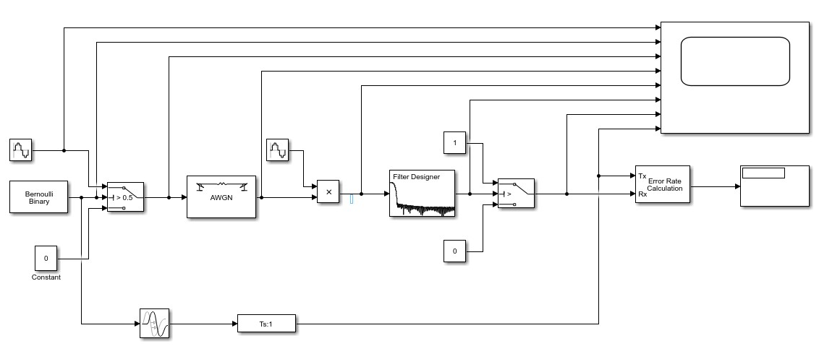
Figure 1: ASK block diagram

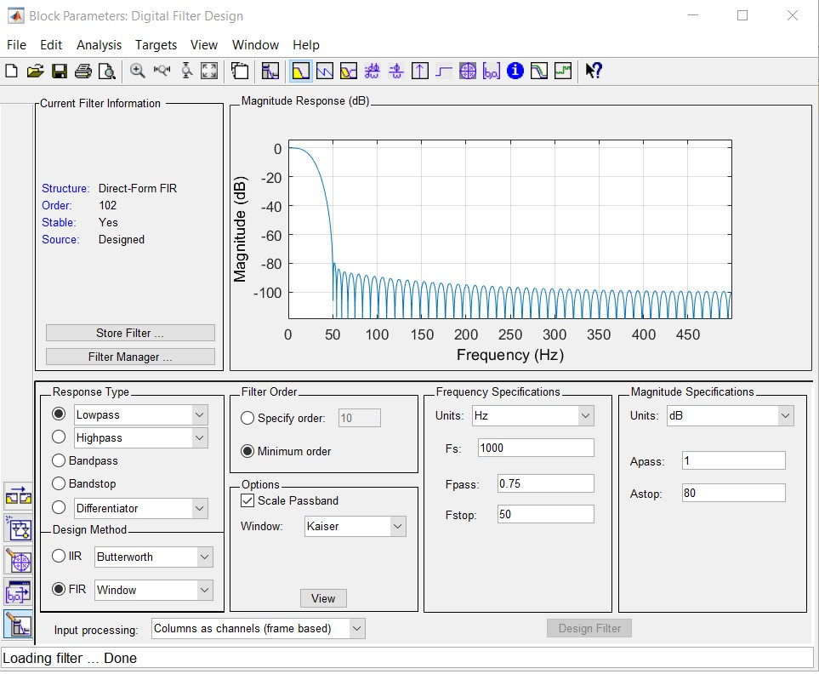
Figure 2: ASK filter design
The graph derived from the oscilloscope of the system without any noise added (Figure 3) showed the following information:
- Line 1: The carrier wave
- Line 2: The signal from the Bernoulli random number generator
- Line 3: The modulated signal
- Line 4: The transmitted signal including the added noise
- Line 5: The demodulated signal
- Line 6: The filtered signal
- Line 7: The output signal
- Line 8: The original signal from the Bernoulli random number generator with a delay added
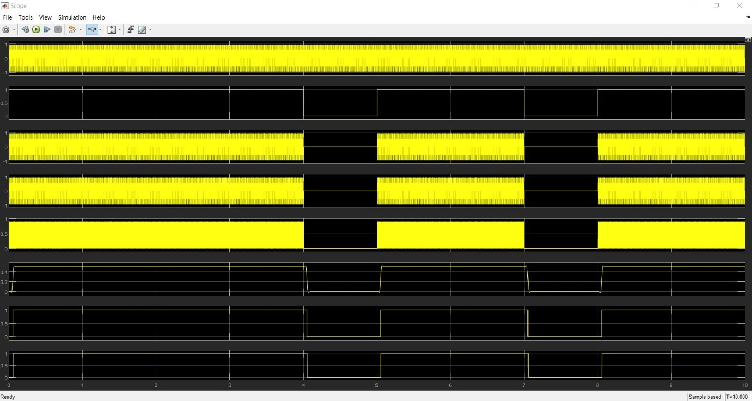
Figure 3: Oscilloscope of the ASK without noise

PSK
The PSK system was constructed as shown in Figure 4. The two sine waves were both set to an amplitude of “1”, the frequency set to 2xπx100 with a sample rate of 1/1000. The phase of one of the sine waves was set to “0” whilst the other was set to “π”. The filter was designed to be a low pass filter with the details set up as shown in Figure 5. The time delay added to the original signal as it passed into the error rate calculator was set to 0.06 and the sample time set for the signal specification was set to “1”.
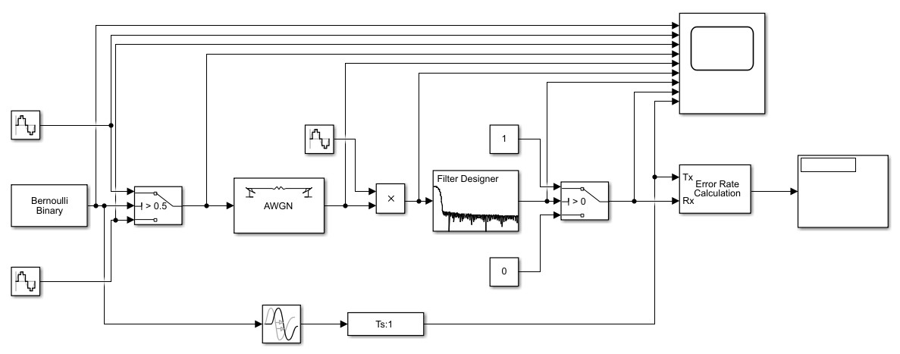
Figure 4: PSK block diagram
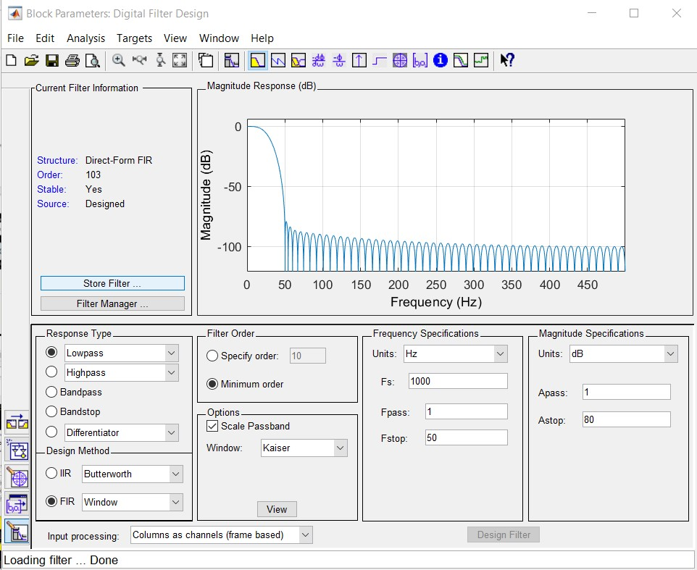
Figure 5: PSK filter design
The graph derived from the oscilloscope of the system without any noise added (Figure 6) showed the following information:
- Line 1: The signal from the Bernoulli random number generator
- Line 2: The carrier wave
- Line 3: The out of phase signal
- Line 4: The modulated signal
- Line 5: The transmitted signal including the added noise
- Line 6: The demodulated signal
- Line 7: The filtered signal
- Line 8: The output signal
- Line 9: The original signal from the Bernoulli random number generator with a delay added

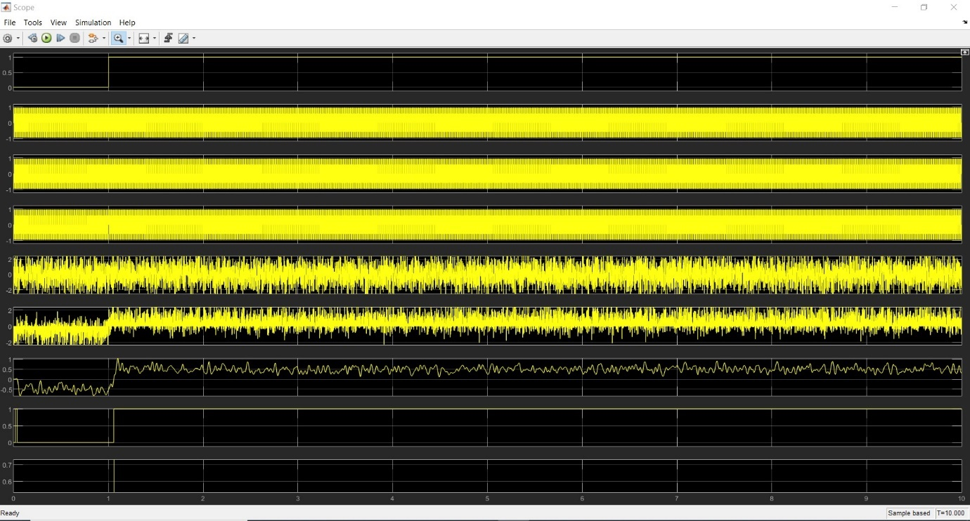
Figure 6: Oscilloscope of the PSK without noise

QPSK
The QPSK system was constructed as shown in Figure 7.
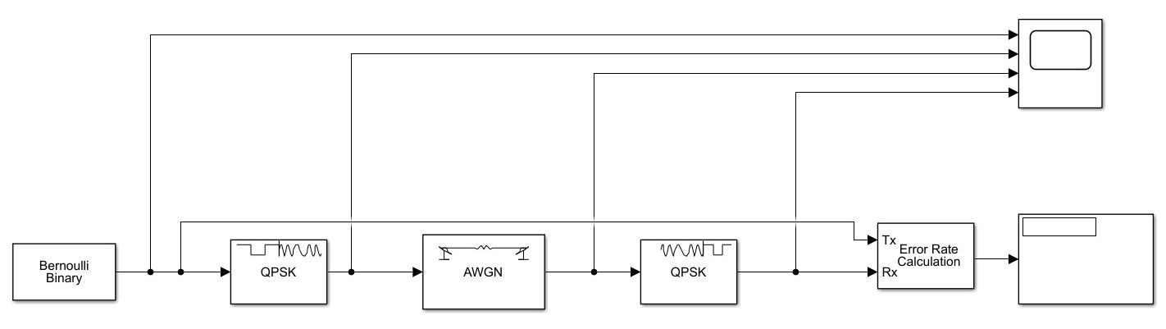
Figure 7: QPSK block diagram
The graph derived from the oscilloscope of the system without any noise added (Figure 8) showed the following information:
- Line 1: The signal from the Bernoulli random number generator
- Line 2: The modulated signal
- Line 3: The transmitted signal including the added noise
- Line 4: The demodulated signal

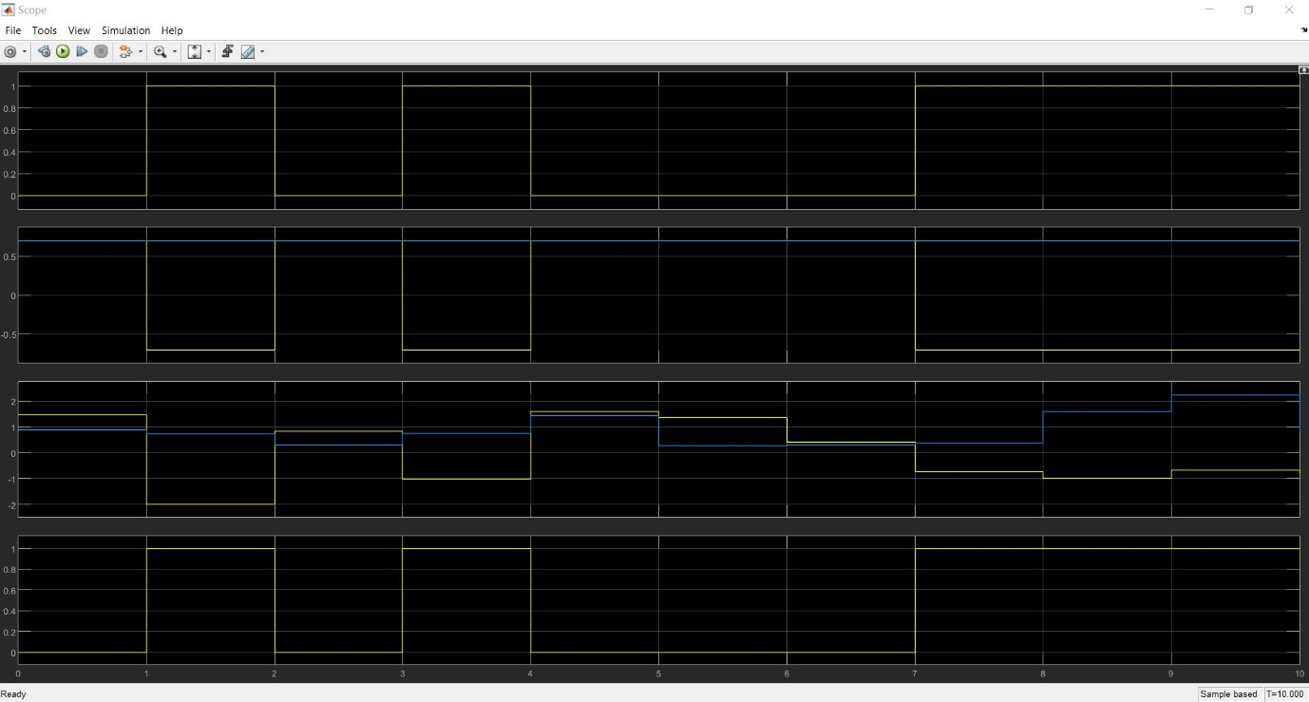
Figure 8: Oscilloscope of the QPSK with no noise
The constellation diagram for this system is shown in Figure 9.
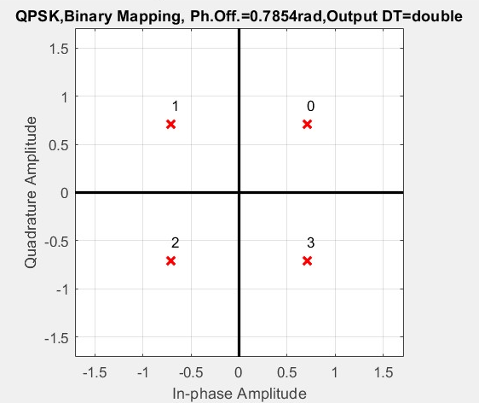
Figure 9: QPSK constellation diagram

QAM
The QAM system was constructed as shown in Figure 10.
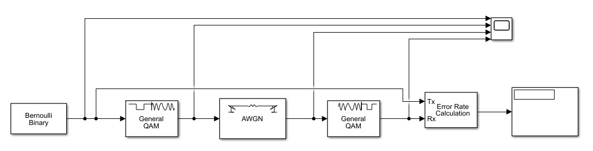
Figure 10: QAM block diagram
The graph derived from the oscilloscope of the system without any noise added (Figure 11) showed the following information:
- Line 1: The signal from the Bernoulli random number generator
- Line 2: The modulated signal
- Line 3: The transmitted signal including the added noise
- Line 4: The demodulated signal
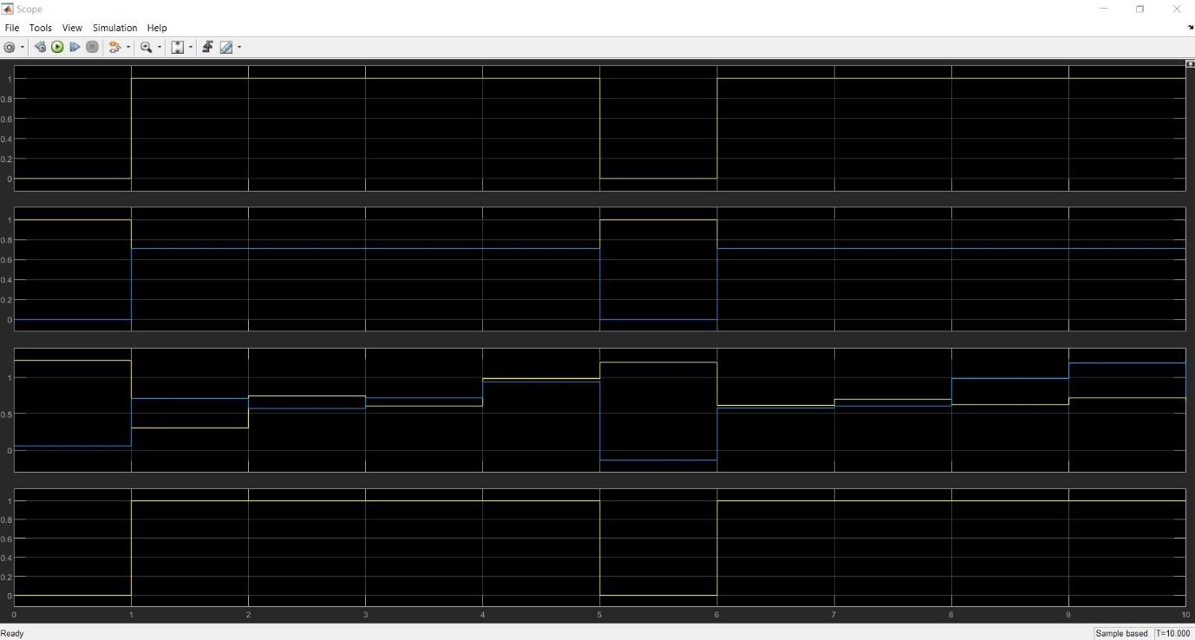
Figure 11: Oscilloscope for the QAM with no noise
The constellation diagram for this system is shown in Figure 12.
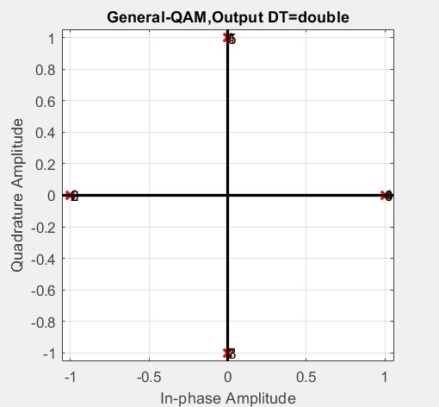
Figure 12: QAM constellation diagram

Results
The results for each simulation for all four models are shown in Annex A-D. For each simulation the error rate and the number of errors were recorded. The averages were taken, the percentage of failure was calculated and graphs of percentage failure against the noise were produced.

ASK
The average results for the ASK system are shown in Figure 13 and the graph of the percentage of failure against the noise is shown in Figure 14. These results show that as the noise increases up to 100db the percentage of errors increases gradually and settles between 40-50% at the 30db point.
Averages
Noise (db) | Error rate | Number of errors detected | Percentage failure
0 | 0.09 | 1 | 9.09
-10 | 0.22 | 2.4 | 21.82
-20 | 0.36 | 4 | 36.36
-30 | 0.4 | 4.4 | 40.00
-40 | 0.4 | 4.4 | 40.00
-50 | 0.47 | 5.2 | 47.27
-60 | 0.42 | 4.6 | 41.82
-70 | 0.41 | 4.5 | 40.91
-80 | 0.44 | 4.8 | 43.64
-90 | 0.54 | 5.9 | 53.64
-100 | 0.46 | 5.1 | 46.36
Figure 13: ASK average results table

Figure 14: Graph of noise against percentage failure for ASK

PSK
The average results for the PSK system are shown in Figure 15 and the graph of the percentage of failure against the noise is shown in Figure 16. These results show that as the noise increases up to 100db the percentage of errors increases gradually and settles between 40-50% at the 40db point.
Averages
Noise (db) | Error rate | No errors detected | Percentage failure
0 | 0 | 0 | 0.00
-10 | 0.144 | 1.6 | 14.55
-20 | 0.261 | 2.9 | 26.36
-30 | 0.352 | 3.9 | 35.45
-40 | 0.425 | 4.7 | 42.73
-50 | 0.444 | 4.9 | 44.55
-60 | 0.471 | 5.2 | 47.27
-70 | 0.464 | 5.1 | 46.36
-80 | 0.509 | 5.6 | 50.91
-90 | 0.49 | 5.4 | 49.09
-100 | 0.519 | 5.7 | 51.82
Figure 15: PSK average results table

Figure 16: Graph of noise against percentage failure for PSK

QPSK
The average results for the QPSK system are shown in Figure 17 and the graph of the percentage of failure against the noise is shown in Figure 18. These results show that as the noise increases up to 100db the percentage of errors increases dramatically with a small amount of noise with a percentage failure of between 60-80% occurring with 10db of noise.

Averages
Noise (db) | Error rate | No errors detected | Percentage failure
0 | 0.108 | 1.2 | 10.91
-10 | 0.63 | 6.9 | 62.73
-20 | 0.639 | 7 | 63.64
-30 | 0.595 | 6.5 | 59.09
-40 | 0.739 | 8.1 | 73.64
-50 | 0.667 | 7.2 | 65.45
-60 | 0.73 | 8 | 72.73
-70 | 0.676 | 7.4 | 67.27
-80 | 0.702 | 7.7 | 70.00
-90 | 0.784 | 8.6 | 78.18
-100 | 0.685 | 7.5 | 68.18
Figure 17: QPSK average results table

Figure 18: Graph of noise against percentage failure for QPSK

QAM
The average results for the QPSK system are shown in Figure 19 and the graph of the percentage of failure against the noise is shown in Figure 20. These results show that as the noise increases up to 100db the percentage of errors increases dramatically with a small amount of noise with a percentage failure of over 80% occurring with 10db of noise and over 90% with 20db of noise.
Averages
Noise (db) | Error rate | No errors detected | Percentage failure
0 | 0.054 | 0.6 | 5.45
-10 | 0.793 | 8.7 | 79.09
-20 | 0.91 | 10 | 90.91
-30 | 0.91 | 10 | 90.91
-40 | 0.91 | 10 | 90.91
-50 | 0.928 | 10.2 | 92.73
-60 | 0.928 | 10.2 | 92.73
-70 | 0.964 | 10.6 | 96.36
-80 | 0.919 | 10.1 | 91.82
-90 | 0.919 | 10.1 | 91.82
-100 | 0.946 | 10.4 | 94.55
Figure 19: QAM average results table

Figure 20: Graph of noise against percentage failure for QAM

Discussion
The results from the simulations show both the ASK and the PSK systems are more resilient to noise than the QPSK and the QAM systems. Although the percentage of failure increased as the noise increased for the ASK and PSK simulations they didn’t reach the 50% failure rate until the noise reached around 80-90db. The QPSK and QAM both suffered high failure rates with very little noise introduced with the QPSK having a slightly lower percentage failure rate than the QAM. This is to be expected due to the QAM having a more complex constellation than QPSK.
Some of the errors which occurred within the ASK and the PSK simulations may have been a result of the demodulated signal and the original signal not being synchronised as they enter the bit error calculator or the synchronisation of the sine waves at the transmitter and the receiver. The synchronisation of these waves is essential to ensure that the bit error calculator calculates the error correctly and the signal can be demodulated correctly respectively.
QPSK and QAM systems can transmit more symbols than ASK and PSK systems. [4, pp. 81-82] There is a trade-off, however, as an increase in the number of symbols transmitted makes it more difficult for the receiver to detect each symbol in the constellation which can increase the number of errors. [4, p. 83] A slight error in the phase or frequency of the carrier wave at the demodulator will result in a loss or a distortion of the signal and increase the errors. [2, p. 171]
If more results were taken at smaller noise intervals it would be possible to determine the how little noise was required for the QAM and QPSK to begin failure. For the ASK and PSK systems increasing the noise over 100db would allow the point which they both fail to be determined. Increasing the time the simulation was run for would allow more data to be transmitted and therefore allow a more accurate representation of the percentage of failure to be determined.

Conclusion
Although the QPSK and QAM systems can transmit more data than ASK and PSK systems they are more susceptible to noise with even small amounts causing a large percentage of symbol errors. QPSK and QAM systems would need to have shielding against noise designed into the system to prevent noise from interfering with the signal and causing errors.

References

[1] | S. Haykin, Digital Communication Systems, John Wiley & Sons Inc, 2014.
[2] | B.P.Lathi, Modern Digital and Analog Communication Systems, Oxford: Oxford University Press, 1998.
[3] | D. S. Mosey, “UWTSD Moodle,” 2020. [Online]. Available: https://moodle.uwtsd.ac.uk/course/view.php?id=1984. [Accessed 28 11 2020].
[4] | M. Parker, Digital SIgnal Processing, Oxford: Elsevier, 2010.

Annex A: ASK results

ASK
Run Serial | Noise (db) | Error rate | Number of errors detected | Total no of symbols
1 | 0 | 0.09 | 1 | 11
2 | 0 | 0.09 | 1 | 11
3 | 0 | 0.09 | 1 | 11
4 | 0 | 0.09 | 1 | 11
5 | 0 | 0.09 | 1 | 11
6 | 0 | 0.09 | 1 | 11
7 | 0 | 0.09 | 1 | 11
8 | 0 | 0.09 | 1 | 11
9 | 0 | 0.09 | 1 | 11
10 | 0 | 0.09 | 1 | 11
Average |  | 0.09 | 1
1 | -10 | 0.18 | 2 | 11
2 | -10 | 0.27 | 3 | 11
3 | -10 | 0.27 | 3 | 11
4 | -10 | 0.18 | 2 | 11
5 | -10 | 0.09 | 1 | 11
6 | -10 | 0.18 | 2 | 11
7 | -10 | 0.09 | 1 | 11
8 | -10 | 0.36 | 4 | 11
9 | -10 | 0.36 | 4 | 11
10 | -10 | 0.18 | 2 | 11
Average |  | 0.216 | 2.4 | 11
1 | -20 | 0.27 | 3 | 11
2 | -20 | 0.27 | 3 | 11
3 | -20 | 0.36 | 4 | 11
4 | -20 | 0.45 | 5 | 11
5 | -20 | 0.36 | 4 | 11
6 | -20 | 0.27 | 3 | 11
7 | -20 | 0.45 | 5 | 11
8 | -20 | 0.55 | 6 | 11
9 | -20 | 0.45 | 5 | 11
10 | -20 | 0.18 | 2 | 11
Average |  | 0.361 | 4 | 11
1 | -30 | 0.36 | 4 | 11
2 | -30 | 0.45 | 5 | 11
3 | -30 | 0.27 | 3 | 11
4 | -30 | 0.36 | 4 | 11
5 | -30 | 0.55 | 6 | 11
6 | -30 | 0.18 | 2 | 11
7 | -30 | 0.45 | 5 | 11
8 | -30 | 0.36 | 4 | 11
9 | -30 | 0.64 | 7 | 11
10 | -30 | 0.36 | 4 | 11
Average |  | 0.398 | 4.4 | 11
1 | -40 | 0.09 | 1 | 11
2 | -40 | 0.45 | 5 | 11
3 | -40 | 0.55 | 6 | 11
4 | -40 | 0.45 | 5 | 11
5 | -40 | 0.45 | 5 | 11
6 | -40 | 0.73 | 8 | 11
7 | -40 | 0.27 | 3 | 11
8 | -40 | 0.36 | 4 | 11
9 | -40 | 0.27 | 3 | 11
10 | -40 | 0.36 | 4 | 11
Average |  | 0.398 | 4.4 | 11
1 | -50 | 0.36 | 4 | 11
2 | -50 | 0.55 | 6 | 11
3 | -50 | 0.45 | 5 | 11
4 | -50 | 0.36 | 4 | 11
5 | -50 | 0.64 | 7 | 11
6 | -50 | 0.73 | 8 | 11
7 | -50 | 0.64 | 7 | 11
8 | -50 | 0.45 | 5 | 11
9 | -50 | 0.27 | 3 | 11
10 | -50 | 0.27 | 3 | 11
Average |  | 0.472 | 5.2 | 11
1 | -60 | 0.55 | 6 | 11
2 | -60 | 0.64 | 7 | 11
3 | -60 | 0.27 | 3 | 11
4 | -60 | 0.45 | 5 | 11
5 | -60 | 0.36 | 4 | 11
6 | -60 | 0.45 | 5 | 11
7 | -60 | 0.27 | 3 | 11
8 | -60 | 0.18 | 2 | 11
9 | -60 | 0.45 | 5 | 11
10 | -60 | 0.55 | 6 | 11
Average |  | 0.417 | 4.6 | 11
1 | -70 | 0.36 | 4 | 11
2 | -70 | 0.45 | 5 | 11
3 | -70 | 0.45 | 5 | 11
4 | -70 | 0.27 | 3 | 11
5 | -70 | 0.36 | 4 | 11
6 | -70 | 0.45 | 5 | 11
7 | -70 | 0.55 | 6 | 11
8 | -70 | 0.45 | 5 | 11
9 | -70 | 0.27 | 3 | 11
10 | -70 | 0.45 | 5 | 11
Average |  | 0.406 | 4.5 | 11
1 | -80 | 0.36 | 4 | 11
2 | -80 | 0.45 | 5 | 11
3 | -80 | 0.27 | 3 | 11
4 | -80 | 0.55 | 6 | 11
5 | -80 | 0.36 | 4 | 11
6 | -80 | 0.45 | 5 | 11
7 | -80 | 0.64 | 7 | 11
8 | -80 | 0.36 | 4 | 11
9 | -80 | 0.55 | 6 | 11
10 | -80 | 0.36 | 4 | 11
Average |  | 0.435 | 4.8 | 11
1 | -90 | 0.55 | 6 | 11
2 | -90 | 0.55 | 6 | 11
3 | -90 | 0.55 | 6 | 11
4 | -90 | 0.64 | 7 | 11
5 | -90 | 0.55 | 6 | 11
6 | -90 | 0.45 | 5 | 11
7 | -90 | 0.64 | 7 | 11
8 | -90 | 0.36 | 4 | 11
9 | -90 | 0.73 | 8 | 11
10 | -90 | 0.36 | 4 | 11
Average |  | 0.538 | 5.9 | 11
1 | -100 | 0.18 | 2 | 11
2 | -100 | 0.55 | 6 | 11
3 | -100 | 0.45 | 5 | 11
4 | -100 | 0.82 | 9 | 11
5 | -100 | 0.45 | 5 | 11
6 | -100 | 0.36 | 4 | 11
7 | -100 | 0.55 | 6 | 11
8 | -100 | 0.64 | 7 | 11
9 | -100 | 0.27 | 3 | 11
10 | -100 | 0.36 | 4 | 11
Average |  | 0.463 | 5.1 | 11

Annex B: PSK results

PSK
Run Serial | Noise (db) | Error rate | Number of errors detected | Total no of symbols
1 | 0 | 0 | 0 | 11
2 | 0 | 0 | 0 | 11
3 | 0 | 0 | 0 | 11
4 | 0 | 0 | 0 | 11
5 | 0 | 0 | 0 | 11
6 | 0 | 0 | 0 | 11
7 | 0 | 0 | 0 | 11
8 | 0 | 0 | 0 | 11
9 | 0 | 0 | 0 | 11
10 | 0 | 0 | 0 | 11
Average |  | 0 | 0 | 11
1 | -10 | 0.09 | 1 | 11
2 | -10 | 0.18 | 2 | 11
3 | -10 | 0.09 | 1 | 11
4 | -10 | 0.09 | 1 | 11
5 | -10 | 0.27 | 3 | 11
6 | -10 | 0.09 | 1 | 11
7 | -10 | 0.09 | 1 | 11
8 | -10 | 0.18 | 2 | 11
9 | -10 | 0.27 | 3 | 11
10 | -10 | 0.09 | 1 | 11
Average |  | 0.144 | 1.6 | 11
1 | -20 | 0.27 | 3 | 11
2 | -20 | 0.27 | 3 | 11
3 | -20 | 0.27 | 3 | 11
4 | -20 | 0.09 | 1 | 11
5 | -20 | 0.18 | 2 | 11
6 | -20 | 0.36 | 4 | 11
7 | -20 | 0.27 | 3 | 11
8 | -20 | 0.36 | 4 | 11
9 | -20 | 0.18 | 2 | 11
10 | -20 | 0.36 | 4 | 11
Average |  | 0.261 | 2.9 | 11
1 | -30 | 0.36 | 4 | 11
2 | -30 | 0.36 | 4 | 11
3 | -30 | 0.36 | 4 | 11
4 | -30 | 0.09 | 1 | 11
5 | -30 | 0.36 | 4 | 11
6 | -30 | 0.55 | 6 | 11
7 | -30 | 0.36 | 4 | 11
8 | -30 | 0.27 | 3 | 11
9 | -30 | 0.45 | 5 | 11
10 | -30 | 0.36 | 4 | 11
Average |  | 0.352 | 3.9 | 11
1 | -40 | 0.55 | 6 | 11
2 | -40 | 0.45 | 5 | 11
3 | -40 | 0.45 | 5 | 11
4 | -40 | 0.18 | 2 | 11
5 | -40 | 0.45 | 5 | 11
6 | -40 | 0.36 | 4 | 11
7 | -40 | 0.73 | 8 | 11
8 | -40 | 0.45 | 5 | 11
9 | -40 | 0.45 | 5 | 11
10 | -40 | 0.18 | 2 | 11
Average |  | 0.425 | 4.7 | 11
1 | -50 | 0.36 | 4 | 11
2 | -50 | 0.45 | 5 | 11
3 | -50 | 0.36 | 4 | 11
4 | -50 | 0.36 | 4 | 11
5 | -50 | 0.64 | 7 | 11
6 | -50 | 0.36 | 4 | 11
7 | -50 | 0.36 | 4 | 11
8 | -50 | 0.55 | 6 | 11
9 | -50 | 0.45 | 5 | 11
10 | -50 | 0.55 | 6 | 11
Average |  | 0.444 | 4.9 | 11
1 | -60 | 0.45 | 5 | 11
2 | -60 | 0.36 | 4 | 11
3 | -60 | 0.36 | 4 | 11
4 | -60 | 0.64 | 7 | 11
5 | -60 | 0.45 | 5 | 11
6 | -60 | 0.18 | 2 | 11
7 | -60 | 0.45 | 5 | 11
8 | -60 | 0.36 | 4 | 11
9 | -60 | 0.82 | 9 | 11
10 | -60 | 0.64 | 7 | 11
Average |  | 0.471 | 5.2 | 11
1 | -70 | 0.55 | 6 | 11
2 | -70 | 0.64 | 7 | 11
3 | -70 | 0.27 | 3 | 11
4 | -70 | 0.55 | 6 | 11
5 | -70 | 0.45 | 5 | 11
6 | -70 | 0.55 | 6 | 11
7 | -70 | 0.36 | 4 | 11
8 | -70 | 0.64 | 7 | 11
9 | -70 | 0.27 | 3 | 11
10 | -70 | 0.36 | 4 | 11
Average |  | 0.464 | 5.1 | 11
1 | -80 | 0.64 | 7 | 11
2 | -80 | 0.55 | 6 | 11
3 | -80 | 0.45 | 5 | 11
4 | -80 | 0.64 | 7 | 11
5 | -80 | 0.45 | 5 | 11
6 | -80 | 0.73 | 8 | 11
7 | -80 | 0.36 | 4 | 11
8 | -80 | 0.27 | 3 | 11
9 | -80 | 0.64 | 7 | 11
10 | -80 | 0.36 | 4 | 11
Average |  | 0.509 | 5.6 | 11
1 | -90 | 0.73 | 8 | 11
2 | -90 | 0.64 | 7 | 11
3 | -90 | 0.55 | 6 | 11
4 | -90 | 0.45 | 5 | 11
5 | -90 | 0.36 | 4 | 11
6 | -90 | 0.45 | 5 | 11
7 | -90 | 0.36 | 4 | 11
8 | -90 | 0.36 | 4 | 11
9 | -90 | 0.55 | 6 | 11
10 | -90 | 0.45 | 5 | 11
Average |  | 0.49 | 5.4 | 11
1 | -100 | 0.73 | 8 | 11
2 | -100 | 0.18 | 2 | 11
3 | -100 | 0.36 | 4 | 11
4 | -100 | 0.36 | 4 | 11
5 | -100 | 0.64 | 7 | 11
6 | -100 | 0.64 | 7 | 11
7 | -100 | 0.36 | 4 | 11
8 | -100 | 0.64 | 7 | 11
9 | -100 | 0.55 | 6 | 11
10 | -100 | 0.73 | 8 | 11
Average |  | 0.519 | 5.7 | 11

Annex C: QPSK results

QPSK
Run Serial | Noise (db) | Error rate | Number of errors detected | Total no of symbols
1 | 0 | 0.18 | 2
2 | 0 | 0 | 0
3 | 0 | 0.18 | 2
4 | 0 | 0.27 | 3
5 | 0 | 0.09 | 1
6 | 0 | 0.09 | 1
7 | 0 | 0 | 0
8 | 0 | 0.18 | 2
9 | 0 | 0 | 0
10 | 0 | 0.09 | 1
Average |  | 0.108 | 1.2
1 | -10 | 0.64 | 7
2 | -10 | 0.64 | 7
3 | -10 | 0.64 | 7
4 | -10 | 0.36 | 4
5 | -10 | 0.64 | 7
6 | -10 | 0.55 | 6
7 | -10 | 0.64 | 7
8 | -10 | 0.82 | 9
9 | -10 | 0.55 | 6
10 | -10 | 0.82 | 9
Average |  | 0.63 | 6.9
1 | -20 | 0.73 | 8
2 | -20 | 0.64 | 7
3 | -20 | 0.64 | 7
4 | -20 | 0.55 | 6
5 | -20 | 0.91 | 10
6 | -20 | 0.73 | 8
7 | -20 | 0.64 | 7
8 | -20 | 0.55 | 6
9 | -20 | 0.55 | 6
10 | -20 | 0.45 | 5
Average |  | 0.639 | 7
1 | -30 | 0.55 | 6
2 | -30 | 0.64 | 7
3 | -30 | 0.64 | 7
4 | -30 | 0.55 | 6
5 | -30 | 0.64 | 7
6 | -30 | 0.55 | 6
7 | -30 | 0.64 | 7
8 | -30 | 0.64 | 7
9 | -30 | 0.55 | 6
10 | -30 | 0.55 | 6
Average |  | 0.595 | 6.5
1 | -40 | 0.82 | 9
2 | -40 | 0.82 | 9
3 | -40 | 0.73 | 8
4 | -40 | 0.73 | 8
5 | -40 | 0.64 | 7
6 | -40 | 0.82 | 9
7 | -40 | 0.73 | 8
8 | -40 | 0.73 | 8
9 | -40 | 0.82 | 9
10 | -40 | 0.55 | 6
Average |  | 0.739 | 8.1
1 | -50 | 0.82 | 9
2 | -50 | 0.73 | 8
3 | -50 | 0.64 | 7
4 | -50 | 0.64 | 7
5 | -50 | 0.82 | 8
6 | -50 | 0.55 | 6
7 | -50 | 0.64 | 7
8 | -50 | 0.55 | 6
9 | -50 | 0.64 | 7
10 | -50 | 0.64 | 7
Average |  | 0.667 | 7.2
1 | -60 | 0.82 | 9
2 | -60 | 0.73 | 8
3 | -60 | 0.64 | 7
4 | -60 | 0.82 | 9
5 | -60 | 0.64 | 7
6 | -60 | 0.82 | 9
7 | -60 | 0.64 | 7
8 | -60 | 0.73 | 8
9 | -60 | 0.73 | 8
10 | -60 | 0.73 | 8
Average |  | 0.73 | 8
1 | -70 | 0.73 | 8
2 | -70 | 0.73 | 8
3 | -70 | 0.73 | 8
4 | -70 | 0.64 | 7
5 | -70 | 0.73 | 8
6 | -70 | 0.55 | 6
7 | -70 | 0.64 | 7
8 | -70 | 0.55 | 6
9 | -70 | 0.73 | 8
10 | -70 | 0.73 | 8
Average |  | 0.676 | 7.4
1 | -80 | 0.82 | 9
2 | -80 | 0.82 | 9
3 | -80 | 0.55 | 6
4 | -80 | 0.45 | 5
5 | -80 | 0.91 | 10
6 | -80 | 0.73 | 8
7 | -80 | 0.64 | 7
8 | -80 | 0.73 | 8
9 | -80 | 0.55 | 6
10 | -80 | 0.82 | 9
Average |  | 0.702 | 7.7
1 | -90 | 0.91 | 10
2 | -90 | 0.64 | 7
3 | -90 | 0.73 | 8
4 | -90 | 0.82 | 9
5 | -90 | 0.91 | 10
6 | -90 | 0.82 | 9
7 | -90 | 0.64 | 7
8 | -90 | 0.91 | 10
9 | -90 | 0.82 | 9
10 | -90 | 0.64 | 7
Average |  | 0.784 | 8.6
1 | -100 | 0.64 | 7
2 | -100 | 0.55 | 6
3 | -100 | 0.73 | 8
4 | -100 | 0.64 | 7
5 | -100 | 0.73 | 8
6 | -100 | 0.64 | 7
7 | -100 | 0.73 | 8
8 | -100 | 0.82 | 9
9 | -100 | 0.64 | 7
10 | -100 | 0.73 | 8
Average |  | 0.685 | 7.5

Annex D: QAM results

QAM
Run Serial | Noise (db) | Error rate | Number of errors detected | Total no of symbols
1 | 0 | 0 | 0
2 | 0 | 0 | 0
3 | 0 | 0.09 | 1
4 | 0 | 0.09 | 1
5 | 0 | 0 | 0
6 | 0 | 0.09 | 1
7 | 0 | 0.09 | 1
8 | 0 | 0 | 0
9 | 0 | 0.09 | 1
10 | 0 | 0.09 | 1
Average |  | 0.054 | 0.6
1 | -10 | 0.73 | 8
2 | -10 | 0.91 | 10
3 | -10 | 0.82 | 9
4 | -10 | 0.82 | 9
5 | -10 | 0.73 | 8
6 | -10 | 0.73 | 8
7 | -10 | 0.73 | 8
8 | -10 | 0.73 | 8
9 | -10 | 0.82 | 9
10 | -10 | 0.91 | 10
Average |  | 0.793 | 8.7
1 | -20 | 0.91 | 10
2 | -20 | 0.91 | 10
3 | -20 | 1 | 11
4 | -20 | 0.91 | 10
5 | -20 | 0.91 | 10
6 | -20 | 0.91 | 10
7 | -20 | 0.91 | 10
8 | -20 | 0.82 | 9
9 | -20 | 0.91 | 10
10 | -20 | 0.91 | 10
Average |  | 0.91 | 10
1 | -30 | 1 | 11
2 | -30 | 0.91 | 10
3 | -30 | 0.82 | 9
4 | -30 | 1 | 11
5 | -30 | 0.91 | 10
6 | -30 | 0.91 | 10
7 | -30 | 0.91 | 10
8 | -30 | 0.91 | 10
9 | -30 | 0.82 | 9
10 | -30 | 0.91 | 10
Average |  | 0.91 | 10
1 | -40 | 0.82 | 9
2 | -40 | 0.91 | 10
3 | -40 | 0.82 | 9
4 | -40 | 1 | 11
5 | -40 | 0.82 | 9
6 | -40 | 1 | 11
7 | -40 | 0.91 | 10
8 | -40 | 1 | 11
9 | -40 | 0.91 | 10
10 | -40 | 0.91 | 10
Average |  | 0.91 | 10
1 | -50 | 1 | 11
2 | -50 | 0.91 | 10
3 | -50 | 0.91 | 10
4 | -50 | 1 | 11
5 | -50 | 0.91 | 10
6 | -50 | 0.82 | 9
7 | -50 | 0.91 | 10
8 | -50 | 0.91 | 10
9 | -50 | 0.91 | 10
10 | -50 | 1 | 11
Average |  | 0.928 | 10.2
1 | -60 | 0.91 | 10
2 | -60 | 0.91 | 10
3 | -60 | 1 | 11
4 | -60 | 0.91 | 10
5 | -60 | 0.82 | 9
6 | -60 | 0.91 | 10
7 | -60 | 0.91 | 10
8 | -60 | 0.91 | 10
9 | -60 | 1 | 11
10 | -60 | 1 | 11
Average |  | 0.928 | 10.2
1 | -70 | 0.91 | 10
2 | -70 | 0.91 | 10
3 | -70 | 1 | 11
4 | -70 | 0.91 | 10
5 | -70 | 1 | 11
6 | -70 | 1 | 11
7 | -70 | 1 | 11
8 | -70 | 1 | 11
9 | -70 | 0.91 | 10
10 | -70 | 1 | 11
Average |  | 0.964 | 10.6
1 | -80 | 1 | 11
2 | -80 | 0.91 | 10
3 | -80 | 0.91 | 10
4 | -80 | 0.91 | 10
5 | -80 | 0.91 | 10
6 | -80 | 0.91 | 10
7 | -80 | 0.91 | 10
8 | -80 | 0.91 | 10
9 | -80 | 0.82 | 9
10 | -80 | 1 | 11
Average |  | 0.919 | 10.1
1 | -90 | 0.91 | 10
2 | -90 | 0.91 | 10
3 | -90 | 0.91 | 10
4 | -90 | 0.82 | 9
5 | -90 | 1 | 11
6 | -90 | 1 | 11
7 | -90 | 0.82 | 9
8 | -90 | 0.91 | 10
9 | -90 | 1 | 11
10 | -90 | 0.91 | 10
Average |  | 0.919 | 10.1
1 | -100 | 0.91 | 10
2 | -100 | 0.91 | 10
3 | -100 | 0.91 | 10
4 | -100 | 1 | 11
5 | -100 | 1 | 11
6 | -100 | 0.91 | 10
7 | -100 | 0.91 | 10
8 | -100 | 1 | 11
9 | -100 | 0.91 | 10
10 | -100 | 1 | 11
Average |  | 0.946 | 10.4

