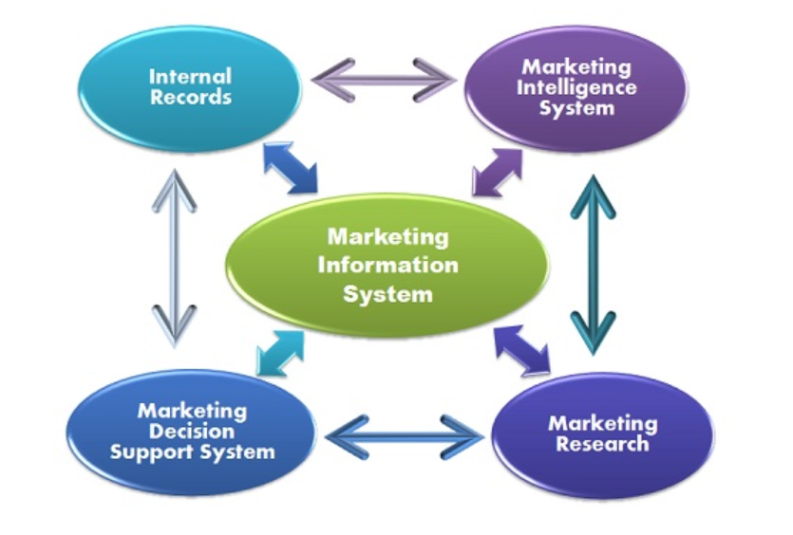

Name : Georgiana Cobzaru
Student number :1815178
Module Title : M4X01916 – Marketing Essentials
Assignment Title : Analyse the importance of marketing information system , it’s effectiveness within the hospitality and tourism industry as a tool for marketing, information gathering and communication
Module Lecturer Name : Dr . Oluwaseun Adegbite

Table of Contents :
- Introduction 3
- Management information system in hotel Mera Brise 3
- Information gathering 4
- Comunication informations 5
- Efficient Marketing Information System in Hotel Mera Brise 6
- Conclusion 7
7 References 7

Lux Garden Hotel, Azuga

1. Introduction

The marketing information systems of a travel company use a complex data storage system such as: analyzing and comparing all the information received in order to make the best marketing decisions.
Due to the rapid and advanced technology development, not too long, the marketing information system uses IT information that also helps to exchange information with multiple businesses and because of the performance of increasing Internet information availability, the IT system has developed so so much data can be accessed very quickly over the Internet.
Lux Garden Hotel is a famous five star hotel. In order to make himself known on the Romanian market he needed a lot of advertising and a great help was the wonderful landscape where the hotel was. Azuga resort has several five-star hotels and to be competitive on the Lux Garden Hotel market, it must always keep in mind the marketing information systems.

2 . Marketing Information System Analysis in Lux Garden Hotel, Azuga
In acourding with moodle.uwtsd.ac.uk/pluginfile.php “The majority of marketing information systems utilise mainly internal data because this is easy to obtain, but research has shown that managers require mainly external information on which to base long-term decisions. Internal data usually is only of operational importance, whereas strategic decisions require information on market trends, competitor strategies and economic and political fluctuations ( Xu and Kaye,1995)”.
The hotel has several methods of collecting information from tourists. The hotel collects information at any point in any area: at the entrance, in the room, in the restaurant. Every tourist after his departure is analyzed and recorded data about his stay in the hotel. It is also monitored from the time of entry to the exit time. Of great importance, the hotel manager also gives her reviews on www.booking.com. The hotel collects all the positive and negative information received in these comments on this site.
Lux Garden Hotel, Azuga understand that "the internet is potentially a cheap and fast way to access useful external environmental data to improve marketing decision-making, but for this data to be used to its best advantage it needs to be incorporated into marketing information system. The internet, as and source, should then complement existing sources of internal and external data, providing a fuller picture on which to base decision. " https://moodle.uwtsd.ac.uk

3 Information Gathering

The marketing information system has the task of collecting regular reports on the activity, as well as reports made on request to determine unusual situations. The hotel collects and stores all the comments received on www.booking.com Moreover, the hotel also keeps track of comments that are found all over the hotel and can be completed by tourists all the time. These notebooks are found at the restaurant, at reception, in the room, on the lobby at the entrance.
The negative ones that are the most common are sent to the departments concerned for analysis.
Among the most common problems in the hotel are:
- The very small spa
- The menu is not wide enough
- The WiFi signal is weak
- Hard cushions
These issues were sent to the assigned departments in turn to be resolved.

Besides, the hotel also keeps good information from the tourists who come to relax. Among the most relevant good information were:
-Cleaning up the room
- Engage very respectful
- Views and landscapes

Also in this case, this information is sent to those departments to be praised and rewarded for doing a very good job and adding value to the hotel. Receiving this information from managers and the work of both managers and tourists, the employees have an even greater determination to do the right job.

In acourding with www.booking.com the hotel has the following notes received from tourists:

personal | 9.5
facilities | 8.9
Comfort / Quality | 8.3
cleaning | 9.6
Location | 9.3
Wifi gratuity | 9.0

Lux Garden Hotel, Azuga has a pretty big review but it is more than that. The average hotel rating is 9.2

4. Comunication Information
Making a marketing decision is always based on the internal or external information, permanent or non-permanent, that marketing managers have and generates the decisional information in action, the marketing act being carried out within the cycle: Marketing information, marketing decision, actions marketing. "http://www.rasfoiesc.com/business/marketing/SISTEMUL-INFORMATIONAL-DE-MARK14.php" All hotel issues will be sent to the person in charge of the hotel's maintenance and effectiveness, which in turn will send them to the internal departments. Communication needs to be fast and the other departments need to respond as quickly as possible to the Solution and implementation deadline. Lux Garden Hotel is a luxury hotel so it has to meet the standards expected by tourists.
- The first and biggest problem is that the spa is very small. This issue was sent to the administrative department. The problem of where people dream of relaxing as in movies has already been taken into account, and staff are already working to make the spa rebuilt, expanded and more useful for tourists to feel good and relax, that he wants to come back endlessly.
- The hotel's second problem is the menu. Customers want that when they sit at the table after a well-deserved hiking in the mountains and after the fun of the party, they also have a good and diversified meal. This issue will be communicated to the person in charge of the hotel who in turn will discuss with the chef or even hire another chef to meet the tastes and pleasures of the clients. Iua will take into account the diversification of traditional mountain food, but also the diversification of modern foods for all tastes, and last but not least, the diversification of sweets for both big and small pofticios.
- The third problem is the poor WiFi signal. Tourists show dissatisfaction because we live in a world where technology is very important to most of the world. This issue is not just for customers and staff because it's a good internet speed. The problem will be sent to the responsible person who will tell the IT Specialist to improve the signal.

- The fourth problem is that of hard cushions. Customers complain about hard cushions because they are at a five star hotel and they want to feel like they are. I want after a day full of beautiful activities to come and put her head on a soft and good pillow to be able to rest, that the next day she can take her head with good energy, and how sleep it is very important, we need all the quality stuff like: soft pillows, clean and iron linen, fresh air and much more. The person in charge of the hotel maintenance will also consider this problem and will tell the staff to remedy the situation and to make it all to the liking of the tourists to come back with love and why not with new people.
All these negative and good reviews are very important because the hotel develops thanks to the clients and all the reviews have to be taken seriously but the most important ones are the negative ones because they make the biggest advertisement and if another person is looking for this hotel and he sees many disadvantages, even if they are exaggerated, man tries and looks for a hotel with the most advantages.

5. Efficient Marketing Information System in Lux Garden Hotel, Azuga

The main components of the information system are data and information. Over the past decade, their importance has been well underlined for effective management. For the specialists these terms have the following meanings: Data are actual facts, transactions, recorded events, economic data represent the actions, processes and certain facts for an enterprise. Information is also very important because it gets good knowledge the receiver uses. The receiver must communicate the unknown and unexpected situation and if the message does not have the correct attributions, the receiver will take it as data and no information.
Following the reviews, managers have gathered the advantages and disadvantages, and they have made good changes for the hotel to meet the expectations of the tourists.
Like any other hotel started slightly down and in time has undergone major changes to make the hotel one of the standards expected for tourists: In 2013, the hotel was named Hotel of the Year and received good-value awards even by a diploma of excellence thanks to the chef, the bartender, the Spa center. In accounting with http://www.luxgardenhotel.com/about/ In the year 2017 Lux Garden Hotel 5 star is on the podium of the winners of the Hotel leisure category at the Hotel Tourism & Leisure Investment Conference. By the year 2019 the hotel was in a continuous development and now Lux Garden Hotel attracts its clients to enjoy the most beautiful moments in a dream location with a fresh mountain air, landscapes like story and comfort to standards expectations! The hotel is located near the ski slopes and the lower gondola in Azuga.
- Conclusions

"Knowing and anticipating the mutations that take place in the enterprise environment, and especially on the market where it unfolds or is about to launch its products, is inconceivable without a continuous and systematic flow of information organized in a unitary, modern, to ensure their coordination and subordination to the same end goal: meeting current and prospective consumer demands.
Any inconsistency with market requirements involves rebates on prices and tariffs, additional costs of attracting and servicing clinics, which significantly affects the efficiency of economic operations. "Http://www.rasfoiesc.com/business/marketing/SISTEMUL-INFORMATIONAL-DE-MARK14.php"
For a thriving business, a marketing information system regime must be followed
- It is necessary to know the market, the place and the surroundings so that it can be seen by all tourists, can make a good advertisement, capture the area, in order to have a continuous flow, it is also necessary a complex system of information, coordination and subordination so that the goal can be reached, That to satisfy all the wishes of the tourists.
- Attention to market requirements is also very important because any noncorrection can lead to solid costs that can affect the efficiency of economic operations.
In conclusion, any manager needs to understand the importance of marketing the information system for the hotel to grow, prosper, and bring innovative innovation all the time to attract tourists

7. References

www.booking.com Reviews about Lux Garden Hotel available @ :
https://www.booking.com/hotel/ro/lux-garden.en-gb.html?aid=1610684;label=lux-GYWxp2shv3oMeDW6wWzKVgS349813888923%3Apl%3Ata%3Ap1%3Ap2%3Aac%3Aap1t1%3Aneg%3Afi%3Atiaud-294889295653%3Akwd-801314887352%3Alp20907%3Ali%3Adec%3Adm;sid=4f654e1f484597e4259d833e64b66833;dest_id=-1151446;dest_type=city;dist=0;group_adults=2;hapos=1;hpos=1;room1=A%2CA;sb_price_type=total;sr_order=popularity;srepoch=1559304965;srpvid=c77156420304018d;type=total;ucfs=1&#hotelTmpl

www.moodle.uwtsd.ac.uk information about internet
https://moodle.uwtsd.ac.uk/pluginfile.php/255618/mod_resource/content/1/Marketing%20information%20systems%20in%20tourism%20and%20hospitality%20small%E2%80%90%20and%20medium%E2%80%90sized%20enterprises%20a%20study%20of%20Internet%20use%20for%20market%20intelligence.pdf

"http://www.rasfoiesc.com/business/marketing/SISTEMUL-INFORMATIONAL-DE-MARK14.php"

