BMSS4009
Using Design Thinking to Create Possible Solutions.
Lucy Richards - 2318074
Owen Penton-Voak - 2306032
Eleanor Frost - 2318096

Contributions:
Lucy Richards contributed to discussions in lectures, 8 slides on the powerpoint presentation, production of the leaflet and 5 minutes of the oral presentation.
Owen Penton-Voak: contributed to discussions in lectures, 2 slides on the powerpoint presentation, writing and references in the supporting document and 5 minutes of oral presentation.
Eleanor Frost: contributed to discussions in lectures, 9 slides on the PowerPoint presentation, writing and references in the supporting document and 5 minutes of the oral presentation.

Scripts:

We are Harmony Haven, an inclusive and equitable camp based in North Wales. Our mission is to improve the well-being of the general population, and to give them an experience with us that will help them to build healthy habits into their daily life.
Motivation – Our motivation is driven by the fact that households on low incomes, experience higher rates of morbidity and mortality, compared to those from higher income households. This in turn significantly affects their health outcomes and health seeking behaviours. Also, children from low-income households may also face a higher prevalence of cardiovascular disease risk, such as obesity and tobacco exposure.
Our vision is to provide our facility for free, to allow us to target those less advantaged or less inclined to visit such a destination! From yoga to football, high ropes to paddleboarding, vegetarian food to a healthy roasts, we really do cater to all needs! At harmony haven, we target a different audience. We want those who are less likely to usually go to a wellness retreat, to come to us! Although our initial setup is in the North of Wales, our vision is to eventually have destinations across Wales, so that Welsh residents can benefit from our service! Our ethos is centred around a community initiative, and so visitors to our site will feel part of a community with a shared vision of life improvement.
Leaflet
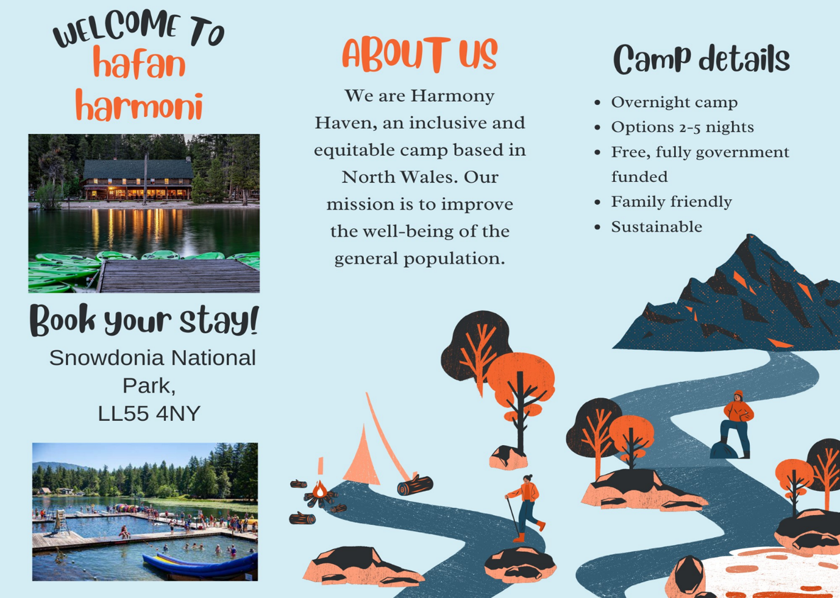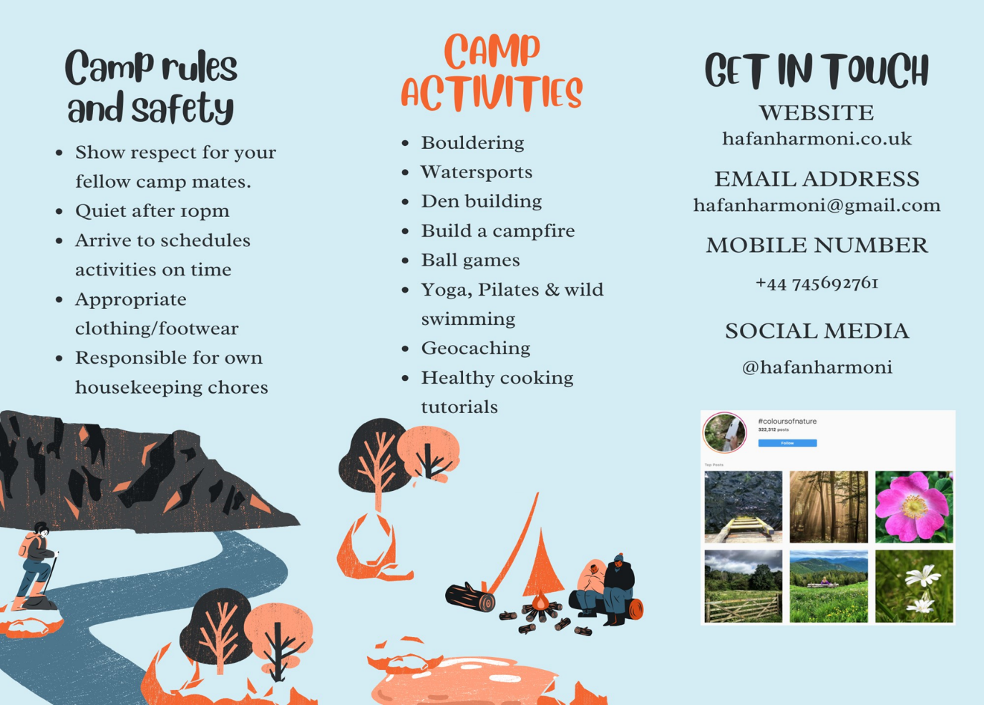

Harmony Haven, a beacon of unique opportunity, is singularly dedicated to fostering inclusivity and equity in daily life. It offers transformative experiences that are unparalleled, providing unique opportunities for growth and development. It caters to individuals of all backgrounds, regardless of race, gender, socioeconomic status, or ability. These unique opportunities are designed to ignite your curiosity and excitement, inviting you to explore a world of inclusivity and equity.
By providing a platform where everyone is welcomed and valued, we promote access to sports and create a nurturing environment where individuals can thrive and excel. At Harmony Haven, we strive to create a safe and supportive space where everyone can feel comfortable and confident to explore their potential. This environment is carefully crafted to make you feel safe and supported, encouraging you to push your boundaries and reach new heights.
Inclusivity in sports and activities goes beyond mere participation; it's about creating a culture of belonging where everyone feels respected and empowered to reach their full potential.
By embracing diversity in all forms, we celebrate the unique talents and perspectives that everyone brings to the table. This diversity fosters innovation and creativity, enriching our programs and enhancing the overall experience for all who visit.
Harmony Haven believes that anyone with drive and enthusiasm can become an ambassador of our mission and aim, pushing the boundaries of stereotypical ideals. We strive to impart the concept that everyone has their place in society, breaking down the beliefs and barriers set upon everyone.
Our camp is a beacon and a steppingstone of hope and progress in today's contemporary challenges, marked by persistent inequalities and systemic barriers. We actively address social justice and equality issues, confronting the root causes of exclusion and discrimination and paving the way for a more inclusive and equitable future. Through education, advocacy, and action, we strive to dismantle barriers and create pathways to success for all members of our community.
The impact of our inclusive and equitable camp extends far beyond its boundaries. By fostering a sense of belonging and acceptance, we strengthen the social fabric of our surrounding area, building bridges across divides and fostering a spirit of unity and cooperation. Our efforts not only enrich the lives of individual participants but also contribute significantly to our community's overall well-being and cohesion, leaving a lasting positive influence. This impact is a testament to the power of inclusivity and equity, inspiring hope and resilience in the face of adversity.
At the heart of our mission is a commitment to empowering individuals to reach their full potential, both personally and externally. Through mentorship, coaching, and skill-building activities, we equip participants with the tools and confidence they need to succeed. By instilling values such as teamwork, resilience, and fair play, we prepare them to become leaders and changemakers in their communities.
Ultimately, individuals of all ages and backgrounds feel the impact of our inclusive and equitable camp. From young athletes seeking opportunities for growth and development to marginalized communities yearning for representation and inclusion, our camp catalyzes positive change, inspiring hope and resilience in the face of adversity. By championing diversity and inclusion, we create a brighter, more inclusive future for future generations.
Moving forward, Harmony Haven aims to partner with the NHS, Sport Wales and continue to partner with Sport England as future expansions progress, further establishing itself as a leading provider of inclusivity and equitable practices. Integrating our mission, and the aim of the Future Wales (2020), Harmony Haven Working with the NHS and mentioned public bodies will allow us to provide a more structured and nurturing environment that caters to everyone's needs—gaining funding and opportunities to evolve and integrate ourselves into local communities' health sectors. In 2022/23, recorded that for the past two years, 59.3% of disabled people did not have a cash-earning job (Adam, Brown and Diong, 2023). Just by providing jobs to people who are disabled, we can ensure a safe space to cater to their needs and allow them to use their strengths to inspire other people to join our Harmony Haven. By allowing them to join our camp, we can have constructive conversations on how we can build and improve our business and can have personal opinions rather than having a standardized process which we follow and obey. Including other protected characteristics in our agenda we can supplement an ever-evolving mission to conquer contemporary challenges. Throughout the design thinking process presenting the prototype to a selection of people enhanced our own empathy towards the targeted audience. This part of the process has made our agenda concrete and our resolution to succeed unwavering.
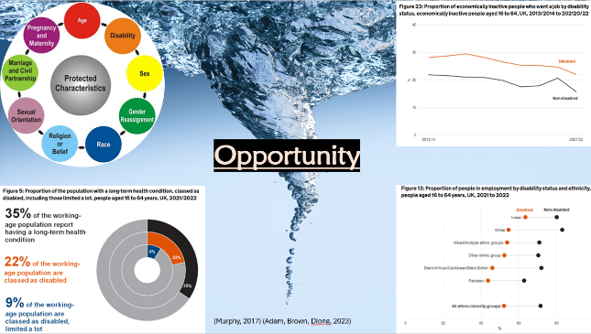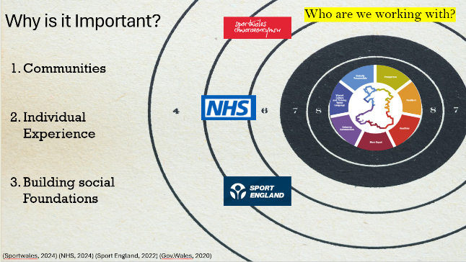

Our campsite vision was constructed through design thinking; we identified a wicked problem we wanted to explore and devised a possible solution to tackle it.

Wicked problems are issues with no one solution and any resolution is not inherently good or bad (Rittel and Webber, 1973). However, design thinking is a process that creates potential solutions or improvements for problems (Pressman, 2018). It is established by five key parts: information gathering, problem analysis, idea generation, prototypes and evaluation; by utilising each stage, solutions can be produced to tackle a situation; highlighting optimal strategies to explore (Pressman, 2018).

As it is a tool that can potentially improve wicked problems, we followed the steps of design thinking, choosing to investigate participation in outdoor activities and sports and the inequalities that exist within their parameters.

History shows prejudice and repression concerning factors such as the binary structure of gender identity and identification, with a lack of awareness fuelling a fear of violence and negative conformity (Eger, Munar and Hsu, 2022). Meanwhile, invisible white privilege dominates outdoor activities, while the labelling of 'able-bodied' individuals exhibits the stereotypical image of precedence without any regard for the existence of disabled others (Warren et al., 2014). In recent history, disability is perceived as a problem to be fixed and disabled people are not seen as 'normal' or capable of fitting into society (Beames, Mackie and Atencio, 2019).

Despite this, in current society, the perception of disability is shifting and therefore the recognition of disability in outdoor activities is changing too (Beames, Mackie and Atencio, 2019). Change needs to happen, and a consultation by the UK government found that disabled people wanted more equality of opportunity, inclusion and assistance with the cost of living (Gov.uk, 2024). The Disability Action plan and the National Disability Strategy reflect this, while the well-being of future generations act in Wales also aims to improve the physical and mental well-being of its population (Gov.uk, 2022; Gov.uk, 2024; Llywodraeth Cymru | Welsh Government, 2021).

By imagining ourselves in the position of individuals who have barriers to participation, we collaborated to create the idea for a campsite that would facilitate youth and adults from all backgrounds. We wanted our camp to include multilingual opportunities, disabled access, and facilities for all people, of any age, gender or sexuality to be themselves in a safe, fun environment. We presented our prototype to a selection of people, who gave us constructive feedback on ways to improve.

Responses ranged from having 'lots of bins', 'colour-coded paths' and 'rollercoasters', to worries surrounding safety and the size of the camp relative to the number of people.

Applying this feedback to our prototype, and researching similar campsites, we designed 'Harmony Haven' an inclusive, diverse, equitable, and free campsite with facilities that adapt to its participants' needs.

The rudimentary hypothesis of the proposal is to create a space where the barriers to participating in outdoor activities do not exist. Measuring the impact will be reflected in our participants, whereby if the camp is a success, we will have a community of people from all across the country, and the world, that have a place to visit where they can celebrate their differences and be connected through their similarities.

This is important as outdoor activities offer benefits such as developing social and emotional skills while boosting confidence and independence to realise ambitions (The Outward Bound Trust, 2024a).

However, achieving our goal involves organisational considerations and the undisputable needs of participants. Part of design thinking is critical evaluation, so some negatives must be considered.
Funding appears as one of the biggest barriers to participation and it can be difficult to get volunteers or members of staff in low-income areas (Waite et al., 2023) especially who have time to attend training.
Also, despite the inclusive facilities, individuals get nervous when in new places and they may feel at risk or constrained (Waite et al., 2023).

Additionally, obtaining the funding for such a project will require extensive work. Our mission aligns with policies such as the Well-being of Future Generations Act and the National Disability Strategy, from which we could procure funding, however, the proposition may be impeded by it’s volume and potentially overzealous aims.

Our proposal is unique in our mission for inclusivity. While providers such as The Outward-Bound Trust reflect the rewarding value of adventure, their courses for this year appear to be offered exclusively to ten to 22-year-olds with costs between £575 and £2,050 (The Outward Bound Trust, 2024b). Our camp will boost emotional, physical and social benefits while supporting the various needs of the population while being free. In the future, a partnership with associations such as The Outward-Bound Trust could bring the fruitful benefits of participation in physical activity to many more people.

PowerPoint slides:
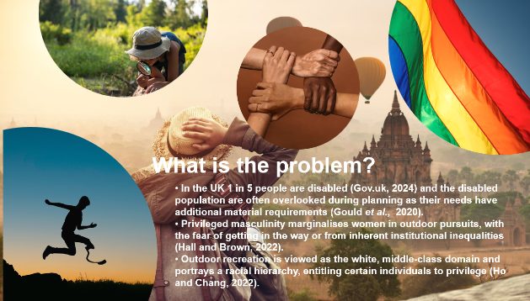
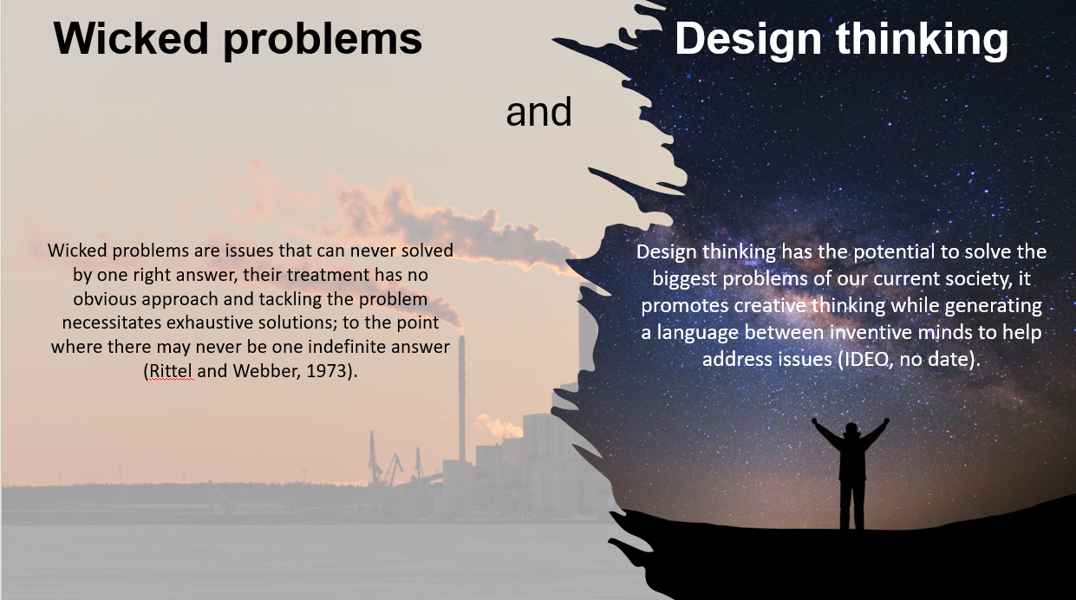
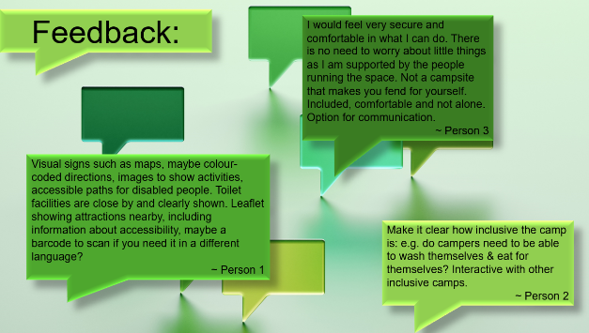
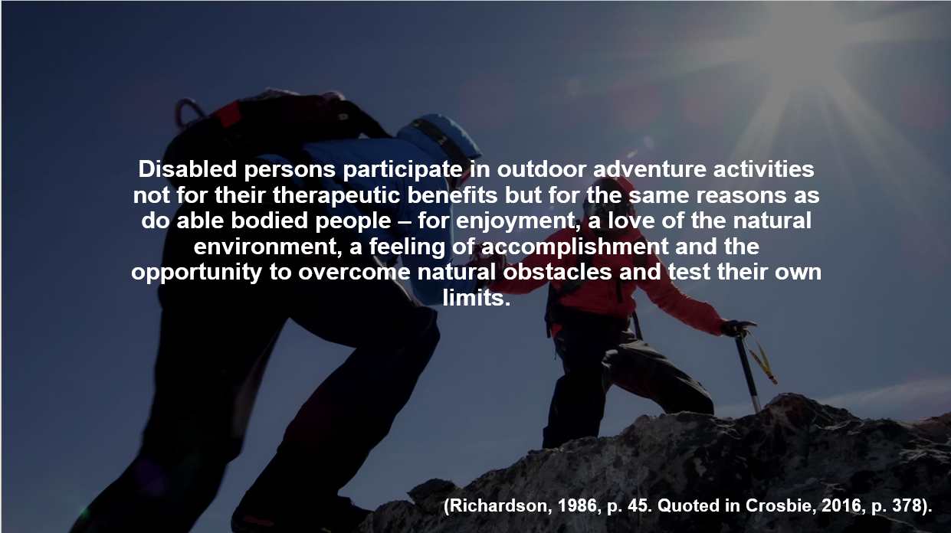
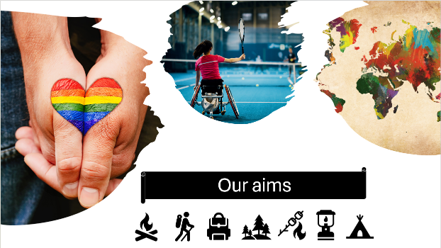
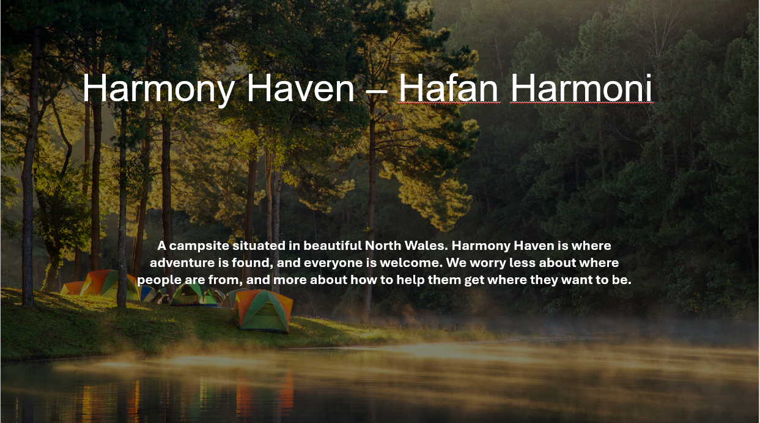
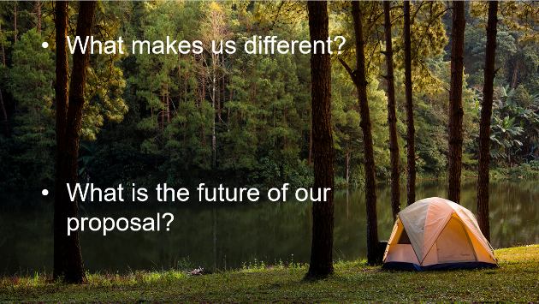
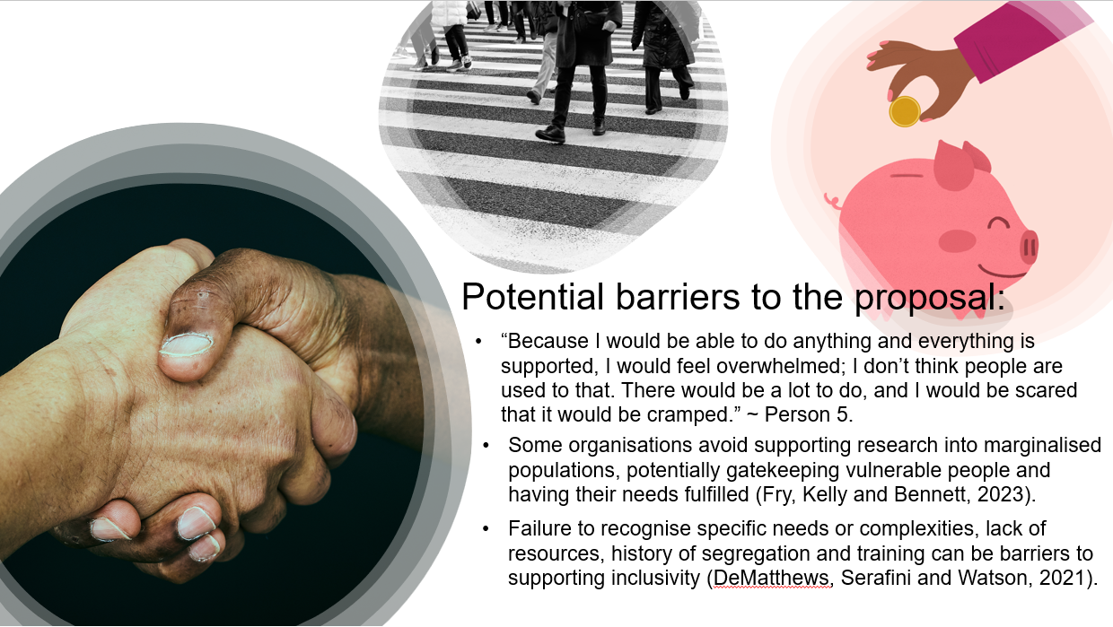
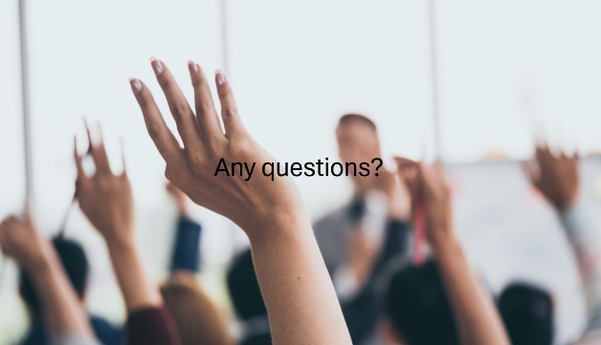
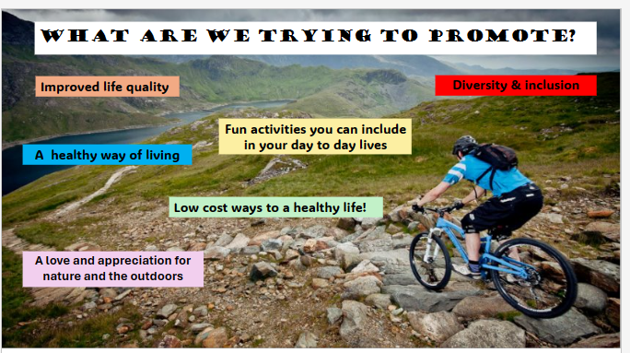
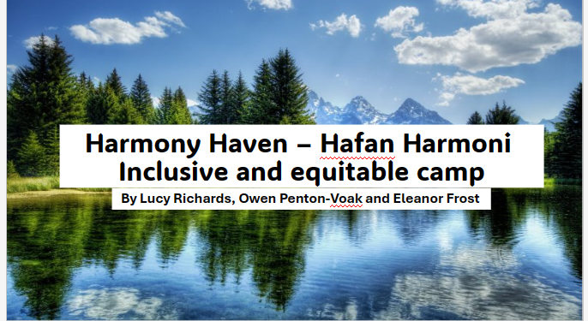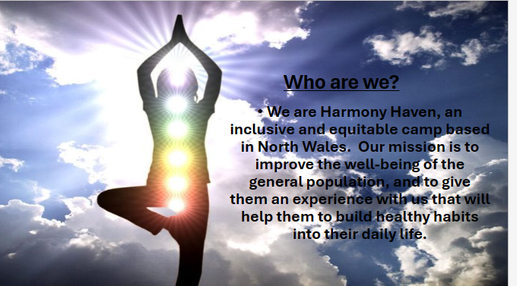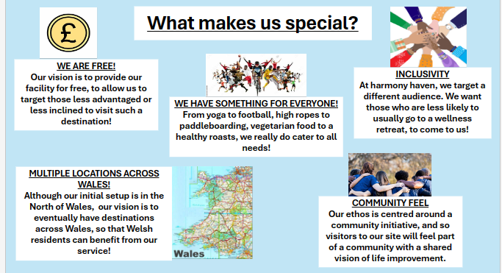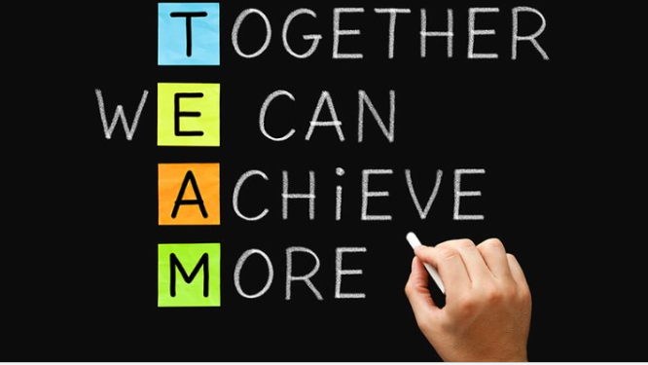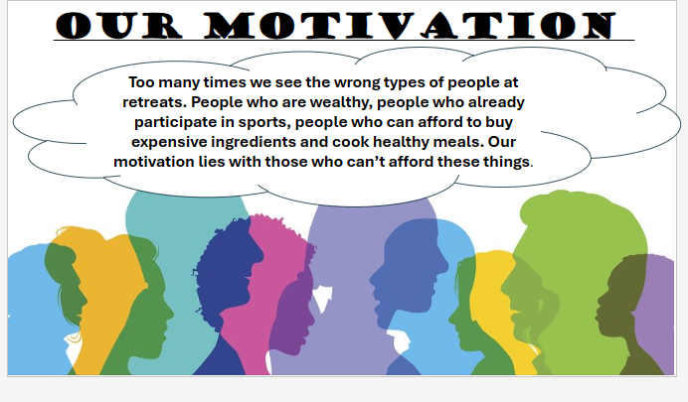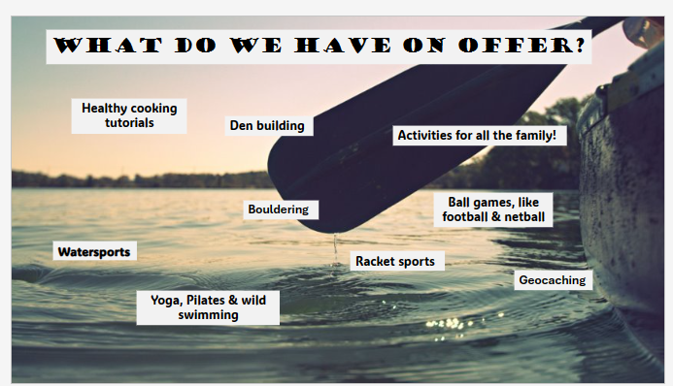
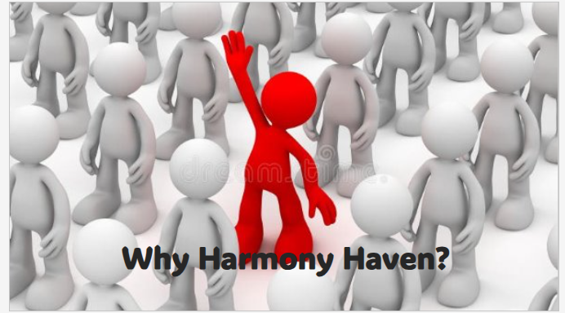
Reference List:
Adam, M., Brown , A. and Diong, J. (2023). Employment of disabled people 2022. [online] GOV.UK. Available at: https://www.gov.uk/government/statistics/the-employment-of-disabled-people-2022/employment-of-disabled-people-2022#:~:text=In%202021%2F2022%2C%2059.3%25.
Beames, S., Mackie, C. and Atencio, M. (2019) Adventure and society. New York: Springer Berlin Heidelberg.

Crosbie, J. (2016) Disability and the outdoors: Some considerations for inclusion. In B. Humberstone, H. Prince, & K. Henderson (Eds.). Routledge international handbook of outdoor studies. London: Routledge. pp. 378– 387.

DeMatthews, D.E., Serafini, A. and Watson, T.N. (2021) ‘Leading Inclusive Schools: Principal Perceptions, Practices, and Challenges to Meaningful Change’, Educational administration quarterly, 57(1), pp. 3–48. Available at: https://doi.org/10.1177/0013161X20913897.

Eger, C., Munar, A.M. and Hsu, C. (2022) ‘Gender and tourism sustainability’, Journal of sustainable tourism, 30(7), pp. 1459–1475. Available at: https://doi.org/10.1080/09669582.2021.1963975.

Fry, S.L., Kelly, D.M. and Bennett, C. (2023) ‘Inclusive research: Repositioning the “hard to reach”’, Journal of advanced nursing, 79(8), pp. 2779–2781. Available at: https://doi.org/10.1111/jan.15555.

Gould, R., Harris, S.P., Mullin, C. and Jones, R. (2020) 'Disability, diversity, and corporate social responsibility: Learning from recognised leaders in inclusion', Journal of Vocational Rehabilitation, 52(1), pp. 29-42. Available at: https://doi.org/10.3233/JVR-191058.

Gov.uk (2022) Policy paper: National Disability Strategy: Forewords, about this strategy, action across the UK, executive summary, acknowledgements. Available at: National Disability Strategy: Forewords, about this strategy, action across the UK, executive summary, acknowledgements - GOV.UK (www.gov.uk). (Accessed: 5 May 2024).

Gov.uk (2024) Policy paper: Disability Action Plan. Available at: Disability Action Plan - GOV.UK (www.gov.uk). (Accessed: 5 May 2024).

Gov.Wales (2020). Future Wales- National Plan 2040. [online] Available at: https://www.gov.wales/sites/default/files/publications/2020-11/working-draft-national-development-framework-document-september-2020.pdf.

Hall, J. and Brown, K.M. (2022) ‘Creating feelings of inclusion in adventure tourism: Lessons from the gendered sensory and affective politics of professional mountaineering’, Annals of tourism research, 97, pp. 103505. Available at: https://doi.org/10.1016/j.annals.2022.103505.

Ho, Y.C.J. and Chang, D. (2022) ‘To whom does this place belong? Whiteness and diversity in outdoor recreation and education’, Annals of leisure research, 25(5), pp. 569–582. Available at: https://doi.org/10.1080/11745398.2020.1859389.

IDEO (no date) Journey to mastery. Available at: Journey to Mastery | IDEO | Design Thinking. (Accessed: 8 May 2024).

Llywodraeth Cymru | Welsh Government (2021) Well-being of future generations (Wales) act 2015: the essentials. Available at: Well-being of Future Generations (Wales) Act 2015: the essentials | GOV.WALES. (Accessed: 9 May 2024).

Murphy, H. (2017). Equality, diversity and inclusion - protected characteristics champions. [online] Cardiff University. Available at: https://blogs.cardiff.ac.uk/university-executive-board/2017/12/12/equality-diversity-and-inclusion-protected-characteristics-champions/.

nhs.uk (2024). NHS. [online] NHS. Available at: https://www.nhs.uk/.

Pressman, A. (2018) Design thinking: a guide to creative problem solving for everyone. New York: Routledge.

Ray-Chaudhuri, S., Waters, T., Wernham, T. and Xu, X. (2023). lnstitute for Fiscal Studies Living standards, poverty and inequality in the UK: 2023 IFS Report R265. [online] Available at: https://ifs.org.uk/sites/default/files/2023-09/R265-Living%20standards%2C%20poverty%20and%20inequality%20in%20the%20UK-2023-1.pdf.

Rittel, H. W. J. and Webber, M.M. (1973) ‘Dilemmas in a General Theory of Planning’, Policy sciences, 4(2), pp. 155–169. Available at: https://doi.org/10.1007/BF01405730.

sport england (2022). Sport England. [online] Sportengland.org. Available at: https://www.sportengland.org/.

SportEngland (n.d.). Creating a sporting habit for life Disability Data Analysis. [online] Available at: https://sportengland-production-files.s3.eu-west-2.amazonaws.com/s3fs-public/disability-presentation-summary.pdf?VersionId=H8z1pJnRBnjAv99cr3REOS5v95bLseK9.

The Outward Bound Trust (2024)a Our social impact report. Available at: Our Social Impact (outwardbound.org.uk). (Accessed: 29 April 2024).

The Outward Bound Trust (2024)b Your summer adventure. Available at: Choose your adventure (outwardbound.org.uk). (Accessed: 9 May 2024).

Waite, S., Husain, F., Scandone, B., Forsyth, E. and Piggott, H. (2023) '”It’s not for people like (them)”: structural and cultural barriers to children and young people engaging with nature outside schooling', Journal of adventure education and outdoor learning, 23(1), pp. 54-73. Available at: https://doi.org/10.1080/14729679.2021.1935286.

Wales, E.S. in W. to T. | S. (n.d.). Enabling Sport in Wales to Thrive. [online] Sport Wales. Available at: https://www.sport.wales/.

Warren, K., Roberts, N.S., Breunig, M. and Alvarez, M.A.G. (2014) ‘Social Justice in Outdoor Experiential Education: A State of Knowledge Review’, The journal of experiential education, 37(1), pp. 89–103. Available at: https://doi.org/10.1177/1053825913518898.

