Name: George Perkins
Student Number: 1700820
Course: BA Graphic Design
Tutor: Louise Burston
Word Count: 2324

Dissertation Proposal
Introduction
Graphic designers can have numerous responsibilities to fulfil ranging from being professional to ensuring that everything they produce conveys their intended message. Graphic designers also have the responsibility of raising important questions: What is the purpose of the work? Is it purely for financial gain for large corporations?

The job of a graphic designer is far more than simply making things look appealing to the public in order to sell products; it is to communicate a message and encourage people to make informed decisions about what they do and how they act. With that comes the responsibility of sustaining the planet in which we live. In this essay I will be discussing the responsibility of graphic designers and how we can sustain our planet. In order to collect the information I will have to use a number of credited websites, as I need the most up-to-date and recent facts and statistics to make my findings as accurate as possible.

Graphic Design
The first keyword/phrase that I will be exploring is graphic design. Graphic design is a means of communicating messages and using the platform as a graphic designer, it raises the question – what can we do in order to sustain the world in which we live? As the Earth’s state deteriorates at such an alarming rate, graphic designers must start to consider why a product is made, is it eco-friendly, who is consuming the product and how will the product be consumed.

Design is one of the most effective methods of communication. For brands and businesses it is a way to convey their ethos through the means of a logo or advertisement, and for artists it can be a way for them to convey a personal message of emotion. Within my dissertation I would like to discuss the way in which design can spark important conversations and how it is such an effective form of communication.

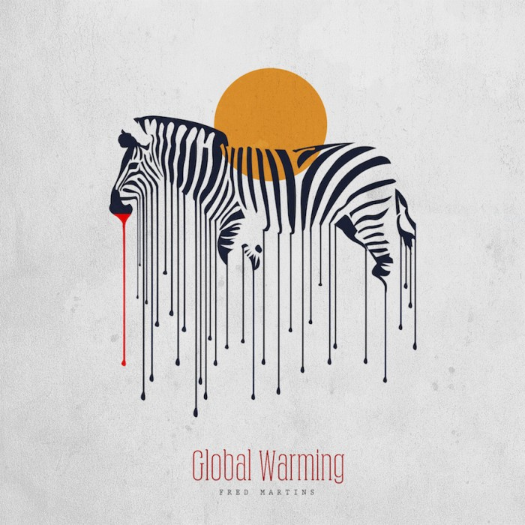
(Martins, 2015)
Here is an illustrative piece of art by Fred Martins. Nigerian-born Martins has triggered an emotional response by telling us a grave message regarding climate change. Martins came to the conclusion that creating pretty pieces of art wasn’t enough, and that he wanted to spark emotional responses through his artwork (Design Indaba, 2019).

This is an excellent example to expand upon in my dissertation as it is using design in order to provoke an emotional response in the viewer. This artwork is part of a global warming series from Martins, which all feature melting animals suggesting that climate change is on the rise. What I particularly like about this piece is that he plays with the natural stripes of the zebra, continuing them down to give a melting appearance.

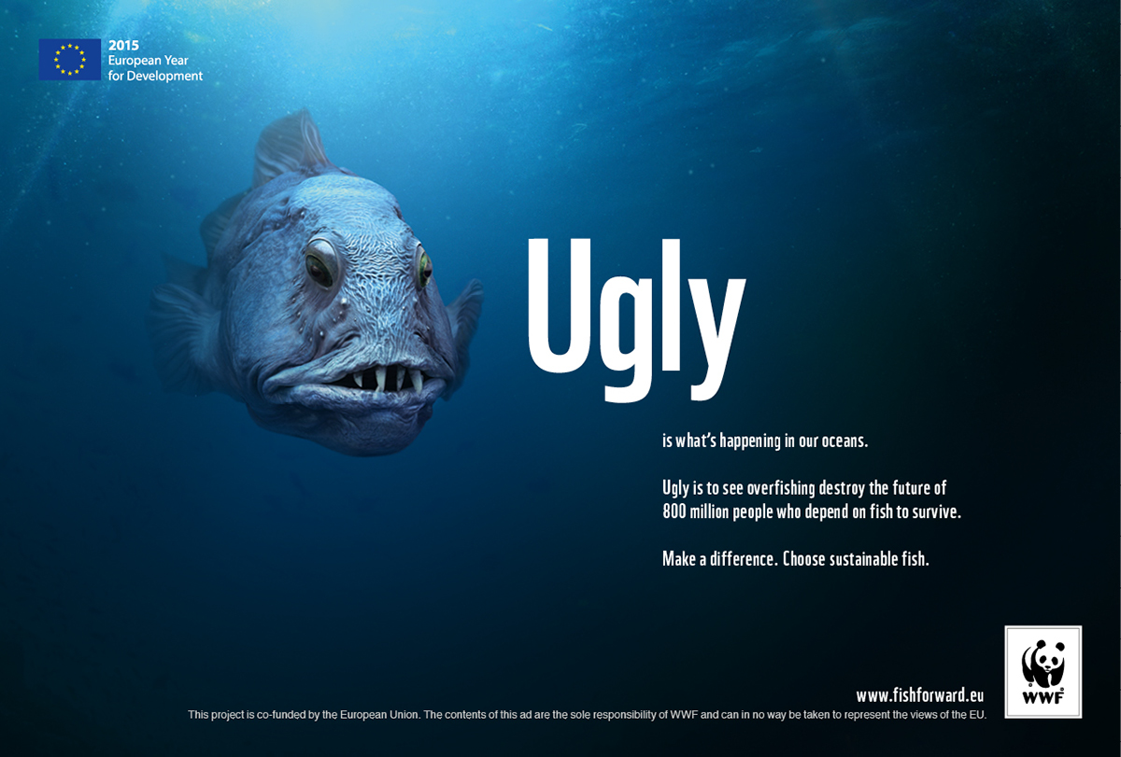
(WWF, 2018)
Here is a campaign called ‘The Fish Forward Project’ by the WWF which promotes the consumption of sustainable fish. The campaign targets the EU which is the largest importer of seafood in the world and encourages them to consider the social and environmental impacts of unsustainable fishing on the planet (WWF, 2018).

This is an excellent example of large corporations such as the WWF using the means of graphic design to promote sustainable practices. The campaign features many different designs, which all include an image of a fish and a large supporting adjective. Using an image of a stereotypically unattractive fish and pairing it with the word ‘ugly’ it automatically sparks an emotion of sympathy, which entices the public to discover more. This clever and effective use of graphic design is the driving force behind the campaign, which is subsequently beneficial to the sustainability of the Earth.

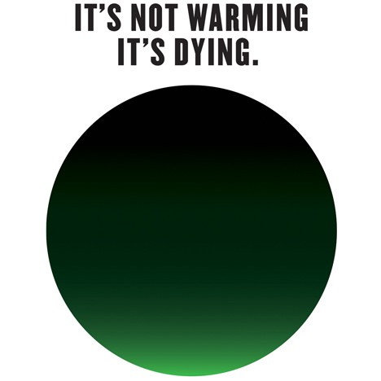
(Glaser, 2014)
‘It’s not warming, it’s dying’ is a campaign with the purpose of creating new urgency around climate change, and to stop us from using the term ‘global warming’ (Medium, 2015). The artist and designer behind this campaign is Milton Glaser, who is most famously known for designing the I *heart* NY logo. Glaser is one of the most famous and celebrated designers in America, therefore by creating a sense of urgency around the major global threat of climate change, it is likely that a large number of people will be influenced by this and take the same stance.

Within the campaign, the Earth is represented by a green circle that appears to be covered in smoke. The amount of vibrant green is very limited in this design, suggesting that there is only a slight glimmer of hope left for the planet. This design is extremely simple, yet very effective as when it is paired with the typography above saying ‘it’s not warming, it’s dying’ it is rather self-explanatory. The simplicity of the design also suggests that the issue is an urgent matter and there is no beating around the bush about it.

This is also a perfect example of graphic design being used to raise awareness of issues regarding sustainability and climate change. Despite it being a very simplistic design, it communicates the message of global warming very well, and is a very good example to reference and expand upon in my dissertation.

Sustainability
The second keyword that I will be exploring is sustainability. As defined by the Oxford Dictionary, sustainability is ‘the ability to be maintained at a certain rate or level’ and ‘the avoidance of the depletion of natural resources in order to maintain an ecological balance’ (Simpson, 2010). Sustaining the world in which we live is crucial for our future years on this Earth. Meeting the requirements of humans while preserving the world’s eco system requires us to take an accelerated movement towards sustainability. Statistics from NASA show that Carbon Dioxide levels, global temperature and sea level are all the highest they have ever been, with the amount of arctic ice and ice sheets at an all-time low (NASA, 2019). These alarming statistics aren’t surprising; however they do raise the question of what we must do in order to stabilise and decrease these figures. Researching into sustainability further within my dissertation will be essential for me to explore what more I can do as a graphic designer to help try and reverse the damage that we have created over the years.

Education is key when it comes to issues such as sustaining the Earth. One of, if not the most famous educators of this subject is Sir David Attenborough. Attenborough is an English broadcaster, writer and naturalist recognised for his educational documentaries. He has been the recipient for numerous awards, including several BAFTA awards, and a knighthood in 1985 (Britannica, 2019). The education from Attenborough has touched millions, and the impact of these teachings have undoubtedly made great movements in the way in which we help our planet.

Attenborough has recently used his platform to promote The Lion’s Share. In 2015, a list of 17 Sustainable Development Goals were outlined, which address global challenges that we face including climate and environmental degradation. (UN, n.d.). The Lion’s Share gives advertisers of large corporations the opportunity to act on some of these sustainable development goals by making a change in the way they recognise animals in their advertisements. The Lion’s Share encourages the corporate world to contribute a sum of money each time an animal appears in their advertisement, which will go towards wildlife conservation, habitats and animal welfare (The Lion's Share Fund, n.d.).

This campaign encourages the designers of corporations to use their creations to improve the sustainability of wildlife. This would be an excellent example to use within my dissertation as it is a prime example of putting design to good use and helping to sustain the planet.

For many graphic designers, working sustainably isn’t something they have ever considered. The book ‘SustainAble’ is an excellent means of educating those graphic designers who have the determination to reconsider the way in which they design. Graphic designers are considered ‘trendsetters and leaders’ (Sherin, 2008), and within this book it explains the various ways in which graphic designers can improve their resources and consider the eco-friendliness of what they design. It brilliantly outlines what sustainable design is, the best ways to practice sustainable design and the way in which corporations can use it within their businesses. Designers have an ethical responsibility to reverse the effects their work has had on the environment, and although we aren’t the main cause of the destruction, in the long run we still worsen the condition. Using this book as a reference point in my dissertation will be brilliant in providing me with greater knowledge and understanding of the topic, allowing me to apply it to my own craft.

Another serious issue in regard to sustainability is package design. ‘Sustainable Graphic Design: Tools, Systems, and Strategies for Innovative Print Design’ is a book that helps designers explore eco-friendly materials and production techniques, and shows them how to produce more sustainable designs (Jedlicka, 2010). This book really emphasises the choices that not only graphic designers, but humans make in terms of their impact on the environment. This book takes a holistic approach to the topic of sustainability, which will be useful to reference in my dissertation, as I can expand on step-by-step the effects that we have on the Earth’s resources.

Responsibility
Having responsibility is part of everyday human life; through being responsible of your own body and actions; through your job and family. Graphic designers also hold an element of responsibility when it comes to producing a high-standard piece of work for a client or ensuring that a message is communicated well.

When considering responsibility within graphic design, ethics can play a massive role. In the book ‘GOOD’, Lucienne Roberts discusses ethics within the practice of graphic design and how graphic designers can make good in the world (Roberts, 2006). Much of what Roberts discusses is about the history of design, and how design has played a role in many of life’s events. Roberts explains how during World War II, strong communication was required between governments, therefore encouraging graphic design to evolve creatively into an alternative means of communication. This stresses the significance of graphic design within life, and how it even began to play such an important role in the responsibility of communication during the War.

Alternatively, Roberts also goes onto explaining the difficulties that can arise with graphic designers when it comes to their responsibilities. When graphic designers have to consider contracts, clients, colleagues, themselves and their work, it can become hard to serve everybody well, all while trying to fulfil the responsibilities they also have on society. Graphic designers may also struggle to fulfil their responsibilities as a designer when taking money into consideration. It becomes easy for one to delegate responsibilities for people to achieve for society and themselves, however there are a number of factors to consider first.

This book would be a good reference for my dissertation as it covers many topics in relation to the responsibility of graphic designers, which I am then able to expand upon. I feel that it would be beneficial to not only discuss the responsibility of graphic designers on society, but to also discuss the ethics of graphic design and the problems with trying to sustain certain responsibilities of graphic designers.

Another useful source for my dissertation is the book ‘Do Good Design’ (Berman, 2008). Within this book, David Berman explains how designers have a social responsibility as design is at the heart of some of the world’s biggest challenges and solutions. He also claims that designers are responsible for so much of the world, the things we consume and the expectations we have of society. He interestingly points out how we must consider how powerful designers are when considering the responsibility within graphic design, as it is the designer’s creativity which creates the best deception in the world.

This view is also shared by Shel Perkins. Perkins believes that there are three different responsibilities that graphic designers must abide by; professional behaviour, professional expertise and professional values (Perkins, 2006). In regard to his beliefs about professional values, he believes that designers have a responsibility to consider the moral values of their work, and what impact the work will have on the planet. He believes that there is less attention given to societal obligations for designers, and there is more consensus on professional attitudes towards clients and jobs.

In First Things First Revisited, Rick Poynor (Poynor, 1999) also agrees with the notion that graphic designers have a responsibility within society, and believes that a designer’s creativity should not be wasted on advertising but should rather be focussed on contributing to society.

Within my dissertation, all of these sources are gateways into discussing a graphic designers ethical and social responsibility, and what designers are actually doing for their community and the world in which they live. They all keep raising the questions of what is the actual purpose of a designer’s work, and is it purely for financial gain?

Dissertation Question
Approaching this piece of writing I knew that I wanted to discuss how graphic design can not only benefit corporations but benefit society. Exploring how graphic design is used as a means of communicating serious matters, how the Earth is in an alarming need of immediate action and sustaining, and the various responsibilities that a graphic designer possesses, it only seems natural to explore the possibility that graphic designers can design for social change and to help sustain the planet. Putting great focus on the obligations that graphic designers take on through their creations, I would like to further investigate the following research question:
“As a graphic designer, how can I design for social change?”
Alongside my question, here is a list of sub questions that may be useful as chapters for my dissertation:
What is the graphic designer’s responsibility?
Do graphic designers have a social responsibility?
Do graphic designers have an ethical responsibility?
What is social design?
How has social design been used in the past?
Can graphic design help to sustain the planet?

Bibliography
Berman, D., 2008. Do Good Design. 1st Edition ed. s.l.:Peachpit Press.
Britannica, T. E. o. E., 2019. David Attenborough. [Online]
Available at: https://www.britannica.com/biography/David-Attenborough
[Accessed 3 May 2019].
Design Indaba, 2019. Nigerian artist uses posters to tackle issues of climate change. [Online]
Available at: https://www.designindaba.com/articles/creative-work/nigerian-artist-uses-posters-tackle-issues-climate-change
[Accessed 6 May 2019].
Glaser, M., 2014. It’s Not Warming, It’s Dying. [Art].
Jedlicka, W., 2010. Sustainable Graphic Design: Tools, Systems, and Strategies for Innovative Print Design. 1st Edition ed. s.l.:John-Wiley & Sons.
Martins, F., 2015. GLOBAL WARMING. [Art].
Martins, F., n.d. Global Warming. [Art].
Medium, 2015. Milton Glaser’s “It’s Not Warming, It’s Dying” Finds New Life as Designer Bags. [Online]
Available at: https://medium.com/foossa-files/milton-glaser-s-it-s-not-warming-it-s-dying-finds-new-life-as-designer-bags-c12d127bbfe7
[Accessed 6 May 2019].
NASA, 2019. NASA: Climate Change and Global Warming. [Online]
Available at: https://climate.nasa.gov
[Accessed 3 May 2019].
Perkins, S., 2006. Ethics and Social Responsibility. [Online]
Available at: https://www.aiga.org/ethics-and-social-responsibility
[Accessed 7 May 2019].
Poynor, R., 1999. Emigre Essays First Things First Revisited. [Online]
Available at: https://www.emigre.com/Essays/Magazine/FirstThingsFirstRevisited
[Accessed 7 May 2019].
Roberts, L., 2006. GOOD: an Introduction to Ethics in Graphic Design: Ethics of Graphic Design. 1st Edition ed. s.l.:AVA Publishing.
Sherin, A., 2008. SustainAble: A Handbook of Materials and Applications for Graphic Designers and Their Clients. 1st Edition ed. New York: Rockport Publishers.
Simpson, J., 2010. Oxford Dictionary of English. 2nd Edition ed. s.l.:Oxford University Press.
The Lion's Share Fund, n.d. The Lion's Share Fund. [Online]
Available at: https://thelionssharefund.com
[Accessed 3 May 2019].
UN, n.d. About the Sustainable Development Goals. [Online]
Available at: https://www.un.org/sustainabledevelopment/sustainable-development-goals/
[Accessed 3 May 2019].
WWF, 2018. Fish Forward. [Art] (WWF).
WWF, 2018. Fish Forward Description. [Online]
Available at: https://www.fishforward.eu/en/fish-forward-description/
[Accessed 4 May 2019].

