
APPENDIX GA36d

LEVEL 7 ASSESSMENT SPECIFICATION

Student name: | Lauren Wynne Donnelly | Student ID number: | 1803330
Programme: | Secondary PGCE
Module: | Curriculum Development and Enhancement
Module code: | ECSP7002 | Contribution to Overall Module Assessment (%): | 100%
Lecturer: | Helen Denny | Internal Verifier:
Assignment Title: | Research Study including Ethics Form | Word count (or equivalent): | 10.000 words in total including an Ethics form (to be given in on January 11th 2019)
Submission deadline: | May 13th 2019 | Return date of provisional marks & written feedback: | June 10th 2019
Submission method: | All written assessments, where practical and possible, must be submitted via Turnitin unless otherwise instructed by the Lecturer. (Please DO NOT put this assessment specification into Turnitin or it will match many similarities with other students’ submissions.)  Alternative submission method (if applicable):  Late submission of the assessment will result in a late penalty mark. Penalties for late submission: Up to one week late, maximum mark of 50%. Over one week late, 0%. Only the Extenuating Circumstances Panel may approve a change to submission dates.
Academic honesty / referencing: | Academic honesty is required. In the main body of your submission you must give credit to authors on whose research and ideas your work is based. Append to your submission a reference list that indicates the books, articles, etc. that you have used, cited or quoted in order to complete this assessment.

Assessing the impact of peer assessment on Key Stage 3 learners.

Introduction:
School A is a Welsh medium school in the Neath valley, South Wales. The school is a green support category school and average attendance 93%. The school has recently become a pioneer 3-19 school, and there are 1323 pupils on roll- 616 girls and 555 boys. Approximately 12% of students are eligible for Free School Meals (FSM), which is almost 50% less than the local authority, and 4% less than Wales as a whole. 19.2% of pupils are noted to have Special Educational Needs (SEN), but only 0.6% of pupils are statemented as having SEN (MyLocalSchool, 2019). The class in which the research was undertaken was a year 8 class with 23 pupils. It is a mixed ability class with no More Able and Talented (MAT) pupils, and additionally, no pupils in the class are noted as having low literacy rates. 5 pupils in the class have been identified as having Special Educational Needs- 3 with General Learning Difficulties (GLD), and 2 with Specific Learning Difficulties (SPLD). The class on the whole is average, but there are a small number of pupils who are above average. As with every class, there are stronger pupils and some pupils (in addition to those noted to have SEN) that require more support. On the whole, they respond well to feedback and are engaged in lessons. They complete the majority of work with some additional support when it is required. Due to the presence of a number of pupils with SEN, these pupils are provided with more scaffolding than others during some tasks (such as extended writing tasks), which is to be expected. There is occasionally a teaching assistant in the class, who works with one pupil in particular but does circulate the class, providing additional support to those who need it.
The topic of peer assessment was chosen in order to assess how well pupils respond to peer assessment and to explore how it had an impact on their classwork. Peer assessment is a technique that is more prevalent in some schools than others, and as a teacher-researcher I was interested in its effectiveness, but also interested in how it improves pupils’ self assessment techniques and hoped to see how it creates more independent learners.

Literature Review:
The research project that is discussed in this report is action research into peer assessment in the classroom. The term action research was first used by Kurt Lewin to describe “research that helps the practitioner”, in which the research provides the researcher with clarity about issues within the classroom (Baumfield, Hall & Wall, 2013). In this instance, the practitioner is the class teacher, and the complex situation is the improvement that peer assessment can provide in school work.
The process of action research involves a series of linked enquiries with teachers formulating questions which they formulate directly from their classroom experiences at each stage of the process (Baumfield, Hall & Wall, 2013). The classroom experiences can be categorised into areas such as questions the class may present, common misconceptions or common mistakes a specific class make regularly.
Action research can also be described as ‘practitioner enquiry’. Practitioner enquiry can be a step in the process that begins with reflection and leads to sustained action research (Baumfield, Hall & Wall, 2013). If action research is to be carried out, the reflection needs to focus on a particular area in which the practitioner is keen to change, or sees a lack of progress. This area then forms the central focus of the action research. Furthermore, within a practitioner-enquiry framework, where the purpose of research is the intent to improve the learning of the participants, then participatory approaches often seem an effective but also a sensible way forward.
Action research requires participation from those being researched (Kemmis & McTaggart, 2000). Participatory methods emphasise the participation of respondents (pupils) in the collection, synthesis and/or analysis of data. The responsibility for the research process is less focussed on the researcher and more equally distributed across all those involved, so instead of doing research to a target audience, we do it with them (Baumfield, Hall & Wall, 2013).

Kemmis & McTaggart (2000) describe action research as “participatory research”. They state that action research involves a spiral of self-reflection, which include cycles of:
- Planning a change,
- Acting and observing the consequences of the planned change,
- Reflecting on these consequences and then replanning,
- Acting and observing,
- Reflection.
As previously menyioned, action research is a method that is often used to improve practice (Koshy, 2010). As stated by Kemmis & McTaggart (2000), it involves action, evaluation, critical reflection and then evidence based changes in practice. Although action research often increases student attainment, it is important to always remember that action research is situation-based and context specific. Action research attempts to improve educational practice by using groups of participants (in this case, the pupils) and uses their own practical actions and reflects on the results of those actions, however these results may be varied when compared with other classes. Action research attempts to use an idea in practice in order to improve or change something (Ebbutt & Elliot, 1985). Koshy (2010) states that action research can involve problem solving, if the solution to the problem leads to the improvement of practice. Again, Koshy (2010) implies that activities or research that works with some classes may not necessarily work with others. During action research, findings will emerge as action develops, but these findings are not conclusive or absolute, but context specific. This must be remembered in order to produce reliable results (Koshy, 2010).
When teachers simultaneously take on the role of researchers, they become “practitioner enquirers” (Wilson, 2013). The inside knowledge that they possess on their classroom and pupils in their classes with whom they are undertaking research with means that the researcher has a deep understanding of the interactions and dynamics within the practice concept. This can be a huge advantage as researchers know the dynamics of classes and what makes them “tick”, but Wilson (2013) also argues that this can also be seen as a negative, as the practitioner is so close to the context that they can limit or prevent objective thinking and therefore limit the true outcome of the research. Hopkins (2014) presents a counter argument by saying that first and foremost, a teacher’s primary job is to teach. He states that research methods should not disrupt the teaching commitment, and therefore by becoming a practitioner enquirer, the teacher is deliberately and consciously expanding their role to include a professional element, which could be a distraction from their primary role. Hopkins (2015) then goes on to state that is assumed that the teacher wouldn’t allow the research to interfere with their priority, which is teaching, and therefore would not limit the findings of the research.
However, it is further discussed that there is an element of bias which needs to be considered carefully as the class teacher becomes the researcher. School based, educational action research is the process whereby practitioners are able to discuss and respond to school-based problems, often in their own classroom. It is also gives practitioners an opportunity to engage in self-reflection, allowing them to understand and improve their own practice (Wilson, 2013). Some may argue that the class teacher is too close to the class being researched and therefore the discussion of the issues being researched may be a sensitive topic and needs to be approached tentatively.
Assessment for learning is a key part of education for both teachers and pupils and is intrinsic in the teaching-learning cycle (Ofsted, 2004). When people begin their initial teacher training, their own progress is made a focus rather than the pupil’s progress. This is due to the fact that their assessment techniques are usually weaker due to lack of practice (Ofsted, 2004). It is therefore noted that it is becoming increasingly important for teachers in particular to focus on current assessment practices and how they relate to successful learning and effective teaching. By doing this, teachers are ensuring that they provide the best learning experience for every single pupil in their classroom (Dillon & Maguire, 2007).
Assessment for learning is at its most efficient and effective when it is used consistently in every lesson. Its repeated use allows pupils to become familiar with the certain techniques that certain teachers use, therefore improving their work (Ofsted, 2004). When pupils build a familiarity with these techniques, there are displays of better work and better engagement. By allowing pupils the opportunity to build their skills and use these techniques, we develop “ambitious, capable learners, who are ready to learn throughout their lives”, which is one of the four purposes of Donaldson’s (2015) Successful Futures curriculum.

Formative Assessment:
Assessment for learning is any form of assessment where the first priority from a design and practice point of view is to serve the purpose of promoting students’ learning (Black et. al., 2003). Black et. al. (2003) also note that assessment activities can help pupils’ learning if the assessment provides information that teachers and pupils can use as feedback to assess themselves and each other. Through adapting the teaching and learning activities in which they are engaged, both pupils’ attainment and engagement can improve. This type of assessment becomes formative assessment when the evidence is then used to adapt the teaching techniques and methods in order to meet pupils’ learning needs (Black et. al., 2003). It may be similar for some classes but in other classes it could be totally different. Every class is different and this must be remembered at all times during research. In assessment for learning, teachers need to use a variety of tools to find out where their pupils are in their learning. As they collect this data, they can decide on what the students need next in order to improve and/or succeed in a certain field/particular subject skill (Dillon & Maguire, 2007). This is known as formative assessment. Formative assessment requires a rich base of data and also students that are willing to take on advice which allows them to improve their performance (Dillon & Maguire, 2007). The goal is to find out what students know, what they have some background knowledge on and what they do not know (Black and Harrison, 2004). Gibbs and Simpson (2004) note that formative assessment works best when students are encouraged to make effective use of the feedback and respond to it. Formative assessment such as peer-assessment records can be used as a data collection tool (Baumfield, Hall & Wall, 2013). Formative assessment is part of teachers’ day-to-day work and supports them in knowing the individual success needs of students. It requires teachers to focus on the current assessment practices being used in their classrooms, and how they relate to successful learning and effective teaching. (Baumfield, Hall & Wall,2013).

Peer Assessment:
A popular form of formative assessment is peer assessment. Peer assessment is an exercise in which students swap books with a peer, and then typically in a different colour pen, the pupils mark each other’s work, adding comments suggesting how the work could be improved. It does not contribute towards the pupil’s final grade/level and has a qualitative output (Gielen et. al., 2010). Peer assessment is met with a strong emphasis placed on students’ active involvement in the assessment process itself (Black et. al., 2003). Due to this, peer assessment has shown an increase in student self-regulation and achievement, increasing overall attainment (Harris, Brown & Harnett, 2015). Peer assessment allows the discussion of the strengths and weaknesses of a piece of work and identifies areas where pupils can improve (Gielen et. al., 2010). However, Topping (2013) argues that even teachers themselves sometimes question whether students can consistently provide accurate and appropriate feedback that allow peers to improve their work. Pupils are well known to peer assess another pupil’s work by adding comments that are not deemed as particularly useful, or constructive. This is mainly due to the fact that students are often novices, especially when schools or departments do not use peer assessment consistently. It has been shown that peer assessment has the potential to improve communication and collaboration skills between pupils. Additionally, Harris et. al. (2014) note that there is evidence to suggest that without sufficient training, students are unlikely to create comments well aligned with the expected outcomes of the task. For this reason, schools are somewhat reluctant to allow pupils to peer assess their classmates’ work. Due to this, it is becoming increasingly important to provide pupils with a model that they can use to ensure levels of feedback are effective (Harris, Brown & Harnett, 2015). In practice, peer assessment turns out to be a crucial part of self-assessment. Peer assessment is valuable to teachers as students may accept criticisms of their work from one another in a constructive way, whereas they would not act on this feedback if it was given by a teacher. Peer assessment is also valuable because the comments will be in everyday language that students themselves use. It is also noted that peer assessment is valuable as students learn by becoming teachers (Sadler, 1998).
However, Harris et. al. (2014) noted that low-level feedback or comments made in peer assessment tasks are often unrelated to the success criteria, and therefore do not provide learners with ideas or suggestions on how they could improve their performance in a practical or literal way. This reiterates the reason why students require a model to evaluate the levels of feedback and whether they are deemed appropriate or not (Harris, Brown & Harnett, 2015).
As with any method, participatory methods have both advantages and disadvantages (Baumfield, Hall & Wall, 2013). The main advantage is that participatory research is a bottom up approach, and therefore there is a transparency on issues related to power and the management of ethical issues that arise. The main disadvantage is that it is implied that due to the level of involvement of the researcher in the investigation, that there will be a high chance of bias in the results (Baumfield, Hall & Wall, 2013).
Van Zundert et. al. (2011) have also shown that the cognitive load and complexity of the task are crucial to the effectiveness and benefit of the peer assessment, and ensuring that pupils have sufficient “training” in the methods in which they are using to provide useful and purposeful feedback is becoming increasingly important, especially as it is beginning to be used as a widespread assessment technique amongst schools. Peer assessment allows pupils to develop as independent learners, which is one of the key aspects of Donaldson’s Successful Futures initiative (2015).
When done successfully, peer assessment decreases the amount of time that teachers spend marking and providing feedback to students, but also allows the pupils to see where they can improve their work immediately (Wiliam, 2011).
Research that has been previously undertaken on peer and teacher feedback in education identifies the benefits of peer assessment and proves these benefits to be of equal or even greater effect than feedback that is provided by the class teacher (Tsui & Ng, 2000) than in first language writing classes (Nelson & Murphy, 1993). Sadler (1989) states that “good feedback lies at the heart of good pedagogy”, with its source (i.e. teachers or peers) being less important than its quality, encouraging teachers to use peer assessment as an AFL tool in their classrooms. Sadler (1989) also notes that although peer and teacher assessors might follow the same assessment procedure, due to a teacher’s background, the feedback could be viewed more trustworthy and feasible. Using peer assessment contributed to learning in the classroom, with questioning and critical thinking showing improvements and fair assessment skills developed in classes that had been using peer assessment regularly (Izgar & Akturk, 2018).
Tsui & Ng (2000) noted that the research undertaken on peer and teacher assessment in extended writing exercises showed positive benefits of peer comments, with peer assessment having a greater effect than comments left by teachers. Good feedback is said to lie “at the heart of good pedagogy” (Sadler, 1998).
Friendship relations and personal problems have been shown to effect peer assessment negatively, meaning peers who did not have a strong bond with the person they were assessing gave low scores, whereas those who had a strong bond were overgenerous with their marks (Yilidrim & Simsek, 2006). Furthermore, although peer assessment brought about positive changes in pupils’ work in a number of studies, it is not as refined as feedback that comes from a teacher. Teacher feedback was found to be far more sophisticated, and therefore more trustworthy (Gielen et. al., 2010). This was due to the fact that teachers possess much higher experience in marking, and in most part, are marking a number of tasks that are similar. This allows them to give pupils an insight into other areas of difficulties previous pupils have found, and allows them to formulate the most effective form of feedback. A good teacher knows how to provide feedback in the most effective way, and therefore pupils are not always regarded as the most trustworthy source for feedback (Gielen et. al., 2010). However, teachers’ feedback is often misunderstood or misinterpreted by students (Yang et. al., 2006). This has been found to be particularly true in secondary education as the “knowledge gap” between pupils and teachers is usually vast (Yang et. al., 2006). On the other hand, it is argued that because teachers are required to divide their time between a large number of pupils, that peer assessment has the upper hand (Cho & MacArthur, 2010).
Bloxham & West (2004) stated that another argument in favour of peer assessment is that it allows pupils to understand feedback more clearly. As previously mentioned, the “knowledge gap” between teachers and pupils is evident during the secondary school age, and therefore when a pupil participates in the assessment before having to peer mark, it is much easier to see the learning goals (Rust et. al., 2003). Van Zundert et. al. (2011) have also implied that the cognitive load and complexity of the feedback provided by teachers is too high for students to fully understand, and therefore the effectiveness and utility of the peer assessment is much greater. Furthermore, peer assessment is a faster approach then teacher feedback. There may be a delay in feedback in teacher led feedback, whereas peer assessment can be done immediately, which allows pupils to answer to that feedback immediately (Gibbs & Simpson, 2004). The advantage that this holds is that students can act on this feedback and improve a piece of work immediately before they move on to a new topic, whereas the delay in teacher led feedback often means that pupils are studying a new topic before they can act on the feedback and improve their work (Gibbs et. al., 2004). Therefore, feedback from a peer that is provided almost immediately can have a more positive impact than feedback from a teacher weeks later (Gibbs et. al., 2004). Gielen et. al. (2010) also note that several ‘immediate’ peer assessment sessions during the initial drafting stage of assessments that require pupils to write an extended piece of work could actually decrease teacher workload as there is already feedback provided on those pieces of work. Of course, there will be a requirement of ‘training’ and initial supervision to ensure pupils are giving their peers effective feedback, but once they are well practiced, the teacher workload could be decreased significantly (Gibbs & Simpson, 2004).
Yang et. al’s (2006) study found that the impact of teacher and peer feedback is different. Pupils viewed teacher feedback as more professional and trustworthy than peer assessment, and were more obliged to include and work on feedback that teachers had left in further pieces of work, rather than peer comments. They also noted that the pupils who disregarded peer assessment were less self-regulated when it came to their learning, as they took the teachers comments as gospel, and some noted that they didn’t need to improve anything that the teacher hadn’t pointed out, as teachers always point out every mistake. This again implies that peer assessment is more successful in the long term when compared to teacher assessment. However, Cohen, Manion & Morrison (2007) argue that the pupils involved in educational research cannot be regarded as having the same skillset as the researcher and therefore the researcher and participants are not on equal terms when marking skills are compared. They note that it is extremely important to keep this in mind at all stages of the research progress, producing an argument that suggests that the effectiveness of peer assessment is not as high when it is compared with teacher feedback.

School Policy and Practice:
Peer assessment has been used in schools for several years. It is a form of formative assessment, which allows class teachers to repeatedly keep track of how pupils in a class are performing, therefore allowing them to identify areas which they need improve, before allowing them to act on feedback and improve their work. School A do not promote or present a strong policy on peer assessment/marking. It is done within their Geography department for some assessment tasks, but it is not a policy that is rolled out strongly across the school as a whole. Due to this, some of the pupils were apprehensive to peer mark alone. For this reason, I provided the pupils with a worksheet with a key and structure to follow, which included the success criteria and gave a short tutorial on how we were going to use the success criteria to peer assess the work. It has been stated by Van Zundert et. al. (2011) that the cognitive load and complexity of the task are crucial to the effectiveness and benefit of the peer assessment, and ensuring that pupils have sufficient “training” in the methods in which they are using to provide useful and purposeful feedback
Once students had completed the peer assessment, they re-drafted the piece of work with the improvements that were suggested. This allowed me to compare their initial mark with their final mark. School A uses level marking when pupils complete extended writing tasks, which is done from a level marking sheets written by the head of department. To ensure the marking was on par with the department marking policy, a handful of books were marked before verifying the marking with the head of the department. As soon as she was happy that the marking was correct, the remaining books were marked. The school uses a level marking policy in every department (apart from Mathematics). Some may argue that these sort of mark schemes are subjective and are dependent on opinion of the marker rather than the content of the work, but it has been proven as an effective method and is used widely in schools across the United Kingdom.

Methodology & Ethics:

The term ‘action research’ is often used when discussing research teachers undertake as part of their professional development. Elliott (1991) developed a model of practitioner research, suggesting that either teachers could either carry out the research themselves, or they could commission someone else to do it. In either case, the teacher was used as it did not require additional research into the class/dynamics in order to understand ‘the social situation in which the participant finds himself’ (Somekh & Lewin, 2011). Theories are not validated independently and then applied to practice, but they are validated through practice and therefore the teacher is the ideal candidate for the practitioner (McAteer, 2013). Theory can be tested in practice, not just applied. Instead of being research on a social setting, the research is carried out either by the participants themselves.
The methodology that was used in this research was a pre-test and post-test, with an intervention between the tests. Pre-tests are conducted before the experiment begins –and post-tests after it has been completed. These data sets are then used to identify differences between two or more groups on measurements of the dependent variable (Somekh & Lewin, 2011). The research was carried out over a series of 4 lessons.
Hattie & Timperley (2011) stated that feedback is one of the top 10 influences on student achievement.
In line with this statement, this research activity aimed to:
- Establish how peer assessment impacted student attainment,
- Establish differences in student engagement after exposure to peer assessment,
- Use peer assessment as a tool to improve student attainment,
- Teach/coach participants how to peer assess correctly and efficiently, and reflect on this as a form of self-assessment.
Sadler (1989) implies that it is very difficult for students to achieve a specific learning goal if they do not understand the goal and/or cannot assess the steps that they need to take in order to reach that goal. Peer assessment can therefore be suggested to be a key factor in the learning and allows pupils access into fully understanding their learning goals (Sadler, 1989).
In this research, participants were given a simple pre-diagnostic test, which involved an extended writing task on a topic they had already studied and had background knowledge on. This was called the first draft. Their first draft results were then noted confidentially in order to compare them with the post-diagnostic test results. They were not given any prior coaching in peer assessment at this point.
Pupils were then given an intervention where they were asked to peer assess their neighbours work with the provided success-criteria (which we had devised first as a class, so everyone could contribute) to follow (see appendix 1). There are many different ways in which peer assessment can be used, but in this research, the technique used was one where students used the success criteria that the class created together before writing their first draft. Pupils had to use 3 different coloured highlighters to highlight aspects of the success criteria on a worksheet that was created as a key. They then highlighted present aspects of the success criteria in their peers work with the corresponding colour. This was done so that no pupil had to make comments on another pupil’s work, but also by using this technique, the peer assessment was a positive experience as all pupils had some colour on their work, which showed them that they had used the success criteria well (see appendix 2 for examples).
Once everyone had peer assessed, the work was swapped back, and pupils were asked to reflect on areas of their work that they could improve, before writing an improved second draft, where they made sure they included everything that they had left out of the first draft. In theory, both student effort and attainment should have showed an improvement when compared to the pre-diagnostic test results. The research concludes that on the whole, when their work was level marked, their levels in the post-test showed an improvement, suggesting that the peer assessment was completed effectively and had a positive impact. This wasn’t due to an improvement of subject knowledge, as the pre and post-tests were on the same topic, but due to their improved understanding of how to peer assess effectively and their improved awareness of the requirements that this entailed. This technique has been noted by Black et. al., (2003) to significantly improve not just student effort, but student participation in tasks. The theory behind pre-tests and post-tests describe them as “the study of one research entity at two time points separated by a critical event” (Wilson, 2013). A critical event is one that would be expected to impact case observations significantly, which in this instance is the peer assessment. Black et. al. (2003), noted that using peer-assessment allowed pupils to see clearly what was required of them and how to complete the work successfully. By doing this, pupils should be able to guide their own work and become more independent learners, causing an overall improvement in attainment levels. This was certainly seen in the work that was completed in the post-test.
Dylan Wiliam (2011) states that there is a wide range of evidence that shows that involving pupils in their own learning encourages pupils to become the owners of their own learning, which in turn produces vast improvements in their learning. By using the pre-diagnostic, intervention & post-diagnostic technique, participants will be coached and encouraged to take accountability for their own learning, rather than expecting all feedback to come from the researcher (who in this instance is their class teacher).
Before this research was undertaken, the relevant ethics form was submitted and approved to the University of Wales Trinity Saint Davids’ (UWTSD) University Ethics Committee. This was done in order to follow the legal and institutional requirements that are in line with educational research. The nature of the data involved meant that there were some risks identified with the research and the participants, as it requires social participation of young individuals. These risks included the participants feeling under pressure to take part in the research. This pressure arises due to the power imbalance of the researcher being the teacher.
This risk was minimised by explaining to the pupils’ what the purpose of the research was, inviting them to ask questions and seeking their permission to proceed before any research was undertaken. If there were any objections (there were none in this case), they would have been respected (Cohen, Manion & Morrison, 2007). It was important that participants were informed that their participation was entirely consensual, and that their progress or attainment would not be impacted if they decided not to take part in the research. This was done in order to minimise participants’ emotional distress or embarrassment. The technique used also minimised embarrassment as peers left no subjective comments on other pupils’ work. This in turn allowed everyone to receive the same constructive feedback.
Secondly, data protection had to be considered. All information was kept confidential, on an encrypted and password protected memory stick and all information is kept anonymous in this write up of the research. Confidential and anonymous treatment of participants’ data is considered “the norm” for the conduct of research (BERA, 2018:21). All participants were reminded that they had the option to withdraw at any time. This was done to ensure that participants were not exposed to any stress or invasion of privacy, and therefore combining this step with informed consent was paramount to ensure anonymity and data protection, as suggested by Frankfort-Nachmias, Nachmias & Nachmias (1992). Cohen, Manion & Morrison (2007) imply that ethical consequences are often overlooked and underestimated by inexperienced teachers. This reinforces the decision to follow ethical guidelines so particularly, to ensure a minimal level of unnecessary stress or embarrassment was caused for participants or researcher.
BERA (2018: 29) note that “all educational researchers should aim to protect the integrity and reputation of educational research by ensuring that they conduct their research to the highest standards”. They also imply that educational researchers should not criticize their participants in any defamatory or unprofessional manners, in order to withhold professional and accurate results (BERA, 2018). It is also recommended by BERA (2018) that researchers “identify an appropriate contact whom participants or other research stakeholders can contact in order to raise questions or concerns”. Due to the presence of the subject mentor as an observer in all lessons undertaken in this research study, there was always a secondary member of staff, which they could voice any concerns of complaints to. It is also noted by BERA (2018) that researchers should present their findings, and the practical significance of their research, in a clear, straightforward fashion, and that researchers are responsible tor making the results of their research public for the benefit of educational professionals, policymakers and the wider public. School A are aware that this research report is being written and are permitted to request a copy for their own benefit.
BERA state in their 2018 guidelines that researchers have a responsibility to think through their duty of care before they begin to collect data for a project. Researchers are required to do this to recognize any potential risks that may arise during the data collection stage, and to prepare themselves for the event that they are required to be in a position to minimize and manage any distress or discomfort that arises (BERA, 2018:19). They also suggest that researchers should take the appropriate steps to ensure the effects of research designs that are perceived to advantage one group of participants over another are minimized (BERA, 2018: 20). This was particularly important in this research project, as there was no control class used, therefore only one class from the year saw the intervention and its benefits. Some may argue that this is unfair, but there was no control class used for a reason, and that reason was at the forefront of the ethical decisions made throughout.
Additionally, researchers have a responsibility to inform participants about the outcomes of the research in which they were or are involved (BERA, 2018:8). Informed consent is described as “the procedure in which individuals choose whether to participate in an investigation after being informed of the factors that would be likely to influence their decisions” (Diener & Grandau, 1978). BERA (2018) also outline that participants’ voluntary informed consent to be involved in a study should be obtained at the start of the study, and that researchers will remain sensitive and open to the possibility that participants may wish, for any reason and at any time, to withdraw their consent (Frankfort-Nachmias, Nachmias & Nachmias, 1992). It was ensured that all participants in this study were informed before research took place. Informed consent is considered a right to freedom, and in a democracy, being free is a condition. Once limitations and/or restrictions are placed on this freedom, they must be justified and consented to, as the ethics form suggests (Cohen, Manion & Morrison, 2007). Another important ethical guideline that BERA (2018:13) suggest researchers should follow is to consider the extent to which the researcher’s reflective research into their own practice impinges on others involved in the research due to the power relationships arising from dual roles of teachers, researchers or researching-teachers, and their impacts on pupils.

Evaluation:
Norris (1990) states that evaluation employs active research and research methodologies in order to shed a light and give better understanding of a problem in action. The evaluation of this problem can be seen as an extension of the research due to their shared methodologies and methods. The results of this report were carried out over a sequence of 4 lessons, each 50 minutes in length. The lessons were chosen beforehand and were planned to ensure that every element of the research could be carried out as efficiently as possible, ensuring accurate results. The techniques used in this report were a pre-test, intervention and a post-test. Pre and post-tests have been noted by Kumar (2014) to have positive effects on students’ achievement, by measuring change in a “situation, phenomenon, issue, problem or attitude” (Kumar, 2014: 136-7). Kumar (2014) implies that pre-test and post-test designs are the best way to measure impact or effectiveness of a strategy, such as peer assessment. Kumar (2014) also states that pre-tests and post-test techniques are one of the simplest, but most effective way to measure the impact of an intervention (which in this instance is peer assessment), which is an important part of this research project.

Research and evaluation are closely bound together (Cohen, Manion & Morrison, 2007). In research where the researcher’s task is evaluation of the effectiveness and/or implementation of a certain technique or policy, such as peer assessment, the separation of research and politics can be difficult (Cohen, Manion & Morrison, 2007). There is a trend seen in almost every educational research project where this evaluation is taking place. In the results of this report, it is clear that peer assessment improved the results of the post-test, which was the outcome that was expected. However, Burgess (1993) says that the improvements or deterioration of results are sometimes biased when policy makers fund the research in question. In this report there is a smaller risk of bias as the project was not funded, but as the class teacher, some small bias must always be considered, even if the bias is only there subconsciously without the researcher’s awareness.
However, it has been noted by Kumar (2014) that pre-test and post-test designs also have disadvantages. For example, the pre/post-test design has a time lapse between the two contacts, and due to the fact that they are designed to measure total change, as researchers we are unable to be certain whether independent or peripheral variables (the intervention) are causing the change witnessed in the dependent variable (the pupils) (Kumar, 2014).

This research was carried out over a sequence of 4 lessons, but some of the work was set as homework as the time constraints meant that this was the only way to complete the research. This could have led to parental intervention on the first draft, which meant that when pupils re-drafted in school with no outside help, they were incapable of reproducing that level of work. It could be argued again that those pupils who did have parental guidance could have produced a better first draft than possible individually, and therefore the results are skewed as their improvement has not been shown accurately and could have been an even bigger result than the one presented.
The evaluation is a revision of the original theory, supported by the basis of the results of the hypothesis (Cohen, Manion & Morrison, 2007). Denzin & Lincoln (1994) imply that reliability should always be considered throughout the evaluation process. For example, in this research project, the data could be called subjective, as what produced results for this class may not produce the same results with a different class. Also, it must be considered as a researcher that different interpretations could have been made with the same class if they had undertaken the pre-test and post-test at a different time. This requires further research, but at the time that the research project was undertaken, there were time constraints, which limited the extent in which you could take this research. Furthermore, this research does not contain a control class, which could have shed some further light on how effective the intervention was. As the methodology required pupils to re-draft a piece of work, it could be argued that due to their knowledge that re-drafting means to improve; it was this knowledge that improved results, rather than the peer assessment itself. With the use of a control class who did not use peer assessment as an intervention, this question could have been answered, thus improving reliability of this research project.

The resources used in the research were created by the researcher and were created for the purpose of the task alone. They were created with differentiation in mind, and allowed pupils to perform to the best of their ability.
There were 3 main resources used throughout the task;
- A language mat containing key words and sentence starters,
- A formal letter structure,
- Peer assessment key.
For the less able pupils who needed more support in an extended writing task, there was also a scaffold sheet, which required them to use key words to fill in the blanks of the letter. The resources worked well and pupils were engaged in the task. The additional scaffolding was a strength and it allowed weaker pupils to complete a formal letter, which they wouldn’t have been able to do without a differentiated sheet. By providing a sheet with a key for peer assessment, all pupils were given the same information and this allowed the peer assessment to flow much better than it would have if pupils were not provided with a sheet. This also ensured that all pupils had constant access to the success criteria, but also that all pupils had the same wording, which is important.

From the results collected, it can be seen that all pupils made an improvement in the extended writing task when their pre-test level mark was compared with their post-test level marks. The way in which the task was marked was through the use of level descriptors, where marks were awarded depending on the content pupils provided which matched descriptors.
As a class, the peer assessment worked well as an intervention. None of the pupils decreased their mark in the post-test, but 92% of pupils improved their mark between the pre-test and post-test (figure 1). Most pupils improved by reaching the next level descriptor, but were within the lower grade answers of the level, so were awarded with level minuses (e.g. increased from level 3 to level 4-), but 48% of pupils increasing their level mark by one whole level (e.g. from level 5 to level 6). The raw results can be seen in appendix 3, and the level mark that pupils achieved can be seen in figure 1. Figure 1 does not include – or + level descriptors, only whole levels. The – and + level marls can be seen in appendix 3.

Figure 1: Pre and Post Test Results (mean level)

Conclusions:
The aim of this report was to assess the effect of peer assessment on a key stage 3 class. As previously mentioned, the whole class improved their marks when the pre-tests and post-tests were compared. These results agree with the previously mentioned statement by Dylan Wiliam (2011), where he states that involving pupils in their own learning encourages them to become the owners of their own learning, which in turn produces vast improvements in their learning. It is evident from the results of this research that the involvement of pupils in their work through the use of peer assessment vastly improved not only the quality of their work, but the ownership they take in the work itself showed a significant increase. Pupils were considerate and took advice of their peers on board; but were also considerate towards others’ work, and therefore an improvement was seen in their work. The highlighting technique worked well in this research project as it ensured no pupil was giving or given unconstructive feedback. All pupils could clearly see where they had done well, and which areas they could improve their work by using the peer assessment key.
As a class, the peer assessment worked well as an intervention, with everybody understanding clearly what needed to be done and how to improve. None of the pupils’ marks decreased in the post-test, and 92% of pupils improved their mark between the pre-test and post-test, proving the intervention allowed pupils to reflect on their work and allowed them to identify areas to improve.

As previously mentioned, the research was carried out over a sequence of 4 lessons, but due to time constraints and school closure some work had to be completed as homework. If the research could have been carried out over a longer period of time, it is possible that a further improvement would have been seen.
Action research aims to fix a ‘problem’ identified in the classroom (Impact Wales, 2018), and develop a strategy that is likely to impact on the problem. The research succeeded in doing this, with all pupils improving their marks. Although there were limitations with the research, the project as a whole was a success. The assessment of the use of peer assessment as an assessment for learning technique showed a positive result and as previously mentioned, all pupils improved their level marks. Kumar (2014:159) also states that “research is a means to action, either to improve your practice or to take action to deal with an issue”. This allows us as teachers to trial techniques and discovers what works best for our pupils. The data collected in this research project could be labelled as subjective and context specific, but it is clear to see that the peer assessment researched and developed in this report has worked well in this class, and it would be interesting to explore how effective it is in other classes, and develop this research further to evaluate its true effectiveness.

Limitations and Developments:
Moving forward, there were a handful of limitations, which could have had an effect on the research and if repeated, could be considered differently and/or changed to minimise the limitations on the research. As implied by Kumar (2014), pre-test and post-test designs have disadvantages. For example, the pre/post-test design has a time lapse between the two contacts, and due to the fact that they are designed to measure total change, as researchers we are unable to be certain whether independent or peripheral variables (the intervention) are causing the change witnessed in the dependent variable (the pupils) (Kumar, 2014). These are some of the main issues that came across with this research.
For example, the time constraints on the research were the most significant limitation. If the research were to be undertaken a second time, it would be ensured that more time was allowed to undertake the research. Even though there were 4 lessons set aside to undertake the research, one lesson was lost due to extreme weather and closure of the school, which lead to students having to complete the first draft at home. As previously mentioned, this could have led to parent intervention and therefore alteration of results, leading to an unfair test. Unless there is certainty that all pupils received the same amount of support in the same conditions, a fully fair test cannot be guaranteed. There were also 2 pupils who did not bring their books into school as they had forgotten them, meaning no results were collected from these pupils.

Secondly, there was no control class used. If a control class had been available, results from the two classes could have been compared, in order to determine whether peer assessment was the true cause of the improvement on their work, or whether simply re-drafting was the intervention that caused the improvement. There was no control class used due to time constraints, which has been discussed previously. In the presence of a control class, a broader set of results could have been collected, allowing for further comparisons between the control and the non-control class.
To further validate the results, there is a statistical test that could be used. The test is most commonly used when there is only one group of participants, and when data is collected from the same group of participants, under two different conditions. This is known as the paired sample t-test and is frequently used in pre-test/post-test designs (Somekh & Lewin, 2011). The hypothesis of this research was that pupils would have performed better on the post-test than the pre-test, as they were given an intervention (in this case the peer assessment). Using a paired sample t-test would assess whether or not the results are statistically significant different between the level marks in the pre-test and the post-test, suggesting improvement.
Finally, the research into this topic needs to be researched further. It must be emphasised that an improvement in grades with this particular class in this particular time does not guarantee improvements with every class in every other school. School context is very important in this research and research projects such as this one is very specific in what they are trying to achieve and the time and quality of the intervention used requires further research, as they are not guaranteed to have the same impact in another school, reinforcing Kumar’s (2014) point, and agreeing with the limitations that arise within action research.

Reference List:

Baumfield, Hall & Wall (2013). Action Research in Education.
Black, P. and Harrison, C. (2004). Science Inside the Black Box. London.
Black, P., Harrison, C., Lee, C., Marshall, B., & Wiliam, D. (2003). Assessment for learning: Putting it into practice. Maidenhead: Open University Press.
Bloxham, S and West, A (2004) Understanding the rules of the game: marking peer assessment as a medium for developing students' conceptions of assessment. Assessment & Evaluation in Higher Education, 29 (6). pp. 721-733.
British Educational Research Association [BERA] (2018), Ethical Guidelines for Educational Research, fourth edition, London.
Cho, K. and MacArthur, C. (2010). Student revision with peer and expert reviewing. Learning and instruction, 20 (4), pp.328-338.

Cohen, L, Manion, L & Morrison, K (2007). Research Methods in Education.

Denzin, N. K., & Lincoln, Y. S. (1994). Handbook of qualitative research. Thousand Oaks, CA: SAGE.

Diener, E. & Crandall, R. (1978). Ethics in Social and Behavioural Research. Chicago, IL: University of Chicago Press.

Dillon, J. & Maguire, M. (2007). Becoming a Teacher: Issues in Secondary Teaching. Open University.
Donaldson, G. (2015). Successful Futures: Independent Review of Curriculum and Assessment Arrangements in Wales
Ebbutt, D. and Elliott, J. (1985). Issues in teaching for understanding. Longman [for School Curriculum Development Committee].

Elliot, J. (1991). Action research for educational change. McGraw-Hill Education (UK).

Frankfort-Nachmias, C., Nachmias D., & Nachmias, D. (1992). Research methods in the social sciences. New York.

Gibbs, G. and Simpson, C. (2004). Does your assessment support your students’ learning. Journal of Teaching and learning in Higher Education, 1(1), pp.1-30.
Gielen, S., Peeters, E., Dochy, F., Onghena, P., & Struyven, K. (2010). Improving the effectiveness of peer feedback for learning. Learning and Instruction, 20, 304–315.
Harris, L. R., Brown, G. T. L., & Harnett, J. (2014). Understanding classroom feedback practices: A study of New Zealand student experiences, perceptions, and emotional responses. Educational Assessment, Evaluation and Accountability, 26, pp. 107–133.
Harris, L.R, Brown, G.T.L & Harnett, J.A. (2015). Analysis of New Zealand primary and secondary student peer- and self-assessment comments: applying Hattie and Timperley’s feedback model, Assessment in Education: Principles, Policy & Practice, 22 (2), pp. 265-281.
Hattie, J., & Timperley, H. (2007). The power of feedback. Review of Educational Research, 77, pp. 81–112.
Hopkins, D. (2014). A teacher's guide to classroom research. McGraw-Hill Education (UK).

Hopkins, D. (2015). Improving the quality of education for all: A handbook of staff development activities. Routledge.
Impact Wales (2018). “A Short Guide to Action Research”. Accessed April 2019 at https://www.impact.wales/wp-content/uploads/2019/02/A-guide-to-Action_Research.pdf
Izgar, G & Akturk A.O. (2018). Mixed method research on Peer Assessment. International Journal of Evaluation and Research in Education (2) pp. 118-126
Kemmis, S. and McTaggart, R. (2000). Participatory action research. Handbook of qualitative research, pp.567-605.

Koshy, V. (2009). Action research for improving educational practice: A step-by-step guide. Sage Publications, London.

Kumar, R. (2014). Research methodology: A step-by-step guide for beginners. Sage Publications, London.

McAteer, M. (2013). Action research in education. Sage Publications, London.

My Local School, Welsh Government website (Accessed 2019). Available at: http://mylocalschool.wales.gov.uk

Nelson, G.L. and Murphy, J.M. (1993). Peer response groups: Do L2 writers use peer comments in revising their drafts? TESOL quarterly, 27 (1), pp.135-141.

Norris, N. (1990) Understanding Educational Evaluation. London: Kogan Page

Office for Standards in Education [Ofsted] (2004). “Assessment for Learning: the impact of National Strategy support” Handbook for the inspection of initial training of further education teachers, London: Ofsted.

Rust, C., Price, M. and O'Donovan, B (2003). Improving students' learning by developing their understanding of assessment criteria and processes. Assessment & Evaluation in Higher Education, 28(2), pp.147-164.

Sadler, D.R. (1989). Formative assessment and the design of instructional systems. Instructional science, 18(2), pp.119-144.

Somekh, B., & Lewin, C. (2011) Theory and methods in social research, 2nd Ed. Sage Publications, London.
Topping, K. (2013). Peers as a source of formative and summative assessment. In J. H. McMillan (Ed.), Sage handbook of research on classroom assessment (pp. 395–412). Los Angeles, CA: Sage.
Tsui, A.B. and Ng, M. (2000). Do secondary L2 writers benefit from peer comments? Journal of second language writing, 9(2), pp.147-170.
Van Zundert, M. J., Sluijsmans, D. M. A., Könings, K. D., & van Merriënboer, J. J. G. (2011). The differential effects of task complexity on domain-specific and peer assessment skills. Educational Psychology, 32 pp. 127–145.
Wiliam, D (2011). Working Inside the Black Box, Assessment for Learning in the Classroom. Sage Publications.

Wilson, E. (2013) School Based Research. Sage Publications, London.

Yang, M., Badger, R., & Yu, Z. (2006). A comparative study of peer and teacher feedback in a Chinese EFL writing class. Journal of Second Language Writing (15) pp. 179-200

Yilidrim, A., & Şimşek, H. (2006). Qualitative research methods in social sciences (6th edition). Ankara: Seçkin Yay inci.

(7926 words)

Appendix 1: Peer Assessment Key

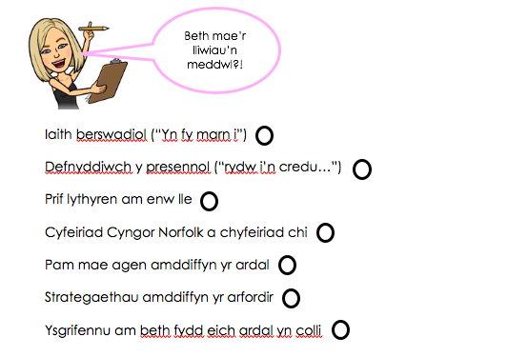

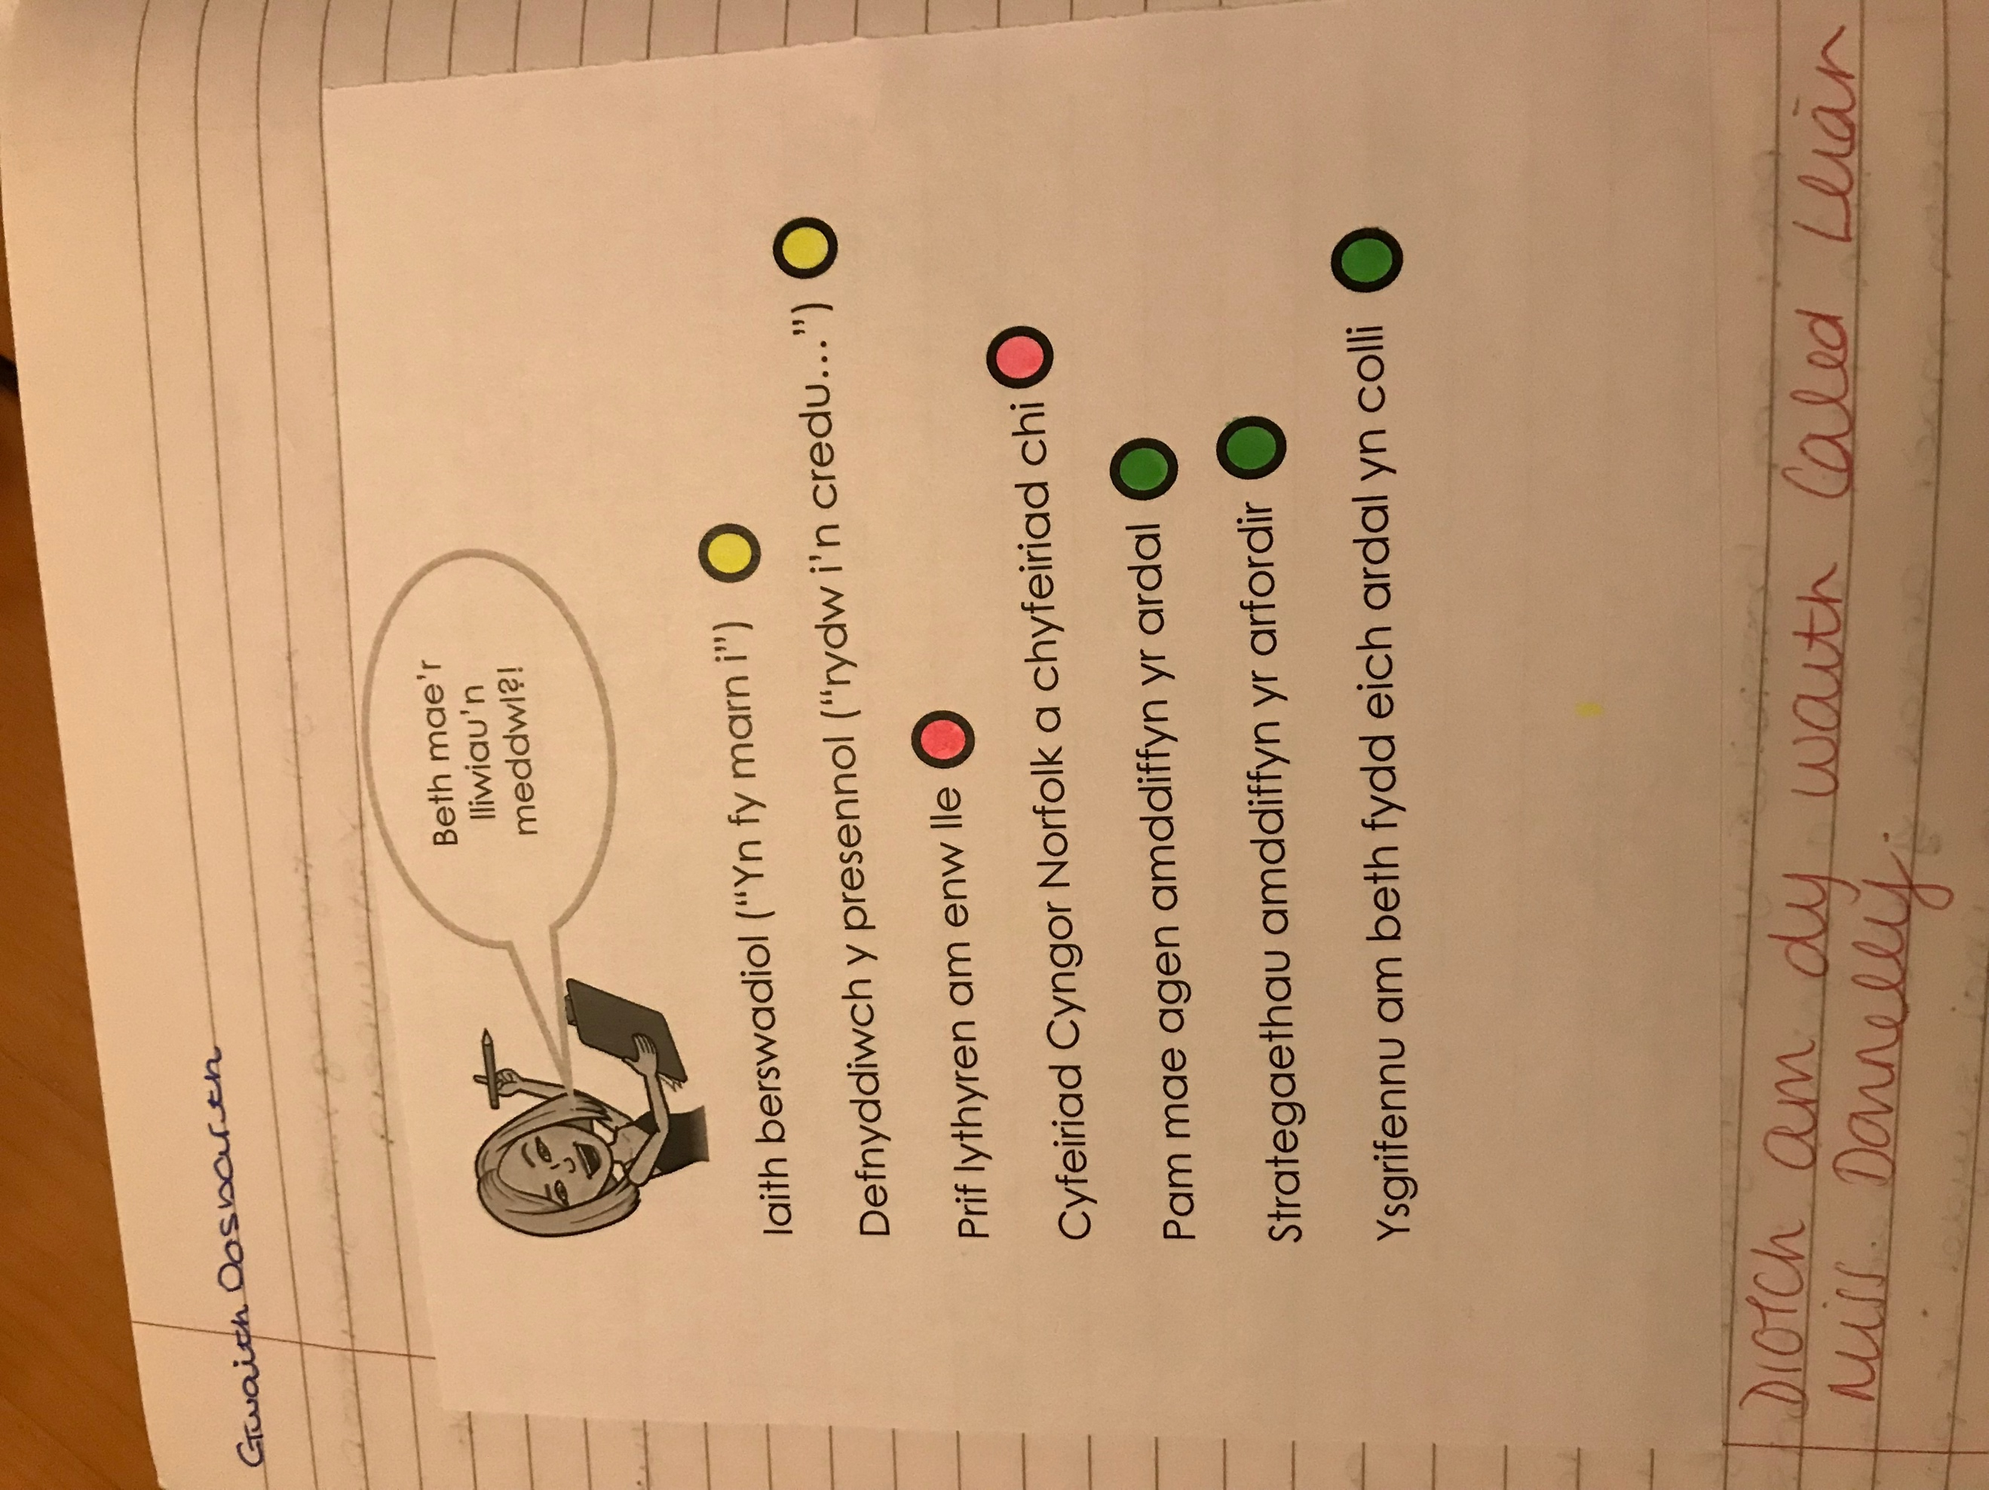
Appendix 2: Examples of pupil work
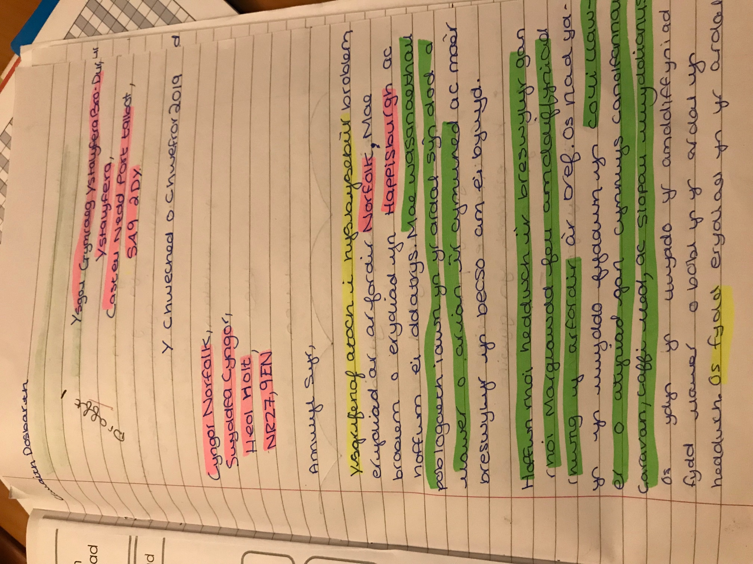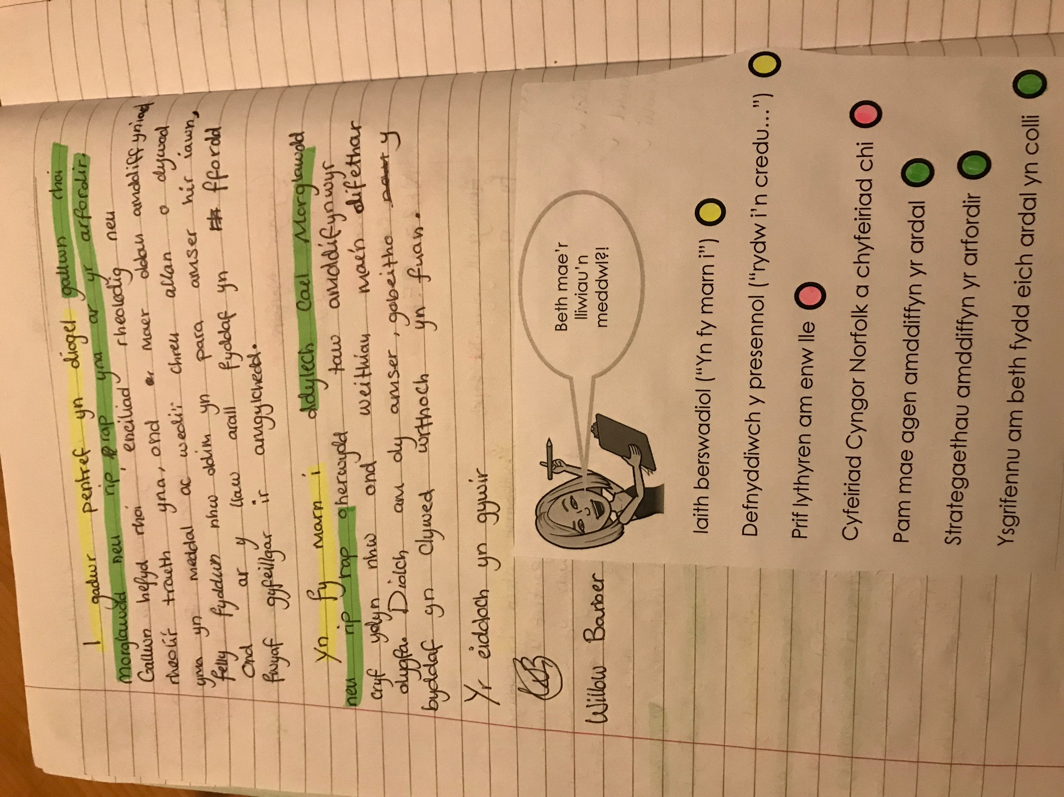

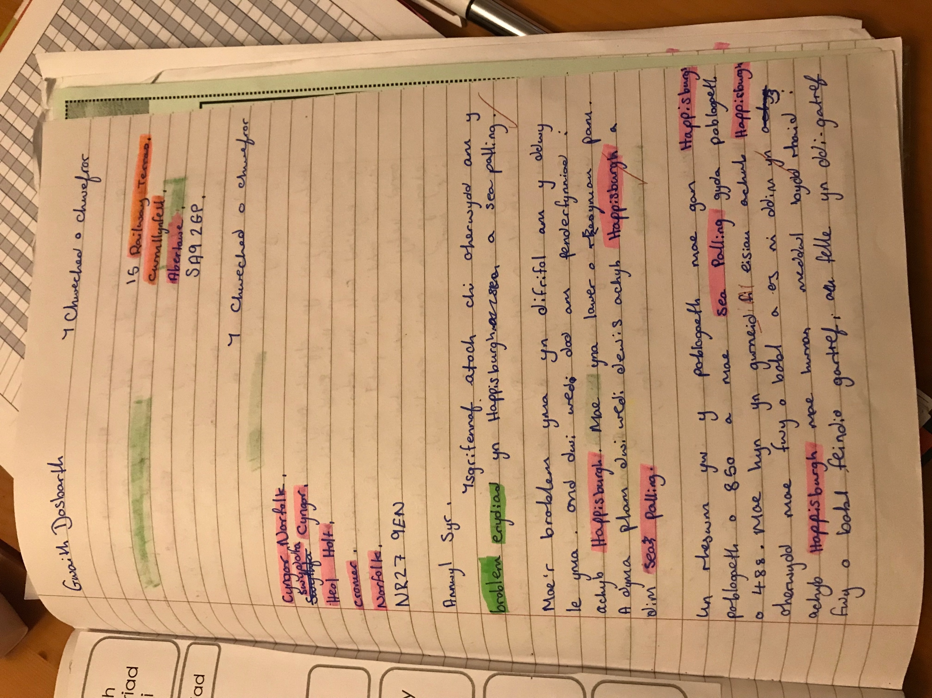

Appendix 3: Raw Marks including – and + level indicators.

Pupil | Pre-test Level | Post-test Level
1 | 5 | 6
2 | 3 | 4+
3 | 5 | 6
4 | 4 | 4+
5 | 5- | 5+
6 | 4 | 4+
7 | 3 | 4
8 | 3 | 4
9 | 5 | 6-
10 | 5 | 6
11 | 3 | 4
12 | 3 | 4
13 | 4 | 4+
14 | 5 | 6-
15 | 4 | 4+
16 | 3 | 4-
17 | 4 | 4+
18 | 4+ | 5+
19 | 4 | 4+
20 | 3 | 4
21 | 3 | 4
22 | 4 | 5
23 | 4 | 4+

