Post 1

Based on my learning from unit 1, the biggest threat to contemporary society is climate change. I was shocked to learn how rapidly co2 levels have risen since the industrial revolution. This information is coming from (NASA, no date).

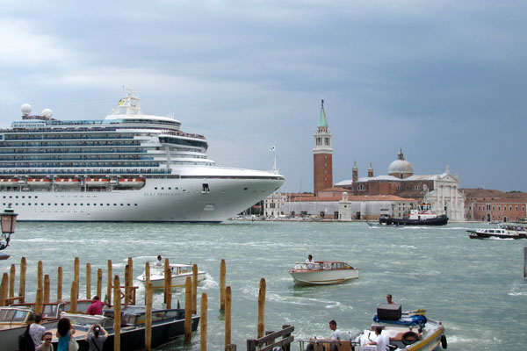
Climate change will have a big impact on the tourism industry. Rising sea levels will mean that places people go on holiday today could be threatened by sinking. According to Weforum (2019), Venice is sinking at 0.08 inches yearly. It has got to a point where the government has had to implement a flood barrier, which has been in the works for nearly twenty years and was expected to be finished in 2022. The impact of climate change and tourism is clear in the city, where certain paths are closed off at certain times of the year due to serve flooding. Moreover, tourists keep coming to one of the most visited places in Italy because of its remarkable architecture, which can be detrimental to the city. The city can have up to four to five cruise ships a day emitting fumes onto the city, with many of them not staying in the city for more than a couple of hours and not buying much when they are there, which has a detrimental effect on the locals who live there. Italy is implementing a tourism tax to try and help pay for vital restoration work (Eaglescliffe, 2022)

In unit 1, topic one, we were shown a video on climate change. I learned that the population of wild animals in the last 50 years has reduced by 60%. This will greatly impact the tourism industry as many people go abroad to see wild animals they cannot see in their native country. More animals going extinct may lead to fewer people going to countries they once would have.

The National Library of Medicine (2022) reported that global warming would severely challenge the sector. The challenges they outline are species extinction, disruption to tourism aviation and serval tourism activities. It also highlights that rising temperatures will harm the tourism sector and the tourists, who will have to take extra care when travelling.

Workers' productivity is also a big factor when considering the tourism sector. Under hotter temperatures, workers will need more rest and water. Not having them may cause less productivity in the workplace and lower mood overall. Subsequently, this may harm guests or tourists. Moreover, higher temperatures may lead to water shortages and, therefore, could significantly affect how the tourism establishment is run.

Another key threat to the tourism industry is our reliance on fossil fuels to fly planes. Fossil Fuels harm global warming, with 89% of global co2 emissions coming from them (source topic 1). With the net zero coming into place in 2050, and with more countries trying to take action to save the planet, the airlines will have to change how they are currently doing things. One way to do this, according to Air bp (2022), is in the form of SAF, which stands for sustainable aviation fuel. It is produced by sustainable feedstocks and will lead to a significant reduction of 80% in carbon emissions compared to traditional jet fuel. SAF is currently limited, and with a higher price tag, it is not being readily utilised. However, it is hoped that in time the price will come down.

Post 2
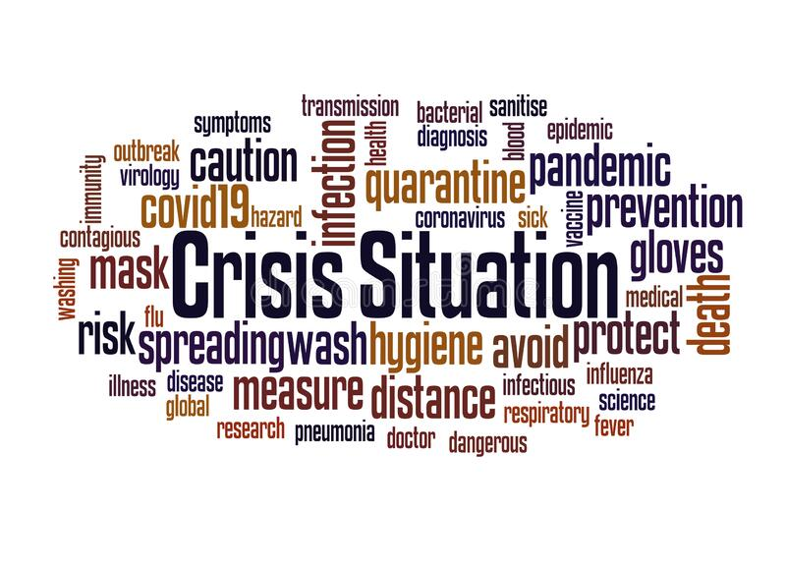
Based on my learning from unit 2, I reflected on the types of skills that I would need to be successful when working in the tourism industry. One such example is being able to manage a crisis. A crisis can happen at anytime, and you must be ready for it when it does. I learnt that there are three types of people during a crisis situation: people that fight, people that freeze and people that flight. (Topic 2 p.8) In the tourism sector, this may happen when the fire alarm goes off for example, and the guests are counting on you to ensure they are safe. Keeping calm during this situation is important. In the best-selling book Thinking, Fast and Slow by Daniel Khaneman (2012), he says that slow thinking is best because it offers people to be more rational. It can take the emotional heat out of a crisis and can help to better understand what is happening. When the fire alarm goes off, instead of panicking and getting the guests all worked up, I have learnt that it is best to take a step back and think for a second about what I need to do, to ensure everyone is safe. This could be making sure that no one runs and pushes people over so that everyone can get out of the building safely.
Turning a crisis into an opportunity
Having effective negotiation and team working skills is also important in a crisis. This is so that the crisis can be averted through a shared understanding. Mutual understanding is a key part of the negotiation. The ability to see the world through other people’s eyes is important. We all have different beliefs, needs, and feelings, enabling us to see things from their perspective, which will further help resolution.
I want to work as a tour guide in the near future. This job would entail decision-making skills, such as deciding where to go on the tour and what is best suited for the right type of people. For example, I would not take older people to a theme park. Decision-making skills refer to the abilities you use to choose the best option between two or more alternatives.
Albert Einstein once said, “we cannot solve our problems with the same thinking we used when we created them”. (NC State, 2015, p.1)
Another way I can make better decisions and be more successful in travel and tourism is by using probabilistic thinking. Using this method allows a person to think about all outcomes that may occur, both positive and negative. Probabilistic thinking involves estimating the likelihood of any specific outcome using logic. It is one of the best methods for improving the accuracy of our decisions.
As part of the unit, I learned how to build and use mental models. For example, I can narrate a scenario in my head about an event I have coming up, and by doing this, I can mentally plan how the day will go and what I’m going to do for it.

Post 3
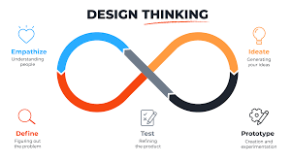
Based on my learning from unit 3, I have learned that employers look for employees who can use critical, creative and imaginative thinking. One way of doing this is by design thinking. This involves grouping problems into three categories: a simple problem, a complex problem, and a wicked problem. A simple problem relates to one cause and one effect. A complex problem is one that may have multiple and interlinked causes and a wicked problem is harder to solve, as it may be linked to a group of people or an area, and it may not have a permanent solution. Design thinking can also be broken down into five key stages; empathy is the first stage of design thinking. It is the ability to understand what someone else is thinking or feeling. For example, in my sector, I may have a situation of a lost child coming to me saying they are lost. I must empathise with the child and can do this in a few ways. Understanding how the child thinks and feels about the situation can help to emphasise better and put the child at ease. The next stage is to define. It refers to being able to show and describe something clearly and completely. This could, for instance, include clearly explaining terms and conditions to guests to avoid confusion or disagreements later on. Ideate comes next on the stages. This is about finding and generating ideas to fix a problem; this stage follows onto prototype, where the ideas are tried out. Regarding the travel and tourism field, the prototype stage is neither practical nor realistic. There is little opportunity to try ideas before a real problem occurs, so this is a shortcoming of the stages. Testing is the final step in design thinking, and it is where the final idea is put to the test. When doing this, it is important to listen to what others say and adjust the idea to ensure the best possible outcome.
I have learned a lot during the time I have been doing unit 3 about design thinking. I can see both positives and negatives about it; for example, a positive is that it allows us to put ourselves in other people’s shoes which is very important in the hospitality sector as you will be speaking to people daily. You need to understand what the guests are thinking. Unfortunately, I don’t think all the stages, such as the prototype stage, are relevant.

Link to WordPress https://technolgy7.wordpress.com/wp-admin/post.php?post=6&action=edit
Email: 2205975@student.uwtsd.ac.uk
Password: Travelandtourism

References

Dredge, D. (2019) Design thinking for tourism and the visitor economy, Medium. Regenerative Tourism by Design. Available at: https://medium.com/the-tourism-colab/design-thinking-for-tourism-and-the-visitor-economy-3db0d37b5db5 (Accessed: March 10, 2023).
EAGLESCLIFFE, B.E.T.H. (2022) Venice, Italy is being destroyed by tourism and flooding, Venice, Italy Is Being Destroyed by Tourism and Flooding. Available at: https://wanderwisdom.com/travel-destinations/Venice-Tourism-Sinking (Accessed: March 10, 2023).
NC STATE . (2015) Innovation is No Longer an Optional Business Strategy . Available at: https://www.ies.ncsu.edu/wp-content/uploads/sites/15/2015/08/IES_SB_InnovationEngineering_150728_Final_LoRes.pdf (Accessed: 5 March 2023).
Overtourism in Venice - responsible travel (no date) responsibletravel.com. Available at: https://www.responsibletravel.com/copy/overtourism-in-venice#:~:text=Overtourism%20boils%20down%20to%20the,55%2C000%20permanent%20residents%20%5B1%5D . (Accessed: March 10, 2023).
Sibitane, Z.E., Dube, K. and Lekaota, L. (2022) Global warming and its implications on nature tourism at Phinda Private Game Reserve, South Africa, International journal of environmental research and public health. U.S. National Library of Medicine. Available at: https://www.ncbi.nlm.nih.gov/pmc/articles/PMC9105327/ (Accessed: March 6, 2023).
What is sustainable aviation fuel (SAF) and why is it important?: News and Views (2022) Air bp. Available at: https://www.bp.com/en/global/air-bp/news-and-views/views/what-is-sustainable-aviation-fuel-saf-and-why-is-it-important.html (Accessed: March 5, 2023).
What is sustainable aviation fuel? (no date) Aviation. Available at: https://aviationbenefits.org/faqs/what-is-sustainable-aviation-fuel/#:~:text=Aircraft%20today%20are%20powered%20by,reduce%20aviation's%20net%20CO2%20emissions. (Accessed: March 5, 2023).

