

Module: Supply Chain Strategies

Programme: HND Logistics and Supply Chain Management

Student: Jodi Emanuelli

Student Number: P093663

Lecturer: Ged Edwards

Table of Contents

1. OBJECTIVES iii
2. INTRODUCTION 1
3. MAIN BODY 2
3.1 Characteristics of a logistics function .……………………………………………2
3.2 Strategic plan approach.…………………………………………………………………3
3.3 PESTLE Analysis ……………………………………………………………………………..4-5
3.4 Last mile Environmental impacts on an organisations strategic plan …5-7
3.5. Last mile Social impacts on an organisations strategic plan ……….......7-8
4. CONCLUSION 9

II

1. Objectives

The aim of the report is to:
- Define the characteristics of the logistics function
- Examine the strategic plan approach
- Assess the effectiveness of the PESTLE analysis as a strategic planning tool
- Evaluate the impact of the last mile delivery service on an organisation’s strategy

III
2. Introduction
Primary Transport, Distribution Depot and Local delivery are principal features of a logistics function and are considered to play a major part of strategic planning, within a distribution function.
Effective strategic planning ensures that an organisation has a clear focus on setting goals, and working collaboratively towards achieving these goals, in response to a continuously changing environment. A generalised methodology to strategic planning, associated to the characteristics of a logistic function, includes marketing, finance and logistics, which feature in the strategic plan.
The PESTLE analysis, a popular strategic planning tool, is frequently used to identify any possible negative or positive scenarios and provides strategies for avoiding or benefitting from them. The six factors that comprise the PESTLE analysis have both positive and negative impacts on an organisations strategy. Environmental and social are considered in this report, as, it can be claimed that these factors have the greatest impact on an organisation utilising the last mile delivery service.

1
3. Main Body
3.1 – Characteristics of a logistics function
The important characteristics of a logistics function can be categorised as Primary Transport, Distribution Depot and Local delivery.
Primary transport activities involve above average volume movements between the distribution points of an organisation’s supply chain, such as, incoming movements from suppliers to warehouses, movements between warehouses within an organisation’s internal system and mass outbound consignments to customer warehouses. The use of sizeable vehicles, mainly bulk being transported and a small number of, often single, deliveries, guarantees that primary transport is frequently superior in terms of value per unit conveyed than secondary transport.

Local delivery, or secondary transport movements, characteristically consist of lesser volume movements from an organisation’s distribution depots to the customers. These deliveries will frequently be multi-drop activities, to places that vary daily or travelling to regular predetermined settings, such as retail stores. “As a key element of many logistics networks, secondary transport movements offer several opportunities for improvement and optimisation” (Catalyst Logistics, 2018). When optimising secondary transport routes, influences that need to be considered include customer whereabouts and any possible access constraints, size and readiness of vehicles, availability of drivers and driver hour’s restrictions, delivery time limitations and any special handling requirements, such as vehicle fitted for or tail lift. Evaluating all the features of secondary transport movements, enables organisations to recognise opportunities for improved efficiency which could lead to reducing financial costs and time.

The distribution depot, sometimes referred to as branch or distribution warehouse, is typically smaller than an organisations principal depot and its function is to receive, provide interim storage and redistribute merchandise corresponding with customer orders as they are accepted. “Distribution centers are a key part of the distribution chain for products, order fulfilment, and storing produced goods prior to their shipment to wholesale, retail or customers” (TechTarget, 2018).
In addition, distribution depots facilitate large scale transportation of goods to both retail and individual customers. If located advantageously, distribution depots streamline and reduce costs when transporting goods to a destination, that is, wholesale shipping to the core of a market. By eradicating, for example, taxes and VAT expenses a customer would be required to pay if ordering globally, distribution depots facilitate international trade with more competition.
2
3.2 – Strategic plan approach
Strategic planning is an organizational management activity that is used to set priorities, focus energy and resources, strengthen operations, ensure that employees and other stakeholders are working toward common goals, establish agreement around intended outcomes/results, and assess and adjust the organization's direction in response to a changing environment" (BalancedScorecardInstitue, 2018).
Effective strategic planning generates strategies that, with an emphasis on leader’s vision for the future, will determine what and organisation is, who it assists, the actions it takes to make progress and why it takes them. Strategic planning enunciates the direction an organisation is taking and how success will be recognised. Usually, and organisation’s strategic planning will be based around a time scale of three to five years.
A generalised approach to strategic planning, related to the characteristics of a logistic function, includes marketing, finance and logistics, which feature in the strategic plan.
An organisation communicates its functions and what it could provide for customers through effective marketing, which includes advertising, branding, corporate identity and demonstrations. Successful marketing enables discussion with customers and provides an organisation with opportunities to present the advantages customers would get from their goods or services. Marketing material is most advantageous when it is easily understandable and allows the customer to recognise why they should select a specific service or product.
In terms of finance “A product as well as a service is only worth what customers are prepared to pay for it” (MarketingForLogistics, 2014). However, cost, or price, needs to be competitive as cost to the customer is significant. Price will determine where an organisation is placed in the market as, customers will anticipate better value or quality for money if the cost is greater. It is imperative that an organisation recognises the need to look after existing customers as price is not necessarily their prime reason for their loyalty to the organisation.
With regards to logistics, distributing products to a location, where customers can purchase the product, needs to be suitable and convenient. “The product must be available in the right place, at the right time and in the right quantity, while keeping storage, inventory and distribution cost to an acceptable level” (MarketingForLogistics, 2014). An important principle for selecting a supplier is delivery performance.

3
3.3 – PESTLE Analysis
The first stage of a strategic analysis should include an evaluation of the external environment of the organisation within which it functions. Factors such as technological changes, current changes to regulations and the economic climate are included. A PESTLE analysis, a popular strategic planning tool, enables an organisation to review and assess the impact of the external environment. This tool provides the opportunity for an organisation to recognise the political, economic, social, technological, legal and environmental factors that could possibly impact on a mission and its planning procedure. The PESTLE analysis facilitates the identification of likely prospects and threats connected to a strategy and provides methods for avoiding or benefitting from them.
Political factors take account of, for example, environmental regulations, tariff and trade restrictions and tax policies. Economic factors consist of, for example, interest rates, economic growth indicators and unemployment trends. Population growth rate, social classes and cultural aspects are examples of social factors. Technological change, basic infrastructure level and technology incentives are incorporated in technological factors. Legal factors can include labour laws, tax laws and any other laws related to an organisation that are not contemplated in political factors. Environmental factors include statistics, such as, climate change, pollution and carbon footprint data.
An analysis of these factors supports an organisation in acquiring a thorough understanding of the macro environmental factors that could have a positive or negative affect on the strategic planning procedure. This understanding enables and organisation to develop appropriate strategies to attain any goals set. Therefore, a PESTLE analysis can be a key factor of the strategic planning process.

Below is a PESTLE analysis relating to the last mile delivery, characterised as a local delivery logistical function. “Last mile delivery is defined as the movement of goods from a transportation hub to the final delivery destination. The final delivery destination is typically a personal residence. The focus of last mile logistics is to deliver items to the end user as fast as possible” (Datex, 2018). The increasing demand for the type of retail, which integrates the various methods of shopping available, for example, online or by phone, has ensured that last mile logistics has evolved into a popular method. This omnichannel retailing has compelled retailers to assess, and regulate accordingly, their existing transportation. Last mile delivery can vary from fifty miles to just a few streets and frequently, last mile logistics comprises of small parcel hauliers delivering goods to customers.

4

(Figure 1. Jodi Emanuelli, 2018)

3.4 – Last mile Environmental impacts on an organisations strategic plan
Although the PESTLE analysis comprises of the six factors that have both positive and negative impacts on an organisation’s strategy, this report will focus on environmental and social as, it can be claimed that these factors, have the greatest impact on an organisation utilising the last mile delivery service.
“The last mile problem comprises one of the most-highest polluting segments of the supply chain in which companies deliver goods to end customers” (InformaUK, 2017).
Developing a sustainable strategic plan for an organisation will impact upon the actual strategy as, climate change demands differing approaches, depending on the particular business of an organisation. However, these approaches should blend with the overall strategic plan.
There are many positive impacts a company incorporating a sustainable strategy will benefit from. Reducing electricity and water usage, employing recycling strategies and lessening the volume of waste sent to landfill sites will decrease environmental impact. An organisation can create positive public relations when green initiatives are introduced into their strategic plan. Although initial outlay costs incurred when an organisation introduces green strategies, the long term decreased expenses will ultimately prove beneficial.
Today’s trend towards an organisation’s strategic plan being characterised by environmental responsibility, has seen strategies, such as, the introduction of electric vehicles, which reduces harmful air pollution, used for the last mile delivery. Recharging electric vehicles using renewable energy, can lead to a reduction in greenhouse gas emissions and these vehicles could be a positive factor in terms of noise.
5
In 2017, DHL pledged to reduce its logistic related emissions to net zero over the next thirty to thirty-five years. This strategy of zero emissions logistics is reinforced by four short-term milestones to be attained in the first ten years as a segment of DHL’s environmental protection plan, named GoGreen. One short-term milestone is “to operate 70% of its own first and last mile services with clean pick-up and delivery solutions, such as by bike and electric vehicle” (DHLInternationalGMBH, 2018).
As part of DHL’s GoGreen strategy, StreetScooter vehicles are operating in Europe and should ultimately reduce carbon dioxide emissions. DHL’s strategic plan of operating seventy percent or more of its own first and last mile services, aims to increase their electric vehicle fleet by December 2018. The new electric vehicles will replace diesel vehicles and the expectation is that this could result in a “total saving of 12,500 tonnes of CO₂ and 4.75 million liters of fuel every year” (DHLInternationalGMBH, 2018).
Initially, Germany will benefit from buying the new electric vehicles. “The country’s CO2 emissions have fallen from 11.6 metric tons per capita in the early 1990s to 9.4 metric tons in 2013 and have held steady since then” (WorldBankGroup, 2018).

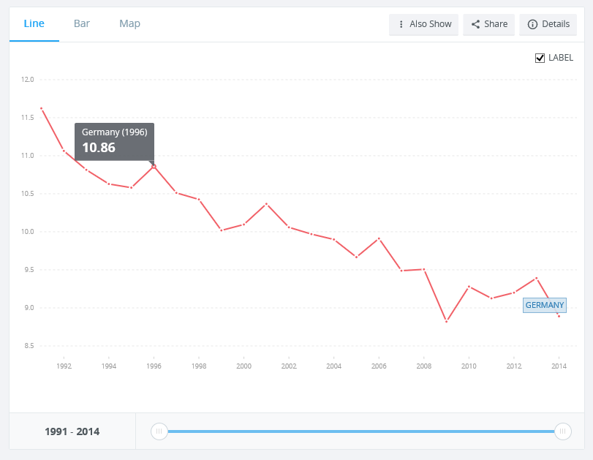
(Figure 2. WorldBank, 2018)

6
DHL have extended green urban delivery, to attain goals in their strategic plan, by introducing a City Hub for cargo bicycles, to facilitate inner-city deliveries. The City Hub can transport up to four containers. The customised cargo bicycles, or Cubicycles, can transport a container of up to a hundred and twenty-five kilogrammes. For example, the trailor is delivered in to the middle of a city and, for the last mile delivery, the containers are loaded on to two Cubicycles. This strategy of replacing standard delivery vehicles with those which will significantly reduce emissions, can save “an equivalent CO2 saving of over sixteen tons per year and a significant reduction in other emissions” (DHLInternationalGMBH, 2018). DHL’s use of bicycles for express delivery functions is advantageous as, traffic congestion can be avoided, more stops per hour can be made, they produce zero emissions and this strategy promotes sustainable urban living. The City Hub strategy should ensure that DHL’s last mile delivery service will be faster and more reliable and, for example, are equipped with Global Positioning System for consignment tracking and solar panels are used for self-powering.

3.5 – Last mile Social impacts on an organisations strategic plan
The social factor from the PESTLE analysis, convenience for the consumer and corporate social responsibility, incorporate strategies that have a significant impact on an organisation utilising the last mile delivery service.
The rapid development of eCommerce has resulted in organisations needing to develop strategies to facilitate customer requirements. Consumer expectations for swift and reliable delivery experience and helpful communication have evolved, and, the greatest challenge, and a crucial component of the supply chain, can be offering an effective last mile delivery service. “A Voxware survey involving 600 consumers examined delivery expectations when purchasing online. According to the survey, 62% of respondents were less likely to shop with a retailer if an item wasn’t delivered within two days of the date promised” (MitchellesNY, 2018).
It has become more important for logistic providers to offer the last mile delivery as a positive experience for the customer. Organisations are required to regularly review their strategic plan, with the development in technology, to ensure that further delivery choices and high-quality services are available to their customers.
The introduction of initiatives, such as, locker collection points, could be part of an organisation’s strategy to improve delivery procedures for customers. This product self-collection strategy results in heightened convenience, flexibility in accepting deliveries or returning goods and customer satisfaction, which will ultimately develop customer loyalty. “The use of parcel lockers simplifies the ‘last-mile challenge’ for retailers through the consolidation of deliveries at a single self-collection point” (SPecommerce, 2015). To meet customer needs, parcel lockers are constantly evolving and, parcel
7
delivery and collection are streamlined with the innovative solution parcel lockers provide. In addition, the security of customer’s online purchases can be improved with the digitization of parcel locker systems.
DHL have developed a partnership with InPost UK as part of their social strategic plan, to provide further flexible delivery options, to meet the needs of eCommerce and provide a convenient service to customers. This newly developed strategy provides customers with the opportunity to select their nearest InPost parcel locker, with access to their deliveries twenty-four hours per day. This strategy ensures that the customer has a convenient, safe and secure parcel collection point.
“Today’s customers are time short, online savvy and want to receive their deliveries quickly and conveniently. Providing increased flexibility, with 24 hour access, lockers eliminate the need for customers to wait in for a parcel and allow for delivery locations to be tailored to their needs” (PostandParcel, 2017)

Consumer’s delivery preferences and priorities
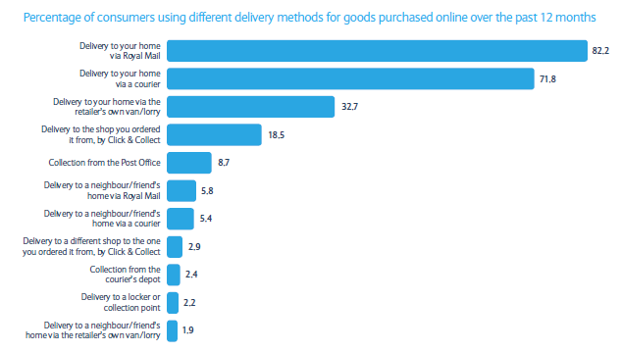
(Figure 3. Barclays, 2018)
The figure above demonstrates that, although delivery to home remains the most popular service, the use of locker collection points and click and collect are rising in popularity due to the convenience, flexibility and security this option offers.
Ecommerce has enabled logistic companies to use digital channels to swiftly connect to a wider customer base. Parcel lockers are considered to become a key factor in the last- mile delivery service, as they provide the means to meet customer expectations of convenience, flexibility, greater control, efficiency and low costs. The benefits for logistic companies include reductions in cost and the opportunity to provide enhanced customer experience, leading to improved customer satisfaction.
8
Conclusion
An evaluation of the important characteristics of a logistics function, Primary Transport, Distribution Depot and Local delivery, demonstrates the key role they play as part of effective strategic planning within a distribution function. The Primary transport provides value per unit transported, and, evaluating all the features of local or secondary transport movements, enables organisations to recognise opportunities for improved efficiency, which could lead to reducing financial costs and time. The positive features of distribution depots are that they improve the efficiency of the distribution chain for products, fulfilling orders and for storing goods.
Effective strategic planning articulates the direction an organisation takes and how success will be recognised. The PESTLE analysis is a valuable tool used by an organization and all six factors have both positive and negative impacts on an organisation’s strategy on an organisation’s strategy.
This report demonstrates the many positive impacts a company incorporating a sustainable strategy will benefit from, and, convenience for the consumer and corporate social responsibility, incorporate strategies that have a significant impact on an organisation utilising the last mile delivery service. The benefits of ecommerce for logistic companies include reductions in cost and the opportunity to provide enhanced customer experience, leading to improved customer satisfaction. It can be argued that the many positive aspects are a result of effective strategic planning.

9
References
Anon, (2018). (Online) Available at: http://www.asean.org/storage/images/2015/september/transport-facilitation/batch-3/Marketing-for-Logistics/ (Accessed 8 Feb. 2018).
Anon, (2018). (Online) Available at: https://www.business2community.com/strategy/pest-analysis-can-help-strategic-planning-01420731 (Accessed 8 Feb. 2018).
Balancedscorecard.org. (2018). The Basics of Strategic Planning, Strategic Management and Strategy Execution. (Online) Available at: http://www.balancedscorecard.org/BSC-Basics/Strategic-Planning-Basics (Accessed 8 Feb. 2018).
BasketsGalore Blog. (2018). DHL Inpost Lockers - How it works | BasketsGalore Blog. (Online) Available at: https://basketsgalore.co.uk/blog/2015/07/dhl-inpost-lockers-how-it-works/ (Accessed 12 Feb. 2018).
BusinessDictionary.com. (2018). What is distribution center? definition and meaning. (Online) Available at: http://www.businessdictionary.com/definition/distribution-center.html (Accessed 7 Feb. 2018).
Catalyst-logistics.co.uk. (2018). Transport management Software | Vehicle routing software tool. (Online) Available at: http://www.catalyst-logistics.co.uk/logistics-solutions/transport/primary-transport-management (Accessed 7 Feb. 2018).
Data.worldbank.org. (2018). CO2 emissions (metric tons per capita) | Data. (Online) Available at: https://data.worldbank.org/indicator/EN.ATM.CO2E.PC (Accessed 12 Feb. 2018).
Datex Corporation. (2018). What is Last Mile Delivery? Part One. (Online) Available at: https://www.datexcorp.com/last-mile-delivery-part-1-omni-channel-retail-affecting-transportation-logistics/ (Accessed 11 Feb. 2018).
Design, K. (2018). Benefits of Becoming a Sustainable Business // Eco-officiency. (Online) Eco-officiency.com. Available at: http://www.eco-officiency.com/benefits_becoming_sustainable_business.html (Accessed 11 Feb. 2018).
Dhl.com. (2018). DHL | Press Release | English. (Online) Available at: http://www.dhl.com/en/press/releases/releases_2017/all/express/dhl_expands_green_urban_delivery_with_city_hub_for_cargo_bicycles.html (Accessed 12 Feb. 2018).
Dhl.com. (2018). DHL | Sustainability | English. (Online) Available at: http://www.dhl.com/en/sustainability.html (Accessed 11 Feb. 2018).

10
Dpdhl.com. (2018). Deutsche Post DHL Group | Oct 02, 2017: StreetScooter shifts into high gear. (Online) Available at: http://www.dpdhl.com/en/media_relations/press_releases/2017/streetscooter_shifts_into_high_gear.html (Accessed 12 Feb. 2018).
Ecommerce News. (2018). DHL tests cargo bicycles in Germany and the Netherlands. (Online) Available at: https://ecommercenews.eu/dhl-tests-cargo-bicycles-germany-netherlands/ (Accessed 12 Feb. 2018).
Home.barclays. (2018). Cite a Website - Cite This For Me. (Online) Available at: https://www.home.barclays/content/dam/barclayspublic/docs/BarclaysNews/2014/September/the-last-mile-report.pdf (Accessed 11 Feb. 2018).
https://parcel.dhl.co.uk/?gclid=Cj0KCQiAiKrUBRD6ARIsADS2OLmCz6X2PKw7a7hc-XeC_Xw7MHAeFIftAFKlKMRf_0Vf015PDyyOMFgaAkE3EALw_wcB (Accessed 12 Feb. 2018).
Mitchell's NY Blog. (2018). Overcoming Last Mile Logistics Challenges - Mitchell's NY Blog. (Online) Available at: https://www.mitchellsny.com/blog/overcoming-last-mile-logistics-challenges/ (Accessed 11 Feb. 2018).
Morana, J. (2013). Sustainable Supply Chain Management. Wiley-ISTE.
Parcel.dhl.co.uk. (2018). DHL Courier Services for Parcel Delivery UK & International | DHL Express. (Online) Available at:
Relative Marketing. (2018). Understanding The Marketing Mix And The 4 Ps. (Online) Available at: http://www.relativemarketing.co.uk/blog/understanding-the-marketing-mix-and-the-4-ps/ (Accessed 8 Feb. 2018).
Rushton, A., Croucher, P. and Baker, P. (2014). The handbook of logistics and distribution management. London: Kogan Page.
Smallbusiness.chron.com. (2018). Four Functions of Marketing Logistics. (Online) Available at: http://smallbusiness.chron.com/four-functions-marketing-logistics-21833.html (Accessed 8 Feb. 2018).
Tinsley, M. (2018). 7 trends in last mile delivery. (Online) Blog.flexerent.co.uk. Available at: https://blog.flexerent.co.uk/7-trends-in-last-mile-delivery (Accessed 11 Feb. 2018).
Transportation Management Company | Cerasis. (2018). What is Last Mile Logistics & Why Are Shippers Looking at this Function?. (Online) Available at: http://cerasis.com/2017/09/19/last-mile-logistics/ (Accessed 11 Feb. 2018).
WhatIs.com. (2018). What is distribution center? - Definition from WhatIs.com. (Online) Available at: http://whatis.techtarget.com/definition/distribution-center (Accessed 7 Feb. 2018).
11

