4. Chapter Four: Analysis of Results

4.1 Introduction
The previous chapter defined the research's methods and methodology. This chapter aims to analyse the diverse factors contributing to the association between ACES and criminality. The literature review within this study emphasised that there is a visible lack of existing academic research and studies on police officers having adequate training on ACES since 2020, importance of early intervention implemented and absence of collaboration between agencies. As a result, primary research has been undertaken, in the form of a survey, to address the research questions. The findings of this research will be presented in graphs and tables to demonstrate patterns and trends identified, and to categorize themes by conducting this type of research, it will assist in filling the gap in the current literature and how well this is being addressed and prevented. It is hoped that by gaining a better understanding from response officers, PCSOS and CSE officers who engage in this research, it will boost confidence and awareness on ACES and improve training. Comprehending the intricacies of this link can guide policy and practice with the aim at breaking the cycle of trauma and crime.

4.2 Data Analysis
Data analysis is the systematic examination, organisation, and extraction of information from extensive datasets to elucidate patterns or themes, with consistent or analogous responses potentially indicating solutions to research questions (Bryman and Hardy, 2009). This chapter's data analysis will consistently aim to address the research question often referenced in the project. (Nguyen et al., 2021) proposed the theory of jigsaw puzzle completion analysis. Consequently, it was determined that integrating various data sets and study findings yields a more comprehensive and detailed analysis. The data was collected and processed using the Microsoft Office Forms survey application. This way of gathering data was easily accessible for the participants and was not time consuming. (David, 2024) determined that a consistent and precise methodology is essential for research reliability. In this research, all participants have maintained anonymity and were presented with identical questions and response possibilities. The questionnaires were sent via email to 40 individuals, there were 33 respondents. Questions were mixed with open and closed questions, and multiple-choice answers. All findings from the primary survey will be in the Appendix.

4.3 Questionnaire Findings
The questionnaire aimed to compare views of response officers, CSE officers, and PCSOs. Results showed 68% were police officers, 19% were PCOS, and 13% were CSE officers. However, there is no way to analyse whether to results and opinions of response officers differed from PCSOs and CSE officers because all questionnaires were anonymous and had the same questions to answer. The table below demonstrates the findings:

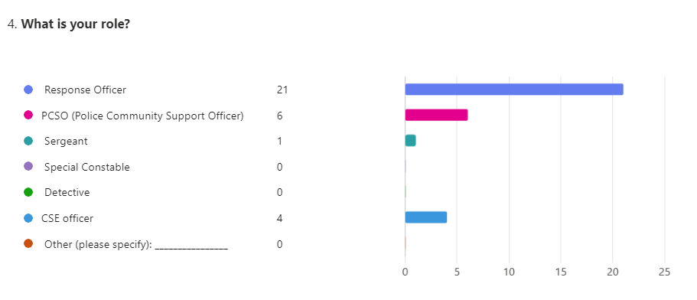

4. 5.1 Evaluate the link between adverse childhood experiences and criminality through existing research?

When analysing the data 66% of the participants strongly agreed that ACES contribute to individuals engaging in criminal behaviour, while 34% agree. In addition, participants were also asked how often individuals involving in criminal behaviour display signs of having ACES. 56% of the participant’s said daily and 34% said weekly. These echo (Ford et al., 2019). findings, as noted in the literature review. Having analysed the findings, it is evident that there is a very clear pattern which would indicate that ACES are connected to criminality. The charts below demonstrate the findings:
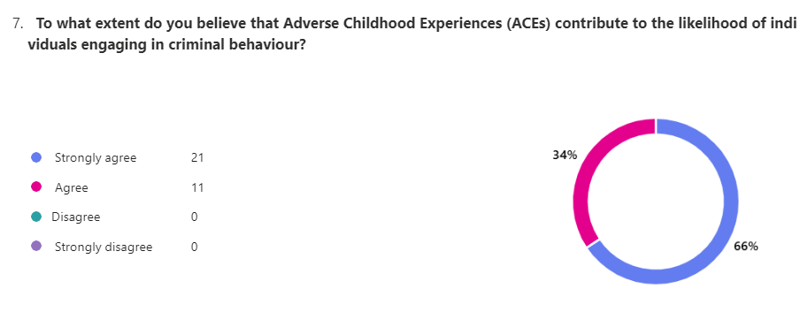

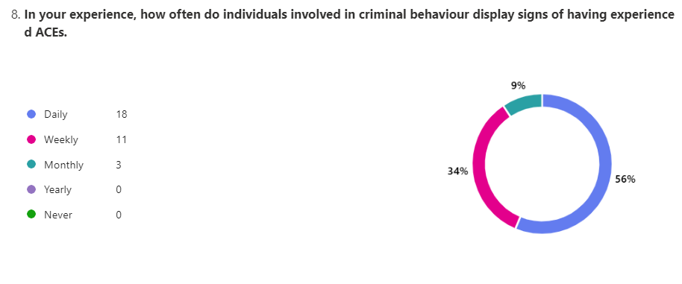
    - Is there enough awareness of Police officers recognising the signs of ACES. Have they had adequate training to provide the early intervention?

When analysing the 33 responses, in relation to receiving any formal training on ACES ,13% of the participants said that they had extensive training, 69% said that they have had some training , while 13% said that they have not received any ACE – specific training , while 13% said No, but had received related training (e.g., trauma-informed care, vulnerability).

In addition, participants were asked If they had received training on ACEs, how effective was it in increasing their understanding of the potential link between ACEs and criminality. 40% of those surveyed said ‘somewhat effective’, while 27% of the participants said, ‘no training’, 7% said ‘somewhat ineffective’, with 7%, ‘neither effective nor ineffective’. while 20% thought that it was ‘very effective’.

When analysing date further, regarding sufficient training on how to address trauma – related needs of victims of crimes linked to ACES ,53% of participants thought that the training was inadequate, while 31% said somewhat adequate training, while only 6% said that they received adequate training and 9% were unsure.

It is evident that there are discrepancies within the literature review whereby (Rodriguez et al., n.d.) states that training completed by 80.7% of police and MA partners, enabled them to confidently respond to vulnerabilities using an ACE-informed training. In the Literature review The Chief Constable of South Wales Police and Welsh forces pledged to become trauma-informed organizations to improve service delivery, mitigate trauma effects, and prevent re-traumatization (College of Policing, 2018). This is Clearly not happening .This strategy will be expanded upon in the conclusion and further recommendations suggested. The charts below demonstrate the findings:

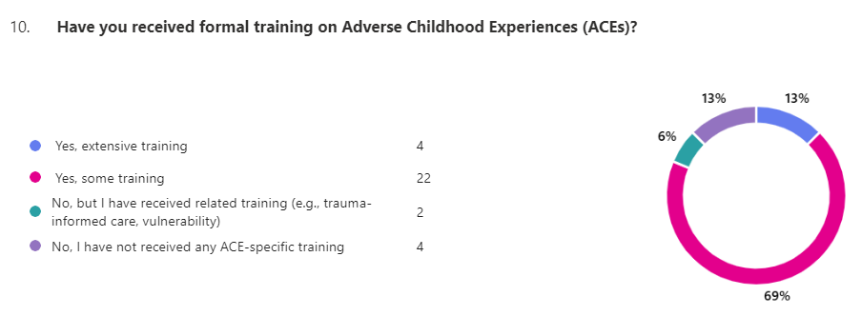

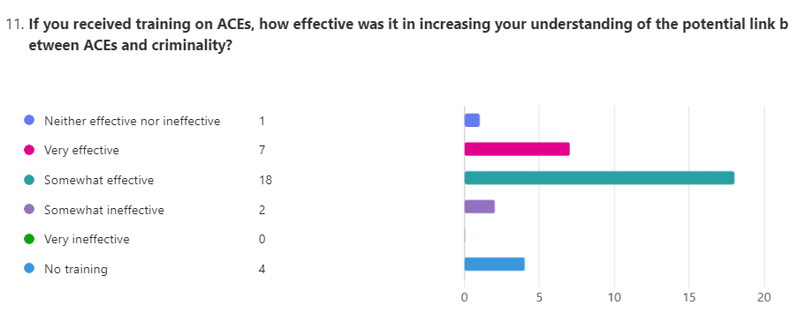

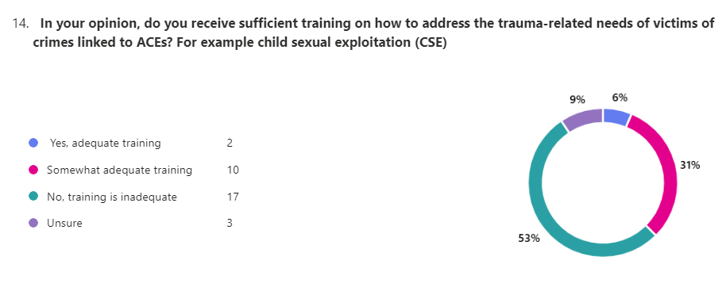

When analysing the data 91% participants said yes that they believe early intervention could prevent future criminal behaviour in individuals who have been exposed to ACES. Only 9% were unsure.

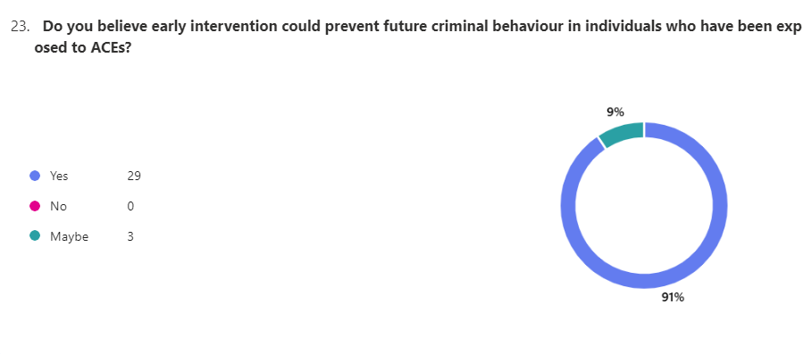

In addition, participants were asked if they believe that is there adequate early intervention programs available to address the needs of individuals affected by ACEs before they become involved in criminal behaviour. 78% said ‘no’,3% answered’ yes’ and 19% answered ‘maybe’.
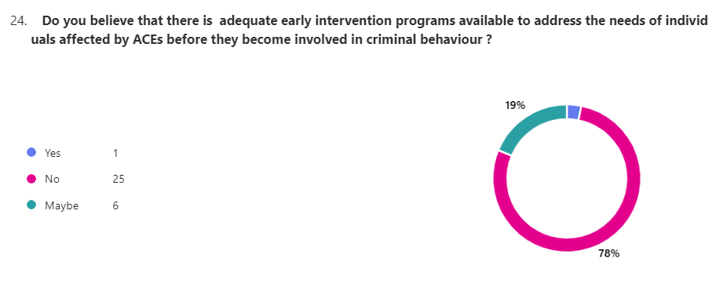

When the participants were asked if they feel is there enough focus and prevention (rather than reactive measures) when dealing with individuals affected by ACES in their roles, 75% participants answered ‘no’ and 13% of the participants answered ‘yes’, while 13% of the participants answered ‘maybe ‘
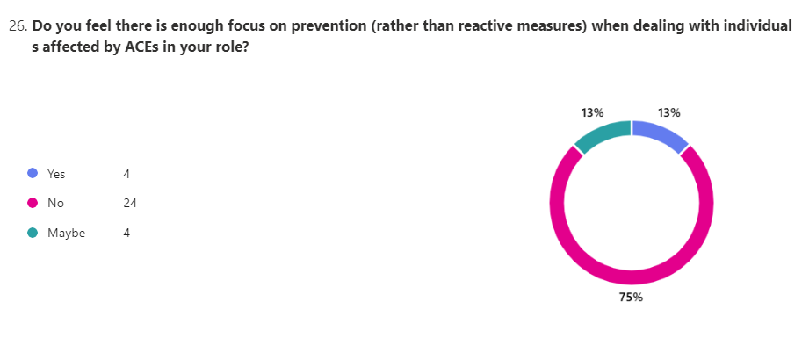
These findings clearly shows that the participants believe that there are not adequate early intervention programs available and no focus on prevention. (Masten et al., 2008) notes in the literature review how early intervention can be effective in reducing the likelihood of future criminality. This is further supported by (Kerig, 2018). This strategy will be expanded upon in the conclusion and further recommendations suggested.

4.3.3 To examine whether the police are working with the right support agencies?
When analysing the 33 responses, 75% of the participants said that no, not proactively enough when police work with multi agencies. 13% said yes but there were gaps in intervention, while 9% said yes proactively & effectively, only 3%were unsure. This differs to what (Rodriguez et al., n.d.) states in the literature review. This strategy will be expanded upon in the conclusion and further recommendations suggested. The chart below demonstrates the findings:

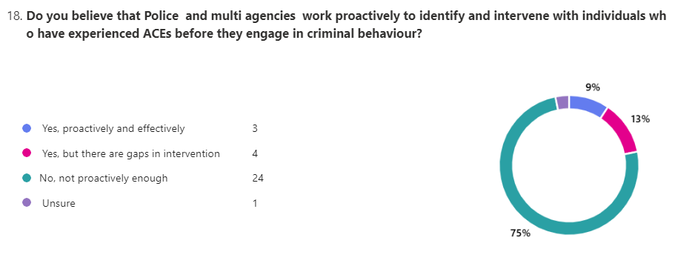
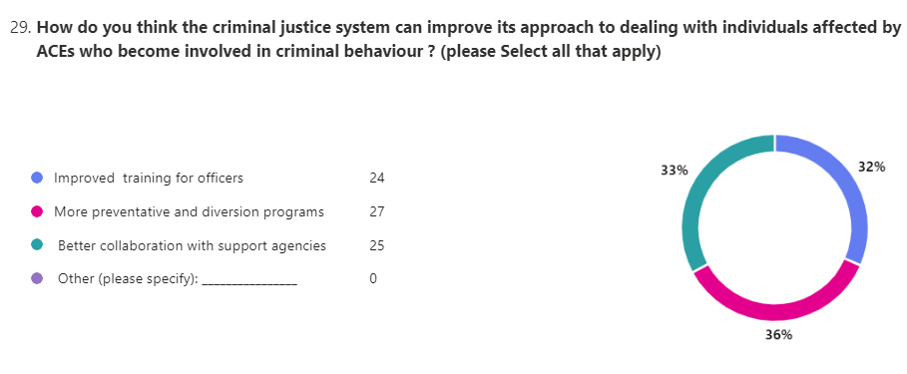

When the participants were asked how do you think the criminal justice system can improve its approach to dealing with individuals affected by ACES who become involved in criminal behaviour , 36% of participants support the implementation of preventative and diversion programs, 33% suggest better collaboration with support agencies, and 32% suggest improved officer training, This findings conclude to my conclusion.

4.4 Conclusion

In conclusion the study suggests closing the gap between ACEs and criminality by increasing officer training, improving communication and accountability across agencies and ensure a solid system of implementing early intervention. This approach reduces the likelihood of individuals engaging in the criminal justice system, alleviating the burden on policing and prison services. A correlation has been made between this research and literature review. The following chapter will examine the data in greater depth to discover distinct trends, allowing for recommendations to be made.

.
Word count
1253

Bibliography

Bryman, A and Hardy, M. (2009) Handbook of Data Analysis. London: Sage Publications
David, E. (2024). 12 Advantages & Disadvantages of Questionnaires. [online] ProProfs Survey Blog. Available at: https://www.proprofssurvey.com/blog/advantages-disadvantages-of-questionnaires/.
(Accessed 29th of January 2025)
‌
Nguyen, T.N.M., Whitehead, L., Dermody, G. and Saunders, R. (2021). The use of theory in qualitative research: Challenges, development of a framework and exemplar. Journal of Advanced Nursing, 78(1). doi:https://doi.org/10.1111/jan.15053.
(Accessed on 29th of January 2025)
‌

