Marketing plan written for

Premier Inn Hotels

Student Name: Zakaria Chowdhury

Student ID Number: 2222623

Lecturer’s Name: Chris Wilkin

WORDCOUNT: 1658

Table of Contents

1. Introduction 1
2. Situation Analysis 1
3. Objectives 4
4. Strategy 5
5. Tactics 6
6. Action 6
7. Control 7
8. Conclusion 7
References 10
Component-B: Presentation 12
Slide 1: Market Audit- SOSTAC Analysis 12
Slide 2: Market Audit-SWOT Analysis 12
Slide 3: Market Audit-Pestle Analysis 13
Slide 4: Segmentation, positioning and Targeting 13
Slide 5: Situation Analysis 14
References 15
Appendix: Action Plan 12

1. Introduction
The main objective of the marketing plan remains the attraction of the potential customer as well as to retain the existing one relating to the Premier Inn hotel which is one of the largest groups within the UK which is situated near London Heathrow Airport Terminal. It will comprise the discussion on the situation analysis, the objective of the plan, action plan with the marketing activities as well as the USPs and their measurement for the success of the hotel group. The marketing plan through the framework of 4Ps of marketing mix will also be evaluated within the marketing plan.

2. Situation Analysis
SOSTAC Analysis – In the table below is a concise and organized overview of the key points for each stage of the SOSTAC analysis for Premier Inn hotel.
Situation | - Established brand in the hospitality industry with over 800 hotels in the UK and internationally.  - Intense competition and reduced demand due to the pandemic.  - Strong reputation for quality and value for money.
Objectives | - Increase occupancy rates by 10% in the next 12 months.  - Increase direct bookings on the company website by 15%.  - Expand the international presence of the brand by opening five new hotels in the next three years.
Strategy | - Safety measures.  - Marketing strategy.  - Innovation.  - Expansion.
Tactics | - Implement safety measures.  - Develop marketing strategy.  - Invest in technology.  - Expand business through acquisitions or partnerships.
Actions | - Train staff on safety procedures.  - Develop marketing campaign.  - Invest in technology.  - Explore acquisition or partnership opportunities.
Control | - Monitor and evaluate performance regularly and adjust tactics and strategies as necessary to achieve objectives.
Table 1: SOSTAC Analysis
(Source: Whitbread PLC)

“5 'C's”
Company: SWOT analysis
Strengths | Weakness
- The company has over 35000 employees in over 16000 hotels and restaurants in the UK and over 80000 rooms (Whitbread PLC, 2023). | - In February 2018, agency staff cleaned the toilet with the same towels, causing hygiene issues.
Opportunities | Threats
- Possibilities for hotel guest-designed decorations.  - German market growth (Ghauri, 2014). | - Hygiene concerns, Marriott International, InterContinental Hotels, and others can damage brand image.
Table 2: SWOT Analysis
(Source: Whitbread PLC, 2023)
Customers (Customer profile and segmentation)
Background of the Customer and geographic | Education: Bachelor and Masters  Income: Between 750 pounds/month or over  Gender: Both men and women  Age: 21-65
Behavioural Pattern | Company’s regular customers, potential customers and subscribers.
Consumer’s Demography | Cities like Leeds, London, Southampton, Manchester and other major cities.
Preferences of email | Click rate of 25 per cent and the click rate of 45 per cent.
Table 3: Customer profile
(Source: Designed by the Learner)
“Competitors”
Five Forces Factors | Description
Bargaining power of customers | UK customers have more hotel group choices, increasing their negotiating power.
Bargaining power of suppliers | Premium hotels have local UK suppliers, reducing supplier power.
Threats from new entrants | Premier's quality makes the UK market risky for entrants.
Threats from competition | Premier Inn has stiff competition from Marriott, IHG, and Morrison's hotels in the UK. (Nannelli et al., 2019).
Threat from substitute | Substitutes offer the same services, but Premier Inn's brand and image reduce the danger.

Table 4: Porter’s Five Forces
(Source: Nannelli et al., 2019)
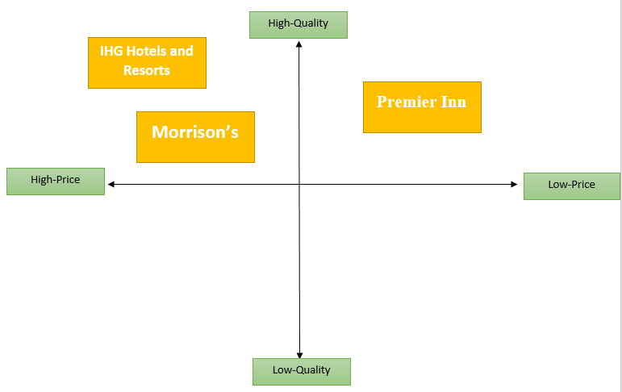
Figure 1: Perceptual; map of Premier inn hotels Competition
(Source: Designed by the Learner)
“Collaborators”
Premier Inn's Direct Link helps its CRS/PMS book rooms (Anon, 2018). Company interacts with major partners include Emirates Group, its travel and tourist provider.
‘Climate”
Pestle Factors | Description
Political Factors | Brexit's trade restrictions hinder Premier Inn's business.
Economic Factors | VAT, other taxes, and inflation affect company.
Social Factors | Employment and class availability boost the company's operations.
Technological Factors | The adoption of the “what3word” location technology helps to guide the customers in connecting easy entrances (Anon, 2023).
Environmental Factors | Sustainability and carbon reduction enhance the company's image.
Legal Factors | Following the guidelines might help the company avoid legal issues like the 2015 hotel shower death (Marshall, 2015).

Table 5: Premier Inn Pestle Analysis
(Source: Anon, 2023)

3. Objectives
‘SMART target”
The major aim of the marketing plan is to attract and strengthen the relationships with the new and potential customers.

Specific | Measurable | Achievable | Relevant | Time-Bound
Attracting new potential customers | Use of Net Promoter Score can be helpful for gauging customer loyalty. | Effective marketing campaigns through different mediums. | High range of purchases from the new customers. | 5 months
Retaining the existing customers | Use of the Customer Effort Score is vital for the measurement of customer satisfaction resulting in retaining them. | Initiation of customer loyalty programmes and providing offers and discounts. | Positive feedback from the existing customer in the company’s pages and websites. | 8 months

Table 6: Smart Objectives
(Source: Created by the learner)

4. Strategy
Value proposition of Premier inn hotel, its differentiation, the communication and the delivery of the value proposition
The major value propositions of the company are to offer the quality services for the consumers and also the affordable hotels for the visitors. The objective is also to positively impact the world (Bowie et al., 2017). The value proposition is communicated and delivered to the customers through the direct measure as well indirectly through the company’s website. Effective listening effectively and building rapport with the customers.
Value proposition link with the segments of customer and its effects on positioning and targeting of Premier Inn
The value proposition of providing quality and affordable accommodation can be essential mainly for the transient guests (Housden, 2008). The value proposition can be significant for the target market as it communicates the clearest benefits that the company provides to the customers (Smith and Zook, 2020). The value proposition helps in positioning as it helps in the establishment of the image and reputation of the Premier Inn and the customers can perceive it in a specific way.
“Bowman’s strategy clock”
It is a tool which mainly has 8 positions which highlights the strategy for the hotel group to succeed within the commercial sector. The first position is the low price low value added where the point of price of service and the value both are low. The second is low price which provides the lowest cost option for customers (Kotler and Kartajaya, 2017). The third is hybrid which has low price and differentiation. Fourth price is differentiation where the hotel will focus on differentiating the services and products followed by the fifth position which is the focused differentiation focusing on the high value and high price. Risky high margins where the price is high without the added value (Kotler et al., 2020). Another is monopoly pricing wherein a single Premier Inn controls the pricing and product followed by the last position that is loss of market share which is the worst position as a company exits the market and the share is declined.

5. Tactics
4Ps Marketing mix
Product - The company's primary selling points consist of a highly comfortable double and king-size bed to its client groups, an en-suite bathroom, and coffee making facilities for the customers to use throughout their stays at the establishment. Also, the organisation maintains a separate restaurant that serves the finest cuisine and drinks of the highest possible standard.
Place – Customers are able to identify Premier Inn London at Heathrow Airport Terminal. This allows consumers to quickly reach the company's hotel branches. The firm uses various platforms, including both online and physical mediums in their marketing efforts.
Price – When it comes to selling their goods and services in the market, company organisations have discovered that price is the most essential factor in determining whether or not customers would buy their wares. This is because pricing is the factor that most directly affects the bottom line (Ryan, 2012). The principal pricing method that Premier Inn use is referred to as the value pricing strategy, and its primary objective is to provide its clients with high-quality services that provide an outstanding return on the money that those visitors spend. In addition to that, it makes use of the price discrimination strategy, which enables it to supply its customers with the rooms at the prices that are the most cheap on nights such as Friday, Saturday, and Sunday.
Promotion – Print magazines are included among the conventional forms of media as well as the more modern online platforms that include advertisements for Premier Inn's various hotel locations (Clow and Baack, 2013). The company advertises the hotels on a variety of digital platforms, including social media platforms such as Facebook, Twitter, and Instagram, which are among the most significant chances for marketing (Chaffey and Ellis- Chadwick, 2019). The majority of the reading material that is in printed form at the company comes in the shape of magazines and newspapers (print media).

6. Action
A one-page action plan is a brief summary of the goals a person has set for his or her business and the steps that person will take to reach those goals. This summary may be found on the first page of an action plan. A one-page action plan is beneficial because it allows individuals to have a clear and concise understanding of their goals at a glance. The succinctness of the plan also helps individuals stay focused on the most important tasks. The action plan has been shown through a GANTT in the Appendix.

7. Control
One of the company's unique selling propositions is the excellent quality of the products and services it provides, as well as the affordable rates at which it can supply clients with hotel rooms. It is possible that without doing so, the growth of higher sales and income rates, as well as the attraction of a large number of customers, would not be possible (Ryan, 2012). In addition to the favourable response of the target audience, sales and money generation may be used as primary metrics to determine the amount of success achieved by an endeavour.

8. Conclusion
The marketing strategy was mostly based on a hotel chain in the United Kingdom called Premier Inn, which is located in that country. The development of an efficient budget and an accurate knowledge of the purchasing patterns of target audiences were two of the most difficult aspects of the marketing strategy to tackle successfully. It is vital to carry out fruitful research on consumer behaviour, illustrate the spending habits of the current market, and precisely define marketing goals in order to develop a spending plan that will be effective. Only then can a successful spending plan be established.

References
Anon, 2023. what3words. [online] Available at: https://www.premierinn.com/gb/en/news/2019/what3words.html [Accessed 27 Feb. 2023].
Marshall, T. 2015. Premier Inn being sued for £1m over death of woman scalded by hotel shower. [online] Evening Standard. Available at: https://www.standard.co.uk/news/uk/premier-inn-being-sued-for-ps1m-over-death-of-woman-scalded-by-hotel-shower-a3113156.html [Accessed 27 Feb. 2023].
Anon, 2018. Distribution partners. [online] Available at: https://www.premierinn.com/gb/en/business/distribution-partners.html [Accessed 27 Feb. 2023].
Whitbread PLC. 2023. About us - Whitbread PLC. [online] Available at: https://www.whitbread.co.uk/about-us/#:~:text=With%20over%20840%20hotels%20in,the%20heart%20of%20our%20business. [Accessed 27 Feb. 2023].
https://www.whitbread.co.uk/about-us/our-business-model/investors - SOSTAC Analysis
[Accessed 25th February 2023]
Jobber, D. and Ellis-Chadwick, F 2020, Principles and practice of marketing. 9th ed. London
Bowie,D. Buttle,F. Brookes,M &amp; Mariussen,A 2017, Hospitality Marketing. 3 rd ed, Routledge, London
Smith PR and Zook ZE 2020. Marketing Communications. 7 th ed, Kogan Page, London
Kotler, P., Armstrong, G., Harris, L. and He, H., 2020. Principles of marketing. 8 th European ed, London: Pearson Education Limited.
Clow, K and Baack, D 2013, Integrated Advertising, Promotion and Marketing Communications. 6th ed, Pearson, London
Chaffey, D and Ellis- Chadwick, F. 2019. Digital Marketing. 7 th ed, Pearsons, London.
Ghauri, P N 2014. International Marketing, 4 th Ed, McGraw Hill, London
Housden M 2008, Marketing Research & Information, Butterworth Heinemann, Oxford.
Kotler,P and Kartajaya, H. Marketing 4.0 Moving from Traditional to Digital 2017. Wiley. New York.
Ryan, D. 2012. Understanding Digital marketing: Marketing Strategies for Engaging The Digital Generation. Kogan Page, London.
Nannelli, M., Buhalis, D., Franch, M. and Della Lucia, M., 2019. Disruption of the market structure in the tourism and hospitality accommodation service. The impact of the new short-term rental players. E-review of Tourism Research, 17(3).

Component-B: Presentation

Slide 1: Market Audit- SOSTAC Analysis
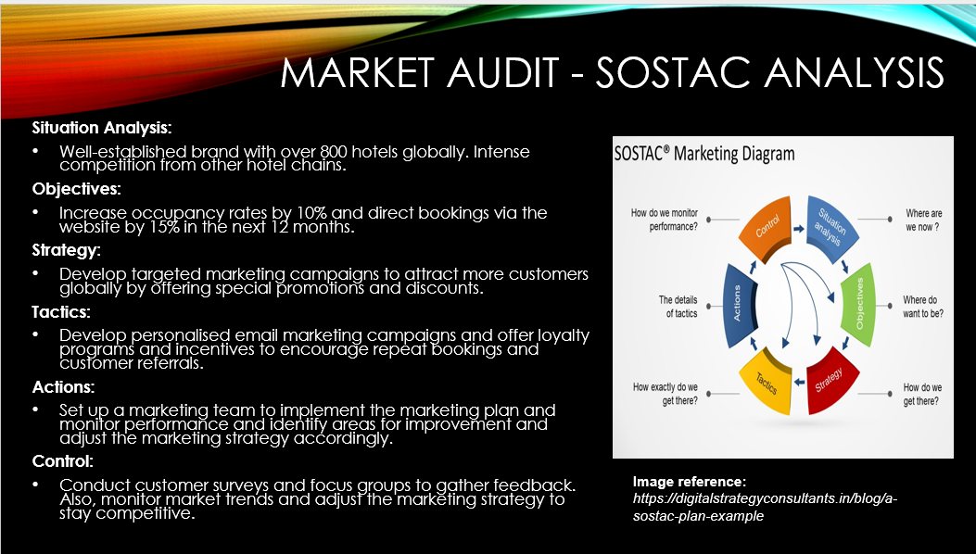

Slide 2: Market Audit-SWOT Analysis
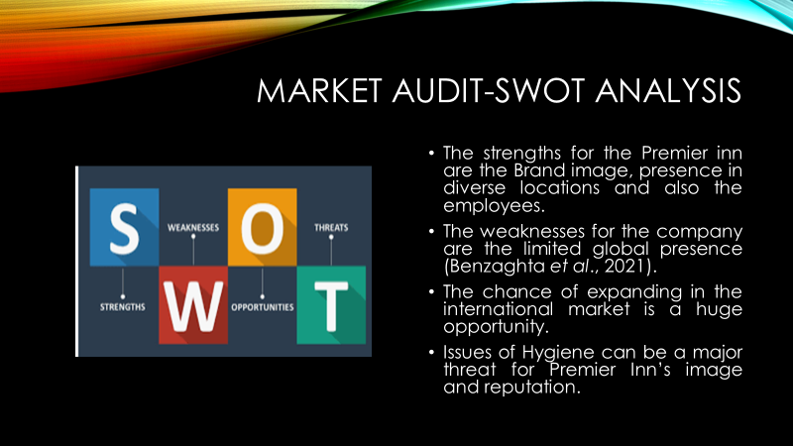

Slide 3: Market Audit-Pestle Analysis
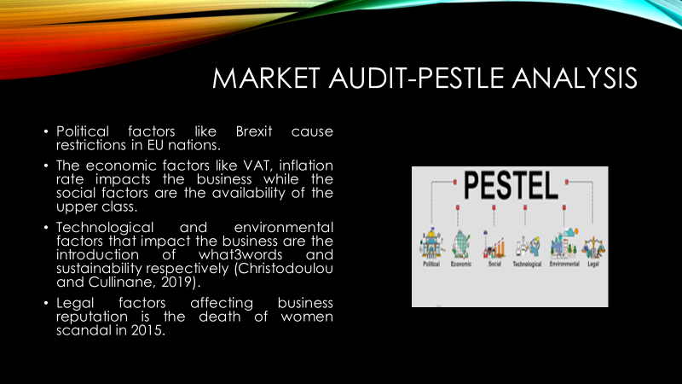

Slide 4: Segmentation, positioning and Targeting
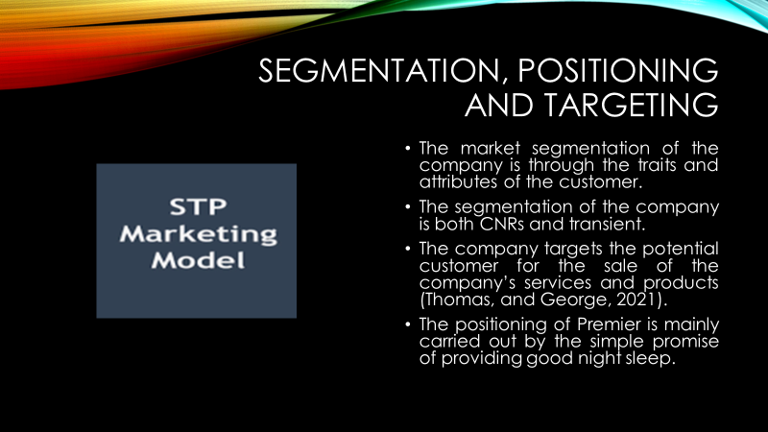

Slide 5: Situation Analysis
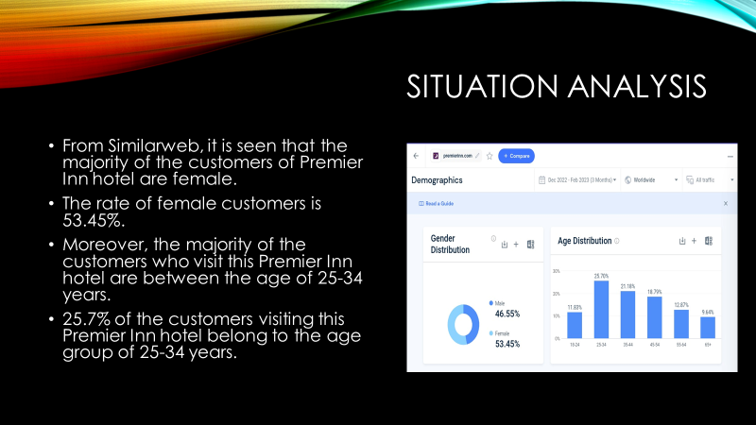

References

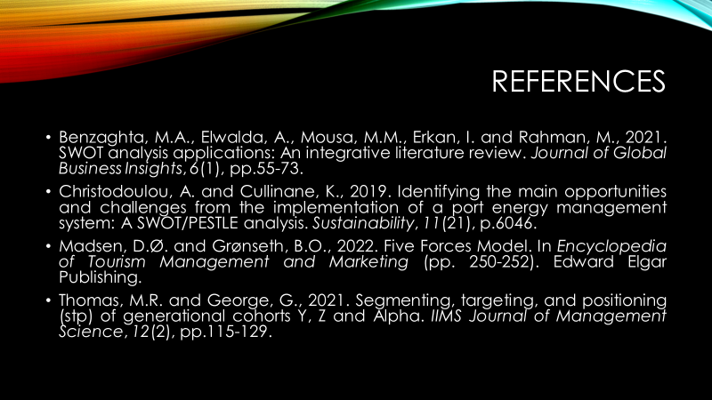

Appendix: Action Plan
Figure: Work Plan shown through the GANTT Chart

