University of Wales Trinity Saint David
School of Engineering

Thermofluid Mechanics
M5X00406

Suriya Krishna
1803204

Table of Contents
Heat Exchanger 3
Types of Heat Exchangers 4
• Plate/Fin Heat Exchangers 4
• Shell and Tube Heat Exchangers 5
Materials Used in Heat Exchangers: 6
TecQuipment TD1007 Heat Exchanger 6
Ways to Improve The Performance of a Heat Exchanger: 7
Experimental Procedure 8
Experiment 1 8
Experiment 2 8
Experiment 3 8
RESULTS – GRAPHS 9
Experiment 1 9
Experiment 2 11
Experiment 3 13
Experiment 2 and Experiment 3 Water Power comparison 15
Table of results 16
Experiment 1 16
Experiment 2 16
Experiment 3 16
References 17

Heat Exchanger
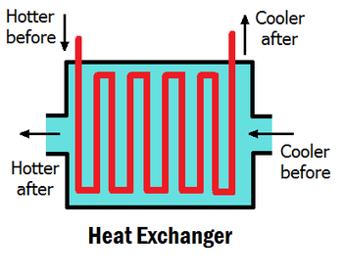
A heat exchanger is an apparatus that permits heat from a liquid/gas to pass to a second liquid/gas without the two having to come to contact together. It utilizes the principle of Conduction for heat transfer. Heat exchangers can be seen in our daily life such as air conditioners, refrigerators, exhaust systems, radiators, electrical heaters, computer heatsinks etc. In vehicles, a radiator is used to cool the engine down by absorbing the heat from the hot coolant that comes into the radiator from the engine block. A fan on one side of the radiator blows cool external air into the fins of the radiator to cool down the hot coolant. This cooled coolant is recirculated back into the engine to maintain a constant engine temperature for efficient function of the engine. The exhaust systems are used to pump out the heat produced from the combustion chamber of an engine into the atmosphere. These are the two most common heat exchangers found in vehicles. (BePeterson Everything You Need To Know About Shell And Tube Heat Exchangers, n.d.) (Thermex What Is A Heat Exchanger, n.d.)
(Bethel Afework, n.d.)

Types of Heat Exchangers
There are three main types of heat exchangers:
- Plate/Fin Heat Exchangers – these heat exchangers utilize stacks of plates/fins with a certain amount of uniform gapping between them. The surface area and number of plates depends on the application of the heat exchanger. They use the ambient cold air around them to cool the plates/fins down which in turn cool down the device that requires cooling using conduction. These type of heat exchangers are most commonly seen on computer heatsinks and air-cooled motorcycles. The engine blocks on air cooled engines have quite a number of fins surrounding the block, using the cold air outside to cool the engine down.
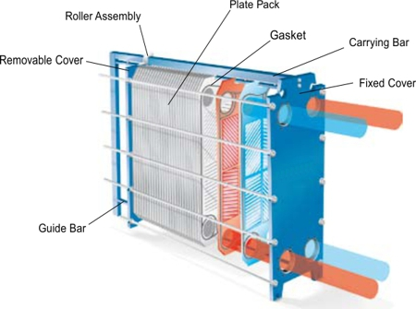
(JBJ Plate Heat Exchangers, n.d.)
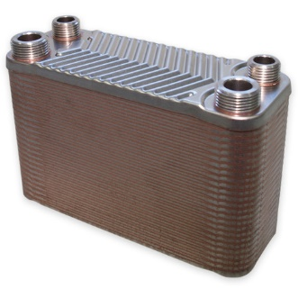
(ManoMano Hrale Stainless Steel Heat Exchanger 50 Plates max. 90 kW Plate Heat Exchanger, n.d.)

- Shell and Tube Heat Exchangers – these heat exchangers consist of a tube (also called tube stack or tube bundle) carrying one fluid and the tube is surrounded by a shell consisting of another fluid, a tube header, where the fluid enters the tube and a tube rear header were the fluid exits the tube. These fluids can flow in the same direction as each other, opposite direction or at a cross flow. The tubes vary in diameter, thickness, length, material and layout pattern depending on the application. These heat exchangers are most commonly seen being utilized in air-conditioning and refrigerators. They also have more heat transfer efficiency when compared to plate/fin heat exchangers thus, they are used in heavy duty applications.
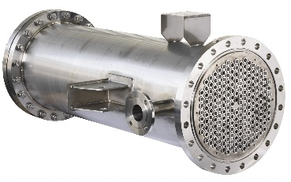

(Mariner Spotted Shell Tube Type Heat Exchanger, n.d.)

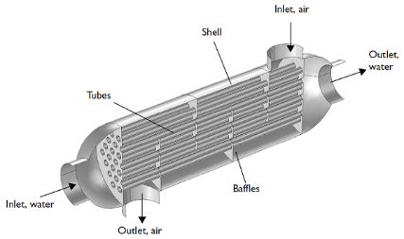
(Comsol How To Model Shell And Tube Heat Exchanger, n.d.)

Materials Used in Heat Exchangers:
Heat exchangers do not always have to be manufactured using metals, although they do conduct heat efficiently. For low temperature applications such as swimming pools or a shower which operate at everyday room temperatures, plastics that have been engineered and modified to conduct heat efficiently can be used. They are easier to manufacture and since they are corrosion resistant and weigh less, the buying costs and maintenance costs decrease drastically when compared to metal heat exchangers. Composite materials have surfaced in the market. They combine the best of both worlds. They possess the high thermal conductivity of a metal and the lightness and corrosion resistance of a plastic. They have a wide range of applications ranging from general household uses to industrial applications. Lastly, metal heat exchangers. They are mainly targeted at heavy duty applications such as transportation and industrial applications as they have high thermal conductivity which is a prerequisite for such applications. (Explan That Stuff How Heat Exchangers Work, n.d.)

TecQuipment TD1007 Heat Exchanger
The heat exchanger which was utilized is the TD1007 Heat Exchanger manufactured by TecQuipment. It sits in a lab atop a table. It works using a cooling air passage, hot water supply and the requisite dials and instruments for gathering information and operation. To sustain temperatures, it contains a PID controlled electric heater inside its hot water tank, a pump and water level displays. The tank is fixed with an electrically controlled valve to control the flow of water and has a safety kit which protects it from overfilling, over-heating and low water level. The water flow rate is measured using a flow meter control and precision needle valve.
Cold air travels through a vertical passageway which comprises of an orifice plate which is attached to a differential pressure transducer. Just before entering the horizontal passageway containing the heat exchanger, the cold air travels through a centrifugal fan which is preset at a specific speed. The air makes an exit through a hand operated slide-valve. To control and measure the air flow, students utilize the orifice and valve.
To measure the temperatures of the water inlet, outlet and the air inlet and outlet, thermocouples are attached to these inlets and outlets. Temperatures, water flow rate and orifice pressure are exposed on digital displays near the controls. To enhance safety and for a hassle-free operation, the heat exchanger is equipped with self-healing quick connectors and quick release clamps, so no tools are required to install the heat exchanger.
Students are able to understand and grasp the operation of the heat exchanger quite easily as there is a mimic diagram fixed to the main unit panel. This diagram contains information about the heat exchanger and how to install the heat exchanger too. The heat exchanger has been very cleverly designed with transparent side panels, so students can look inside the heat exchanger and understand the build and functioning on a visual level too. (TecQuipment Water To Air Heat Exchangers, n.d.)

The entire equipment comprises of:
- One standard heat exchanger
- 32 tubes in total, separated into two banks of 16 allowing the attachment of a thermocouple at midpoint
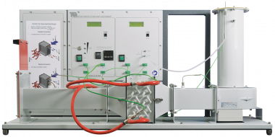
- TecQuipment also supplies an optional VDAS-F system. This provides accurate real-time data, monitoring, calculation and vital readings on a computer.

(TecQuipment Water To Air Heat Exchanger, n.d.)

Ways to Improve The Performance of a Heat Exchanger:
- Increase mass flow rate slightly. Too high of an increase will not let the heat transfer occur effectively as the fluid would be travelling too fast for heat transfer to take place, hence affecting results negatively.
- Fluid with higher specific heat capacity and higher thermal conductivity. Water is widely used in common heat exchangers, but a coolant is a better option as it is engineered to absorb much higher amounts of heat compared to water.
- Increase surface area of pipes by utilizing fins. Higher surface area allows the heat to transfer more effectively.
- Insulating the pipes. This helps in trapping the heat in the pipes, so that radiation doesn’t get in play. The lower the thermal conductivity of the applied insulator, the better heat gained inside the pipes. The thickness of the insulation also plays a vital role in the amount of radiation reduced.
- Change pipe material to copper. Copper is a vastly greater material than rubber when it comes to conduction. Copper has a much lower thermal inertia than rubber. Thermal inertia is the degree of slowness with which the temperature of a body approaches that of its surroundings and which is dependent upon its absorptivity, its specific heat, its thermal conductivity and dimension. (Merriam Webster Thermal Inertia, n.d.) (Bre Increasing Heat Exchanger Performance, n.d.) (Slide Share Heat Transfer Heat Exchangers, n.d.)

Experimental Procedure
Set up the heat exchanger and connect as for parallel flow. This is standard for all three experiments.

Experiment 1
Experiment 1 is to show how different water flow rates affect the performance of the heat exchanger for a set water temperature and air flow.
- Set heater tank temperature to 60 degrees Celsius.
- Take note of ambient air temperature and check orifice diameter.
- Set the airflow using the slide valve to give orifice pressure drop of 250 Pa (+/- 5Pa tolerance).
- Set the water flow using the hand operated valve to 2.25 L/minute (+/- 0.01 L/minute).
- Allow a minimum of five minutes for the temperatures to stabilize before recording of readings.
- Repeat experiment for lower water flow rates, 1.75, 1.25, 0.75 and 0.25 L/min.

Experiment 2
Experiment 2 is to show how different air flow rates affect the performance of the heat exchanger for a set water flow and temperature.
- Set heater tank temperature to 60 degrees Celsius.
- Take note of ambient air temperature and check orifice diameter.
- Set the airflow using the slide valve to give orifice pressure drop of 250 Pa (+/- 5Pa tolerance).
- Set the water flow using the hand operated valve to 0.25 L/minute (+/- 0.01 L/minute).
- Allow a minimum of five minutes for the temperatures to stabilize before recording of readings.
- Repeat experiment for lower air flow rates, 200, 150, 100 and 50 Pa pressure drops.

Experiment 3
Experiment 3 is to show how different hot water supply temperatures affect the performance of the heat exchanger for a set water flow.
- Set heater tank temperature to 45 degrees Celsius.
- Take note of ambient air temperature and check orifice diameter.
- Set the airflow using the slide valve to give orifice pressure drop of 250 Pa (+/- 5Pa tolerance).
- Set the water flow using the hand operated valve to 0.25 L/minute (+/- 0.01 L/minute).
- Allow a minimum of five minutes for the temperatures to stabilize before recording of readings.
- Repeat experiment for lower air flow rates, 200, 150, 100 and 50 Pa pressure drops.

RESULTS – GRAPHS

Experiment 1

The graph shown above show the relationship between mass water flow rate on the X-axis and the power in watts on the Y-axis. It shows that with increase in water flow, the power transfer increases. As seen, there is a balance between Qw and Qa till 1.75 L/min, after which Qw maintains its power at around 600 watts. This suggests that at this point is the maximum power value.

The graph displayed above, shows the relationship between mass water flow rate on the X-axis and temperature efficiency on the Y-axis. It shows that efficiency of air increases with increase of mass flow rate but the efficiency of water decreases with increase of mass flow rate. The mean efficiency shows a gradual decline. The heat exchanger generates an elevated temperature drop for a set amount of emitted power, thus, this provides a higher temperature efficiency for the water stream. Nonetheless, the higher temperature drop provides a lower temperature gradient between air and water at the finish of the water flow within the heat exchanger.

The graph displayed above, shows the relationship between mass water flow rate on the X-axis and heat transfer coefficient on the Y-axis. As shown in the graph, there is a sudden rise in the beginning between 0.25 L/min to 1.25 L/min and it gradually evens out after that point. This proves that increasing the mass flow rate after the optimum value, does not enhance the performance.

The graph displayed above, shows the relationship between mass water flow rate on the X-axis and percentage difference between Qw and Qa on the Y-axis.

Experiment 2

The graph displayed above, shows the relationship between mass air flow rate on the X-axis and the power in watts on the Y-axis. Lower mass air flow rates show that there is a gradual increase in water power but the same cannot be said for air power. There is a steady decrease in air power initially and it gradually levels out.

The graph displayed above, shows the relationship between mass air flow rate on the X-axis and temperature efficiency on the Y-axis. This graph shows that with increasing mass air flow rate, there is an increase in water efficiency but a decrease in air efficiency. The average efficiency shows a balanced increase with increasing mass air flow rate.

The graph displayed above, shows the relationship between mass air flow rate on the X-axis and heat transfer coefficient on the Y-axis. As shown the in the graph, there is a linear rise in heat transfer coefficient with increase in mass air flow rate until 200 Pa, which seems to be the optimum point, after which it levels out. This proves that increasing the mass air flow rate after the optimum value, does not necessarily enhance the performance.

The graph displayed above, shows the relationship between mass air flow rate on the X-axis and percentage difference between Qw and Qa on the Y-axis.

Experiment 3

The graph displayed above, shows the relationship between mass air flow rate on the X-axis and the power in watts on the Y-axis. Lower mass air flow rates show that there is a gradual increase in water power but the same cannot be said for air power. There is a steady decrease in air power initially and it gradually levels out and both Qw and Qa converge at around 250 Pa. This shows that the heat transfer has reached its limit at 45 degrees Celsius.

The graph displayed above, shows the relationship between mass air flow rate on the X-axis and temperature efficiency on the Y-axis. This graph shows that with increasing mass air flow rate, there is an increase in water efficiency but a decrease in air efficiency. The average efficiency shows a balanced increase with increasing mass air flow rate.

The graph displayed above, shows the relationship between mass air flow rate on the X-axis and heat transfer coefficient on the Y-axis. As shown the in the graph, there is a linear rise in heat transfer coefficient with increase in mass air flow rate until 200 Pa, which seems to be the optimum point, after which it levels out. This proves that increasing the mass air flow rate after the optimum value, does not necessarily enhance the performance.

The graph displayed above, shows the relationship between mass air flow rate on the X-axis and percentage difference between Qw and Qa on the Y-axis.

Experiment 2 and Experiment 3 Water Power comparison

The changes I would make to attain higher accuracy from my results would be:
- Utilize a higher variety of temperatures than just two temperatures.
- Operate the heat exchanger using a coolant rather than water as coolant has a higher thermal capacity and absorbs heat far more effectively.
- Change the pipe material to reduce thermal inertia, preferably copper as it is known for its high thermal conductivity.
- Increase surface area of the pipes by installing fins on the exterior of the pipes.
- Insulate the pipes to maintain the heat inside the pipe rather than escaping through radiation.

Table of results

Experiment 1

Experiment 2

Experiment 3

References
BePeterson Everything You Need To Know About Shell And Tube Heat Exchangers. (n.d.). Retrieved from BePeterson: http://www.bepeterson.com/blog/everything-you-need-to-know-about-shell-and-tube-heat-exchangers
Bethel Afework, J. H. (n.d.). Energy Education Heat Exchanger. Retrieved from Energy Education: https://energyeducation.ca/encyclopedia/Heat_exchanger
Bre Increasing Heat Exchanger Performance. (n.d.). Retrieved from Bre: https://www.bre.com/PDF/Increasing-Heat-Exchanger-Performance.pdf
Comsol How To Model Shell And Tube Heat Exchanger. (n.d.). Retrieved from Comsol: https://www.comsol.com/blogs/how-model-shell-and-tube-heat-exchanger/
Explan That Stuff How Heat Exchangers Work. (n.d.). Retrieved from Explain That Stuff: https://www.explainthatstuff.com/how-heat-exchangers-work.html
JBJ Plate Heat Exchangers. (n.d.). Retrieved from JBJ: https://www.jbj.co.uk/plate-heat-exchangers.html
ManoMano Hrale Stainless Steel Heat Exchanger 50 Plates max. 90 kW Plate Heat Exchanger. (n.d.). Retrieved from ManoMano: https://www.manomano.co.uk/heat-exchanger-for-boiler/hrale-stainless-steel-heat-exchanger-50-plates-max-90-kw-plate-heat-exchanger-3214353
Mariner Spotted Shell Tube Type Heat Exchanger. (n.d.). Retrieved from Mariner Spotted: https://marinerspotted.com/2016/12/shell-tube-type-heat-exchanger/
Merriam Webster Thermal Inertia. (n.d.). Retrieved from Merriam Webster: https://www.merriam-webster.com/dictionary/thermal%20inertia
Slide Share Heat Transfer Heat Exchangers. (n.d.). Retrieved from Slide Share: https://www.slideshare.net/assalihi/heat-transfer-heat-exchangers
TecQuipment Water To Air Heat Exchanger. (n.d.). Retrieved from TecQuipment: https://www.tecquipment.com/water-to-air-heat-exchangers
TecQuipment Water To Air Heat Exchangers. (n.d.). Retrieved from TecQuipment: https://www.tecquipment.com/water-to-air-heat-exchangers
Thermex What Is A Heat Exchanger. (n.d.). Retrieved from Thermex: http://www.thermex.co.uk/news/blog/160-what-is-a-heat-exchanger

