Tourism travel planning for brexit
The possible impact of a no agreement
KIRSTY ALEXANDRA SMITH
P149187
Table of Contents
Executive Summary 2
Introduction 2
Brexit 2
The importance of travel and transport in tourism 2
The economy 3
Strategic planning 3
Tourism importance to the UK 3
Tourism Statistics between the EU and the UK 3
The problems that the UK face due to the no deal agreement 4
Air Transport 5
Travel constraints 5
What will happen to pre-booked flights and holidays? 5
Security and the law 5
The importance of aviation success in the UK 6
Ownership Regulations 6
Visas and Passports 6
The Channel Tunnel 7
Duty, security and facilities 7
Concluding Recommendations 8
References 9

Executive Summary
A ‘No Deal agreement has been announced and the UK in its uncertainty is hoping that in the transition period politicians and transport planner will secure the countries future through strategic planning and contingency plans because ‘movement is an integral part of tourism.” (Cooper and Hall, pg.3, 2013)
A no deal agreement on the industry will see security and laws null and void. Longer queues for immigration at the airport and boarder of the Channel Tunnel. (J.P, 2018) Uncertainty and invalid passports with Brits and Europeans needing visas to visit each opposing country. (ABTA,2018) Saying goodbye to airspace rights, UK airlines taking their headquarters out of European countries and the possibility of no more free movement of goods or people around the Europe for UK citizens. Passenger rights are no longer recognised and a costlier access to travel all together. (J.P, 2018)
Strategic planning through the use of a SWOT analysis to look at case studies like Norway or Switzerland to piece together a good deal in the transition period to the EU. (Wilkinson, 2016) Offering the EU similar rights that would be requested such as ‘open skies’ and trade rights within the UK would benefit both parties. 29.3 million Brits travelled to the EU on holiday in 2014 and the EU should consider the UK’s importance to the growth of the European economy. (VisitBritain, 2018) Finally, security should be of upmost importance to any country and sharing data systems to identify terrorists and missing persons should not even need negotiating. (Butcher, 2018)

Introduction
The purpose of this report is to analyse the implications of travel to and from the UK if a no deal agreement following Brexit is to happen, making strategic recommendations to the politicians and transport planners of the United Kingdom.

Brexit
‘On 23 June 2016, the people of the United Kingdom voted to leave the European Union. Until exit negotiations are concluded, the UK remains a full member of the European Union, and all the rights and obligations of European Union membership remain in force.’ (Revised Draft Airports National Policy Statement: new runway capacity and infrastructure at airports in the South East of England, page 11, 2017) The UK will divorce the EU when Tereasa May invokes article 50, no withdrawal agreement will mean a 21-month transition period will take place this is an important time for the UK to set some strategic plans in motion (Devlin et al., 2018)

The importance of travel and transport in tourism
“In 2016, 1.2 billion international tourist receipts were accounted for, representing more than 10% of the global population” (Rodrigue, Comtois and Slack, pg.2017) Transport allows people to explore new cultures and places for tourism. The growth of tourism comes from the development and growth in transport, connecting people to new places. (Rodrigue, Comtois and Slack, 2017)
The mobility of tourists depends on many different factors, the most pressing during the negotiations of Brexit would be, ‘political rights’ international tourists need political rights to be able to travel to and from countries across the EU without the issue of international laws, visas and passports. (Cooper and Hall, 2013)

The economy
The economy and its currency will always be sensitive to changes within the everchanging world. After the Brexit referendum the pound was down 10% against the US dollar. (Treanor, Goodley and Allen, 2018) Economists are saying if there is a no deal the industry could see more fluctuations in the currency as political uncertainty weakens currency. (The Telegraph, 2018)

Strategic planning
‘Strategic planning is an organizational management activity that is used to set priorities, focus energy and resources, strengthen operations, ensure that employees and other stakeholders are working toward common goals, establish agreement around intended outcomes/results, and assess and adjust the organization's direction in response to a changing environment.’ (Balancedscorecard.org, 2018)

Tourism importance to the UK
In 2013 Tourism accounted for 9% of the GDP of Britain and injected £126.9bn into the country’s economy. The UK welcomed 39.2 million inbound visitors who spent £24.5 billion when visiting in 2017. (VisitBritain, 2018)

Tourism Statistics between the EU and the UK
‘UK residents made 37 million holiday and business trips to the EU in 2015, and EU residents made over 16 million similar trips to the UK. The EU is the UK’s biggest market for overseas holidays and a critical market for businesses. Many trips to the EU are planned and booked at short notice.’ (Abta.com, pg4, 2018) Figure 1. Outlines the figures and statistics of UK inter EU travel.

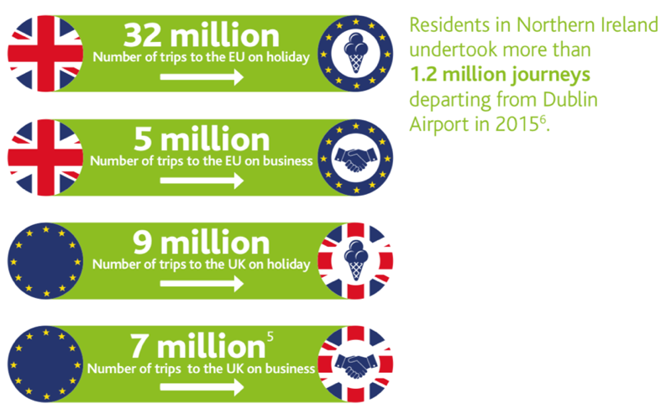

Figure 1. Holiday and business statistics (Abta.com, 2018)

The problems that the UK face due to the no deal agreement
- Longer queues at the borders. (J.P, 2018)
- Hard boarder in Ireland. (J.P, 2018)
- Falling out of regulatory bodies; air safety, medicines, nuclear materials, food and car inspection. (J.P, 2018)
- Cancer treatment may not be allowed to be transported. (J.P, 2018)
- Food and car export issues. (J.P, 2018)
- Green cards needed for driving in EU for insurance. (ABTA, 2018)
The UK is currently bound to a variety of laws that affect the industry which post Brexit need to be addressed. Some of these are:
- The free movement of goods and people within the EU
- Safety standards
- Integrated transport systems
- Workers’ rights
- Security and passenger rights
- Environmental sustainability standards (Butcher, 2018)

Air Transport

Travel constraints
The UK currently has no restriction to where their airlines can fly in EU and is able to sell tickets to anyone from any of the 28-member states. (Yapp et al., 2018) Nevertheless, The UK leaving the EU could have detrimental impacts on its aviation industry as the UK would no longer be a part of the EU single market, not only would there be travel constraints between both parties the EU has travel agreements with other countries such as the US and Canada which could be problematic. The EU has unrestricted access to 44 other countries and negotiations can take time. (Morris, 2018) There would also be some restrictions on airspace rights, flight cancellations without prior warning, no compensation and insurances won’t be liable to pay out. (Wright, 2018) Airfares are expected to rise by 15-30% if the UK does not secure an agreement deal before March 2019. (Butcher, 2018)

What will happen to pre-booked flights and holidays?
The biggest problem facing the aviation industry is that there is much uncertainty to what will happen if there is a no deal, travel agents and tour operators are still selling flights past the date the UK will exit. There is a massive fear within the industry that people may be stuck in the EU if flights become grounded or will encounter a loss of money for the flights already booked. (Leggett and Bowler, 2018) Chief commercial officer of Flybe said “Right now we will continue to sell in the hope and belief that when a conclusion comes to the Brexit scenario, common sense will prevail and people will realise the need for intra-Europe travel," (Morris, 2018) Many Tour operators have included ‘Brexit Clauses’ to holiday packages and flights to warn people that their tickets may be invalid after Brexit. (Morris, 2018) The aviation industry group IATA believes that in a worst-case scenario that less than 5 percent of flights from the UK to Spain would be in operation. (Wright, 2018)

Security and the law
‘If there is ‘no deal’ then there would be no implementation period, with a sudden change in the UK-EU relationship. This would have implications for the movement of goods, people, services, and areas of cooperation such as data-sharing and security. The precise impact would depend on whether the UK and EU could quickly reach agreements on issues such as travel, data-sharing and customs arrangements before March 2019.’ (Morse, pg.5 2018)
The UK is a part of the European Aviation Safety Agency (EASA) currently and it allows authorities like CAA to issue relevant safety approvals and licences. However, post Brexit policies such as EASA may be void. (GOV.UK, 2018) Media reports have said that the EU will no longer trust the UK’s Security systems following a no Brexit agreement. (Coffey, 2018)

The importance of aviation success in the UK
Transportation of goods by plane is crucial to the UK economy. In 2014, 40% of the trade of goods was transferred via UK airports generating £140 billion into the UK economy. (ApSimon et al., 2015) Airport expansion across the UK relies on the productivity and success of the growing tourism industry which includes business transport and connectivity. The airports in the UK are looking to expand and development for expansion is in many of their plans. Each of the airports planning expansions are being put forward for commission to ensure growth in the industry and the UK continues to be a hub for aviation. (ApSimon et al., 2015) Heathrow airport plans are in motion for a third runway in 2026, increasing its capacity by 130 million and take-offs by 54% better connectivity to the UK will strengthen the economy. (Calder, 2018) (ApSimon et al., 2015) The EU benefits largely from UK inbound visitors as can be shown in Figure 2. Cheaper airfares have connected people all over Europe. ‘In the UK alone, low-cost carriers served almost 100 million passengers last year, or about 40% of the total market.’ (ApSimon et al., page 63, 2015)
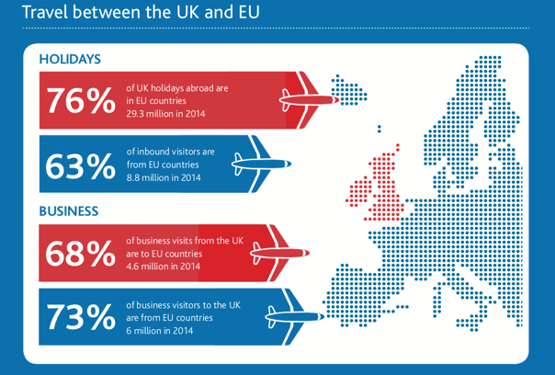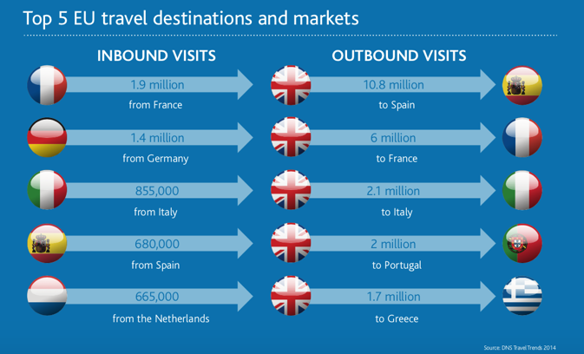
Figure 2. Visitor figures (Deloitte, 2018)

Ownership Regulations
‘Presently, EU majority-owned and -controlled airlines have the right to establish themselves in any EU Member State and operate freely within the borders of the EU.’ (Butcher, pg16, 2018) Nevertheless, after Brexit this may not be the case there is a huge threat to British companies operating out of European hubs. Airlines that are a member of the EU have freely been allowed to set up a base within a member state and fly without restriction in under the ‘open skies agreement’ there have been many negative reports which have cautioned UK airlines that ‘they would need to relocate their headquarters or sell off shares to EU nationals if they want to continue flying routes within continental Europe after Brexit.’ (Butcher, pg16, 2018)

Visas and Passports
Visas to enter any EU country could be an issue and there is talk about the British passport returning back to the old version the blue style passports, all of these appear costly to brits wanting to travel to the EU. (Godfrey, 2018) British citizens will be known as the ‘third country nationals’ and the free movement around Schengen countries will no longer be an option. (Everett, 2018)

The Channel Tunnel
‘The Tunnel is the UK’s only surface transport link to mainland Europe and as such a different set of legal requirements apply due to the international nature of the travel it facilitates.’ (Butcher, pg.29, 2018)
The channel tunnel would have so many issues if there is a no deal agreement, membership in the EU influences border management as it is owned by multiple governments. (Morse, 2018) ‘Eurostar International Limited (EIL) runs international train services through the Channel Tunnel, it has long term access rights to the Tunnel, HS1 and at St. Pancras International. It used to be entirely publicly owned by the French state railway SNCF (55%), the Belgian state railway SNCB (5%) and the UK Government (40%). The UK Government sold its share to Caisse de dépôt et placement du Québec (CDPQ) and Hermes Infrastructure in March 2015.’ (Butcher, pg.29, 2018) 40% of the people employed are British. (Butcher, 2018) ‘Eurostar services could be disrupted’ and even stopped says BBC News, (2018) ‘Eurostar trains would be turned back from Europe if Britain crashes out of the EU without a deal, a leading French minister has warned.’ (Merrick, 2018)
‘If there is ‘no deal’ then there would be no implementation period, with a sudden change in the UK-EU relationship. This would have implications for the movement of goods, people, services, and areas of cooperation such as data-sharing and security. The precise impact would depend on whether the UK and EU could quickly reach agreements on issues such as travel, data-sharing and customs arrangements before March 2019.’ (Morse, pg.5, 2018)

Duty, security and facilities
Firstly, The EU would have to ensure goods crossing the border would have to be in compliance with the single market laws and that the correct duty had been paid. There could be chaos at the boarders, the UK would not have access to security systems which the EU uses to track terrorists and missing persons. (Wright, 2018) The British government will have to develop new systems, create boarder facilities and to ensure trade continues. ‘Effective management of the border is critical for the UK after it leaves the EU. It is fundamentally important to our national security, economy and international reputation.’ (Morse, pg11, 2018) Currently the CDS have to process 55 million declarations a year, it has been predicted that after the UK exits the EU that figure could rise to 260 million a year. (Morse, 2018)

Concluding Recommendations
The future for the UK and EU relationship relies heavily on an agreement which needs strategic planning to have a healthy agreement between both parties which can benefit all involved. ‘The strategic plan presents a broad picture of what the organization desires to accomplish and provides the identifiable paths to follow to achieve that end’ (Edgell and Swanson, pg.246, 2013) There are a few areas that need to be addressed for the future of the UK-EU relationship to flourish again. Firstly, evidence through this report suggests that it is crucial for the EU and the UK to support each other through aviation agreements and the continuous operation of the Channel Tunnel, both parties use these systems for trade and tourism. (Abta, 2018) Agreements on route permissions is of upmost importance and agreeing on licencing for safety for safety and security is vital. (Everett, 2018) UK tourist to the EU are worth £37.4 billion annually. (Everett, 2018)
In aviation the UK airlines should consider joining more alliances with other airlines in European countries which will allow more routes and the safeguard of flights operating in and around Europe. Reminding the EU how the UK citizens are valuable consumers in tourism and that the low-cost airline industry is an important division for British nationals and EU citizens connecting them to the UK and the rest of Europe meeting consumers need for low cost travel. (Abta, 2018) The UK should think about adopting a similar agreement with the EU as countries like Switzerland, having air rights, trade agreements and haulage rights which will be fruitful for both the EU and the UK as tourism and trade will continue to grow. (Butcher, 2018) Even looking at Norway as a suitable model when discussing agreements, Norway has a close relationship with the EU. However, they are not part of the EU but has access to parts of the internal market it is a complex case, but it works well. (Blogs.lse.ac.uk, 2018)
Security is of upmost importance to everyone globally and an alliance agreement in this dangerous era is crucial for all countries globally to share data networks of terrorism and missing persons. (J.P,2018)
By developing strategic plans like SWOT analysis to identify if plans are feasible when presenting them to opposing parties this will prove them to be credible and well analysed. A swot analysis will classify strengths, weaknesses, opportunities and threats of the project. The strengths and weaknesses will identify the internal factors and the threats and opportunities will look at the external factors. SWOT analysis are great for weighing up uncertainty. (Wilkinson, 2016)
Leaving the EU with a no deal politicians should use the transition period to agree on a deal to support the tourism industry and the UK economy.

References
ABTA. (2018). Brexit: advice for travellers. [online] Available at: https://www.abta.com/tips-and-advice/brexit-advice-for-travellers [Accessed 17 Nov. 2018].
Abta.com. (2018). Making a success of Brexit for travel and tourism. [online] Available at: https://www.abta.com/sites/default/files/media/document/uploads/Making%20a%20success%20of%20Brexit%20for%20travel%20and%20tourism.pdf [Accessed 16 Nov. 2018].
Agreement, W. and Sandhu, S. (2018). What is a ‘no deal’ Brexit? The consequences of the UK leaving the EU without agreement. [online] inews.co.uk. Available at: https://inews.co.uk/news/brexit/no-deal-brexit-what-meaning-uk-leave-uk-consequences/ [Accessed 20 Nov. 2018].
ApSimon, H., Brown, I., Clark, C., Everitt, L., Forster, P., Jennings, R., Joyce, R., Kempton, A., McKechnie, G., Mackie, P., McNaughton, A., Morrell, P., Neal, J., Overman, H., Paulson, G., Pearce, B., Quarnby, D., Schafer, A., Shine, K., Starkie, D. and Thomas, C. (2015). Airports Commission: Final Report. [online] Assets.publishing.service.gov.uk. Available at: https://assets.publishing.service.gov.uk/government/uploads/system/uploads/attachment_data/file/440316/airports-commission-final-report.pdf [Accessed 27 Nov. 2018].
Balancedscorecard.org. (2018). The Basics of Strategic Planning, Strategic Management and Strategy Execution. [online] Available at: https://www.balancedscorecard.org/BSC-Basics/Strategic-Planning-Basics [Accessed 20 Nov. 2018].
BBC News. (2018). A guide to where we are with Brexit. [online] Available at: https://www.bbc.co.uk/news/uk-politics-46192884 [Accessed 28 Nov. 2018].
BBC News. (2018). Eurostar disruption risk in no-deal Brexit. [online] Available at: https://www.bbc.co.uk/news/uk-politics-45835128 [Accessed 28 Nov. 2018].
Blogs.lse.ac.uk. (2018). Could the Norway model work for Britain? Twelve points to help you decide | British Politics and Policy at LSE. [online] Available at: http://blogs.lse.ac.uk/politicsandpolicy/could-the-norway-model-work-for-britain/ [Accessed 29 Nov. 2018].
Butcher, L. (2018). Brexit and transport. House of Commons Library.
Calder, S. (2018). Heathrow expansion: what happens now?. [online] The Independent. Available at: https://www.independent.co.uk/travel/news-and-advice/heathrow-airport-expansion-third-runway-parliament-debate-vote-gatwick-a8416611.html [Accessed 14 Nov. 2018].
Coffey, H. (2018). What a no-deal Brexit means for holidaymakers. [online] The Independent. Available at: https://www.independent.co.uk/travel/news-and-advice/brexit-no-deal-travel-flights-aviation-security-safety-holiday-a8553551.html [Accessed 14 Nov. 2018].
Cooper, C. and Hall, C. (2013). Contemporary tourism. Oxford: Goodfellow publishers.
Devlin, A., Hughes, D., Lockett, j., Petkar, S. and Solomon-Brady, H. (2018). What date will Britain leave the EU, when was Article 50 triggered and what is the Lisbon Treaty?. [online] The Sun. Available at: https://www.thesun.co.uk/news/1900423/article-50-lisbon-treaty-brexit-eu-european-council-march-29-2019-commons-vote/ [Accessed 26 Nov. 2018].
Edgell, D. and Swanson, J. (2013). Tourism policy and planning. 2nd ed.
Everett, s. (2018). ‘No deal’ Brexit: what it could mean for British tourists and air travel. [online] The Conversation. Available at: http://theconversation.com/no-deal-brexit-what-it-could-mean-for-british-tourists-and-air-travel-103357 [Accessed 29 Nov. 2018].
Financial Times. (2018). What would a no-deal Brexit mean for your finances? | Financial Times. [online] Available at: https://www.ft.com/content/d89459d2-9023-11e8-b639-7680cedcc421 [Accessed 14 Nov. 2018].
Godfrey, K. (2018). Post-Brexit travel could see Britons charged £52 visa every time they enter EU countries. [online] Express.co.uk. Available at: https://www.express.co.uk/travel/articles/978238/brexit-news-travel-eu-visa-summer-holidays-europe [Accessed 17 Nov. 2018].
GOV.UK. (2018). Aviation safety if there’s no Brexit deal. [online] Available at: https://www.gov.uk/government/publications/aviation-safety-if-theres-no-brexit-deal/aviation-safety-if-theres-no-brexit-deal [Accessed 10 Nov. 2018].
J.P (2018). What would happen if Britain left the EU with no deal?. [online] The Economist. Available at: https://www.economist.com/the-economist-explains/2018/08/06/what-would-happen-if-britain-left-the-eu-with-no-deal [Accessed 18 Nov. 2018].
Leggett, T. and Bowler, T. (2018). No-deal Brexit 'could ground aircraft'. [online] BBC News. Available at: https://www.bbc.co.uk/news/business-44725606 [Accessed 26 Nov. 2018].
Lyons, K., Weaver, M., Sparrow, A., Rawlinson, K., Pegg, D., Syal, R., Walker, P., Elgot, J., Crerar, P., Finch, J. and Kettle, M. (2018). Brexit deal: Theresa May determined to 'see this through' amid growing criticism – as it happened. [online] the Guardian. Available at: https://www.theguardian.com/politics/live/2018/nov/15/brexit-deal-theresa-may-takes-agreement-to-parliament-politics-live [Accessed 28 Nov. 2018].
Mallinson, H. (2018). Pound to euro exchange rate: Brexit fears keep sterling at a low. [online] Express.co.uk. Available at: https://www.express.co.uk/travel/articles/1021860/pound-euro-exchange-rate-brexit-news-theresa-may-EU [Accessed 15 Nov. 2018].
Merrick, r. (2018). Eurostar will not run if there is a no-deal Brexit, French Europe minister warns. [online] Msn.com. Available at: https://www.msn.com/en-gb/news/brexit/eurostar-will-not-run-if-there-is-a-no-deal-brexit-french-europe-minister-warns/ar-BBNhmQ3 [Accessed 27 Nov. 2018].
Morris, C. (2018). Reality Check: Would a 'no deal' Brexit prevent planes flying?. [online] BBC News. Available at: https://www.bbc.co.uk/news/uk-45019603 [Accessed 20 Nov. 2018].
Morse, A. (2018). The UK border: preparedness for EU exit. National Audit Office.
Petherbridge, l. (2018). ABTA’s response to the Welsh Affairs Committee Inquiry on the Devolution of Air Passenger Duty to Wales. ABTA, pp.1-4.
Revised Draft Airports National Policy Statement: new runway capacity and infrastructure at airports in the South East of England. (2017). [ebook] London: Department for Transport. Available at: http://www.gov.uk/government/publications [Accessed 24 Nov. 2018].
Rodrigue, J., Comtois, C. and Slack, B. (2017). The geography of transport systems. New York: Routledge.
The Telegraph. (2018). What will happen to the pound after Brexit?. [online] Available at: https://www.telegraph.co.uk/financial-services/currency-exchange/international-money-transfers/pound-forecast-post-brexit/ [Accessed 14 Nov. 2018].
Treanor, J., Goodley, S. and Allen, K. (2018). Pound slumps to 31-year low following Brexit vote. [online] the Guardian. Available at: https://www.theguardian.com/business/2016/jun/23/british-pound-given-boost-by-projected-remain-win-in-eu-referendum [Accessed 19 Nov. 2018].
VisitBritain. (2018). Britain's visitor economy facts. [online] Available at: https://www.visitbritain.org/visitor-economy-facts [Accessed 20 Nov. 2018].
What Brexit might mean for UK travel ABTA. (2018). London: Deloitte.
Wilkinson, J. (2016). The Impact of Brexit. [online] The Strategic CFO. Available at: https://strategiccfo.com/the-impact-of-brexit/ [Accessed 28 Nov. 2018].
Wright, O. (2018). Airlines try to avoid paying out if Brexit cancels flights. [online] Thetimes.co.uk. Available at: https://www.thetimes.co.uk/article/airlines-try-to-avoid-paying-out-if-brexit-cancels-flights-fq9j6ggbx [Accessed 17 Nov. 2018].
Yapp, C., Turner, G., Nash, A., Calder, M., Wallace, I., Rennie, S., Pinto, D., Poyser, D., flinter, E., bellamy, r., knell, D., Wood, A., Lee, C. and Giles, M. (2018). Brexit and Aviation | Richard Corbett. [online] Richard Corbett. Available at: https://www.richardcorbett.org.uk/brexit-briefings/brexit-and-aviation/ [Accessed 10 Nov. 2018].

