Applied Computing

Wales Institute of Science and Art (WISA)


Advanced Networking (ACCA5024)

Lab 1: Design and build a Simple Network


n.kaliyamurthy@uwtsd.ac.uk 1

Topology
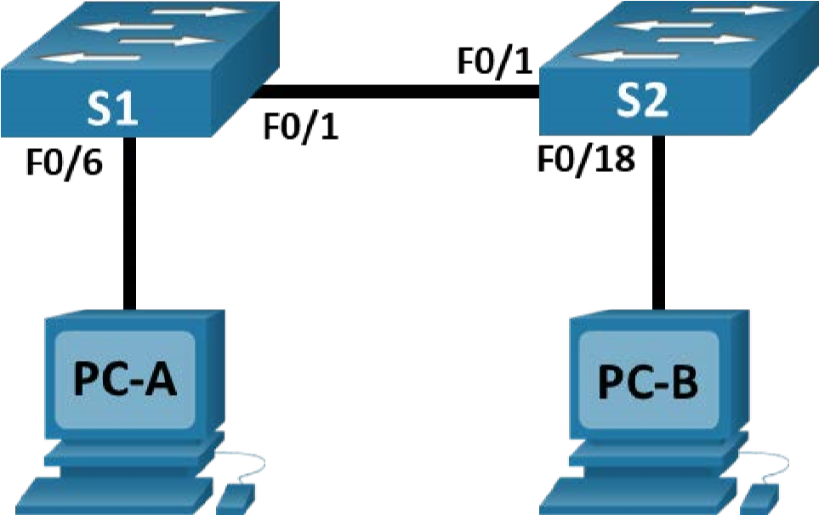
Addressing Table
Device | Interface | IP Address | Subnet Mask
S1 | VLAN 1 | 192.168.1.1 | 255.255.255.0
S2 | VLAN 1 | 192.168.1.2 | 255.255.255.0
PC-A | NIC | 192.168.1.10 | 255.255.255.0
PC-B | NIC | 192.168.1.11 | 255.255.255.0
Objectives
- Understand the Switch IOS and its environment
- Set Up the Network Topology
- Configure PC Hosts
- Configure and Verify Basic Switch Settings
Background / Scenario
In this lab, you will build a simple network with two hosts and two switches. You will understand the Switch and End device configurations, and will configure basic settings.
Use of commands like Show, Copy, and Ping will help you in easy understanding of the existing topology.
Environment
- Packet Tracer 7.3.1

Instructions
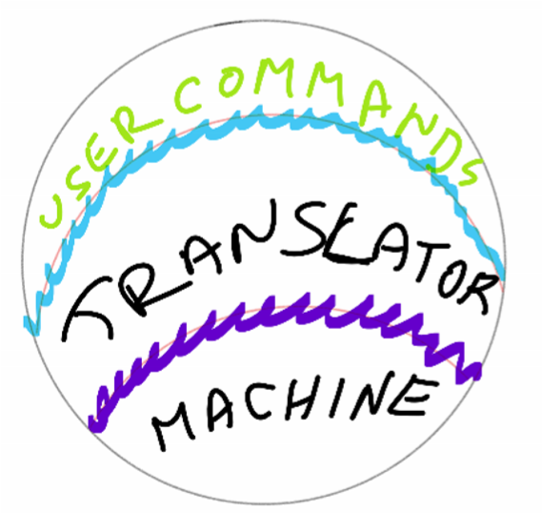
Step 1: Understand the Device Terms
Shell - The user interface that allows users to request specific tasks from the computer. These requests can be made either through the CLI or GUI interfaces.
Kernel - Communicates between the hardware and software of a computer and manages how hardware resources are used to meet software requirements.
Hardware - The physical part of a computer including underlying electronics.

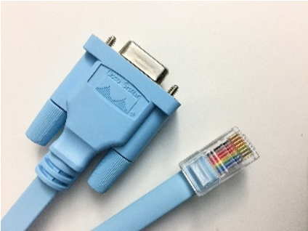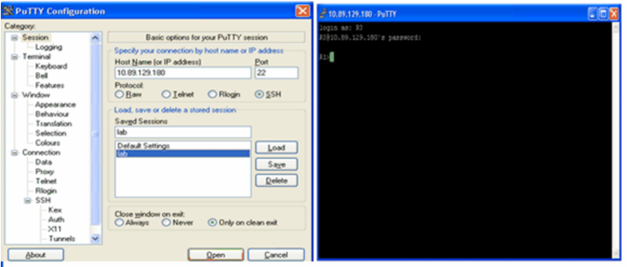
a.

Accessing the device

Use either a Console or a Secure Shell (SSH) (a secure remote CLI connection to a device, through a virtual interface) or Telnet (an insecure remote CLI connection)

Use terminal emulation tools like PuTTY, Tera Term etc to connect to the device

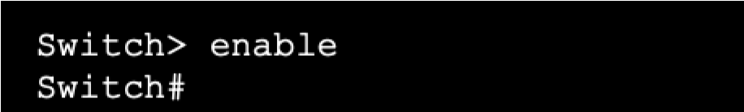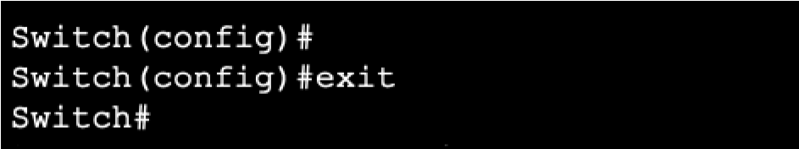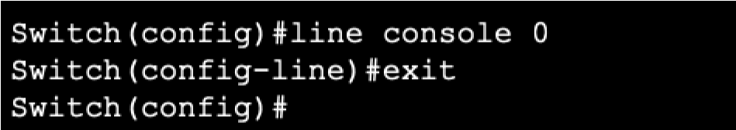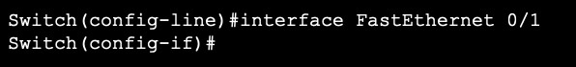
b.

Modes

User EXEC mode

Privileged EXEC mode

Global Configuration mode

Line Conf
iguration mode

Interface Configuration mode

e. HOT Keys!
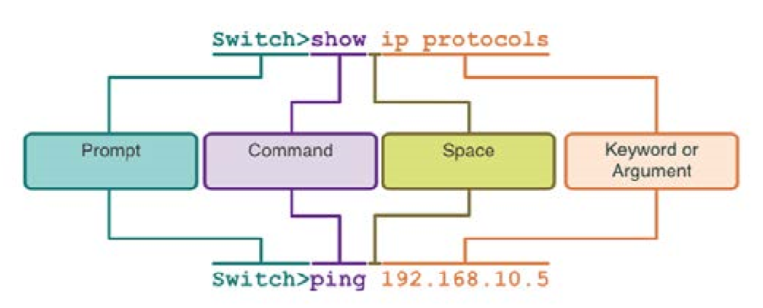
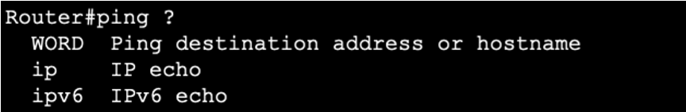
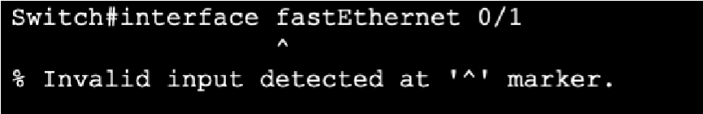
- TAB Key Completes a partial command name entry.
c.

IOS Command Structure

d.

Help!

#

Context
-
sensitive help

Command syntax

- Backspace Erases the character to the left of the cursor.
- Left Arrow or Ctrl+B Moves the cursor one character to the left.
- Right Arrow or Ctrl+F Moves the cursor one character to the right.
- Up Arrow or Ctrl+P Recalls the commands in the history buffer,
beginning with the most recent commands.
- Ctrl-C When in any configuration mode, ends the
configuration mode and returns to privileged EXEC mode.
- Ctrl-Z When in any configuration mode, ends the
configuration mode and returns to privileged EXEC mode.
- Ctrl-Shift-6 All-purpose break sequence used to abort
DNS lookups, traceroutes, pings, etc.
- Ctrl + A Move to the 1st character
- Ctrl + E Move to the last character

Step 2: Set Up the Network Topology
In this step, you will cable the devices together according to the network topology. a. Design the Topology as given above in Cisco Packet Tracer 7.3.1
Step 3: Configure PC Hosts
- Configure static IP address information on the PCs according to the Addressing Table.
PC→Desktop→ IP Configuration → “Configure IP, Subnet Mask as per addressing table
- Verify PC settings and connectivity.
From PC-A, open a Command Prompt PC→Desktop→Command Prompt to verify the PC settings and connectivity using the ipconfig command at the prompt.
To test the connectivity to PC-B, enter ping 192.168.1.11 at the prompt. The ping should be successful. If not, troubleshoot as necessary.

Step 4: Configure and Verify Basic Switch Settings
- In the switch, initially, erase the existing configuration and reload.
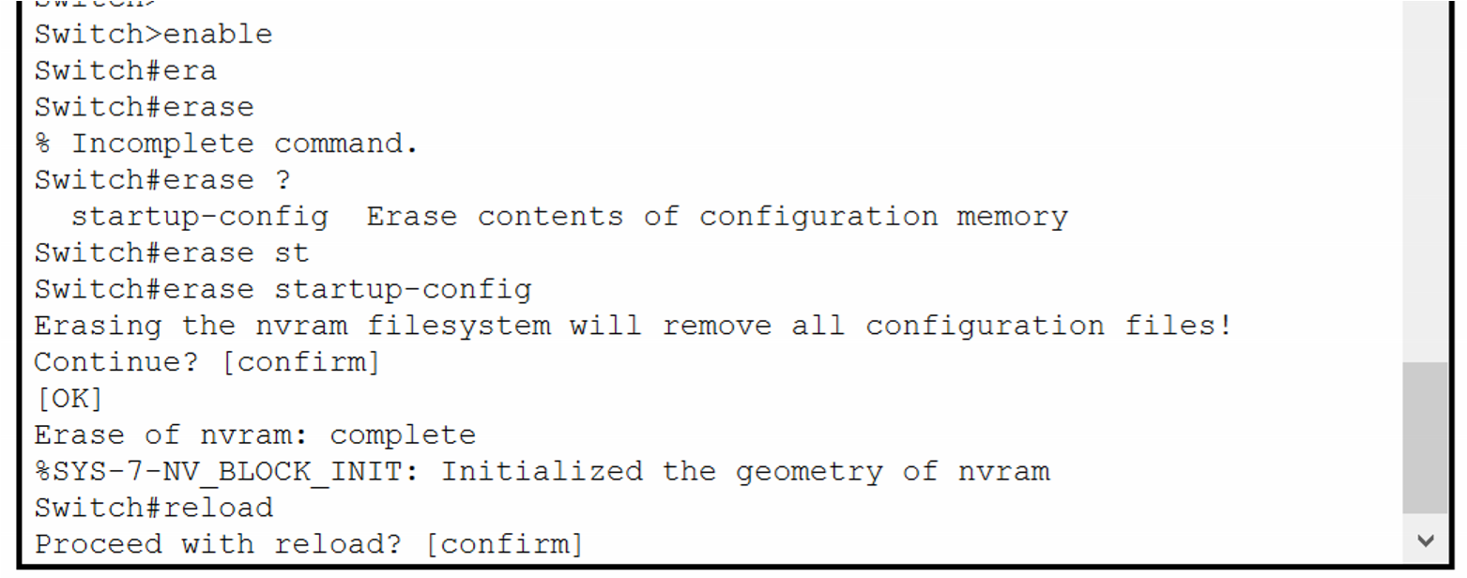
- Enter the global configuration mode.
Open Configuration WindowSwitch> enable
Switch#
The prompt changed from Switch> to Switch# which indicates privileged EXEC mode. Use the configuration terminal command to enter configuration mode. Switch# configure terminal
Enter configuration commands, one per line. End with CNTL/Z. Switch(config)#
The prompt changed to reflect global configuration mode.

- Give the switch a name according to the Addressing Table. Use the hostname command to change the switch name to S1. Switch(config)# hostname S1

- Prevent unwanted DNS lookups.
To prevent the switch from attempting to translate incorrectly entered commands as though they were hostnames, disable the Domain Name System (DNS) lookup. S1(config)# no ip domain-lookup
- Enter local passwords. Use class as the privileged EXEC password and cisco as the password for console access. To prevent unauthorized access to the switch, configure passwords.
S1(config)# enable secret class
S1(config)# line con 0
S1(config-line)# password cisco
S1(config-line)# login
S1(config-line)# exit

- Configure and enable the SVI according to the Addressing Table.
S1(config)# interface vlan 1
S1(config-if)# ip address 192.168.1.1 255.255.255.0 S1(config-if)# no shut

- Enter a login MOTD banner to warn about unauthorized access.
A login banner, known as the message of the day (MOTD) banner, should be configured to warn anyone accessing the switch that unauthorized access will not be tolerated.
The banner motd command requires the use of delimiters to identify the content of the banner message. The delimiting character can be any character as long as it does not occur in the message. For this reason, symbols, such as the #, are often used.
S1(config)# banner motd # Enter TEXT message. End with the character '#'.
Unauthorized access is strictly prohibited and prosecuted to the full extent of the law. # S1(config)# exit
- Save the configuration.
Use the copy command to save the running configuration to the startup file on non-volatile random access memory (NVRAM).
S1# copy running-config startup-config Destination filename [startup-config]? [Enter] Building configuration...
[OK] S1#
- Display the current configuration.
The show running-config command displays the entire running configuration, one page at a time. Use the spacebar to advance paging. The commands configured in Steps a - h are highlighted below.
S1# show running-config Building configuration...

Current configuration : 1409 bytes !
- Display the IOS version and other useful switch information.
Use the show version command to display the IOS version that the switch is running, along with other useful information. Again, you will need to use the spacebar to advance through the displayed information.
S1# show version
Cisco IOS Software, C2960 Software (C2960-LANBASEK9-M), Version 15.0(2)SE,
RELEASE SOFTWARE (fc1)
Technical Support: http://www.cisco.com/techsupport Copyright (c) 1986-2012 by Cisco Systems, Inc.
Compiled Sat 28-Jul-12 00:29 by prod_rel_team

- Display the status of the connected interfaces on the switch.
To check the status of the connected interfaces, use the show ip interface brief command. Press the spacebar to advance to the end of the list.
S1# show ip interface brief
Interface IP-Address OK? Method Status Protocol
Vlan1 192.168.1.1 YES unset up up
FastEthernet0/1 unassigned YES unset up up
_{Close Configuration Window.}FastEthernet0/2 unassigned YES u nset down down l. Configure switch S2.
Repeat the previous steps for Switch S2. Make sure the hostname is configured as S2.

  - Record the interface status for the following interfaces.
Interface | S1 Status | S1 Protocol | S2 Status | S2 Protocol
F0/1 | Up | Up | Up | Up
F0/6 | Up | Up | Down | Down
F0/18 | Down | Down | Up | Up
VLAN 1 | Up | Up | Up | Up
  - From a PC, ping S1 and S2.
Both S1 and S2 when pinging the IP address respond after 1st Packet times out
------------------------------------------------------------------------
  - From a switch, ping PC-A and PC-B.
Ping to PC-A responded with 5 successful packets, Ping to PC-B responded with 4 successful packets after 1st one dropped.
------------------------------------------------------------------------
Record your reflection
Why do you erase the Startup Configuration in the switch? Is it required for all/ any switch or only for an old switch?
It is not necessary to erase config on a new switch, but for best practise you should, as it makes sure no existing config has been set on the device. It should always be done for old devices when repurposing them.
______________________________________________________________________ Are all the FastEthernet ports on the switches up? Yes/ No. If YES, Why? If No, Why?
No, the ports are set to down as the ports will only come online once there is a physical connection in to the port, Ports can be set to down manualy via the command line with a physical link present.. Also for Virtual Lans e.g. Vlan1, the vlan has to be brought online manually via the no shut command.
__________________________________________________________________________ What is your understanding on PING and TRACEROUTE utilities? What is the purpose of using them?
PING command is used to send ICMP packets from the initiating device to the target. The aim is to confirm that the packet has been received by the receiving client. TraceRoute is used to confirm each hop (the devices along the route from sender to receiver) When running Traceroute it will note each hop of the route and its IP address, and confirm a ping time for each hop if possible.
__________________________________________________________________________

