MODULE CODE: BMHP6026

PROGRAMME: BSC (HONS) HEALTH AND SOCIAL CARE

MODULE: DIGITAL TRANSFORMATION IN THE HEALTH AND CARE PROFESSIONS

TOPIC: Electronic Health Records (EHRs): A Critical Evaluation of Digital Transformation in UK Health and Social Care

LECTURER: MATRIN SVEJDA, TOMY ADATTU CHACKO AND ZAKIYYAH AHMED

STUDENT NAME: - S. Hortense Assoh
STUDENT ID: - 2245799
DATE OF SUBMISSION:- 05/07/2026
TABLE OF CONTENTS
1. Introduction 4
2. Overview of Electronic Health Records and Digital Transformation in the UK 5
3. Critical Evaluation of Electronic Health Records in UK Health and Social Care 6
3.1 Impact on the Workforce 6
3.2 Impact on Service Delivery 7
3.3 Impact on Patients and Service Users 8
3.4 Impact on Community and Population Health 9
4. Conclusion and Recommendations 10
4.1 Conclusion 10
4.2 Recommendations 10
Reference List 12

LIST OF FIGURES

Fig 1: Global Electronic Health Records (EHRs) Market 4
Fig 2: Overview of electronic health record (EHR) data utilisation 6
Fig 3: Advantage Of Electronic Health Records (EHRs) 7
Fig 4: Electronic Health Records (EHRs) Impact on Patients and Service Users 9

1.
The UK's health and social care has been digitally transformed, which has been a driver of innovation that improves health care access, outcomes, patient safety, and efficiency. The Electronic Health Records (EHRs) have been among the most significant changes because they have replaced paper records with electronic records (Adeniyi et al., 2024). EHRs assist in access and sharing of patient data in time with healthcare professionals and promote evidence-based care and coordination. They are introduced as per the NHS digital transformation plans that are patient-centered and integrated service provisions. According to NHS England (2025a), 93% of NHS providers in England currently use electronic patient records, and over 39 million people are registered to use the NHS App. Besides, the COVID-19 pandemic has enhanced the application of EHR, which is supportive of continuity of care and remote care. The report will be a critical evaluation of the implementation of electronic health records in health and social care in the UK. It will address how EHRs have transformed workforce practices, service delivery, patient experiences, and health outcomes in the community. It considers both the positive and the negative impact based on the prevailing literature, governmental documents, and healthcare policy that provides an overall evaluation of this important digital innovation.
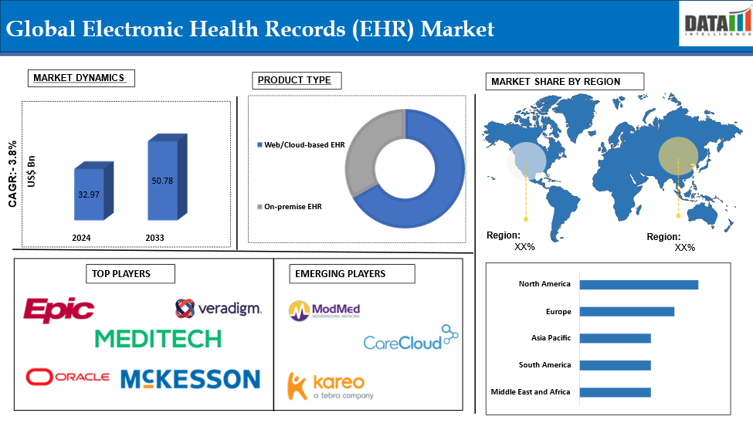

Fig 1: Global Electronic Health Records (EHRs) Market
(Source: Datamintelligence, 2025)

2. Overview of Electronic Health Records and Digital Transformation in the UK
Electronic Health Records (EHRs) refer to web-based portals that are secure management and storage of health information of a patient during the healthcare process of an individual. The EHRs provide the authorised health workers with the ability to access, update, and transfer patient information in real-time in healthcare facilities, unlike the old paper records, which helps to ensure integrated care and enhance communication among primary care, hospitals, community services, mental health teams, and social care organisations (NHS England, 2025a).
One of the major goals of the digital transformation of healthcare in the United Kingdom has been the introduction of EHRs. The NHS Frontline Digitisation Programme saw about 1.9 billion expended to aid in the implementation and improvement of electronic patient record (EPR) systems. There is an increasing trend in the utilisation of digital healthcare services. 93% of NHS Trusts in England have an EPR system, and more than 39 million individuals are registered users of the NHS App (NHS England, 2025). Moreover, EHRs are useful in population health management, research in healthcare, and evidence-based decision-making. Nevertheless, the issues surrounding the cost of implementation, cybersecurity, interoperability, training of staff, and digital exclusion are still high (Alzu'bi et al., 2021).
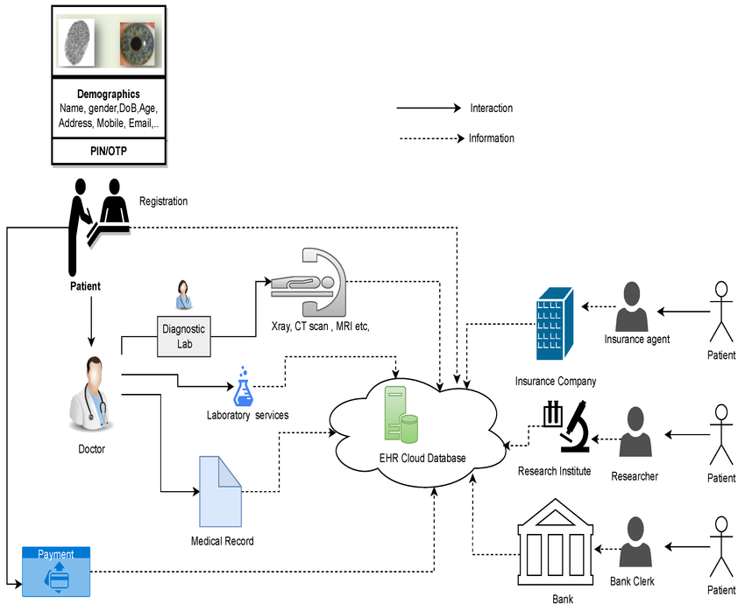

Fig 2: Overview of electronic health record (EHR) data utilisation
(Source: ResearchGate, 2025)

3. Critical Evaluation of Electronic Health Records in UK Health and Social Care

3.1 Impact on the Workforce
The adoption of Electronic Health Records (EHRs) has transformed the workforce practices in health and social care organisations in the UK in a revolutionary manner. With EHRs, it is possible to have real-time access to patient data and apply it to make informed clinical choices and build multidisciplinary teams. This is more relevant because 93% of the NHS Trusts of England had changed to an electronic patient record system by 2025 to enable more information to be shared in health care facilities (NHS England, 2025a). The interoperability will result in an increased degree of coordination and continuity of care and reduction in communication barriers among the clinicians and nurses as well as among pharmacists and social care professionals. The digitalisation of records also has been changing the competencies of the workforce. NHS England (2023a) found out that digital skills will be among the primary aspects of the future healthcare workforce, and the employees will be required to acquire digital skills in managing digital records, information management, and cybersecurity. However, challenges remain. The survey of the British Medical Association (2022) revealed that a number of clinicians found that they had an additional workload with digital documentation that led to a heavier workload and less time spent with the patient, resulting in a stressful experience. The effective introduction of EHR, in its turn, presupposes that the workforce will be trained regularly, the leadership will be offered, and the organisation will have to assist the workforce to ensure that the benefits will be maximised, the level of digital fatigue and resistance towards change will be reduced (Avendano et al., 2022).
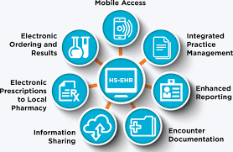

Fig 3: Advantage Of Electronic Health Records (EHRs)
(Source: Avontix, 2025)

3.2 Impact on Service Delivery
Electronic Health Records (EHRs) have resulted in improved healthcare service delivery because of an enhanced level of coordination, efficiency, and patient-centered care. The past systems, which were paper-based, were likely to open loopholes in the communication process in addition to bringing slowness in the process of relaying information and duplication of evaluation. EHRs will be able to eradicate such dilemmas as they provide one point of patient data that can be accessed securely in a medical facility. By 2025, 93% of NHS trusts had implemented Electronic Patient Records (EPR), and they have greatly enhanced sharing of digital information and coordination of care (NHS England, 2025b). Enhanced continuity of care is one of the benefits of EHRs. A patient can utilise the services of different medical professionals to collaborate with him or her, and collaboration among the medical professionals can be enhanced with the help of EHRs. NHS alone reported that over 20.8 million GP health record views were delivered via the NHS app in 2025, meaning that more and more individuals are willing to utilise digital records in the provision of medical care (NHS England, 2025a). Patient safety has also been aided by EHRs since they possess the clinical decision-support systems that can inform whether the drugs are interacting, whether the drug has an allergy, and the probability of prescribing the drugs. When there are efficient referrals, discharge planning, and diagnostic reporting, the operations will be more efficient. However, interoperability of systems, high cost of implementation, and cybersecurity are still there. As a result, although EHRs have made a big impact on service delivery, their effectiveness over the long term is highly tied to future investment, integration of technologies, and personnel training, as well as the possibility to maintain digital infrastructure (Holmes et al., 2021).

3.3 Impact on Patients and Service Users
The success of electronic health records (EHRs) depends on patient perspective, as it is directly related to access, safety, and quality of healthcare. EHRs have also led to continuity of care, as the healthcare providers have been assisted to get the right information about patients in different healthcare environments. Therefore, patients will not be required to complete much of the same information multiple times, and this will save time and enhance provider-provider communication. Digitalisation of healthcare is evident in the sheer amount of NHS App registered patients in England (over 34 million) by 2025 (NHS England, 2025c).
It has also enhanced the degree of patient engagement since the patients can now get access to more health information using the EHRs. By 2024, the users of the NHS App, who already have accessed GP records and ordered millions of repeat prescriptions (the majority of which are ordered online), will be almost half a billion; therefore, they will make a choice on their own and cooperate to do it (NHS England, 2024). Furthermore, EHRs may also enhance patient safety because they decrease the number of documentation errors, records that are lost, and medication errors. It provides an idea that the rate of medication errors could be cut in half, prescriptions could be more specific, and treatment delivery could be introduced with the introduction of EHR (Kohane et al., 2021). There are hindrances to such benefits. The inability to access online resources, cybersecurity risk, and the issue of information privacy are threats to the validity of patients and equal access. This is why healthcare organisations are encouraged to view digital healthcare transformation to ensure that everyone who uses the services can benefit from the generation of new technologies (Negro-Calduch et al., 2021).
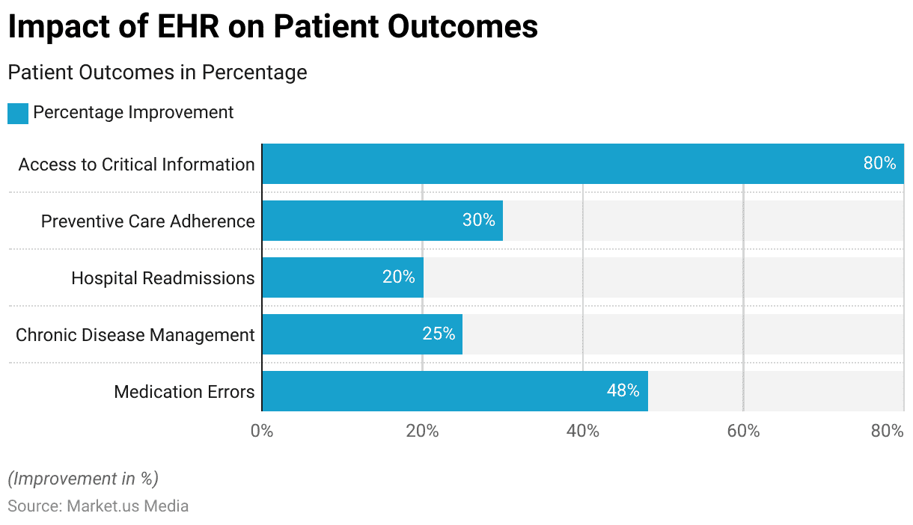

Fig 4: Electronic Health Records (EHRs) Impact on Patients and Service Users
(Source: MarketMedia, 2025)

3.4 Impact on Community and Population Health
The adoption of Electronic Health Records (EHRs) has had major impacts on the community health outcomes and healthcare management on a population scale. The EHR systems allow tracking of diseases, resource allocation, planning of public health, and evidence-based policymaking as the systems produce vast health information. Over 90% of NHS Trusts had installed Electronic Patient Record (EPR) systems by the year 2025, creating huge datasets that could be utilised in the analysis of population health and to enhance services (NHS England, 2025a). One of the main benefits of EHRs is that they help in population health management. Aggregated data prove to be helpful to healthcare organisations to track the prevalence of disease, vaccine coverage, healthcare utilisation, and health inequities. The online records played a crucial role in determining the individuals that are clinically vulnerable and planning the vaccine programmes in the face of the COVID-19 pandemic. By September 2024, over 146 million doses of COVID-19 vaccines were given in the UK, as aided by digital health information systems (UK Health Security Agency, 2024). Integrated care is also improved by EHRs as the information might be exchanged among the NHS organisations, the local authorities, and the social care providers. This helps in the coordination of care of the individuals with complex needs, especially the aged and other people with long-term conditions. However, digital exclusion is an issue. It is estimated that by 2023, there will be 4.7 million adults in the UK lacking the most basic digital skills, which might limit their access to digital healthcare (Lloyds Bank, 2023). As a result, addressing the issue of digital disparities and making sure that individuals trust in the data management is crucial to maximise the positive impact on a community level.

4. Conclusion and Recommendations

4.1 Conclusion
Electronic Health Records (EHRs) were one of the most radical digital changes in UK health and social care over the last decade. Their usage revolutionised the work practice, service, patient experiences, and population health management. Access to clinical data, multidisciplinary collaboration, and safer and more integrated care were all enhanced by the EHRs. The analysis revealed the following advantages, such as better communication, increased efficiency, patient safety, patient engagement, and health planning with the community. However, more documentation workloads, interoperability, cybersecurity, digital exclusion, and privacy were issues. Overall, the EHRs could revolutionise healthcare delivery but had to be constantly invested in and managed to bring the maximum benefits in the long term.

4.2 Recommendations
- Enhance Workforce Digital Competencies
The medical institutions are urged to continue investing in comprehensive programs of training in digital skills. The ongoing technical development will assist the medical personnel to be proficient in utilising EHR systems, be abreast of the technological advancements, and provide digital records and information management on the upper grade level (Pinevich et al., 2021).
- Improve Interoperability Across Health and Social Care Systems
The national program should be aimed at enhancing the interoperability of EHR systems in NHS organisations, local authorities, and social care providers. The policies of information sharing and normalised systems would facilitate a flow of information with ease and improve continuity of care and duplication of services (Si et al., 2021).
- Strengthen Cybersecurity and Data Governance
Infrastructure, staff awareness programmes, and proper data governance structures are some of the areas that should be maintained by healthcare organisations in terms of cybersecurity spending. Tighter security controls are needed to help protect precious patient data and ensure the trust and adherence of the population to UK GDPR and the Data Protection Act 2018 (UK Health Security Agency, 2024).
- Address Digital Exclusion
The steps should be taken to overcome the barriers to digital access to healthcare by individuals. These include the development of the digital literacy programmes, alternative access routes for the vulnerable groups, and community-based support to ensure that the vulnerable groups can equally access digital health technologies (Kohane et al., 2021).

Reference List
Adeniyi, A.O., Arowoogun, J.O., Chidi, R., Okolo, C.A. and Babawarun, O. (2024) The impact of electronic health records on patient care and outcomes: A comprehensive review. World Journal of Advanced Research and Reviews, 21(2), pp.1446-1455. https://doi.org/10.30574/wjarr.2024.21.2.0592
Alzu'bi, A.A., Watzlaf, V.J. and Sheridan, P. (2021) Electronic health record (EHR) abstraction. Perspectives in health information management, 18(2).https://ahisp.kglmeridian.com/view/journals/phim/18/2/article-1g.xml
Avendano, J.P., Gallagher, D.O., Hawes, J.D., Boyle, J., Glasser, L., Aryee, J., Katt, B.M., Hawes, J., Boyle, J.J. and Aryee, J.N. (2022) Interfacing with the electronic health record (EHR): a comparative review of modes of documentation. Cureus, 14(6). https://www.cureus.com/articles/101576#!/
British Medical Association (2022) Electronic health records and workload pressures in the NHS. London: BMA. [Online]. Available at: https://www.bma.org.uk/advice-and-support/nhs-delivery-and-workforce/pressures/an-nhs-under-pressure (Accessed on: 1 June 2026)
Department of Health and Social Care (2022) A plan for digital health and social care. London: DHSC. [Online]. Available at: https://www.gov.uk/government/publications/a-plan-for-digital-health-and-social-care (Accessed on: 1 June 2026).
Holmes, J.H., Beinlich, J., Boland, M.R., Bowles, K.H., Chen, Y., Cook, T.S., Demiris, G., Draugelis, M., Fluharty, L., Gabriel, P.E. and Grundmeier, R. (2021) Why is the electronic health record so challenging for research and clinical care?. Methods of information in medicine, 60(01/02), pp.032-048. https://www.thieme-connect.com/products/ejournals/abstract/10.1055/s-0041-1731784
Kohane, I.S., Aronow, B.J., Avillach, P., Beaulieu-Jones, B.K., Bellazzi, R., Bradford, R.L., Brat, G.A., Cannataro, M., Cimino, J.J., García-Barrio, N. and Gehlenborg, N. (2021) What every reader should know about studies using electronic health record data but may be afraid to ask. Journal of medical Internet research, 23(3), p.e22219.https://www.jmir.org/2021/3/e22219/
Lloyds Bank (2023) UK Consumer Digital Index 2023. Lloyds Banking Group. Available at: Lloyds Bank Consumer Digital Index 2023 Report (Accessed: 2 June 2026)
National Audit Office, (2020) Digital transformation in the NHS. London: National Audit Office. [Online]. Available at: https://www.nao.org.uk/reports/digital-transformation-in-the-nhs/ (Accessed on: 1 June 2026).
Negro-Calduch, E., Azzopardi-Muscat, N., Krishnamurthy, R.S. and Novillo-Ortiz, D. (2021) Technological progress in electronic health record system optimization: Systematic review of systematic literature reviews. International journal of medical informatics, 152, p.104507. https://doi.org/10.1016/j.ijmedinf.2021.104507
NHS England, (2022) A plan for digital health and social care. [Online]. Available at: https://www.gov.uk/government/publications/a-plan-for-digital-health-and-social-care (Accessed on: 1 June 2026).
NHS England, (2023a) Digital, data and technology strategy. London: NHS England. [Online]. Available at: https://www.england.nhs.uk/digitaltechnology/ (Accessed on: 1 June 2026).
NHS England, (2023) Transforming primary care through digital technology.[Online]. Available at: https://www.england.nhs.uk/long-read/delivery-plan-for-recovering-access-to-primary-care/ (Accessed on: 1 June 2026).
NHS England, (2024) Frontline Digitisation Programme. London: NHS England. [Online]. Available at: https://www.england.nhs.uk/long-read/frontline-digitisation-programme/ (Accessed on: 1 June 2026).
NHS England, (2025a) Digital maturity assessment report 2024–2025: Key findings. [Online]. Available at: https://digital.nhs.uk/data-and-information/digital-maturity-assessment-report-2024-and-2025-results/key-findings (Accessed on: 1 June 2026).
NHS England, (2025b) NHS App statistics. Office for National Statistics (2024) Internet access – households and individuals, Great Britain. [Online]. Available at: https://www.england.nhs.uk/2025/12/record-numbers-using-nhs-app-to-manage-health (Accessed on: 1 June 2026)
Pinevich, Y., Clark, K.J., Harrison, A.M., Pickering, B.W. and Herasevich, V. (2021) Interaction time with electronic health records: a systematic review. Applied clinical informatics, 12(04), pp.788-799. https://www.thieme-connect.com/products/ejournals/abstract/10.1055/s-0041-1733909
Si, Y., Du, J., Li, Z., Jiang, X., Miller, T., Wang, F., Zheng, W.J. and Roberts, K. (2021) Deep representation learning of patient data from Electronic Health Records (EHR): A systematic review. Journal of biomedical informatics, 115, p.103671. https://www.sciencedirect.com/science/article/pii/S1532046420302999
Tapuria, A., Porat, T., Kalra, D., Dsouza, G., Xiaohui, S. and Curcin, V. (2021) Impact of patient access to their electronic health record: systematic review. Informatics for Health and Social Care, 46(2), pp.194-206. https://doi.org/10.1080/17538157.2021.1879810

