ACMA6007

Barrie John

1811176

Plant And Asset Engineering

Andrew Thorn

Contents.

- Figures and tables list........................................................................................ 3
- Introduction.......................................................................................................4
- A History of the Llanelli plant...............................................................................4
- The chosen equipment.......................................................................................6
- The Current Maintenance Programme.................................................................7
- Reason for change..............................................................................................8
- Analysis of the breakdown..................................................................................9
- The new checking method..................................................................................11
- How to track the fin form....................................................................................13
- . Conclusion and Recommendations..................................................................15
- References........................................................................................................15

1.Figures and Tables list.

- Plant Profile........................................................................................................5
- Product list.........................................................................................................5
- Photo of Compco Tubemill..................................................................................7
- Screenshot of MP2 system..................................................................................8
- Photo of damaged inner fin roll............................................................................9
- Photo of rolls in the mill.......................................................................................10
- Flower diagram of the inner fin.............................................................................11
- Equipment used for resin sampling......................................................................13
- Equipment used for resin sampling......................................................................13
- Picture of potted sample......................................................................................13
- Picture of machine used for polishing potted sample............................................13
- Potted sample under a microscope......................................................................14

2.Introduction
This report completed by Barrie John evaluates the effectiveness of a chosen maintenance strategy for a dedicated piece of equipment. The report will give a background of the company and what the chosen machines role in the company is, it will also outlay the current maintenance programme and will evaluate how this can be improved along with why the new method has been chosen. The report will consider any additional costs or resources that may be needed to implement the improvements. Finally, the conclusions and any recommendations will be considered with a view to making them the standard for future similar machinery.

3. A History of the Llanelli plant
Marelli Automotive Systems (MLUK) is automotive components manufacture who is based in Llanelli, South Wales. It has been in business since 1944 and traded under several different name including Morris Motors, Llanelli Radiators to Calsonic Kansei. The organisation employs over 250 people. MLUK supplies to a high-end OEM Customer base including Nissan, JLR, VW Audi and Stellantis.
MLUK produce a wide range of heat exchange products that include Radiators, Condensers, Low Temperature Radiators, and many more cooling components that are used in a wide range of vehicles.
MLUK have recently entered the Electric Vehicle (EV) market with the introduction of a Battery Cooling Plate production line which is seen as the future with the global change in car design.

Figure 1 below shows the Marelli plant profile.

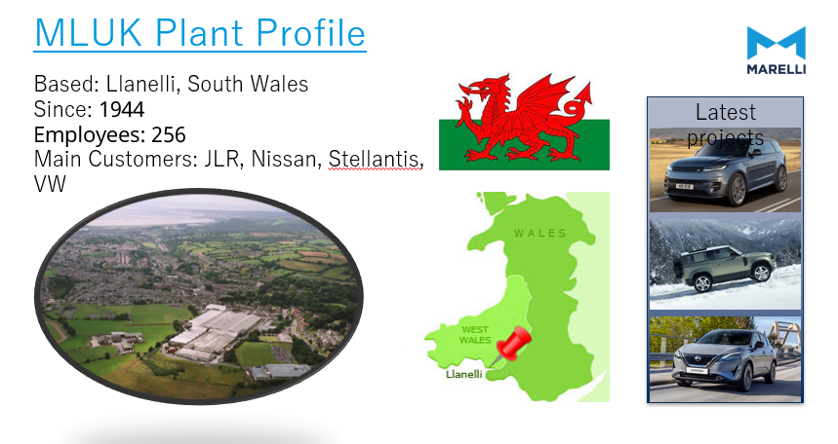
Figure 1.

Figure 2 below shows the Marelli product and list.

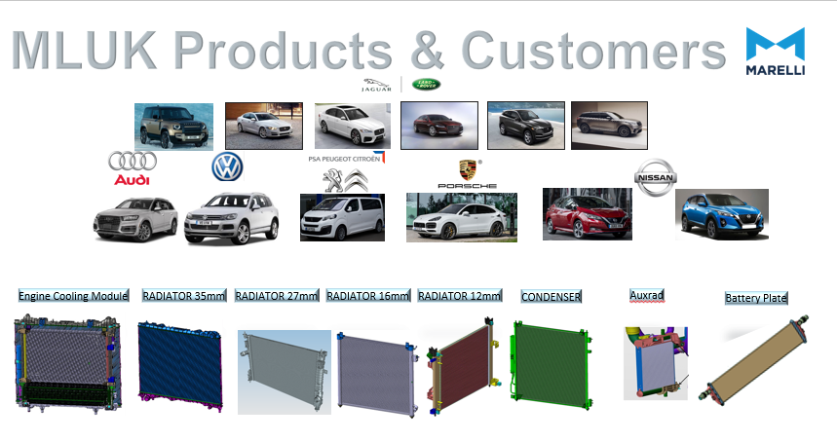
Figure 2.

4.The chosen equipment.
The chosen equipment for this report is the compco tube mill.
What is a tube mill?
A tube mill is a machine used to produce aluminium tubes. It starts by processing a flat strip or coil of metal into a cylindrical shape, which is then pressed or welded to form a continuous tube. Tube mills are very common industries such as oil, gas, automotive and construction.
The functions of a mill:
Uncoiling:
The manufacturing process begins with the uncoiling of a coil, typically made of aluminium, steel or stainless steel. The strip passes between a series of rollers that flatten and straighten it, these are used to ensure uniformity by removing any deformities or bends.
Forming:
Once the strip is flattened it enters the forming section of the tube mill. This is where the rolls begin to gradually bends the strip into a tubular shape. The rolls are designed to progressively shape the strip while ensuring that the desired dimensions and tolerances are achieved.
Sizing and Shaping:
Once formed, the tube passes through a series of sizing and shaping rolls. These ensure the tube attains its precise dimensions. Additionally, the rolls may also be used to incorporate specialized profiles that allow the manufacture to produce tubes with specific cross-sectional shapes, that can include oval, square and rectangular tubes.
Cutting and Finishing:
When a tube reaches the desired length, it is cut to size using a cutting mechanism commonly known as a guillotine. Any sharp edges or burrs need to be removed, resulting in a smooth and finished tube.
Quality Control and Inspection:
Throughout the tube mill process, there are many quality control measures that are implemented to maintain the correct integrity and consistency of the manufactured tubes. Some tube manufactures will also use Non-destructive testing techniques, such as ultrasonic or eddy current testing to detect for defects. Additionally, to ensure stringent quality standards are maintained dimensional measurements, surface inspections, and material analysis are carried out.
A Tube mill is a vital machine in the production of aluminium tubes. This is achieved by following a series of precise manufacturing steps, these include uncoiling, straightening, forming, sizing, and finishing. Tube mills transform a raw material into a high-quality, ready-to-use tube. (Galaxie, 2024)

What does the compco tube mill produce?
The Compco tube mill produces tubes for the MLA condenser.it consists of two mills producing a tube holder and an inner fin which are then joined and pressed together to form the finished product. In this report we will be looking at the inner fin mill and the wear on the forming rolls.
Figure 3 below shows the Compco Tube mill.
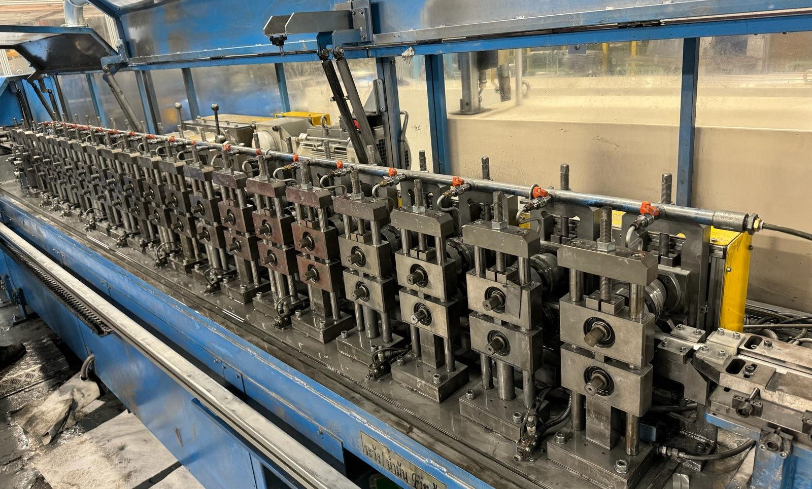
Figure 3.

5.The Current Maintenance Programme
Currently the machine is maintained by periodical checks that are logged on the maintenance system known as MP2.
MP2 is a data base used by maintenance to determine the frequency and list of pre-determined checks to be carried out on a piece of equipment. This is compiled by the engineering team when a machine is first commissioned. These checks are meant to allow for the maintenance team to inspect the machine for wear and tear, also basic tasks suck as oiling and greasing of wear parts. All machine breakdowns are also recorded on this system to allow for tracking of repeat issues.

Figure 4 below show a screen shot of the MP2 system.
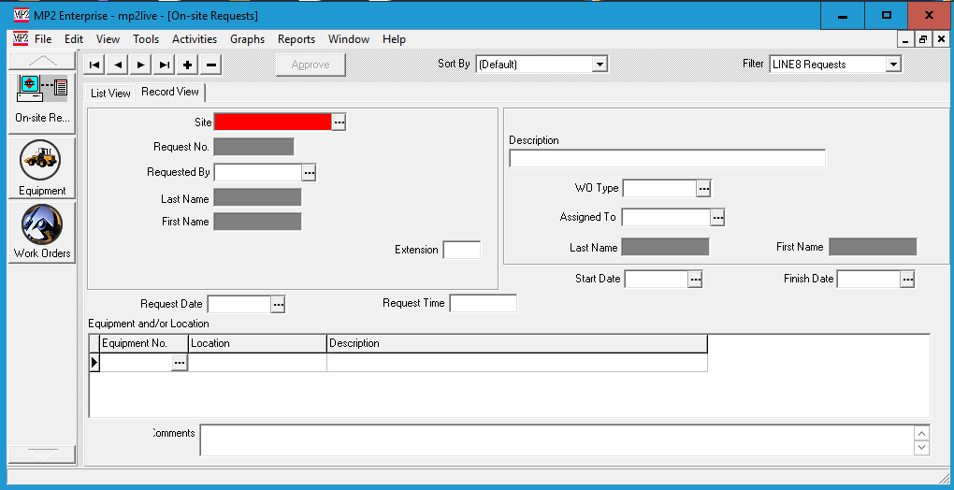
Figure 4.

6.Reason for change.
Despite the current maintenance programme and periodical checks there was recently a major breakdown where the Compco mill was down for several days resulting in the need for new rolls, engineers flying in from Japan to support the breakdown and all safety stock being exhausted. All this at great cost to the company.

Aswell as the breakdown the potential fallout of the breakdown could have resulted in.
- Overtime to catch back downtime.
- Express freight to customer.
- Line stoppages of customer resulting in charges to company.
- Loss of confidence with customer.
- Loss of future orders.
- Closure of plant.

7.Analysis of the breakdown.

What was the issue?
The reason for the breakdown was damage to one of the forming rolls of the mill. There was a chip in the roll that resulted in the mill mis-forming of the inner fin. This resulted in reject tubes.

Figure 5 below shows the damaged forming roll.
Figure 5.

Figure 6 below shows the roll in the mill.
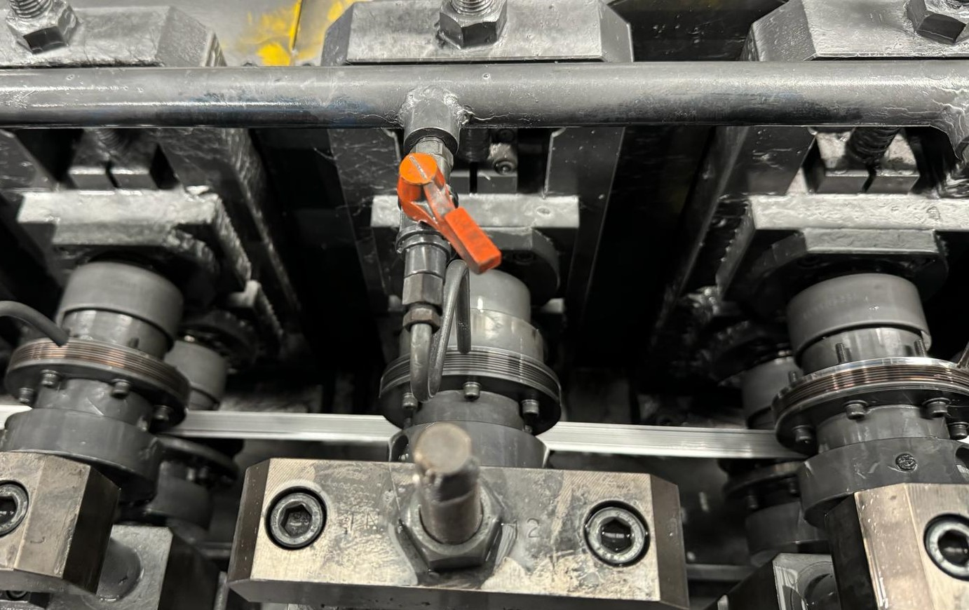
Figure 6.

Despite the checks and maintenance programme in place the wear on the roll was not seen before the breakdown. This meant that the lost time and resulting extra costs were not avoidable.
New rolls were fitted, and the machine was back up and running but it was identified that a more robust checking method was needed for this piece of equipment.

8.The new checking method.
As part of the repair checks under the microscope of the form of the tube were carried out. These are known as flower diagrams.
What are flower diagrams?
flower diagrams are an engineering drawing that maps out the forming of the fin shape.
What are “engineering drawings”? Engineering drawings are used to allow engineers to communicate design ideas and include technical information. Why use engineering drawings? They allow engineers and other professionals to map out the design process. An engineering drawing represents a complex design that can be either two- or three-dimensional using paper or computer projection. (Wise, 2021)

Figure 7 below shows a flower diagram of the inner fin.

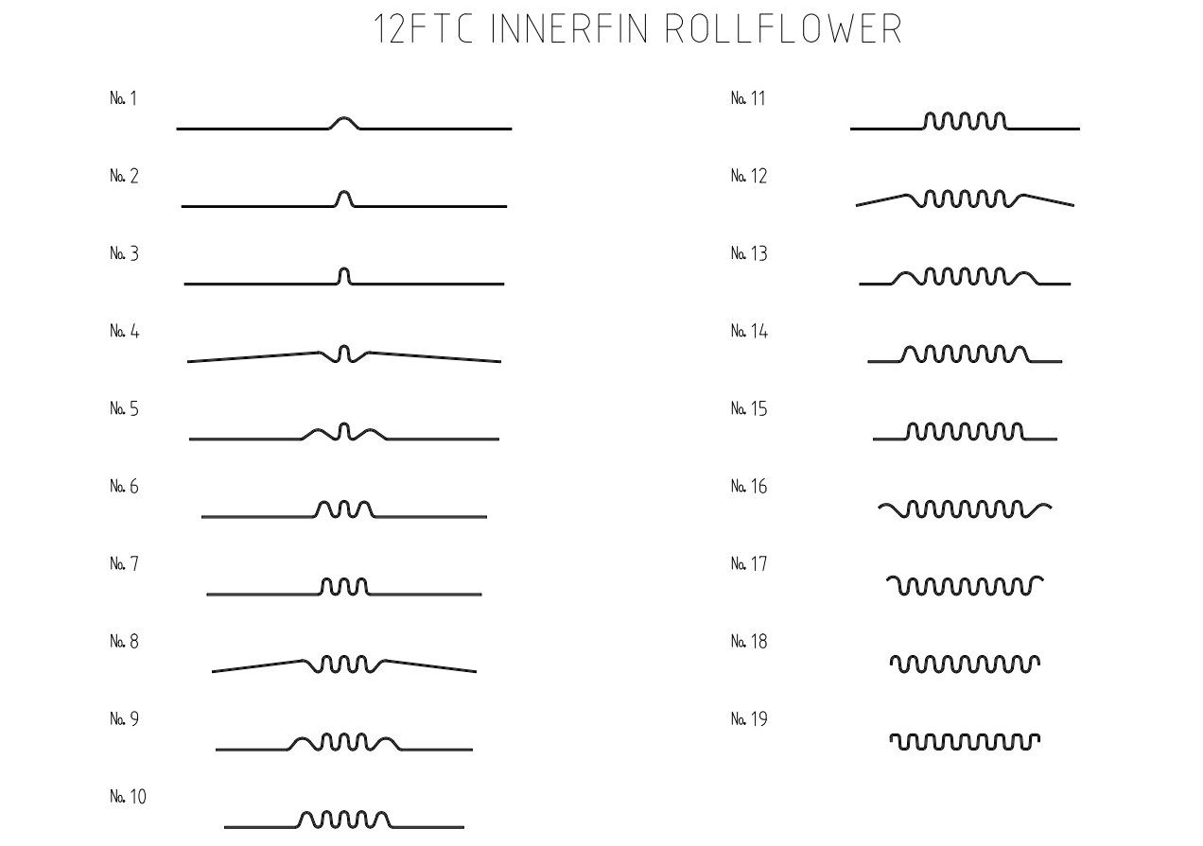
Figure 7.

Using this flower diagram and condition monitoring it was decided that monitoring the wear of the roll could be achieved by monitoring the form of the flower diagram.

What is condition monitoring?
Condition monitoring is a predictive maintenance tool that relies on real-time data collection to monitor machines wear to detect faults and anomalies.
Companies that use condition monitoring use the approach as a way to identify potential problems before critical assets fail, thus allowing minimum unplanned downtime and maximizing asset lifespan.
Normally, this monitoring process involves continuous data collection of the asset to track a range of diagnostics, these can include temperature, sound and vibration levels are just a few of the parameters that are tracked.
This data allows maintenance to analyse and interpret it using different techniques and software tools available. Some of the most common uses for condition monitoring data are:

Trend monitoring. Trend monitoring uses continuous measurement and data analysis to identify trends that points to deterioration of equipment. More specifically, the company can decide by which metric is the best indicator of equipment health. This assessment helps to anticipate when the equipment has detreated to its critical limit. Trend monitoring is frequently used to track engine performance.
Condition checking. Unlike trend monitoring, condition checking relies on periodic measurement of equipment during the running cycle allowing maintenance then uses the data to assess the current condition of the machine.
Condition monitoring techniques are ideal for tracking rotating equipment (for example, gearboxes, shafts, milling machines, etc.). This allows companies to optimize maintenance operations, especially in industries such as manufacturing where machines and equipment are critical to daily operations.
In such industries, even a small malfunction can cause significant financial losses and reductions in productivity. A good example, in a manufacturing plant, a faulty machine can lead to production delays, missed deadlines, and increased costs.
In the end, condition monitoring can allow a maintenance team to take a more proactive approach to maintenance. (IBM, 2024)

Why use condition monitoring to track the compco mill?
By using condition monitoring to track the wear of the rolls using the flower diagram of the fin form it allows for maintenance to see wear in the rolls that is not visible by eye. This allows for the team to plan and decide when the rolls should be changed before the mill breaks down allowing for parts and manpower to be ready at a pre-planned time. (Edwards, 2024)

9.How to track the fin form
With the decision to use condition monitoring to track roll condition of the mill a robust and repeatable way of checking needs to be put in place. Weekly potted sampling of the inner fin form was decided to be the best option as it is a low-cost way to monitor the roll condition.
What is a potted sample?
A potted sample is a way of inspecting a specific sample material. This is when a sample of material is placed in resin and then polished back before being viewed under a microscope. (Lee, 2024)
Below figures 8 & 9 show the equipment used for resin sampling.
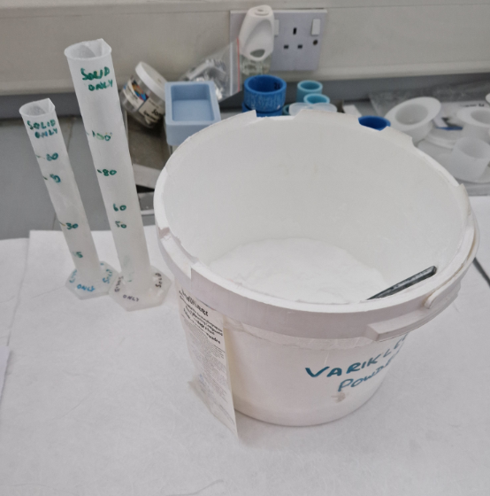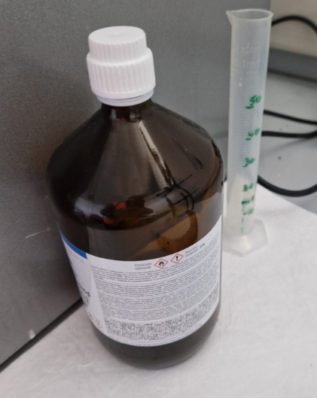
Figure 8. Figure 9.
Figure 10 & 11 below shows the potted sample and the machine used to polish back the sample.
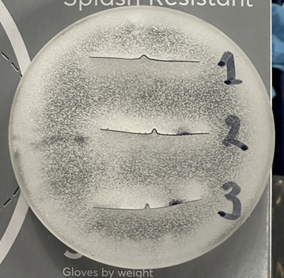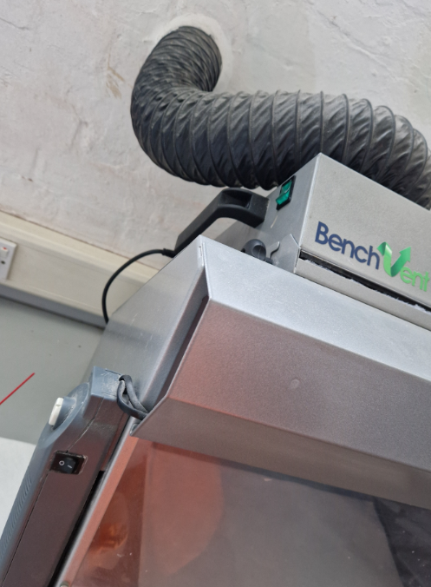
Figure 10. Figure 11.

Once completed a report can be compiled to show the form of the inner fin and allow for measurements that can be tracked to show any change caused by roll deterioration. This will allow for a planned change of the rolls at a time suitable to the maintenance team prior to breakdowns occurring.

Below figure 12 shows the potted sample under a microscope with measurements for tracking wear of the rolls.

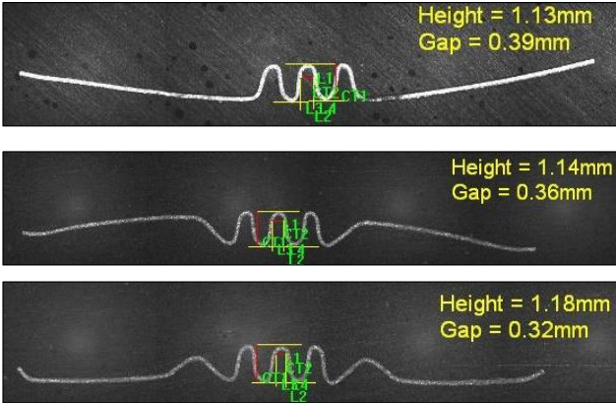
Figure 12.

10.Conclusion and Recommendations.
In Conclusion condition-based monitoring of the inner fin is an ideal way track wear of the mill rolls and plan to replace before a critical breakdown occurs. Whereas the old MP2 planned maintenance schedule would only allow for periodical assessments of the mill and fix breakdowns as and when they occurred the new method of weekly potting of fin samples not only allows for the engineering team to see the wear and plan replacements in advance. It also enables the team to track the rate of deterioration which can then be used to develop alternative materials that can improve the performance of rolls and mill.
All this is at a low cost to the company as resin and potting of samples is something already used within the company so there is no need for new equipment to carry out these checks.
Recommendations.
It has been recommended to the management that this check be carried across all mills as a way of tracking wear on key rolls. This easy, effective, and low-cost way of monitoring roll condition will allow for all tube mills to have an accurate way to track and plan for replacement of key components without the loss of Time, productivity, quality and at no extra cost such as overtime and express freight to the company.

11.References.
Edwards, T. (2024, 03 15). Planned Maintenance. (B. John, Interviewer)
Galaxie. (2024). Understanding the Role and Functioning of a Tube Mill. Retrieved from galaxiecorp.com: https://www.galaxiecorp.com/2023/06/07/understanding-the-role-and-functioning-of-a-tube-mill/
IBM. (2024, 03 23). What is condition monitoring. Retrieved from ibm.com: https://www.ibm.com/topics/condition-monitoring
Lee, D. (2024, 03 03). How Potted samplea are done. (B. John, Interviewer)
Wise, G. (2021). Science direct. Retrieved from sciencedirect.com: https://www.sciencedirect.com/topics/engineering/engineering-drawing

