

Student Name | Alisha Kauser
Student ID | 2322734
Module | Component 1 - Portfolio
Module Code | BMHP5015
Lecturer | Raheela Shaikh

Task 1 – Personal Brand
As a caring and skilled health and social care worker, I provide a special combination of abilities developed in a variety of positions in assisted living, home care, as well as end-of-life nursing facility care. I started my adventure by working in end-of-life care for three years, during which time I gained a great deal of empathy and learnt how to offer dignity and comfort in delicate situations. Building upon this foundation, I have worked in supported living for the past four years, encouraging self-reliance and establishing friendly environments for people with different needs.
Effectively communicating with colleagues and patients, dealing with emergencies with patients and delivering person-centred care are my main strong points. I'm great at establishing trusting bonds between patients and their families and making sure their opinions are valued. I am skilled at developing care plans and speaking out for the welfare of people I care for (Kwame and Petrucka, 2021).
I'm dedicated to lifelong learning and development. Although my commitment motivates me to provide excellent treatment, I am also actively working on delegating, enabling my colleagues to increase the efficacy of our team. I am committed to providing outstanding care and have a strong desire to have a positive influence. My future goal is becoming a paramedic, dedicating my career to saving lives and providing critical care to those in emergency situations (Samardzic, Doekhie and Wijngaarden, 2020).
My current commitment to providing outstanding care is fuelled by my former experiences, which have evolved from compassionate end-of-life care to empowered independent living. I'm concentrating on developing my delegating abilities and pursuing my goal of becoming a paramedic so that I may provide essential care during emergencies.

Task 2 - Network Map and Rationale
This network map shows the interrelated connections that help me improve both personally and professionally in a variety of ways (Miles, 2017).

Career
Support
Social
Community

My Network

Colleagues

Family

Linkedln

Friends
Careers Advisor
University Lecturers
Husband
Friends
Siblings
Mentors
Online Forums
Local Groups
Library

My network is a complex system including social, professional, support, and community components. LinkedIn, academic professors, and career counsellors are examples of career networks that are essential for professional growth and keeping updated of market developments. My spouse, friends, family, and mentors all offer emotional and practical support during trying times and promote personal development. Social connections include friends and coworkers, creating bonds and a feeling of community that improve general well-being (Martino, Pegg and Frates, 2015). Family, neighbourhood associations, online forums, as well as the local library all promote community involvement by providing a variety of resources and viewpoints.
For both professional and personal development, this network is essential. It gives people access to opportunities, knowledge, and a support network all of which are important for overcoming obstacles and accomplishing objectives. A developing network depends on sustaining and fostering these relationships through consistent communication and active involvement in each level. This complete approach guarantees a comprehensive support network that addresses various parts of my life.

Task 3 - Blog Neglect In NHS


(NHS Support Federation, 2025)
Introduction:
Neglect in the National Health Service (NHS) is a serious problem that needs to be addressed right away. It entails not giving patients the care they require, which could endanger their health. Neglect can have serious repercussions, even if it is frequently unintended.
Defining Negligence in Medical Field:
Neglect in healthcare refers to several mistakes, such as incorrect medicine administration, poor management of pain, as well as insufficient safeguards against avoidable injury. It even goes so far as to disregard necessities like hydration, food, and cleanliness. These mistakes can worsen pre-existing diseases and lengthen hospital stays, which can have a substantial effect on an individual's recovery and general health (Reader and Gillespie, 2013).

Underlying Reasons for Neglect:
Due to employee shortages and limited resources, the NHS is under immense pressure. Healthcare workers that are overworked may find it difficult to provide each patient the individualised attention they need, which could result in mistakes and failing to identify patient suffering. The situation has been made worse by systemic problems including poor education and interaction breakdowns. After one year, 54% of nurses in our sample experience mild burnout, with emotional weariness increasing by 10% and cynicism increasing by 19%. Burnout had a significant impact on organisational turnover, with a 12% increase in nurses departing for each unit rise on the emotional exhaustion scale, but it was not a factor in position turnover (Kelly, Gee and Butler, 2021).
Preventing Neglect:
The NHS is taking steps to prevent neglect, such as expanding its workforce, improving its training initiatives, and encouraging accountability and openness. Finding and fixing systemic problems requires empowering healthcare workers to voice concerns without worrying about retaliation. Including families in the treatment process and advocating for patients can help guarantee that needs are satisfied and possible issues are dealt with right away (Fukami, 2024).
Conclusion:
According to the National Health Service, neglect is not acceptable and must be prevented by a dedicated effort. A positive healthcare setting for everyone receiving treatment can be achieved by increasing awareness, assisting medical staff, and pushing for improved facilities and systems. Also making sure patients safety should remain a priority.

Task 4 - NHS Equality, Diversity and Inclusion Quiz
1- What is the primary goal of the NHS Equality, Diversity, and Inclusion Improvement Plan?
The plan intends to make the NHS more equal and welcoming for everyone, including staff and patients. It focuses on valuing diversity while offering equal opportunity (NHS England, 2023).
2- How does the NHS EDI Improvement Plan propose to tackle the gender pay gap?
The plan seeks to eliminate the gender pay gap by increasing pay transparency, assisting women in advancement, and addressing biases in recruiting and compensation choices. This ensures that everyone gets a fair opportunity.
3- What is meant by the term ‘intersectionality’ as used in the NHS EDI Improvement Plan?
Intersectionality refers to understanding how many different elements of a person's identity (such as gender, ethnic background, and disabilities) combine to result in different responses to discrimination or disadvantage within the NHS. It is about acknowledging that people might face numerous obstacles at once.
4- Why is it important for the NHS to create a psychologically safe work environment?
The NHS must create a psychologically secure workplace so that employees may voice their concerns, share ideas, and voice up without intimidation. This enhances employee wellness, collaboration, and care for patients.
5- How does the NHS EDI Improvement Plan suggest improving the experience of internationally recruited staff?
The NHS EDI Enhancement Plan aims to improve working conditions for international employees by providing them with equal opportunities for advancement and assistance with issues like language and integration to ensure they experience greater assistance at work.
6- What role does leadership play in advancing EDI objectives according to the NHS Improvement Plan?
The NHS's leaders must advocate for EDI by demonstrating its significance, ensuring the organization's success, and fostering an environment where everyone receives treatment fairly and with respect. EDI is made possible by effective leadership.

7- Identify one way the NHS EDI Improvement Plan aims to reduce health inequalities within the workforce.

The NHS EDI plan assists in eliminating health disparities within the workforce by ensuring that everyone has access to health care, with priority given to those in greatest need, so that everyone has the opportunity to be in good health and succeed.
8- Why does the NHS EDI Improvement Plan emphasise the importance of collecting and analysing data on protected characteristics?
The NHS obtains information on characteristics that are protected to identify unfair treatment as well as uneven opportunities. This allows them to develop detailed goals and determine whether they accomplish their objectives to make conditions equitable for everyone.

9- Explain how flexible working policies can contribute to equality and inclusion in the NHS workforce.

Flexible work arrangements assist the NHS to be equitable and welcoming by allowing employees to change their workload to match their circumstances, such as if they have children, impairments, or religious demands. This allows more individuals to work for the NHS while balancing their personal lives.
10- What is one strategy mentioned in the NHS EDI Improvement Plan to combat bullying and harassment in the workplace?
The NHS EDI Enhancement Plan recommends educating all employees about what is unacceptable in order to prevent bullying and harassment. This makes the workplace more welcoming and respectful for all.

Task 5 - A Letter to Yourself
Dear me,

I understand you're in a dark place right now. The weight of everything is tearing at you, especially since you recently lost your beloved cat. The guilt is eating away at you, and memories of past problems are emerging, making everything seem miserable. I understand your pain, and it's alright to be frustrated. Remember that your emotions are valid, and admitting them is the first step towards healing.

Reflecting on previous suicide attempts reveals how important emotional intelligence and resilience could have been. Understanding your triggers and emotional responses may have led to a different outcome. Developing these skills could have helped me navigate those situations with greater self-compassion and understanding. Resilience is not about avoiding pain, it is about learning to deal with it. Building that expertise requires time and effort, and it's important to recognise your development.

It's alright to be sad, angry, and confused right now when you're grieving for your cat. Don't deny your feelings. Instead, strive to comprehend them. Recognise that your cat brought joy and love into your life, and it is reasonable to be saddened by his passing. The bond that you shared was genuine and meaningful. Use the tools you've learnt about emotional intelligence to process these feelings in a healthy manner. Talk to someone you trust, write in a notebook, or simply allow yourself to experience feelings as they arise. Remember that seeking professional help demonstrates strength, not weakness. You are not alone, and you possess the strength to overcome this.

Yours sincerely,
Alisha kauser

Task 6 - GANTT Chart
I am using a Gantt chart to visually represent my project's tasks, durations, and dependencies, thereby enhancing coordination and transparency.. This technology is important because it enables efficient scheduling, progress tracking, and beneficiary communication enabling timetable alignment and ensuring deadlines are fulfilled. Gantt charts are crucial project management tools because they provide a clear visual depiction of project schedules. They support the division of large tasks into smaller, more manageable tasks, the assignment of deadlines, and the identification of task interdependence. The project's scope can be better understood thanks to this visual method, which also helps to illustrate progress in relation to the plan (Gantt Charts, 2024).

Task | Jan | Feb | Mar | Apr | May | June | July | Aug | Sep | Oct | Nov
1- Complete H&S Level 5
2- update Cv
3- Cover letter
4- Update LinkedIn Profile
Complete level 6 H&S
Job Search
VoluntaryWork

Gantt Chart Colour coded Task
Colour | Statues
Green | Completed
Purple | Inprogress
Orange | Not started

Task 7 - Making Changes- Report
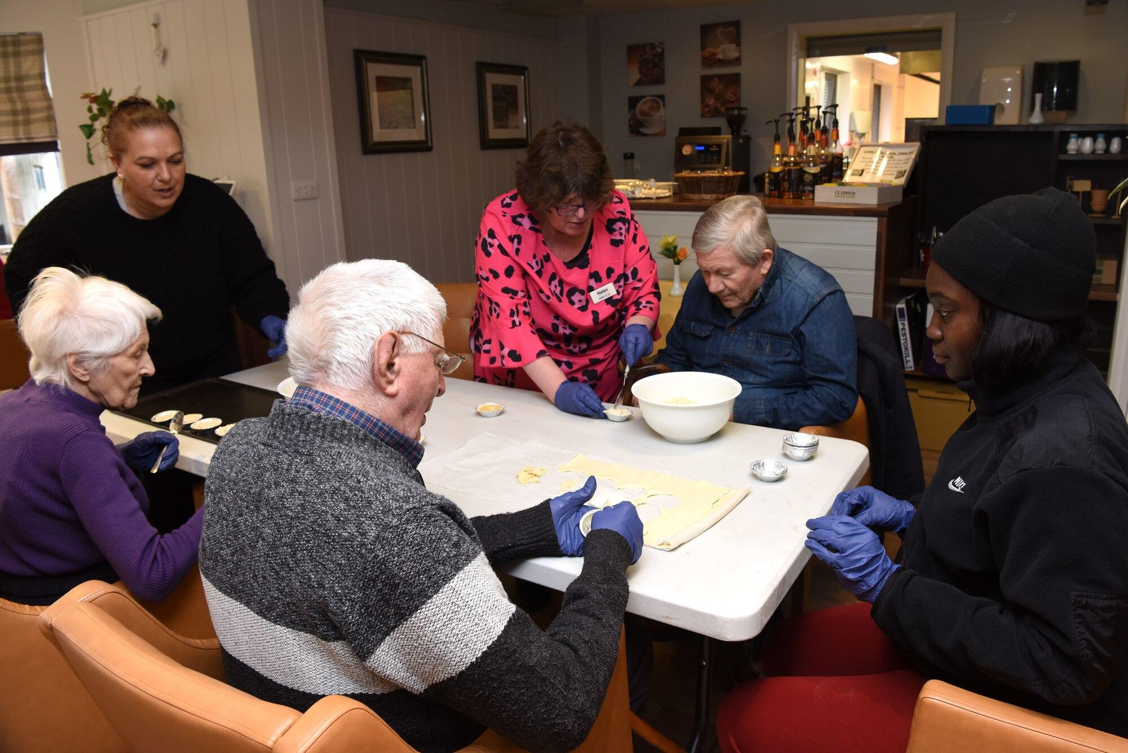(unknown source)
My main aim as a care home management is to provide person-centred care to enhance residents' well-being. This strategy not only improves our residents' standard of life but additionally creates a more vibrant and stimulating work environment for all of our staff members. In order to provide more customised care and respect each individual's preferences and needs, I will be launching a thorough staff training program.
I will employ a training specialist to conduct workshops for every employee in order to accomplish this. Understanding various cultures, improving communication with residents, and developing individualised care plans are all topics covered in the course. This comprehensive approach guarantees that all aspects of resident care will be customized according to their unique preferences and needs. In order to practise, staff members will carry out scenarios, examine examples, and reflect on what they have learnt (O’Daniel and Rosenstein, 2018).
Staff members must listen effectively, be compassionate, and understand various backgrounds for this to be successful. By developing these abilities, our staff will be able to deliver really compassionate and efficient care. Additionally, they must be effective at documenting residents' preferences and incorporating them into their everyday care (Sharkiya, 2023).
A potential problem may occur that it can be difficult to schedule time to attend training while some employees are hesitant about change. I will allow employees to assist in organising the training and demonstrate to them how person centred care improves the well being of residents as well as staff members. Extra assistance will be offered, and training will be divided into manageable sections.
This strategy aligns with established change management techniques, implementing new training, and integrating person-centred care into our culture. Additionally, (Kotter, 1995). 8-Step shift Model will assist us in creating a team, communicating our goal effectively, and making everyone feel that this change has become important.
Task 8 - Self-Reflection
Networking and Career Development
I applied Gibbs' Reflective Cycle (1988) to reflect on what I learnt about networking and employability throughout this module. An important experience was the career search session, during which I learnt how political, economic, and social issues influence job chances and how to apply Linkedin for my personal branding.
Feelings: In the beginning, I was hesitant to create a professional online profile because I didn't have any experience with Linkedin professionally. However, as I studied its aspects, I became inspired and confident in demonstrating my abilities.
Evaluation: The session was beneficial since it emphasised the importance of networking and social capital in professional development. I was successful in creating a Linkedin profile, but I could have done more to extend my network by engaging with peers.
Analysis: This encounter was significant since networking is necessary for career advancement. Phillips and Ellinas (2014) highlight measures such as connecting, listening, and helping others, which I now view to be achievable strategies. The knowledge of Dunbar's Law further helped me recognise the importance of maintaining important connections instead of just quantity.
Conclusion: In order to strengthen professional relationships, I should have participated more effectively in conversations concerning employment obstacles and discussed my personal experiences.
Action Plan: In the future, I intend to continue improving my Linkedin profile, participate in relevant groups, while applying networking strategies that include supporting and assisting others. This will help me build a stronger professional network and increase my employability.

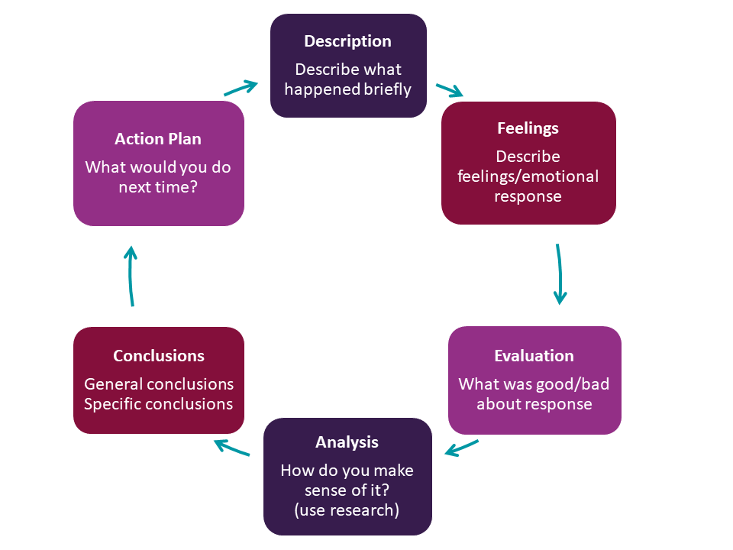
(University of Hull, 2024)

Reference

Fukami, T. (2024) ‘Enhancing Healthcare Accountability for Administrators: Fostering Transparency for Patient Safety and Quality Enhancement’, Cureus, 16(8), pp. 1–6. Available at: https://doi.org/10.7759/cureus.66007.
Gantt Charts (2024) Mindtools. Available at: https://www.mindtools.com/aktsij3/gantt-charts/ (Accessed: 17 November 2025).
Gibbs, G. (1988) Learning by Doing, a Guide to Teaching and Learning Methods. Available at: https://dsdweb.co.uk/wp-content/uploads/2021/10/learning-by-doing-graham-gibbs.pdf (Accessed: 17 November 2025).
Kelly, L.A., Gee, P.M. and Butler, R.J. (2021) ‘Impact of Nurse Burnout on Organizational and Position Turnover’, Nursing Outlook, 69(1), pp. 96–102. Available at: https://doi.org/10.1016/j.outlook.2020.06.008.
Kotter, J. (1995) Leading change: Why Transformation Efforts Fail, Harvard Business Review. Available at: https://hbr.org/1995/05/leading-change-why-transformation-efforts-fail-2 (Accessed: 17 November 2025).
Kwame, A. and Petrucka, P. (2021) ‘A literature-based Study of patient-centered Care and Communication in nurse-patient interactions: Barriers, facilitators, and the Way Forward’, BMC Nursing, 20(158), pp. 1–10. Available at: https://doi.org/10.1186/s12912-021-00684-2.
Martino, J., Pegg, J. and Frates, E.P. (2015) ‘The Connection prescription: Using the Power of Social Interactions and the Deep Desire for Connectedness to Empower Health and Wellness’, American Journal of Lifestyle Medicine, 11(6), pp. 466–475. Available at: https://doi.org/10.1177/1559827615608788.
Miles, J. (2017) How to map your network | Career Returners, Career Returners. Available at: https://careerreturners.com/networking/how-to-map-your-network-2/ (Accessed: 17 November 2025).
NHS England (2023) NHS England» NHS equality, Diversity and Inclusion (EDI) Improvement Plan, www.england.nhs.uk. Available at: https://www.england.nhs.uk/publication/nhs-edi-improvement-plan/ (Accessed: 17 November 2025).
NHS Support Federation (2025) Staff Shortages - NHS Support Federation, NHS Support Federation. Available at: https://nhscampaign.org/issues/staff-shortages/ (Accessed: 17 November 2025).
O’Daniel, M. and Rosenstein, A.H. (2018) Professional Communication and Team Collaboration, National Library of Medicine. Agency for Healthcare Research and Quality (US). Available at: https://www.ncbi.nlm.nih.gov/books/NBK2637/ (Accessed: 16 November 2025).
Reader, T.W. and Gillespie, A. (2013) ‘Patient Neglect in Healthcare institutions: a Systematic Review and Conceptual Model’, BMC Health Services Research, 13(1). Available at: https://doi.org/10.1186/1472-6963-13-156.
Samardzic, M.B., Doekhie, K.D. and Wijngaarden, J.D.H. (2020) ‘Interventions to Improve Team Effectiveness within Health care: a Systematic Review of the past Decade’, Human Resources for Health, 18(2), pp. 1–42. Available at: https://doi.org/10.1186/s12960-019-0411-3.
Serrat, O. (2017) Understanding and Developing Emotional Intelligence, ResearchGate. Available at: https://www.researchgate.net/publication/318018981_Understanding_and_Developing_Emotional_Intelligence (Accessed: 16 November 2025).
Sharkiya, S.H. (2023) ‘Quality Communication Can Improve patient-centred Health Outcomes among Older patients: a Rapid Review’, BMC Health Services Research, 23(1), pp. 1–14. Available at: https://doi.org/10.1186/s12913-023-09869-8.
University of Hull (2024) Reflective writing: Gibbs, Hull.ac.uk. Available at: https://libguides.hull.ac.uk/reflectivewriting/gibbs (Accessed: 17 November 2025).

