BA (Hons) Leadership and Management Skills for the Workplace Level 5

Module Name: Developing Relationship and Workplace Achievement
Title of the report: Development of a plan by meeting the identified personal development needs and expectations of individual employees in a chosen organisation
(Term 2)
(BMSW5102_LON)
Student Name: Angelica Costache
ID Student:1818635 (G2)
Lecturer Name: Gregory Cowan

Executive summary
The report has focused on the appraisal system in context to Revolut. The theories of HRM have been covered in the study together with the evaluation of the applied models. A professional development plan has been further created in the study.

Table of Contents
1. Introduction 4
2. Evaluation of the development of performance appraisal tools and techniques available 4
2.1 Theories related to the human resource management 4
2.1.1 Bureaucratic management Theory 4
2.1.2 The Standard Model theory 5
2.2 Evaluation of the performance appraisal techniques implemented by Revolut 6
3. Effectiveness of the performance appraisal tools in identification and satisfaction of needs of the organisation and individual success 8
3.1 Evaluation of the effectiveness of the performance appraisal techniques in terms of satisfying employee need 8
3.2 Evaluation of the effectiveness of the performance appraisal techniques in terms of organisational success 9
4. Proposal of a professional development plan for the chosen organisation to meet development needs and expectations of an individual employee 10
5. Conclusion 13
References 14

1. Introduction
Employees are the key factors of an organisation. The human resources management has recruited the candidate as per the needs of an organisation. On the other hand, the HR management needs to maintain a healthy relationship between the worker and the company. For this reason, a company needs to take some strategies which help the management to know the needs of the individual employees. After knowing this, the company manages the worker as per their needs. Training, communication, performance solution, recruiting software, payroll service, benefits management platforms are the key human resource management tools to monitor as well as know the needs and demands of the individual employees of the organisation.
Revolut is a financial technological banking company in the UK that was founded in the year 2015. The company has provided online banking services amongst UK based people. Nowadays, the company has 2.158 employees and the organisation has many branches all over the United Kingdom. The tech banking company Revolut has created an app that helps the customer to find various online banking services like, home loans, insurances, education loans, car loans to the people of the UK.
The company Revolut has used the training tool to know the needs of the customer as well as re-skilled the existing staff members of the company. On the other hand, the company uses the performance solutions techniques which help the organisation to evaluate the performance of the employee and help them to grab the working goal. Simultaneously, using the recruiting software, the company can choose as well as find the right candidate for a successful business. Using the recruiting software, the finance company Revolut has detected the pricing system as well as taken the right pricing strategy for various services and products. Thus, using the above tools and techniques the human resources management of Revolut may meet the needs of individual employees.

2. Evaluation of the development of performance appraisal tools and techniques available

2.1 Theories related to the human resource management

2.1.1 Bureaucratic management Theory
The Bureaucratic Management Theory facilitates the analysis of the individual aspects of the structure of an organization. The bureaucratic management theory lays focus on each and every field of the company and aims towards its development (Malvini Redden and Scarduzio 2018, p. 224). Revolut’s adoption of the bureaucratic management theory might prove beneficial for them as it would facilitate the company to record and store their valuable data in a systematic manner. The theory might enable Revolut to predict any upcoming issues by initially recognizing the possibility of the issue. Efficient recruitment of the employees through this theory might ultimately lead to the economic growth of the company. The demands and needs of the employees might also be identified and satisfied efficiently by the implication of this theory. The hierarchical structure of the theory would enable Revolut to place its employee sections according to their level of importance without depriving them of their deserved rights. Hence, the theory might be able to strengthen the bond between the employees and the company.
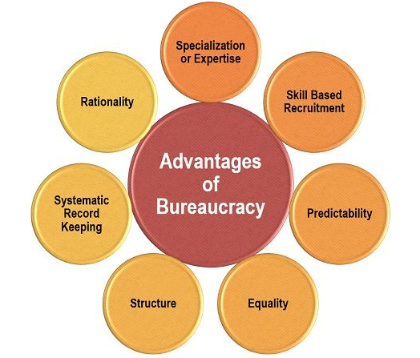
Figure 1: Bureaucratic management Theory
(Source: Malvini Redden and Scarduzio, 2018, p. 224)

2.1.2 The Standard Model theory
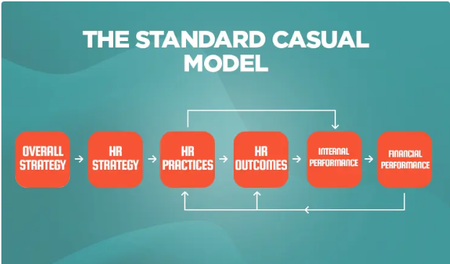
Figure 2: Standard Casual model
(Source: Techatanaset, 2019, p. 150)
The above stated diagram of the Standard Casual Model gives a clear representation of the core aspects of HRM system. The most important aspect upon which this model lays especially focuses upon the hierarchical process of trading practices (Techatanaset, 2019, p. 150). It enables to clarify the position of the individual working for an organization by further meeting up their needs and demands. Equality or non discrimination is also promoted by the model, which preserves the healthy ambience of the workplace. Efficient recruitment of the employees is a very crucial factor that determines the growth of an organization. The standard casual model might facilitate the organization to appoint the employees by keenly observing their talents and quality. The model might influence the working performance of the company by strengthening their position in the respective organisational department.

2.2 Evaluation of the performance appraisal techniques implemented by Revolut
Performance appraisal has been crucial to retain a skilled workforce to provide profits to the business. The key "performance appraisal tools” implemented by Revolut have been “effective communication”, “ranking method” and “checklists” (Revolut.com. 2021). “Effective communication” with the employees has been maintained by the organisation to motivate them for meeting the organisational goals. Engagement with the organisation has been crucial to reaching the expected goal of the organisation.
Feedback has been provided to the workforce by the management to acknowledge the performance and service provided to the organisation. Understanding the skills of the employees has been essential to plan the resource effectively. Confidence among the employees has developed through effective communication with the subordinates. The development of trust has been a fundamental factor for organisational success (Naeem et al. 2017, p.75). Spirit of the workforce has been the other perspective developed by effective communication systems.
“Ranking” has been the method that has been used in the organisation to measure the performance of the employees providing those ranks. The ranks have been given according to the instance of achievement earned by them in context to organisational needs. Competition among the workforce has been developed by using ranking in the process of performing the appraisal. It has been done both individually and team-wise.
A large number of employees have been critical to evaluate effectively by the human resource department. In contrast, the task becomes easier when the appraisal has been done team-wise. In addition to that, some disadvantages have been present in the ranking method such as lack of effective structure (Islami and Islami, 2019, p.1). In that case, employee satisfaction has been difficult to maintain. The ranking system had some adverse effects on the existing workforce.
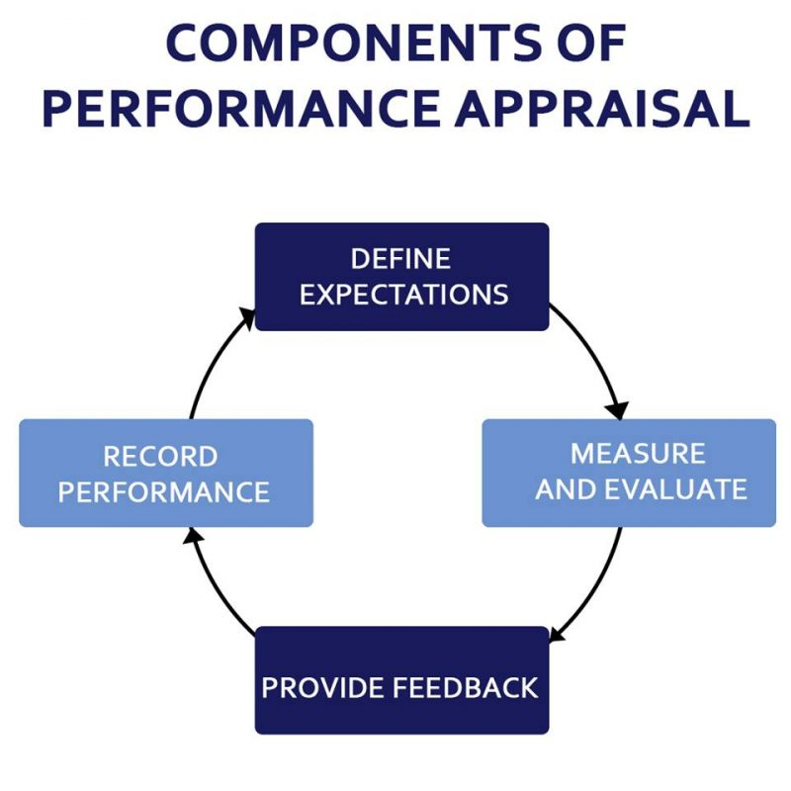
Figure 3: components of performance appraisal
(Source: Iqbal et al.2018, p.287)
“Checklists” have been the process that contains several statements regarding a particular job. Checklists have been marked by the management by measuring the performance of individuals. The rating has been provided to the employees by the management of Revolut to encourage them to perform better in future. It has been the most used method of performance management in an organisation. The key disadvantage of the process has been the consumption of time (Saha and Majumder, 2017, p.71). Evaluation of individual employee's needs excessive tome of the management which provides a delayed outcome.
Revolut has focused on the development of effective communication between the employees and management to provide productivity. As the company operates in the e-money segment in the UK, the satisfaction of the customers has been essential. It can be provided by the improved service which can be improved by positive employee satisfaction.

3. Effectiveness of the performance appraisal tools in identification and satisfaction of needs of the organisation and individual success

3.1 Evaluation of the effectiveness of the performance appraisal techniques in terms of satisfying employee need
The needs of the individual employee have been important for the organisation to retain the skilled workforce for a longer period. The Needs of the employees have different perspectives. According to Idowu (2017, p.25), “work-life balance" has been crucial for managing the productivity of the workforce which provides a competitive advantage to the company. Revolut has been focused on the development of effective communication among the management and employees. Regular review of the objectives of an organisation has been effective for the evaluation of individual performance.
Review of the objectives as well as the development of new objectives has been done by reviewing the past performance of the employees. Discussions among the employees and the management have been focused on by the HRM of Revolut to provide the service to the employees (Al-dalahmeh et al. 2018, p.35). Performance of the employees has been improved by the implementation of the appraisal in the process and provides training accordingly.
Flexibility in the working hours has been another important aspect for enhancement of the performance of the existing workforce in banking. Value creation among the employees has been important to perform in critical scenarios (Raguseo, 2018, p.190). Implementation of modern technology has improved the way of performance management. Big data has been helpful to manage a big database of employees. As Revolut is a medium-size organisation, management of performance has been effective for the organisation by the implementation of effective communication.
Comparison among the employees sometimes provides an adverse effect to the performance. The attrition rate has been higher in the selected company which has been the key area of the management that needs to improve. The company has incurred a loss of £207 million in 2021. It has been a result of customer dissatisfaction (Revolut.com, 2021). This in turn reflects despite using performance appraisal roles quite efficiently Revolut needs to go a long way to achieve employee satisfaction. Significantly the performance of an individual employee reflects on the performance of an organisation. The impact of technology has been higher in the business process of Revolut. Training of the workforce has been decided by implementing appraisal techniques which have been helpful for the development of talent.
Competence of the employees developed the expected customer service which helped in customer satisfaction. Revolut has gained 5.5 million customers in 2019. The company faced a huge loss in 2021 (Revolut.com, 2021). The consequences of lack of retention of the top management have been faced by the company in terms of loss of revenue.
Long term planning of career has been implemented by the employees to be successful in the organisation. Development of strategy has been done by the organisations to provide effective service to the customers. In addition to that, succession planning can be done efficiently by the companies after evaluation of the performance of the existing workforce.

3.2 Evaluation of the effectiveness of the performance appraisal techniques in terms of organisational success
Performance appraisal has been a helpful process in the enhancement of the performance of the employees. Improved performances of the employees have been effective in the process to improve the performance of the organisation simultaneously (Boon et al. 2019, p.2499). Well trained employees have been important for service sectors as the behaviour of the employees have been reflected in the satisfaction level of the employees. The leadership of an organisation provides direction to the workforce to achieve the goals both personally and professionally.
Strengths of the employees have been identified by the HRM which has been utilised to achieve the organisational goals. Individual performance of the employees cumulatively enhanced the position of the organisation in the competition (El-Kassar and Singh, 2019, p.490). Clarification of the goals of the organisation has been conveyed to the employees which have been effective for the management to create value among the existing workforce.
Expectations of the organisation have been fulfilled by the employees once the importance of the work done by them can be evaluated effectively. Rewarding from the management motivates the workforce to perform better. In the initial stage of employment monetary rewards attract more employees to perform better (Polnaya et al. 2018, p.6). It has been the decision of the management of the organisation to decide effective appraisal for the existing workforce.
Issues of performance have been addressed by the management in the initial stage which has been effective for improvement of performance at the initial stage. Discussion of the improvement has been crucial for the enhancement of the performance of the employees. It has reflected on the performance of the organisation. Orientation of the employees needs to be focused on the goals of the company. In addition to that, customer satisfaction has been the other important aspect for the progress of the organisation.
Training and development of the workforce have been decided by the company which has motivated the employees to achieve the goals of the organisation. The realisation of the managers about the effectiveness of the training to the individuals has been an important factor to determine effective training and development procedure (Raguseo, 2018, p.188). Modification of the reward system has been further done by the managers which have been useful for the satisfaction of the employees.
It can be said that the company has been benefited from the enhanced performance of the employees. Monitoring of the performance has been needed to decide effective training programs for the development of effective performances. The performance of the organisation has been dependent on the performance of the individual employees.

4. Proposal of a professional development plan for the chosen organisation to meet development needs and expectations of an individual employee
The professional development plan has been crucial for the success of an organisation. The professional development plan has been given below:
Professional development plan for Revolut
Objective: | Achieving sustainability by introducing value creation among the employees. Provide better service to the existing customer base.
Strategy | Suitability | Feasibility | Acceptability | Responsible person | Timeframe
Skill and knowledge development | The strategy will be suitable to create a better workforce (Subramanian and Kumar, 2017, p.835) | Implementation of the strategy requires a time of the management | Highly acceptable | HRD | 6 months
Goal setting | Achieve sustainability in the competition to achieve customer satisfaction | Effective training and development will be effective for the feasibility | Highly acceptable | Top management | 6 months
Career development of existing workforce | Improvement of the performance of the existing workforce (Efendi, 2021, p.325) | Career development strategy will be feasible for the organisation | Moderate acceptance | HRM | 1 year
Enhanced communication | Effective communication will be important to maintain relations with the workforce and the organisation | It will be a feasible strategy if the management can be corporate with the HRM | Highly acceptable | Managers of each department | On job process
Enhancement of capabilities | It will be helpful for the management to achieve the organisational goal (Ali et al. 2021, p.20) | The strategy will be feasible for the organisation | Acceptable | Management and finance department | 1 year
Table 1: Professional development plan
(Source: Created by author)
Analysis:
The professional development plan for the selected organisation has been divided into five effective strategies. "Skill and knowledge development” has been the most important factor to improve the quality of the workforce. Service of the organisation will be improved by enhancement of the skills of the employees to handle the advanced service capabilities. It has been a feasible aspect as the HRD of the organisation has been active in providing training to the workforce to activate the organisational goals.
Goal setting will be another crucial aspect of the enhanced performance of the workforce. Meeting the goals of the organisation leads to the personal and professional achievement of the employees. The top management will be responsible for setting goals to achieve sustainability in the global market (Ali et al. 2021, p.20). Career development of the workforce will be focused by the organisation for achieving enhanced quality in the work process. HRM of the organisation will be responsible for guiding the workforce in professional attainment.
Enhancement of communication will be the key focus of the management of Revolut in the process of achieving employee satisfaction. Managers of each department of the company will be responsible for the enhancement of communication among them. The capabilities of the organisation need to be enhanced to provide effective service to the customers. The financial department and the management of the company will be responsible to provide effective equipment to improve the service of the company.

5. Conclusion
Followed by the above study, the evaluation of the business performance appraisal tools and techniques has been concluded in the report. The implication of the bureaucratic management theory and its importance in relevance to Revolut’s present market position can be understood in a vivid manner. It can also be summed up hat the efficient management of each and every business operation might boost up the business expansion and facilitate it to reach the top position in the relevant market. Special focus has been laid on adopting the required techniques to satisfy the demands and needs of the employees by the organization. The implication of the mentioned theory and the model and its contribution towards the well being of the company can help to manage the performance of the firm. However, several techniques and practices that are required to be adopted by the organisations have been discussed in a broad way in the study that can result in a fruitful way.

References
Al-dalahmeh, M., Khalaf, R. and Obeidat, B., (2018). The effect of employee engagement on organizational performance via the mediating role of job satisfaction: The case of IT employees in Jordanian banking sector. Modern Applied Science, 12(6), pp.17-43.
Ali, B.J., Anwar, G., Gardi, B., Jabbar Othman, B., Mahmood Aziz, H., Ali Ahmed, S., Abdalla Hamza, P., Burhan Ismael, N., Sorguli, S. and Sabir, B.Y., (2021). Business Communication Strategies: Analysis of Internal Communication Processes. Ali, BJ, Anwar, G., Gardi, B., Othman, BJ, Aziz, HM, Ahmed, SA, Hamza, PA, Ismael, NB, Sorguli, S., Sabir, BY (2021). Business Communication Strategies: Analysis of Internal Communication Processes. Journal of Humanities and Education Development, 3(3), pp.16-38.
Boon, C., Den Hartog, D.N. and Lepak, D.P., (2019). A systematic review of human resource management systems and their measurement. Journal of management, 45(6), pp.2498-2537.
DeNisi, A.S. and Murphy, K.R., (2017). Performance appraisal and performance management: 100 years of progress?. Journal of applied psychology, 102(3), p.421.
Efendi, S., (2021). The Role of Knowledge-Based Signature Skill (Specific Knowledge-Based Professional Ability) as a Mediation Variable in Intellectual Capital, Intrinsic Motivation, Empowerment of Creativity on Performance:(Empirical Study at Private Universities DKI Jakarta). Italienisch, 11(2), pp.321-334.
El-Kassar, A.N. and Singh, S.K., (2019). Green innovation and organizational performance: the influence of big data and the moderating role of management commitment and HR practices. Technological Forecasting and Social Change, 144, pp.483-498.
Idowu, A., (2017). Effectiveness of performance appraisal system and its effect on employee motivation. Nile Journal of Business and Economics, 3(5), pp.15-39.
Iqbal, M.Z., Akbar, S., Budhwar, P. and Shah, S.Z.A., (2019). Effectiveness of performance appraisal: Evidence on the utilization criteria. Journal of Business Research, 101, pp.285-299.
Islami, X. and Islami, V., (2019). Performance appraisal and the quality of working life. Islami, X, Islami, 2019, pp.1-2.
Malvini Redden, S. and Scarduzio, J.A., (2018). A different type of dirty work: Hidden taint, intersectionality, and emotion management in bureaucratic organizations. Communication Monographs, 85(2), pp.224-244.
Naeem, M., Jamal, W. and Riaz, M.K., (2017). The relationship of employees' performance appraisal satisfaction with employees' outcomes: Evidence from higher educational institutes. FWU Journal of Social Sciences, 11(2), pp.71-81.
Polnaya, I., Nirwanto, N. and Triatmanto, B., (2018). The evaluation of lecturer performance through soft skillls, organizational culture and compensation on private university of Ambon. Academy of Strategic Management Journal, 17(2), pp.1-9.
Raguseo, E., (2018). Big data technologies: An empirical investigation on their adoption, benefits and risks for companies. International Journal of Information Management, 38(1), pp.187-195.
Revolut.com (2021).about-revolut.Available at:https://www.revolut.com/about-revolut.Accessed:26.11.2021
Saha, A. and Majumder, S., (2017). Impact of information technology on performance appraisal. International Research Journal of Human Resources and Social Sciences (IRJHRSS). 81, 89.
Subramanian, V. and Kumar, A.A., (2017). Skill enhancement influenced by effective training. Asian Journal of Management, 8(3), pp.834-840.
Techatanaset, P., (2019). A Casual Relationship Model of Accountants’ Knowledge and Skills Affecting Quality of Financial Report. Parichart Journal, Thaksin University, 32(2), pp.147-155.

