

UNIVERSITY OF WALES TRINITY SAINT DAVID
MSc Cybersecurity and Digital Forensics
Module: Research Methods and Professional Development (ACFA7004)
Assessment Component 1: Research Proposal

A Privacy-Preserving Zero-Trust Architecture for Decentralised
Social Media APIs Using Graph Neural Networks

Student Name: Hetvi Patel
Student ID: 2529465
Supervisor: Dr Suresh Shanmugasundaram
Table of Contents
List of Figures 1
List of Tables 1
1. Introduction 1
1.1 Context and Background 1
1.2 Research Problem 1
1.3 Research Aim and Objectives 1
1.4 Significance of the Research 1
2. Literature Review 1
3. Research Design and Methodology 1
3.1 Research Design 1
3.2 Research Methods and Materials 1
4. Expected Outcome 1
5. Timeline 1
6. References 1
7. Appendices 1

List of Figures
Figure 1.1: BOLA attack / threat model in decentralised social APIs.
Figure 3.1: Design Science Research (DSR) methodology cycle applied to this project.
Figure 3.2: Four-plane system architecture and request flow.

List of Tables
Table 1: SMART objectives compliance check.
Table 2: System architecture components and functions.
Table 3: Evaluation metrics and justification.
Table 4: Software and hardware requirements.
Table 5: Risk register and contingency plan.
Table 6: Six-month project timeline and milestones.

1. Introduction

1.1 Context and Background
A) Overview of the Research Field
As decentralised platforms shift from top-down control to a federated model, they typically do so through protocols that facilitate that change. ActivityPub is an example of this in action and facilitates such change for a social media network by being based upon open Application Programming Interfaces that allow multiple disconnected servers to interconnect, adding increasing nodes and growing the network as with Metcalfe’s Law, but in doing so, it rapidly increases its overall attack surface.
This access is not theoretical; it is measurable. Salt Security has shown that traffic directed at APIs increased at an annual rate that significantly outpaces general internet traffic [15]. Gartner predicts that by the middle of the 2020s, APIs will make up the majority of the web application attack surface [16].
A high proportion of publicly documented API data breaches affecting social media and fintech platforms between 2022 and 2024 involved Broken Object Level Authorisation as a contributing issue — a business-logic issue that perimeter security fails to capture.
The second problem is more general but has implications for the first problem in the context of API security: an unprecedented boom in Non-Human Identities (NHIs) has been driven by Generative AI and autonomous agents [4], [5]. These are actors who present themselves at an API endpoint, rather than human users. They might prove their identity through API keys, service accounts, or OAuth tokens. However, because the assumption behind perimeter-based architectures is that anyone already on the network can be trusted implicitly, a Zero-Trust model such as the one set out by NIST in Special Publication 800-207 [3] — which continuously authenticates users regardless of network location — is likely to be adopted more broadly to address this issue.
Graph Neural Networks (GNNs) have been introduced recently to map social network structure and anomalous behaviour.
B) Current Developments
Instead of static, binary access control responses, research is leaning towards constant, risk-adapted access control, with machine-learned trust scores taking precedence over traditional decision logic. This coincides with an evolving attack vector driven by autonomous, AI-powered threat actors who rely less on brute-forcing credentials and more on chaining abandoned or ignored NHIs, allowing them to gain escalated privileges across an organisation [5]. Because GNNs analyse an item within its context, evaluating its relationships to surrounding elements rather than considering it in isolation, they are a strong model for detecting and preventing these types of attacks [9].
The biggest challenge facing the use of GNNs as a social API protection layer is that leveraging user telemetry for the training process requires respecting privacy.
Local Differential Privacy [10] and other techniques, such as zero-knowledge proofs, come into play as a solution to protect user data while still offering security protections to identify malicious activity. Together, these four key trends — API-centric security and attacks, NHI growth, GNN-based protection, and privacy-based cryptography — define the research topic of this work: building a unified, privacy-respecting Zero-Trust framework to secure decentralised APIs.

1.2 Research Problem
A) Problem Definition
The proposed framework addresses this gap: the lack of an efficient, privacy-protected Zero-Trust API defence against object-level authorisation exploits and adversarial ML model-based attacks on decentralisation.
B) Current Challenges
First, stateless API endpoints are prone to business-logic bugs, as unambiguously illustrated by BOLA. OWASP ranks it as the top priority among API risks [1]. Empirical studies have recently revealed that it is difficult to detect through static analysis [2].
Second, GNNs used for anomaly and botnet detection have a weakness of their own: adversarial poisoning attacks can exploit them using imperceptibly subtle edge modifications, causing GNN classification accuracy to drop dramatically [7] and turning the detection layer itself into a potential attack target.
Third, continuous authentication under Zero-Trust requires large amounts of behavioural telemetry, which raises users’ privacy concerns. LDP offers a formal privacy guarantee, yet each increment of added noise also impairs classification accuracy [10]. There is, as yet, no framework to reconcile the three-way balancing act between authorisation integrity, model robustness, and privacy cost.

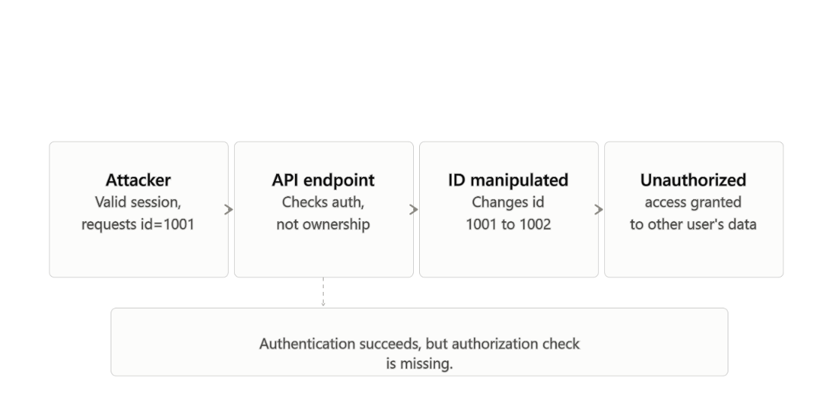
Figure 1.1: Threat model illustrating BOLA exploitation and identity-chained NHI escalation in a decentralised social API. (Source: Author, 2026)
Previous work has addressed only part of this problem. Huang et al. [2] improved BOLA detection, but their work did not consider adversarial or privacy dimensions. Zügner et al. [7] and Gosch et al. [8] investigated GNN resilience without addressing identity governance issues.
Bhaila et al. [10] addressed part of the privacy-utility trade-off in GNNs but did not propose a complete, deployable Zero-Trust gateway.
No prior work has combined authorisation, adversarial resilience, and privacy within a time-sensitive framework that meets existing network constraints — this is the gap between current research literature and system requirements that this work addresses.
Research Questions
- RQ1: How can a Zero-Trust API gateway detect BOLA exploitation in decentralised social APIs without relying on static rate-limiting or signature-based rules?
- RQ2: To what extent does Local Differential Privacy degrade Graph Attention Network detection accuracy under adversarial perturbation?
- RQ3: What latency overhead does zk-SNARK-based identity verification introduce in a decentralised social API context, and is it compatible with real-time response requirements?

1.3 Research Aim and Objectives
Research Aim:
The goal of this research is to design, construct, and test a privacy-preserving Zero-Trust API security scheme for distributed social networks. A Graph Attention Network with adversarial robustness and zk-SNARKs will be incorporated to identify abnormal Non-Human Identity behaviour without leaking any users’ private information.
SMART Objectives:
- Identify all relevant recent academic literature on API security vulnerabilities (in particular BOLA) and their application/integration with Zero-Trust within decentralised protocols like the ActivityPub specification, by the end of Month 1.
- Develop an NIST SP 800-207-compliant API gateway that utilises SPIFFE/SPIRE to ensure continued workload identity attestation for Non-Human Identities, by Month 2.
- Design and train a Graph Attention Network with Local Differential Privacy for detecting abnormal access patterns in API data with an F1-score of at least 0.90 against adversarial perturbation, by Month 4.
- Build a zk-SNARK verification layer that supports identity establishment without revealing social graph telemetry, by Month 5.
- Evaluate and compare the hybrid architecture against baseline systems on latency overhead (target < 100ms per request) and computational efficiency, by the end of Month 6.
- Table 1: SMART Compliance Check
- 1. Literature synthesis — Specific: Scope: BOLA, ZTA, ActivityPub. Measurable: Completed SLR. Achievable: Public literature. Relevant: Grounds later design. Time-bound: Month 1.
- 2. Gateway architecture — Specific: NIST SP 800-207 compliant. Measurable: Architecture diagram. Achievable: SPIFFE/SPIRE open standards. Relevant: Sets detection platform. Time-bound: Month 2.
- 3. GAT + LDP model — Specific: F1 ≥ 0.90 under perturbation. Measurable: F1, precision, recall. Achievable: CIC-IDS dataset, GPU access. Relevant: Answers RQ2. Time-bound: Month 4.
- 4. zk-SNARK layer — Specific: Identity proof, no telemetry exposure. Measurable: Proof-of-concept demo. Achievable: SnarkJS open-source. Relevant: Answers RQ3. Time-bound: Month 5.
- 5. Integrated evaluation — Specific: Latency under 100ms, throughput. Measurable: RPS and ms figures. Achievable: Docker/Kubernetes test environment. Relevant: Validates the aim. Time-bound: Month 6.

1.4 Significance of the Research
Academic significance:
This work provides empirical findings that advance understanding of how LDP modifies the decision boundary of a GNN under attack conditions [7], [8], [10], addressing the gap left by studying the privacy-utility trade-off and adversarial robustness in isolation from one another.
Technical significance:
The research pairs zk-SNARK verification with workload attestation [6] and dynamic risk scoring to counter identity-chained attacks.
Practical significance:
Platform operators receive a deployable reference design to counter BOLA attacks and manage increasing numbers of Non-Human Identities produced by AI [4]. Researchers gain a reusable way of evaluating privacy-preserving detection under adversarial attacks. Users benefit from greater protection of their personal data on decentralised systems.

2. Literature Review
This review surveys the existing research on decentralised social network security architectures, API flaws, and privacy-preserving machine learning techniques, drawing on a range of academic papers and industry standards published primarily between 2018 and 2025. Two early sources, [12] and [13], are retained, as they represent essential theoretical guidance. The review is organised around a set of topics that progress from API vulnerabilities to cryptographic solutions, before identifying the research gap this work aims to fill.
Search Strategy
This review follows a structured approach, based on PRISMA guidelines, to avoid an ad-hoc interpretation of the literature. For retrieval, we used IEEE Xplore, the ACM Digital Library, arXiv, ScienceDirect, and the SpringerLink journal repository, as well as standards-related publications by NIST, OWASP, and the Cloud Native Computing Foundation. To execute the retrieval, we used the keywords defined below with standard Boolean operators. Examples: (“Zero Trust” OR “ZTA”) AND (“API security” OR “BOLA”); (“Graph Neural Network” OR “GNN”) AND (“adversarial attack” OR “robustness”); (“Local Differential Privacy” OR “LDP”) AND (“graph” OR “GNN”). Searched articles were limited to results published in the last five years (2020 to 2025), in addition to a small number of seminal articles that established the standards referenced in this work.
Inclusion: Peer-reviewed, in English, directly discussing API security, Zero-Trust Architecture, GNN robustness, or privacy-preserving machine learning. Exclusion: not peer-reviewed; industry sources without supporting data (e.g., pure marketing material); or outside the scope of “security for API, identity and graphs”. This first step yielded approximately 48 potential hits, which were reduced to 24 after screening by title and abstract; full-text inspection of this pool of 24 yielded the final 14 directly cited articles. The remaining sources provided background context.
Theme 1: API Vulnerabilities and the Threat of BOLA
BOLA and Dynamic Policy: OWASP’s top-ranked API flaw is BOLA (Broken Object Level Authorisation), which occurs whenever applications fail to compare an object-level entitlement against the identity of the requestor [1]. Huang et al. [2] examined 101 documented BOLA instances in database-backed applications and found that static taint-tracking security analysis tools — such as their own tool, BolaRay — can detect authorisation gaps missed by existing WAFs. This is because requests are often syntactically correct and session-authorised, and the flaw represents a business-logic issue rather than a structural one. Dynamic, behaviour-based authorisation would be more suitable.
Theme 2: Zero-Trust Architecture and Non-Human Identity Governance
NIST SP 800-207 [3] established Zero-Trust Architecture (ZTA) as the framework for a new wave of systems that use ongoing identity checking. The NIST framework largely assumes human-centric identities, but other standards — such as the OWASP Non-Human Identities Top 10 [4] and ongoing work on agentic AI identity frameworks [5] — recognise a growing number of AI agents that collectively produce a volume of Non-Human Identities too large and diverse for existing infrastructure to manage effectively, which may enable identity chaining. Workload attestation standards [6] utilise cryptographic means to verify workload identities, ameliorating these risks to a degree. However, existing standards have not been sufficiently evaluated for the latency performance they can achieve when deployed on shared, decentralised social networking platforms.
Theme 3: Graph Neural Networks and Adversarial Robustness
GNNs represent the most effective and widely used approach for detecting unusual propagation patterns on social network graphs. Passing information between neighbouring nodes provides relational context that is normally discarded by most table-based approaches [9]. Zügner, Akbarnejad, and Günnemann [7] observed that a slight alteration to a graph’s edges is sufficient to substantially lower GNN-based prediction accuracy.
This shows that the classification model itself can become an attack surface.
Gosch et al. [8] applied adversarial training to protect against these kinds of attacks and identified serious drawbacks, such as the need for large quantities of unencoded graph data, which could harm privacy.
Theme 4: Privacy-Preserving Mechanisms
This framework, Local Differential Privacy for GNNs, was introduced by Bhaila et al. [10].
In their framework, node features and labels are perturbed locally to satisfy differential privacy, and the perturbed data are used to train a centralised GNN.
This framework also resolves the dilemma associated with Theme 3; however, it leads to a significant loss of classification accuracy, which can be explained by the introduction of noise. The privacy-utility trade-off is thus changed, rather than solved.
Points of Agreement and Disagreement
While sources agree, across all of these themes, that behaviour-based continuous monitoring is preferable to static rule-based controls for both authorisation (Theme 1) and anomaly detection (Theme 3), they disagree on what sacrifice should be made for privacy. Bhaila et al. [10] consider a loss of accuracy an acceptable cost for achieving formal privacy guarantees, while Gosch et al. [8] argue that robustness techniques requiring unencrypted telemetry themselves pose a security risk; therefore, privacy and robustness should be designed concurrently rather than independently. Such disagreements arise because the fields of differential privacy and adversarial machine learning have not yet been integrated within the context of a Zero-Trust architecture, as this research aims to achieve.
Theoretical and Technical Frameworks
Here we cite several pieces of existing work that have influenced the design of our framework: the NIST Zero-Trust reference model [3] provides us with the logic for persistent verification; the Graph Attention method [9] provides us with mechanisms for computing the relationship anomaly scores; the local differential privacy randomised response model [10] gives us a framework for constructing provable privacy guarantees; we also utilise zero-knowledge proof systems (zk-SNARKs), which allow one party to prove they know something without disclosing what it is. The fusion of these technologies serves as the theoretical foundation for the four-plane architecture in Section 3.
Literature Summary and Research Gap Justification
The body of literature demonstrates that APIs are structurally insecure against BOLA [1], [2]; that ZTA offers the desirable property of constant verification, but is difficult to govern NHIs at scale [3], [4], [5]; that GNNs provide excellent detection properties, but are susceptible to adversarial attacks [7], [8], [9]; and that LDP is the current best standard for combining GNN training with privacy concerns [10]. Existing architectures fail to combine these features within a single layer without the components negating one another. In this proposal, we propose a BOLA-secure API gateway based on LDP-GNNs for threat detection and zk-SNARKs for credential verification, evaluated in terms of low latency and high throughput — the characteristics required by popular decentralised networks such as ActivityPub [14].

3. Research Design and Methodology

3.1 Research Design
This work adopts an objectivist stance, interpreting system security, detection performance, and latency as objective, measurable characteristics of a technical artefact rather than as matters of subjective interpretation. This aligns with the research questions, which concern objective aspects of the behaviour of system artefacts (specifically, F1-score, latency in milliseconds, and system throughput). This work also adopts a positivist epistemology: knowledge about the performance of an architecture is best obtained through controlled experiments and direct measurement.
This offers a position that is independent of the researcher’s own perception and that can be replicated by another researcher using the same dataset and setup.
The researcher’s professional background — including experience in SOC operations, threat-intelligence tooling, and enterprise network configuration — informs this proposal, such as the emphasis placed on latency as an operational reality for SOC managers. Although this experience informs the architecture design and practicalities, each design decision is grounded directly in existing work, so professional intuition is offset by empirical evidence.
The general approach is Design Science Research (DSR). This research follows the DSR process model [12] proposed by Peffers et al. and will be evaluated according to the DSR guidelines [13] from Hevner et al.
DSR is suitable for this project because it must lead to an IT artefact — namely, a complete architecture that solves a given problem — rather than only proving a purely theoretical fact.
Moreover, DSR provides the build-and-evaluate cycle required by this project.
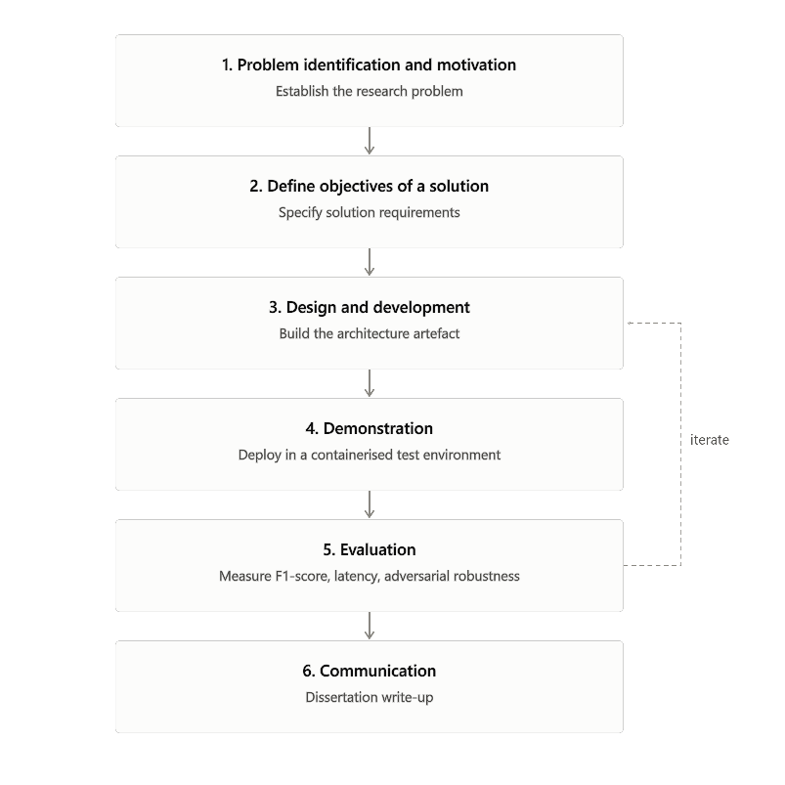
Figure 3.1: Iterative DSR cycle applied to this project, following Peffers et al. [12]. (Source: Author, 2026)

3.2 Research Methods and Materials
A) Research Methods
The overall methodological approach is Design Science Research (DSR), which follows the process model described by Peffers et al. [12] and is validated against Hevner et al.’s [13] seven guidelines. This project suits DSR because the final artefact to be delivered — an operative architecture — serves to solve a specific technical problem, rather than merely contribute a theoretical fact. Additionally, DSR supports an iterative construction-evaluation process, which is essential to the successful outcome of this project, because the architecture must be built, tested in a safe testing environment, and measured against specific quality and performance criteria before any claims of feasibility and applicability can be made.
System Architecture and Workflow
The new architecture comprises four stages, or planes. The client request enters the first of these — the Ingestion Plane — where it meets the Envoy Proxy at the edge; the API Gateway receives the inbound request and passes it to the second plane — the Authentication Plane — which uses a zk-SNARK proof, alongside SPIFFE/SPIRE, to verify client workload identity without disclosing credential metadata [6]. After authenticity verification, the request is passed to the third plane — the Analysis Plane — where an LDP transformation is applied to the data first, followed by threat-scoring via a Graph Attention Network to identify anomalous traffic patterns [9], [10].
In the fourth and final plane — the Policy Enforcement Plane — a Kubernetes-native ZTA Policy Engine decides whether to service the request or discard it, based on the assessed threat level [3].
This flow is summarised in Table 2 for clarity.
Figure 3.2: End-to-end request flow across the Ingestion, Authentication, Analysis, and Policy Enforcement planes. (Source: Author, 2026)
Component | Technology stack | Function
Input and ingestion | Envoy Proxy, API Gateway | Intercepts decentralised social media API requests (REST/GraphQL) at the network edge
Authentication plane | SPIFFE/SPIRE [6], zk-SNARKs | Validates the client's zk-SNARK proof, confirming a valid workload identity without exposing credential metadata
Analysis plane | PyTorch Geometric, LDP [10], GAT [9] | Perturbs request telemetry via Local Differential Privacy, then evaluates topological behaviour through a Graph Attention Network to flag anomalies
Policy enforcement | Kubernetes, ZTA Policy Engine [3] | Routes or drops the request based on the GNN's continuous risk score
Table 2: System architecture components and functions.
Data Analysis and Evaluation
Three evaluation dimensions will test the architecture's viability, summarised in Table 3.
Metric category | Specific metrics | Justification
Security efficacy | F1-score, Precision, Recall | Balances precision and recall given the class imbalance typical of anomaly-versus-normal traffic
Adversarial robustness | Accuracy under perturbation (ε) [7], [8] | Quantifies resistance to graph poisoning attacks
System performance | Latency (ms), Throughput (RPS) | Measures overhead against the sub-100ms threshold required for social media responsiveness
Table 3: Evaluation metrics and justification.
B) Research Materials
The Graph Attention Network will be trained and tested on the CIC-IDS2017/2018 benchmark datasets [11], plus synthetically generated decentralised social network topologies. These datasets contain labelled instances of API abuse and distributed anomalies that match the detection task. Table 4 details the software and hardware requirements.
Category | Requirement
Programming languages | Python 3.10+ (model training and simulation), Go (custom Envoy proxy filters)
Machine learning libraries | PyTorch, PyTorch Geometric, Scikit-learn, Pandas
Security and infrastructure tools | SnarkJS, Envoy Proxy, SPIFFE/SPIRE, Kubernetes
Hardware | Cloud server, minimum 64GB RAM, 16 vCPUs, dedicated GPU (e.g., NVIDIA RTX 3090 or AWS EC2 p3.2xlarge)
Table 4: Software and hardware requirements.
Ethical Considerations
No human research participants are involved in this study. This project does not gather information directly from users of the web; it does not involve any personal user identities or data that could directly identify individuals. Experimental results use the freely available CIC-IDS2017/2018 public benchmark datasets [11] (which are anonymised and released for free research use) and synthetic graph topologies constructed specifically for the purpose of this project.

4. Expected Outcome
Expected Results
The final architecture is expected to demonstrate that combining local differential privacy with zk-SNARKs can protect the telemetry of individual users, while the Graph Attention Network maintains an anomaly-detection F1-score above 0.90. We anticipate a small cryptographic latency overhead of between 30 and 50 ms per transaction, which may need to be offloaded onto state-channel caching for the system to achieve sub-second transaction times.
Implications
- Academic: a validated Design Science Research artefact showing threat-intelligence gathering can be decoupled from identity exposure.
- Technical: empirical data on the computational thresholds of embedding zero-knowledge proofs into API gateways.
- Industry: a reference design for mitigating BOLA and governing NHI sprawl, aligned with NIST SP 800-207 [3].
Limitations
Synthetic and offline benchmark datasets [11] cannot fully capture zero-day topological shifts during live federation events. Computational limits within the project timeframe will also constrain the depth of the Graph Neural Network evaluation.
Risk Register
Table 5 identifies the main risks to project delivery, with likelihood, impact, and planned mitigation.
Risk | Likelihood | Impact | Mitigation / contingency
zk-SNARK integration not complete by Month 5 | Medium | High | Fall back to a lighter-weight commitment scheme (hash-based proof); document zk-SNARK as future work
GAT fails to reach F1 ≥ 0.90 under adversarial perturbation | Medium | Medium | Report actual F1 with analysis of the shortfall; compare against a standard GCN baseline
Cloud GPU access delayed or over budget | Low | High | Use university HPC cluster or a scaled-down local GPU with a smaller graph sample
CIC-IDS dataset does not map well to social-graph structure | Medium | Medium | Add synthetic ActivityPub-style graph generation earlier, in Months 1 to 2
Adversarial testing takes longer than one month | Medium | Low | Reduce adversarial attack variants tested to a single, well-documented poisoning method
Latency results exceed 100ms target with no clear cause | Low | Medium | Profile each architectural plane separately to isolate the bottleneck
Table 5: Risk register and contingency plan.

5. Timeline
Table 6 sets out the six-month project timeline, structured around the DSR phases.
Month | Key activity | Milestone
1 | Literature synthesis; system parameter definition; CIC-IDS dataset acquisition and preprocessing | Finalised research design and literature framework
2 | Simulation environment setup (Envoy, SPIRE, Kubernetes); API gateway development | Operational baseline network infrastructure
3 | Development and training of the Graph Attention Network integrated with Local Differential Privacy | Trained anomaly-detection model
4 | zk-SNARK verification layer integration; adversarial testing | Fully integrated system architecture
5 | Quantitative data extraction; evaluation of latency, throughput, F1-score, and robustness | Complete data analysis and results
6 | Document formatting, critical synthesis, language editing, supervisor review | Final dissertation submission
Table 6: Six-month project timeline and milestones.

6. References
[1] OWASP, "OWASP Top 10 API Security Risks – 2023," OWASP Foundation, 2023. [Online]. Available: https://owasp.org/API-Security/editions/2023/en/0x11-t10/
[2] Y. Huang, C. Shi, J. Lu, H. Li, H. Meng, and L. Li, "Detecting Broken Object-Level Authorization Vulnerabilities in Database-Backed Applications," in Proc. ACM SIGSAC Conf. Computer and Communications Security (CCS), 2024, pp. 2934–2948. doi: 10.1145/3658644.3690227.
[3] S. Rose, O. Borchert, S. Mitchell, and S. Connelly, "Zero Trust Architecture," NIST Special Publication 800-207, Aug. 2020. doi: 10.6028/NIST.SP.800-207.
[4] OWASP, "Non-Human Identities (NHI) Top 10," OWASP Foundation, 2025.
[5] "A Novel Zero-Trust Identity Framework for Agentic AI: Decentralized Authentication and Fine-Grained Access Control," arXiv:2505.19301, 2025.
[6] SPIFFE Project, "SPIFFE Specification," Cloud Native Computing Foundation. [Online]. Available: https://github.com/spiffe/spiffe/blob/main/standards/SPIFFE.md
[7] D. Zügner, A. Akbarnejad, and S. Günnemann, "Adversarial Attacks on Neural Networks for Graph Data," in Proc. 24th ACM SIGKDD Int. Conf. Knowledge Discovery and Data Mining (KDD), 2018, pp. 2847–2856. doi: 10.1145/3219819.3220078.
[8] L. Gosch, S. Geisler, D. Sturm, B. Charpentier, D. Zügner, and S. Günnemann, "Adversarial Training for Graph Neural Networks: Pitfalls, Solutions, and New Directions," in Proc. NeurIPS, 2023. arXiv:2306.15427.
[9] P. Veličković, G. Cucurull, A. Casanova, A. Romero, P. Liò, and Y. Bengio, "Graph Attention Networks," in Proc. Int. Conf. Learning Representations (ICLR), 2018. arXiv:1710.10903.
[10] K. Bhaila, W. Huang, Y. Wu, and X. Wu, "Local Differential Privacy in Graph Neural Networks: A Reconstruction Approach," arXiv:2309.08569, 2023.
[11] I. Sharafaldin, A. H. Lashkari, and A. A. Ghorbani, "Toward Generating a New Intrusion Detection Dataset and Intrusion Traffic Characterization," in Proc. 4th Int. Conf. Information Systems Security and Privacy (ICISSP), 2018, pp. 108–116.
[12] K. Peffers, T. Tuunanen, M. A. Rothenberger, and S. Chatterjee, "A Design Science Research Methodology for Information Systems Research," Journal of Management Information Systems, vol. 24, no. 3, pp. 45–77, 2007. doi: 10.2753/MIS0742-1222240302.
[13] A. R. Hevner, S. T. March, J. Park, and S. Ram, "Design Science in Information Systems Research," MIS Quarterly, vol. 28, no. 1, pp. 75–105, Mar. 2004.
[14] W3C, "ActivityPub," W3C Recommendation, 23 Jan. 2018. [Online]. Available: https://www.w3.org/TR/activitypub/
[15] Salt Security, "State of API Security Report," Salt Security, 2024.
[16] Gartner, "Predicts 2023: APIs Demand Improved Security and Management Capabilities," Gartner Research, 2023.

7. Appendices
Appendix A: Completed Ethics Form (submitted separately via Moodle).
Appendix B: Diagram set (Figures 1.1, 3.1 and 3.2), included within Sections 1 and 3.

