LV6 Contemporary Themes
– Conference Learning Log
Job Fair Event 

Student Name: | Narcisa Maria Ieremie

Week 1 | Monday 20th July 2020
Planning:

- It has been decided to organise an event about the job fair.
- All the tasks of the event has been divided into a team of four members.
- For the success of the event, meeting will be conducted once a week, so that the progress of the different tasks can be evaluated.
Date and venue for the job fair event has also been selected.
- For attracting the candidates for the event a marketing plan will also be developed.

Organising:

- For the different activities of the event, it is important to organise necessary resources such as finances, technological equipment etc.
- I will be responsible with the sponsorship, advertisement and managing, therefore, required material and resources needs to be organised.

Managing:

- Scheduling of the meetings and other activities will be done.
- Proper documentation must be done.
- Team will look after the different activities and will also support the event.

Marketing:

- Since the venue has been selected, therefore, the development of marketing plan will also be started.
- A website, social media marketing and print advertisement will also be developed.
- For the sponsorship of the events, list of different sponsors such as people, companies will be prepared. Apart from this, I would also like to seek the help of different government organisations for the sponsorship of event.
- Along with the list I will also collect the contact information of different people.

Technical:

Focus for the Week:

- In the first week, we will mainly focus on the establishment of effective communication strategies, so that the team must be aware about the different activities of the event.
- Apart from this, it has been bring into the consideration of the team members that any issue or problem in the event must be discussed with the team members.

Student Signature:
Narcisa Maria Ieremie

Date:20.07.2020

Week 2 | Monday 27th July, 2020
Planning:

- Deciding the advertising themes for the event.
- In addition to this, the designs of the social media campaigns and website will be started so that it can be finalised till the time.
- Managing the conferences and meetings.
Organising:

- For the marketing umbrella theme is one of the effective themes therefore, I have selected umbrella theme.
- Theme chosen: Hotel Industry Job Market in 2020
- Contacting the different companies and meeting them for finalising the promotional videos and relevant content for the website.
- Arranging equipment for the developing video content for the promotion of the event on social media platform, website of the event, and other platforms.
- Contacting the different sponsors and meeting them.
- Contacting with the guest speakers.
Managing:
- Arranging the meeting schedules with the companies, guests and sponsors.
- Managing the meeting plans and communicating them to the different stakeholders.
- Managing the scheduling of the video making.
Marketing:

- Being the team head of the marketing team, it is my responsibility to delegate the different tasks and activities among the different team members.
- I have asked the team members to support in the marketing campaign by providing different materials.
- Set up of an auxiliary team to support for the marketing plan and future endeavours.
- Discussion about the different social media platforms such as FB, Instagram ,LinkedIn, Twitter etc. to promote the event.
- Finalisation of the required materials, for this, outside people of the business will also be approached to perform the activities such as print outs- pamphlets etc.
- Communicating the team about the different marketing campaigns and promotional activities.
- Discussion about the video content with the team and asking them about the different ideas.

Technical:

- My entire marketing team do not have enough technical experience, because of that the team is facing problem in designing the websites, logos etc.
- Therefore, our technical team will help our team, so that the needs of the event can be fulfilled.
- Finalising the design of the logos, website themes, its look etc.
- I have contacted an outside company to help with information management, social media campaign and website maintenance.
- Approval of the website template for the further development, further information is needed for the site from all other department heads, Erol requested more meetings with the marketing team to help set up for the event.
- Design of the logo approved by the team.
- Progress report of the previous weeks work has been updated and the information has been shared with all the team members.
Problems/Resolution Action Plan :

- In this week, some problems and issues has been faced by the team members. One of the problem which affects the advertising process of the event is the lack of communication.
- To resolve the workplace problems and to solve the problem of lack of communication, it is necessary that all the team members must stay in touch with each other.
- Apart from this, I feel that the meetings organised were not successful as expected.
- Some of the team members did not understand their roles properly which is affecting their working.
- Meetings must be kept on schedule and in future team leaders must be in touch with each other all throughout the planning stage.
- Lack of understating roles and responsibilities resolved by Andreea (team leader).
- Competition between department heads encouraged as to get more ideas on the discussion table.
- A debate system has been set up so team members can support their ideas if any have issues.

Focus for the Week:

- An overall introduction video summarising all chosen topics will be put together as opposed to individual videos for each topic.
- Generating public interest to attract viewers.
- Importance of attendance from all team members.
- Marketing team to Goals: deciding on logo, website colour scheme and email signature to reinstate brand and develop a brand voice, and
- Consider creating an e-mail list to create publicity ready for website launch
- Creating the email so that I can contact with the outside people such as sponsors, advertisers, owners of the venue etc.
- Technical team is ready to set up the marketing plan along with this, the team is also ready to create the publicity videos for the event.
- I have agreed upon the full set-up of the marketing plan and ready to launch the first stage of promotional techniques by using online advertising.
- Next stage of publicity to be set up and sponsors to show prominently.

Student Signature:
Narcisa Maria Ieremie

Date:27.07.2020

Week 3 | Monday May 3th August, 2020
Planning:
- Deserving charities may get donations after being encourage by the limelight videos of speaker, instead of multiple guest.
- Self-recorded videos by all the team worker will be synced on the website.
- All the related and supported documents will be sent for final upload process.

- Name of the team, logos and the design of website has been confirmed.
- Profile and pictures has been confirmed and for uploading it has been sent to technical team.
- Marketing team has completed the section of about us and invitation email work is in process by the same team.
- Making of the promotional videos for advertisement.
- Contacting with the guest speakers and the other supporting staff.
- Upgrading the social media campaigns and platforms, along with this, the current needs will also be identified.
- All team members to submit final pitches for any additional event requirements.Event should be finalized by next week (all major areas of interest)
Organising:
- Recent time limit has been encountered.
- Team members are ready for the further exchange of the information.
- Uploading process and the self-record videos of everyone is the discussion topic.
- Inspection of progress, list of emails and slogan work is being done by marketing team.
- By Gantt chart process progress check should be uploaded.
- The videos of each member of the team must be time bound, so that it can simply and effectively convey the motive of the event.
- Setting up the professional team for the recording to the promotional videos and also for the event video log creation.
- Finalisation of the pamphlet designs and other boards for the advertising of the event. It will be helpful in sharing the information about the events and the sponsors of the events. it will be helpful in attracting the participants for the events.
- This week is the last week of providing all the necessary and additional information which will be published in the pamphlets.
Managing:

- “New Opportunities” slogan has been finalised by the managing team.
- For all the promotional and advertising materials 1st august has been set as the deadline. Therefore, printing of the pamphlets and other materials must be started. After this deadline, no changes can be made, as the printing of the necessary materials will get started.
- Last date for self-recording videos is 1st August which is confirmed after a discussion between the management team and technical team of the event.
• Event responsibilities of marketing team has also been discussed in the meeting between marketing team and technical team.
- Meetings schedules of the final presentations will be decided so that the sponsors can finalise the materials and the information.

Marketing:

• Brochure production has been missed by the marketing team.
• By using canvas pro. For creating encouraging content marketing team has to work with me.
• For universities colleges and hospitality industry locations marketing team creates a mailing list add a contact list.
- Setting up an Advertising campaign at local Universities with the help of the guest speakers, UWTSD collaboration required.
- I have to meet with the technical team for the onsite promotion ideas, further meeting no venue from now on to visualize projected plans on location.
- Final meetings between Marketing and Technical before Print Approval for pamphlets and posters.
Technical:

- Promotional videos must be uploaded on the website.
- Meeting between the marketing and technical teams to discuss about the promotional ideas.
- On the website technical team has uploaded a promotional video for the event.
• Tickets and some profiles for the event has been uploaded by me.
- For uploading all the videos of event on YouTube channel, Dan has to collect all the videos of event.
- Successful linkage of the different social media platforms with the main website of the event.
- Uploading the event profile on the website.
- First stage of paid advertising set up on websites, Sponsors have gratuity but other companies need to pay to get their profiles promoted.

Problems/Resolution Action Plan:

- Communication and time limits were set for this week are more productive and also and also target has been achieved for this week.

Focus for the Week:

- The main work for this week is to discuss about the work of the website by suggesting a technical team meeting and also the decision in case of separate promo video or one initial video.
- For the assurance of the team work progress that we are making weekly update should be given by Gantt chart and website.
- Self-made videos of the team and the slides which will be presented at the time of event and promotional video of the event will be sent to technical team.
- Technical approval of the different materials from the marketing and technical team.
- It is the time to set up the weekly checklist.
- All the related marketing materials will be sent to the technical team after getting the approval from the marketing and team leaders. it has been done so that these materials can be uploaded to the site.

Student Signature:
Narcisa Maria Ieremie

Date:03.08.2020

Week 4 | Monday 10th August, 2020
Planning:

- Deadlines of all the activities has been finalised and team members has been communicated about the deadlines.
- General recap and getting updates on the progress of the various tasks done for the event.
- Site visits by the team members to verify the location.
- As planning was done before so the main thing at this is point is to go according to plans, everyone should take care of the time limits and meet the deadline.
- Normal updates and the review of the planning.
Organising:

• In case of any support organise a meeting between technical and marketing team.
- Every team member is working hard to meet the time limit.
- Final touches for the pamphlets, billboards, and posters etc.
- Final deadlines of the advertisers, along with the marketing team.
- Scheduling of the meetings between the different departments, so that the progress of the work can be verified and the further needs can be identified.
Managing:

- The management team of the event had not shared a single meeting minute with the other teams.

Marketing:

- Section information for the event is not ready.
- For the design of bio, images, and promotional video , decision has been taken
- I am waiting for the approval of the marketing plan by the team.
- Final decisions about the layout of the website.
- Sharing of the marketing information with the team.

Technical:

- Design of website has been discussed and finalised with the marketing team and been modified.
- Final form of the website is ready to launch, although a final approval from Andrea has to be received.
- Planning of the site and finalising the setup of the stage.
- Copyright issue of social networking platforms such as WiX.com and YouTube has been discussed by in the technical meeting.
- Technical team meeting will suggest the self-video of team members of 30 second, topics or bio and pictures.
Problems/Resolution Action Plan:

- The only problem with the management team is not attending the meetings, a minutes of meeting are not illustrative.

Focus for the Week:

- Main focus is to make a descriptive outline of the event.
- Website access should be given to every team worker so that they can check the updates of the event and also they can capture the moment of their learning logs.
- Rest of the profiles should be synced on the website.
- About us section should be completed by marketing team, Flayer information and brief description for the website should also be completed by marketing team.
- Final approval of the pamphlets, posters and billboards.
- Uploading other information on the website.

Student Signature:
Narcisa Maria Ieremie

Date:10.08.2020

Week 5 | Monday 17th August 2020
Planning:

- According to the planning team has to finish designing of website and profiles uploading.
- About us section and description of the event should be updated by this week.
- Flyer along with writing information should be updated.

Organising:

• discussing out all the missing points and description in the meeting with marketing team.

Managing:

- Meetings with management are not found to be descriptive.

Marketing:

- Conference introduction shall be ready.
- About us section of the website must be designed and created properly.

Technical:

• Profiles are completed and ready for the conference.
- All the required information are to be filed in all sections.
- Adding some other recommended information for assignment has to be added on web portal.

Problems/Resolution Action Plan:

- No issues

Focus for the Week:

- Presentation slides of the team members should be ready for the event for recording.

Student Signature:
Narcisa Maria Ieremie

Date:17.08.2020

Week 6 – Final Week | Monday 24 August 2020
- The video content of the different team members are prepared and ready to upload on the website.
- All the social media platforms are ready to upload the content with the motive of promotion and advertising.
- I have also contacted with the different sponsors, who will help in the event.

Appendixes

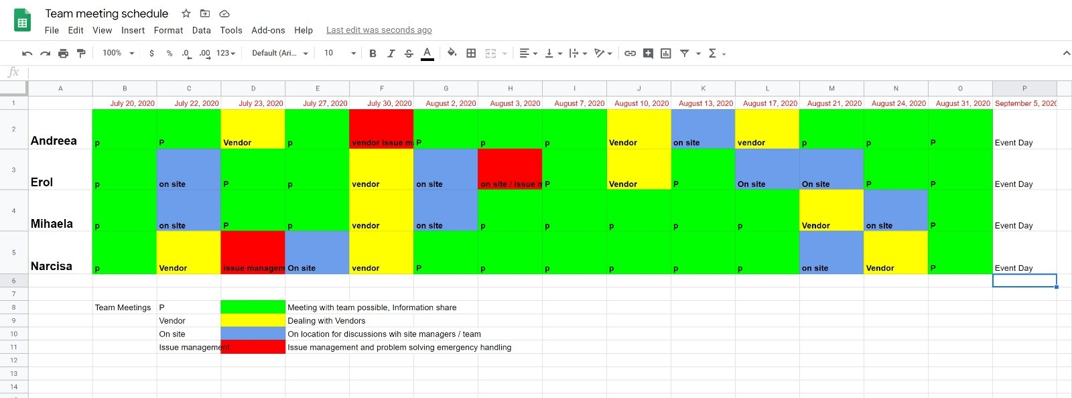


Roles for the event:
Erol: Production and Stage, Technical Supervisor and on site Director of the event
Narcisa: Sponsorships and Advertising, Marketing Team leader
Mihaela : Attendee and Venue Management Supervisor, F&B Coordinator
Andreea :Project Team Leader, Main Event Organiser and Guest Speaker liaison,

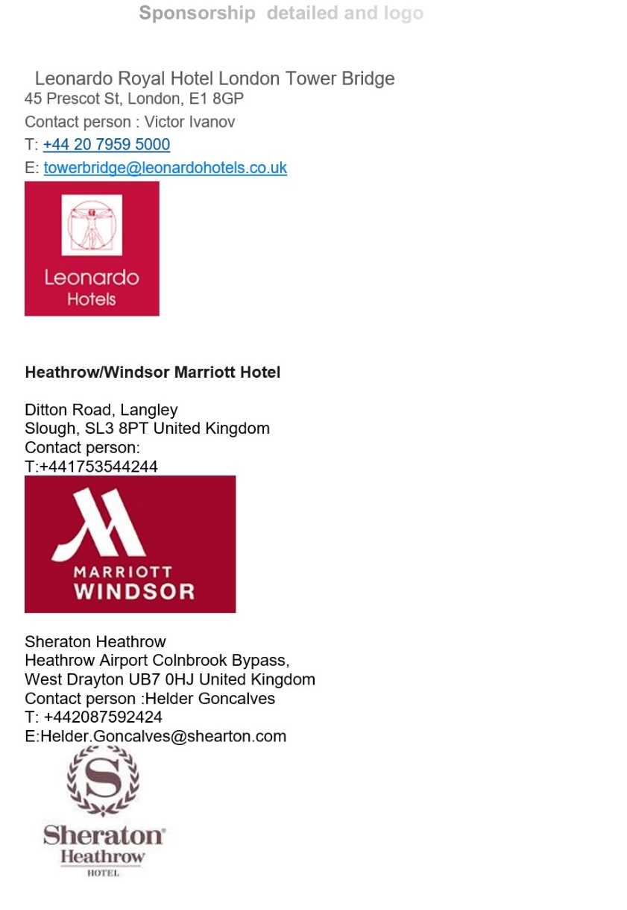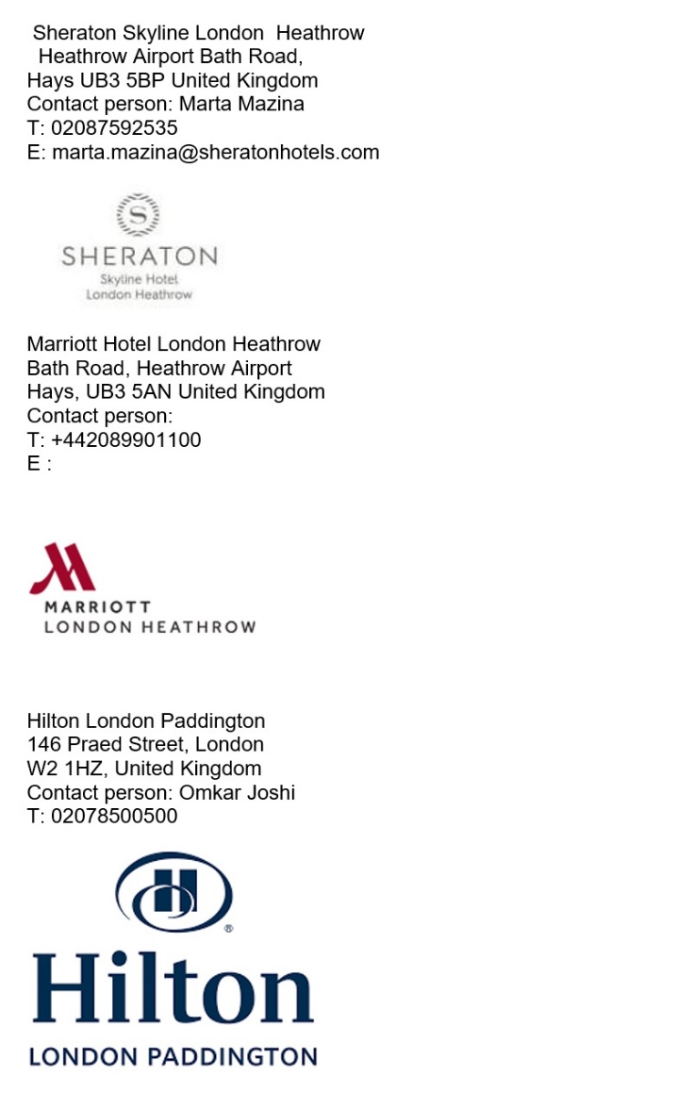

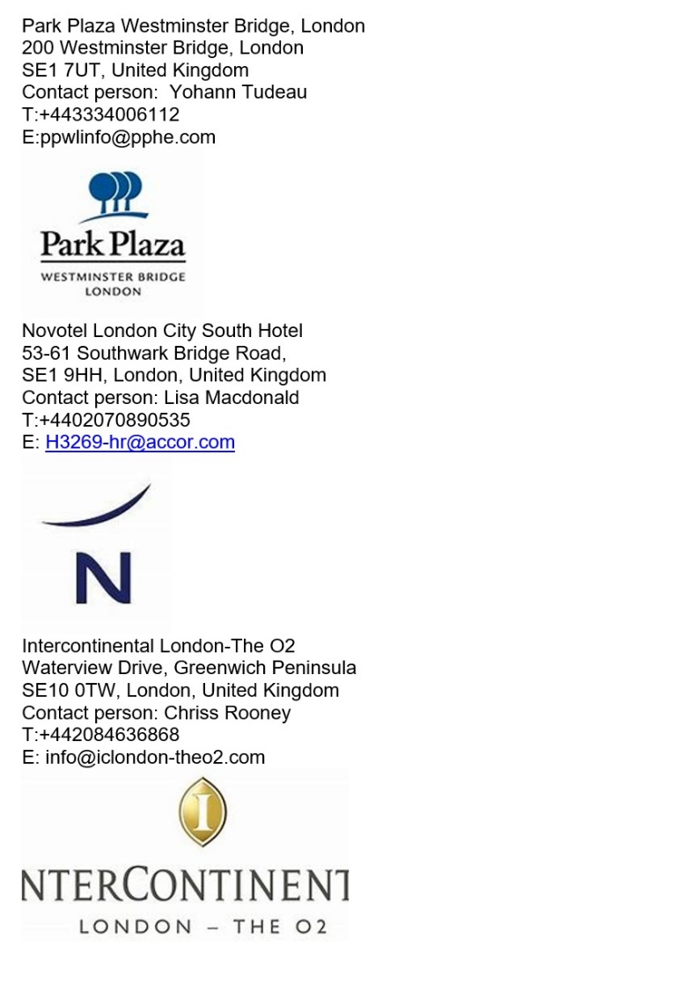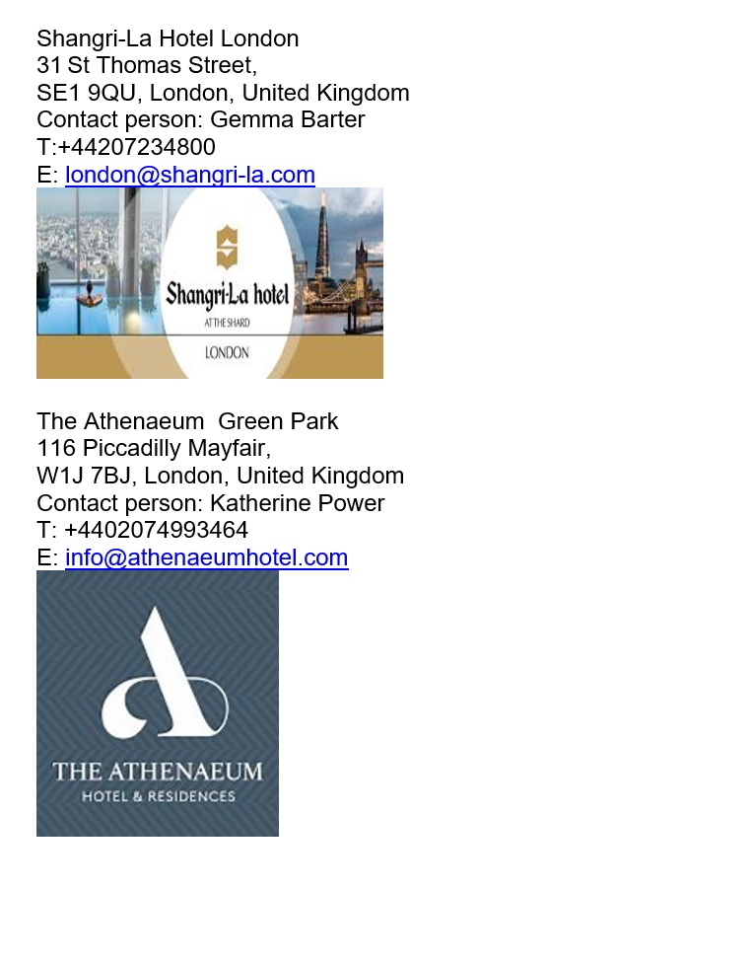

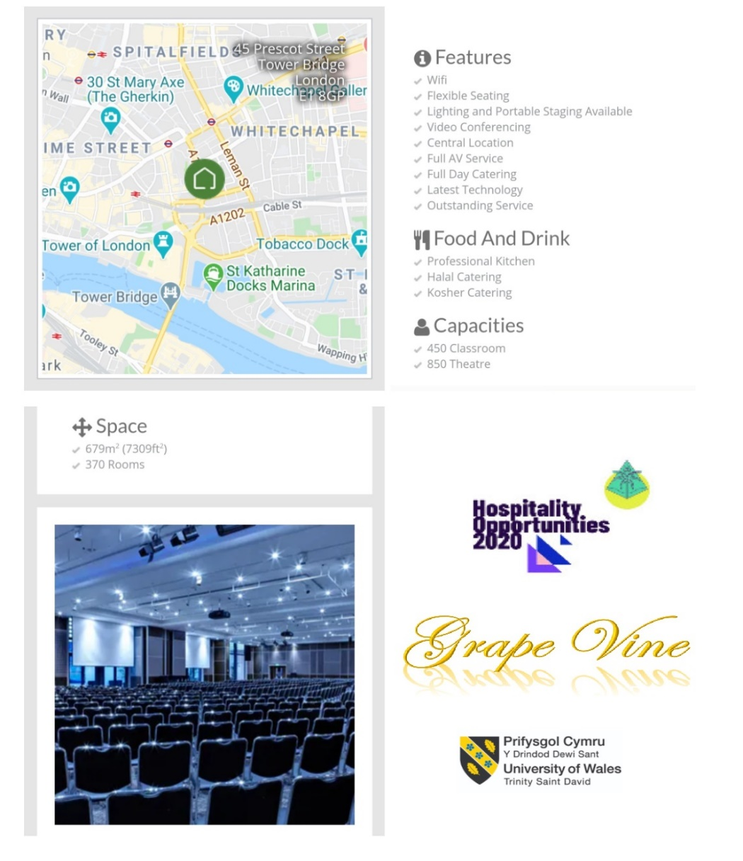

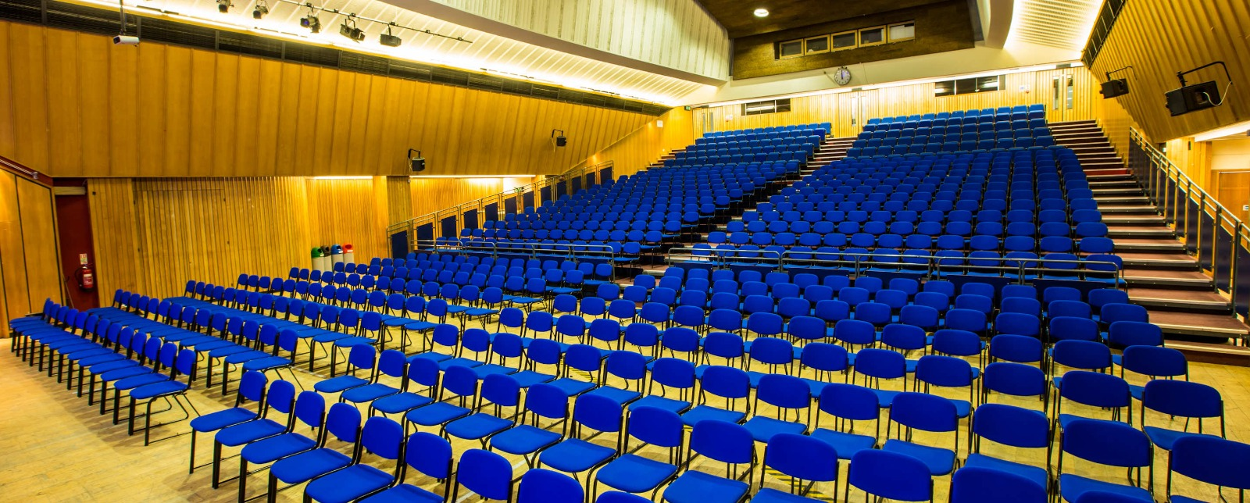
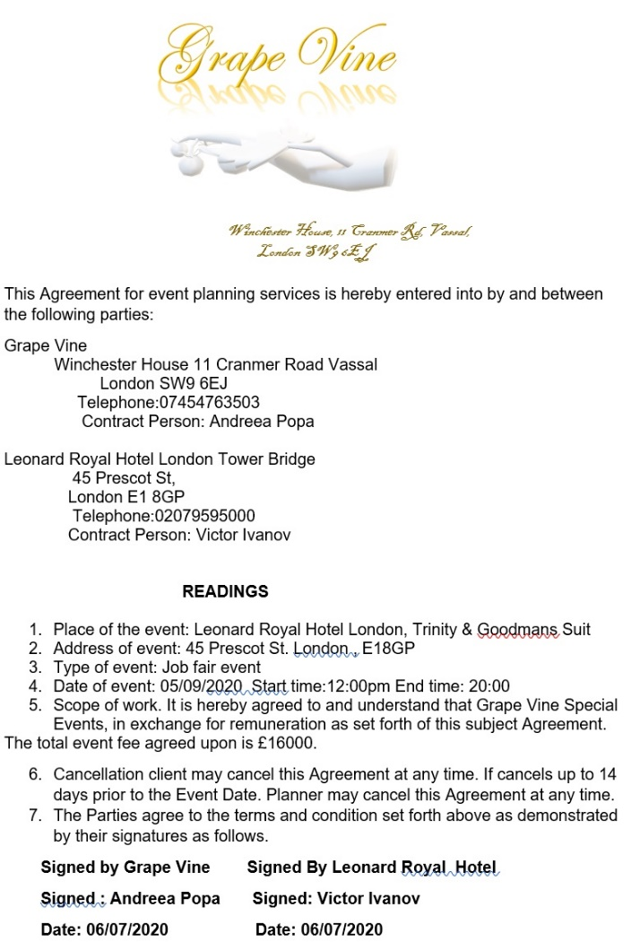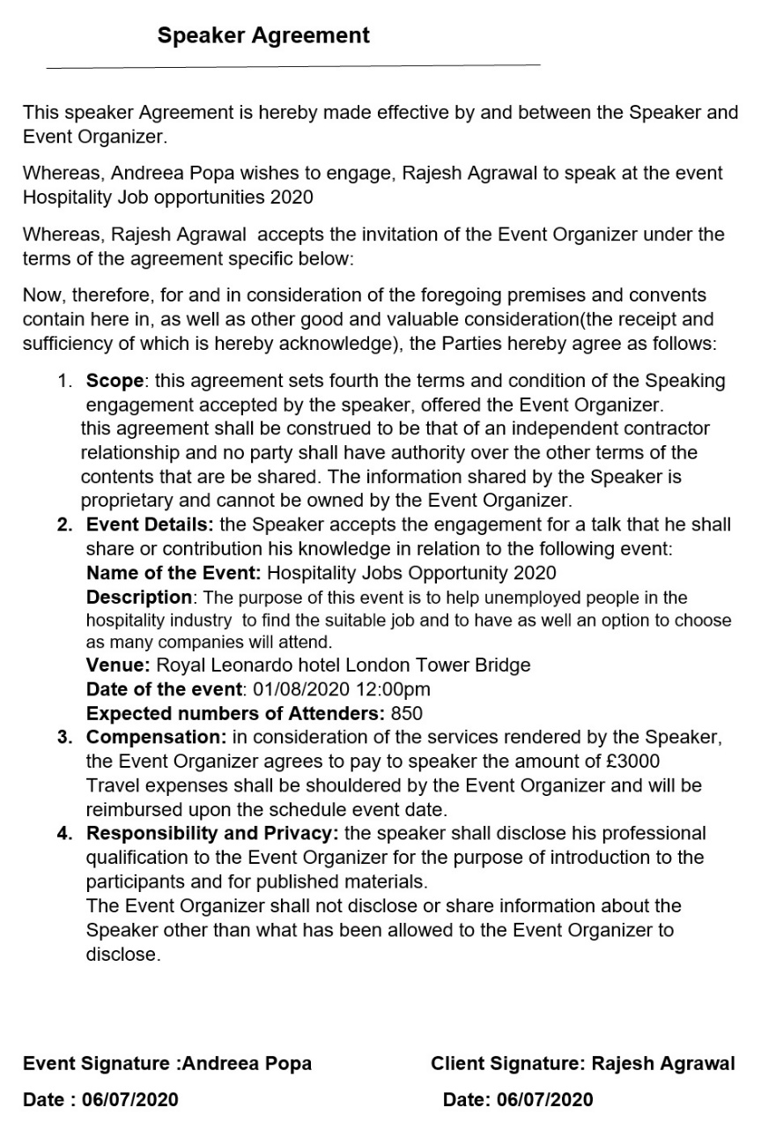
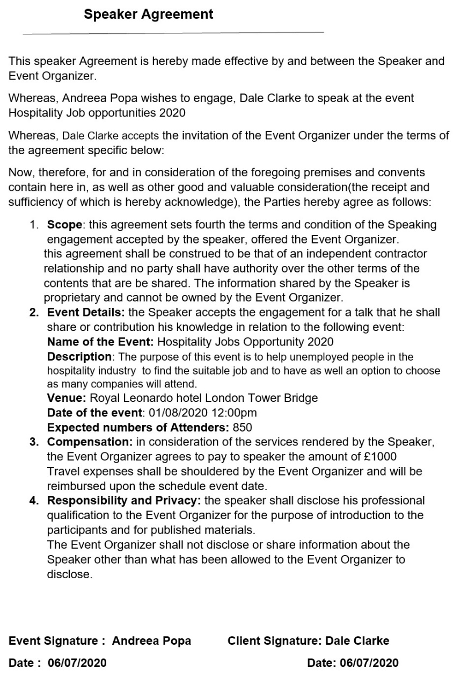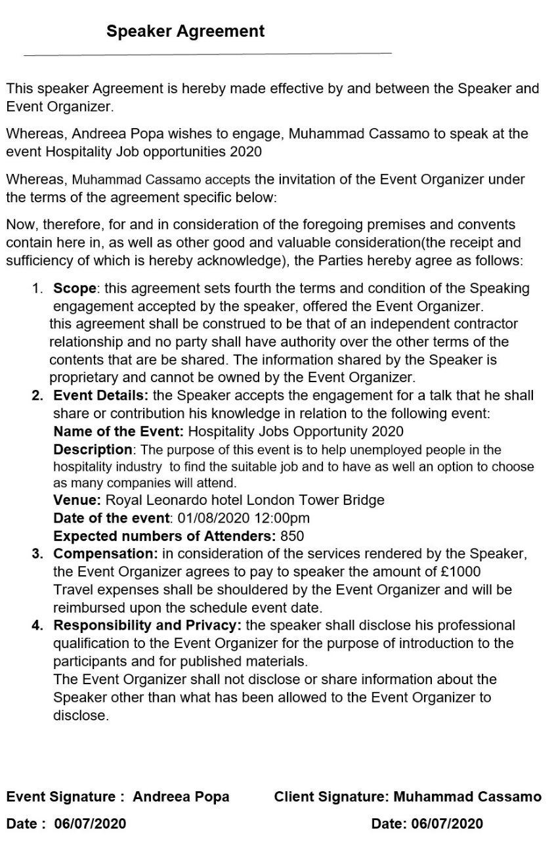
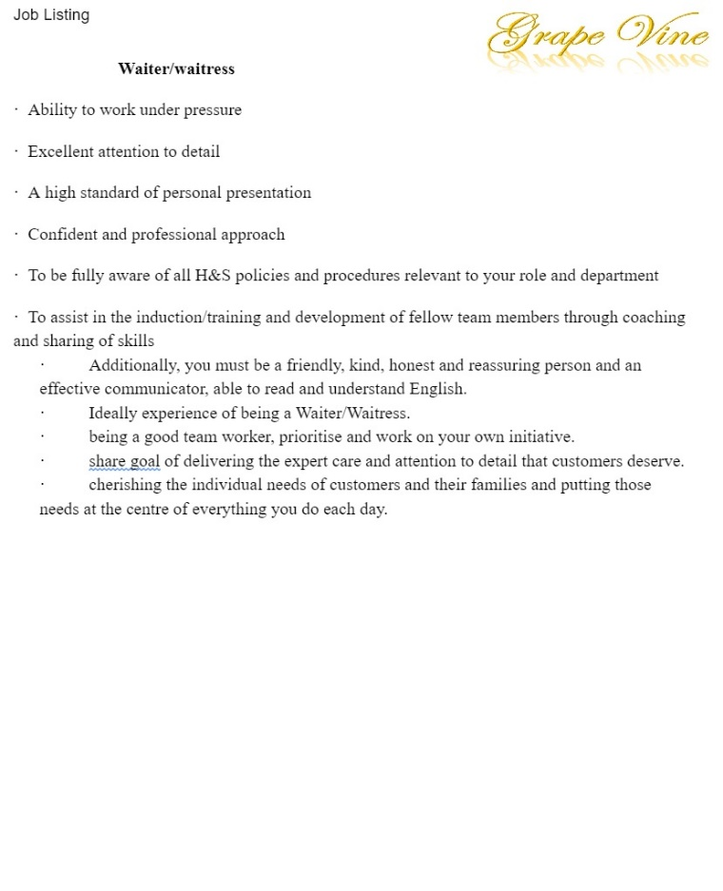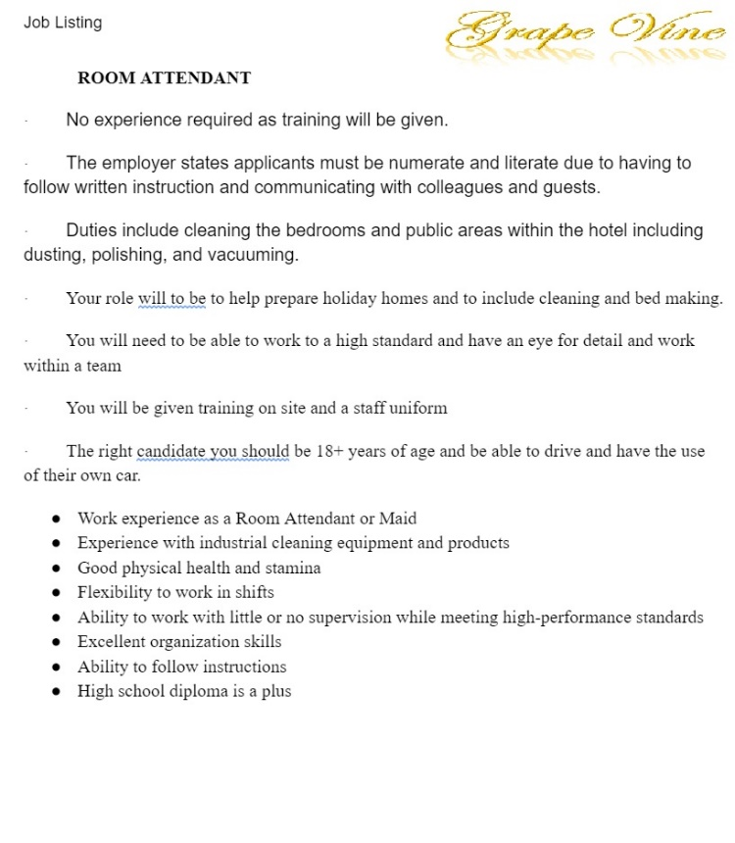
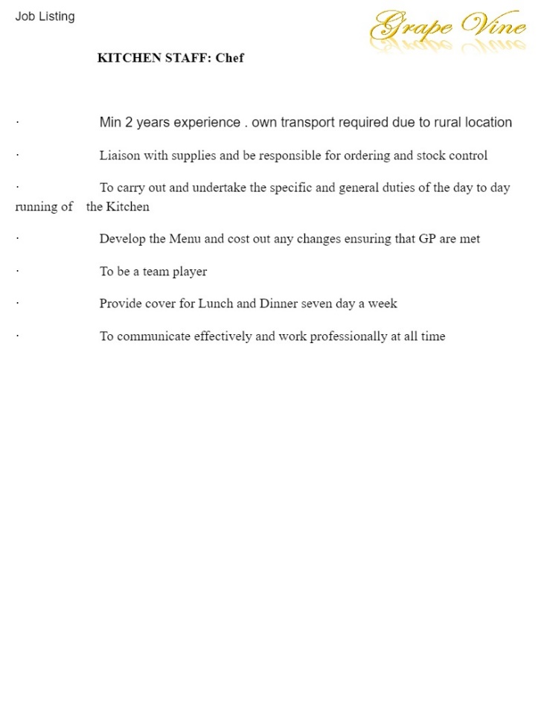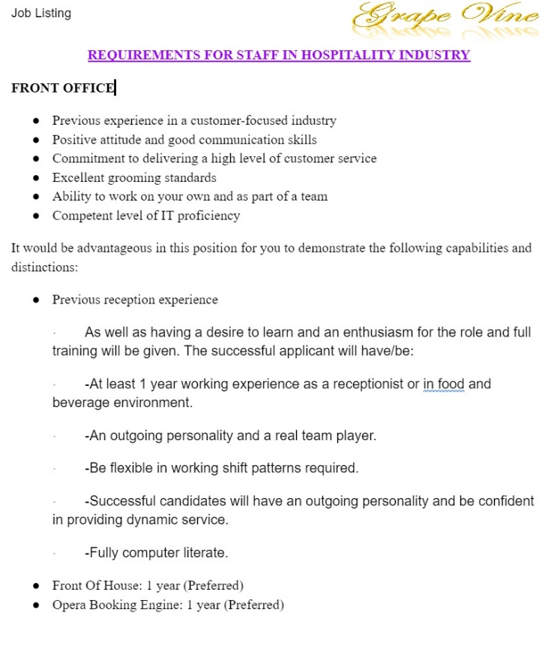
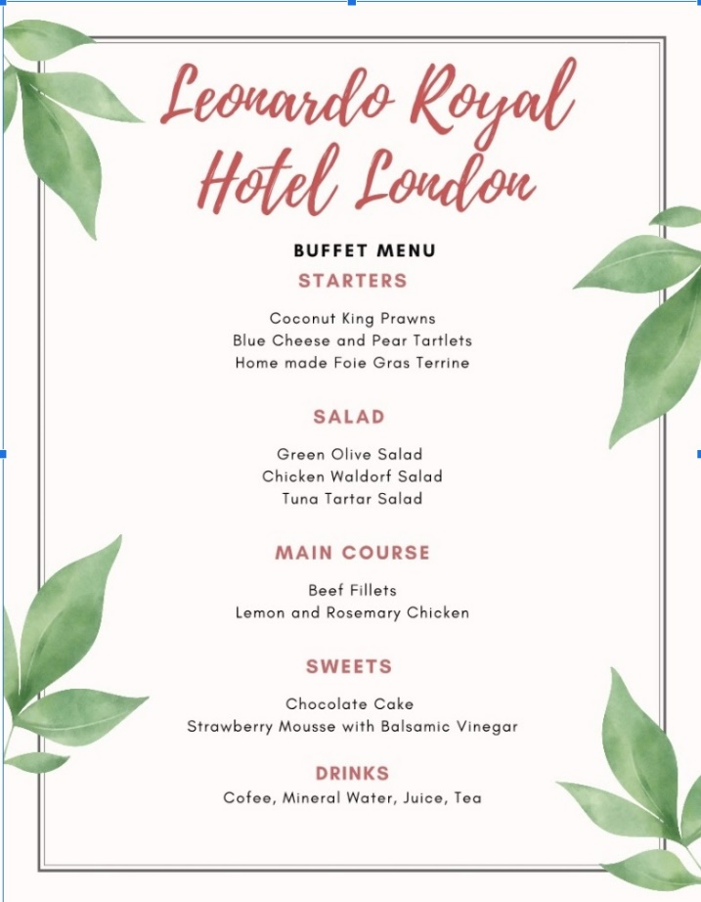
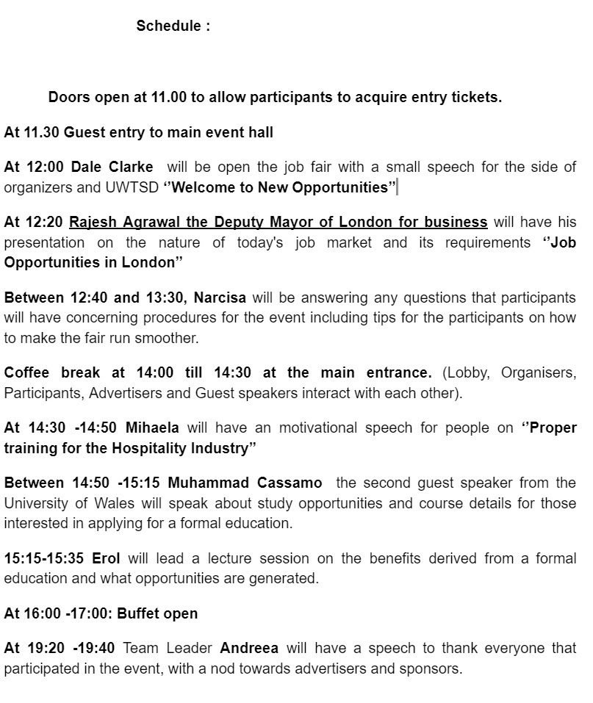
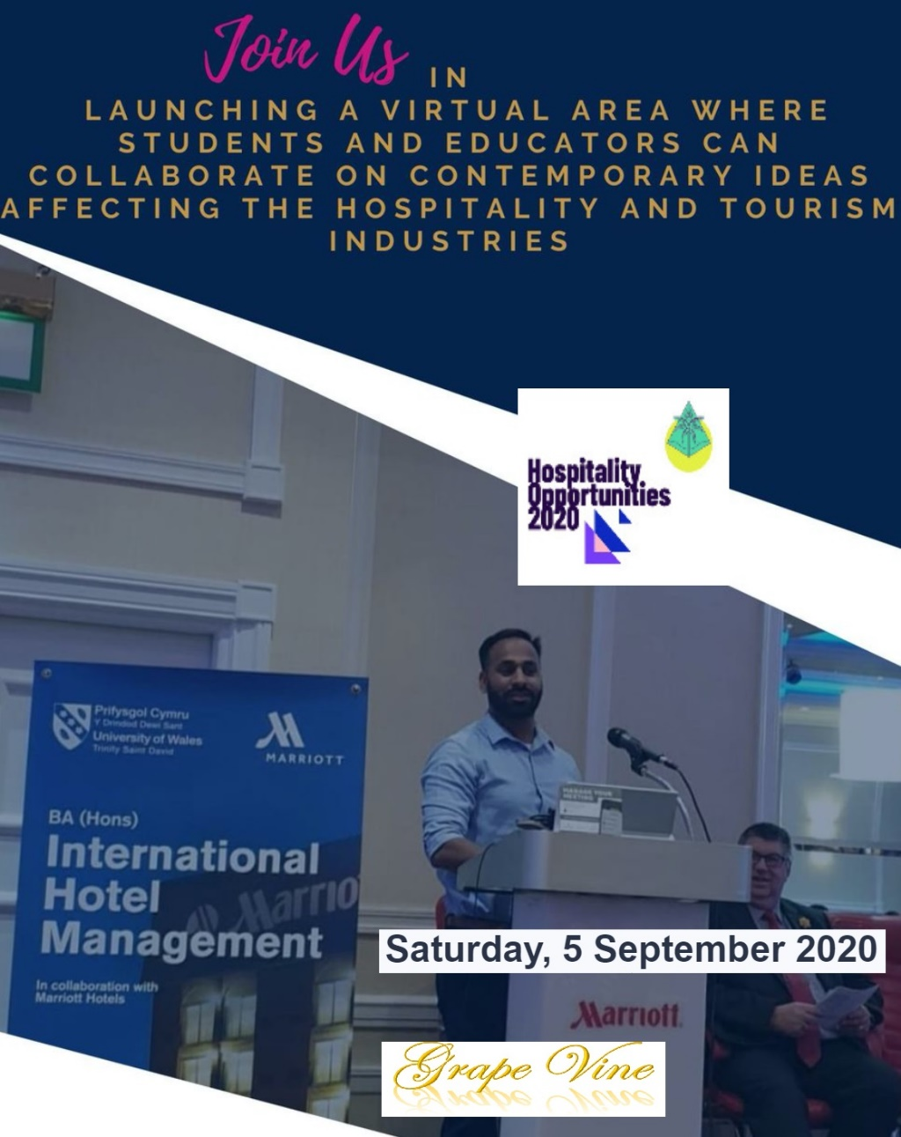

APPENDIX 1 SUMMARY OF THE LEARNING LOG

My responsibility is to raise funds for the events and to make the people aware of the event. Hence, I am responsible for bringing sponsors for the events, as negotiating the finding is my first and foremost duty. Therefore, it is my responsibility to participate in the initial planning of the event so that I can easily understand the project scope and chart. In addition to this, it is my responsibility to meet different people and convince them about the event. Therefore, to meet different people and organisations I have to collect the contact information of different people and organisation. Apart from fundraising, I am also responsible for educating and informing the people about the event, so that a huge number of people can visit the event. Hence, I need to develop a proper marketing plan which will be helpful in educating the people about the attributes and benefits of the event. Moreover, I have also made a list of government organisations, regulatory agencies, non-profit organisations etc. and will ask them to sponsor the event.
To perform the different roles I am responsible for the planning and implementation of the marketing program. In addition to this, I also need to develop a website, create social campaigns through emails and print works etc. apart from this, an attractive logo will also be created for creating a brand image of an event among the society and the community. Other than this, I am also responsible for creating an e-mail list for the promotion of the website which will be launched. After the development of the website, it will be my responsibility to review the uploading of different videos and content on the website, so that it can attract candidates.
For this event, I have been assigned the responsibilities of sponsorship and advertising and marketing. There are several roles which I have to perform. Some of the roles and responsibilities had been discussed above. For the success of the events, it is crucial to find some sponsors, so that we can get financial support for our event. Therefore for this, I need to interact with different people and organisations. I have already made a list of different people, with whom I need to interact with. However, this email list will also be helpful for the marketing campaign. Apart from sponsorship, there are several tasks which I need to perform for the marketing function such as designing the logo, creating the website, making the videos and other content for the site etc. in addition to this, I have to create an email list so that marketing of the website can be done through email. In addition to this, I am planning that instead of the number of guest speakers, I will only upload such video content which will not only act as promotional videos for the website and event but will also encourage donations and charities. It will be helpful in attracting the sponsors along with the marketing of the event. Apart from this, I have asked the teammates to create their video content so that we can upload it on the website. It will not only reduce the cost of guest speakers but also be helpful in educating the people about the benefits of the events. Since, name and logo are one of the important factors for any product, business or event. As it helps the people in recognising the brand. Therefore, the designs of logo, website and name have been completed. The technical team will help us in developing the logo and website of the event, as we do not have such talents in our marketing team that can create and develop the designs. Therefore, all the necessary material such as pictures, bio’s etc. have been sent to the technical team. I have conducted a thorough study of different websites and I have learnt that each website includes an about us column which contains the information of the brand, its products, their motive etc. This column is very helpful in educating the people about the brand and its purpose. Therefore, I have also completed the about us section for our website. It will help in providing the different information of the event to the visitors. Apart from this, it will help in increasing the number of stakeholders. Since the work of the website and other related has done, therefore the marketing team is currently working on the invitations, which will be mainly sent through the emails. After the completion of the website designing, I have also uploaded the promotional videos and some profiles on the website to increase the traffic on the website. Apart from the website of the event, the technical team has also suggested to us about the copyright of the social media platforms and YouTube channel. Other than this, the description of the conference will also be unloaded on the website. After the competition of all the tasks, it is my responsibility to review all the activities and update the about us section and conference description section regularly, so the visitors can get updated information.

