Marketing Management – Assessment 2

Table of Contents
(Question a) 3
Introduction 3
MACRO Environmental Analysis (PESTLE) 3
Porters Five Forces 4
SWOT Analysis 5
Segmentation, targeting and positioning (STP Model) 6
Marketing mix strategies of the company (4Ps) 7
Conclusion 9
(Question b) 9
Include recommendations of future marketing strategies for your chosen organisation. 9
References 10

(Question a)

Introduction
As a component of a company's strategy technique to create and execute marketing initiatives, the advertising function employs promotional tools, approaches, procedures, and analysis. Marketing management has a significant role in a company’s ability to generate revenue, develop an identity, and understand its targeted audiences. Through recruiting potential consumers, growing an existing client base, and enhancing communication with customers, including establishing an organization's identity, marketing management focuses on guaranteeing a business venture is running successfully. Therefore, it is one of the most crucial parts of any business, and it becomes more critical in retail sectors like Tesco. This report will discuss the marketing management of Tesco, its macro environmental analysis like PESTLE, Porter's five forces, and Swot analysis. Further, the STP model of Tesco and marketing mix strategies will be discussed which will boost the company’s sales. Lastly, important recommendations will be provided which would help the company in developing more effective marketing strategies in the future.

MACRO Environmental Analysis (PESTLE)
Political factor
Tesco carries out its operations on a global scale hence international factors political in nature do have a significant impact on its functions. According to Carey, (2023), the company is currently dealing with the adverse effects of Brexit and especially the EU referendum. The chairman of Tesco, John Allan has spoken out about the impending political factors which could negatively affect the business and that it has posed a serious threat to stakeholders and investors alike for the future of the company. The local authority also proposed a tax on the company which later gets rejected primarily to avoid increases in price, such initiatives could potentially harm the company thus making it an unfavourable factor for the company.
Economic factor
The labor costs do have a significant impact on supermarkets in the UK, the wage bill yearly is GBP, 4.5 billion, and recently the UK wage which is the minimum went up to the hike of 4.4% for people who are 25 and above, such movement upwards have cost Tesco a huge amount of finances. This factor would also be affecting the company in a negative manner and is evidently unfavorable (swotandpestleanalysis, 2022).
Social factors
The shopping trends of customers are changing over time, in addressing the demand for goods and services, the company focused on grocery retail must also focus on the beliefs and attitudes of customers as well as the factors concerning the increased risk of obesity among the population and therefore introduce a healthy line of organic food. As per a PWC report, 65% of Tesco shoppers are loyal customers hence Tesco is required to take prompt action on this factor (crow-jack, 2023).
Technological factors
The retail company has introduced RFID technology, which has indeed improved the in-store experience for the customers. It keeps an automatic count of the stock and inventory and removes it after sales. Such information is necessary for store managers, and this would indeed work for the company to its advantage.
Environmental factors
The company recently has been urging its customers to shop online on its domain besides that the company's retail drivers use routes that are fuel-saving rates and also take an initiative in recycling. The company also promises to use energy sources that are renewable and would generate 100% of the electricity by 2030 (businessmavericks, 2023).
Legal factors
The company has also faced backlash in the past regarding its discrimination towards its workers on the grounds of gender and low pay. They have also been accounted for fraud charges and misleading stakeholders which have put the image of the company negatively.
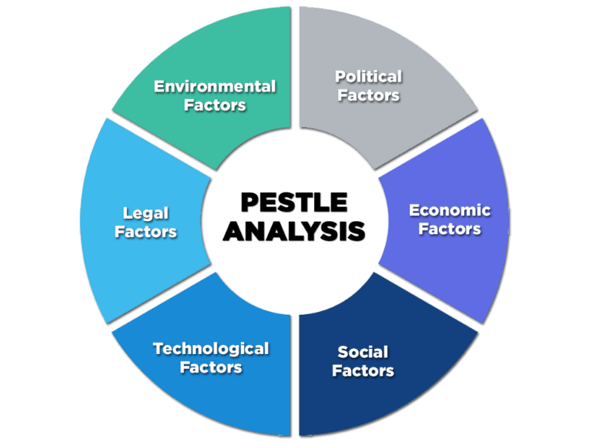
Figure 1: PESTLE analysis
[source: Enterslice, 2023]

Porters Five Forces
The risk posed by entrants that are new
Tesco happens to be a multinational corporation retailer that mainly concentrates on durables that are consumer-friendly, and it's one of the largest retailers internationally. Setting up a shop and making it perfectly functional requires a large sum of money for a new entrant. Furthermore, it would be difficult for a new entrant company to match up with the sales and marketing efforts of a well-established retail giant like Tesco which already has a strong holding on the market.
The Threat of Substituting Products
Despite the fact that there is various merchandise that could be substituted for the current goods sold by the company, the kind of quality Tesco opts for is unmatched by most of its competitors selling the same kind of product. Furthermore, Tesco happens to sell merchandise that already meets the demands of the market, so the posed threat is on the lesser side giving power to the company.
Negotiating the power of consumers
According to Liem and Arif, (2023), a huge proportionate number of competing retail vendors in the nation is what drives the bargaining power of the customer. The products that are supplied by the shops have barely any differences and almost remain the same, the quality of the product remains the same as well as the price hence the customers do not have much bargaining power.
Suppliers' bargaining power
the distributors and suppliers relatively have got less negotiating leverage. There are multiple suppliers who would be supplying the raw materials across multiple retail chains; hence it won't be difficult for Tesco to change its supplier, hence it does not pose a threat (Quin, 2023).
Competitive rivalry
Tesco faces a stiff competitive challenge from various other retailers such as carrefour, Walmart, Asda, and Sainsbury. Like Tesco, these retailers also have supply chains that are strong and logistic networks that are competent and they sell products at nearly identical prices (Li et al. 2023).
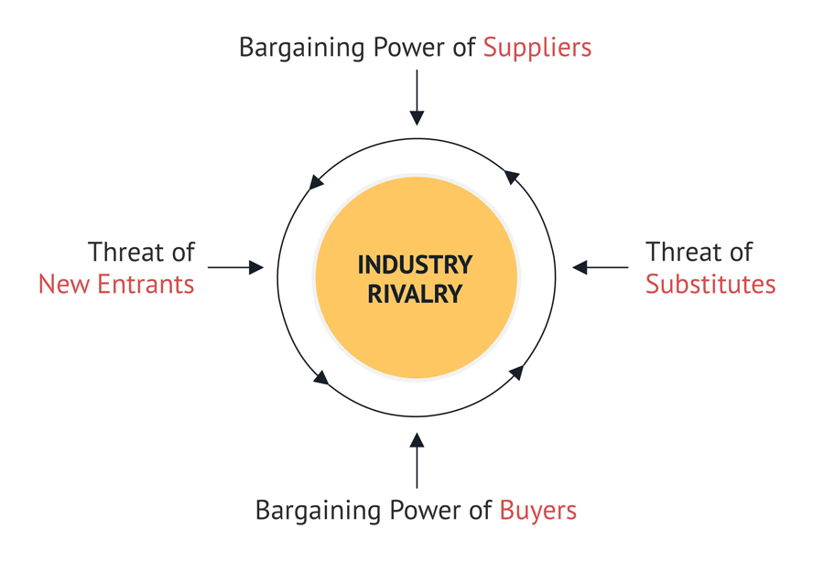
Figure 2: Porter's five forces
[source: consulterce, 2022]

SWOT Analysis
Strengths
Tesco happens to be the largest of all grocery retailers in the United Kingdom, the retail company happens to have the highest profit earnings and purchases compared to other chains of supermarkets across the country. As per the annual report of the retail company, its revenue is going to be 57.8 billion, and it also has a market share of almost 27.9% compared to the other four big supermarkets (globaldata, 2023).
Weaknesses
While Tesco happens to be the leading price holder in the United Kingdom market, its low pricing strategy may result in profit margins that are lower. Other than that, a few grocery outlets of Tesco have had poor operational management in specific markets. According to experts, the retail company didn't do enough research before entering certain markets (Payne et al. 2023).
Opportunities
Tesco has recently introduced a new discount shop called jack which has recently experienced rapid growth. It does have the necessary potential in expanding this business and successfully compete with Aldi and Lidl.
The retail company could also develop strategic linkages with other brands, which would allow the company to offer more products and attract more customers as a result.
Threats
According to Aiezza (2023), Tesco’s position in the market is currently under threat and jeopardy a result of the rising and improving growth and functional output of competitors like Walmart, with a merger from ASDA and Aldi. The country’s economic upheaval and regulations from the government are also affecting the organizational effectiveness of Tesco’s stores in certain areas.

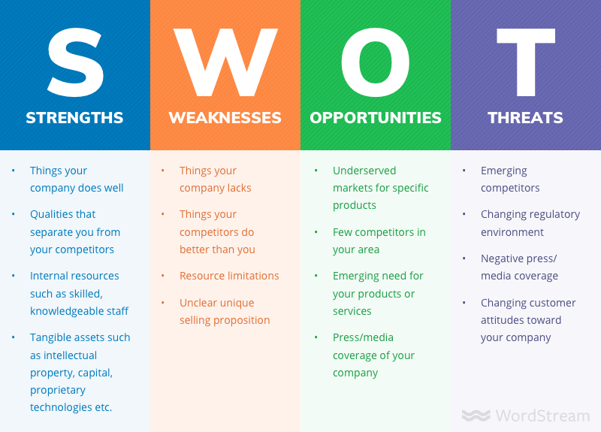
Figure 3: SWOT analysis
[source: Wordstream, 2019]

Segmentation, targeting and positioning (STP Model)
The retail industry customers have a different variety of requirements, preferences, and expectations which varies depending on their location, resources and technological capabilities.
Segmentation
It is the technique Tesco uses to divide the total marketplace into tiny categories and subgroups that share characteristics, purchasing patterns, and economic backgrounds. Geographic segmentation, as per Shen, (2022), where the markets are divided according to their locations, nations, cities, neighbourhoods and Tesco follows highly efficient geographical segmentation in the international markets. It is proactive in providing its customers with a variety of products depending on their cultures, and cuisines, and it also looks after its critical transportation costs as it varies from location to location, but it should not affect its customers. Another type of segmentation is demographic, where Tesco divides the vast markets into smaller groups or categories based on customers’ incomes and their life cycles.
Targeting
Tesco concentrates on a certain industry after identifying different customer categories in the marketplace. In this process, the company finds proper partners who would help in targeting the proper markets and customer base (Nekmahmud et al. 2020). Tesco comprises proper infrastructures where its products can effectively target the customers and also the quality and life cycles of products which will help in targeting a large customer base in every international market.
Positioning
In today's fiercely competitive industry, promoting the brand and brand value are highly essential for successfully running the business. Tesco has extraordinary positioning in the world markets, where it has successfully and consistently acquired the top position in the retail industry (Asdi and Putra, 2020). Their excellent marketing strategies, diversity in products and high-quality products with efficient customer service have enabled Tesco to maintain the best positioning in the world markets.

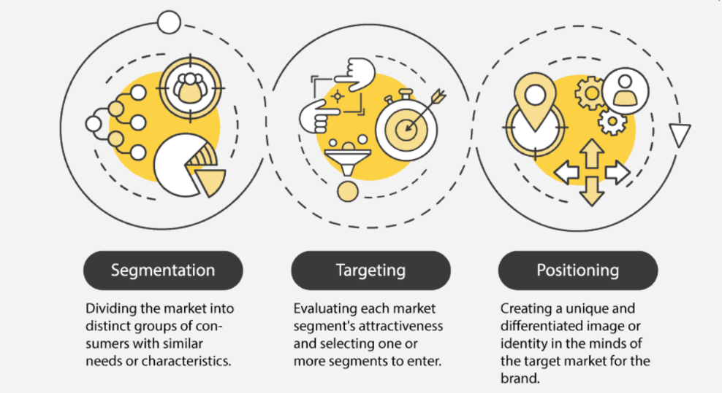
Figure 4: STP Model
(Source: feedough, 2023)

Marketing mix strategies of the company (4Ps)
An essential approach for figuring out ways to sell any goods now or in the coming years is called a marketing mix. There are 4Ps of marketing mix, namely, Price, Place, Product, and Promotion.
Price: Tesco is equipped with a solid distribution network infrastructure, which enables them to consider taking advantage of sectors of the economy of this magnitude and provide goods at the most competitive pricing. According to Yaning, (2021), Tesco always gives high priority to its products' qualities and does not skimp on quality to save costs. They frequently take reviews or feedback from their customers on their pricing and try to reduce unnecessary expenses. As a consequence, Tesco employs the expense leadership approach.
Place: Tesco operates 6,900+ shops throughout 15+ nations, including the UK, Japan, and others. Tesco has a wide variety of shopping outlets with a wide range of goods and amenities and among them are “Tesco Metro”, “Tesco Express”, “Tesco Extra”, and “Tesco Superstore”. Tesco's supermarkets are massive outlets that provide a wide range of non-food goods in addition to consumables. Tesco Metros are more smaller outlets that comprise specific goods and are main;y located in small cities. Far more compact is “Tesco Express”, mostly selling slightly elevated-priced goods (Niazi et al. 2021). “Tesco Extra” are vast outlets or supermarket that deals with a variety of goods, from eatables to daily merchandise, all under one roof.
Product: From its very establishment, Tesco has expanded tremendously, and it now provides a wide range of products in a number of different varieties including groceries, electrical equipment, wellness, entertainment, fashionable items, lifestyle, and decoration items, gifting products, recreation and exercise equipment, cosmetics, accessories, baby items, etc. This shows that Tesco has become a superpower in the retail industry, and it does have its own brands.
Promotion: Tesco puts a lot of effort into attracting consumers with their well-known low-margin strategy. Tesco employs printing and digital advertisements widely as it is an attempted way to attract customers and provide information about the company, both in present and future (Alqahtani, 2020). For attracting and retaining customers, it provides offers and “buy-one-get-one” approaches and also provides “club cards” for its loyal customers.

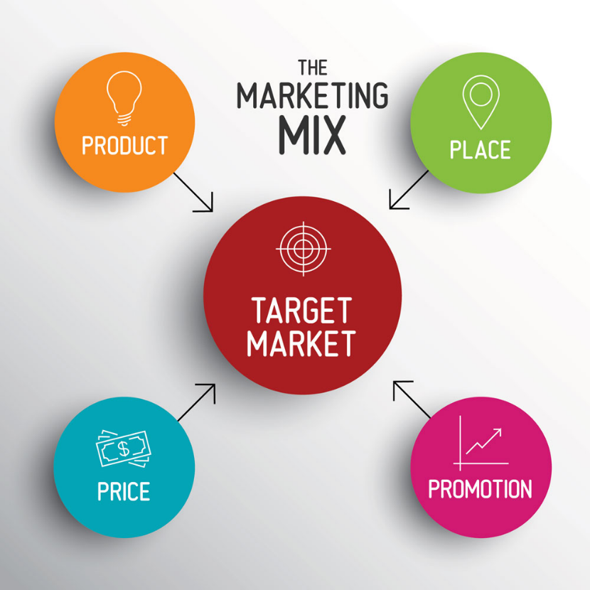
Figure 5: Marketing Mix(4Ps)
(Source: thebusinessplanshop, 2023)

Conclusion
Marketing management is the most crucial aspect for any business to conduct and run successfully. The companies recruit efficient marketing managers who propose innovative marketing approaches for the company to effectively attract customers and make revenues. There are many aspects of marketing management and some of them are discussed above in regard to considering Tesco which is the number one supermarket or retailing industry in the world. Tesco’s macro environmental analysis has been provided in terms of PESTLE where its political, economic, social, technological, logical and environmental assessment has been provided along with Porter’s five forces. Further, a SWOT analysis has also been conducted to understand the company’s strengths and weaknesses, the STP model which helped in analyzing its segmentation, targeting, and promotion and lastly the marketing mix or 4Ps which is necessary for every business.

(Question b)

Include recommendations of future marketing strategies for your chosen organisation.
Tesco is considered among the major retail organisations in the UK market which have maintained its position in the market through constant development through the years. But there are certain barriers or issues that must be mitigated effectively in order to maintain the reputation of the company and also for increasing its revenue scale. The company has experienced severe backlash regarding the low pay of the labours and discrimination in the workplace which has further declined the sales margin of the company. In this scenario, the company must implement strict policies regarding gender and racial discrimination in order to ensure equal growth opportunities for everyone (Gupta et al. 2019). Moreover, for resolving the problem of the low pay scale, the company must keep reviewing its salary structure with the help of the remuneration committee constantly in order to modify the pay scale as per the performance of the employees and the contemporary economic condition of the country. Additionally, even though Tesco offers healthy food options to its customers, it must increase its organic product range as per the customer demands in order to increase its loyal customer base.
Tesco has experienced certain issues as a result of entering a new market without proper research, Thus, the implementation of a dedicated research and development team will help Tesco to research different factors such as market trends, customer demands, rules and regulations of respective governments and others (Zafar et al. 2019). This initiative will help the company in recognising certain challenges that may hinder the performance of the company and also develop efficient strategies that will ensure the productivity of Tesco.

References
Aiezza, M.C., (2023). The Twitter Crier: A Comparative Discourse Analysis of How British Grocery Retailers Target Their Market Through Microblogging. Languaging Class: Reflecting on the Linguistic Articulations of Structural Inequalities, p.117
Alqahtani, M.H., (2020). From the traditional marketing mix (4Ps) in sport to new marketing mix (3Ps): Toward a paradigm shift from practitioner’s perspective (Doctoral dissertation, Middle Tennessee State University).
Asdi, A. and Putra, A.H.P.K., (2020). The effect of marketing mix (4P) on buying decision: Empirical study on brand of Samsung smartphone product. Point Of View Research Management, 1(4), pp.121-130.
businessmavericks.org, (2023). Available at: https://businessmavericks.org/pestle-analysis-of-tesco/https://swotandpestleanalysis.com/pestle-analysis-of-tesco/. [Accessed on: 11.03.2023]
Carey, R., (2023). Tesco announces major nationwide change in first-of-its-kind deal. Lancashire Telegraph (Blackburn, England), pp.NA-NA
Consulterce.com, (2022). Available at: https://consulterce.com/five-forces-analysis/. [Accessed on: 11.03.2023]
Crowjack.com, (2023) Available at: https://crowjack.com/swot-analysis/tesco. [Accessed on: 11.03.2023]
Enterslice.com, (2023) Available at: https://enterslice.com/learning/pestle-analysis-a-mechanism-for-analysis-of-businesses/. [Accessed on: 11.03.2023]
Feedough.com, (2023). [Available at: https://www.feedough.com/what-is-stp-marketing-the-stp-model-explained/]. [Accessed on: 02.03.2023]
Globaldata.com, (2023). Available at: https://www.globaldata.com/company-profile/tesco-plc/swot-analysis/. [Accessed on: 11.03.2023]
Gupta, G.R., Oomman, N., Grown, C., Conn, K., Hawkes, S., Shawar, Y.R., Shiffman, J., Buse, K., Mehra, R., Bah, C.A. and Heise, L., (2019). Gender equality and gender norms: framing the opportunities for health. The Lancet, 393(10190), pp.2550-2562.
Li, X., Xu, M., Zeng, W., Tse, Y.K. and Chan, H.K., (2023). Exploring customer concerns on service quality under the COVID-19 crisis: A social media analytics study from the retail industry. Journal of Retailing and Consumer Services, 70, p.103157.
Liem, A.G. and Arief, N.N., (2023). Integrated Marketing Communication Strategy for Cosmetic Retail Company: a Study of New Central Palu. Journal of Economics and Business UBS, 12(1), pp.413-430.
Nekmahmud, M., Farkas, M.F. and Hassan, A., (2020). Tourism marketing in Bangladesh. In Tourism Marketing in Bangladesh (pp. 11-27). Routledge.
Niazi, N., Rashid, M. and Shamugia, Z., (2021). Role of Marketing Mix (4Ps) in Building Brand Equity: Case Study of Shell Petrol, UK. International Journal of Applied Business and Management Studies, 6(1), p.2021.
Payne, J., Lloyd, C. and Jose, S.P., (2023). ‘They tell us after they've decided things’: A cross‐country analysis of unions and digitalisation in retail. Industrial Relations Journal, 54(1), pp.3-19.
Qin, H., (2023). Research on Service Quality Enhancement of Community Group Buying Business Based on Information Era: Taking MEITUAN SELECTED as An Example. Frontiers in Business, Economics and Management, 7(3), pp.170-172.
Shen, J., (2022), April. Analyzing on the Going Global Marketing Strategy–Taking Shein as an Example. In 2022 International Conference on Creative Industry and Knowledge Economy (CIKE 2022) (pp. 225-229). Atlantis Press.
Thebusinessplanshop.com, (2023) [Available at: https://www.thebusinessplanshop.com/fr/blog/marketing-mix-4p]. [Accessed on: 02.03.2023]
Wordstream.com, (2019) Available at: https://www.wordstream.com/ws/2019/12/20/swot-analysis. [Accessed on: 11.03.2023]
Yaning, L., 2021. Stages and methods of marketing analysis of the market: annotation to master's thesis.
Zafar, M.W., Shahbaz, M., Hou, F. and Sinha, A., (2019). From nonrenewable to renewable energy and its impact on economic growth: the role of research & development expenditures in Asia-Pacific Economic Cooperation countries. Journal of cleaner production, 212, pp.1166-1178.

