

Assessment 2

Programme:BA Business Management
Module : The Global Business Environment
Module code : LCCB4005
Module Lecturer: Dr Molly Jack
Student : Basiul Vlada ( 2028043 )

Executive Summary
The Covid epidemic is generating disruption and financial problems all over the world. From Asia to Europe to North America, no country has been spared the infection's assets or the financial consequences. Furthermore, the epidemic has affected nearly every field, and the global coordinated automotive industry is no exception. Manufacturing facility closures, production network interruptions, and request reductions have all resulted in severe losses. Furthermore, some automobile dealers will always close, leading the floor plan lending business sector to decrease. The paper explores the pandemic's influence on the vehicle industry, specifically Rolls Royce. It covers major initiatives and megatrends that the organisation is attempting to implement to overcome losses.

Table of Contents
Introduction 4
The Impact of Pandemic on the automobile industry 4
Megatrends in the Automobile industry after the pandemic 7
Development of Survival and Success factors in the industry considering those megatrends 9
Conclusion 10
Reference List 11

Introduction
The COVID-19 pandemic has had a significant impact on the globally integrated automobile sector. Side consequences include a disruption for Chinese parts being sent out, a massive scope of generating interferences across Europe, and the closure of several manufacturing units in the United States. This is putting extreme strain on a sector that was already adjusting to a drop in global interest, and it is probably encouraging expanded consolidation and securing movement. This report aims to study the impact of the pandemic on the automobile industry.
Rolls-Royce is a worldwide driving power frameworks company that is preparing for the future century by satisfying the demands of clients, investors, and workers. In the 2000s, Rolls-Royce Group PLC has been on a tear. The London-based company, well known for its prior luxury automobile sector, is one of the world's leading high-capacity gas turbine manufacturers motors for the avionics industry (Rolls-Royce, 2020). Rolls-Royce has made a name for itself in this ferocious global market by developing an innovation that enables a single motor model to be altered to construct all the more spectacular, and more efficient, aeroplane motors. The later part of the report will discuss and analyses the influence of the pandemic on the sector and develops industry survival and success factors with megatrends in mind.

The Impact of Pandemic on the automobile industry
The epidemic has had a tremendous financial impact, and the car industry has been extremely sluggish since roughly 2019. Specifically, between the end of the first and second trimesters in March and May of last year, 2020, a second when the lockdown was feasible and all-out production blocks in various nations throughout the world, including Italy. Vehicle sales fell by 15% globally in the underlying lengthy periods of 2020, according to data from the National Automobile Dealers Association. This decline was also visible in new car production (Faist Blog, 2021). Remembering that during the pandemic outbreak in China, several manufacturing factories stopped down, and not a single car left the sequential construction systems in Wuhan. In 2020, over 78 million mechanised vehicles were produced worldwide, a decrease of 16% from the previous year, 2019. It is the greatest fall ever recorded in the history of the globe. According to projections, global car sales would fall to less than 70 million units in 2021, a decline from a peak of 97 million automobiles and light commercial vehicles, of which 73 million vehicles were sold in 2017. In terms of transactions, a decline of 13.8 per cent is projected for the 2019-2022 period, highlighting an obvious downward trend that began in 2019. The cause of this collapse may be traced back to the epidemic.
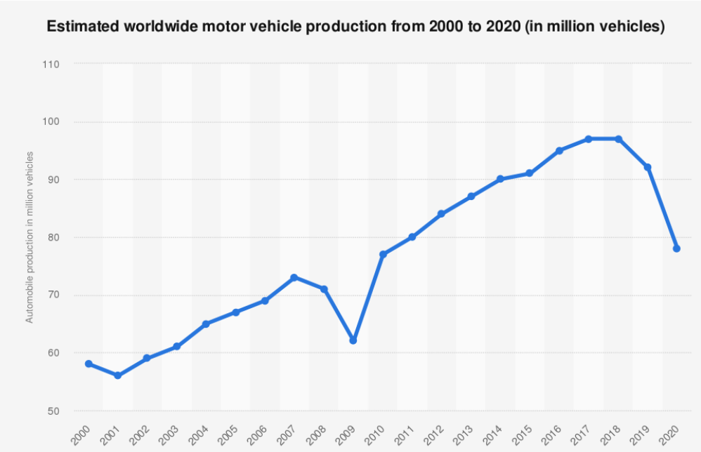
Figure: Shows the drop in production of automobiles.
Source: (Faist Blog, 2021)

Rolls-Royce is part of an automobile firm that has taken a significant impact as a result of the epidemic. Several pieces of evidence are broadly found in articles and the internet. Joanna reports in the 2020 issue of "The Guardian" that Rolls-Royce suffers a £5.4 billion loss when the Covid-19 takes to the skies. Rolls-Royce, the designer of the jet motor, issued an unequivocal warning about the company's damage from the Covid-19 outbreak, revealing a £5.3 billion loss in the first half of the year. According to the firm, orders would not rebound to pre-Covid levels until 2025. (Partridge, 2020). As airlines cut flights and aircraft manufacturers cut production, the pandemic lowered the popularity of their engines. In 2020, Rolls-Royce had intended to create 450 motors, but currently only intends to deliver 250. It is continuing to spend money, to spend £3-£4 billion by the end of the year, and has said that it would most likely be unable to secure sufficient funding to satisfy its demands.
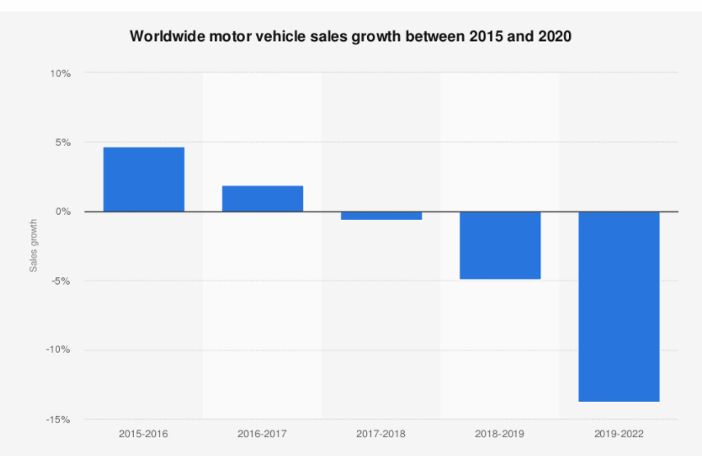

Figure: Shows the sales growth in a worldwide motor vehicle.
Source: (Faist Blog, 2021)

Rolls-Royce was one of the most notable business casualties of the Covid pandemic. The collapse in long-distance airhead out spurred the establishment of the massive aeroplane powered by Britain's air motor inventor, slashing its earnings. Rolls-Royce's immediate test, a somewhat tougher one, is in convincing financial sponsors that it would be one of the world's champions in the fight against environmental change (Pfeifer, 2021). Decarbonisation is a challenge for the gathering, as it is for other aviation groups. Before the pandemic, a percentage of Rolls-then Royce's £15.4bn in annual basic earnings came from its common aviation segment, whose engines power a fraction of the world's largest aircraft. Due to the pandemic, Rolls-Royce has revealed intentions to lose 8,000 positions internationally, or more than 15% of its workforce, with UK employees accounting for 66% of the total. According to the company, 3,500 of its UK employees have requested willful repetition or have chosen to leave the company, significantly lowering the need for obligatory redundancies. So far, 5,000 individuals in the company's common aviation sector have left, bringing the total number of employees to 48,000; another 5,000 are expected to leave by the end of the year.

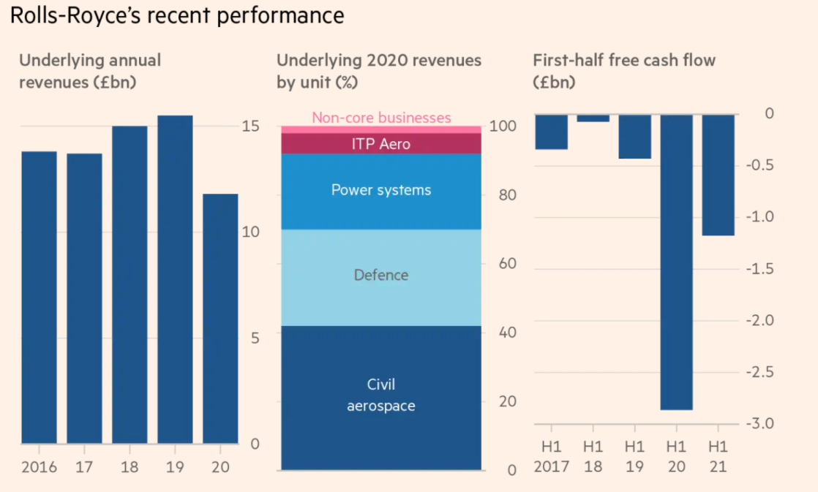
Figure: Recent performance of Rolls-Royce
Source: (Pfeifer, 2021)

Another piece of news is that Rolls-Royce will temporarily halt processing operations to save costs. According to the Financial Times, Rolls-Royce Holdings Plc, an English aircraft manufacturer, plans to temporarily halt industrial locations, restrict working hours, and slash perks as part of new cost-cutting initiatives. According to the Financial Times, the business is also facing strike action at its most established site in Barnoldswick, Lancashire, UK, in reaction to intentions to relocate some manufacturing to Singapore. Employees at Rolls-Royce were alerted via email that the firm was experimenting with new techniques in its current cost-cutting effort to respond to a decline in aviation interest as a result of the COVID-19 infection, which alluded to a source with knowledge of the situation (Reuters, 2020). While attempting to balance the impact of the COVID-19 outbreak, which has grounded flights and weighed heavily on the organization's coffers, Rolls-Royce will approach investors for $2.6 billion on Tuesday (Reuters, 2020). Financial supporters are expected to help the liberties problem by backing CEO Warren East's plan to cut 9,000 jobs and shut manufacturing units.

Megatrends in the Automobile industry after the pandemic
After the pandemic, it can be expected to see huge changes in the industry of automobiles. For the last decade, the industry was already faced extreme challenges. The economic pressure has increased after the pandemic. The pandemic's impact is wide-ranging, not limited to a specific geographical location, but rather exceedingly global, and felt across the whole production network, across organisations, and over a much-broadened schedule with varying time skylines (van Hoek and Loseby, 2021). So, the changes in the industry will be seen in the automotive value chain in after-sale & sales.
- The escalation of Acquisition & Mergers- The industry faced great challenges in 2020’s first half. It will take many years to recover from that. Many companies will make great deals for acquisition for this pressure. It will create prospects to merge between companies that are struggling. Also, some of the automobile suppliers will be bankrupt who didn't make their transition process to the digital transformation of their value chain.
- The growth of electric vehicles in the US, China & Europe- The demand for electrical vehicles (EV) will increase after the pandemic. The legislation for severe CO2 was pressed by the EU recently. The incentives on EV's will be reduced by 20% by the government of China. This will further increase the growth of EVs in the market. This will lead to inspiring many entrepreneurs to EV start-ups like Rivian & Fisker.
- Level 3 & Level 4 autonomy- It can be expected to see the market distribution of Level 3 autonomy this year by various car companies like Honda, Daimler, Toyota, Xpeng and Ford. The automatic lane structure is spread out by the new regulations of the UN in 60 countries. There is little doubt that the pandemic's impact on the automobile industry is unprecedented (Radic and Stevanovic, 2020). But the autonomy of Level 4 is another thing. Only the robotaxi service by Waymo is offering this autonomy. No other companies are offering this right now. It will take most of the decade to start reliable and safe service of L4 autonomy in large cities. It can be said various car companies will depend on technology companies to reach this level. A recent great example of this is the partnership between Nvidia and Daimler.
- Micro mobility over mass transit- The pandemic created the fear of infection. So, the people changed their transportation medium from mass transit to e-bikes, e-scooters and cars. This will be continued not only for Covid but also for they are satisfied by the new alternatives. Some people have bought e-bikes to go to their works. They will not easily return to mass transit. It can be expected to see the rise of companies of shared micro-mobility.
The renowned car company Rolls-Royce announced that they will no longer sell cars that are run by gasoline. They are planning to create only electric cars by the year 2023. It is a historical decision of the company. It is in huge demand in recent times after the pandemic. It is proven that the pandemic didn't affect the selling of Roll-Royce luxury cars. They had a record sale in the first quarter of 2021. It can be said that the new decision of the company will continue to thrive their selling in the near future.

Development of Survival and Success factors in the industry considering those megatrends
During the COVID-19 pandemic, digitalized programmes have grown considerably more strategic and relevant. Computerized tools enable us to overcome physical barriers and communicate with representatives, clients, and business partners, as well as states and other places, as well as people from various backgrounds on a global scale. In these trying times, Rolls Royce has familiarised advanced drives with a larger local region to help with strong growth. The automobile industry is dealing with a major problem as a result of a halt in the economy/total national production (GDP). The COVID-19 is having an impact on the tourism sector, voyaging, and vehicle expos (KM and KG, 2021).

Rolls-Digital Royce's Academy, Yocova, and Emergent Alliance are three ground-breaking advanced initiatives that have been launched for the current year to empower computerised learning, improve the exchanging of ideas, and help organisations in their post-pandemic recuperation using information (Rolls-Royce, 2020). Rolls-Royce welcomed a gathering of driving organisations to collaborate on Emergent, another worldwide collaboration of information examination specialists aimed at investigating new, more productive methods of assisting organisations and state-run administrations as they recover from the financial impact of COVID-19. The gloomiest possibility is that this pandemic will have a significant impact on business and the economy all around the world (Zulkifli, Yazid and Shamsudin, 2020). The Emergent Alliance combines traditional monetary, company, travel, and retail informative collections with behaviour and opinion data to provide fresh insights into the COVID-19 environment and assist with outlining reasonable solutions for aid recovery. Associations can use their experiences to aid in the early dynamics that could mitigate the pandemic's negative repercussions.

The reconstruction of the Rolls-Royce business has been dominated by two subjects: transitory moderation measures to get cash and longer-term rebuilding to shrink the firm while accelerating development on culture and pioneers. Following the influence of COVID-19, we discovered a huge method to downsize our business, focusing on Civil Aerospace where the effect was the strongest. Rolls Royce despatched an important study of their offices to assist appropriately adapting future loads and constraints, as well as to reduce the expenditure base. The audit identified a variety of actions, including a proposal to consolidate comparative movement from many locations into fewer centre destinations. A large reconstruction results in a loss of around 9,000 employment globally. The defence industry, based in the United Kingdom and the United States, has remained strong during the epidemic, with no need to reduce staff.
Rolls-Royce has released an update about the steps being taken to protect individuals and the business at this difficult time, as well as the impact of the COVID-19 interruption on our monetary and functional exhibition. Organizations all around the world are being forced to adapt faster than any other location since it is difficult to overcome the epidemic if the economy does not operate (Prianyshnykova and Hudenko, 2020). The suggested makeover will have a significant impact on the Civil Aerospace industry, where they will conduct a detailed audit of the workplace appearance. It will also include ideas for their primary support abilities. The power Systems company and ITP Aero are now developing, planning, and implementing extensive steps to deal with the current situation.

Conclusion
In conclusion, it can be mentioned that the pandemic has affected every field of the whole world, especially the automobile industry greatly. The car companies are suffering losses and taking new initiatives like merging and collaborating with technology companies to cope with the situation. The Rolls-Royce car company also announced plans to make electric cars in the coming years. This study has dealt with the global business environment. For this reason, the impact of the pandemic on the automobile industry has been explained. In addition, the megatrends in the automobile industry after the pandemic have been explained. On the other hand, the development of survival and success factors in the industry considering those megatrends has been illuminated.

Reference List
Faist Blog, 2021. Covid-19’s impact on the automotive industry worldwide. [online] Faistgroup.com. Available at: <https://www.faistgroup.com/news/covid-19-impact-automotive-industry/> [Accessed 23 November 2021].
KM, K.R. and KG, N.K., 2021. Impact of Covid-19 Pandemic in the Automobile Industry: A Case Study. International Journal of Case Studies in Business, IT and Education (IJCSBE), 5(1), pp.36-49. Available at: https://srinivaspublication.com/journal/index.php/ijcsbe/article/view/480
Partridge, J., 2020. Rolls-Royce reports record £5.4bn loss as Covid-19 hits aviation. [online] the Guardian. Available at: <https://www.theguardian.com/business/2020/aug/27/rolls-royce-reports-record-loss-as-covid-19-hits-aviation> [Accessed 23 November 2021].
Pfeifer, S., 2021. Rolls-Royce looks beyond Covid to an even bigger challenge. [online] Ft.com. Available at: <https://www.ft.com/content/f049bfc9-f429-46ff-b9d9-6f08a40f1d83> [Accessed 24 November 2021].
Prianyshnykova, M.V. and Hudenko, O.D., 2020. Corona-test of the Real Economy and Financial and Economic Imperatives to Overcome the Effects of the COVID-19 Pandemic. Problemy Ekonomiky, (3), pp.18-24. Available at: https://www.problecon.com/export_pdf/problems-of-economy-2020-3_0-pages-18_24.pdf
Radic, N., Radic, V. and Stevanovic, M., 2020. Economy Impact of the Coronavirus Pandemic on the Automobile Industry. Oditor, p.55. Available at: https://scindeks-clanci.ceon.rs/data/pdf/2217-401X/2020/2217-401X2003055R.pdf
Reuters, 2020. COVID-19 effect: Rolls-Royce to temporarily shut factories, slash benefits. [online] Business Today. Available at: <https://www.businesstoday.in/auto/story/covid-19-effect-rolls-royce-to-temporarily-shut-factories-slash-benefits-276880-2020-10-27> [Accessed 24 November 2021].
Rolls-Royce, 2020. Rolls-Royce proposes major reorganisation to address medium-term impact of Covid-19. [online] Rolls-royce.com. Available at: <https://www.rolls-royce.com/media/press-releases/2020/20-05-2020-rr-proposes-major-reorganisation-to-address-medium-term-impact-of-covid-19.aspx> [Accessed 24 November 2021].
van Hoek, R. and Loseby, D., 2021. Beyond COVID-19 supply chain heroism, no dust settling yet–lessons learned at Rolls Royce about advancing risk management thinking. International Journal of Operations & Production Management. Available at: https://doi.org/10.1108/IJOPM-03-2021-0141
Zulkifli, N.A., Yazid, M.F.M. and Shamsudin, M.F., 2020. How will the market players in the automotive industry strengthen their market positioning during the pandemic Covid-19 outbreak and recession. Journal of Postgraduate Current Business Research, 1(1). Available at: http://www.abrn.asia/ojs/index.php/jpcbr/article/view/101

