

Contemporary Themes in the Hotel and Hospitality Sector
BMIH6001

Student Name: Maria Mihaela Hirs
Student ID: 2226556

Table of Contents
Introduction 3
Literature Review 3
Methods 5
Conclusion 6
Recommendations 7
Reference 8

Introduction
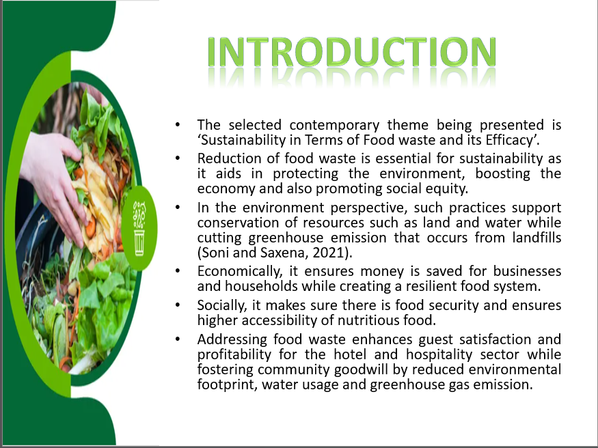
On viewing food waste to be a resource and by implementing sustainable strategies for food management, it is possible for the societies to create a resilient system of food which is beneficial for the economy, environment and the people.
The significance of the hotel and hospitality sector is high due to the economic contributions like boosting national GDP and creating jobs (Parfitt, Croker and Brockhaus, 2021). The sector plays a vital role for tourism with promotion of local development and cultural exchange by supporting businesses and encouraging infrastructural investment.

Literature Review
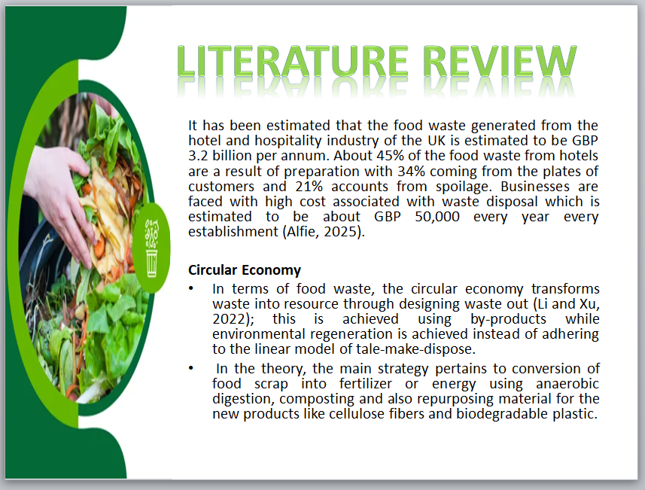
The advantage of circular economy is the potential for achieving long term benefits economically and environmentally like waste reduction, low consumption of resources, creation of job and higher innovation. The disadvantages of circular economy include higher initial infrastructural cost, scope of limited choices for consumers and the requirement of notable changes in the behaviour if the business and consumers for succeeding.
Theory of Sustainable Resource Management
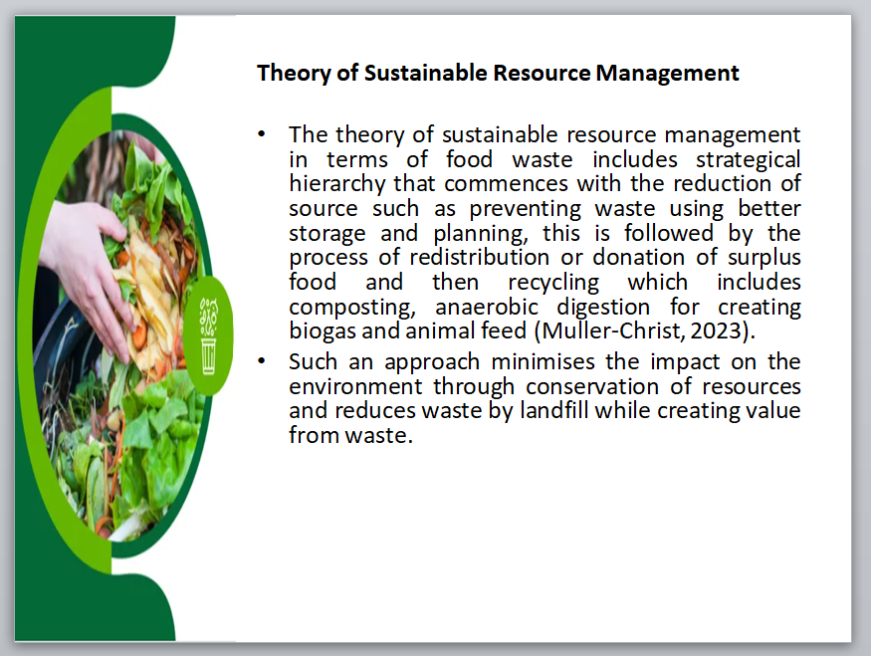
The advantages of such an approach include protection of the environment, cost saving and higher efficiency along with resource conservation and reputation enhancement. The disadvantages associated with the approach include higher initial cost, scope of social disruption from bigger projects and technological limitations.
Behavioural Theories
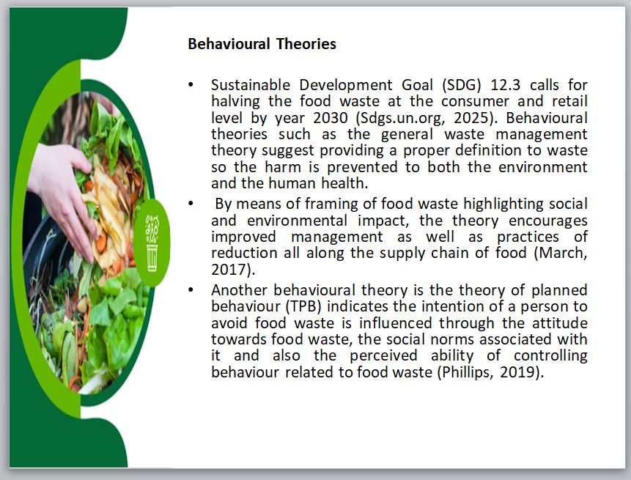
The advantages of the theory include health improvement, job creation, revenue generation, environmental protection and resource conservation while the disadvantages are high cost of implementing and maintaining, health risk to those working with hazardous materials and scope of pollution from incineration if management is inadequate.
The advantages of the theory include a comprehensive framework in terms of the predicting behaviour that is based on social norms, attitudes and also the perceived control on behaviour with the broader applicability in different fields. The disadvantages comprise of an over emphasis on decision making that is rational, low consideration for habitual and emotional factors and also the inability of completely accounting for environmental or situational constraints that build gap between the actual behaviour and the intended behaviour.

Methods
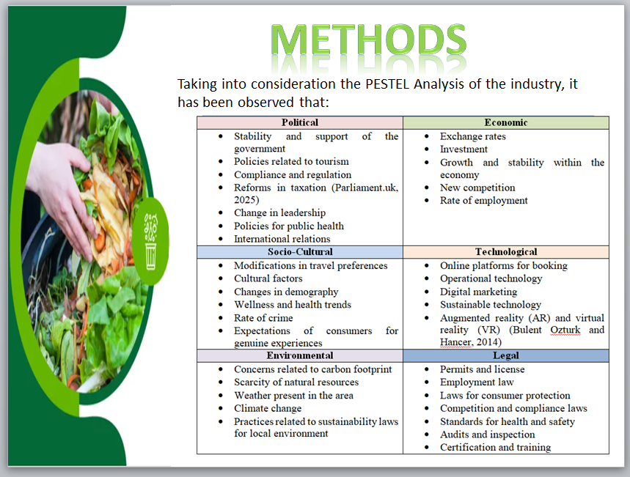
Sustainability in Terms of Food waste and its Efficacy has been an endeavour that has been focused on through improved reduction of food waste. The key strategies involved in the include smart technology for inventory and tracking, rethinking the supply chain by encouraging local sourcing and also implementation of operational changes such as staff training and portion control. Such efforts have improved on environmental sustainability and also boosted profitability along with brand reputation.
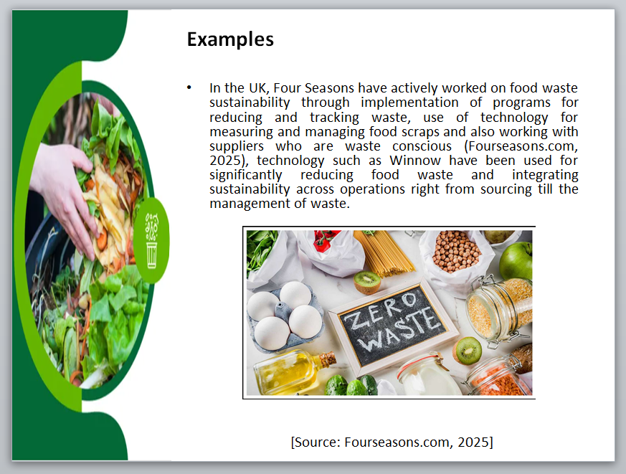
UK hotels have demonstrated mixed rate of success in food waste related sustainability with certain major chains being able to reduce waste notably using targeted initiatives though the industry on the whole still faces challenges.
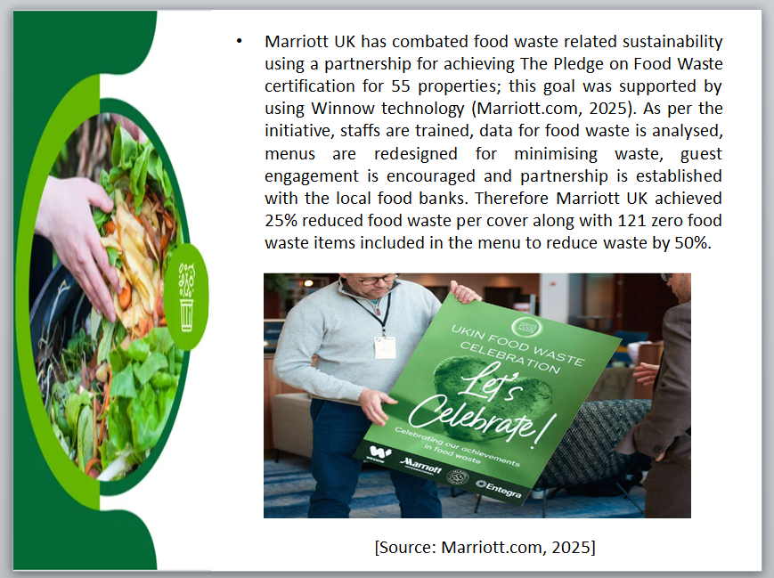
Success is driven with the adoption of AI powered tracking technology for waste, menu adjustments, waste reduction certification and staff training though till date, huge quantities of food is discarded that can be prevented.
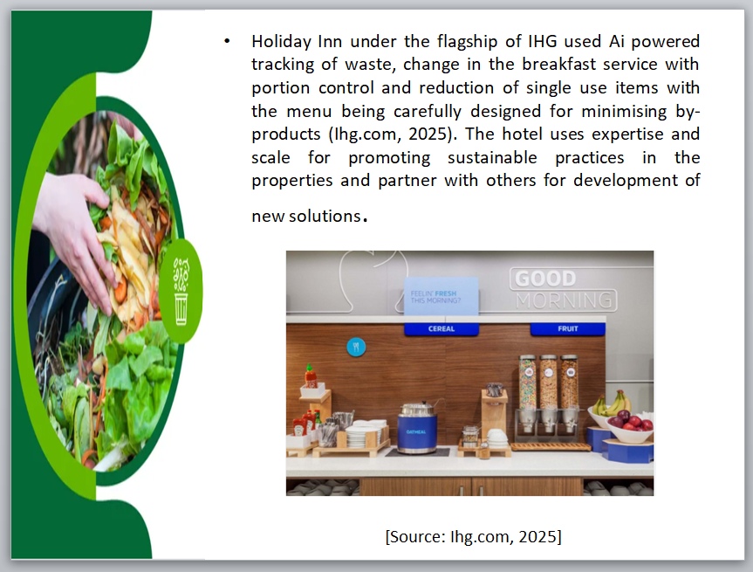
The hotel uses expertise and scale for promoting sustainable practices in the properties and partner with others for development of new solutions.

Conclusion
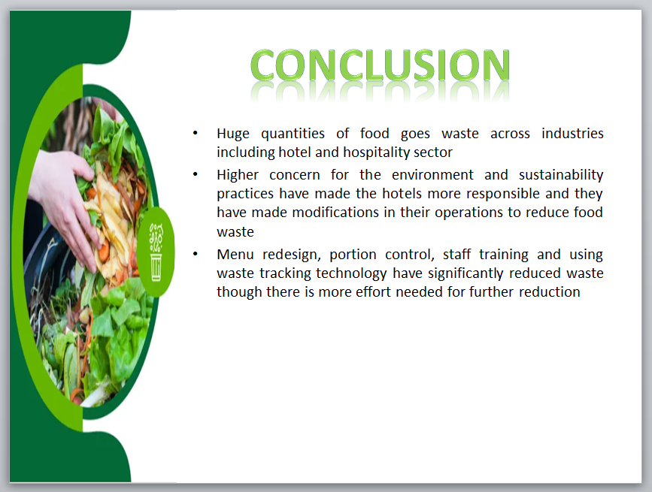
Food is required for energy, growth and basic health while the environment is crucial for wellbeing and human survival. As humans, a little effort towards food waste reduction and sustainability endeavours will benefit not only the businesses but the economy and the environment.

Recommendations
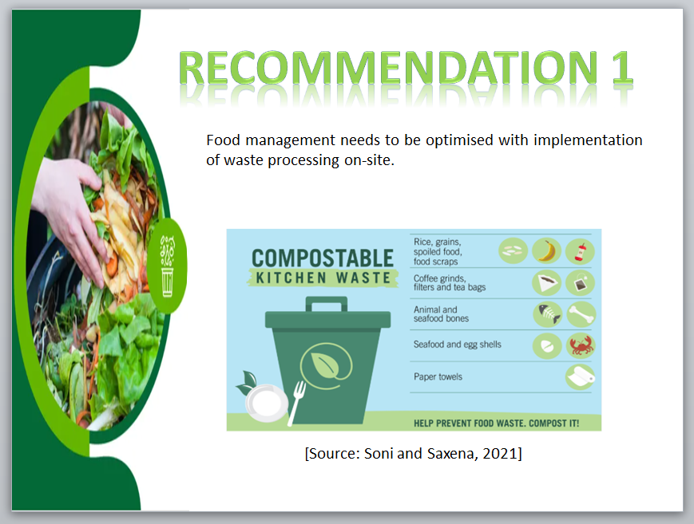
This would be a beneficial aspect for the business to ensure effective waste management process in place.
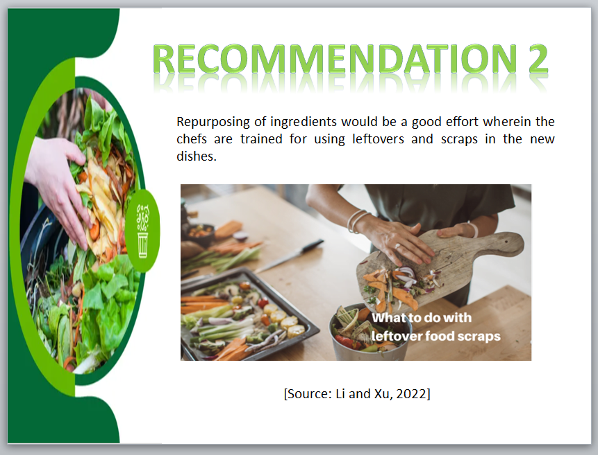
Making use of the leftover food is best way to reduce wastage further and employee training would can help the business attain its targets.
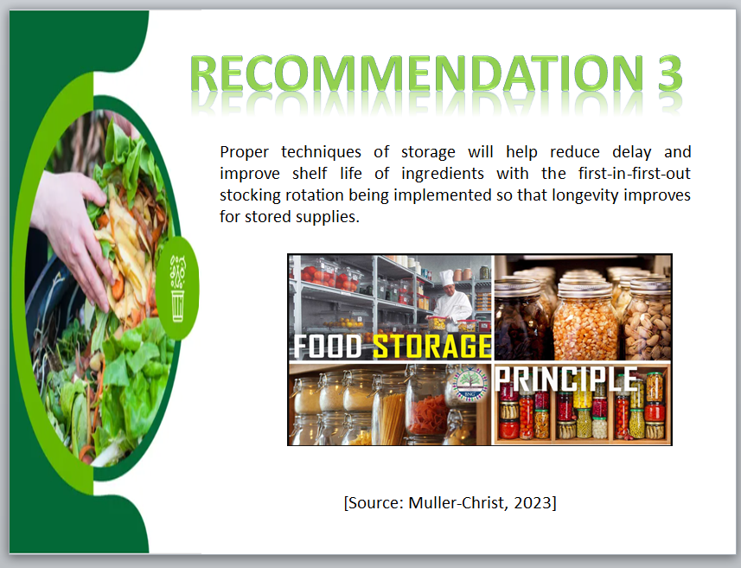
Ensuring longer shelf life of the food items can not only lead to cost savings as the material requirements can be controlled but would also help in betterment of supply chain management.

Reference
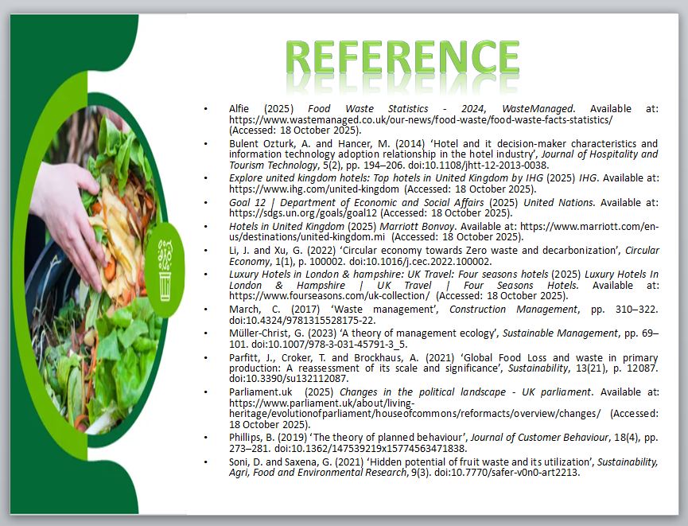
Alfie (2025) Food Waste Statistics - 2024, WasteManaged. Available at: https://www.wastemanaged.co.uk/our-news/food-waste/food-waste-facts-statistics/ (Accessed: 18 October 2025).
Bulent Ozturk, A. and Hancer, M. (2014) ‘Hotel and it decision-maker characteristics and information technology adoption relationship in the hotel industry’, Journal of Hospitality and Tourism Technology, 5(2), pp. 194–206. doi:10.1108/jhtt-12-2013-0038.
Explore united kingdom hotels: Top hotels in United Kingdom by IHG (2025) IHG. Available at: https://www.ihg.com/united-kingdom (Accessed: 18 October 2025).
Goal 12 | Department of Economic and Social Affairs (2025) United Nations. Available at: https://sdgs.un.org/goals/goal12 (Accessed: 18 October 2025).
Hotels in United Kingdom (2025) Marriott Bonvoy. Available at: https://www.marriott.com/en-us/destinations/united-kingdom.mi (Accessed: 18 October 2025).
Li, J. and Xu, G. (2022) ‘Circular economy towards Zero waste and decarbonization’, Circular Economy, 1(1), p. 100002. doi:10.1016/j.cec.2022.100002.
Luxury Hotels in London & hampshire: UK Travel: Four seasons hotels (2025) Luxury Hotels In London & Hampshire | UK Travel | Four Seasons Hotels. Available at: https://www.fourseasons.com/uk-collection/ (Accessed: 18 October 2025).
March, C. (2017) ‘Waste management’, Construction Management, pp. 310–322. doi:10.4324/9781315528175-22.
Müller-Christ, G. (2023) ‘A theory of management ecology’, Sustainable Management, pp. 69–101. doi:10.1007/978-3-031-45791-3_5.
Parfitt, J., Croker, T. and Brockhaus, A. (2021) ‘Global Food Loss and waste in primary production: A reassessment of its scale and significance’, Sustainability, 13(21), p. 12087. doi:10.3390/su132112087.
Parliament.uk (2025) Changes in the political landscape - UK parliament. Available at: https://www.parliament.uk/about/living-heritage/evolutionofparliament/houseofcommons/reformacts/overview/changes/ (Accessed: 18 October 2025).
Phillips, B. (2019) ‘The theory of planned behaviour’, Journal of Customer Behaviour, 18(4), pp. 273–281. doi:10.1362/147539219x15774563471838.
Soni, D. and Saxena, G. (2021) ‘Hidden potential of fruit waste and its utilization’, Sustainability, Agri, Food and Environmental Research, 9(3). doi:10.7770/safer-v0n0-art2213.

