Title: Appraisal on Premier Inn brand awareness and marketing strategies
MARKETING MANAGEMENT – ASSESSMENT 1
MBA- Masters of Business Administration

Name of the Student
Name of the University
Student ID

Table of Contents
Introduction 3
Overview of the selected organisation 3
Current efficient marketing systems and strategies of selected organisation 5
Differentiated value proposition of Premier Inn 7
Strategies to be taken to create innovative marketing strategies for raising awareness of the brand 8
Evaluating the customer journey across a variety of communication channels 10
Strategies to be meet current and future stakeholders’ expectations 11
Conclusion 12
References 13

Introduction
Marketing management is referred to as a procedure characterised by planning, execution, and carefully tracking the overall marketing strategies of a business enterprise (Adams, Freitas and Fontana 2019). In the competitive environment of contemporary businesses, it becomes very important for organisations to strategise marketing goals as impeccably as possible (Velu and Jacob 2016). However, strategizing marketing approaches would not serve the purpose of acquiring the target customer base for long term unless, the management process is at place. This becomes vital due to constantly changing business landscape, brand awareness, advancement in digitalisation, competitiveness, and increasing needs and customer expectations (Farida and Setiawan 2022). In this context, the present task is about an organisation and the wide range of challenges and criticalities that it has experienced over the years. A thorough analysis of such problems will be conducted with the aim of suggesting improved marketing strategies based on the value proposition of the business enterprise. The recommended strategies would be so made, that the company would be able to enhance its brand awareness and strategically fulfil long-term customer needs in the competitive market. Throughout the report, relevant discussions will be made based on appropriate theoretical models.

Overview of the selected organisation
The business enterprise chosen for this task is Premier Inn, one of the largest hospitalities (hotel) brands based in England, United Kingdom. It is a limited-service hotel operating in a wide variety of locations across England, including suburbs, city centres, as well as airports (Premierinn.com 2023). Originally, the hotel was started in 1987 as a small Travel Inn by Whitbread. The hotel chains operate with diligence and fervour and majorly compete with Ibis and Travelodge hotels in terms of customer acquisition and preferences in the consumer market of the UK hospitality sector. Over the years, the business acquired potential revenues and customer base, and finally in the year 2004, the acquisition of another hotel chain by Whitbread, marked the beginning of Premier Lodge for almost £536 million (Brandrepublic.com 2023). Sooner, Whitbread had merged Premier Lodge with Travel Inn, and named the hotel chain, Premier Inn, that characteristically accounts for nearly 70% of the annual earnings of Whitbread. Premier Inn operates in several countries including Qatar, Germany, Isle of Man, Ireland, United Arab Emirates, and many more. Most hotels of the Premier Inn have been newly established, although many of them are housed within the inner-city areas across the country
Reportedly, the hotel business has more than 72, 000 rooms and almost 800 outlets all over the world (Bbc.co.uk 2023). The hotel rooms feature suite facilities worth almost £307m pre-tax profit (Campaignlive.co.uk 2023). The hotel chain has acquired great prominence and market reputation all over the UK over the years and have significantly acquired huge customer base in due course. Customer convenience, quality and supremacy are the major elements that Premier Inn offers to win customer loyalties with its services. The hotel provides several work placements and apprentice services to young people, thereby demonstrating its strategic commitment and inclination towards corporate social responsibility as well.
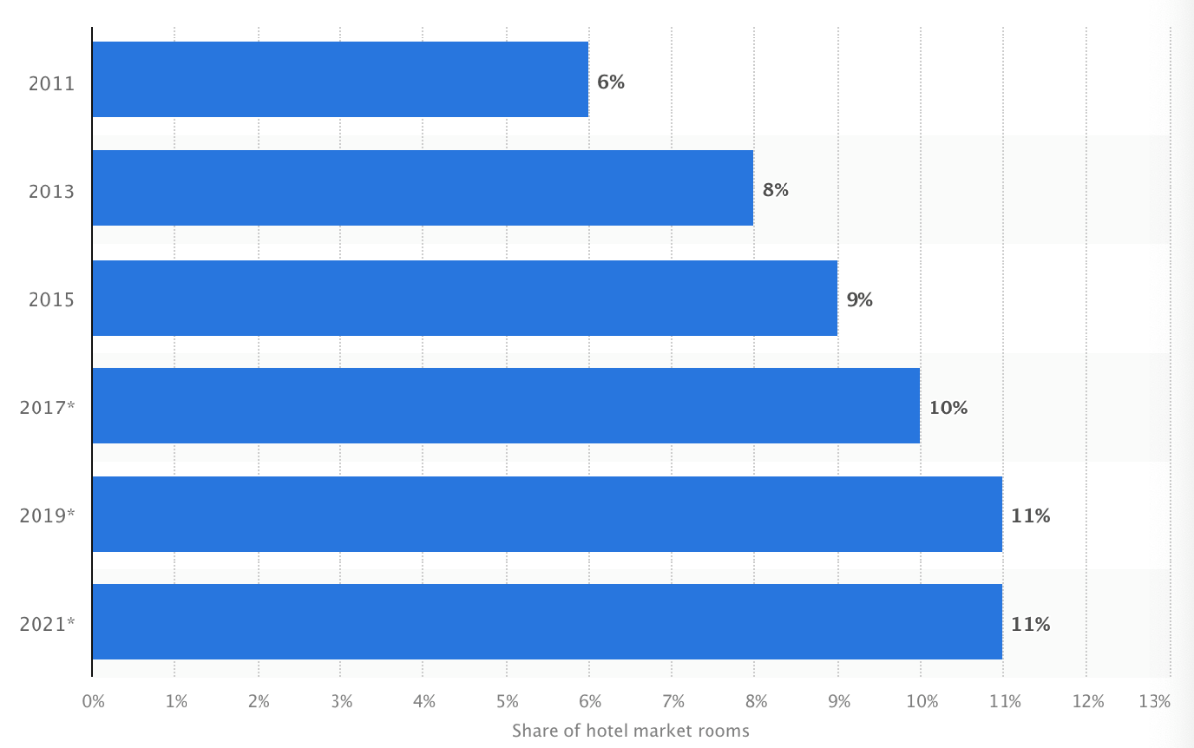
Figure 1: Hotel room shares of Premier Inn in the UK between 10 years
(Source: Statista.com 2023)
At the same time, Premier Inn has also sold off many of its smaller hotel chains to Good Night Inns, of which mostly all hotel groups have been a part of Premier Lodge sites in prominent locations. Premier Inn is one of the first hotel chains to invest in television advertising based on prime time. Even when the merger happened, animated adverts have been used to systematically advertise the overall merger process (Campaignlive.co.uk 2023).
Challenges faced by the chosen organisation
Over the years, Premier Inn has adopted various strategic approaches that have led to the onset of a wide variety of challenges. Especially, after the onset of the covid-19 pandemic, the strategic operational activities and internal pace of the hospitality sector of the UK facilitated increasing challenges for Premier Inn as well (Premierinn.com 2023). While some issues have been common across the entire business sector, others have had long-term consequences that must be addressed with continuity in the present consumer market of the United Kingdom. Some of the major challenges faced by Premier Inn are discussed as follows:
Severe staff shortage
The unprecedented effect of the pandemic incurred huge economic crises for Premier Inn due to lack of sales and customer revenues (Premierinn.com 2023). Under these circumstances, the hotel faced severe manpower crises as well. The hotel chain confirmed that hospitality-wide staff shortage represented a material number of potential vacancies that remained unfilled (Bbc.com 2023). One of the major reasons behind staff shortage is the sudden cutdown on remuneration by the hotel management, followed by staff attrition which affected the customer service facilities offered by Premier Inn to a greater extent. Employee costing is among a wide variety of price pressures facing most businesses and, in this aspect, Premier Inn also faced rising utility costs. Under such circumstances, Whitbread also introduced employee retention bonus of almost 10 million euros annually which imposed significant cost burden on the hotel in the most uncertain time as a whole.
Dealing with disruption and issues in supply chain
From logistics disruption, to labour, and workforce segment, the global pandemic has adversely affected all segments of the hotel’s supply chains. Reportedly, deficit in labour supply resulted in poor competitive performance of Premier Inn among other hotel chains across the local region of Dunstable, UK (Theguardian.com 2023). This not only impacted customer service and hospitality performance of Premier Inn, but also substantially, resulted in customer losses followed by economic downturns for the hotel chains. Disruption in sales and distribution of customer services also reduced the long-term brand awareness of the hotel across Dunstable and other areas of the country.
Training gaps and ineffective customer service
Following staff shortage, it is necessary for managers to introspect existing managerial strategies and identify training needs of employees (Theguardian.com 2023). In this aspect, Premier Inn’s training customisation has been significantly low due to lack of management perspectives and strategised actions. This is perhaps one of the other reasons most employees decided to switch brands in the most uncertain pandemic phase in the wake of better opportunities and career prospect. Training deficits not only impacted staff performance, but also left customers with a disappointing experience from the hospitality services, reflected in several online platforms (Reuters.com 2023).
Recruitment and selection inadequacy
Hiring and retaining talented staff has been one of the most common challenges facing Premier Inn in the hospitality sector of the UK. The increase in labour cost is the main reason behind the human resource issues in staff recruitment as per staff experiences. As stated in Reuters.com (2023), to satisfy day-to-day business targets, Whitbread adjusted with such increasing pay scale to some extent, but it has significantly enhanced costing pressure on the management throughout the phase of the global pandemic and even afterwards.

Current efficient marketing systems and strategies of selected organisation
The contemporary marketing system and strategies used by Premier Inn mainly focus on creative customer services to enhance guest experience. To boost customer experience substantially, the hotel chain has introduced a wide range of technological segments. Reportedly, the hotel chain is available through most GDS-based platforms including Galileo, Amadeus, and more (Premierinn.com 2023).
The Brand Equity Model of Keller can be used to elucidate the current marketing system and approaches of Premier Inn. As stated by Prachaseree, Ahmad and Isa (2022), to develop a strong brand, it is necessary to shape how potential customers feel or think about a given product or service of the brand. It is necessary for businesses to facilitate ways that offer the most appropriate customer experiences around the brand.
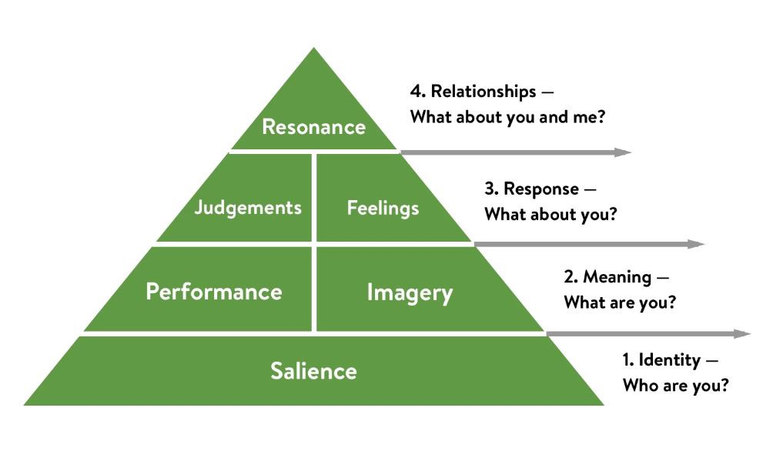
Figure 2: Keller’s framework of brand equity
(Source: Self-developed)
In the present case of Premier Inn, the hotel’s salient marketing prospects is based on advertisements on various platforms including social networking sites. This is how Premier Inn promotes its identity by strengthening its corresponding brand awareness among customers. That is, promotional marketing system is very strongly and saliently associated with the effectiveness of the hotel. As per Premierinn.com (2023), Premier Inn aims to strategically invest almost 20 m euros into marketing with the focus on expanding its reach over digital platforms. This has significantly boosted the strategic performance and competitiveness of the hotel brand over others in the hospitality sector of the UK. In simpler words, the company not only enhances brand identity or awareness, but also seeks to ensure that all perceptions concerning the hospitality brand are appropriate to customers at each phase of the buying process. This also defines the concept of imagery that determines how effectively a brand can meet consumer needs on socio-psychological levels (Prachseree, Ahmad and Isa 2022). In this case, Premier Inn resorts its strategies by taking consumer feedback very carefully and re-iterate part of its strategic marketing processes as per customer needs. Dev (2022) shows that beyond marketing processes, Premier Inn has channelised an “invest to win” framework to offer convenience and quality not just to leisure customers, but also to business visitors. All these strategic targets are provided by Premier Inn at a very affordable budget to make people and systems feel positive about the services offered, without any operational barrier. Using such strategies, Premier Inn has significantly received huge brand response in the UK market; yet lack of management consistency is the major reason behind the operational and customer retention issues faced by the hotel.

Differentiated value proposition of Premier Inn
Premier Inn in United Kingdom as a hotel chain is one of the largest hotel brands in the United Kingdom with more than 72,000 rooms and 800 hotels. It has its presence in varied vicinities in the country such as city centres, suburbs, and airports. Value proposition refers to the value that delivers the consumers valuation for the purchases. The products and services need to be attractive to bring better engagement to the brand. The value proposition needs to be communicated to consumers either through direct promotion or through the website of the company. The value proposition must be persuasive towards the consumers. The customer value proposition helps the companies to convince the consumers to purchase the products and services and provides additional value to the consumers over the competitors. As per the view of Bailetti and Tanev (2020), the value of the firm can be enhanced among all stakeholders by aligning them to the objectives of marketing. As per the model of Pokorna (2015) the business model canvas for value proposition represents the values offered to consumers. The value proposition presents the way the firms can create value to the consumers and creates values through Products and services which the consumers need to gain, and pain reliever attributes refers to the way consumers can get rid of the issues and challenges. The value Proposition canvas for Premier Inn represents the benefits that are useful to gain high consumer value. It brings more affordable pricing by competing in pricing strategies and focuses on environmental sustainability and enhancement of features.
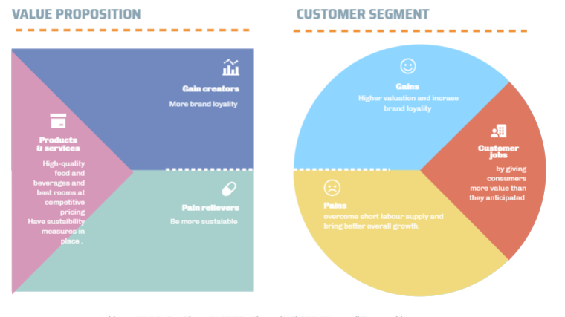
Figure 3: Value Proposition Canvas
(Source: Self-Developed)
The value Proposition canvas model depicts the way Premier Inn can utilize the varied facets in order to meet the challenges and bring better results. The products and services can be sustainable ways to give high-quality rooms and food or beverages services. The pain relievers are providing competitive pricing adding value to consumers and sustainability in its action adding value to all stakeholders. The gain creators refers to the gains that the stakeholders attain. The better valuation refers to the added value to consumers , employees and other stakeholders. The consumers perspective showcase that the consumers gain higher value and the pain is that there is increased costs and lower-ualty services. Premier Inn would ensure best quality services at highly competitive pricing and also provide more sustainability.

Strategies to be taken to create innovative marketing strategies for raising awareness of the brand
Premier Inn is a popular hospitality brand in the United Kingdom. The marketing strategy needs to be enhanced in order to raise brand awareness (Bernarto et al., 2020). Brand awareness and trust are important attributes as it entails in forming high valuable relationships to the consumers. Brand awareness refers to developing the brand equity and it is related to strengthening brand information that permits markets to measure consumers ability to identify the brands in varied conditions. Applying the innovative strategy to raise brand awareness is essential and the Brand Equity model by Keller can be applied in order to understand the varied aspects related to creation of new innovative marketing for raising awareness of the brand. As per the view of Çınar (2020), Customer-Based brand equity model, the power of branding shapes through the consumers learning. Keller has extended the Aaker brand equity model and differentiation of the consumers responses to the brand in line to the information about the brand for promoting the brand name. The CBBE (customer-based brand equity) model creates a high level of awareness and familiarity with the brand and brings strong and positive association to the consumers. The power of branding shapes the time through which consumers learn. The Keller Pyramid attributes four dimensions which are Identity, Meaning, Responses, and Relationships.
Brand Identity - This refers to the way the consumer refers to the brand and the way it is distinguished from others. The brand identity refers to the activity by the firms to make the consumers aware of the products and services.It is the first step in the equity model and essential to build brand awareness (Zia, Younus and Mirza 2021). Premier Inn can create brand awareness and identify the brand name by investing in social media channels to attract the larger target audience. It can use influencer marketing through latest social media portals to propagate the brand name. The influencers can showcase the brand offering such as high-quality services and sustainability in its efforts in order to draw consumers towards it. Though Premier Inn currently has a large base of followers on social media portals like Facebook or Instagram, it needs to invest in strategies like influencer marketing which is more popular in order to attract the target audiences.
Brand Meaning- The Brand meaning refers to the consumers becoming aware of the brand. The consumers must be made aware of the brand meanings. Brand Performance is an essential part of creating brand meaning. Brand performances entail loyalty of the consumers. The companies are more preferred which has attained success in performances.
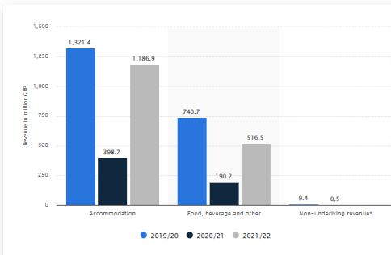
Figure 4: Revenues of the Premier Inn which is largest brand under United Kingdom
(Source: Statista 2023)
The pandemic showcased the revenues that are high for Premier Inn showcasing good level of performances. Hence the brand can promote its high growing performance recovering well after pandemic to showcase positive brand image to foster growth. The brand can collaborate with varied travel portals. The current state in varied travel portals such as Tripadvosr (2023) has high rating on the site for the hotel. It can flaunt the positive reviews of the company through varied portals showing positive performances. The next domain is brand image, this refers to target branding of the brand. One effective innovative marketing strategy can be to showcase the brand loyalty and its positive attributes such as using storytelling as a way to connect to prospective consumers increasing brand loyalty. Another way to promote Premier Inn can be showcasing the activities as part of community well-being and employee benefits in order to enhance brand value. The employees are more likely to be attracted to firms which bring community services and employee care as major attributes.
Brand Responses- Brand Responses refers to realty matching the expectation of the consumers. The happy and satisfied consumers contribute positive brand feelings and generate better brand attraction (Raji et al., 2020). The brand response for Premier Inn can be boosted through the customers providing high positive reviews to the hotel. Premier Inn must provide customer reviews to all guests and encourage them to fill them. A reward such as a discount for filling the reviews online in the next visit can be motivational attributes to draw consumers attention. This will be an effective way to grow its review base and get responses from consumers building a brand.
Brand Relationships- The Brand relationship refers to the thinking of the consumers, and the way they feel. (Keller 2020). Premier Inn must promote the brand in effective ways and ensure high-quality services to ensure that consumers have positive relations to the brand.

Evaluating the customer journey across a variety of communication channels
According to Zhang and Huat (2019), it is essential to understand the buying behaviour of the consumers. The customer buying behaviour model is essential to understand to promote the Premier Inn through varied communication channels it uses. The first domain is the need for recognition. In this aspect the consumer recognises the actual state of the services offered. They try to explore goods to satisfy their needs. Premier Inn must post customer reviews and real photos posted by consumers through travel websites in order to promote the Premier hotel amenity and services it offers. It leads to the second stage which is information search. The consumers try to explore as much as possible about the brand. Premier ion needs to be active on all travel portals, and hotel booking websites and also utilise SEO optimisation in order to rank high on the web pages for search. This will bring greater awareness of the brand offerings. The third stage is the information used by consumers and evaluating alternative brands. After that buyers make purchases by selecting the most suitable. With competitive pricing, high-quality food and beverage and rooms, along with suitability operations and encouraging pet-friendliness to attract a higher target population along with good views in the accommodation domain and open green spaces and centralised location of its hotels, it attracts consumers towards selecting the brand. The post-purchase evaluation is important for return consumers and word of mouth. Hence ensuring services and offerings as per the offerings promoted and ensuring positive online reviews will be helpful. It creates better word of mouth promotion as well.

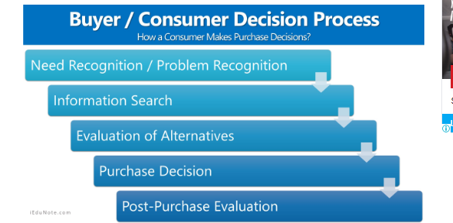
Figure 5: Consumer Buying Behaviour Model
(Source: Self-Developed)

Strategies to be meet current and future stakeholders’ expectations
Premier Inn has a strong brand presence and image. Ot needs to ensure new strategies to cater to all stakeholders needs, especially the employees whose best productivity will boost company brand awareness and positive image auditing in rebounding higher revenues. The customers have another major segment in stakeholders as they provide the boost to the revenues and sales and form the major crux of the brand image through online reviews of the hotel through online sites. The strategies that can be implemented are as follows:
Target new consumers by making the hotel pet-friendly
Showcasing its community practice such as beginning charity and environmental sustainability efforts as using solar power in certain hotel segments to save non-renewable sources of energy.
Nurture the flow of feedback from consumers and identify the loopholes identified by consumers and working upon them.
Create effective campaigns online and promote through influencer marketing as well to create a larger brand awareness. It can use new techniques such story-telling as an attractive tool to draw target consumers' attention. Along with this it can apply the SEO optimization in order to ensure that through search results Premier Inn has a leading listing. Moreover, it must collaborate on all travel portals and hotel booking sites for paid promotions of the hotel. These are effective way to use communication channels to reach a wider audience.
Making new policies for promotion of employment such as rewards and pearls. Initiating upgrading training programs for all employees in order to understand latest needs and cater to them effectively.
Maximise the promotional offers by the hotel to the target consumers in order to draw their attention and make them select the hotel for purchase.
Upgrade the latest amenities with modern day equipment in order to meet the latest needs.
The logistics disruption from Pandemic has led to Premier Inn facing losses. Along to this the supply chain segment has been disrupted. In order to boom the company and rebound from pandemic losses and rebound brand awareness, it needs to upgrade to the latest supply chain strategies.
Using the online portals to give promotions to consumers in the post-pandemic era can be another effective way to reach out to larger target audiences. It can foster a large base of audience by providing attractive promotions and additional new services offered by Premier Inn such as new food items, pet-friendly areas and upgraded rooms.

Conclusion
In a nutshell it can be concluded that the report presents the fact that Premier Inn has a strong market positioning and it holds the ability to prioritise the needs of the consumers. Premier Inn can apply the innovative marketing strategies to showcase the brand and ensure the right application to bring positive buying purchase behaviours. The varied challenges pertaining to Premier Inn has been elucidated as staff shortages, training and development gaps creating hollow in efficient consumer services, and issues in supply chain. These can be overcome as elucidated by adopting right strategies to meet all stakeholders needs. The major stakeholders are consumers, and employees which contributes to the growth and success of the firm. By ensuring efficient services to consumers and ensuring right human resource staffing and training the marketing objectives and branding for Premier Inn can be fulfilled.

References
Adams, P., Freitas, I.M.B. and Fontana, R., 2019. Strategic orientation, innovation performance and the moderating influence of marketing management. Journal of Business Research, 97, pp.129-140. [Available at: https://www.sciencedirect.com/science/article/pii/S0148296318306891]
Bailetti, T. and Tanev, S., 2020. Examining the relationship between value propositions and scaling value for new companies. Technology Innovation Management Review, 10(2).[Available at: https://timreview.ca/article/1324]
Bbc.co.uk 2023. Downturn hits Premier Inn sales. Available at: http://news.bbc.co.uk/2/hi/business/8102287.stm. [Accessed on 2nd Feb 2023]
Bbc.com 2023. Available at: https://www.bbc.com/news/business-59048014. [Accessed on 2nd Feb 2023]
Bernarto, I., Berlianto, M.P., Meilani, Y.F.C.P., Masman, R.R. and Suryawan, I.N., 2020. The influence of brand awareness, brand image, and brand trust on brand loyalty. Jurnal Manajemen, 24(3), pp.412-426.[Available at: http://ecojoin.org/index.php/EJM/article/view/676 ]
Brandrepublic.com 2023. Premier Travel Inn unveils rebrand after hotels merger. Available at: https://www.campaignlive.co.uk/article/premier-travel-inn-unveils-rebrand-hotels-merger/221132?src_site=brandrepublic. [Accessed on 2nd Feb 2023]
Campaignlive.co.uk 2023. Premier Travel Inn unveils rebrand after hotels merger. Available at: https://www.campaignlive.co.uk/article/premier-travel-inn-unveils-rebrand-hotels-merger/221132?src_site=brandrepublic. [Accessed on 2nd Feb 2023]
Çınar, K., 2020. Customer Based Brand Equity Models in Hotel Industry: A Literature Review. Strategic Innovative Marketing and Tourism: 8th ICSIMAT, Northern Aegean, Greece, 2019, pp.281-288. [Available at: https://www.researchgate.net/profile/Mounir-Elatrachi/publication/339812910_Determinants_of_ICT_Integration_by_Teachers_in_Higher_Education_in_Morocco/links/5ec31c49299bf1c09ac8f187/Determinants-of-ICT-Integration-by-Teachers-in-Higher-Education-in-Morocco.pdf#page=293]
Dev, C.S., 2023. About the International Centre for Hotel and Resort Management at the University of West London., pp.1-10. [Available at: https://www.researchgate.net/profile/Francis-Buttle/publication/290448158_Hospitality_Marketing_Principles_and_Practices/links/63ae174bc3c99660ebb38331/Hospitality-Marketing-Principles-and-Practices.pdf]
Farida, I. and Setiawan, D., 2022. Business Strategies and Competitive Advantage: The Role of Performance and Innovation. Journal of Open Innovation: Technology, Market, and Complexity, 8(3), pp.163-178. [Available at: https://www.sciencedirect.com/science/article/pii/S2199853122007648]
Keller, K.L., 2020. Consumer research insights on brands and branding: a JCR curation. Journal of Consumer research, 46(5), pp.995-1001. [Available at: https://watermark.silverchair.com/ucz058.pdf?]
Pokorná, J., Pilař, L., Balcarová, T. and Sergeeva, I., 2015. Value proposition canvas: identification of pains, gains and customer jobs at farmers' markets. AGRIS on-line Papers in Economics and Informatics, 7(665-2016-45080), pp.123-130.[Available at: file:///C:/Users/hp/Downloads/agris_on-line_2015_4_pokorna_pilar_balcarova_sergeeva.pdf]
Prachaseree, K., Ahmad, N. and Isa, N.M., 2022. Reviews of Brand Equity for Online Retailers. ABAC Journal, 42(1), pp.52-72. [Available at: http://www.assumptionjournal.au.edu/index.php/abacjournal/article/view/6077]
Premier Inn London euston hotel - hotel reviews, photos, rate comparison (no date) Tripadvisor. Available at: https://www.tripadvisor.in/Hotel_Review-g186338-d215522-Reviews-Premier_Inn_London_Euston_hotel-London_England.html (Accessed: February 2, 2023).
Premierinn.com 2023. About Premier Inn. Available at: http://premierinn.com/. [Accessed on 2nd Feb 2023]
Premierinn.com 2023. Covid-19 and Premier Inn. Available at: https://www.premierinn.com/gb/en/business-blog/five-big-challenges-facing-travel-managers-today.html. [Accessed on 2nd Feb 2023]
Premierinn.com 2023. Distribution partners. Available at: https://www.premierinn.com/gb/en/business/distribution-partners.html#:~:text=Request%20a%20callback-,GDS,Amadeus%2C%20Galileo%20and%20Apollo). [Accessed on 2nd Feb 2023]
Published by Statista Research Department and 15, J. (2022) Whitbread Revenue by Business Segment 2022, Statista. Available at: https://www.statista.com/statistics/739891/revenue-whitbread-united-kingdom-uk-by-segment/ (Accessed: February 2, 2023).
Raji, R.A., Mohd Rashid, S., Mohd Ishak, S. and Mohamad, B., 2020. Do firm-created contents on social media enhance brand equity and consumer response among consumers of automotive brands?. Journal of Promotion Management, 26(1), pp.19-49. [Available at: https://www.tandfonline.com/doi/abs/10.1080/10496491.2019.1612490?journalCode=wjpm20]
Reuters.com 2023. Available at: https://www.reuters.com/world/uk/premier-inn-owner-eyes-full-uk-recovery-2022-losses-narrow-2021-10-26/. [Accessed on 2nd Feb 2023]
Statista.com 2023. Premier inn shares of hotel rooms in the United Kingdom (UK) 2011-2021. Available at: https://www.statista.com/statistics/755691/premier-inn-share-of-hotel-market-rooms-united-kingdom-uk/. [Accessed on 2nd Feb 2023]
Theguardian.com 2023. Whitbread plans to offset rising cost at Premier Inn. Available at: https://www.theguardian.com/business/2022/jan/12/whitbread-plans-to-offset-rising-costs-with-higher-premier-inn-room-rates. [Accessed on 2nd Feb 2023]
Velu, C. and Jacob, A., 2016. Business model innovation and owner–managers: the moderating role of competition. R&D Management, 46(3), pp.451-463. [Available at: https://onlinelibrary.wiley.com/doi/abs/10.1111/radm.12095]
Zhang, Y. and Huat, G.K., 2019. Impact of Online Reviews on Consumer Post-purchase Attitude Change and Transaction Failure. [Available at: https://web.archive.org/web/20210815045832id_/https://aisel.aisnet.org/cgi/viewcontent.cgi?article=1636&context=icis2019 ]
Zia, A., Younus, S. and Mirza, F., 2021. Investigating the impact of brand image and brand loyalty on brand equity: the mediating role of brand awareness. International Journal of Innovation, Creativity and Change, 15(2), pp.1091-1106. [Available at: https://www.ijicc.net/images/Vol_15/Iss_2/15273_Zia_2021_E1_R.pdf]

