Richard Watson

The use of directional control valves and time delay circuits in Pneumatic Process Control
Electro hydraulics & pneumatics

Table of Contents
Introduction 2
Health and Safety 2
Pneumatic Circuit 3
Electro-Pneumatic Circuit 6
Price list for the Electro-Pneumatic Circuit 7
Conclusion 8
Bibliography 9

Introduction

For This assignment a task was set to design and produce a pneumatic and electro pneumatic circuit. The brief was that a polymer processing plant needs a system designed and priced both as a pneumatic and electro pneumatic to decide which would be the best. The two systems will require a safety guard to be lowered and then a thermoplastic blister pack to be welded together. The two sheets are placed onto the fixture which contains a heating element. Another heating element is then pressed to making contact with the sheets.
The circuit will have three double acting cylinders A,B and C, these will extend and retract simultaneously. As the Cylinder’s A and B make contact with the sheets they will be required to hold position for 12 seconds to weld the sheets together. After 12 seconds the piston A and B will retract. A guard is required on the circuit, which will lower once started and then raise once the operation has completed.
The cylinders in operation on the circuit will be labelled as A, B and C. A and B are the heating elements and piston C will be the guard.
The sequence of the circuit will consist of the following: C+ , A+ B+ 12 seconds A- B- C-.

Health and Safety

Health and Safety is essential within the workshops, Safety glasses must always be worn whilst at the rigs, with all bags and coats left tidily underneath chairs, ensuring there is no chance of accidents from trips or falls. The lecturer at the start of every session unlocks all safety doors and switches on the compressor.

Pneumatic Circuit

The design for the pneumatic circuit was first designed on the program OFT2, this is a great tool to have as it saves time and can be built safely with no mess, once happy with the design the system can be operated on the program with airlines that work correctly highlighted blue. This program also shows fittings moving as they would in a real-world situation. All fittings must be individually labelled to prevent conflicts. Once the diagram was complete the program produced a item list which can then be individually priced.

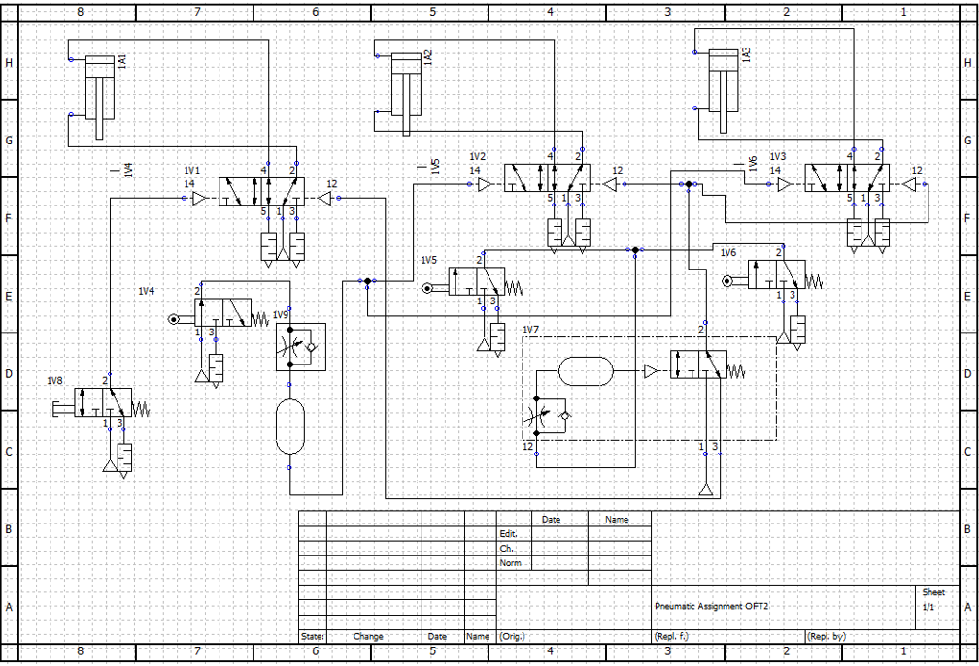

In the picture below is the fully pneumatic circuit. This method brought forward a lot of issues that needed attention to sort out. Some of these issues include cylinders A and B moving together, the guard cylinder being temperamental by not lowering and raising fully and also air leakages.
By using the split circuit fault finding technique which involves splitting the circuit in half and then proceeding by halves eliminating areas of the circuit searching for leaks. (Technology, 2020) The pressure regulator was set at 3 bar, which is the maximum setting for the fittings on the circuit. If the indicator showed a lower setting and a noise is heard then this indicated a leak. By using this process, a lot of issues were resolved.
The 3/2 way time delay unit was difficult to get right, it wasn’t possible to set it to exactly 12 seconds but got it to within 11 seconds. Another fault had occurred with the 5/2 way double pilot valve, as this was sticking. This was resolved by replacing this with another, allowing the cylinders to operate and function properly.

The final system is operated pushing the 3/2 way push button valve which allows air to travel along to the 5/2 double pilot valve, this then actuates the guard cylinder to extend C+, as the C+ extends it hits a 3/2 way roller valve which allows air to travel to another 5/2 way double pilot valves which connects to cylinders A and B, these cylinders then extend. A+ B + and hold extension for approximately 11 seconds, once they retract, the air from the exhaust from a timer delay sends air to the 5/2 double pilot valve for the guard to activate and C- will retract.

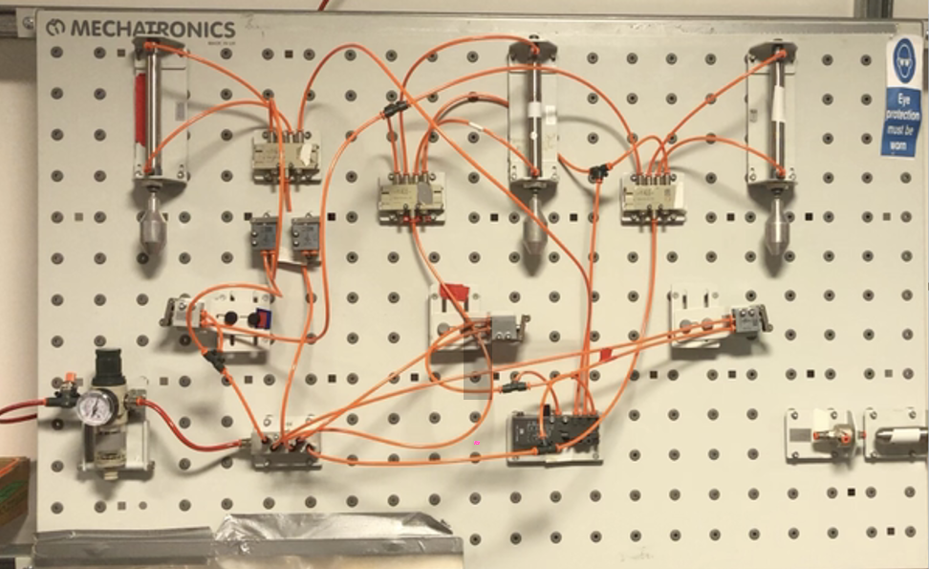

OFT2 Item List and Price list Pneumatic
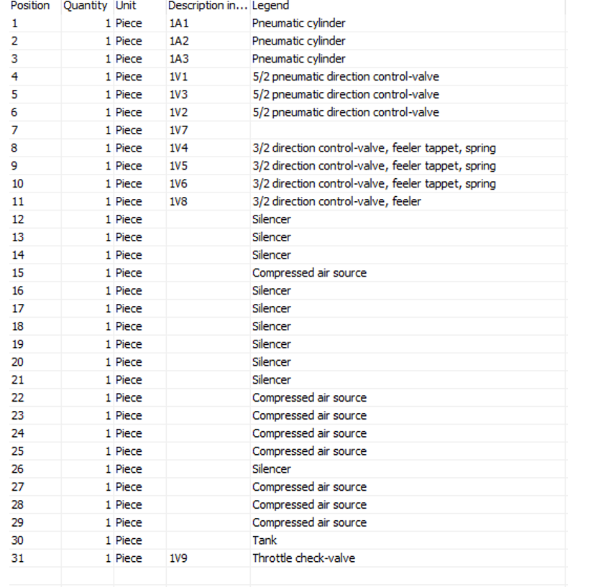
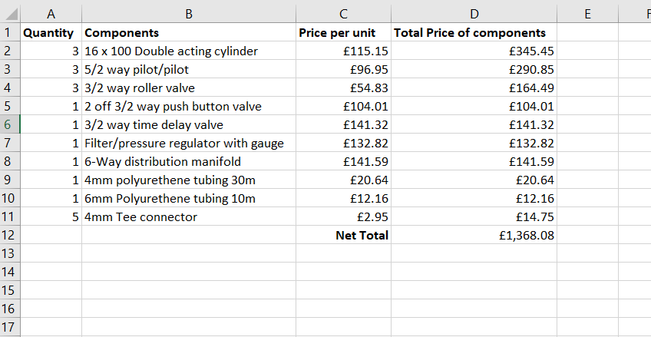

Electro-Pneumatic Circuit

Once a Pneumatic circuit had been perfected an electro-pneumatic design was required. The system is essentially the same but many of the fittings on the circuit are changed to fittings that use 12V d.c. The system straight away had a lot of conflicts and a decision was made to split the circuit into two separate systems, one for the guard and one for the press. (Technology, 2020)
The circuit starts with a push button which sends a signal to a solenoid which operates the double acting cylinder C, C+, this cylinder extends and hits a roller switch that sends a signal to operate a green light which tells the operator that the press button is ok to operate. The button for the press is operated which sends a signal to cylinders A and B, A+ B+ which then extend. once A+ B+ have extended a roller motion switch is then activated which sends a signal to an orange light showing that contact has been made with the sheet, the timer is then operated and delays the retraction of the cylinders for approximately 12 seconds. A relay switch is activated and allows the cylinders on the circuit to be retracted A- B-, once these have retracted the guard button can be pressed which then retracts the cylinder C-.
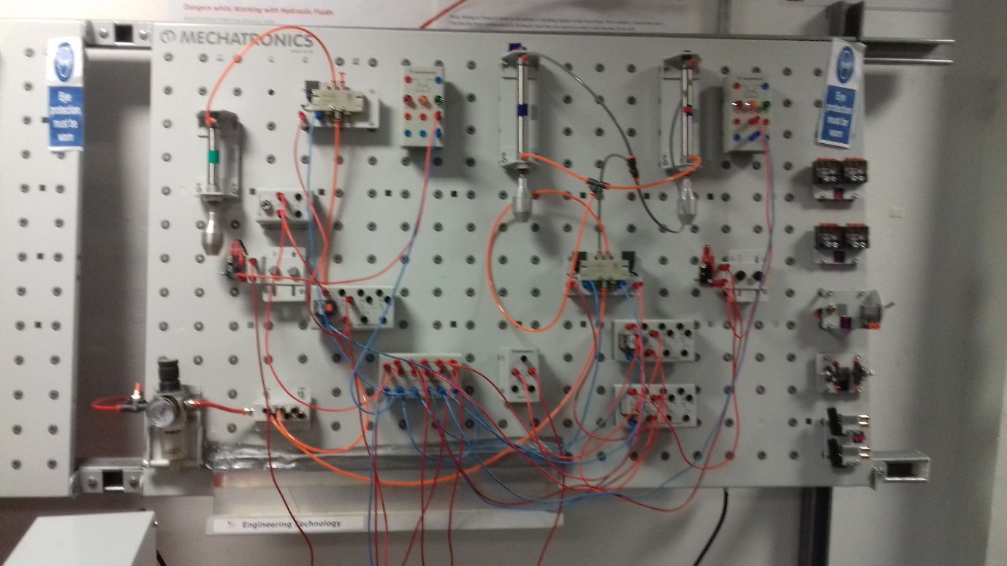

Unfortunately, the circuit diagram for this system could not be accessed on OFT2 on college computer system due to the college closure regarding the Covid 19 pandemic.

Price list for the Electro-Pneumatic Circuit

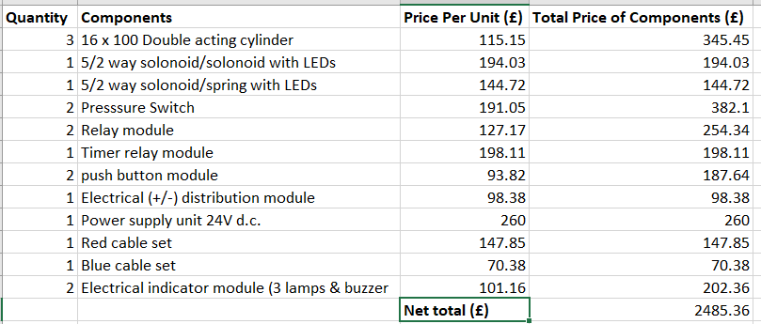

Conclusion

By creating a Pneumatic and Electro-Pneumatic versions of this project It was found that the Electro-Pneumatic was the more stable to run, whilst also being the neatest as all electrical wires can be hidden as they are very low maintenance, it was felt that even though it was the most expensive option, coming in at £2485.36, It was found that this method was far more reliable than the pneumatic circuit with far less complications.
There was a lot to be learned by doing the half split method for fault finding. By splitting the circuit in half and repeating the process for the rest of the circuit, the fault can be narrowed down to an individual component. (Technology, 2020)

Bibliography
Technology, L. (2020). https://www.ecmweb.com/maintenance-repair-operations/article/20889049/the-beauty-of-halfsplitting.

