University Of Wales Trinity Saint David Birmingham

Assignment Title | Task 2 – Research Report
Module | Digital Skills and Research Methods.
Module code | BMSW4003
Student Name | Raluca Maria Ionita
Student ID | 2120292
Lecturer | Ngozi Ibeji

Table of Contents
Introduction……………………………………………………………………………………...…….2
Task 2………………………………………………………………………………………………….2
Research design………………………………………………………………………………...……3
Ethical considerations………………………………………………………………..………………3
Results…………………………………………………………………………………………………4
Findings……………………………………………………………………………………………….5
Discussion…………………………………………………………………………………………….5
Conclusion…………………………………………………………………………………………….6
References……………………………………………………………………………………………7
Appendix 1……………………………………………………………………………………………8

Introduction
Virtual learning is a new kind of education that has the potential to alter the way people learn in the modern world. The instructor instructs students in a virtual classroom rather than in a one-on-one classroom setting by using online resources. Technology has made it possible for children to study from the comfort of their own homes in the same way as they would in a classroom (Jain, 2015). Virtual learning environments (VLEs) are becoming consolidated in educational institutions. As a result, it doesn't seem vital to examine their acceptability. However, it is difficult to make them a significant part of students' performance. There are many factors that impact student performance, making it practically impossible to identify all students and much more complex to quantify their effect on the likelihood of learning (Sneha, and Nagaraja, 2014).

Task 2.
A virtual learning environment (VLE) known as "Board" was shut down from public usage in 2000 despite the fact that computers have been utilised at the Open University in the UK since the early 1970s. More than 3700 educational institutions in over 60 countries utilised the Board's software in 2010. It was founded in 2001 and has evolved to be the second most well-known online learning platform since then. There are now over 49,365 dynamic destinations in more than 75 languages in 212 countries across the world thanks to Moodle's expansion since its 2001 beginnings. In order to help professors design online courses, Moodle was established with a main purpose of connecting students and facilitating collaborative content creation. A significant part of a country's formal education system is implemented in its educational institutions, and virtual learning environments have played a critical role in helping to support and promote formal education in several nations throughout the globe. VLEs have the potential to play a crucial role in supporting learning in non-formal and informal circumstances in the context of change and innovation, according to the authors According to their research, only logs, forum operations, and the amount of resources accessible were important indicators of success for students. Students' test scores varied by 21% as a result of these factors. Undergraduates' motivation was boosted by other students seeing their remarks, and they felt more passionate about taking on a functional role in the course as a result of collaboration tools like gatherings, according to Demian and Morrice study (2012). Students often choose for online classes over traditional ones because of the perceived convenience they provide.
As part of the "Online Education System (E-Learning Model)" project, Nagarajan and Jiji (2010) collaborated. To create an online educational system, a new paradigm has been presented. While the number of students and courses being given via the internet has increased, so has the demand for educational institutions to streamline their processes in order to fulfil the needs of both their students and their clients.
Raheem and Khan (2020) point out that the government is taking the required steps to avoid kids from being compelled to relocate during epidemics so that they may finish their education at home. It is for this reason that the federal government has pushed many educational institutions to put in place appropriate safety measures for online lectures to prevent the system from collapsing,
In order to find out how students with impairments may access virtual learning environments, the researchers set out to look at a variety of options (VLEs).
There is no escaping the influence of technology; it is inescapable. We are always surrounded by technology, whether we are checking our phones first thing in the morning or shutting down the lights after finishing the day's work on the internet. As a former elementary school teacher, I can attest to the positive impact that technology may have on a student's education. It's possible that in certain circumstances parents and teachers may see technology as a tool that has a negative impact on a child's ability to learn. I'd want to point out to you that effective use of technology in the classroom has the potential to boost student achievement. Our modern society's use of technology assists in the development of stronger character values, promotes student retention of course knowledge, and fits students' various learning styles.
Students benefit from the use of technological tools that help them develop stronger character traits such as teamwork, organisation, respect, leadership, self-confidence, and resourcefulness. The greater a student's chances of success in life are, the stronger their character values are. Google documents, for example, is a software tool that allows anybody who has access to the Google link to contribute to the document, which is often used at colleges.
Because technology supports students' individual learning methods, accommodates those with disabilities, enhances students' academic performance and helps them build strong character values, it is beneficial to students' academic success.

Research design
Quantitative methods were used with qualitative ones in this research as they have been in many others related to e-learning. We employed an approach that lays a heavy focus upon individual responses, behaviours, and experiences in order to gather data. The online questionnaire, which was distributed via the internet, had both closed and open questions. Questionnaires were filled out and then analysed in Excel for the quantitative research. WhatsApp was used to send out the survey link to anybody who wished to participate. The survey was provided this manner in order to make it as simple as possible. ten University students were invited to fill out the survey. Over the course of group training, understudies were encouraged to finish the review on their own. In order to estimate the size of a simple delegate test, an example size calculation was done based on the data. In order to get agent results, a reaction speed of 37% and a base example size of 10 were required. Prior to the end of the examination, students were made aware that the results of the evaluation would not be made public. As a result of the survey's completion, the study's data might be used in any manner. Before the final data collection, which will take place in one and a half weeks, a few reminder emails were sent out. To a large extent, the analysis takes on a simply descriptive tone. It is not necessary to offer descriptive statistics for the problem-solving questions since the remaining unresolved questions are small in number and may be documented without alteration.
Ethical consideration
To a large extent, the analysis takes on a simply descriptive tone. It is not necessary to offer
descriptive statistics for the problem-solving questions since the remaining unresolved
questions are small in number and may be documented without alteration. In order to conduct
the research, the author of the project, had to ask the participant to the study if they are
agreeing to take part in the survey, but also ensure their information it will be kept safe,
during and after the research.

Results

Question | Strongly agree | Agree | Neutral | Disagree | Strongly disagree
Are you confident in using MS Teams to work with your colleagues? | 8
3. Rank these applications in order of how confident you feel using them?  Ms Teams  VLE  Ms Word  Whatsapp  Moodle | 1st choice 12.5%  2nd choice 25%  3rd choice 37.5%  4th choice 12.5%  5th 12.5% choice
Is Moodle user friendly | 50% | 40% | 10%
Moodle has enhanced my learning | 50% | 30% | 15% |  | 5%
I feel confident using technology to collaborate with my peers or colleagues | 30% | 50% | 20%
Do you feel anxious if you are asked to collaborate using technology? | Yes 8  No 1
Do you see the value of using technology to collaborate

Findings
Moodle as a Virtual Learning Environment (VLE) has a positive influence on the students, who believe that it is an important learning tool that increases their efficacy as a student. In addition, Moodle has been shown to assist improve the quality of their learning, according to the findings. Not only that, but the vast majority of students believed that they learnt far more effectively with the assistance of Moodle than they would have without.
Students generally choose virtual learning environments (VLEs), although there are some concerns about accessibility and internet connectivity. These may prove to be ineffective for the student in the long run.
After much research, it has been determined that the only method to continue the teaching process during a pandemic is via the use of electronic media. It has been determined that virtual classes are now required in order to function properly.
Students with disabilities are unable to use the VLEs since they are not designed for them. This is a poor method of educating children.

Discussion
Most university students use Moodle on a daily basis, with just 10% doing so less often, according to a study that used it as a learning management system (LMS). They aid in the development of knowledge and meaning, the reconstruction of habits and behaviours, and the formation of new habits and behaviours in a context that is shared by all those involved in the educational process because they facilitate contact and interrelation in a continuous communication process (Alves, Miranda, and Morais, 2017).
50 percent of those who answered strongly and 40 percent agreed that Moodle is user-friendly. Ten percent of those in attendance were neutral. Because of its focus on interactivity and symbiotic content creation, Moodle was developed to aid instructors in creating online courses (Vaganova, et al., 2017). Moodle has a positive impact on students, according to 30 percent of respondents and 50 percent of those who didn't use it. Those who took the poll disagreed with this statement by 20%. Virtual learning environments (VLEs) have the potential to play an important role in promoting learning in non-formal and informal situations when seen from the standpoint of change and innovation (Vaganova, et al., 2017). According to these studies, it is clear that certain students do not like virtual learning settings.
As a whole (40% strongly agreed), while the rest (30%) agreed that Moodle gives information on every topic 20% of respondents who answered the poll question disagreed with the statement, while 10% were undecided. Schools, colleges, and businesses are increasingly turning to web-based educational systems to augment their conventional face-to-face instruction as well as to include online technology into their curriculum. Additionally, these systems gather information that is beneficial to students in their study of course material and the utilisation of learning environments based on technology and digital resources (Alves et al., 2017; Miranda et al., 2017; Morais et al., 2017). Fifty percent said they strongly agreed, and another thirty percent said Moodle has enhanced their educational experience.. However, 15% of those who replied were neutral, but 5% strongly disagreed with the claim, As a result of the data, it may be possible to anticipate how interested students are in their courses and institutions, as well as how likely they are to drop out of school (Stricker, Weibel, and Wissmath, 2011). Over two-thirds of those polled said they strongly agreed, and seventy-five percent said Moodle had increased their worth as a student in some manner. Ten percent of the students were unable to concur with the professor's comments. Demian and Morrice (2012) found that students' motivation rose when other students saw their contributed comments and that they were more willing to engage actively in the course because of the use of collaborative tools like forums. Students choose online courses because they are seen to be more convenient than face-to-face classes.
Many students find Moodle to be useful, with 50 percent strongly agreeing and 20 percent agreeing. Thirty percent of the students were in favour of remaining unaffiliated. There must be a thorough understanding of virtual learning environments (VLE) in order for them to be used effectively in any given setting. There are many different types of learning contexts and settings that develop from new educational ideas and behaviours in the digital society. Learning settings and contexts are other names for them (Alves, Miranda, and Morais, 2017).

Conclusion
In conclusion, technology is advantageous to students in ' academic achievement since it supports unique learning styles, accommodates persons with special needs, increases student learning, and aids in the development of strong character values among young people. Our contemporary world is fast changing, particularly when it comes to technology, and as educators, it is critical that we do all we can to mould the young minds of today for a brighter future. This involves incorporating technology and seeing it as a beneficial instrument to assist students in achieving their educational objectives. In general, the impact of technology on education is favourable, as long as it is utilised in the proper manner.

References
Abas, S (2019) Reading the world-teaching visual analysis in higher education.
Alves, P(2017) The influence of virtual learning environments in students performance.
Baker., ( 2013)The learning impact of virtual learning environment. Teacher education advance,ent.
Demian, P (2012) The use of virtual learning environments.
Jain, P (2015) Virtual learning environment. International journal of IT.
Kumar, G (2011) using moodle and virtual learning environment in the academic.
Gibbs, G (1988) A guide to teaching and learning methods.
Simkova, M (2013) Effective use of virtual learning environment
Sneha, J (2014)Virtual learning environments.

Appendix 1.
Are staff and students confident in using technology to collaborate? Yes No 1. Do you give your consent to this questionnaire? Yes No
2. Are you confident in using MS Teams to work with your peers or colleagues?
3. Rank these applications in order of how confident you feel using them
MS Teams
VLE
Ms Word
WhatsApp
Moodle
I feel confident using technology to collaborate with my peers or colleagues
Strongly Agree
Agree
Disagree
Strongly disagree
Option 5
Do you feel anxious if you are asked to collaborate using technology?
Yes No
Do you see the value of using technology to collaborate?
Yes/ No
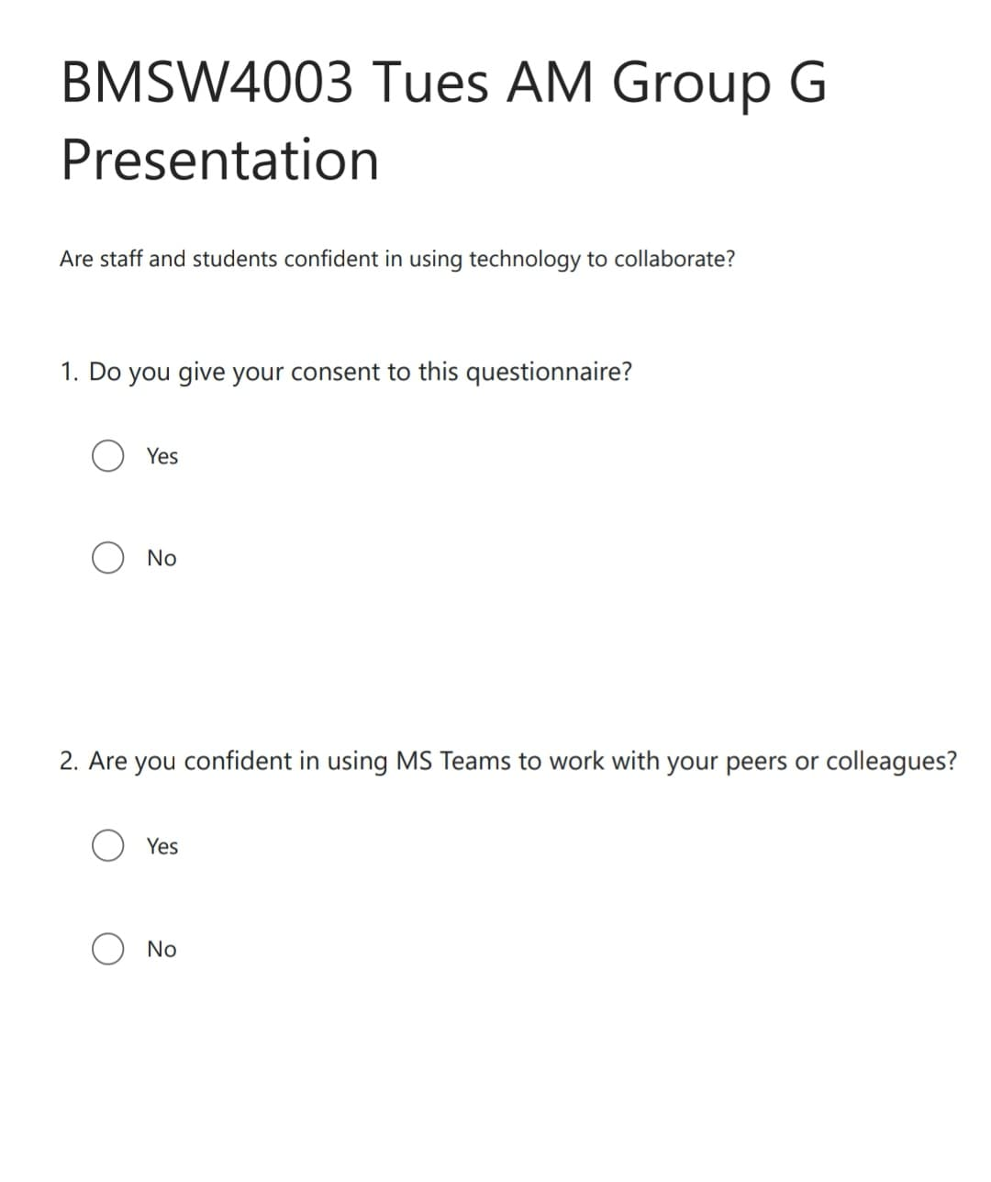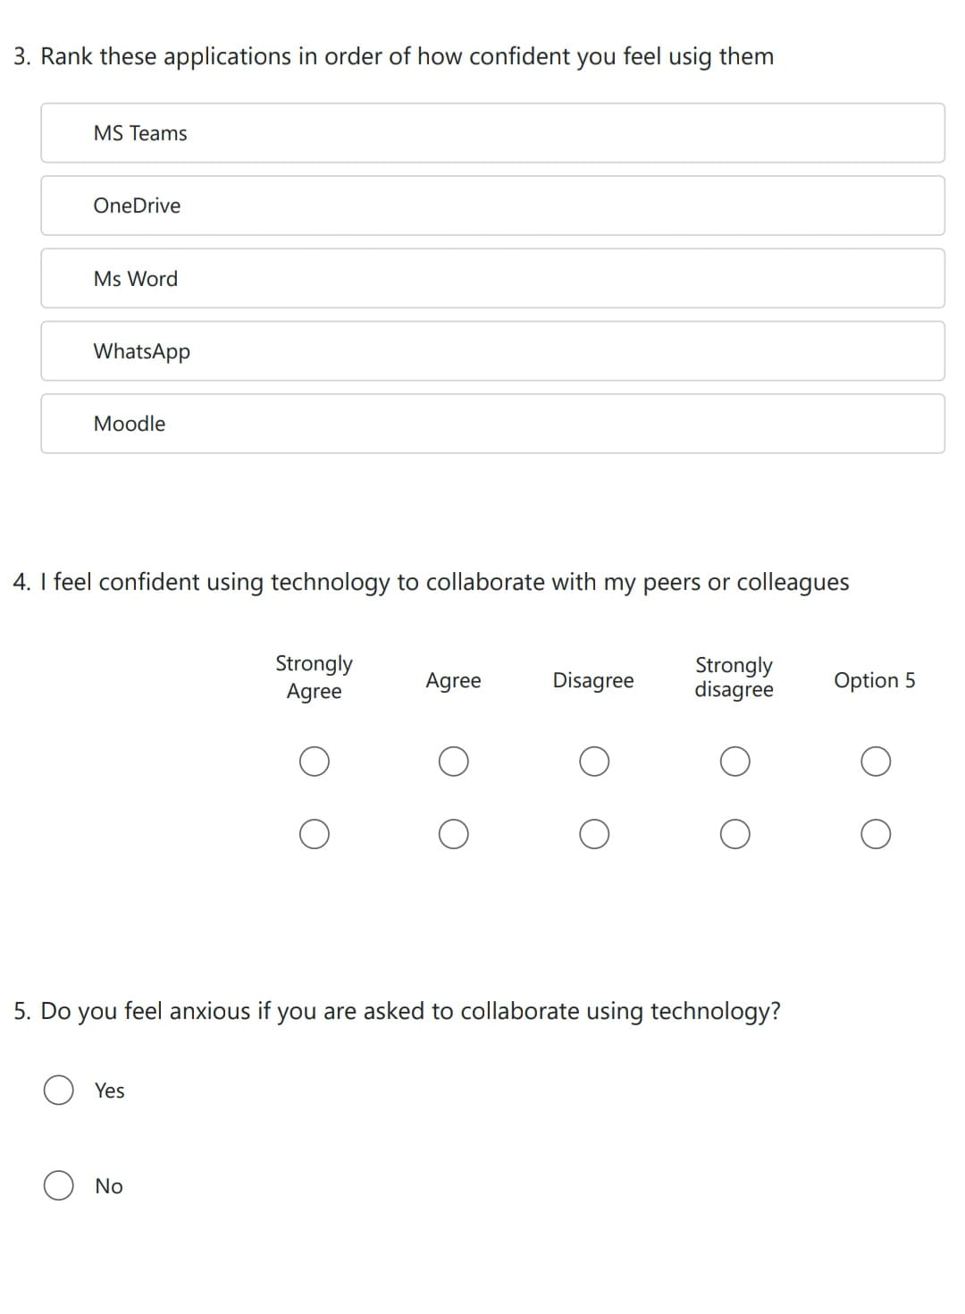
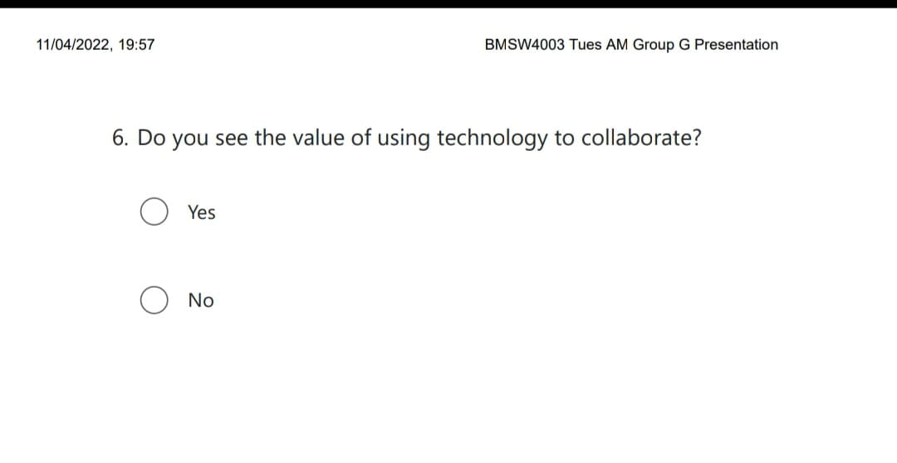

Responses to questionnaire


