Kai Tang

Electrical EXAM

22/01/2021

Words words words Words words words Words words words Words words words Words words Words words words Words words words Words words words Words words words Words words Words words words Words words words Words words words Words words words Words words Words words words Words words words Words words words Words words words Words words Words words words Words words words Words words words Words words words Words words Words words words Words words words Words words words Words words words Words words Words words words Words words words Words words words Words words words Words words Words words words Words words words Words words words Words words words Words words Words words words Words words words Words words words Words words words Words words Words words words Words words words Words words words Words words words Words words Words words words Words words words Words words words Words words words Words words Words words words Words words words Words words words Words words words Words words Words words words Words words words Words words words Words words words Words words

Q1
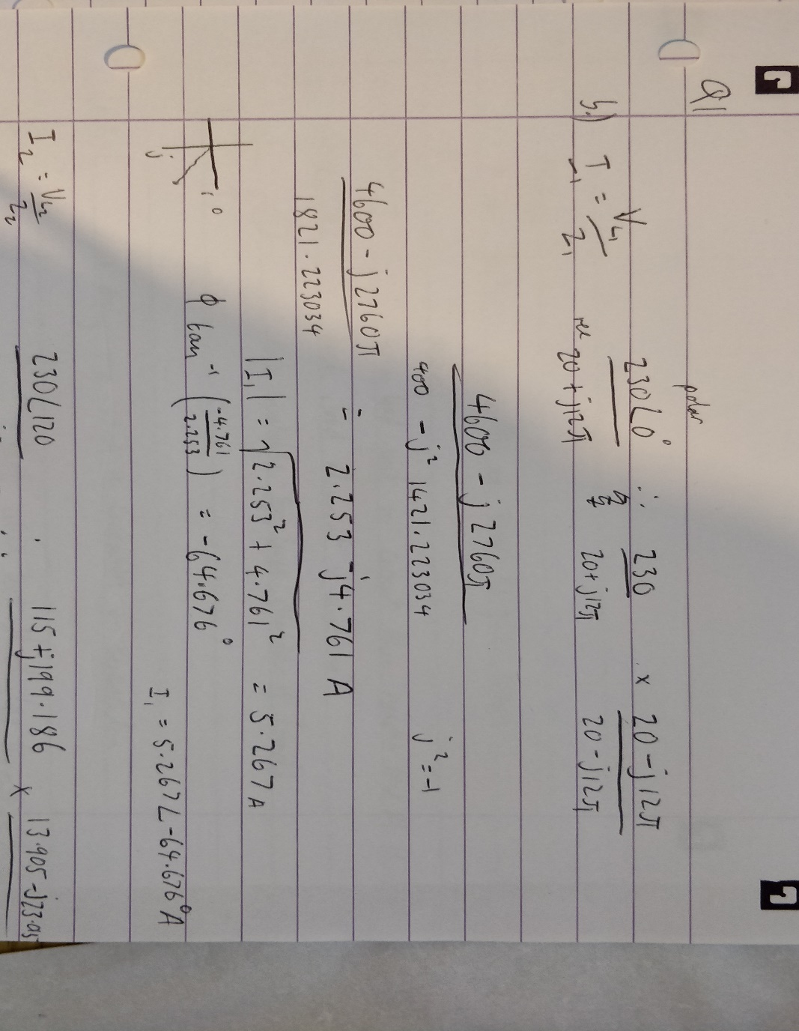

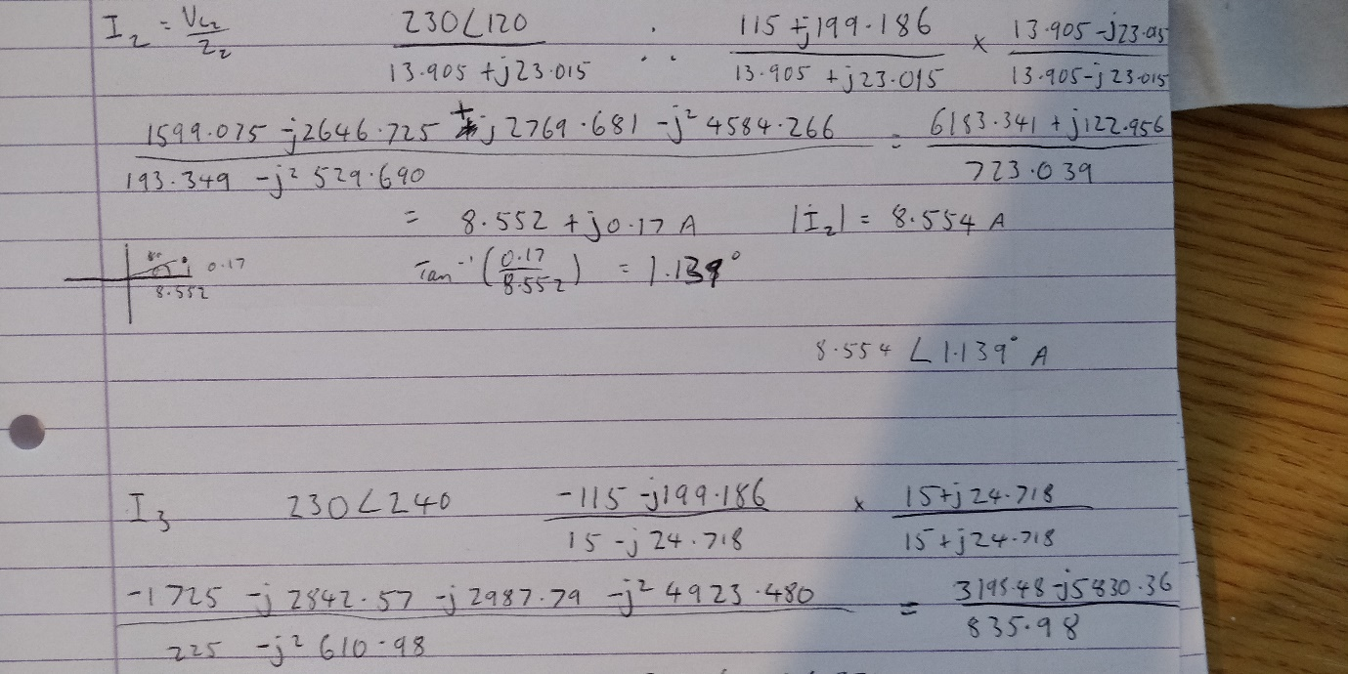

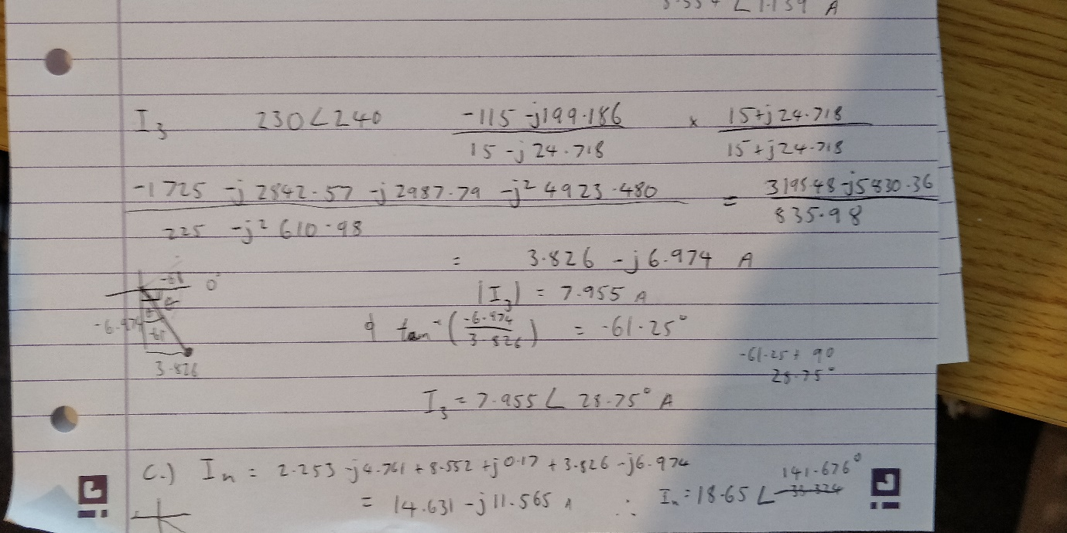

Q2

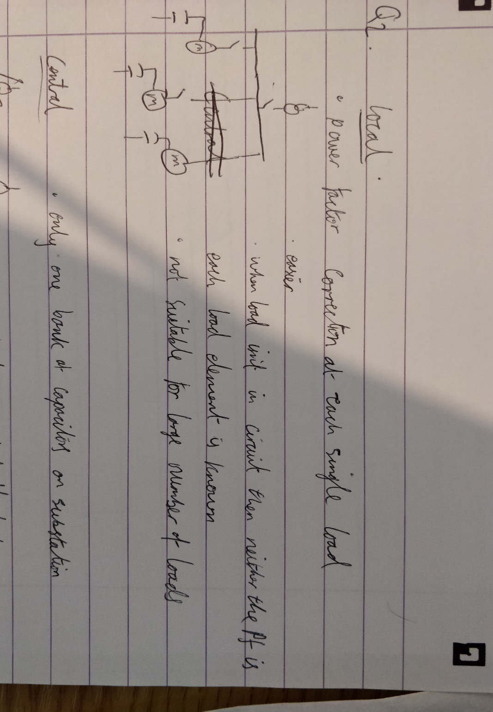

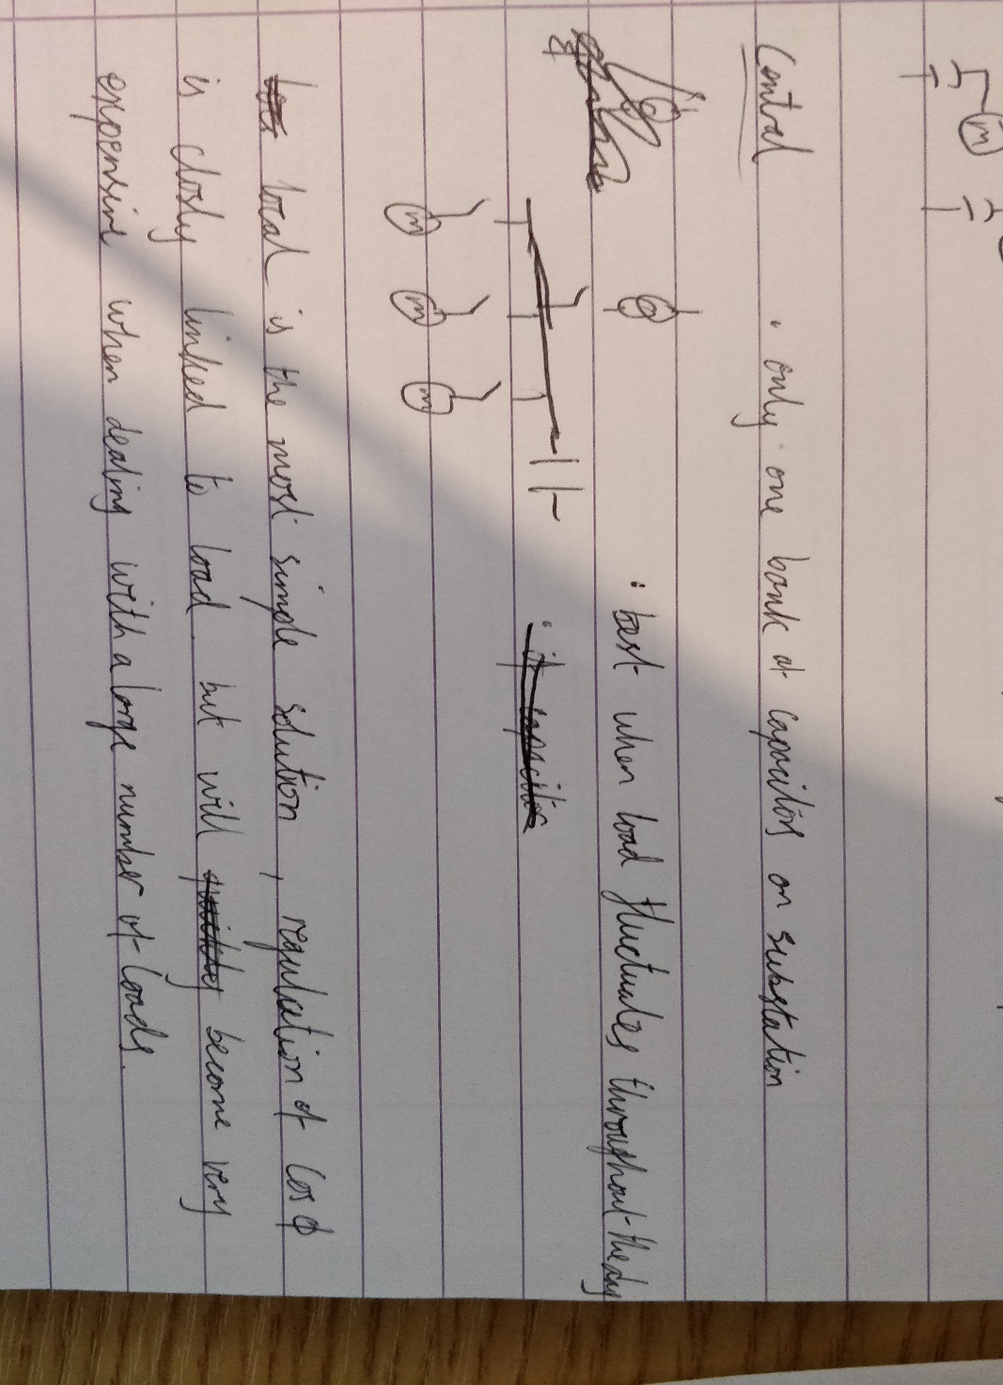

Q3

Q4

