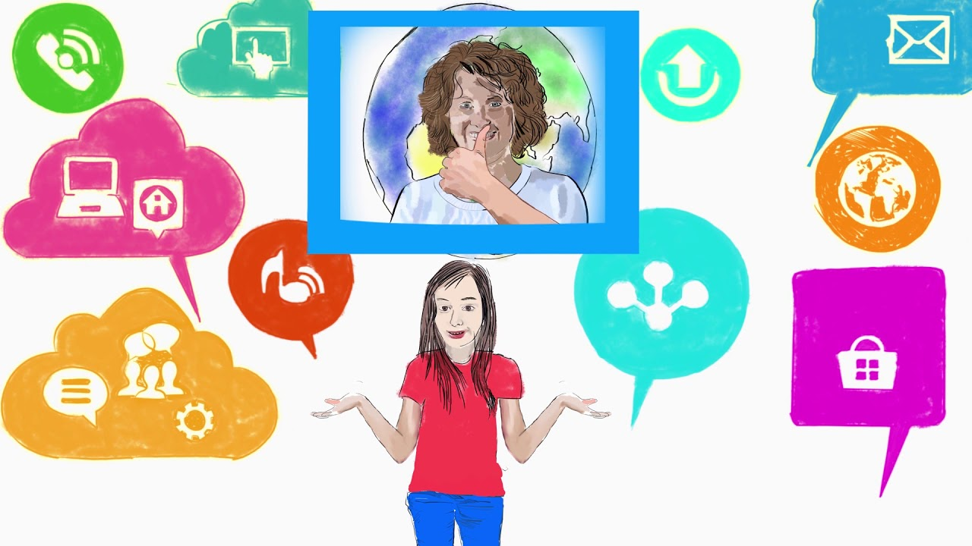
ECIE6002
Moving away from the traditional classroom
The Silent Digital Revolution

Assignment
Name: A.Richards
Student No: 2015583
Assignment: Blog Minimum of 4 entries 4000 words in total (approx.1000 words per blog)
Foundation Degree Inclusive Education
Cindy Hunt
University of Wales Trinity Saint David Swansea – Wales
07.01.2024
Amanda Richards –Parssa Nykoo 2015583@student.UWTSD.ac.uk

We are going to transform you into Digital Competent Superheroes!
(Hotcore.info, ND)
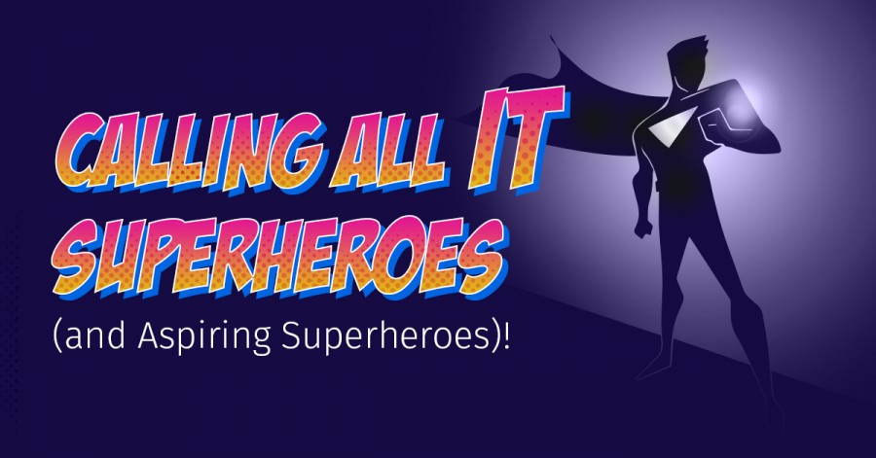
Good Morning Class are you sitting comfortably then I shall begin I am going to take you on a journey!
(Hotcore.info, ND)
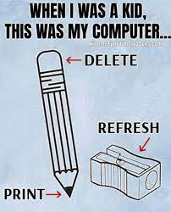
Yes when I was a pupil, my pencil was my computer....
“Now, now quiet down, no laughing please”
I am sure you hear your parents talk about “in my day”. Well when you become parents I am sure your comment will be more……“In my millisecond”
Why?
Why you ask, because education is changing, how you learn is changing…..
Today’s topic technology or as you may now know it, IT is changing. Changing at the speed of light and that is why we now need to all up skill, we all need to become “Digitally Component”.
Important people at the Senedd, People such as Donaldson and governing bodies such as Estyn all had thoughts on education and how it needed to be relevant and looked at how to improve education and your learning opportunities.
So…
The Welsh Government, put together the Digital Competence Framework (DCF). (HWB, 2019) publishing it in September 2016. It offered guidelines around digital skills and competences and advised educators on what students needed to acquire throughout their educational journey. (HWB, 2019) It was decided that inside Wales's new curriculum, it was to be one of the cross-curricular skill frameworks and was the first section of the new curriculum to be delivered to students. (Donaldson, 2015)
(Dictionary.com)

Miss what does that mean?
It means the development of our abilities and knowledge in the use of contemporary systems and that we refer to technology as “digital competence”. (HWB, 2018) Which also means that, we need to ensure that we all become self-assured and knowledgeable about the digital world as it is more important than ever for today's students, which is you! (HWB, 2018) This will mean, for you, as the young person that your future and professional life will benefit greatly from acquired skills and talents. (Estyn, 2019)
(Dictionary.com)
Miss so is it just ICT?
Information and communications technology (ICT) is one example of a skill set within the DCF. But should not be mistaken with computer competence. Which is a whole learning area starting as young as three and taking us all the way up to sixteen plus and beyond. (HWB, 2022)
Schools in Wales are and will have the chance to use the DCF to use and improve these abilities in a variety of settings and subjects all through the curriculum. Cross Curriculum studies. (Estyn, 2019)
(Dictionary.com)
Why Miss?
To prepare you the student for success in a world that is becoming more and more digitally savvy. That is why the DCF was created. (HWB, 2018)
The narrative started with a gentleman named Professor Graham Donaldson (2015) he authored a paper titled "Successful Futures” (Donaldson, 2015) which was an “Independent Review of Curriculum and Assessment Arrangements in Wales". He claimed that digital competency was just as vital as literacy and numeracy which fell in line with a 2013 suggestion by an independent ICT Review Panel. (Gov.Wales, 2015) and the “four primary strands” were born as the main focus. (Estyn, 2019)

(Dictionary.com)
Miss who did what? And why?
What? The Welsh government, education workers, national partners decided on the four main components of the Digital Competence Framework (DCF). (HWB, 2018) This covered governing entities, labour unions, diocesan authorities, local authorities, and Estyn. The Welsh Government then produced the DCF, which was created as a component of the curriculum reform in Wales. (Estyn, 2019)
Why? They believed that pupils should be allowed to practise and polish their gifts while they are in school, and that all learners should have the chance to improve their digital competency skills. (Estyn, 2019)
Also the DCF states that students: (HWB, 2022)
- Grow and enhance their speaking, reading, writing, and listening skills in order for them to become proficient.
- Demonstrate the ability to solve problems and apply mathematical knowledge practically.
- Develop self-assurance in their capacity to utilise various technologies.
- Finally, be capable of understanding and communicating with others.(Gov.Wales, 2022)
Sounds a big job Miss!
(Dictionary.com)
Miss tell us more, what else does it say?
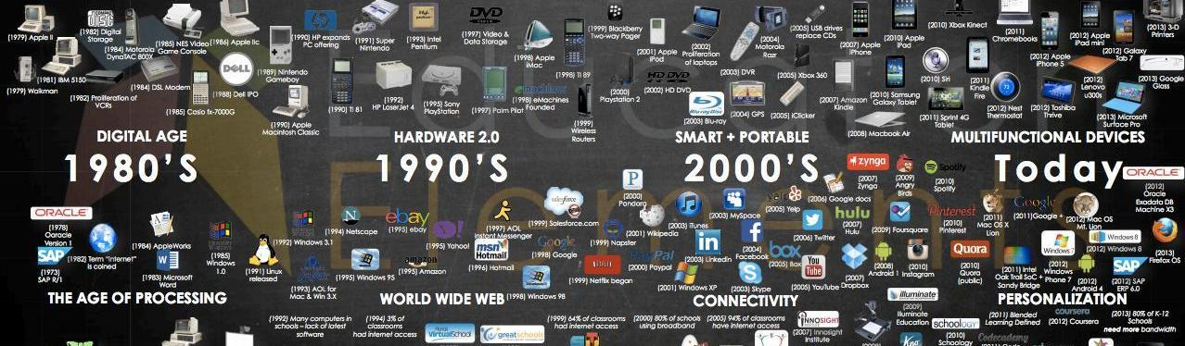
To remain competitive in the global workplace, students in Wales should be afforded every chance to maintain contact with their overseas peers. Students between the ages of three and sixteen must become proficient in the four digital skill areas. (Gov.Wales, 2022)
(Sutori,ND)

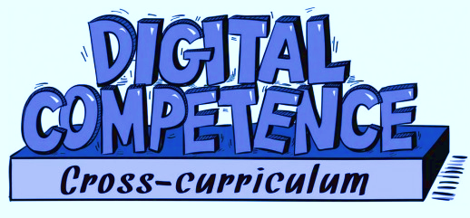

Let us now look at what the four skill areas are, and how this already can be seen in Welsh Comprehensive schools!

- Digital Citizenship: Students learn about their rights and responsibilities, including subjects like internet safety, privacy, and moral conundrums. (HWB, 2022)
So how do we cover this in school and throughout Wales?
- Wales offers instruction and training in online safety teaching pupils how to protect their personal information and use the internet responsibly. Taught in Personal and Social Education (PSE) and as part of the PSE curriculum. (Gov.Wales, 2022)

(Dictionary.com)
Miss? Yes Jonnie!
I have learnt all that getting ready for my BTEC and GCSE Qualifications.
Really what Subjects Jonnie?
- Succeeding within Education, Employment and Training (SWEET),
- Agored Cymru, and Princes Trust. (School A, 2023)

Also Pupils please let your parents know that just like you and I and all the staff in school they can use the school website. This is updated frequently.

- School website provides links to current and useful support resources. Everyone can participate in a dynamic learning environment through the school website and its interactions. It means that everyone can upskill and stay up-to-date. (School A, 2023)

- Interacting and collaborating: utilising digital tools for networking, communication, and cooperation in an efficient manner. (Gov.Wales, 2022) This involves having the ability to use digital communication platforms, collaborate in virtual teams, and comprehend online (Gov.Wales, 2022)
So how do we cover this in school and throughout Wales?
- Working together group assignments virtually with programmes such as Microsoft Teams or Google Docs. (School A, 2023)
(Dictionary.com)
Miss? Yes Jonnie!
Do you mean like when we use different digital platforms, and learn how to collaborate and communicate in order to exchange ideas, produce papers, and give feedback to our peers. (HWB, 2022)
Exactly Jonnie well done! Can you give me an example from a subject in school?
- We are doing it right now in exam prep, in our oral component of the GCSE English Language qualification assessment. We are working as a group. Preparing a speech on a selected topic. We are using shared drive on one drive to share ideas and put our presentation together. We sometimes work at home and are still able to communicate and share ideas through these platforms. (School A, 2023)
- Also performing Arts we do not use text book we use Chrome Books or IPads. (School A, 2023)
Miss you taught us last week that using the Chrome books follows the DCF aims and objectives (School A, 2023) but that you desperately are aiming to hold onto the creativity element of our course. But the effects of the DCF are a topic for another conversation because you were going to teach us all about the DCF. (Gov.Wales, 2022)
(Dictionary.com)
Miss? Jonnie can we give someone else a chance please? Last one!

- Producing: Using a range of resources and media, students learn how to produce and distribute digital material. This covers abilities like web design, multimedia production, and coding. (HWB, 2022)
Last one, Jonnie!
- PowerPoint to create digital presentations. Make our slides visually appealing, add multimedia components, and use digital tools to give presentations effectively. (HWB, 2022)
- Create a budget using Excel spreadsheets.
- Google Charts can be used to digitise our scientific data.

Well done Jonnie you gave great examples. The list is limitless and applies to both subjects and cross-curricular topics. (Gov.Wales, 2022)
Now we have our last of the “four primary strands” (Estyn, 2019) But this time Jonnie let Cindy answer she has had her hand up for ages!
- Data and computational thinking: Students gain knowledge about how to evaluate and comprehend data, apply computational thinking to solve issues, and comprehend how technology affects society. (infolit.uk, 2023)
Come on then Cindy your turn…..
(Dictionary.com)
- We have participated in coding exercises. We made websites in IT. We made a car move in science. We even made a ball bounce up and down on the screen using coding. (School A, 2023)
- Studied spreadsheet data in Science and Geography, Looking at climate change. We turned our calculations into visual Graphs. (School A, 2023)
- Also data can be utilised to make defensible judgements and address problems in the real world. So we write without a bias. (School A, 2023)
Do you know why we teach you coding Cindy?
Because it helps students organise their ideas more effectively, coding has been shown to enhance students' academic writing abilities. This improves their writing and critical thinking skills and helps them succeed academically overall. (Gov.Wales, 2022)
Well done Cindy great research…

Class I will leave you with one last statement which looks at Theory….
So, Connectivism, which is an educational philosophy, explains to us how the Internet has created new channels for individuals to communicate and share knowledge with one another throughout the world. George Siemens (2005) and Stephen Downes (2010) are credited with coining the term "connectivism" to refer to these philosophies of education and learning. Their theory, which addresses social learning through a network, can be connected to constructivism. Piaget (1957) who concentrated on the ways in which people interpret the connections between their thoughts and experiences. (Bates, 2019) Some compare it to learning networks, but it also encompasses the idea that the mind is a network unto itself, existing outside of society. (Learning Theories, 2023) Class I hope you have learnt loads today and enjoyed our discoveries and you are looking forward to becoming your own “Digital Competent Superhero”
Reference List:
- Bates, B. (2019) Second Edition. Learning Theories Simplified. SAGE Publications Ltd.
- Codetoday. UK, (2022) How Coding for Children Can Help With Other Subjects Available at: How Coding for Children Can Help With Other Subjects (codetoday.co.uk) [Accessed 11th November 2023]
- Donaldson, G. (2015). Successful Futures, Independent Review of Curriculum and Assessment Arrangements in Wales. Crown Copyright. Available at: Successful Futures, Independent Review of Curriculum and Assessment Arrangements in Wales: [Accessed 12th November 2023]
- George Siemens (2005) and Stephen Downes (2010) Learning Theories Available at: Connectivism (Siemens, Downes) - Learning Theories (learning-theories.com) [Accessed 11th November 2023]
- Gov. UK, (2015) Keeping Learners Safe, Available at: https://www.gov.wales/sites/default/files/publications/2018-11/keeping-learners-safe-the-role-of-local-authorities-governing-bodies-and-proprietors-of-independent-schools-under-the-education-act-2002.pdf [Accessed 11th November 2023]
- Gov. UK, (2015) Introduction of a Digital Competence Framework, Available at: Written Statement - Introduction of a Digital Competence Framework (10 June 2015) | GOV.WALES [Accessed 11th November 2023]
- Gov.UK (2019) Estyn, Digital Competence Available at: Digital competence: Improving pupils’ digital skills | Estyn (gov.wales) [Accessed 12th November 2023]
- Gov.UK (2022) Developing a vision for curriculum design Available at: Developing a vision for curriculum design - Hwb (gov.wales) [Accessed 12th November 2023]
- Hwb (2018) Digital Competence Framework Guidance. Available at: A curriculum for Wales – a curriculum for life (gov.wales) [Accessed 11th November 2023]
- Hwb (2019) Digital Guidance for Schools Available at: Education digital guidance for schools - Hwb (gov.wales) [Accessed 11th November 2023]
- Hwb (2021) Wales Government The Digital Competence Framework (2021) Available at: Cross-curricular skills frameworks - Hwb (gov.wales) [Accessed 11th November 2023]
- infolit.org.uk (2022) Information Literacy and Digital Competence Framework Available at: Information Literacy and Digital Competence Framework – Information Literacy Website (infolit.org.uk) [Accessed 12th November 2023]
- [School A] (2023) [School A] Online Safety Policy. Swansea: [School A]. Unpublished
- Senedd. Wales (ND) Estyn Available at: CR 04 Estyn.pdf (senedd.wales) [Accessed 11th November 2023]
- 21K School, (2023) The importance of Coding in 21st Century Schools Available at: The Importance of Coding in 21st Century Education - 21K School India [Accessed 11th November 2023]

- IMAGE 1 – Hotcore.info, (ND) Available at: https://images.app.goo.gl/s6ndigUHXggK6Cai6 [Accessed 06th January 2024]
- IMAGE 2 - Hotcore.info, (ND) Available at: https://images.app.goo.gl/s6ndigUHXggK6Cai6 [Accessed 06th January 2024]
- IMAGE 3 - Available at:Dictonary.com, (ND) 🙌 Raising Hands emoji Meaning | Dictionary.com [Accessed 06th January 2024]
- IMAGE 4 – Sutori, (ND) Available at: ECI Technology Timeline | Sutori [Accessed 06th January 2024]

Innovating Education & Educating for Innovation
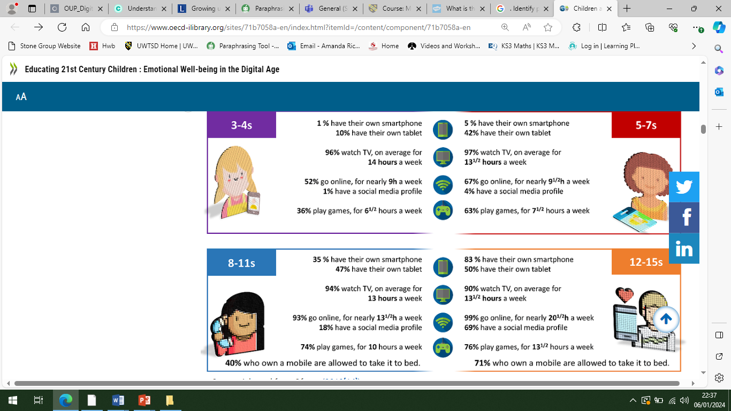 Ofcom, (2018)
The Great Debate….
Technology has become a dominant force in modern culture, and concerns regarding its impact on children's development are becoming more prevalent. As useful as technology can be for education, socialisation, and fostering connections, it can also be harmful to the growth of the brain, social abilities, and emotional regulation. (UNICEF, 2017)
With this in mind will the DCF ever come to fruition or will it be hindered and down trodden by the ever growing narrative and battle of Gen X (School Staff) versus Gen z’s and Gen Alpha! (Students 11 to 16)
(Parents, 2023) Read on……. But first, let's examine the justice scales in light of the current narrative…..


(Vectorstock.com, 2023)
Generation names explained
(Parents, 2023)
The Lost Generation born 1883-1900
The Greatest Generation born 1901-1924
The Silent Generation born 1925-1945
Baby Boomer Generation born 1946-1964
Generation X born 1965-1980
Generation Y born 1981-1996
Generation Z born 1997-2012
Generation Alpha born 2013-2025

Guiding principle or meaningless expressions….
So is the debate answered by merely justifying the reason there is a technology generation gap! Parents, (2023)

Because each generation was raised in a different technological era with access to various resources! Is this small factor even considered when individuals of different generations get together? Parents, (2023)
Technology is advancing quickly and transcending generational divides! Is this sufficient to win the big argument, or do we need to go farther and examine more closely how technology affects our social connections, our brains, and our emotions? (UNICEF, 2017)
Let's examine the contentious issue in more detail….


Adobe. Stock, (ND)
Positive effects:
Opportunities for education: Using the plethora of educational tools available in the internet world, children as well as adolescents can enhance their learning. (UNICEF, 2017)
Increased creativity: Digital technology such as multimedia software and online platforms can encourage creativity and innovation. (UNICEF, 2017)
Global connectivity: Children and teenagers can learn about different cultures and the wider globe through peer relationships made available by the internet. (UNICEF, 2017)

Adobe. Stock, (ND)
Negative effects:
Cyberbullying: In the digital age, children and teenagers are vulnerable to cyberbullying, which can have detrimental emotional and psychological effects. (UNICEF, 2017)
Reduced physical activity: Physical activity levels may be declining as a result of sedentary behaviour brought on by digital media and excessive screen time. (UNICEF, 2017)
Privacy and security risks: Children may inadvertently reveal personal information online, making them vulnerable to identity theft and cybercriminals. (UNICEF, 2017)
Final thought or not…
Is it possible to conclude this argument by looking at the aforementioned factors? Can we critically determine and show that one side of the scale outweighs the other? Do all of the positives match the DCF in terms of alignment? (Hwb 2018) Do the downsides at the other end of the spectrum stem from a knowledge gap between generations? (UNICEF, 2017)
I feel compelled to make a public health announcement at this time, as with any adverse effect….
Please, keep in mind, then, that adverse consequences can differ according on factors like age, usage patterns, and parental monitoring. Setting boundaries and offering guidance on their children' and teens' use of technology is essential for minimising the negative effects. (OECD.org, 2018)
To be really objective and analytical, I don't think a solution is going to happen anytime soon. So let's look into theories in more detail. I know you're thinking, "Why Theory?" A phenomenon can be explained in part by theories. Theories offer condensed explanations for reality's complexity. Theory directs and completes inquiry. (Bates, 2019)
So far we have looked at George Siemens (2005) and Stephen Downes (2010) who as we learnt earlier are credited with coining the term "connectivism".(Western Governors University, 2021)
But now I want to introduce you to….

The catchphrase "the medium is the message," coined by Marshall McLuhan, (1964) perfectly sums up his philosophy that every medium is a distinct kind of environment whose widespread usage transforms individuals and cultures. (Eudaimonia, 2016)

(MULTIMEDIAMAN, 2011)
He forecast that we were on the verge of the fourth electronic age, defined by a technologically connected global community. He referred to it as the "global village" (Eudaimonia, 2016) and predicted a time when everyone would have technological access to the same information. (Telegraph, 2017) Some would say he predicted the internet! (Eudaimonia, 2016)
LMU, (2021)

He predicted that “The way that we send and receive information is more important than the information itself” (Eudaimonia, 2016)
Was he correct?
“Within my life time I have seen black and white TV convert to colour, moved from 3 channels to an estimated 480” (BBC, 2020)

Fact or Fiction…

- Social media – Key board warriors – Job loss – Arrests – Gossip Columns – Invasion of privacy or need to know! (Eudaimonia, 2016)
- Reduction in our recall – memory spans shrinking or are they! (BBC, 2017)
- Conversations – or Emoji’s! (Eudaimonia, 2016)
- Children reported using a remote control to turn down abuse in the home! True or False? (Eudaimonia, 2016)
- Pressing on a word in a book expecting the definition to pop up! Or over use of a kindle? (Eudaimonia, 2016)

Is it fact or fiction? You never know! To really decide that would require its own blog!
But what I have concluded is that Marshall McLuhan, (1964) was a forward thinking man of his generation and that his statement that the “media massages your brain to behave in a particular way” has strong rooted connotations in today’s society! (BBC, 2017)
This closes the circle on Wales' rationale for using the DCF framework and highlights the significance of digital literacy in the classroom. Considering that it gives students a hands-on experience using information and communication technologies to find, assess, create, and share knowledge. Making sure that technical and cognitive skills are addressed as well. (Agored Cymru, 2023) But does it resolve the initial disagreement that sparked this blog? UNICEF (2017) states that "as useful as technology can be for education, it is harmful to the developing brain.”? Or is it? Or are our brains going through an evolution right now? I think that is a blog for another day…
But before I leave, keep in mind the health warning I said earlier and the fact that government and educational laws and processes are put in place with a purpose! And that is for the safety of our pupils. (School A, 2023)
My primary takeaway is that it is everyone's responsibility to watch out for the less fortunate members of society. The 2020 Welsh Safeguarding Procedures delineate the obligations and accountabilities of practitioners to ensure the protection of individuals and minors who are susceptible to maltreatment or disregard. (Social Care Wales 2020)

Reference List:
- Agored Cymru (2023) Available at: Essential Digital Literacy Skills (agored.cymru) [Accessed 19th November 2023]
- Bates, B. (2019) Second Edition. Learning Theories Simplified. SAGE Publications Ltd.
- BBC, (2017) Available at: Busting the attention span myth - BBC News [Accessed 19th November 2023]
- BBC, (2020) Available at: How the news changes the way we think and behave - BBC Future [Accessed 19th November 2023]
- Eudaimonia (2016) The media is the message Available at: https://www.youtube.com/watch?v=gCr2binb4Fs [Accessed 19th November 2023]
- Hwb (2018) Digital Competence Framework Guidance. Available at: A curriculum for Wales – a curriculum for life (gov.wales) [Accessed 11th November 2023]
- OECD.org, (2018) Children & Young People’s Mental Health in the Digital Age Available at: Children-and-Young-People-Mental-Health-in-the-Digital-Age.pdf (oecd.org) [Accessed 18th November 2023]
- Ofcom,(2018) Children and Parents, media use and attitudes report Available at: Children and Parents: Media Use and Attitudes Report 2018 (ofcom.org.uk) [Accessed 18th November 2023]
- [School A] (2023) [School A] Online Safety Policy. Swansea: [School A]. Unpublished
- Social Care Wales (2020) Wales Safeguarding Procedures Available at: https://safeguarding.wales/int/i1/i1.p1.html [Accessed 19th November 2023]
- Siemens, G. (2005) cited by Western Governors University (2021) Connectivism Learning Theory Available at https://www.wgu.edu/blog/connectivism-learning-theory2105.html#close [Accessed 18th November 2023]
- Telegraph, (2017)Who was Marshall McLuhan and how did he predict the internet? (telegraph.co.uk) [Accessed 19th November 2023]
- UNICEF, (2017) How does the time children spend using digital technology impact their mental well-being, social relationships and physical activity Available at: Children-digital-technology-wellbeing.pdf (unicef-irc.org) [Accessed 18th November 2023]
- Parents, (2023) A Year-by-Year Guide to the Different Generations Available at: What Generation Am I? A Guide to Generations by Year (parents.com) [Accessed 18th November 2023]

- IMAGE 1 – Ofcom,(2018) Children and Parents, media use and attitudes report Available at: Children and Parents: Media Use and Attitudes Report 2018 (ofcom.org.uk)
- IMAGE 2 – Vectorstock.com, (ND) Available at: Blank newspaper template daily news folded paper Vector Image (vectorstock.com) [Accessed 18th November 2023]
- IMAGE 3 – Adobe. Stock, (ND) Available at: negative and positive staying in balance - pictured as a metal scale with weights and labels negative and positive to symbolize balance and symmetry of those concepts, 3d illustration Illustration Stock | Adobe Stock [Accessed 18th November 2023]
- IMAGE 4 – MULTIMEDIAMAN, (2011) Available at: The Extensions of Man – MULTIMEDIAMAN [Accessed 19th November 2023]
- IMAGE 5 – LMU, (2021) Available at: The Medium Is the Message – Or Is It? - LMU This Week [Accessed 19th November 2023]

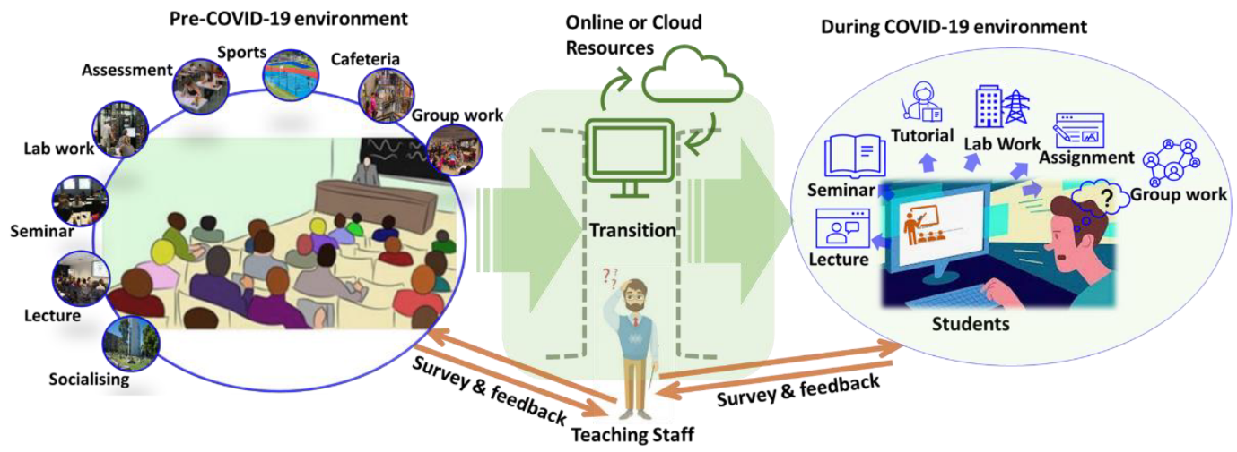
MDPI, (2023)
PRE-COVID EDUCATIONAL ENVIRONMENT VERSUS POST COVID EDUCATIONAL ENVIRONMENT
Advanced Learning, (2018)
PEN PORTRAIT PRE-COVID JOB ROLE
Job Title: CREDU, TIDE, LAC Learning Coach
Roles and Responsibilities:
- Educator
- Coaching
- Mentoring
- Alternative curriculum delivery
- Safeguarding
- Multi Agency Meetings
- Admin
- NEET Prevention (NEET = Not in Education, employment or training. Post 16)
- 1:1 support emotional well being
- Family Liaising and support
- Behaviour management
- ALN support
- Planning and delivering lessons
- Marking
PLACE OF WORK: 90% School, 10% Meetings at County Hall, Cockett House.
EQUIPMENT: Mobile, Static office based computer.
Hours 37.5 per week – 8:30 to 4:30 Monday to Friday

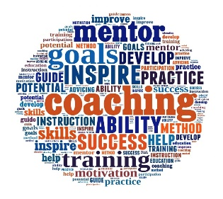
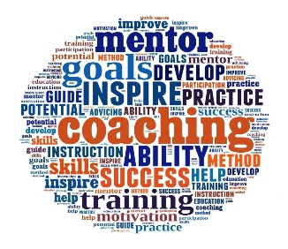
Advanced Learning, (2018)
PEN PORTRAIT during – COVID - JOB ROLE
Job Title: CREDU, TIDE, LAC Learning Coach
Roles and Responsibilities:
- Educator – On line
- Coaching – By Phone
- Mentoring – Door steps, text messages, teams meetings, watts app, and emails.
- Alternative curriculum delivery- Hard copies hand delivered, Google Classroom, on line
- Safeguarding – Phone calls, door visits, on line.
- Multi Agency Meetings - Teams
- Admin – home, provided with school lap top, dependant on connectivity with school WIFI
- NEET Prevention (NEET = Not in Education, employment or training. Post 16) – Door Stop visit to complete college applications
- 1:1 support emotional wellbeing – Door stop visits, School feeder HUBS, Free school delivery packages;
- Family Liaising and support – Mobile phone, emails, texts, door stop visits
- Behaviour management – No control, left to parents and community
- ALN support – Adjusted to pupil needs
- Planning and delivering lessons – Google Classroom, Hard Copies
- Marking – Google Classroom
PLACE OF WORK: 100% transit- Home, car, outside pupil’s homes, off sight venues with COVID precautions.
EQUIPMENT: Mobile, School Lap Top, Head phones.
Hours per week – Too many to count as totally accessible due to technology. Monday to Friday – Nobody understood boundaries and work life balance. Both Line mangers and school community

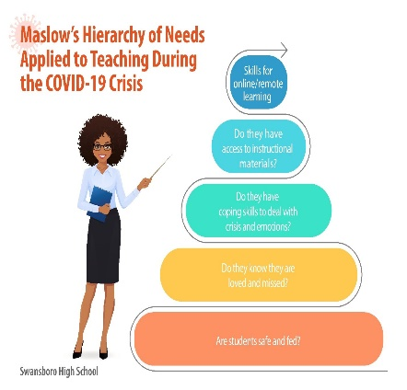
Has COVID changed education for ever?
Differences in the availability of resources required for at-home learning became evident when schools abruptly closed to the majority of students. Various elements were found to influence the experiences of children and young people. One of them was that, during the initial lockdown, the schools with the greatest needs were unable to use an online learning platform. Ofcom (2021) “this statement stood strong in my place of work”.
ASCD, (2023)
- Approximately forty nine percent of students qualify for free school meals, which is more than the seventeen point four percentage average for secondary schools in Wales. It has one of the highest percentages among all Welsh secondary schools. (Estyn, 2016)
- Approximately seventy percent of students reside in Wales' twenty percent most impoverished areas. (Estyn, 2016)
- Roughly nine percent of students are members of ethnic minority groups. Nine percent of the students which equates to forty three pupils have English as a second language. (Estyn, 2016)
- Meaning that many students only had access to mobile phones and occasionally the internet, creating financial barriers to learning. (EdTech 2021)
- A little over half of students are listed on the special education needs register, which is a substantial percentage more than the twenty-five point four percent national average. (Estyn, 2016)
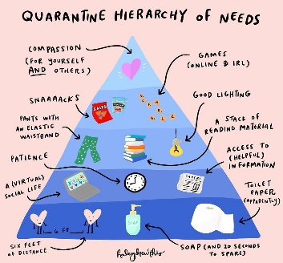
According to Maslow (1943) a person's attempt to satisfy their five basic needs which leads to motivation. (Bates, 2019) were evidently affected. As the above statistics point out in my education setting it was to be expected if we look at Maslow’s (1943) Hierarchy of needs theory we are able to reflect back on how and why. If we just look at two areas free school meals and technological equipment.
Starting with not being able to eat regularly led to a great deal of stress, which totally undermined the first level of "psychological needs." This was due to having so many pupils entitled to free school meals. (Bates, 2019) At the start of the pandemic we put together food parcels which we delivered. Later on as people were coming to terms with the situation vouchers were initiated. Following a successful campaign spearheaded by football player Marcus Rashford, food vouchers were extended to families in the UK that had children enrolled in free school meals throughout the summer months. (Gov.UK, 2021) This call to action was seen as a positive outcome for all involved and I believe Maslow (1943) would have been tapping Marcus Rashford on the back. (Bates, 2019)
Working from home being educated at home became a whole new arena. Parents having to juggle education as well as work. This opened up a new market place for big tech companies and anyone that was smart enough to get on the band wagon to ensure our need for “love and belonging” became fulfilled. (Bates, 2019) This is where as a school we found the biggest gap. Technological equipment was lacking in the community. As a school we struggled to fulfil and match the needs of our pupils as did all schools. (Ofcom, 2021) here is where we learnt and visualised people’s creative skills in regards technology PS4, Xbox became the new computer at home. Students were taught how to access Google Classroom and continue their studies. (Ofcom, 2021) not seeing friends and family for months seemed a bit easier, some would say thank God for zoom, but it still didn’t satisfy our need for “love and belonging” in the same way. (Bates, 2019
I can hear Maslow (1943) now what about “self-actualise” (Bates, 2019) I think I would answer him and say given that the previous four levels were severely disrupted, did "self-actualization" ever have a chance? Not sure about you but that sounds like a song to me…..

Reference List:
- Bates, B. (2019) Second Edition. Learning Theories Simplified. SAGE Publications Ltd.
- Estyn, (2016) Available at: Dylan Thomas Community School | Estyn (gov.wales) [Accessed 25th November 2023]
- EdTech (2021) The Impact of Digital Exclusion In Children's Education 2021 Available at: The-Impact-of-Digital-Exclusion-In-Childrens-Education-21-1.pdf (teachertoolkit.co.uk) [Accessed 26th November 2023]

Gov.UK, (2021) National free school meals voucher scheme opens to orders
Available at: National free school meals voucher scheme opens to orders - GOV.UK (www.gov.uk) [Accessed 26th November 2023]
- Ofcom (2021) Digital divide narrowed by pandemic, but around 1.5m homes remain offline Available at: https://www.ofcom.org.uk/about-ofcom/latest/media/media-release/2021/digital-divide-narrowed-but-around-1.5m-homes-offline [Accessed 25th November 2023]
- IMAGE 1 – MDPI,(2023) Available at: Sustainability | Free Full-Text | Exploring Teaching and Learning Experience during COVID-19 Pandemic in Engineering Education (mdpi.com) [Accessed 25th November 2023]
- IMAGE 2 – Advanced Learning, (2018) Available at: Six Reasons You Need An Instructional Coach - ALP (alplearn.com) [Accessed 25th November 2023]
- IMAGE 3 – ASCD, (2023) Available at: Maslow’s Hierarchy of Needs and the Covid-19 Crisis (ascd.org) [Accessed 26th November 2023]
- IMAGE 4 - Liminal Space (2024) Available at: The Resilience Economy - by Lauren Capelin - Liminal Space (substack.com) [Accessed 7th January 2024]


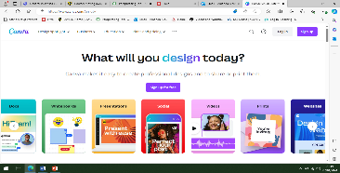

Debates over…. just a straight forward introduction to a software package that we use in our education setting and the reason why!
Software – named “Canva”
Reason – To increase creativity – links to real world roles, Graphics, Social media influencer, Content creators, Performance Art, all in line with “Digital Competence”. (HWB, 2018)
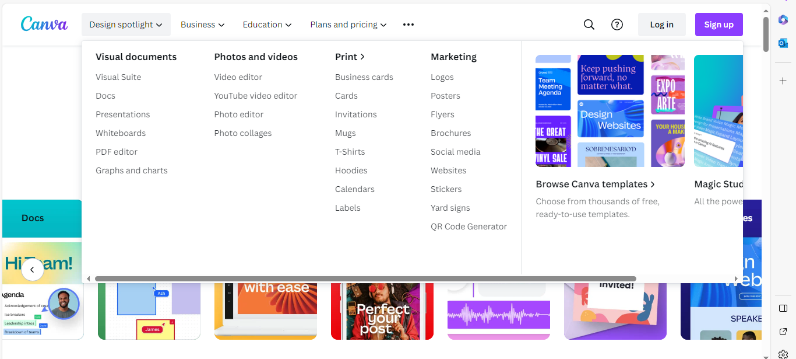
Design Spotlight – Options as seen in image
Audience/Age range – Comprehensive, Ages 12 to 16
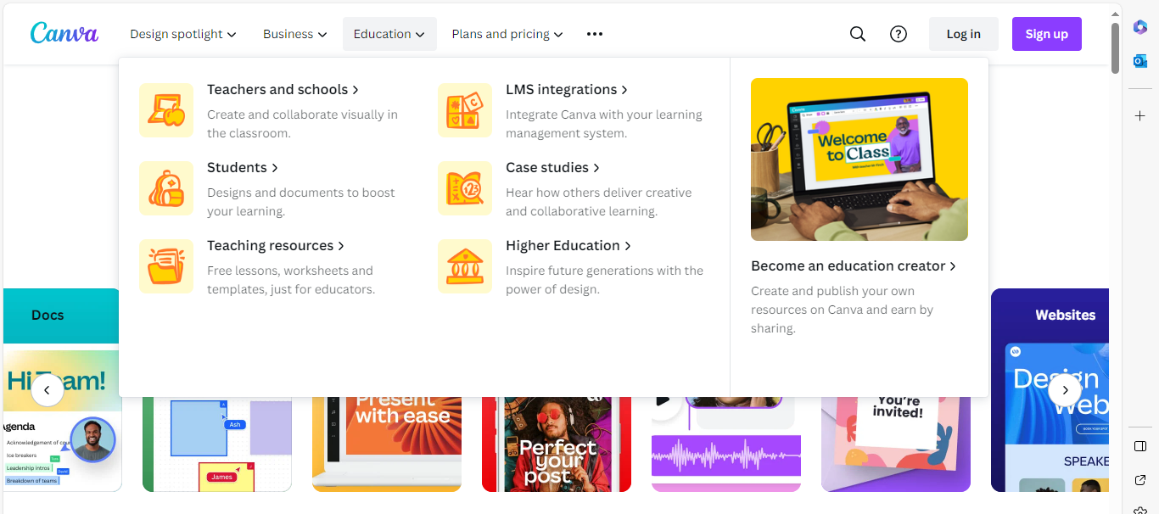

If we think back to blog 1 we looked at the “four primary strands” which were born as the main focus of the DCF. (Estyn, 2019) one of those areas if you recall was called Producing: which uses a range of resources and media, and students learn how to produce and distribute digital material. This covers abilities like web design, multimedia production, and coding. (HWB, 2021) all in line with the “Digital Competence Framework”. (HWB, 2018) which we hit and utilise when using” “Canva” Pupils are only using this software at present in our IT suites and during IT lessons due to costs. However that does not mean it cannot be used in cross curriculum subjects as the IT suites can be booked for use by all subjects in and around the school.
I know I said no debate but we do have to briefly look at AI because “Canva” does actually fall into this category and at present AI is hot news and opening up debates around its impact on education and learning. As recent as November, Parliament (2023) published a paper on this hot topic stating that “AI could be used by students to complete tests and homework. Essays produced by AI pose a danger to education and the college admissions process. In addition to the unethical nature of this kind of cheating, students who utilise AI to do their assignments could not be acquiring the necessary knowledge and abilities! (Parliament.UK 2023) these are strong words and add to the narrative of this hot topic as I am sure it will continue and the need to actually understand the bias in AI algorithms. Before conclusions can be drawn. Also training is required and that is something that my education establishment has started. “If you cannot beat them join them springs to mind” but I use this loosely and very much tongue in cheek! I feel that this is a good place to draw to a close as I really believe AI would be a blog in itself and I know I am hot on the tails of reaching my word count!

Reference List:
- Canva (2023) Available at: Canva: Visual Suite for Everyone [Accessed 7th January 2024]
- Gov.UK (2019) Estyn, Digital Competence Available at: Digital competence: Improving pupils’ digital skills | Estyn (gov.wales) [Accessed 12th November 2023]
- Parliament.UK (2023) Available at: Educational technology: Digital innovation and AI in schools - House of Lords Library (parliament.uk) [Accessed 7th January 2024]
- Hwb (2018) Digital Competence Framework Guidance. Available at: A curriculum for Wales – a curriculum for life (gov.wales) [Accessed 11th November 2023]
- Hwb (2021) Wales Government The Digital Competence Framework (2021) Available at: Cross-curricular skills frameworks - Hwb (gov.wales) [Accessed 11th November 2023]
- IMAGE 1 – GURU, (2023) Available at: Difference between Hardware and Software (guru99.com) [Accessed 7th January 2024]
- IMAGE 2 – Canva (2023) Available at: Canva: Visual Suite for Everyone [Accessed 7th January 2024]

