5C002
Centre Number: | 669
Centre Name: | UWTSD
Learner Number: | 9119014
Learner Surname: | Astell
Learner Other Names: | Lynda
Word Count: | 4,243 (Resubmission)

Evidence Based Practice

AC 1.1

Evidence-Based Practice (EBP) in HR refers to a systematic process of using multiple sources of reliant, trustworthy and relevant data and applying critical thinking to improve decision making and the impact of HR practice. This can include a combination of data within the organisation, academic research, professional expertise, and stakeholder input (Rousseau & Barends, 2011).

EBP has evolved from the concept of Evidence Based Medicine (EBM) first introduced within medical literature in 1991, followed by an EBM international working group introducing the term EBP in 2005 (Institute of Psychotherapy, 2025). Both patients and professionals wanted medicine to be more scientific, reliable, and transparent and wanted to ensure that decisions were based on solid evidence rather than tradition, anecdote, or authority (Zimmerman 2013).

With an understanding of the important role of the patient in the evolution of EBP in medicine, the importance of EBP in Human Resource Management becomes clearer. as Kroon (2022) observes that People are vital to organisational success, contributing through their performance, ideas, and collaboration. However, managing people is complex because they have minds of their own and issues like resistance to change, low motivation, and workplace politics can really slow down progress (Kroon, 2022). Evidence based HR decisions are therefore key in keeping people aligned with the goals of their organisations.

Because people make choices and workplaces constantly evolve, effective, evidence-based HR decisions are the key to addressing challenges and keeping organisations, and the people within them, aligned with organisation goals.

Fig 1.1a, adapted from a medical example (Institute of Psychology, 2025) clearly highlights the significance of drawing on various sources of evidence including research, HR practices, and employee input. The extent to which each source contributes (represented by the size of each circle) can differ greatly depending on the individual employee and the specific HR decision being made.

What is also clear is the importance of ‘employee values and preference’ – actively engaging with and listening to the employee voice in EBP

An example of the positive value of EBP is described by Leonteva (2024). TechCorp, a mid-sized technology company, needed to quickly hire a team of software developers for a new product launch. In haste, they failed to properly research the target candidate group and failed to define clear candidate profiles. As a result job adverts were generic and failed to attract suitable candidates, and screening and interviews were unstructured, leading to inconsistent and poor hiring decisions. Consequently, new recruits were not a good fit for the roles and high turnover then caused delays, increased costs, and lowered morale.

Fig 1.1a

This example demonstrates how a lack of evidence-based recruitment practices such as defining competencies, using structured interviews, and targeting the right candidate pool led to significant operational and financial setbacks for TechCorpn. highlighting the importance of research and structured, evidence-based approaches in recruitment to avoid costly mistakes and ensure organisational success.

The goal of EBP is therefore to move away from intuition, tradition, or anecdotal methods and instead adopt practices that are demonstrably effective.

Technivara is experiencing sustained growth and to successfully expand the business will require considered recruitment and selection along with effective employee engagement and retention. EBP will be valuable in both of these people practice areas to ensure effective decision making:

AC 1.2

Below is an evaluation of one analysis tool and one analysis method suited to Technivara’s context.

SWOT analysis (SWOT) is widely valued for its simplicity and accessibility, making it a useful tool for HR professionals and managers at all levels (Chermack & Kasshanna, 2007). It offers a structured approach to the evaluation of both internal factors such as strengths and weaknesses and external factors, including opportunities and threats, thereby supporting comprehensive organisational assessment (Chermack & Kasshanna, 2007). SWOT drives strategic alignment by helping organisations identify areas for improvement and leverage their existing strengths to achieve business objectives (Chermack & Kasshanna, 2007).

Chakrabarty (2024) found that senior managers value SWOT for encouraging collaboration and shared understanding, which strengthens strategic planning. Similarly, Parnell and Gangwish (2023) emphasise that stakeholder engagement is essential for effective decision-making, and tools like SWOT analysis can supports this through inclusive participation.

In terms of decision-making, SWOT helps organisations prioritise actions and make informed choices. Chakrabarty (2024) notes that despite its limitations, SWOT remains widely used for shaping strategy, especially when integrated with real-time data and scenario planning. Palazzo (2024) adds that SWOT aids practitioners in understanding both internal and external factors, enhancing the selection of strategic actions.

SWOT does however have limitations that can reduce its strategic value. It often lacks analytical depth and should be supplemented with more rigorous methods to avoid superficial conclusions (EVX Software, 2024). Additionally, SWOT does not offer a way to prioritize issues or assess their relative impact, which can hinder effective decision-making (Business Model Analyst, n.d.)

Participant bias and input obsolescence can also limit usefulness Outcomes can also reflect the biases of the participants rather than objective data and its static nature also means it will become outdated in fast paced environments (SEA Open Research, n.d.).

At a time of sustained growth and potential expansion, SWOT can help the Technivara leadership team identify what is working well (such as their strong market presence and sector diversity), what needs improvement (like outdated people practices and resistance to change), and where strategic opportunities lie (such as modernising HR systems and adopting evidence-based practices). It also highlights potential risks that could hinder progress, enabling more informed, data-driven decision making.

Sector benchmarking is an analytical method used to compare organisations operating within the same industry or sector. The primary aim is to identify best practices, performance gaps, and opportunities for improvement. This method is particularly valuable in sectors where continuous improvement and accountability are essential (Muravu, 2023).

Benchmarking involves the systematic comparison of an organisation’s performance against those of industry leaders or competitors, enabling organisations to learn from others, take action and enhance their own performance (Camp, 1989)

Benchmarking typically follows a structured methodology. First, organisations identify the specific areas to benchmark. This could be any number of things from financial measures to customer satisfaction. Next, suitable benchmarking partners are selected, usually sector leaders or peers with comparable operations. Data is then collected through surveys, reports, or public databases, followed by a detailed analysis to identify performance gaps and best practices. Finally, organisations develop and implement action plans based on the findings, and establish mechanisms for ongoing monitoring and review

Benchmarking typically follows a structured process with organisations first identifying key areas to assess. They then select suitable benchmarking partners, usually sector leaders or similar peers, and gather data through surveys, reports, or public sources. This is followed by analysis to spot performance gaps and best practices, leading to action plans and systems for ongoing review and improvement. (Big Data Value Association, 2020).

Benchmarking can contribute significantly to quality improvement by facilitating the adoption of evidence-based practices (Willmington et al., 2022).

Despite its benefits, Benchmarking also presents challenges. These including availability of data, comparability issues, and the risk of misinterpreting results without proper understanding. Successful benchmarking requires careful planning, stakeholder engagement, and a commitment to learning and adaptation (Springer, 2015).

Sector benchmarking could be beneficial for Technivara as it allows comparison of its people practices, performance, and processes against industry standards and competitors. This helps identify gaps, inefficiencies, and areas for improvement, especially as the business prepares to expand. For the People Practice Team, benchmarking provides credible, data-driven insights that can support the case for modernising outdated systems and adopting evidence-based approaches, ensuring Technivara remains competitive and aligned with best practices in the electronics and manufacturing sectors.

AC 1.3

Critical thinking means carefully and skillfully thinking through information to make good decisions. In Human Resource Development (HRD), it helps challenge assumptions, improve how decisions are made, and encourage new ideas in managing people (Elliott & Turnbull, 2005).

The key steps to critical thinking are:

- Identifying the actual problem that needs to be resolved
- Gathering the evidence
- Considering various solution options
- Making a decision

Critical thinking in Human Resource Development (HRD) involves several key principles. that help professionals make better decisions and drive innovation.

One key principle is clarity and precision. Critical thinkers aim to express ideas clearly to avoid misunderstandings, especially when interpreting employee feedback or performance data (Dwyer, 2017).

Open-mindedness and empathy are vital, as they encourage HR professionals to consider diverse perspectives, challenging their own biases. This encourages inclusive dialogue and collaborative problem-solving (Online Business School, 2023).

Another core principle is Evidence-based reasoning, which involves making decisions based on data, research, and logical analysis rather than relying on intuition or tradition. This aligns with the growing emphasis on evidence-based HR practices (Buckley, 2013).

Questioning assumptions is equally important, particularly in organisations like Technivara where traditional practices dominate. Challenging whether long-standing systems still serve the company’s needs is a step toward meaningful change.

Constructive scepticism, the habit of not accepting claims at face value encourages HR professionals to seek verification, such as evaluating the real impact of training programmes through performance metrics rather than participant satisfaction alone (Dwyer, 2017).

Logical consistency ensures that arguments and decisions are coherent and persuasive, which is especially useful when presenting proposals to leadership teams.

Finally, reflective thinking allows HR practitioners to evaluate their own thought processes and continuously improve, supporting adaptability in a fast-changing work environment (Brookfield, 2012).

To apply critical thinking effectively to both personal and others’ ideas, and to promote rational and objective debate, HR professionals can follow a structured approach.

They should begin by clarifying the issue, restating the problem or idea in their own words, and asking questions to resolve any ambiguities. Then gathering and assessing evidence from many credible sources such as academic research, HR practices, and employee feedback is essential to ensure a well-rounded understanding. Open-mindedness and empathy are also key, enabling professionals to actively listen to diverse viewpoints and challenge their own biases.

Considering alternative solutions and questioning underlying assumptions is particularly important in organisations where traditional practices may no longer meet current needs. Evidence-based reasoning should guide decisions, relying on data and logical analysis rather than intuition or habit. Maintaining a healthy level of curiosity helps professionals avoid accepting information at face value, encouraging them to seek verification and to ensure that there is logical consistency in arguments.

Finally, reflective thinking allows HR practitioners to evaluate their own thought processes and remain open to adapting their views in light of new evidence. By consistently applying these principles, HR professionals contribute to a culture of rational, inclusive, and evidence-based debate.

AC 1.4

Below are two decision-making approaches that can be applied within Technivara.

Force Field Analysis is a strategic decision-making tool developed by Kurt Lewin (1947) to evaluate the factors that influence change within an organisation. It is based on the principle that any situation is maintained by a balance between driving forces, which push for change and restraining forces, which resist change. By identifying and analysing these forces, decision-makers can better understand the dynamics of a proposed change and develop strategies to ensure its success.

The process begins by clearly defining the change or decision being considered. This ensures that all stakeholders have a shared understanding of the objective.

Next, the team identifies the driving forces, positive factors that support the change, such as improved efficiency, cost savings, or stakeholder support. At the same time, restraining forces are also identified, these include including barriers such as resistance to change, lack of resources, or potential risks (Lewin, 1947).

Each force is then evaluated and assigned a score based on its strength or impact, typically on a scale from 1 to 5. This scoring helps prioritise which forces are most influential and where intervention is needed. For example, if staff resistance is a strong restraining force, targeted training or communication strategies may be developed to mitigate it (Cambridge Institute for Manufacturing, n.d.).

The final step involves developing strategies to either strengthen the driving forces or reduce the restraining forces. By visualising and quantifying the forces at play, Force Field Analysis enables more informed, balanced, and strategic decision-making (Shafaghat et al., 2022).

This tool could be useful for Technivara as it helps identify and evaluate the forces driving and resisting change within the organisation. As the company considers modernising people practices and expanding operations, this tool allows the leadership team to clearly see what factors support progress, such as sustained growth and awareness of outdated systems, and what barriers exist, like Bill’s preference for traditional methods.

Edward de Bono’s Six Thinking Hats (De Bono) is a structured framework for decision-making that enhances critical thinking, creativity, and collaboration. Introduced in 1985, the model encourages individuals and teams to explore problems from a number of perspectives, each represented by a metaphorical "hat." This method of parallel thinking allows participants to focus on one type of thinking at a time, reducing confusion and conflict during group discussions (de Bono, 1985).

Each of the six hats represents a distinct mode of thinking. The White Hat focuses on objective data and factual information, encouraging participants to consider what is known and what needs to be known. The Red Hat allows for the expression of emotions, intuition, and gut reactions without justification. The Black Hat is used for critical judgment, identifying potential risks, problems, and negative outcomes. In contrast, the Yellow Hat emphasises optimism, benefits, and positive outcomes. The Green Hat fosters creativity, encouraging the generation of new ideas and alternative solutions. Finally, the Blue Hat is concerned with process control, managing the thinking process and ensuring that the discussion remains structured and goal-oriented (Kivunja, 2015).

De Bono could be used at Technivara to guide discussions around modernising people practices from all angles using the coloured ‘hats’. White could focus on benchmarking results, Red could explore emotions about change, Black could highlight risks like transition disruption, while Yellow would explore benefits like improved decision-making. Green could encourage creative phased implementation solutions and Blue could manage the whole process. This promotes balanced thinking, reduces bias, builds consensus in a respectful, inclusive way, especially valuable in a company like Technivara where traditional views may resist change.

AC 1.5

Ethics help HR professionals navigate dilemmas, balancing organisational goals with employee rights and wellbeing.

Two widely recognised ethical perspectives, utilitarianism and deontology, offer valuable guidance for shaping decisions.

Utilitarianism is an ethical approach that focuses on the results of actions. The idea is to choosing actions that bring the most benefit to the most people (Bhardwaj & Singh, 2024).

Deontology is based on the philosophy of Immanuel Kant. It says that actions are right or wrong based on whether they follow moral rules, not on what results they produce. This approach values fairness, duty, and respect for people (VQ Solutions, 2024).

For example, an organisation has a limited budget for salary increases. HR must decide how to distribute a 5% overall pay increase.

An approach using deontology would be to give all staff a 5% pay increase whereas a utilitarian decision would allocate the increase based on performance. High performers receive larger raises, others receive less or none. The rationale is that rewarding top performers boosts overall productivity and morale, benefiting the organisation and the majority of employees in the long run.

Klikauer (2014) critiques this approach noting that HR often uses utilitarian theory to justify unequal treatment under the guise of maximising organisational performance. However, he argues that such actions may in fact conflict with some principles of utilitarianism, as they can harm morale and equity among employees

Utilitarianism can lead to unfair outcomes if the needs of a few are ignored for the sake of the majority (VQ Solutions, 2024) although a challenge with deontology is that it can be too strict. Moral duties can conflict, and following rules exactly may not always work in complex situations (CIPD, 2015).

At Technivara, using deontological ethics would mean making sure every employee is treated fairly and respectfully, even if it’s not the most efficient choice. This could be especially important in a company with a traditional management style, where consistency and trust matter.

Both utilitarianism and deontology offer helpful ways to think about ethics in HR at Technivara. Utilitarianism focuses on what benefits the most people, while deontology ensures fairness and respect for individuals. Combining both approaches, Technivara can create HR policies that are effective and ethically responsible, delivering a healthy workplace which supports expansion plans.

AC 3.1

To effectively assess performance at Technivara, both financially and non-financially, it is important to use measurement approaches that align with the company’s strategic goals and operational realities. Below are two distinct methods which could align with Technivara’s context as a growing engineering firm.

Return on Investment (ROI) is a key financial metric used to evaluate how profitable an investment is compared to its cost. In HR, ROI can be especially valuable for assessing the financial impact of initiatives such as training programmes, recruitment campaigns, or technology upgrades.

For instance, Technivara might calculate the ROI of a new employee training programme by comparing the cost of delivering the training with the resulting improvements in productivity or reductions in errors.

As Phillips (2003) highlights, ROI is a critical tool for demonstrating the value of HR interventions in clear financial terms. This not only helps justify HR expenditure to senior management but also guides future resource allocation and strategic planning.

As an example, if Technivara invests £50,000 in a technical training programme and, after implementation, productivity increases by 10%, generating an additional £100,000 in profit, the ROI could be calculated as follows:

ROI = | Cost of Investment | X 100
 | Net Gain

ROI = | £50,000 | X 100
 | £100,000 - £50,000

ROI = | 100%
This result shows that the training programme has doubled the initial investment, making a strong case for similar future initiatives.

While financial metrics like ROI are essential, non-financial indicators such as employee engagement are equally important for understanding organisational health.

One such example is employee engagement which reflects how committed and motivated employees are, which directly influences retention, innovation, and customer satisfaction – all key measures in an expanding business operating in a competitive sector like Technivara.

Engagement surveys are a common tool for measuring factors like job satisfaction, alignment with company values, and perceived support from leadership.

According to Saks (2006), engaged employees are more likely to go above and beyond in their roles, leading to improved performance and lower turnover rates.

For Technivara, conducting regular engagement surveys, such as quarterly pulse checks, can provide valuable insights into workforce morale, especially as the company grows and modernises its practices. For example, if a survey reveals that 65% of employees feel their work is valued, HR can use this data to identify departments with lower scores and implement targeted interventions. Over time, these efforts can help boost overall engagement and reduce staff attrition, supporting a positive workplace culture.

AC 3.2

As Technivara experiences sustained growth and prepares for expansion, modernising outdated HR practices is essential. People practices, encompassing recruitment, development, performance management, and employee engagement are central to building organisational capability and resilience.
According to Burke (CIPD, 2020), organisations create long-term value by investing in human capital, which includes employees’ skills, motivation, and alignment with strategic goals. In this context, effective people practices are not just administrative functions but strategic levers that drive innovation, agility, and performance (Burke, 2020)
Modern people practices can help Technivara transition from a traditional, hierarchical model to an more agile and responsive organisation. McKinsey (2021) highlights that future-ready companies are those that prioritise identity, agility, and scalability, all areas where HR can lead. By redesigning performance management systems, and enhancing employee experience, HR can directly influence productivity, retention, and innovation. These changes are particularly important for Technivara, where legacy systems may hinder responsiveness and employee engagement.
In many engineering firms undergoing sustained growth, strategic HRM plays a pivotal role in aligning workforce capabilities with innovation and business transformation. As Bain & Company (2023) highlights, Leading engineering organisations are shifting from traditional product development to outcome-based solutions, embedding new technologies like AI into their products. This transformation requires not only technical innovation but also a reimagining of people practices such as cross-functional collaboration, agile team structures, and continuous learning cultures to support rapid adaptation and customer-centricity. HRM strategies that prioritise talent development, digital fluency, and interdisciplinary teamwork are essential for engineering firms to remain competitive and responsive in a fast-evolving market (Bain & Company, 2023).
To measure the impact of modernised people practices, two methods can be used.
First, employee engagement surveys remain a powerful tool. Despite the rise of advanced analytics, Judd, O’Rourke, and Grant (2018) argue that surveys remain among the best predictors of behaviour and performance. They provide employees with a voice and offer actionable insights into morale, motivation, and alignment with organisational values. For Technivara, regular engagement surveys could highlight areas of cultural resistance or support during the transition to modern practices.
Second, benchmarked people performance measures such as task and contextual performance can be used to assess the effectiveness of HR interventions. Gifford and Wietrak (2022) emphasise that performance should be measured not only by outcomes (e.g. sales or output) but also by behaviours that support collaboration, adaptability, and innovation. These can be tracked at both individual and team levels, helping Technivara understand how new practices are influencing day-to-day work and long-term capability.
By modernising people practices, Technivara can enhance strategic agility and employee experience, key drivers of sustainable growth. Using tools like engagement surveys and performance metrics allow the company to measure progress, demonstrate value, and continuously refine its approach.

AC 2.1

The following table includes data converted into percentage form, by department, to show: -

- leavers as a % of the total number of employees
- vacancies as % of the total number of employees
- positions filled as a % of the total number of employees

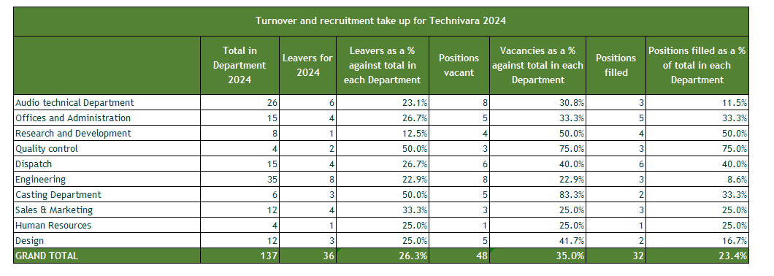
The source table, including formulae can be found by following the following link:

https://gwent-my.sharepoint.com/personal/lynda_astell_coleggwent_ac_uk/Documents/@Personal/CIPD/Evidence%20Based%20Practice/Assignment/Task%202%20Question%208.xlsx

AC 2.2

The following three graphs, based on the table in 2.1, shows leavers, vacancies and positions filled as a % of total employees at Technivara. The graphs are formatted to show departments in descending order of respective rate. The average rate of leavers across all departments is shown by a labelled line on each graph.

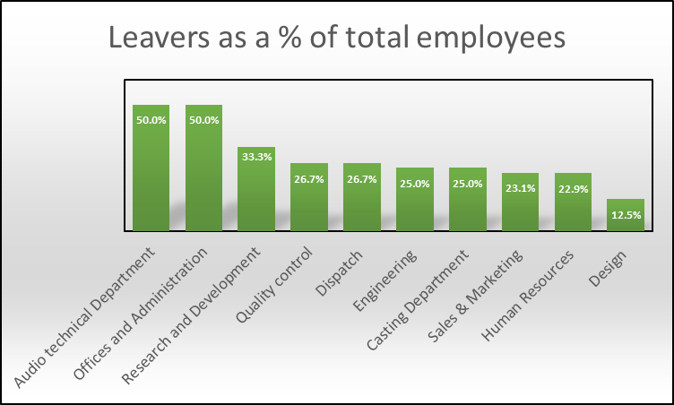
Technivara Average =26.3%

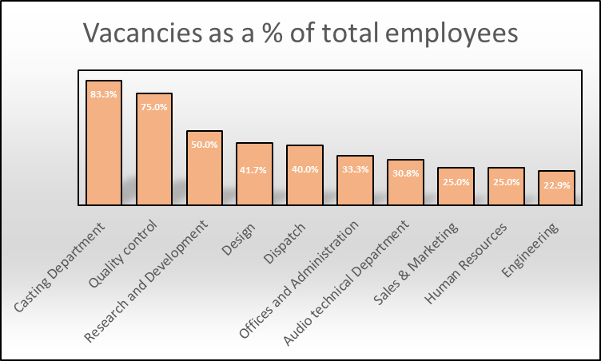
Technivara Average =35.0%

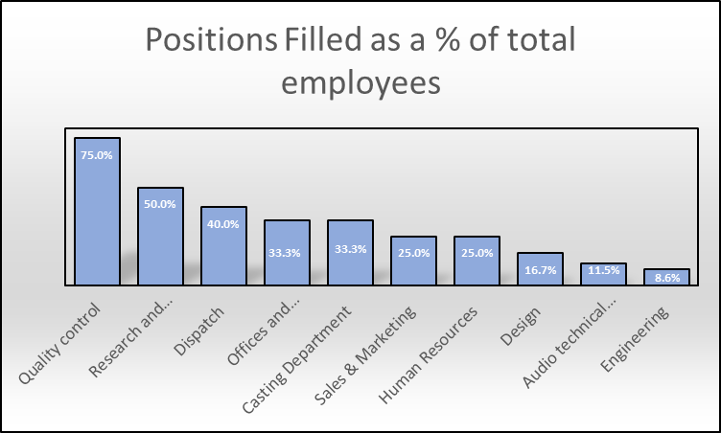
Technivara Average =23.4%

The following graph shows leaver, vacancy and position filled rates by department all on the one chart.

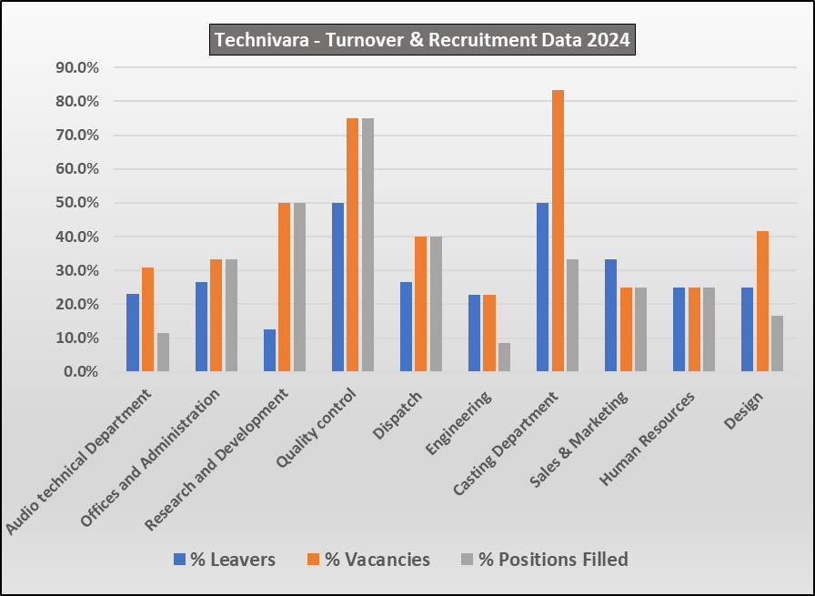
AC 2.3

The evaluation feedback has been analysed using a traffic light Red-Amber-Green (RAG) rating system (Fig. 2.3a). This approach allows for a straightforward visual summary of the results, making it easy to identify areas of strong performance (green), areas requiring attention (amber), and areas of concern (red). The main benefit of using RAG ratings is that they help to quickly highlight priorities and support evidence-based decision-making, ensuring that actions can be targeted where they are most needed. This method also enhances communication of findings to stakeholders by presenting complex data in an accessible and actionable format (Public Health England, 2017).

Each item was assigned a RAG rating using the following broad criteria:
- Green for high agreement (>75% Agree),
- Red for high disagreement (> 75% Disagree).
- Amber for mixed or uncertain responses (all responses falling between the above)

 | % Agree | % Not Sure | % Disagree | RAG Rating*
My learning preferences were considered prior the learning activity | 23.8% | 42.9% | 33.3%
On commencement the faciliator provided a clear set objectives | 92.9% | 7.1% | 0.0%
The learning event was appropriately structured | 54.8% | 26.2% | 19.0%
The faciliator was clearly knolwedgable about the topics | 92.9% | 4.8% | 2.4%
The faciliator provided a clear explanation on topics discussed | 78.6% | 0.0% | 21.4%
Resources used were of a good quality | 85.7% | 14.3% | 0.0%
I was able to engage with meaningful questioning and answering on topics being discussed | 4.8% | 19.0% | 76.2%
At the end of the session the set learning outcomes were achieved | 11.9% | 9.5% | 78.6%
The learning linked to my performace target | 14.3% | 57.1% | 28.6%
I was able to employ the knowledge skills and behaviours into my working role | 14.3% | 52.4% | 33.3%
Fig 2.3a
From the above we can see that the evaluation of the learning activity at Technivara highlights several notable strengths (Green ratings), particularly in facilitator performance and resource quality. An overwhelming majority of participants (92.9%) agreed that clear objectives were established at the outset, and the same proportion recognised the facilitator’s subject expertise.

Furthermore, 78.6% of respondents felt that explanations were clear, and 85.7% rated the quality of learning resources positively. These findings align with research by Hattie (2009), who emphasises that clarity of instruction and facilitator expertise are critical factors in effective learning environments.

High-quality resources and knowledgeable facilitators not only enhance comprehension but also contribute to learner confidence and satisfaction.

However, the feedback also reveals areas for improvement.

Most significantly (Red Ratings), employee ability to engage with meaningful questioning and answering on topics being discussed along with the achievement of set outcomes scored very poorly with over three-quarters of respondees expressing dissatisfaction in both of these areas. The former is of particular concern as a lack of interactivity can hinder deeper learning and critical thinking, as highlighted by Prince (2004), who found that active learning strategies significantly improve learner outcomes.

Other areas for potential improvement (Amber ratings) are as follows:-

- Only 23.8% of participants felt their individual learning preferences were considered prior to the activity, while a third actively disagreed. This suggests a need for more differentiated instructional strategies, as supported by Tomlinson (2014), who advocates for tailoring learning experiences to accommodate diverse learner needs.

- A mere 14.3% of participants felt the content was linked to their performance targets or applicable in their roles. This disconnect underscores the importance of aligning training objectives with individual roles and tasks, as suggested by Kirkpatrick and Kirkpatrick (2016), who argue that training is most effective when it is directly relevant and transferable to the workplace.

- Additionally, while just over half of participants (54.8%) agreed that the session was well-structured, a notable proportion were either dissatisfied or uncertain, indicating room for improvement in the design of the activity.

- Structuring of the learning event and clarity of explanations received some variability in participant response and therefore experience.

In response to the survey results and analysis the following recommendations are put forward:

Further Analysis

- It is important to understand the total number of employees who participated in the learning and development activity to ensure that the percentage feedback is meaningful and that the survey results are valid. An adequate sample size is essential for the reliability and generalisability of survey findings; if the sample is too small, the results may not accurately reflect the views of the wider population, potentially leading to misleading conclusions (Mursa et al., 2025). Clear reporting of participant numbers also supports transparency and strengthens the credibility of the evaluation process.

- To gain a deeper understanding of the issues highlighted in the evaluation feedback it is recommended that qualitative methods be employed. Specifically, conducting focus groups or incorporating open-ended questions in future surveys would allow participants to elaborate on their experiences, particularly in poorly rated areas. This approach aligns with Creswell and Creswell’s (2018) advocacy for mixed-methods research, which enhances the richness and contextual understanding of quantitative findings.

- A further drill down analysis of the feedback data should be undertaken. By examining responses across different participant groups such as by role, department, or prior experience it may be possible to identify patterns. This level of granularity can allow more targeted action and ensures that future learning activities are inclusive and responsive to the needs of all participants.

Practical Actions

- Based on the findings, several practical steps should be taken to improve the design and delivery of future learning activities. Firstly, the structure and content of the sessions should be reviewed and revised to better accommodate diverse learning preferences. This includes ensuring that learning objectives are clearly communicated and that the content is explicitly linked to participants’ performance targets, thereby enhancing relevance and motivation.

- Secondly, while facilitators were rated highly for their knowledge and clarity, there is a clear need to strengthen their ability to foster engagement. Targeted professional development should be provided to equip facilitators with interactive teaching strategies and effective questioning techniques that encourage active participation and dialogue.

- Thirdly, the introduction of real-time feedback mechanisms such as digital polling tools or live Q&A platforms would enable facilitators to adapt their delivery in response to participant needs during the session. This dynamic approach can significantly enhance the learning experience and address issues as they arise.
By implementing these evidence-based recommendations, Technivara can enhance the effectiveness of its learning activities, ensuring they are not only informative but also engaging, relevant, and impactful.

Bibliography

Bain & Company (2023) Engineering and R&D: The Path to New Sources of Value. Available at: https://www.bain.com/insights/the-path-to-new-sources-of-value-engineering-r-and-d-report-2023 (Accessed: September 2025).

Bhardwaj, A. & Singh, S. (2024) ‘Utilitarianism: A Contemporary Perspective’, Journal of Business Ethics, 189(2), pp. 345–359.

Big Data Value Association (2020) Sector Benchmarking: Best Practices and Methodologies. Available at: https://www.bdva.eu/sector-benchmarking (Accessed: September 2025).

Brookfield, S.D. (2012) Teaching for Critical Thinking: Tools and Techniques to Help Students Question Their Assumptions. Jossey-Bass.

Buckley, R. (2013) ‘Evidence-Based HR: The Bridge Between Science and Practice’, Human Resource Management International Digest, 21(4), pp. 3–5.

Burke, R.J. (CIPD, 2020) Human Capital and Organisational Performance. Chartered Institute of Personnel and Development.

Business Model Analyst (n.d.) SWOT Analysis: Advantages and Disadvantages. Available at: https://businessmodelanalyst.com/swot-analysis-advantages-disadvantages/ (Accessed: September 2025).

Cambridge Institute for Manufacturing (n.d.) Force Field Analysis: A Tool for Decision Making. Available at: https://www.ifm.eng.cam.ac.uk/research/dstools/force-field-analysis/ (Accessed: September 2025).

Camp, R.C. (1989) Benchmarking: The Search for Industry Best Practices that Lead to Superior Performance. ASQC Quality Press.

Chermack, T.J. & Kasshanna, B.K. (2007) ‘The Use and Misuse of SWOT Analysis and Implications for HRD Professionals’, Human Resource Development International, 10(4), pp. 383–399.

CIPD (2015) Ethical Practice for HR Professionals. Chartered Institute of Personnel and Development.

Christenson, A. & Jegleim, T. (2020) EAP139: Methodology for assigning Red-Amber-Green status for 2021 Census returns. UK Statistics Authority. Available at: https://uksa.statisticsauthority.gov.uk/wp-content/uploads/2021/01/EAP139-RAG-Status.pdf (Accessed: September 2025).

Creswell, J.W. & Creswell, J.D. (2018) Research Design: Qualitative, Quantitative, and Mixed Methods Approaches. 5th edn. Sage.

de Bono, E. (1985) Six Thinking Hats. Penguin.

Dwyer, C.P. (2017) Critical Thinking: Conceptual Perspectives and Practical Guidelines. Cambridge University Press.

Elliott, C. & Turnbull, S. (2005) ‘Critical Thinking in Human Resource Development’, European Journal of Training and Development, 29(8), pp. 653–665.

EVX Software (2024) Limitations of SWOT Analysis in Strategic Planning. Available at: https://evxsoftware.com/limitations-of-swot-analysis/ (Accessed: September 2025).

Gifford, J. & Wietrak, E. (2022) Measuring Task and Contextual Performance in Organisations. CIPD.

Hattie, J. (2009) Visible Learning: A Synthesis of Over 800 Meta-Analyses Relating to Achievement. Routledge.

Institute of Psychotherapy (2025) History of Evidence-Based Practice. Available at: https://www.instituteofpsychotherapy.com/ebp-history (Accessed: September 2025).

Jud, T., O’Rourke, J. & Grant, A. (2018) ‘Employee Engagement Surveys: Still the Best Predictor of Behaviour?’, Journal of Organisational Psychology, 18(2), pp. 45–59.

Kirkpatrick, D.L. & Kirkpatrick, J.D. (2016) Evaluating Training Programs: The Four Levels. 4th edn. Berrett-Koehler.

Klikauer, T. (2014) ‘Utilitarianism and HRM: A Critique’, Journal of Business Ethics, 120(3), pp. 327–338.

Kivunja, C. (2015) ‘Using de Bono’s Six Thinking Hats Model to Teach Critical Thinking and Problem Solving Skills Essential for Success in the 21st Century Economy’, Creative Education, 6(3), pp. 380–391.

Kroon, B. (2022) ‘The Human Factor in Organisational Success’, International Journal of Human Resource Management, 33(5), pp. 789–805.

Leonteva, I. (2024) ‘The Cost of Poor Recruitment: A Case Study of TechCorp’, HR Review, 29(1), pp. 12–17.

Lewin, K. (1947) ‘Frontiers in Group Dynamics’, Human Relations, 1(2), pp. 143–153.

McKinsey & Company (2021) The Future-Ready Company. Available at: https://www.mckinsey.com/future-ready-company (Accessed: September 2025).

Muravu, R. (2023) ‘Benchmarking in the Engineering Sector: A Review’, Engineering Management Journal, 35(2), pp. 101–110.

Mursa, R.A., Patterson, C., McErlean, G. & Halcomb, E. (2025) ‘How many is enough? Justifying sample size in descriptive quantitative research’, Nurse Researcher. Available at: https://journals.rcni.com/nurse-researcher/evidence-and-practice/how-many-is-enough-justifying-sample-size-in-descriptive-quantitative-research-nr.2025.e1958/pdf (Accessed: September 2025).

Online Business School (2023) Critical Thinking in HR: Principles and Practice. Available at: https://www.onlinebusinessschool.com/critical-thinking-in-hr (Accessed: September 2025).

Palazzo, G. (2024) ‘SWOT Analysis in Modern Strategic Management’, Strategic Management Review, 15(1), pp. 22–30.

Parnell, J.A. & Gangwish, P. (2023) ‘Stakeholder Engagement in Strategic Decision-Making’, Business Strategy Series, 24(4), pp. 301–312.

Phillips, J.J. (2003) Return on Investment in Training and Performance Improvement Programs. 2nd edn. Butterworth-Heinemann.

Prince, M. (2004) ‘Does Active Learning Work? A Review of the Research’, Journal of Engineering Education, 93(3), pp. 223–231.

Public Health England (2017) RAG Ratings Technical Guide. Available at: https://fingertips.phe.org.uk/documents/PHDS%20Guidance%20-%20RAG%20Ratings.pdf (Accessed: September 2025).

Robinson, B. (2024) ‘HR Predictions for 2025: Outdated Practices Will Be Turned on Their Head’. Forbes. Available at: https://www.forbes.com/sites/bryanrobinson/2024/12/09/hr-predictions-for-2025-outdated-practices-will-be-turned-on-their-head (Accessed: September 2025).

Rousseau, D.M. & Barends, E. (2011) ‘Becoming an Evidence-Based HR Practitioner’, Human Resource Management Journal, 21(3), pp. 221–235.

Saks, A.M. (2006) ‘Antecedents and Consequences of Employee Engagement’, Journal of Managerial Psychology, 21(7), pp. 600–619.

SEA Open Research (n.d.) Limitations of SWOT Analysis. Available at: https://www.seaopenresearch.com/limitations-of-swot-analysis (Accessed: September 2025).

Shafaghat, A., Keyvanfar, A., & Abdullahi, M. (2022) ‘Force Field Analysis in Organisational Change’, Journal of Change Management, 22(1), pp. 45–59.

Springer, M. (2015) Benchmarking for Best Practices in Engineering. Springer.

Tomlinson, C.A. (2014) The Differentiated Classroom: Responding to the Needs of All Learners. 2nd edn. ASCD.

VQ Solutions (2024) Ethical Theories in HR Practice. Available at: https://www.vqsolutions.co.uk/ethical-theories-in-hr-practice (Accessed: September 2025).

Willmington, S., Patel, R. & Jones, T. (2022) ‘Benchmarking for Quality Improvement in Engineering’, Quality Management Journal, 29(4), pp. 215–228.

Zimmerman, M. (2013) ‘The Evolution of Evidence-Based Practice in Medicine’, Medical History Review, 87(2), pp. 201–215.

