
Applied Leadership and Management in the Workplace
Module Assignment Submission
Student Name: | Joanna Drozd
Student Number: | 2308210
Module No: | BMSK4013
Module Title: | Management Communication
Statement of Confirmation of Authenticity
By the act of making this submission, the student declares that this is the work of the student named above. The work has not, in whole or in part, been knowingly presented elsewhere for assessment, or where assessment has been built on a previous assessment, this has been identified. Where materials have been used from other sources it has been properly acknowledged. If this statement is untrue, the student acknowledges that an assessment offence has been committed.
Attention is drawn to the plagiarism and unfair practice policies of both the University and of ILM.

Table of Contents
Introduction 3
Section 1: Communication 3
1.1 Relevance of the Communication Cycle for Effective Management Communication. 5
1.2 Importance of Selecting Appropriate Tone, Language, and Formality in Management Communications 7
1.3 Assessing the effectiveness of various verbal and written communication methods in my workplace. 8
Section 2: Motivation 10
2.1 Evaluate theories of motivation relevant to your workplace. 11
2.2 The principal factors that may affect performance and motivation in the workplace. 12
2.3 Select a theory of motivation - apply it to your workplace – evaluate the impact. 13
2.4 Collect and analyse feedback on own verbal and written communication skills. 15
2.5 Evaluate own communication skills as a manager. 16
Conclusion/ Summary / Recommendations (as applicable) 17
References 17
Appendix A 22
Appendix B 33
Appendix C 43

Introduction

Effective communication is crucial to effective management; it enables the flow of information, ideas, and instructions necessary for the efficient operation and unity of the organisation. The communication cycle is crucial because it helps managers navigate complex interpersonal interactions in the workplace. This report will explore the importance of the communication cycle for effective management communication and discuss the significance of choosing the appropriate tone, language, and formality in managerial communication, using illustrative examples from the workplace. In addition, various verbal and written communication methods in organisational contexts will be assessed. Motivation theories relevant to the workplace will be examined, and factors influencing performance and motivation will be assessed.
Furthermore, motivation theory will be applied to a real managerial scenario, and criteria will be developed to assess personal communication skills. Finally, the process of collecting and assessing feedback on communication skills, both verbal and written, will be discussed. Ultimately, this will lead to assessing strengths and areas for improvement in managerial communication. A Personal Development Plan (PDP) will target identified areas to achieve specific improvements. This in-depth exploration is intended to improve my communication effectiveness as a manager and enable me to succeed in the organisation.

Section 1: Communication

From the moment we are born, we possess the ability to communicate using words and gestures to convey messages to others. However, communicating effectively is a skill. We spend more time communicating than doing anything else for example we listen, think, talk, share secrets with friends, participate in teams, ask, and answer questions, exchange information with colleagues, attend public performances and watch television programs. Communication is essential in our personal, professional, and social lives from birth to death.
Communication is a process which according to Rothwell (2004), is a transactional process that involves sharing meaning with others, suggesting that interpersonal communication is dyadic, occurring between two people. Kemoni (2004), citing Ojiambo, further asserts that communication entails giving and receiving information, signals, or messages through talk, gestures, and writing. Ojomo (2004) defines communication as sharing ideas, feelings, thoughts, and messages with others. Moreover, Odini (1999) identifies communication as one of the core competencies that all information professionals should possess. Scott (1961) defines communication as "a process which involves the transmission and accurate replication of ensured by feedback for the purpose of eliciting actions which will accomplish organizational goals."
Overall, communication encompasses various forms of interaction, from verbal exchanges to written messages, gestures, and even nonverbal cues, facilitating the sharing of information, ideas, and emotions among individuals. In the words of Duck & McMahan, (2015), "Communication is the transactional use of symbols, influenced, guided, and understood in the context of relationships”.

Effective communication is foundational to the success of any business. It fulfils two crucial roles within an organization: firstly, it ensures the dissemination of information necessary for employees to fulfil their responsibilities; secondly, it fosters relationships built on trust and commitment. Communication is pivotal in facilitating productivity and maintaining operational efficiency in the workplace. Employees rely on accurate and timely information from their superiors to feel secure in their roles. Moreover, they value the opportunity to exchange ideas, thoughts, and concerns within the company. Research has demonstrated that companies with strong communication practices are better equipped to retain their employees, even after downsizing efforts (Conrad, 2014).

PURPOSE OF COMMUNICATION IN MY WORKPLACE:
· Managing Human Resources: Communication influences, motivates, and maintains relations among diverse employees, ensuring unity despite cultural differences.
· Building Positive Interpersonal Relations: Clear communication bridges cultural gaps, encourages teamwork, and prevents misunderstandings.
· Unity and Harmony: Effective communication holds the organisation together, ensuring seamless operations despite geographical distances.
· Expressing Ideas and Thoughts: Communication empowers individuals to express ideas and feelings effectively, fostering innovation in production processes.
· Team Building and Teamwork: Clear communication enables efficient collaboration, which is essential for solving production issues in teams.
· Delegation of Work: Clear instructions and updates facilitate the delegation of tasks, enhancing overall efficiency.
· Transacting Business: Internal and external communication channels ensure smooth business operations and transactions.
· Building Trust: Transparent communication is the foundation of trust, enhancing the reputation of automotive parts in the market and making the audience feel reassured and confident in our business operations.

1.1 Relevance of the Communication Cycle for Effective Management Communication.

Communication Cycle

The communication cycle is crucial in management for effective communication because it ensures messages are tailored to the needs of recipients, encoded, and decoded clearly, and supported by feedback loops. Managers use this cycle to identify and overcome communication barriers (communication barriers are discussed in the appendix A), ensuring messages are understood in the proper context and environment. By following this cycle, managers enhance collaboration, productivity, and organizational success.

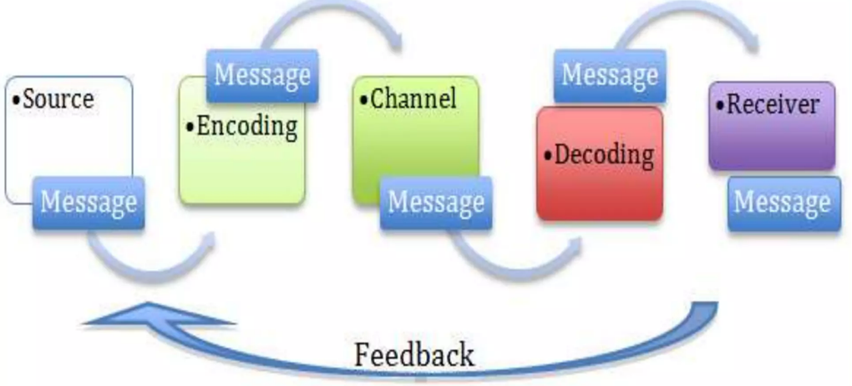

Sender: The individual sending the message should understand their audience and have a clear purpose for the message to avoid misunderstandings.

Message: This is the information the sender wants the audience to understand, conveyed through chosen words and mediums, influenced by communication style.
Transmission and Noise: Messages are sent through various channels, but clear transmission is crucial, considering distractions like physical noise (e.g., phone interference) and personal factors (e.g., accents, culture) that can affect perception.
Receiver: Receivers interpret messages based not only on words and symbols but also on their experiences, emotions, and beliefs.
Feedback: A crucial element of effective communication is the receiver's feedback. It serves as a check to ensure that the receiver's understanding aligns with the sender's intention. This feedback can be verbal or non-verbal, and its importance cannot be overstated.
Detailed descriptions of the stages of the communication cycle and their importance for effective communication in management, especially in the context of informing the team about changes in project implementation deadlines at my workplace, have been included in the Appendix A to this report.

Communication models
Communication models are structured representations that clarify the complexities of the communication process. Their use of metaphorical and symbolic images effectively demonstrates the functioning of communication. Models provide comprehensive insights into the issue by reducing the intricacies of communication and arranging its elements. Nevertheless, they may reinforce conventional perspectives and prejudices while disregarding essential elements of human connection.

When selecting a suitable communication model, it is essential to consider elements such as communication techniques, channels, and the desired objective. Businesses and organisations employ these models to improve communication tactics, examine other possibilities, and evaluate individual conditions. Furthermore, they assist in predicting how message recipients will perceive the communicated information.
The examples and description of selected communication models are discussed in the appendix A.

1.2 Importance of Selecting Appropriate Tone, Language, and Formality in Management Communications

Selecting the appropriate tone, language, and level of formality in management communications is crucial for effective and successful interactions within and outside the organisation. It ensures clarity, professionalism, and cultural sensitivity when conveying messages to diverse audiences. By using clear and easily understood language, managers can prevent misunderstandings and errors in execution. Maintaining a level of formality fosters professionalism, respect, and credibility, especially in formal business settings or when dealing with clients and stakeholders. Being mindful of cultural differences in communication styles helps to avoid offence or misunderstanding, fostering positive relationships and trust.
Moreover, language and tone that resonate with the audience can motivate and engage them, facilitating constructive dialogue and conflict resolution when needed. Effective communication is also essential for leadership and influence, enabling managers to inspire and influence others towards organisational goals. Additionally, adherence to legal and compliance requirements in communication mitigates the risk of legal liabilities. In summary, selecting the appropriate tone, language, and formality level in management communications is fundamental for achieving successful outcomes and maintaining positive relationships in the business environment.
Communication Type | Tone | Language | Formality
E-mails | Professional, polite | Clear, concise | Varies (typically semi-formal to formal)
Team Meeting | Collaborative, inclusive | Clear, jargon-free | Semi-formal
Job Interview | Professional, respectful | Formal, articulate | Formal
Social Media Post | Casual, friendly | Informal, conversational | Informal
Policies | Policies | Formal, technical | Highly formal
1:1 Meetings | Personal, focused | Direct, empathetic | Semi-formal

Various types of communication are discussed in Appendix A.

1.3 Assessing the effectiveness of various verbal and written communication methods in my workplace.

Improving communication within your company is essential to promoting productivity, collaboration, and overall efficiency. In the factory where I work, communication between the assembly and welding departments must be improved. Team leaders need to pay attention to each other and their priorities, which leads to downtime in the assembly department due to a lack of appropriate components. The welding team produces redundant or duplicate components that the assembly department can use.
E-mail is a powerful tool for written communication. Given the linguistic diversity of the staff, including several non-English-speaking immigrants, it is essential that communication is clear and concise, and it is. This helps overcome the language barrier and ensures that everyone understands the message.
However, there are significant gaps in feedback mechanisms. Maintaining open communication with employees about the quality of their work is extremely important. This feedback is crucial to their professional development and can provide valuable insights that help them improve. Currently, the only form of feedback is written warnings or reprimands, which are used in the event of a regulation violation. This approach does not foster a productive work environment or promote growth.
So, increasing the effectiveness of formal meetings regarding verbal communication requires attention. Tone and words often require greater clarity and professionalism. Additionally, meetings often run over the allotted time, indicating organisational shortcomings and neglecting participants' schedules. Even though plans exist, their implementation may require greater consistency, leading to clarity and efficiency.
To improve communication within the organisation, it is necessary to establish more visible channels for receiving feedback and increase the professionalism and effectiveness of verbal communication, especially during formal meetings. This may include training team leaders in effective communication tactics and conducting regular staff meetings for feedback. Additionally, ensuring all individuals maintain their assigned schedules and meet established deadlines would improve communication processes and increase overall efficiency.

Section 2: Motivation

Jaja (2003) defines motivation as the product of the interaction between an individual and their environment, where a motive or drive arises from a compelling need that directs goal-oriented action. While various definitions of motivation exist, a common thread among them is that motivation involves individuals' desire and choice to engage in directed activities with the expectation of fulfilling their needs (Sansone & Harackiewicz, 2000; Ricky et al., 2012). To elicit specific behaviour in individuals, the sources of stimuli that encourage them must be clearly recognized (Kian & Yusoff, 2015).

Flower (2014) observes that many leaders, consciously or unwittingly, base their approach to motivation on Maslow's Hierarchy of Needs. Maslow's theory posits that individuals are initially motivated by fulfilling lower-level needs such as food, water, and security before progressing to higher-level needs like self-actualization. While addressing lower-level needs is essential, individuals can experience higher-level motivation regardless of circumstances.

Kelley (2015) highlights the role of motivation in management, emphasizing that it encompasses more than ensuring employee happiness. Motivated employees exhibit a strong desire to perform, leading to increased productivity, engagement, and investment in their work, ultimately benefiting both employees and managers.

Intrinsic and extrinsic motivation
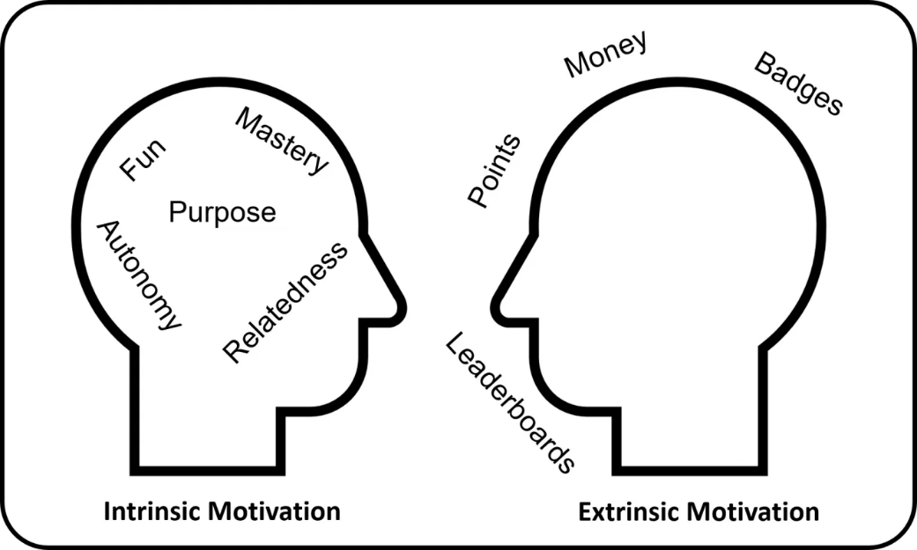Gamified UK

The appendix B elaborates on this discussion of intrinsic and extrinsic motivation, including their distinctions, effects, and interactions.

2.1 Evaluate theories of motivation relevant to your workplace.

The motivational theories along with examples from my workplace have been discussed in Appendix B.

2.2 The principal factors that may affect performance and motivation in the workplace.

Many main factors affect performance and motivation in the workplace, but the most common are:
• Leadership style: An organization's leadership style can significantly impact motivation and performance. Collaborative and empowering leadership usually promotes higher motivation levels, while autocratic or micromanagement styles can lead to decreased motivation and poor performance.
• Work environment: Physical working conditions, organizational culture, and workplace atmosphere can affect motivation. A positive and inclusive work environment typically fosters higher motivation and performance levels.
• Recognition and reward systems: Employees who feel their contributions are valued and rewarded are often more motivated to do good work. Recognition can take many forms, including cash prizes, promotions, and recognition for performance.
• Clear goals and expectations: When employees have clear goals and understand their expectations, they are more motivated to achieve them. Lack of clarity or uncertainty about goals can lead to confusion and a drop in motivation.
• Training and development opportunities: Motivates employees by providing them with learning and development opportunities, demonstrating that the organization values their growth and invests in their future.
• Work-life balance: Maintaining a work-life balance is crucial for staying motivated and preventing burnout. Organizations that prioritize work-life balance tend to have more motivated and engaged employees.
Motivation is essential when evaluating performance because motivated employees are likelier to put effort and energy into their work, leading to higher productivity and quality results. Motivated employees are also more engaged in their work, which can increase job satisfaction and reduce turnover.
Conflict in the workplace can have a significant impact on motivation and communication. Conflicts can arise from different views, personalities, or conflicting interests. Conflict can create tension, negatively affect motivation, and undermine trust and cooperation. Additionally, conflict can hinder effective communication and lead to misunderstandings and breakdowns in cooperation.
To effectively manage conflict and stay motivated while improving communication, organizations can employ several strategies:
• Promote open communication: Encourage employees to express their concerns and views openly and respectfully. Creating a platform for open discussion can help resolve conflicts before they escalate.
• Clarify roles and responsibilities: Clearly defined roles and responsibilities within the team will minimize confusion and reduce the risk of conflict due to misunderstandings or overlapping responsibilities.
• Mediation and dispute resolution training: Providing people with the tools to resolve conflicts constructively helps them resolve them effectively.
• Finding common ground: This encourages conflicting parties to focus on finding common ground and common goals. Individuals can work together to find mutually acceptable solutions by highlighting areas of agreement.
• Implement conflict resolution procedures: Establish clear conflict resolution procedures within the organization. A structured process helps resolve conflicts quickly and fairly.
By proactively managing conflicts and promoting effective communication, companies can create a positive work environment that keeps employees motivated and promotes high performance.

2.3 Select a theory of motivation - apply it to your workplace – evaluate the impact.

Applying the Vroom’s Expectancy Theory of Motivation to the case described in my workplace helps me understand why employees try harder at their jobs, especially regarding safety.

Expectancy:
Before the new safety policies were introduced, employees may have felt helpless and unsure whether their safety efforts would produce results. The accident clearly showed severe risks; it was challenging to make a difference without appropriate action. After introducing new rules and training, employees began to believe that their safety efforts could provide better working conditions.
Instrumentation:
Before the accident, employees may have doubted whether following safety rules would benefit them. Even if they do everything possible, they may still feel that accidents can happen. After implementing new procedures, they saw that their efforts could reduce the risk of accidents and injuries. This made them feel more confident and responsible for their actions.
Value:
Employees value their safety and health, but before the incident, they may not have realised the importance of actual safety measures. After the incident, they began to appreciate the importance of safety for themselves and the entire team and work efficiency. This made them more committed to following the new rules.
Thanks to these changes:
- Employees are more motivated because they see that their efforts make sense.
- Safety becomes a more natural part of the job, which improves the overall safety culture.
- Employees feel more appreciated and safer at work, which increases their job satisfaction.
- It can also increase productivity because employees focus more on their work than safety concerns.
Making changes after an accident is a step in the right direction, increasing motivation and improving workplace safety.

2.4 Collect and analyse feedback on own verbal and written communication skills.

This study aimed to assess various aspects of the author communication competence, understanding their strengths and areas requiring further development.
Research Method: The sample consisted of 30 respondents from professional and educational backgrounds. Respondents were asked to rate the author's communication competencies on a scale of 1 to 10 in 13 different areas.
Research Findings:
- Clarity: The average score was 88%, suggesting effectiveness in conveying thoughts and information.
- Conciseness: The score was 87%, indicating the ability to speak without unnecessary digressions.
- Engagement: The score was 90%, suggesting the ability to engage listeners in conversation.
- Empathy: Rated at 84%, indicating the potential to understand others' perspectives better.
- Nonverbal Communication: The ability to effectively use gestures and facial expressions was rated at 95%.
- Active Listening: Rated at 87%, suggesting good listening skills and responsiveness to others' statements.
- Adaptability: The score was 83%, suggesting the ability to adjust communication style to different situations and individuals.
- Feedback Reception: Rated at 84%, indicating the ability to effectively respond to feedback on communication.
- Conflict Resolution: The score was 81%, suggesting the need for improvement in effectively resolving conflicts through conversation.
- Impact: The 84% score suggests that the author's communication often leads to intended actions or reactions.
- Cultural Sensitivity: Rated at 88%, indicating good ability to deal with cultural differences in communication.
- Self-confidence: Self-confidence: Rated at 79%, suggesting a moderate level of self-assurance in communication with others.
- Written Communication: 92%, indicating effectiveness in writing emails and reports.

These criteria are essential for excelling in management and effectively motivating people, which are crucial for success as a manager. Clear communication, empathy, and conflict resolution skills enable building positive relationships with employees, while confidence, flexibility, and adaptability allow for adjusting to various situations and team needs, encouraging efficient work.

Conclusions: Based on the research findings, the author possesses many communication strengths, such as clarity, conciseness, listener engagement, and the ability to use nonverbal communication effectively. However, areas also require further development, including empathy, conflict resolution, self-confidence, and adaptability to different situations. Further work on these skills is recommended to achieve an even higher level of communication effectiveness.

2.5 Evaluate own communication skills as a manager.

In Appendix C, the SWOT analysis, gap analysis, personal objectives, PDP, and reflection on exploring my communication were discussed.

Conclusion

In summary, effective communication plays a key role in managerial success. It allows for the smooth exchange of information, ideas and instructions within the organization. The communication cycle serves as a helpful guide in navigating interpersonal interactions in the workplace. Choosing the right tone, language and formality is crucial to effective communication. Examples from the workplace illustrate this point. Various verbal and written communication methods were assessed, highlighting their strengths and weaknesses. Understanding motivation theory helps inspire and engage employees. Criteria for assessing personal communication skills and strategies for collecting feedback were developed. This process creates a Personal Development Plan (PDP) to increase communication effectiveness. The purpose of this report is to improve managerial communication skills, leading to organizational success.

References

- Aguinis, H., Simonsen, M., & Pierce, C. A. (1998). Effects of nonverbal behavior on perceptions of power bases. The Journal of Social Psychology, 138, 455–469.
- Amabile, T. M. (2001). Motivational Synergy: Toward a New Conceptualization of Intrinsic and Extrinsic Motivation in the Workplace. Human Resource Management Review, 3(3), 185-201.
- Amabile, T. M., Karl, G. H., Beth, A. H., & Elizabeth, M. T. (1994). The Work Preference Inventory: Assessing Intrinsic and Extrinsic Motivational Orientations. Journal of Personality and Social Psychology, 66(5), 950-967.
- Argyle, M. (1988). Bodily Communication (2nd ed.). Methuen.
- Aristotle. (1909). The Rhetoric of Aristotle: a translation. The University Press.
- Ashman, M. (2018). Introduction to Professional Communications. In Professional communications: OER textbook. BCcampus. Retrieved from https://pressbooks.bccampus.ca/professionalcomms/chapter/8-3-listening-skills/
- Baridam, M. D. (2002). Management and Organization Theory. Sherbrooke Associates.
- Berlo, D. K. (1960). The Process of Communication: An Introduction to Theory and Practice. Holt, Rinehart and Winston.
- Bodie, G. D. (2011). The Active-Empathetic Listening Scale (AELS): Conceptualization and evidence of validity within the interpersonal domain. Communication Quarterly, 59(3), 277-295.
- Boone, L. (2013). What is a communication barrier? | Guideline to overcome communication barriers. Retrieved from https://thebusinesscommunication.com/what-is-a-communication-barriers/
- Brooks, F. P. (2003). Three great challenges for half-century-old computer science. Journal of the Association for Computing Machinery, 50(1), 25–26.
- Bruneau, T. (1993). Empathy and Listening. In A. Wolvin & C. Coakley (Eds.), Perspectives on listening. Norwood, NJ: Alex Publishing Corporation.
- Burgoon, J. K., & Dunbar, N. E. (2000). An interactionist perspective on dominance-submission: Interpersonal dominance as a dynamic, situationally contingent social skill. Communication Monographs, 67(1), 96.
- Burgoon, J., & Johnson, M. L. (1998). The nature and measurement of interpersonal dominance. Communication Monographs, 65(4), 308.
- Colombo, M. (2004). Theoretical perspectives in media-communication research: From linear to discursive models. Forum: Qualitative Social Research, 5(2), 1–11. https://doi-org.ezproxy.uwtsd.ac.uk/10.17169/fqs-5.2.592
- Conrad, D. (2014). Workplace Communication Problems: Inquiries by Employees and Applicable Solutions. Journal of Business Studies Quarterly, 5(4).
- Deci, E. L. (1972). The effects of contingent and noncontingent rewards and controls on intrinsic motivation. Organizational Behavior and Human Performance.
- Duck, S., & McMahan, D. T. (2015). Communication in Everyday Life: The Basic Course Edition With Public Speaking. Sage.
- Fowler, S. (2014). Why Motivating People Doesn't Work…And What Does: The New Science of Leading, Energizing.
- Getchell, K., Dubinsky, J., & Lentz, P. (2023). A Critique of Transmission Communication Models in Introductory Management and Organizational Behavior Textbooks. Journal of Management Education, 47(5), 477–504. https://doi.org/10.1177/10525629231182156
- Hargie, O. (2011). Skilled interpersonal interaction: Research, theory, and practice. London: Routledge.
- Jaja, S. A. (2003). Praxis of Work Behavior. Pinnacle Publishers.
- Kelley, S. (2015, September 15). What is Motivation in Management? - Definition, Process & Types. Retrieved from http://study.com/academy/lesson/what-ismotivation-in-management-definition-process-types.html.
- Kemoni, H. N. (2004). Melvin DeFleur’s information communication model: Its application to archives administration. African Journal of Library, Archives & Information Science, 14(2), 167-175.
- Kian, T. S., & Yusoff, W. F. W. (2015). Intrinsic-Extrinsic motivation revisited: exploring their definitions. International Journal of Management Sciences, 6(3), 136-140.
- Knapp, M. L., & Hall, J. A. (2002). Nonverbal Communication in Human Interaction. Thomson Learning.
- Krone, K. J., Jablin, F. M., & Putnam, L. (1987). Communication theory and organizational communication: Multiple perspectives. In F. Jablin, L. Putnam, K. Roberts, & L. Porter (Eds.), The handbook of organizational communication: An interdisciplinary perspective .Sage.
- Lasswell, H. (1948). The Structure and Function of Communication in Society. In L. Bryson (Ed.), The Communication of Ideas. Institute for Religious and Social Studies, New York.
- Mamoria, C. B. (2013). What is a communication barrier? | Guideline to overcome communication barriers. Retrieved from https://thebusinesscommunication.com/what-is-a-communication-barriers/
- Marczewski, A. (2020, August 4). But What If They Get Addicted To Your Gamified System? Gamified. https://www.gamified.uk/2020/08/04/but-what-if-they-get-addicted-to-your-gamified-system/
- Maslow, A. H. (1996). Critique of self-actualization theory. In E. Hoffman (Ed.), Future Visions: The Unpublished Papers of Abraham Maslow (pp. 26–32). Sage.
- McClelland, D. C. (1988). Human Motivation. Cambridge University Press.
- McGregor, D. (1957). The human side of enterprise. Management Review.
- McLean, S. (2005). The Basics of Interpersonal Communication. Boston, MA: Allyn & Bacon.
- McQuail, D. (2013). Reflections on paradigm change in communication theory and research. International Journal of Communication
- Morgan, P. (2017). The Business Student’s Guide To Study And Employability. Sage Publications Ltd.
- Odini, C. (1999). Training and development of skills in changing information environment. Library Management, 1(2), 100-104.
- Ojomo, O. W. (2004). Communication: theory and practice. In W. E. Adegbija (Ed.), Language, Communication and Study Skills (pp. 77-95). Covenant University.
- Osemeke, M., & Adegboyega, S. (2017). Critical Review and Comparison between Maslow, Herzberg, and McClelland's Theory of Needs. FUNAI Journal of Accounting, Business and Finance (FUJABF).
- Reddy, M. (1979). The conduit metaphor: A case of frame conflict in our language about language. Metaphor and Thought
- Richmond, V. P., & McCroskey, J. C. (2004). Nonverbal Behavior in Interpersonal Relations. Boston, MA: Allyn and Bacon/Pearson Education.
- Riggio, R. E. (2005). Business Applications of Nonverbal Communication. In R. E. Riggio & R. S. Feldman (Eds.), Applications of Nonverbal Communication (pp. 119–138). Lawrence Erlbaum Associates Publishers.
- Rothwell, J. D. (2004). In the company of others: An introduction to communication (2nd ed.). McGraw-Hill.
- Sansone, C., & Harackiewicz, J. M. (2000). Intrinsic and Extrinsic Motivation: The Search for Optimal Motivation and Performance. Academic Press.
- Scott, W. G. (1961). Organization Theory: An Overview and an Appraisal. Academy of Management, Chicago.
- Shannon, C. E., & Weaver, W. (1949). The Mathematical Theory of Communication. University of Illinois Press.
- Story, P. A., Hart, J. W., Stasson, M. F., & Mahoney, J. M. (2009). Using a two-factor theory of achievement motivation to examine performance-based outcomes and self-regulatory process. Personality and Individual Differences.
- Vroom, V. H. (1964). Work and motivation. Wiley.
- Wendland, M. (2013). Controversy over the status of the communication transmission models. Dialogue and Universalism
- Wolvin, A. D. & Coakley, C. (1993). A listening taxonomy. In A. Wolvin & C. Coakley (Eds.), Perspectives on listening. Norwood, NJ: Alex Publishing Corporation.
- World Bank Group. (2010). Non-verbal communication (English). Communication for Governance and Accountability Program (CommGAP). Washington, D.C. Retrieved from http://documents.worldbank.org/curated/en/257091468164983175/Non-verbal-communication

Appendix A

Communication barriers

Communication barriers encompass challenges encountered at various stages of the communication process, posing risks of misunderstanding and confusion (Boone, 2013). When communication is obstructed, leading to failure in reaching the intended recipient, it becomes ineffective, and these hindrances are referred to as barriers (Mamoria, 2013).

I encounter various communication barriers in my workplace daily. These barriers make it challenging for me to communicate effectively with my colleagues and superiors.
Types of Communication Barriers in My Work:
- Physical Barriers: These include distance, noise, poor lighting, and obstructions that physically hinder the transmission or reception of messages.
- Semantic Barriers: Semantic barriers arise from differences in language, jargon, or terminology used by communicators, leading to misunderstandings or misinterpretations of messages.
- Psychological Barriers: Psychological barriers stem from individual differences in perception, emotions, attitudes, and biases, which can affect how messages are sent, received, and interpreted.
- Cultural Barriers: Cultural barriers emerge from diverse cultural norms, values, beliefs, and communication styles, leading to misunderstandings or conflicts in intercultural communication contexts.
- Organizational Barriers: These barriers arise from organizational structures, hierarchies, policies, procedures, and communication channels that may impede the flow of information or discourage open communication.
- Technological Barriers: In the digital age, technological barriers can include issues such as poor internet connectivity, malfunctioning equipment, or lack of familiarity with communication tools, hindering effective communication.
- Personal Barriers: Personal barriers encompass individual traits such as ego, defensiveness, closed-mindedness, lack of trust, or fear of confrontation, which can obstruct effective communication.
Understanding and overcoming these barriers is crucial for improving communication and ensuring smooth workflow.

Stages of the Communication Cycle and Their Importance in Managing Project Deadline Changes at My Workplace

Effective communication is essential in management to ensure the team accurately conveys and understands messages. The communication cycle provides a framework for understanding and improving communication processes. The table below presents the stages of the communication cycle and their importance for effective communication in management at my workplace, in which the manager informs the team about changes in project implementation deadlines.
Stage of Communication Cycle | Description
Source/Sender | The manager communicates information about project deadline changes to the team, tailoring the message to their needs.
Encoding and Decoding | The manager prepares a clear message understandable to the team, and the team analyses the communication, understanding its implications.
Feedback | The team provides feedback and questions, and the manager responds, clarifying any doubts.
Barriers to Communication | If there are language or technical barriers, the manager provides additional explanations and support.
Context and Environment | The manager selects an appropriate form of communication, such as a meeting or email, and fosters an atmosphere of openness.

Communication models
Communication models have been around since the early days of academia and have been refined over time to capture essential aspects of communication. Aristotle was the first to suggest a simple linear model with three elements: the speaker, the message, and the listener (Aristotle, approximately 350 B.C.). This model depicts communication as a one-way flow between the speaker and listener. However, it overlooks many critical dimensions of the communication process, such as feedback and context.
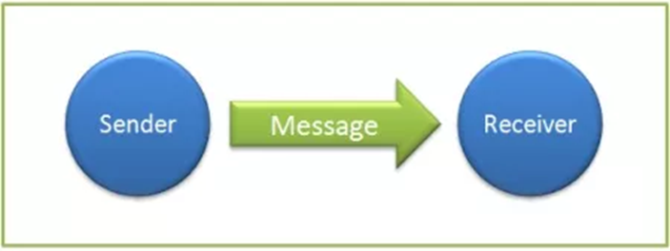
Aristotelian Model of Communication

Lasswell's Communication Model (1948)
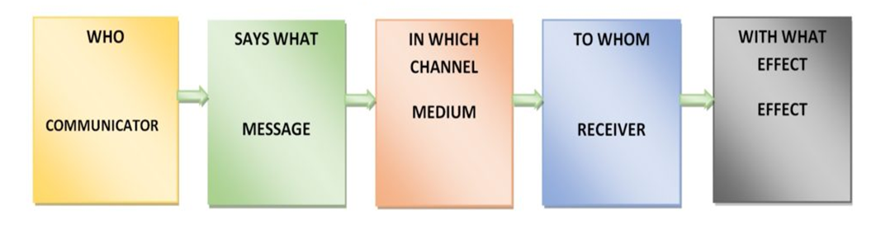Adapted from internet.
Lasswell's communication model discusses five essential elements of what communication looks like:
Who: This means who is speaking. For example, the speaker may be a manager or team leader during a meeting.
Says what: This is what they say. During the meeting, they can discuss project progress and what still needs to be done.
On which channel: This means how they communicate. This could be a face-to-face meeting, video call or email.
To whom: This is the one who listens. Everyone presents, such as team members and department head, attends the meeting.
With what effect: This is the transformative power of communication. After a productive meeting, everyone may gain a clearer understanding of their tasks, fostering a sense of motivation and inspiration to excel in their work.
Lasswell's model is simple, but it only covers some things. It does not cover body language or whether people understand what is said. So, while this is helpful, remember that there are also other essential aspects of communication.

The Shannon-Weaver Mathematical Model (1949)
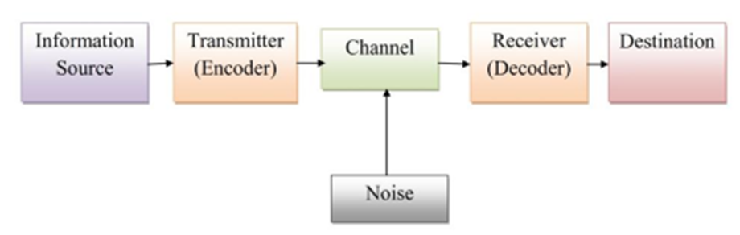Adapted from internet.

The Shannon-Weaver Mathematical Model, also known as the Shannon-Weaver Model of Communication, was proposed by Claude Shannon and Warren Weaver in 1949. It is a foundational communication model based on information theory. The model illustrates the communication process as a linear, one-way message transmission through a channel from a sender to a receiver.
Communication is essential in every workplace, particularly in environments like car parts factories, where precision and efficiency are critical. In this context, the Shannon-Weaver model provides valuable insights into communication.
Sender:
In the factory, the sender of communication is the supervisor or manager. Their role involves conveying instructions, updates, or safety guidelines to the workforce, particularly on the assembly line.
Message:
The message transmitted by the sender contains vital information pertinent to factory operations. This could range from procedural changes to quality standards or safety protocols to ensure smooth and effective production processes.
Channel:
Various channels facilitate the transmission of messages within the factory. These may include loudspeaker announcements, written notices, or face-to-face team meetings. Each channel efficiently disseminates information to the workforce.
Receiver:
Workers on the assembly line, quality control inspectors, and maintenance staff comprise communication receivers. Their understanding of the message is crucial for its successful implementation and impact on factory operations.

Noise:
In a car parts factory, noise from machinery can significantly affect communication effectiveness. Loud equipment operating on the assembly line might interfere with the clarity of transmitted messages, leading to misunderstandings or missed instructions.
Effect:
The effectiveness of communication is reflected in its outcomes or effects on factory dynamics. Clear and well-understood instructions can increase productivity, improve safety practices, and enhance teamwork among workers, resulting in smoother operations and fewer defects.

The critique of the Shannon and Weaver communication model:
Mechanical Model: The model is criticised for its simplified approach to communication, mainly focusing on sending and receiving messages, overlooking the complexity of meaning-making and human elements involved in the communication process (Brooks, 2003; Krone et al., 1987).
Conduit Model: Reddy (1979) introduced the term "conduit model" to emphasise the model's emphasis on transmission, like telegraph or telephone lines. This metaphorical frame is criticised for oversimplifying communication, leading to redundancy, miscommunication, and a lack of attention to meaning.
Utilitarian Bias: McQuail (2013) criticises the model for its utilitarian and controlling nature, viewing communication primarily as a tool for control and influence rather than recognising its broader significance in social interactions.
Contextual Limitations: Scholars like Wendland (2013) argue against the universal application of the model, emphasising its origins in telecommunications and questioning its relevance when applied to different research contexts, such as non-verbal communication.
Language and Transmission: Colombo (2004) points out the model's connection to a theory of language that portrays language as a problem-free and context-free tool for transmitting information, neglecting the complexities of language use and interpretation.

As a team leader in a factory producing door handles for Nissan Infiniti cars, I was responsible for ordering the components necessary to assemble the door handle assemblies.
I sent the order, carefully describing the needed parts and their features. However, when the parts arrived, they did not match the description. Additionally, some handles had the wrong shade of colour, which caused problems matching them to other sets.
At first, I wondered what went wrong. The order description was not detailed enough, and there were communication problems between the supplier and me. Instead of blaming the supplier, I organized a meeting to discuss the situation and find a solution.
During the discussion, it turned out that there were some doubts about the parts' specifications. Thanks to an open discussion, we were able to clarify any doubts and determine the steps necessary to correct the error.
We then took corrective action by contacting the supplier to replace the incorrect parts and correct the colour of the car door handles. We quickly solved the problem and avoided project delays thanks to active communication and teamwork.
This situation taught me how vital clear and effective communication is, especially in purchasing. We overcame the difficulties and continued work without significant disruptions thanks to open communication and teamwork.
Types of communication
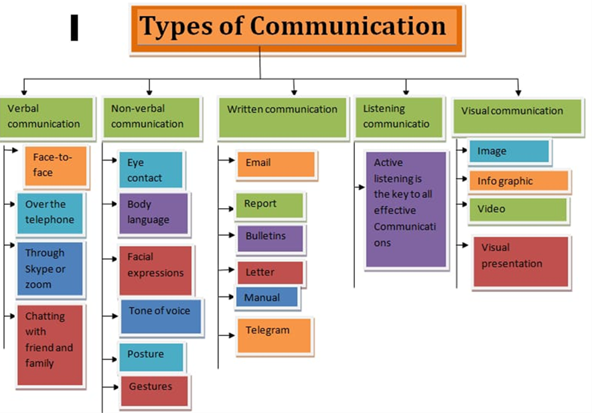

Verbal Communication
Verbal communication involves using spoken words to interact with others. This can occur face-to-face, over the phone, or through video calls like Skype or Zoom. While face-to-face communication is typically preferred, logistical constraints or time limitations may necessitate alternative methods.
Verbal communication can take various forms, ranging from informal conversations with friends to formal settings such as work meetings, interviews, conferences, lectures, or presentations. The effectiveness of oral communication hinges on factors such as the receiver's receptiveness, the pace, volume, and intonation of speech, and clarity of expression.
Non-verbal cues, including visual and body language, play a significant role in supporting verbal communication.
In a business context, verbal communication encompasses activities such as:
- Storytelling helps create a shared understanding and meaning among organizational members and helps employees grasp key organizational values and operational procedures.
- Crucial conversations: These are pivotal discussions involving high stakes, distinct from routine workplace interactions. Examples include presenting a business plan or negotiating a salary raise. Such communications demand skill, preparation, and thoughtful reflection.
Practical verbal communication skills are indispensable in the workplace. Leveraging speech as a means of conveying information enables efficient sharing of ideas and fosters collaboration among team members.

Non-verbal communication
Non-verbal communication encompasses any form that does not involve spoken or written words. It includes gestures, facial expressions, body language, eye contact, tone of voice, and other vocal cues. According to Knapp & Hall (2002), non-verbal communication serves a variety of purposes:
- Expression of Emotion: Emotions are primarily conveyed through facial expressions, body movements, and vocal tones.
- Communication of Interpersonal Attitudes: Non-verbal cues such as tone of voice, eye contact, and touch play a significant role in establishing and maintaining relationships.
- Accompany and Support Speech: Argyle (1988) noted that nonverbal behaviours often accompany and complement verbal communication, aiding in the smooth flow of conversation and indicating attentiveness or agreement.
- Self-Presentation: Non-verbal attributes like appearance, grooming, and posture contribute to how individuals present themselves to others.
- Rituals: Certain nonverbal behaviours, such as greetings, handshakes, or other cultural rituals, serve as social norms and help facilitate social interactions.
These functions highlight the importance of non-verbal communication in understanding and interpreting interpersonal interactions and social dynamics.
(In the appendix, the significance of the crucial role of nonverbal communication in the context of leadership was discussed).
Nonverbal Communication and leadership
Effective leadership hinges on the leader's adeptness in deciphering their followers' emotions and attitudes while conveying unwavering support and motivation, a skill crucial for success (Riggio, 2005). Charismatic leaders excel at interpreting nonverbal cues from others, enabling them to address their followers' needs promptly and effectively.
Nonverbal communication is pivotal in delineating individuals' status within an organisational framework. Dominance and power are conveyed through cues such as eye contact, posture, speaking patterns, and seating arrangements (Riggio, 2005).
Burgoon and Dunbar (2000) assert that the display of power or dominance in interpersonal communication is intricately linked to individual social skills and the dynamic interplay of situational and relational factors.
Aguinis, et al., (1998) highlight the significant impact of nonverbal behaviours on perceptions of power, particularly emphasising how facial expressions influence the perception of various power bases, including reward, referent, legitimate, expert, and credibility. Notably, a relaxed facial expression and direct eye contact play crucial roles in shaping perceptions of credibility.
Interpersonal dominance is characterised by five interrelated dimensions, many of which are conveyed through nonverbal cues. These dimensions encompass persuasiveness or influence, conveying focus and poise, conversational control, and self-assurance (Burgoon & Johnson, 1998).

Listening communication
Active listening encompasses outwardly visible positive listening behaviours and positive cognitive listening practices, aiming to overcome various barriers to effective communication (Wolvin & Coakley, 1993).
Before even receiving a message, active listeners proactively create optimal listening conditions, such as managing physical and environmental distractions and maintaining focus (Wolvin & Coakley, 1993).
While eye contact is commonly associated with attentiveness, it is crucial to consider cultural differences and other factors before interpreting its absence as inattentiveness (Wolvin & Coakley, 1993).
Direct indicators of active listening include referencing previous statements, summarising, asking probing questions, and avoiding interruptions, which help regulate conversational flow (Wolvin & Coakley, 1993).
Note-taking demonstrates active listening by translating information into one's cognitive structures, aiding interpretation, and assimilation (Wolvin & Coakley, 1993).
Empathetic listening involves suspending judgment, paraphrasing to understand the speaker's perspective, and mirroring nonverbal signals to build rapport and empathy (Bodie, 2011; Bruneau, 1993).
Paraphrasing and questioning are effective techniques for empathetic listening, facilitating engagement without monopolising the conversation (Bodie, 2011; Hargie, 2011).
It is essential to refrain from giving unsolicited advice and to acknowledge the speaker's emotions directly or indirectly (Bodie, 2011; Hargie, 2011).
Written communication
Written communication skills encompass the ability to effectively convey information through written text with clarity and appropriateness, considering the audience and purpose. One must address three key elements to enhance writing: content, style, and structure.
Content refers to the substance of the writing, which should be engaging and informative. Developing creative skills can enrich content.
Style pertains to how text is written, and it improves with practice and attention to grammar and punctuation.
The structure involves organising the content logically for readability. Strengthening logical reasoning skills can enhance structure.
Written communication is significant as it provides a lasting record, facilitates legal agreements, and enables sharing ideas and knowledge across distances and cultures.
In the workplace, there are four primary types of written communication: informational, instructional, transactional, and persuasive. Each serves specific purposes, such as providing information, giving directions, conducting transactions, or persuading the audience.

Appendix B

Intrinsic and extrinsic motivation

Motivation may be classified into two categories: intrinsic and extrinsic motivation, which represent different origins of drive. Intrinsic motivation is derived from internal sources such as pleasure, inquisitiveness, self-expression, or the intrinsic difficulty of the activity. In contrast, extrinsic motivation is driven by external incentives or objectives that are separate from the activity at hand, such as receiving praise, recognition, or physical prizes. (Amabile, 1993)

Intrinsic motivation arises from an individual's innate enjoyment or curiosity in a task, without being influenced by extrinsic incentives. It involves finding intrinsic fulfilment in the task itself rather than being motivated by extrinsic rewards. This type of motivation may be described as an intrinsic urge that compels individuals to participate in activities without any external force. Intrinsic motivation, as described by Amabile (1993), refers to the internal drive that individuals must engage in work due to factors such as enjoyment, interest, curiosity fulfilment, self-expression, or personal challenge (Amabile, 1993).
Extrinsic motivation is the desire to participate in an activity to obtain external benefits, as opposed to intrinsic motivation, which arises from internal gratification. Extrinsic motivation is determined by external elements that are not inherent to the individual, such as employment perks, wage raises, rewards, and advancements. Deci (1972) posited that extrinsic motivation frequently presents itself through concrete incentives such as monetary compensation or verbal acknowledgment, which stem from the individual's external surroundings. On the other hand, intrinsic motivation is influenced from inside, fuelled by the inherent gratification obtained from the activity itself or the emotional contentment it provides. According to Amabile (1993), individuals might display either intrinsic, extrinsic, or a combination of both forms of motivation in their job. This highlights the intricate nature of motivational dynamics in organisational settings.
People differ in how they respond to internal and external motivators, as emphasised by Vroom (1964), who proposes that certain workers prioritise internal benefits, while others concentrate on external incentives. According to Story et al. (2009), those who have a strong internal drive are more likely to be drawn to mentally challenging tasks and have the capacity to control their own actions. Hence, conventional external rewards or enforced time limits may not have a substantial impact on their motivation unless they also have elevated levels of extrinsic drive. To effectively engage intrinsically driven individuals, it is important to focus on emphasising the inherent pleasure derived from the activity and promoting self-directed goal setting, as suggested by Story et al. (2009). In addition, Furnham et al. (1998) contend that introverts are more inclined towards extrinsic drive, while extraverts tend to exhibit a preference for intrinsic motivation. Nevertheless, the effect of intrinsic and extrinsic motives on each other is not only determined by individual variations. According to Story et al. (2009), there is a relationship between these two types of motivation, which affects how individuals react to different rewards and task setups.

Extrinsic Motivation | Intrinsic Motivation
Working for a salary raise | Engaging in work because it aligns with your passion
Aspiring for a job promotion | Investing extra time in skill development voluntarily
Performing tasks to gain recognition from colleagues | Striving for self-improvement to derive personal satisfaction
Participating in training to receive a bonus | Collaborating in a team setting because you value teamwork
Completing tasks to avoid penalties or consequences | Seeking out challenges that foster personal growth
Achieving targets to earn performance-based incentives | Finding joy in problem-solving and achieving goals
Engaging in team projects for additional benefits | Experiencing fulfilment from the positive outcomes of your work
Working overtime for extra compensation | Taking satisfaction in seeing the positive impact of your efforts
Adhering to schedules to evade negative repercussions | Pursuing projects that inspire creativity and align with personal values
Contributing to projects to garner positive feedback | Being driven by intrinsic motivation to achieve personal goals

Evaluate theories of motivation relevant to your workplace.

Maslow’s Hierarchy of needs
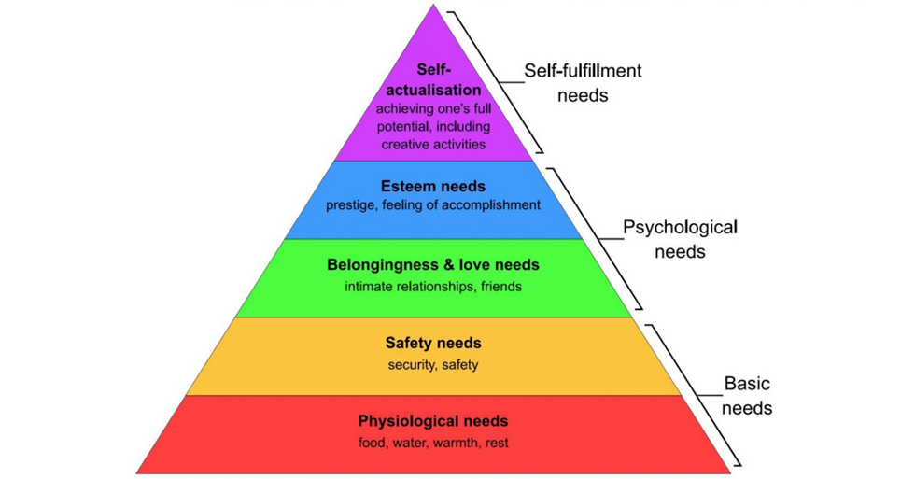
Adapted from internet.
Maslow's Hierarchy of Needs, introduced by Abraham Maslow in 1954, posits that human needs can be arranged into five levels, with each level building upon the previous one. The fundamental idea is that lower-level needs must be satisfied before higher-level needs become motivating factors.
In practical terms, individuals will only be motivated by recognition or esteem if their basic physiological needs, such as food and shelter, are met. For instance, in a workplace setting, employees are unlikely to be motivated by accolades or positive feedback if they need to be paid more to support themselves and their families. Instead, they will prioritize meeting their basic survival needs over any other form of recognition or reward. This concept underscores the importance of addressing employees' fundamental needs as a prerequisite for fostering motivation and engagement in the workplace.

When I worked as a team leader in a company producing car door handles, I loved my job. I had the chance to develop myself and felt professionally fulfilled. However, then changes came. After Brexit, the company announced the liquidation and relocation of the factory to Poland and Romania. It was a shock for me. Suddenly, my basic safety needs were violated. I had to focus on finding a new job. This lasted six long months, and I completely forgot about my professional development. After many difficulties, I finally found a new job. Three months later, I received a permanent contract there, which made me feel safe and stable again. Then, I started thinking again about how to develop professionally and strive for new goals. This experience showed me how important it is to satisfy basic needs before I can focus on higher levels of development and self-realization.
HERZBERG’S MOTIVATION
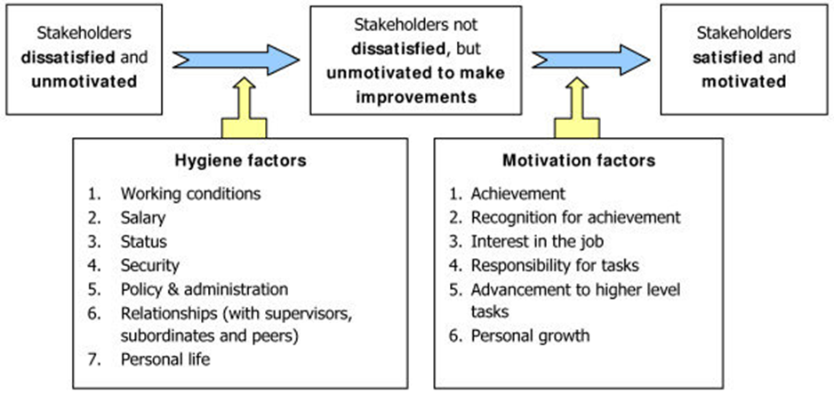Adapted from internet.
Herzberg's Motivation-Hygiene Theory, also known as the Two-Factor Theory, was developed by psychologist Frederick Herzberg in the 1950s. Two distinct sets of factors influence workplace motivation and job satisfaction.
Hygiene Factors (Dissatisfiers): These are factors that, when absent, can cause dissatisfaction but, when present, do not necessarily lead to satisfaction. Examples include working conditions, salary, company policies, and interpersonal relationships. Herzberg argued that improving hygiene factors can prevent dissatisfaction but does not necessarily motivate employees.
Motivational Factors (Satisfiers): These factors directly contribute to job satisfaction and motivation. They include recognition, achievement, responsibility, growth opportunities, and the nature of the work itself. Herzberg suggested that focusing on enhancing these factors leads to increased job satisfaction and motivation.
According to Herzberg, the absence of hygiene factors can create job dissatisfaction, while the presence of motivational factors can lead to job satisfaction and higher motivation levels. Therefore, improving hygiene factors may prevent dissatisfaction but will not motivate employees. True motivation comes from addressing motivational factors.

Example from my work:
Hygiene Factor:
Problem: A lack of parking spaces forced employees to arrive at work earlier, which was inconvenient and frustrating.
Solution: The company decided to expand the parking lot, providing more parking spaces for employees.
The lack of parking spaces was a hygiene factor in Herzberg's theory because its absence caused employee frustration and dissatisfaction. Expanding the parking lot was intended to eliminate this obstacle and improve work comfort, which could reduce the level of dissatisfaction among employees.
Motivational Factor:
Solution: The company introduced an incentive system that rewards machine operators for introducing effective changes in production processes. Each creative suggestion approved and implemented is rewarded with £100.
Solution: Providing employees professional development opportunities can increase their engagement and motivation.
According to Herzberg's theory, introducing a motivational system that rewards employees for initiative and creativity in improving production processes is a motivational factor. The company creates conditions conducive to employee motivation and commitment by rewarding employees for their efforts and commitment. Similarly, providing opportunities for professional development gives employees the prospect of development and promotion, which may increase their commitment to work and satisfaction with their duties.

To sum up, the company successfully managed both hygiene factors, eliminating the problem of lack of parking spaces and motivational factors by introducing a motivation system and providing opportunities for professional development. These activities can improve employee motivation, satisfaction, and work efficiency.

McClelland’s Three Needs Theory

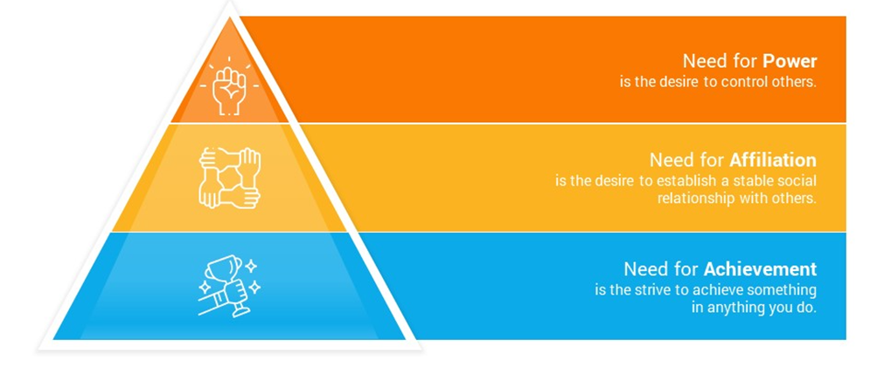
Adapted from internet.
David McClelland's Theory of requirements identifies three main requirements that affect human behaviour:
Need for Success: This need is to excel, complete challenging activities, and achieve personal goals. Achievement-seeking people prefer settings where they can solve problems and complete tasks themselves. They like moderately challenging work with a chance of success.
The urge for affiliation includes positive interactions, social approval, and close partnerships. Individuals with this desire seek group membership, amicable contacts, and conflict avoidance. People respect cooperation and teamwork.
Need for Power: The urge to influence, lead, or control others and the environment. People who require power want authority, like competition, and want to change their environment. Making a difference and being appreciated for their influence motivates them.
McClelland says these requirements vary in intensity and impact conduct. Someone with a strong desire for success may pursue challenging professional objectives, whereas someone with a high need for power may seek leadership positions to dominate and influence.
According to McClelland's theory, my need for success at work is a crucial motivator. I do not treat work only as performing tasks but as a path to success and personal development. I strive for ambitious professional and personal goals, setting high standards for myself and not limiting myself to the minimum. I inspire others to achieve success through cooperation and motivation, believing that an individual's success translates into the team's success. I know the risks at work, but I take them rationally to achieve the set goals. The need for success drives me to take on challenges and constantly develop, both professionally and personally.
McGregor’s Theory X and Y
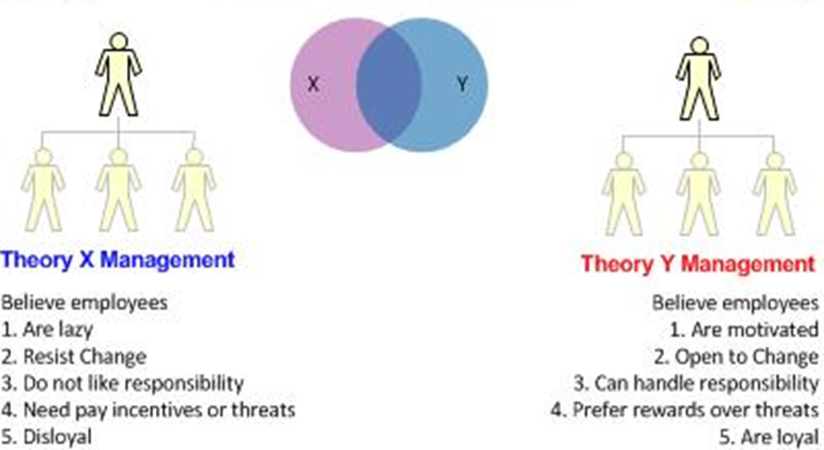
Adapted from internet.
According to McGregor (1957), Theory X and Theory Y are contrasting models that depict managers' assumptions regarding their employees' motivations and behaviours.
Theory X:
According to Theory X, managers believe employees are lazy and dislike work. They assume that employees need to be closely supervised and controlled to ensure they perform their duties. The critical assumptions of Theory X include:
- Employees inherently dislike work and will avoid it whenever possible.
- Employees lack ambition and prefer to be directed by others rather than taking on responsibility themselves.
- Employees are primarily motivated by external rewards and punishments rather than intrinsic satisfaction or fulfilment.
- Management must closely monitor employees to ensure they contribute effectively to organisational goals.
Theory Y:
In contrast, Theory Y suggests that managers believe employees are inherently motivated and can be trusted to perform their jobs without constant supervision. The critical assumptions of Theory Y include:
- Employees do not inherently dislike work and can find it fulfilling and rewarding.
- Employees are self-motivated and seek out responsibility and challenges in their work.
- Employees can exercise creativity and problem-solving skills to contribute to organisational success.
- Management should empower employees and provide opportunities for growth and self-direction rather than relying on strict control and supervision.
Overall, McGregor's Theory X and Theory Y highlight different management approaches based on managers' assumptions about employee motivation and behaviour. Theory X relies on a more authoritarian management style, while Theory Y emphasises a participative and empowering approach.
An example from my work
Theory X:
Managers use the theory when workers on the production line tend to perform poorly or fail to meet safety standards. For example, if an employee ignores safety procedures or shows laziness at work, he or she may be instructed or punished to correct his or her behaviour.
Theory Y:
However, managers use an approach based on Theory Y for employees who show initiative, creativity, and commitment in the production process. These employees are treated as partners in the production process, not just ordinary operators. Managers encourage them to submit ideas for improving production processes and offer support and recognition. For example, if an employee proposes a new way to improve a production line, he or she may receive a bonus.

Appendix C

Evaluate own communication skills as a manager.
STRENGTHS  - Clarity: I effectively convey thoughts and information, ensuring clear communication.  - Conciseness: I can speak without unnecessary digressions, maintaining brevity in communication.  - Engagement: I engage listeners in conversation, fostering active participation and interaction.  - Nonverbal Communication: I utilize gestures and facial expressions effectively to enhance communication.  - Active Listening: I possess good listening skills and responsiveness to others' statements. | WEAKNESSES  - Empathy: There is room for improvement in understanding others' perspectives and demonstrating empathy.  - Adaptability: I need to enhance my ability to adjust communication style to different situations and individuals.  - Conflict Resolution: I need to develop better strategies for resolving conflicts through conversation.  - Self-confidence: I have identified a need to bolster my confidence in communication with others.
OPPORTUNITIES  - Enrol in empathy-building workshops or courses to enhance understanding of others' perspectives.  - Participate in training programs focused on adaptability and flexibility in communication.  - Seek mentorship or coaching to improve conflict resolution skills.  - Engage in self-confidence-building exercises or seek counselling to address confidence issues. | THREATS  - Failure to address weaknesses in communication skills may lead to misunderstandings, conflicts, and decreased effectiveness as a manager.  - Lack of confidence and adaptability may hinder professional growth and career advancement opportunities.
SWOT Analysis

Gap analysis

Objective | Current Position | Deficiency | Action
What do I want to do? | What can I already do? | What am I lacking? | How do I fix this?
Improve empathy and understanding of perspectives. | Good active listening skills and responsiveness to others' statements. | Empathy: Need improvement in understanding others' perspectives and demonstrating empathy. | Enrol in empathy-building workshops or courses to enhance understanding of others' perspectives.
Enhance adaptability in communication. | Able to engage listeners in conversation. | Adaptability: Need improvement in adjusting communication style to different situations. | Participate in training programs focused on adaptability and flexibility in communication.
Develop better conflict resolution strategies | Maintain clarity and conciseness in communication. | Conflict Resolution: Need improvement in developing strategies for resolving conflicts. | Engage in conflict resolution workshops or courses.
Bolster self-confidence in communication | Effectively convey thoughts and information with clarity. | Self-confidence: Identified a need to bolster confidence in communication with others. | Engage in self-confidence-building exercises or seek counselling to address confidence issues.

Personal Development Plan

What do I want to learn? | What do I have to do? | What support and resources will I need? | How will I measure success? | Target Date for Review
Improve empathy and understanding of others' perspectives. | Enrol in empathy-building workshops or courses. | Access to courses or workshops focused on empathy development. | Conduct self-assessments on understanding others' perspectives. Seek feedback from others. | Quarterly review.
Enhance adaptability in communication to different situations and individuals. | Practice adjusting communication style in various scenarios. | Exposure to diverse communication situations. Guidance from mentors or coaches. | Track successful adaptation in various communication scenarios. Seek feedback. | Quarterly review.
Improve conflict resolution skills. | Participate in training programs on conflict resolution. | Mentorship or coaching to improve conflict resolution skills. | Monitor improvement in conflict resolution. Seek feedback. | Quarterly review.
Strengthen self-confidence in communication. | Engage in self-confidence-building exercises or seek counselling | Access to self-confidence-building resources. | Self-assessment of confidence levels in communication. Seek feedback. | Quarterly review.

Personal Objectives

Short Term Goals (next 12 months)
- Improve empathy and understanding:
  - Practice active listening during conversations.
  - Engage in empathy-building exercises or workshops.
- Enhance adaptability in communication:
  - Experiment with different communication styles.
  - Seek feedback from colleagues or mentors.
- Improve conflict resolution skills:
  - Attend conflict resolution workshops.
  - Practice empathy and active listening.
- Strengthen self-confidence:
  - Engage in self-confidence-building exercises.
  - Seek opportunities for positive feedback.
Medium Term Goals (2-3 years)
- Improve empathy and understanding:
  - Actively seek diverse perspectives.
  - Take on leadership roles.
- Enhance adaptability in communication:
  - Continuously refine communication skills.
  - Proactively communicate in diverse situations.
- Improve conflict resolution skills:
  - Act as a mediator or facilitator.
  - Mentor colleagues on conflict resolution.
- Strengthen self-confidence:
  - Take on speaking engagements.
  - Reflect on past successes.
Long Term Goals (3-5 years)
- Improve empathy and understanding:
  - Promote diversity and inclusion initiatives.
  - Serve as a mentor for empathy development.
- Enhance adaptability in communication:
  - Become known as a flexible communicator.
  - Lead training sessions on adaptive communication.
- Improve conflict resolution skills:
  - Develop conflict resolution frameworks.
  - Serve as a resource for conflict resolution.
- Strengthen self-confidence:
  - Demonstrate confidence in various situations.
  - Provide mentorship for confidence building.

Reflection: Exploring My Communication
Evaluating my communication skills as a manager is essential for my professional growth and effectiveness in leading teams. Reflecting on my communication style, I can identify several strengths and weaknesses.
Firstly, clarity stands out as one of my strong suits. I have a knack for straightforwardly conveying information and ideas, ensuring everyone understands the message without confusion. This skill is crucial in managerial roles, where clear communication is critical to alignment and productivity.
Secondly, I pride myself on conciseness in communication. I avoid unnecessary digressions and reach the point, respecting others' time and keeping discussions focused. This brevity enhances efficiency in team interactions and decision-making processes.
Engagement is another area where I excel. I strive to foster active participation and collaboration in team meetings or one-on-one conversations. I create an inclusive environment where everyone feels valued and encouraged to contribute their thoughts and ideas.
Furthermore, my proficiency in nonverbal communication enhances my effectiveness as a manager. I use gestures and facial expressions to reinforce my verbal messages and connect more deeply with others. These nonverbal cues add richness and clarity to my communication, facilitating better understanding and engagement.
Despite my strengths, there are areas for improvement in my communication as a manager. Empathy, for instance, is an aspect I need to work on. While I strive to understand others' perspectives, there is room for improvement in genuinely empathising with their feelings and experiences. Developing a more profound sense of empathy will enhance my ability to connect with and support my team members effectively.
Adaptability is another area of concern. While I communicate effectively with familiar individuals and in routine situations, I need help to adjust my communication style in diverse contexts. Enhancing my adaptability will enable me to tailor my communication approach to different personalities and situations, maximising effectiveness.
Conflict resolution is an area where I need to develop better strategies. I avoid confrontation, which can result in unresolved conflicts simmering beneath the surface. I can foster a more positive and collaborative work environment by improving my ability to address conflicts through constructive conversation.
Lastly, self-confidence impacts my communication effectiveness. Sometimes, I doubt myself in communication, leading to hesitation and uncertainty. Building self-confidence will enable me to communicate more assertively and authentically, inspiring trust and credibility among my team members.
In conclusion, reflecting on my manager's communication skills highlights strengths and weaknesses. By leveraging my strengths and addressing areas for improvement, I can become a more effective communicator and leader in the workplace.

