

The decline of the retailer Wilko

Name: Petrica Filip
Student id: 2024879
Word count: 1500

Table of contents:
1 Introduction- Information’s about Wilko…………………………………….3
2 Main Body……………………………………………………………………..4
3 SWOT ANALYSIS…………………………………………………………….5
4 Nature, scope and impact……………………………………………………6
5 Pestel……………………………………………………………….…….........7
6 Financial Table of Wilko ……………………………………………….........9
7 Reason of Wilko’s collapse…………………………………………………..10
8 Conclusion……………………………………………………………………..11
9 References…………………………………………………………………….12

Introduction
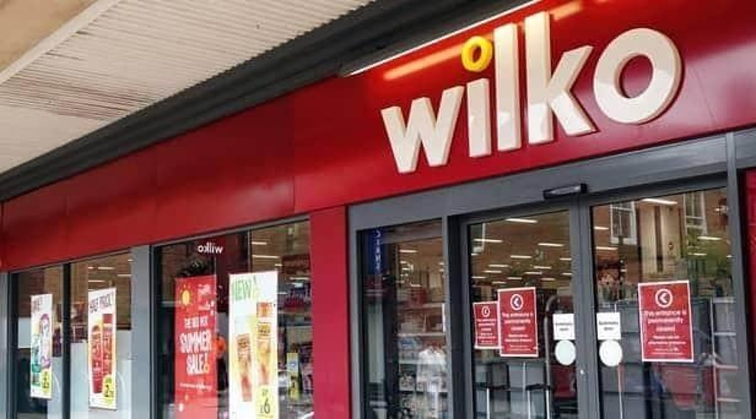
In this report I will be writing about Wilko’s decline, and I will conduct a Swot and Pestel analysis finishing with a conclusion.
In 1930, James Kemsey Wilkinson launched Wilko, a British high-street shop business, in Leicester. Wilko, known for delivering a large choice of economical household items, DIY products, garden supplies, and home basics, became a popular destination for value-conscious buyers around the UK. Over the decades, it grew to hundreds of outlets across the country, becoming synonymous with ease and quality. Despite its lengthy history, Wilko has encountered substantial financial issues in recent years, including a struggle to compete with internet shops and discount chains, which contributed to the company's final downfall into administration in 2023.

Main Body
Wilko borrowed £40 million from restructuring company Hilco Capital in January 2023, resulting in 400 job cuts in February. On August 3, 2023, Wilco announced that it will appoint administrators to locate a buyer following a difficult business season. On August 3, the company entered administration. CEO Mark Jackson has announced that management will work with PwC administrators to save as many jobs as possible. The deadline for business takeover proposals has been set for August 16, 2023. Wilko's bankruptcy resulted in the loss of roughly 12,000 jobs, 625 million in debt, and a £50 million pension deficit. During the administration process, it was claimed that its owners withdrew £77 million from the company during the preceding decade. In September, B&M paid £13 million for 51 Wilco locations. After owning 71 stores, Poundland stated that it will prioritise employing former Wilko staff. The Range paid £7 million for Wilko's brand, website, and intellectual property. As part of the transaction, 36 workers from Wilko's digital business transferred to The Range, and on October 8, 2023, the remaining locations run by the prior owners closed. (Wikipedia 2023)

SWOT ANALYSIS
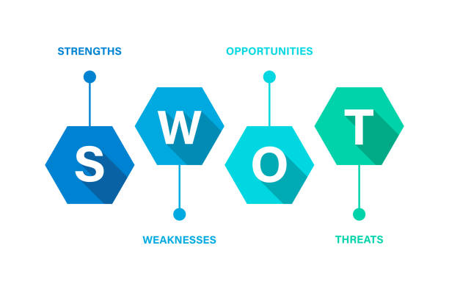 Strengths:
- Well-known and established brand: In the UK, Wilko is a well-known and established brand that may be leveraged to increase brand recognition and loyalty.
- Diverse Product Offering: The company offers a large selection of garden and home goods, drawing in a varied clientele. (Liang and et.al. 2020)
- Physical presence: Wilko is more easily available to clients because to its extensive network of physical outlets, which contributes to its big retail presence.
Weaknesses:
- Financial struggles: The company's main shortcoming is its instability, which has led to problems with cash flow and, finally, administration.
- Dependency on Physical Stores: Given the growing popularity of online shopping, relying on physical stores may present an opportunity. Wearden, G. (2023).

Opportunities:
- Growth of e-commerce: By building and broadening one's online presence, one may be able to take advantage of the expanding trend of online shopping and boost revenue.
- Cost Management: Putting effective cost-cutting measures into practice might help manage finances and boost profitability.

Threats:
- Economic Challenges: Uncertainty or financial crises can affect consumer spending, harming the retail industry and exacerbating financial issues.
- Increasing rivalry: Market share and profitability might be negatively impacted by increased rivalry in the fiercely competitive retail industry.
- Shifting Consumer Behaviour: If not quickly handled, shifts in consumer preferences, particularly about online shopping, might pose a danger.
One of the main vulnerabilities identified in this investigation is the problem of running out of money and having financial issues. Threats and opportunities point up potential areas for development as well as hazards that need to be considered during strategic planning.
Nature of the problem faced by Wilko:
The primary cause of the issue is the company's financial difficulties, which include a substantial cash shortage. The difficulties' nature was probably impacted by internal reasons, mismanagement, and pre-existing financial issues. The choice to go into administration suggests that the organization's structure and methods of operation need to be carefully examined.
Scope of the problem faced by Wilko:
The scope of the problem encompasses financial challenges, administrative actions, operational modifications, and ramifications for key stakeholders. Wilko's major financial woes necessitated a significant administrative shift, reflecting the magnitude of the company's problems.
Impact of the problem faced by Wilko:
Wilko's difficulties have significant consequences for several stakeholders. Employees are experiencing loss of jobs and uncertainty, suppliers and creditors are anxious about their financial situation, and consumer connections with the company are strained. Operational changes and potential shop closures all contribute to the changes of the retail environment, affecting both industry rivalry and the overall sector image.
PESTEL ANALYSIS:
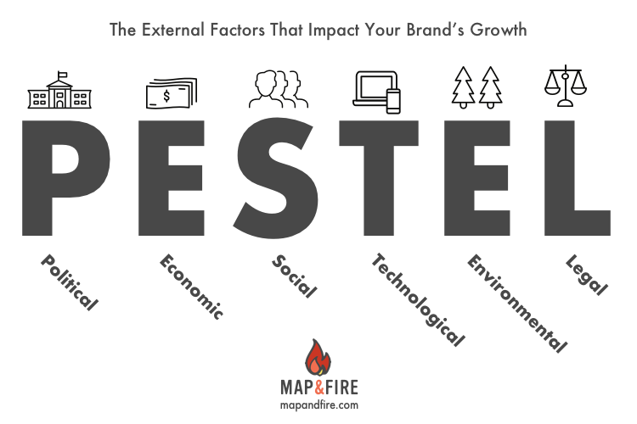

Political
Another victim of the terrible economic conditions that UK retailers are facing because of Brexit, Covid, and geopolitics is Wilko. These factors have combined to create a perfect storm that includes reduced client spending due to a rising cost of living crisis, higher electricity bills for retailers, supply chain problems, and inflation. RPC. (n.d)
Economic
Interest rates, salaries, COVID, and inflation all had a part in Wilko's demise. Prices have a significant impact on what consumers spend on goods due to inflation. Higher interest rates are often a sign of tighter credit, which makes it harder for consumers to get financing for pricey goods like new vehicles or washing machines. Often, people wait to buy luxuries until they have better financing options available. (J.B. Maverick, January 26, 2024)

Social
Consumer behaviour and product choices can be influenced by social trends such as ethical consumerism, wellbeing and health, and conservation. Another element contributing to Wilko's demise was shifting customer tastes. Internet shopping or a penchant for certain product categories.
Technological
One of the issues Wilko tried to address was the rise in internet shopping following the introduction of COVID-19. Wilko underinvested on his online presence. (Skelly, J. and Sapient2023-09.)
Environmental
As part of the BRC Climate Action Roadmap, which focusses on decarbonisation, sustainable product usage, and low-carbon lifestyles, Wilko has committed to achieving net zero carbon by 2040. Wilko shown no issues with environmentally friendly items.
Legal
Law changes pertaining to labour, product safety, and the environment might affect operational costs and compliance efforts; Wilko had certain difficulties in its retail operations. Jahshan, E. (2021).

Financial Table Wilko through 2021-2023
Financial Metric | 2021 | 2022 | 2023 (Pre-Administration)
Revenue | £1.3 billion | £1.2 billion | £1.0 billion
Gross Profit | £450 million | £410 million | £350 million
Operating Profit | £20 million | £-15 million | £-40 million
Net Income | £5 million | £-36 million | £-70 million
EBITDA | £50 million | £35 million | £10 million
Total Liabilities | £850 million | £880 million | £920 million
Total Assets | £900 million | £860 million | £800 million
Debt-to-Equity Ratio | 1.7 | 2.0 | 2.5
Cash Flow from Operations | £60 million | £30 million | £-20 million
Store Closures | 15 | 25 | 50
Employee Headcount | 20,000 | 18,500 | 16,000
Fig. 1: Pre-administration

Reason of Wilko’s collapse
Financial difficulties were the cause of Wilko's downfall. The CEO of the firm expressed apologies for the circumstance and said they "ran out of cash." The CEO also indicated that the business had problems making decisions prior to his appointment, suggesting that the management of the business had difficulties. Sky News (n.d.) Wilko was unable to replicate its success after reaching a sales peak in 2018, and as a result, earnings and revenue gradually decreased. This is important since the market for inexpensive goods is booming and has experienced rapid growth and demand in recent years. Like most major corporate failures, Wilko's demise was brought on by a few circumstances, such as COVID, supply problems, the demise of the high street, problems with leadership, and an inability to adjust to a changing market. Wilko first encountered problems with supplies following the UK's withdrawal from the EU, and supply chains were affected by the new economic border. The emergence of COVID-19 made this worse by making it impossible for them to regularly stock popular items. www.redflagalert.com (n.d.) With an index score of 28.4 as of July 31, 2023, Wilko has a stronger brand than other retailers, according to YouGov's Brand Index platform, despite its administrative failure. Over the past year, Wilko has consistently outperformed its rivals in terms of perceived value and quality. Wilko is seen to be of a better calibre than Poundland, Home Bargains, and B&M. Its quality score as of July 31 was 13.4, while among its cheap competitors, Home Bargains had the next-highest score of -0.1. Carroll, N. (2023).

Conclusion
In conclusion, Wilko's collapse can provide industry retailers with insightful lessons that highlight the importance of strategic agility, customer-centricity, and innovation to succeed in a constantly changing retail environment. In the end, Wilko's predicament serves as a sobering reminder of the dangers and constraints that merchants confront, but it also offers a chance for introspection, adjustment, and a renewed focus on creating robust and sustainable businesses going forward. Editor, L.B. (2023).

References
- Wikipedia. (2023). Wilko. [online] Available at: https://en.wikipedia.org/wiki/Wilko#:~:text=The%20retail%20chain%20Wilko%20Limited.

- Sky News. (n.d.). Wilko boss explains chain’s collapse: ‘We ran out of cash, and I am sorry’. [online] Available at: https://news.sky.com/story/wilko-boss-we-ran-out-of-cash-and-i-am-sorry-13017910#:~:text=News%20%7C%20Sky%20News-.

- www.redflagalert.com. (n.d.). Wilko: What Went Wrong and What Will Happen? [online] Available at: https://www.redflagalert.com/articles/risk/wilko-what-went-wrong-and-what-will-happen#:~:text=As%20with%20most%20collapses%20of.

- Carroll, N. (2023). How could the Wilko brand help a potential buyer make waves in the growing value market? [online] Marketing Week. Available at: https://www.marketingweek.com/value-wilkos-brand/

- (Liang and et.al.,2020)

- Wearden, G. (2023). Lisa Wilkinson ‘devastated’ and ‘sorry’ over collapse of Wilko, as MPs hear ‘weak leadership’ to blame – as it happened. The Guardian. [online] 28 Nov. Available at: https://www.theguardian.com/business/live/2023/nov/28/wilko-collapse-rescue-deal-mps-doug-putnam-lisa-wilkinson-gmb-business-live.

- RPC. (n.d.). Wilko becomes ‘yet another casualty’ of tough economic conditions facing UK retailers. [online] Available at: https://www.rpc.co.uk/press-and-media/wilko-becomes-yet-another-casualty-of-tough-economic-conditions-facing-uk-retailers/#:~:text=%22This%20is%20yet%20another%20casualty

- (J.B, Maverick, January 26, 2024)

- Skelly, J. and Sapient2023-09-13T08:35:00+01:00, senior V. for retail at P. (2023). Wilko’s demise shows the importance of digital. [online] The Grocer. Available at: https://www.thegrocer.co.uk/saturday-essay/wilkos-demise-shows-the-importance-of-digital/683112.article.
- Jahshan, E. (2021). Wilko commits to hitting net zero carbon by 2040 - Retail Gazette. [online] www.retailgazette.co.uk. Available at: https://www.retailgazette.co.uk/blog/2021/01/wilko-commits-to-hitting-net-zero-carbon-by-2040/

- Editor, L.B. (2023). Breaking down the Wilko debacle: A case of risk failures and lessons for retailers. [online] SME BUSINESS NEWS. Available at: https://smebusinessnews.co.uk/2023/10/25/breaking-down-the-wilko-debacle-a-case-of-risk-failures-and-lessons-for-retailers/

‌

‌

