

Undergraduate Dissertation coversheet & feedback form

PLEASE COMPLETE THE TOP SECTION OF THIS FORM AND SUBMIT ONE COPY WITH YOUR DISSERTATION
For completion by student:
Student Name: Daniel Robert Fairfield

Student University Email: 1202486@student.uwtsd.ac.uk
Module code: AHSK6002 | Student ID number:  1202486 |  |  |  | Educational support needs:  Yes
Dissertation title: An Insight into the Phoenician Maritime Activity and Commerce in and Around the Mediterranean and the Industry that Supported it, as well as any Significant Similarities It Bears to Modern Day Globalisation between the years 1200BCE - 332BCE
Supervisor: Louise Steel |  |  | Word count: 9781
I confirm that this is my original work and that I have adhered to the University policy on plagiarism.
Signed ………………Daniel Robert Fairfield……………………………………………
For completion by the first marker:
Comments:

First Marker’s Mark:  Signature: |  |  |  | Date:
For completion by the second marker (if appropriate):

Comments:

Second Marker’s Mark:  Signature: |  | Date:
NB. All marks are provisional until confirmed by the final examination board.

How agreed mark was decided upon—comments for External Examiner:

Proposed Mark:

Signature of External Examiner:

Final Agreed Mark:

An Insight into the Phoenician Maritime Activity and Commerce in and Around the Mediterranean and the Industry that Supported it, as well as any Significant Similarities It Bears to Modern Day Globalisation between the years 1200BCE - 332BCE

Daniel Robert Fairfield

Dissertation submitted in partial fulfillment
of a B.A. (Hons.) in Ancient Civilisations
University of Wales Trinity Saint David
May 2018

Word Count: 9781

Contents:
Abstract 4
Intro 4
The Phoenician Identity 5
Why the Sea? 8
The Environment and Agriculture 8
Specialised Industries and International Trade 10
Relationship with Neighbouring Civilisations 11
The Role of the Sea in Society 13
Elite Seafaring Class 13
Trading Syndicates 15
Worship of the Sea/Ships 16
The Tools of their Profound Success 19
The Alphabet 20
Navigation 22
The Famous Trade Goods 23
Dye 23
Glass 24
Textiles 26
Metallurgy 28
Trees 29
Ships 31
Ship Types 32
The Shipping Industry 33
The Colonies 34
Carthage 35
Cyprus 39
Malta 39
Sicily 40
Cadiz 41
Sardinia 43
Rulership by Outsiders and The End of Their Independence? 45
Protectorate under Egypt 47
Bronze Age Collapse and Resurgence of Phoenician Independence 48
Assyrian overlords 50
Babylonian Rulership 51
The Persian ‘Partnership’ 51
Alexander the Great and The Arrival of Hellenism 53
Successor conflicts and the Seleucids 54
Conclusion 55
Bibliography: 58
Pictures: 59

Abstract
An insight into how the Phoenician technique, technology, mannerisms and philosophy afforded them great successes in maritime sea trade and to examine if their expertise in international trade began to exhibit signs and confirmation of the first civilisation in history to employ globalisation.

Introduction
For this dissertation my focus will be to outline the success of the Phoenician maritime trade empire with particular focus paid to the formula they used to achieve their successes including the goods produced and sold, the ships used to carry them and the industry that supported both.
I will also endeavour to search, analyse and discern from the evidence and accounts that survive for any possible links to the first effective employment of globalisation one might glean from observing the diplomacy and mannerism of Phoenicia as she spread across the Mediterranean not via conquest, as many civilisations would do so after her, but rather by diplomacy and trade did Phoenicia ‘conquer’ the Mediterranean allowing her legacy and people to survive long after her own identity was lost.

The Phoenician Identity
Phoenicia was the first great thalassocracy or mainly seaborne empire as its primary asset and greatest area of control, power and wealth lay not on land but out at sea in its trade routes which afforded Phoenicia enhanced communications with almost all of the ancient civilizations located around and beyond the Mediterranean as civilizations that did not have access to the sea would come into contact with those that did and were thereby exposed to the craftsmanship of the Phoenician artisans and this saw a continuous expansion over time of the Phoenician reputation for quality and ability to meet demands, leading to a subsequent expansion of fame and clientele.

Geographically and politically, Phoenicia was a collection of city states along the Syrian coast in the Levant, notably Tyre, Sidon, Byblos (Gebal) and Arwad (Arados). These states were independently ruled but collectively referred to by other civilisations, firstly by the ancient Greeks between 1200-700BCE, as ‘Phoenicia’. Phoenician translated from ancient Greek roughly means ‘’purple country’’ or ‘’purple people’’ which refers to the purple dye famously associated with, produced at and primarily exported from Tyre..

We know that they did not refer to themselves as ‘Phoenician’, but as can’ani , or Canaanite, although the people of this region often did not see themselves as a whole nation, but as a member of one of the city-states. Individual Phoenicians likely identified themselves with regards to their home port such as ‘Tyrian/Son of Tyre’ or ‘Sidonians’ rather than as Phoenician. It seems fair to say that these city states acted predominantly independently from one another and may have even competed against one another for clientele.
Sidon overtook Byblos as the capital city state in the region in the late 12th and early 11th century BCE. Competition existed between Tyre and Sidon with both cities fluctuating in power and wealth overtime as they vied to be the most powerful and influential of the city states. This competition never truly concluded as both city states waxed and waned in power on regular occasion resulting in one rising above the other in prestige and status.

According to Sanford Holst, Phoenician society was founded on six major principles:
1. International trade in the form of sea-based exchange of goods
2. The creation of powerful partnerships among themselves and others
3. Respect of their womenfolk and Mother Nature
4. Religious tolerance
5. Peaceful resolution of differences
6. Equality and sharing the wealth
The majority of these principles are the reason that the Phoenician society survived for as long as it did, despite multiple takeovers and occupations by the powerful empires around them, such as the Egyptians, Assyrians, Babylonians and Persians. The Phoenicians had no land army, and preferred to resolve any conflict peacefully through negotiation and diplomacy, which they did when facing neighbours who sought to rule them such as the Assyrians whereby they sued for peace and payed tribute to avoid bloodshed or in the case of the Babylonians in 560BCE, after 13 years of being besieged, the king of Tyre surrendered and paid tribute to Nebuchadnezzar II of Babylon in exchange for him breaking his siege of the city and allowing them to remain independent .
A further example of Phoenician peacekeeping and preserving of the peace occurred in 332BCE between Phoenicia and Alexander The Great when all the cities in Phoenicia except Tyre surrendered in the hopes that, in doing so, Alexander would take the other cities and spare Tyre so it could remain as a final bastion of Phoenician cultural independence. These examples demonstrate that given the chance the Phoenicians would always attempt to reach peaceful resolutions or failing that they would attempt to stave off an aggressive neighbour with tributes of coin or valuable trade goods. We begin to see a few stark similarities to modern definitions of globalisation emerge here.

Why the Sea?
Aubet identifies seven major variables for the Phoenician decision to expand their reach via the sea:

The Environment and Agriculture
The Phoenicians occupied a landscape that provided very little in the way of agricultural produce, as the region they lived in underwent a dramatic change in climate around 1200BCE. There was a considerable decline in rainfall, which led to the Mediterranean-type vegetation being replaced with more arid conditions, and the degradation of the woodlands. This change in conditions would have led to a reliance on the sea for survival, as previous to this, the Phoenician agricultural lands were further inland and were affected by the change in climate forcing them to rely on the coastal plains as their new agricultural source.

The coastal plains had been largely unaffected by the change in climate, but they were limited in size, and were unable to support the steadily growing population. This problem was particularly bad in Tyre which was one of the largest Phoenician cities. Tyre became reliant on intensively growing crops on the narrow strip of fertile coastline bordering their city but this would prove insufficient. Despite their best attempts, there was a considerable deficit in grain, as the amount of cereal grown could not sustain the population.
These problems were surely central to the massive expansion that took place between the 10th and 8th centuries BCE, as Tyre and the other cities struggled to support themselves, and so needed to look further afield for sources of food and for new lands to solve the overpopulation problem. By becoming mariners, many Phoenicians would have seen this as a way to escape the poverty that their civilisation was inevitably sliding towards without a new source of food.
It’s not hard for one to imagine that in these circumstances an individual or group of individuals that owned seafaring vessels able to go out and procure fish for the masses or are able to ferry people away from such conditions to more secure colonies likely would have been looked upon as noble and heroic individuals indeed not at all unlike modern relief efforts organised by nations and individuals that aid us in envisioning these ancient Phoenician mariners taking some of the first steps towards globalisation.

Specialised Industries and International Trade

The Phoenicians were specialists in the provision of “luxury and prestige articles destined for international trade.” They became famous for their production of beautifully crafted objects of ivory, gold, silver and bronze, as well as the exquisite glassworks at Sidon. Producing all of these objects required a great amount of raw materials, and the Phoenicians were rapidly using up the resources of their own lands. This meant that they had to look further afield, to Cyprus, Sardinia and Iberia for the raw metals needed to sustain the luxury trade. The Phoenicians were limited in the number of civilisations that they could trade with over land, so the sea provided a whole new range of contacts with whom to trade their wares.

The profitability of the international trade was a great magnet for the Phoenicians, both as a people and as individuals. By participating in the international trade, it may have been seen as a way for an individual to work their way out of the heaving masses up into the independent, venerable and successful ranks of the ‘mercantile aristocracy.’

Relationship with Neighbouring Civilisations

As a coastal people, the Phoenicians would have always relied upon the sea as a means of contact with the other civilisations around them as they were locked in and subjugated for the majority of the Bronze Age by powerful neighbours such as such as Egypt and the Hittites.

When the Bronze Age collapsed, and the Phoenicians were free from any independence crippling ‘overlords’, they took the opportunity to expand as quickly and far-reaching as they could, to prevent themselves being limited by the strip of coastal land they occupied, where they had been “easy prey for land-based armies.” Due to their limited land, the only way they could ‘escape’ was via the sea. The sea became their salvation, as well as providing the foundation upon which their commercial empire was built.

When the Phoenicians were once again subjugated by a powerful neighbour, this time the Assyrians, a great payment of tribute was demanded by the Assyrians from their new subject. In order to afford this tribute, which was mainly paid in silver, iron, tin and lead the Phoenicians would have been forced to expand to find new sources of these raw materials. The Phoenicians were still left with a certain amount of independence, as the Assyrians for the large part did not interfere with the trade as long as the tribute kept trickling in to them from Phoenician coffers, as the income from their Phoenician subjects was vital to the stability of the Assyrian economy.

The Phoenicians had felt great success with the first expansion of their trade network in 1200BCE which granted access to new resources and customers. This may have been a deciding factor in the second expansion in the 8th century BCE, which opened up even more cultural contacts and new ‘neighbours’ with whom to trade. This second expansion led to the founding of Carthage, arguably Phoenicia’s most successful colony, which would not have been possible had they not turned to the sea to expand their influence. Besides broadening and deepening their own stocks and wares, the Phoenicians succeeded in connecting the civilisations of the Mediterranean as they imported goods from one civilisation and exported it to another they gave different civilisations across the Mediterranean access to goods they would never normally have been exposed to and in doing so the Phoenicians became the critical conjoining factor between the civilisations of the Mediterranean, joining them not by conquest but through international trade and improving relations, consequentially igniting the first sparks of globalisation in the region.

The Role of the Sea in Society
The sea was central to the Phoenician society, as it was the source of their livelihood, and the root of everything in their daily lives. The sea dictated many aspects of the life of a Phoenician, from the fisherman who depended on it for produce to the merchants who relied upon the access it granted them to commercial opportunities away from their own shores.

Elite Seafaring Class

We know that the Phoenicians enjoyed great wealth through their merchant ventures, and the basic principles of their society demanded that wealth be shared. But did that mean that everyone was equal, or was there in fact an ‘elite class’ of seafarers that were higher than the other merchants and craftsmen? The importance of the seagoing vessel as a symbol of Phoenician society is already well-established, as the first coins minted by the Phoenicians in the 8th century BCE had such depictions featured upon them such as war galleys.

Markoe reports that “[the king’s] decision-making abilities in the civic sphere were circumscribed by the powers of the… merchant aristocracy.” Various ancient and biblical sources also make references to the wealth and power of a ‘merchant aristocracy’ in both Tyre and Carthage, and it is hinted that this aristocracy was made up of shipping magnates and the heads of trading syndicates. However, it is less clear as to whether this was the case in all Phoenician societies, as very little information about their societal structure has survived. As the population of Phoenician cities were highly mobile, with a high percentage of professional ‘travellers’, such as merchants, shippers, sailors and prospectors, it can also be harder to determine a fixed social structure within their society.

References from various ancient sources including biblical verses refer to a mercantile elite, who wielded great power among the Phoenicians. This is best highlighted in a passage from Isaiah: “Tyre, the crowning city, whose merchants are princes, whose traffickers are the honourable of the earth.” Ezekiel also refers to the Byblos Council of State being presided over by the king and the “princes of the sea.” Texts from Ugarit also make reference to “the great men of the city” who were based around family clans, guilds of merchants and great ‘houses’, including the royal house.

Trading Syndicates

In the account of Wen-Amon, an 11th century BC Egyptian envoy sent to trade directly with the king of Byblos for cedar wood, there are several references to ‘ḥubǔr’, which roughly translates to “community, guild, syndicate, commercial chain, firm, company, association or consortium.” In Wen-Amon’s account, King Zakarbaal of Byblos boasts of the twenty ships in a ḥubǔr with Smendes of Egypt, and a further fifty Sidonian ships in a ḥubǔr with Urkatel of Tanis. This Urkatel was not a member of any royal family, so the fact that he can command a fleet of fifty ships suggests that he was a very powerful merchant, powerful enough to possibly wield more economic power than the king himself.

The revelation of this powerful merchant in the Phoenician port is an indication that there would likely have been others in a similar position of power, suggesting a “highly developed private commerce, operating in circles very close to the palace” that had existed since the earliest times of the Phoenician world. It is likely that these consortia were created for a few reasons one of which may have been to ensure that the merchants remained strong and independent as there is strength in numbers as a necessity to provide protection against piracy for those who were not state-protected merchants.
These companies may have started off small, and then grown into positions of power and wealth by building up the capital to fully equip and protect merchant ships to ensure a profitable trade that would not run afoul of piracy. There are some vague references in the biblical account of Ezekiel that also hints at the presence of these maritime consortia, referred to as “the kings of the islands.” Record from Ugarit also confirm that such commercial firms existed, and were run by powerful ship owners like Urkatel, who provided capital and likely had agents or partners in different cities around the Mediterranean that formed the ḥubǔr.

Worship of the Sea/Ships

Throughout the Phoenician world there have been many expels of iconography or representations of ships or sailing. Is this a hint at the worship of the sea, or even of the ship itself? Lopez et al wrote a paper in 2008 debating the “the social and religious aspects of ancient Mediterranean navigation, concentrating in particular on the importance of the symbolic power of the sea and navigation in constructing not only sailing practices but also daily life.” The starting point of their investigation was whether the Phoenicians ritualised shipping, navigation and the seascape, and how that translated into the many iconographical representations of ships that have been discovered.
The Phoenicians expended great money and effort to have the image of ships engraved into previous items such as ivory or woven into expensive fabrics. As this would have been very expensive, it is likely that only the wealthy would have been able to afford to order such items, indicating that ships and the sea were clearly a very important part of their lives.

During their investigation, Lopez et al found that the artefacts fitted into four clear categories:
1. Representations of rituals performed on board ships
2. Images of ritual performances tied to certain parts of the landscape
3. People accompanied by “sacred symbols such as representations of gods and goddesses, sea spirits, or sacralized objects”
4. Images with clear links between people and ships or seafaring in general
Evidence of rituals performed before ‘setting sail’ is frequent throughout the ancient world, such as images on the wall of the tomb of Kenamon at Thebes of people burning incense or making offerings to deities, and votive statues found at temples or shrines, or even found on the seabed after being thrown overboard as part of a ritual. By examining ritual places such as cave sanctuaries and temples in Phoenician cities, paintings and murals have been found that show ships or people sailing. Particular examples of this can be found in the cave paintings at Laja Alta and Grotta Regina, both of which are difficult to reach cave sanctuaries, suggesting a significant pilgrimage to reach these sites.

The goddess Tanit features prominently in the objects left behind by the Phoenicians. Another manifestation of Tanit was Asherah, to whom the Phoenicians dedicated several of their harbours, showing their belief that she would protect them. One of Tanit’s sacred animals was the dolphin, so the ancient mariners believed that seeing a dolphin on a voyage was a good omen, and a sign that the goddess was looking after them. This superstition has even survived to the modern day, as many sailors still consider dolphins to be good luck.

Many sailors believed that it was not simply their own skill at seafaring that would ensure a successful voyage. They also needed to “curry favour and protection” from the goddess Tanit. For this reason, Phoenician merchants would try to ensure that they had on board a sailor who was also trained in the rituals required to appeases the goddess. They also ensured that stops were made along the journey at certain cave sanctuaries along the route to continue to perform such rituals as to keep them continually protected from harm. One such cave sanctuary was the Grotta Regina mentioned above, which was situated on the island of Sicily.

The Tools of their Profound Success
The Phoenicians have long been recognised as the most successful maritime traders in the ancient world. There were several factors that contributed to this success; the invention of the alphabet, their success with navigation at night, the wide variety of goods they traded, and even the ships themselves contributed to the Phoenicians’ success.

The Alphabet

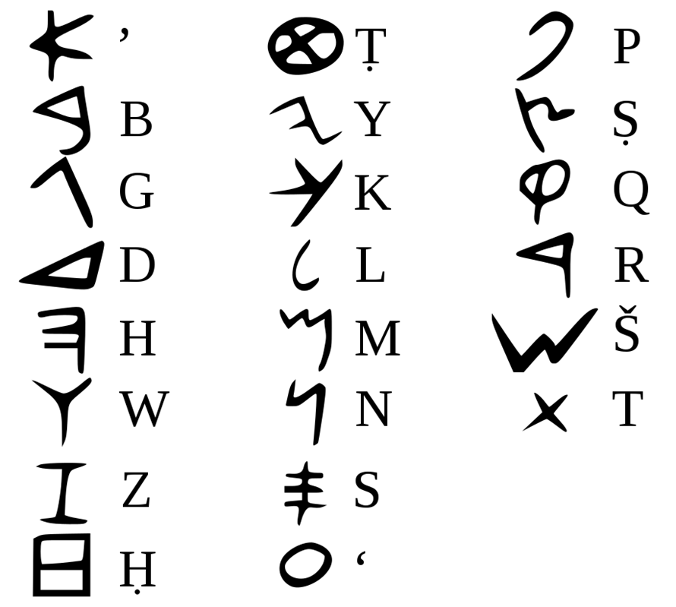
In 1400BC, the earliest form of the Phoenician alphabet was created, with a more refined version being introduced in the 11th century BC. Unfortunately, due to the Phoenician preference for secrecy, very few examples survive, and so it is difficult to tell which of the Phoenician cities it originated from, as each one likely had their own slight differences.
Figure 1 - Phoenician Alphabet, after Wikipedia 2007
The script was likely created as a solution to the problem of travelling merchants having difficulty translating various languages into Cuneiform, the previous written language of the Phoenicians. The new ‘alphabet’ worked by translating phonetic sounds into symbols, rather than whole words into symbols. That way, all the listener would have to do is write down the sounds, and anyone reading it would instantly understand what was being said. A standard writing system would have helped in virtually every area of maritime commerce (record keeping, standard practices of trade, currency, communication between buyers and sellers).

The Phoenician alphabet was transmitted to the colonies in places like Spain as a side-effect of trade there, as the system of writing developed on the Iberian Peninsula was based on the Phoenician characters. The customers buying items from the Phoenicians would have been at a disadvantage by not being able to read the contracts drawn up by the Phoenicians, so it was in their interest to learn this new ‘alphabet’. In Greece, the introduction of the alphabet came from Cadmus of Tyre according to Herodotus, and the Greeks then slowly adapted it for their own use.
The eagerness of the Greeks to adopt the new writing form was important in another way, as it created a new demand for papyrus to write on, which the Phoenicians were able to supply from Egypt. The fact that the Greeks didn’t trade directly with the Egyptians is a sign of how important the Phoenicians were as middlemen, and that they were seen as the “central point of trade in the Mediterranean.”

Navigation

The Phoenicians were among the first to realise that they could determine their location and direction from observing the stars. Their navigation system was based around the guidance of the constellation Ursa Minor, leading the Greeks to refer to that constellation as Phoenician. As the Phoenician trade routes took them far from home, they quickly mastered the art of navigation at night, learning from other cultures they encountered as well as adding their own observations, becoming “the master navigators of their day.”

Towards the end of the Phoenician Era, Pytheas of Marseilles, a Phoenician colony, became the first navigator to realise that the North Star did not actually mark true North. Pytheas was hailed as one of the greatest navigators of his time, having sailed a quarter of the known world and returned safely, as well as being credited with the earliest observations of Britain, Ireland and the North Sea.

The Famous Trade Goods

The Phoenicians were well-practiced at producing wares nobody else could, creating supply and demand. There were four principle products that Phoenicians excelled at making: Purple Dye, the speciality of Tyre; Glass that was the speciality of Sidon; weaved fabrics for clothing and furniture; and elaborate use of metallurgy.

Dye

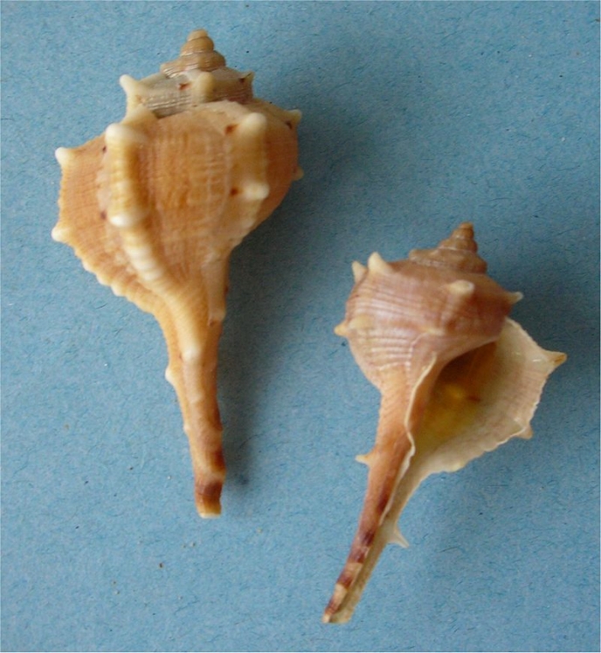
Tyrian Purple was the most well-known of the goods traded by the Phoenicians, so much so that it may have been the source for the name ‘Phoenicia’, or ‘land of the purple people’. The dye was so popular across the Mediterranean that the Phoenicians made trading colonies specifically to grant access to new customers wanting the dye.
Figure 2 - Tyrian purple sea snail shell, after Wikipedia 2007
The dye came from specific species of sea snail, “Hexaplex trunculus, Bolinus brandaris and Stramonita haemostoma” that each gave a slightly different shade of the dye, from blue and purple shades to those of a red-purple colour. The Phoenicians extracted the glands from the sea snails and after fermentation, used the dye to colour woven cloths for sale to the highest bidder.

Glass

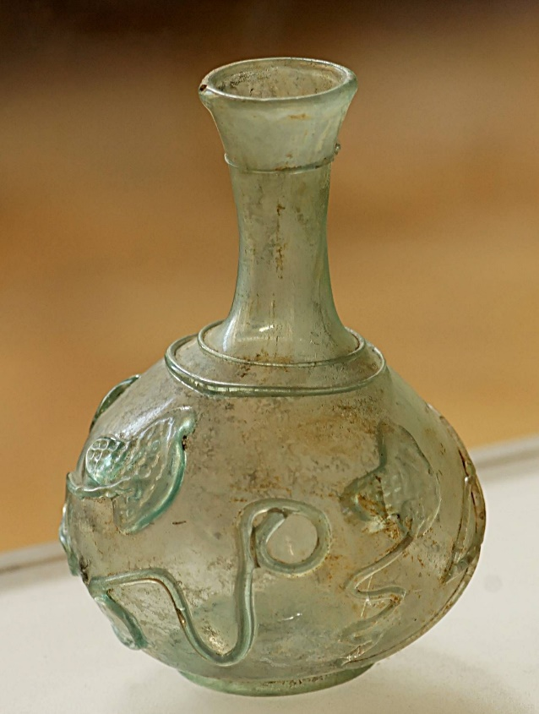
Glasswork was considered a “typical Phoenician craft”, despite originating elsewhere, likely in Egypt. However, like many of their other crafts, the Phoenicians took the Egyptian techniques and style and improved upon them. While the Egyptians used only opaque glass, the Phoenicians developed a technique for making transparent glass beads, and eventually, in the 1st century BC, perfected the technique of glassblowing. The sand in the regions around Tyre were reported to produce the best glass, which led to the Phoenician glassware being revered in the ancient world.
Figure 3 - Ancient Blown Glass Vessel from Sidon, after Pinterest n.d

The greatest of the Phoenician glassworks were based in Sidon, and the wares produced there were highly prized throughout the Phoenician sphere of trade, especially in the later Phoenician years when they formed “an abundant export” to Rome, and were praised by Pliny for their quality. Examples of Phoenician glass have been found all over the Mediterranean, in Crete, Spain, Cyprus, Etruria and Egypt, varying in style, but the most commonly associated with the Phoenicians were a series of cast vessels made from “thick translucent glass” that were then highly polished. Many of these vessels imitated those created in other materials, such as bronze, alabaster or pottery, which Markoe has interpreted as showing a strong relationship among the craftsmen of Phoenicia.

Textiles

The main industry of the Phoenicians was that of textiles. They were famously renowned for the finely decorated fabrics that the Sidonian women wore, and were the envy of their neighbours. Such clothing was often demanded as tribute by those who ruled over the Phoenicians at various points, in particular there are records of the Assyrians receiving Phoenician fabrics as a prominent part of the annual tribute. This was largely due to the wide variety of colourful garments and materials sold by the Phoenicians, likely due to their closely-guarded secret of the Tyrian Dye that I have already mentioned. Homer makes a reference to “the many-coloured garments of the Sidonians,” and depictions of the ‘Asiatics’ on Egyptian monuments were often dressed in clothing of great colour and beauty. The materials used to create these items of clothing were often obtained in trade, decorated by the Phoenicians, and then sold back on for a higher price. Traditionally the materials used were Syrian or Arabian wool, Egyptian Flax, and later silk from Persia.

Phoenician garments were unique among their neighbours for the process in which they were dyed. The Phoenicians were able to produce different hues of colour through a combination of different strength dyes and the process of ‘double-dipping’ the wool. Modern reproductions of this technique have found that the best colours were produced when the wool was dipped into the dye before it was allowed to oxidise, allowing the dye to permeate the fabric. It is not certain what substance was used as a ‘mordant’, to bind the colour to the fabric, but it was likely honey or urine ammonia. Sadly, not a single example of Phoenician fabric has survived, so the conclusions drawn by scholars have been based largely on depictions of the Phoenicians, along with descriptions from ancient sources such as the Bible and Homer.

Metallurgy

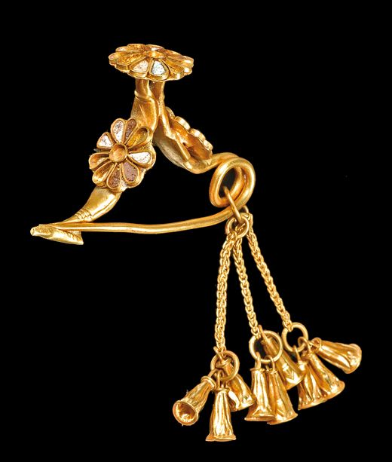
The Phoenicians were master craftsman, and had been producing works of bronze, gold and ivory since the 15th century BC. They were credited as having “played a significant role in the development of metal ware production in the Mediterranean,” although many of their designs originated from the cultures around them; Egyptian, Hittite, Sumerian and Minoan, to name a few. Their role as traders was central to the spread of these designs, as they were sold across the Mediterranean, leading to a “common cultural expression” that was created in the Eastern Mediterranean.

This style spread to the rest of the Phoenician sphere of influence after the collapse of the Bronze Age in 1200BC, when the Phoenicians spread their trade networks out beyond the East Mediterranean, to Greece, Sicily, Spain and beyond. The impact of this was especially great on the Etruscan people, who began styling their own wares after the Phoenicians, to such an extent that it can often be very difficult to tell apart a Phoenician original from an Etruscan copy.
Figure 4 - Gold Fibula Jewellery, after Pinterest n.d.

Trees

As well as their principal trades in crafted products, the Phoenicians’ biggest export of raw materials was the cedar wood that grew in great abundance in their lands. This trade was the “most important factor in their economy,” as many of their neighbouring countries, such as Egypt, had no decent source of wood with which to make seafaring vessels. Cedar was not the only wood exported, although it did make up the bulk of the materials traded with other civilisations. The Phoenician landscape boasted “extensive tracts of cedar, fir, pine, oak and juniper… from Sidon north to Tripoli and beyond.”

Egyptian trade in Cedar wood dates back to before what we consider the ‘Phoenician Era’, to 3200 BC, when the trade with Byblos was the only means for Egypt to gain access to that precious resource. However, from the time of Thutmose III, the trade in Cedar spread to the other Phoenician cities too, as the King embarked on many campaigns that required ever larger quantities of wood. The Egyptian appetite for cedar was insatiable, they not only used it in their fledgling shipbuilding industry for the construction of both river-craft and seagoing vessels, but also for the construction of their houses, palaces and temples. The Egyptians also coveted cedar wood for its fragrant incense, as well as its aromatic resin which was used as part of the embalming process, while the cedar wood itself was used for the coffins of the priestly class and the Egyptian elite.

The importance of the cedar wood trade between the Phoenicians and the Egyptians is further highlighted by the account of Wen-Amon mentioned above, as he was sent by the Egyptians to trade for large amounts of cedar wood, among other goods. However, at this point the Phoenicians were no longer under the control of the Egyptians, and the King of Byblos was able to impose his own conditions for the trade, which shows just how vital the trade was to Egyptians, as Wen-Amon agreed to all of his demands. The cedar trade was clearly vital to the Phoenicians too, as they risked the wrath of the Assyrians, who had imposed a levy on the export of the wood to their rivals, to continue their lucrative trade with the Egyptians.

Ships

The Phoenicians were considered master shipwrights, not unsurprising for a people that made their entire living based on the sea. As they undertook long journeys carrying precious cargo, they needed to ensure that the ships they built would be secure and sturdy enough to travel the trade routes across the Mediterranean and beyond without falling apart or sinking.

Ship Types
The Phoenician-built ships fell into three distinct categories:
1. Small to medium ‘burden craft’ for transporting wooden logs and other supplies up rivers
2. Seagoing merchant vessels, known as ‘Canaanite type’ which used “wide quadrilateral sails” for transporting goods along the main sea-trade routes
3. Phoenician Warships, which were further divided into two types that were both powered by a combination of oarsmen and sails that could be dismantled during combat situations
i. Auxiliary transport vessels, which were designed for the transportation of warriors or supplies, but could also be used as a flagship for a merchant convoy
ii. Combat vessels, with a ram at water-level on the front of the vessel, and could traverse open waters to reach wherever they were needed

Unfortunately, the Phoenicians did not leave behind many depictions of their ships, so what we know about them comes from shipwrecks, such as the Uluburun, or from the images of other civilisations, such as the Palace of Sargon II at Khorsabad, and the Palace of Sennacherib at Nineveh. What we do know is that ships from contemporary or later civilisations seem to have aspects of each of the three categories listed above, such as the Greek Triremes, or even Hebrew ships.

The Shipping Industry
The Phoenicians built their ships from the cedar wood that was plentiful in the surrounding landscape, which made for “highly durable” boatbuilding timber. When other civilisations saw the skill of the Phoenician boatbuilders, they attempted to copy the designs themselves, but the designs were more complex, and so the Phoenicians became the suppliers not only of the cedar wood used to build them, but of the ships themselves. The Phoenicians honed their skills until the boats they built were considered by some to be works of art.

The demand for Phoenician vessels increased during times of war, as rulers such as Thutmoses III and Xerxes used Phoenician ships to transport their troops around the Mediterranean when they were conquering new lands: Thutmoses III’s campaign against the Amorites in 1479BC, and Xerxes campaign against the Greeks during the Persian Wars.

The shipping industry went through several changes to the design of the Phoenician war galleys during the course of the first millennium BC. In the beginning of the first millennium, the standard craft, called the triaconter and the penteconter were single-banked vessels with either 30 or 50 rowers. In the 8th century, the raised deck was invented, allowing for the construction of double-banked galleys, which meant that two floors of rowers could work inside the ship, decreasing the size and creating a “far more compact, shock-resistant vessel.” The new design served the Phoenician navy faithfully through the seventh and sixth centuries, until it was eventually replaced by the Phoenician trireme. This triple-banked vessel was the main vessel used by the Persians when they controlled Phoenicia, as it was faster and better than any of their ships, capable of reaching a top speed of 9 knots when ‘sprinting’. The Phoenician trireme had a few key differences to its Greek contemporary: a higher deck, longer and cone-shaped ram, and a figurehead at the prow, though they likely had the same amount of rowers.

The Colonies
The Phoenicians founded many colonies across the Mediterranean, some simply to serve as trading posts, such as Malta, while others were there to take advantage of the local resources, as was the case in both Cyprus and Sardinia. Some of these colonies would one day grow so large and influential that they became independent from Phoenicia and, in the case of Carthage, would one-day rival even Rome.

Carthage

Carthage originally started out as a Phoenician colony in North Africa, founded by the Tyrian princess Elissa, known to the Greeks as Dido.The traditionally accepted date for the foundation of Carthage is 813 BC, though there is some archaeological evidence for Phoenician activity there fifty years earlier. The foundation story of Carthage tells of Elissa’s marriage to her Uncle Acharbus, who her brother, King Pygmalion of Tyre, had assassinated. Elissa fled to Cyprus, where she gathered those who were loyal to her, along with the high priest of Astarte and eighty religious prostitutes, so that the Phoenician religion may persevere. This group then sailed to the site on the North African coast where they would found Phoenicia’s greatest colony. Elissa’s story did not end there however. The colonists were originally welcomed by the native population, but when the local king Hiarbus, who had allowed them to settle on his lands, fell in love with Elissa, and declared that he would start a war with them if she did not agree to marry him. Elissa was faithful to her husband’s memory, and refused, jumping into a sacrificial pyre. She was subsequently deified by her people, a cult that continued until Carthage’s destruction centuries later, by the Romans in 146 BC.

In the 6th century BC Carthage “bursts onto the scene as a Mediterranean political power,” following the fall of its mother-city of Tyre in the Phoenician homelands to Nebuchadnezzar II in 560 BC. Carthage’s increase in power continued into the 5th century, when the colony gained political dominion over the other colonies in the region, thus beginning the Punic culture. Carthage’s expansion has been attributed to the threat posed by the Greeks, who were also expanding in the area, and had already pushed the Phoenicians to the northwest of Sicily, where previously they had colonised the whole island. Unlike the Phoenician homeland, the North African coast was fertile, allowing Carthage to develop highly sophisticated agricultural systems to which “even Rome acknowledged herself to be indebted to.”

During the 6th and 5th century BC Carthage began systematically seized and occupied the coastal regions around them, building several imposing fortresses around the Gulf of Tanis and Cape Bon. Carthage then made an alliance with the Etruscans against the Greeks, in an attempt to prevent the Greeks taking over the Mediterranean. These actions made Carthage into more of a threat to other major powers, such as the Persian Empire. King Cambyses of Persia decided to deal with this threat by attempting to conquer them, but the Phoenicians back in the homeland, who formed the backbone of the Persian Navy, refused to attack their former colony, so Cambyses called off the attack. Around this time, Rome began to establish itself as a major independent power in the Mediterranean, and recognised the power that Carthage represented, so decided to make a treaty with them to protect themselves.

When Xerxes decided to go to war with the Greeks, Carthage was approached by the Persian-Phoenician delegates to join their side. While the main Persian forces engaged the Greeks, the Carthaginians were dispatched to deal with Geron of Syracuse, who was supporting the Greeks, presenting a united Greek front in the Mediterranean. The Carthaginians were defeated by Geron, and a fragile peace was made, though Carthage’s military might had been temporarily shattered. Several generations later in 409BC, the Carthaginians were granted their revenge, eventually taking over a third of Sicily.

In the third century BC, Carthage began to come into direct conflict with Rome. What followed was termed ‘The Punic Wars’, During this time, both Rome and Carthage lost many troops and ground, with the most famous Carthaginian general, Hannibal, posing the greatest threat that Rome had ever seen. Ultimately, Rome was victorious, and Carthage was assimilated as a Roman Province in 146 BC. Despite this, much of the Punic civilisation and traditions endure for several centuries, as the Romans were not interested in eradicating the culture, merely the threat.

Cyprus
The Phoenicians’ first expansion following the collapse of the Bronze Age in 1200BC was to the nearby island of Cyprus, where they quickly established an outpost at Kition that allowed them to take advantage of Cyprus’ considerable copper reserves. Dating of Phoenician artefacts found on Cyprus suggest that there was a Phoenician presence on the island from the 12th century, but the main emporium at Kition was not built until the 9th century. Cyprus has also been suggested as another major site of the export of Phoenician glass, both in finished products and in the raw glass.

Malta
Malta was likely chosen for the site of a Phoenician colony for its advantageous position in the Mediterranean and its well-protected natural harbours, as it had little to no natural resources, and so served instead as a “place of safe retreat” and refuelling point along the longest of the trade routes. A temple sanctuary in the interior of the island has provided Phoenician artefacts that date back to the 8th century BC, so this is generally accepted as the date the island was settled. The original name of Malta’s sister island Gozo was Gaulos, which was the Phoenician word for a type of merchant ship, which further suggests that the area was controlled by the Phoenicians.

The position of Malta at the passage between the Ionian Sea and the Western Mediterranean proved advantageous to the Phoenicians, as they also had colonies on Sicily, Sardinia, Ibiza, Carthage and Gadir and so were able to use these ports as a triangle of control from which they could monitor trade, and as a landing point before venturing further out into the West. Malta was also situated along the route the current flowed from West to East, so it was easy to navigate.

Sicily
Another major colony for the Phoenicians was on Sicily. They originally had control of ports all over the island until the Greeks created their own colonies in the 7th century BC, and the Phoenicians withdrew to the north-western part of the island; a calculated withdrawal to the “most strategic commercial interests on the island”, according to the Greek historian Thucydides, one of the most informative accounts of Phoenician activity on Sicily. Chief among these remaining bastions of Phoenician commerce was Motya, as it provided the closest access to both Carthage on the North African coast, and Southern Sardinia, both major colonies and trading posts for the Phoenicians.

Unlike the Greek colonisers, the Phoenicians took care to remain on friendly terms with the native Elymians, allowing for a conflict-free occupation of the sites they held. This method of colonisation fits with the Phoenicians’ six principles I have outlined at the beginning of my dissertation, as they seek to find peaceful methods of co-existing above all else. The Phoenicians’ purpose of colonising Sicily was not for conquest, merely for commercial purposes, so they posed no threat to the natives, unlike the Greeks, whose “colonial aims brought them into open conflict with the natives.”

Cadiz
Cadiz was the Phoenicians’ main foothold in the Iberian Peninsula, which was a major source of ores and precious metals. This part of Spain forms “one of the richest sources of raw minerals – gold, copper, iron, tin and silver – in the entire Mediterranean.” The wealth of resources hidden on this stretch of land called to the commercial-minded Phoenicians who appreciated just how valuable this land was, and it was this that called to the Tyrians to embark upon such an ambitious venture. The earliest consistent archaeological record pinpoints the 8th century BC as the date for the colonisation of this region by the Phoenicians, however there are some isolated artefacts that hint at an earlier voyage, perhaps as an experiment or to see how viable settling there would be. It turned out to be the Phoenicians’ most profitable venture. The amount of silver gleaned from Iberia was enough to found many colonies throughout North Africa, Sardinia and Spain.

The Phoenician colony of Cadiz was situated just past the Straits of Gibraltar,on a group of islands just off the coast of the Bay of Cadiz, with the bulk of the settlement on the small northern islet of Erytheia. The decision of Erytheia as the main settlement was cleverly calculated by the Phoenicians. It sat directly opposite the mouth of the River Guadalete, allowing for control of access to the Guadalquivir valley, the entrance to the mineral wealth of Lower Andalusia.

Evidence from the mining sites in the region have shown that the ore was mined by the native population, but the Phoenicians were heavily invested in the operation, as Phoenician furnaces have been found at the coastal city of Huelva, where there was a substantial Phoenician presence, which indicates that they were the ones to refine the ores into metal.

Cadiz, along with Huelva, Almuñécar, Morro di Mezquitilla and Toscanos, was one of the central points for the transmission of the Phoenician alphabet from the 8th century onwards. The fact that the native population felt it necessary to learn the script of the Phoenicians is an indication of how large an enterprise was running from this region.

Sardinia
The island of Sardinia was also rich in mineral wealth, that of copper, iron, and lead with veins of silver. All of these acted as a magnet for the ever-expanding Phoenician trade network, as they saw here an opportunity to obtain access to these minerals, following in the footsteps of the Mycenaeans and the Cypriots who had previously controlled the island. Sardinia was colonised by the Phoenicians towards the end of the 9th century BC, around the same time as Kition on Cyprus and Carthage in North Africa, forming a trade route stretching across the Mediterranean.

The Phoenicians established several settlements on Sardinia, two of the most vital being Cagliari, which was central to gaining control of the region, and Cuccureddus, which served a similar role as a regional trade centre. Another major city was Sulcis, which the Phoenician deemed important enough to construct an isthmus connecting the city to the mainland. Like many Phoenician settlements, Sulcis had two protected harbours, one facing north and one facing south, so that trade ships could still enter the settlement in unfavourable weather.

In the 7th and 6th centuries BC, there was a shift in “territorial consolidation” on Sardinia, as new settlements were created for defensive and commercial purposes. The most important of these was Monte Sirai, which was a fortified hilltop settlement established by Sulcis with the express role of controlling and monitoring access to the Iglesiente region, where most of the mineral wealth came from. Around the same time, commercial interests shifted from the Campanian cost of Italy to the Etruscan coast of the north, though trade with North Africa, the Aegean and the Western Mediterranean remained unchanged.

Rulership by Outsiders and The End of Their Independence?
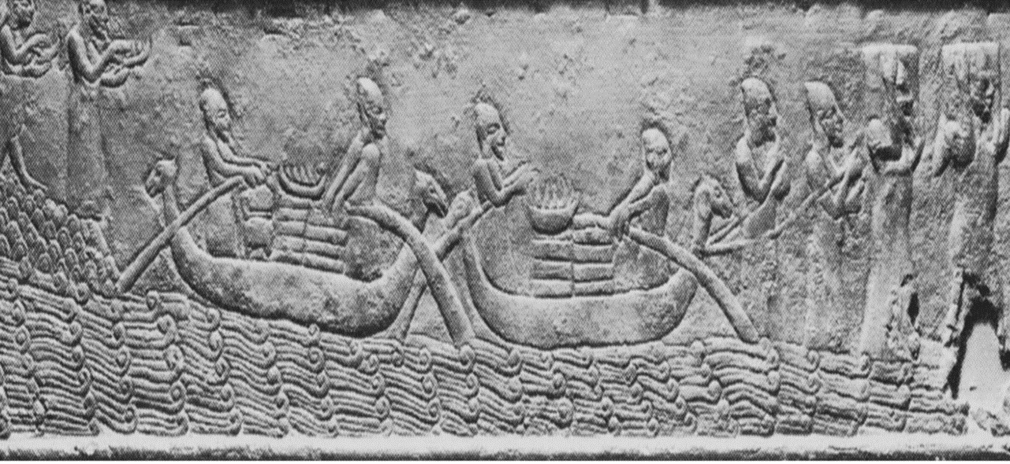
Although the earliest example of Phoenician/Canaanite maritime trade between herself (at that time only Byblos) and one of her neighbours is recorded as 3200BCE in Hierakonpolis.
Figure 5 - Phoenician River Boats, after Friedman 2015

This is ratified by an excavation led by Michael Hoffman in 1985, who discovered the oldest temple in Egypt with four huge cedar columns making up part of its exterior which points to trade occurring between Phoenicia and Egypt in regards to trading Cedar wood.
Unfortunately, no document detailing such a transaction survives from that era though it is heavily implied by later, better documented transactions, that Egypt must have already had an established trade relationship with Phoenicia allowing Egypt to seek out an already familiar trade partner to arrange similar transactions in later years.
Phoenicia’s Independent trade empire flourished from approximately 1200BCE when the Assyrians pushed the Egyptian influence out of the region until 332 BCE when Alexander the Great conquered the region.

During the Phoenician Era, the Phoenicians were ruled over by several different civilisations wanting to take advantage of the great wealth of the trading nation. However, many of these rulers were primarily interested in the tribute that Phoenicia could gift to them, rather than taking over control of the trade empire themselves. Additionally, these conquering neighbours lacked the skill and knowledge that the Phoenician artisans possessed. The Phoenicians managed to retain most of their independence until the arrival of Alexander the Great conquered them in 332 BCE.
This marked the beginning of the end for the Phoenician reputation as independent, globalisation pioneers as their political independence was removed and their identity became more and more Hellenised, until they were “indistinguishable” from other Greek metropolises.

Protectorate under Egypt

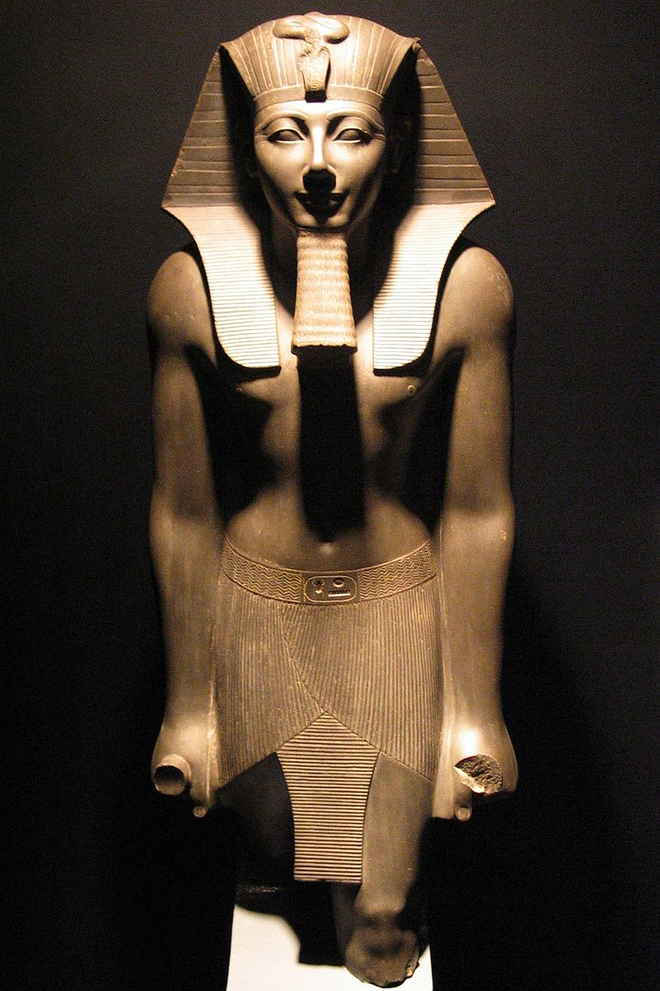
At the beginning of the Phoenician Era, they were loosely ruled by the neighbouring Egyptians, beginning with Thutmose I in 1525 BCE, who demanded tribute from the young Phoenician city-states, and later Thutmose III made the city-states into his vassals. Despite their new status as vassals, the Phoenicians were allowed to retain the majority of their independence, and Egypt in turn protected them from the threat of the Hittites to the north. However, as the Bronze Age drew to a close, the power of the Egyptians began to fail, and the Hittites started to make unchallenged advances towards the now unprotected Phoenicians. Fortunately for the Phoenicians, their unlikely saviours appeared in the form of the invading Sea Peoples in 1200 BCE. The sheer amount of devastation left after 40 years of invasion had crumbled the Hittite threat and reduced the Egyptian power significantly. Meanwhile, the Phoenicians had survived relatively unscathed, despite the destruction of nearly every civilisation around them.
Figure 6 - Thutmoses III, after Wikipedia 2010

Bronze Age Collapse and Resurgence of Phoenician Independence

Following the Collapse of the Bronze Age, the Phoenicians enjoyed several centuries of independence and peace during which they built up their cities and forged new links with the surviving civilisations around them, as well as settling colonies on Cyprus, Malta, Sicily and the Iberian Peninsula. It was during this period that Wen-Amon, the Egyptian Envoy, visited the former vassal of Byblos to trade for cedar. This time, the power was in the hands of the Phoenician King, who was the one setting the terms of the trade.

This era of Phoenician independence did not last forever. In the 10th century BCE, the former major powers of Egypt and Assyria began to rebuild the empires that had been lost at the Collapse of the Bronze Age. Seeing the Assyrians as the bigger threat, the Phoenicians began to court the Egyptians, in the hope of winning their protection once more, without themselves being subjugated. For the next century, the Phoenicians played a careful political game, offering gifts to the Assyrians while maintaining their independence. Their independence was rewarded at the end of the 9th century, when the Assyrians, faced with a threat from the “growing military presence of Urartu in Southern Anatolia”, turned their attention away from the Phoenicians back to their own borders. The time that followed was a period of “greater political freedom” for the Phoenicians, during which time they were able to undertake their commercial ventures without worry of interference or takeover from an outside power.

Assyrian overlords

The freedom enjoyed by the Phoenicians during the early 8th century came to an abrupt halt with the ascension of Tiglath-Pileser III to the throne of Assyria in 744 BCE. The new king was quick to assert his dominance over the region, and launched an aggressive campaign against the surrounding civilisations, bent on total domination of the Levant. In 738 BCE, the whole of the Levant submitted to his reign, and the Phoenician cities were annexed into Assyrian territory. Tiglath-Pileser III recognised the value of Tyre’s commercial status however, and allowed them to operate more-or-less as they wished, so long as they paid an adequate tribute. This remained the case until the reign of Sennacherib in 704 BCE, who tightened the long leash that had been given to Tyre, demanding declarations of fealty and an increase in tribute.

Babylonian Rulership

The decline of the Assyrian Empire, ending in 612 BCE with their destruction at the hands of the Medes, allowed the Phoenicians a brief window of freedom before the rise of the Babylonians under Nebuchadnezzar II, who besieged the city of Tyre for 13 years before the Tyrian King agreed to surrender, with the other Phoenician cities following suit. However, the Phoenician cities were granted a certain degree of autonomy in exchange for the recognition of Nebuchadnezzar as their sovereign, and once again paid tribute to a new ruler. One humiliation the Phoenicians were forced to endure was the loss of their beloved cedar wood trade, which now came under the state control of the Babylonians.

The Persian ‘Partnership’

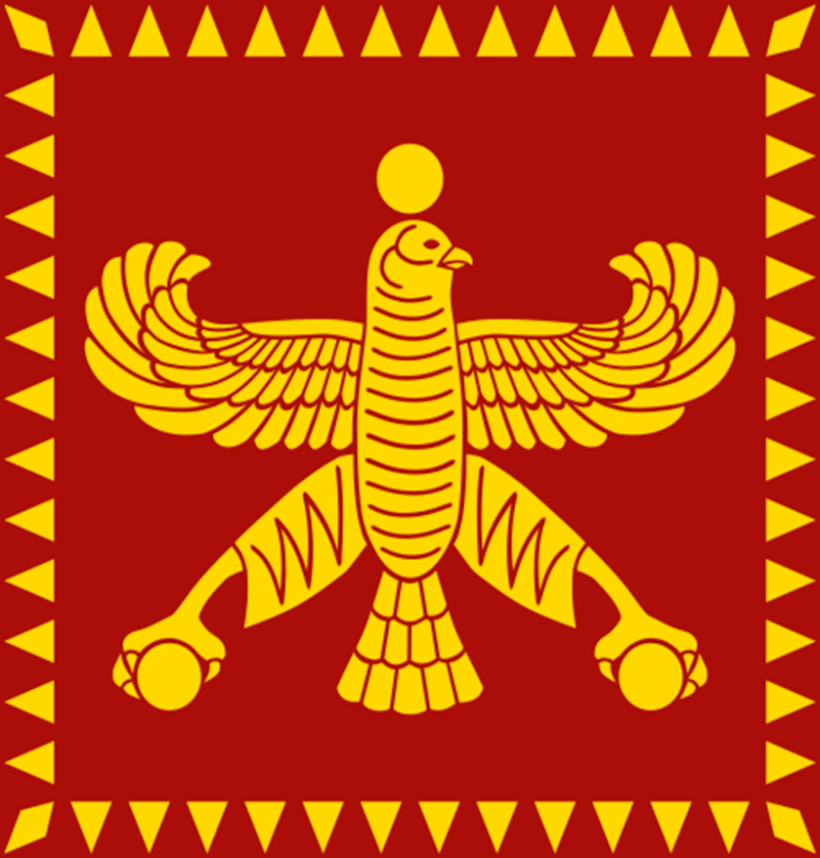
The Babylonian control of Phoenicia did not last long after the death of Nebuchadnezzar. In 539, the conquering Persian Empire under Cyrus the Great conquered Babylon, and the Phoenicians took the opportunity to offer gifts to their saviours. The Persians recognised the value of the Phoenician city-states, and for the first time, Phoenicia entered into a relationship that was more akin to a partnership than that of an oppressed nation.
Figure 7 - Banner of Cyrus The Great, after Wikipedia 2007

Under the Persians, the Phoenicians enjoyed a great deal of freedom, aiding the Persian King Xerxes in his war against the Greeks. However, with the loss of that war, and Xerxes’ blame and subsequent punishment of the Phoenician Captains, using them as scapegoats for the loss at Salamis, led to the Phoenicians losing faith in the Persians, abandoning the war and sailing all of their ships back to their own lands. This dissatisfaction festered, and in 346 BCE, the city of Sidon rebelled. The rebellion was completely crushed, and Sidon burnt to the ground with all of its citizenry massacred.

Alexander the Great and The Arrival of Hellenism

When Alexander the Great conquered the Persian Empire, in 332 BCE, and came down into Phoenicia, the cities surrendered immediately to avoid bloodshed, all except for Tyre. Until this point, the walls of Tyre had never been breached, and they expected Alexander to give up after the experience tyre had with Nebuchadnezzar II. Alexander, however, did not give up the siege nor did it last 13 years. He successfully captured the ‘unbreachable’ city in ???.
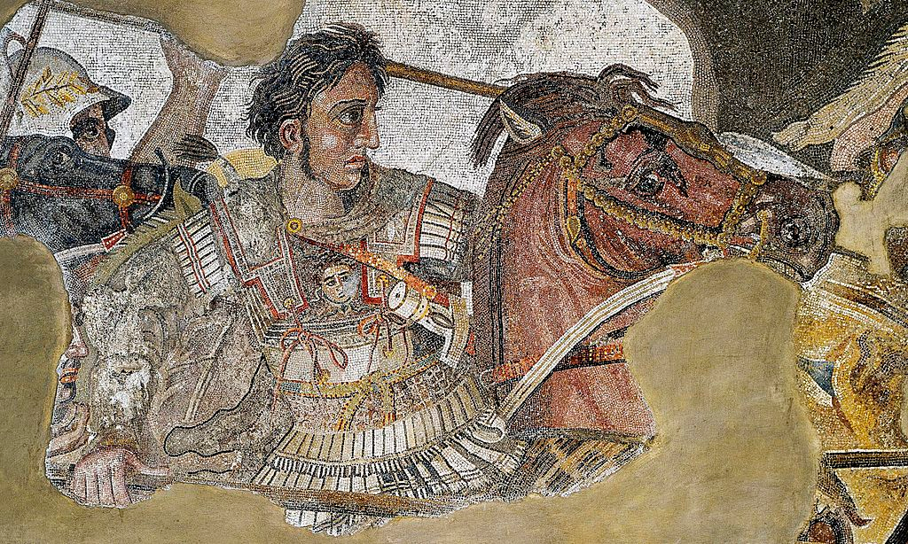
Figure 8 - Alexander Mosaic, after Wikipedia 2018

With the defeat at Tyre, the Phoenicians came under the rule of Alexander, and what is commonly regarded as Phoenician culture slowly died out as it was no longer politically independent and was succumbing to Hellenistic influences under the new Macedonian rulers.

Successor conflicts and the Seleucids


Following the death of Alexander The Great and the fracture of the Successor States, the ownership of the Phoenicians cities changed hands multiple times during the Successor conflict eventually residing within the Seleucid rule from 198-82BC. Under both Alexander and the Successors, the Phoenicians were left mostly to themselves, providing they remained loyal, and paid the required tribute.
Figure 9 – Seleucid Emblem, after Wikipedia 2017

With the conquest of the Levant by Alexander the Great and the fall of Carthage to the Romans two hundred years later, the last remnants of Phoenician culture were absorbed into those of their conquerors. After this point, Phoenicia and her colonies still would have been manufacturing their unique and reputable wares but they no longer had anything to do with the trade and distribution of these wares as this was also taken over and now handled by their rulers.
All political and commercial independence had been removed from them and whilst this will have severely dampened their ability to carry out any form of globalisation as they once had, their rulers and other nations with adequate supplies of their well-regarded trade goods and the knowledge required to achieve a system and reputation anything like what the Phoenicians had, could still use them to achieve globalisation, the same way the Phoenicians did, long after the Phoenician identity had faded.

Conclusion
To conclude, it seems fair for one to say that the Phoenicians made great strides in the field of maritime commerce and they enjoyed abundant achievements and successes as they led the pioneering edge in commerce, international relations and perhaps the earliest and greatest example of globalisation of their time, before and primarily after the collapse of the Bronze Age.
The Phoenicians built up their clientele based on the beautiful, sturdy and well sought after goods that they alone could produce, their ability to reliably meet the demands for these goods utilising an industry designed entirely around the seagoing vessel and the goods they carried, their use of revolutionary methods and technologies in seafaring and ship building to deliver their unique goods and finally, their philosophy of trying to find diplomatic means of resolving situations marking themselves out as a peaceful civilisation, one that did not even maintain a standing military force giving testament to their ability to resolve matters without bloodshed.
Effectively employing globalisation allowed Phoenicians to amass fortunes of coin and trade goods which they could then use to arrange the payments of tributes paid to aggressive neighbours and would-be oppressors to keep the peace and protect her people and her assets which boasts of her economic prowess. With these tools, Phoenicia achieved influence, repute, status and respect on an international and indeed intercontinental level that would last long after she lost her identity to foreign rulers, she lived on in the immaculate works of her people and in the legacy of the first functional use of globalisation in history.

Bibliography:

Aubet, M.E. 1995. ‘From Trading-Post to Town in the Phoenician-Punic West.’ In Cunliffe, B. and Keay, S. Social Complexity and the Development of Town in Iberia: From the Copper Age to the Second Century AD. Oxford: Oxford University Press. 47-66

Aubet, M.E. 1996. The Phoenicians and the West: Politics, Colonies and Trade. Cambridge: Cambridge University Press

Avigad, N. 1982. ‘A Hebrew Seal Depicting a Sailing Ship.’ Bulletin of the American School of Oriental Research 246. 59-62

Casson, L. 1959. The Ancient Mariners. London: Lowe and Brydone

Christian, M.A. 2013. ‘Phoenician Maritime Religion: Sailors, Goddess Worship and the Grotta Regina.’ Die Welt des Orients 43. 179-205

Friedman, Z. 2015. ‘The Phoenician Hippos Figurehead. Preserved Tradition and Types of Ship.’ In Pederson, R.K. (ed) On Sea and Ocean: New Research in Phoenician Seafaring. Marburg: Eigenverlag des Archäologischen Seminars der Philipps-Universität. 19-129

Guimlia-Mair, A. 2015. ‘Phoenician Metalwork: Composition and Techniques’ Bibliotheca Archaeologica Hispana 45. 481-516

Harden, D. 1963. The Phoenicians. London: Thames and Hudson

Holst, S. 2011. Phoenician Secrets: Exploring the Ancient Mediterranean. California: Santorini Publishing

Lopez-Bertran, M., Garcia-Ventura, A., and Krueger, M. 2008. ‘Could You Take A Picture of My Boat Please? The Use and Significance of Mediterranean Ship Representations.’ Oxford Journal of Archaeology 27(4) 341-357

Markoe, G. 2002. Peoples of the Past: The Phoenicians. London: British Museum Press Ltd.

Moscati, S. 1968. The World of the Phoenicians. London: Weidenfeld and Nicholson

Semaan, L. 2015. ‘New Insights into the Iron Age Timber Trade in Lebanon.’ In Pederson, R.K. (ed) On Sea and Ocean: New Research in Phoenician Seafaring. Marburg: Eigenverlag des Archäologischen Seminars der Philipps-Universität 95-120

Sherratt, S. 2010. ‘Greeks and Phoenicians: Perceptions of Trade and Traders in the Early First Millennium BC’. In Bauer, A., and Agbe-Davies, A. Social Archaeologies of Trade and Exchange: Exploring Relationships Among People, Places and Things. California: Left Coast Press

Van Dongen, E. 2010. ‘Phoenicia: Naming and Defining a Region in Syria-Palestine.’ In Rollinger, R., Gufler, B., Lang, M., and Madreiter, I (eds). Interkulturalität in der Alten Welt: Vorderasien, Hellas, Ägypten und die vielfältigen Ebenen des Kontakts. Weisbaden: Harrassowitz Verlag. 471-488

Veropoulidou, R. 2012 ‘The Tyrian Purple: A Royal Dye.’ in. Adam-Veleni, P., and Stefani, E., (eds) Greeks and Phoenicians at the Mediterranean Crossroads. Thessaloniki: Archaeological Museum of Thessaloniki. 103-105

Vonhoff, C. 2015. ‘Phoenician Bronzes in Cyprus’ Bibliotheca Archaeologica Hispana 45. 269-294

Wachsmann, S. Seagoing Ships and Seamanship in the Bronze Age Levant. Texas: Texas A&M University Press

Woudhuizen, F. 2006. ‘The Transmission of the Phoenician Alphabet in the Mediterranean Region’ Rivista di Studi Finici 35.2 91-102

Pictures:

Alexander mosaic - Wikipedia, 2018, ‘Alexander The Great’. Available from: https://en.wikipedia.org/wiki/Alexander_the_Great#/media/File:Alexander_the_Great_mosaic.jpg. Accessed 13th February 2018
Ancient blown glass vessel from Sidon – Pinterest, n.d, ‘Glass - An Illustrated History’. Available from: https://www.pinterest.com/pin/51228514483437566/. Accessed 7th April 2018
Banner of Cyrus The Great - Wikipedia, 2009. ‘Cyrus the Great’. Available from: https://en.wikipedia.org/wiki/Cyrus_the_Great#/media/File:Standard_of_Cyrus_the_Great_(Achaemenid_Empire).svg. Accessed 13th February 2018
Golden fibula – Pinterest, n.d, ‘The Phoenician gold jewellery from Kition’. Available from: https://www.pinterest.com/pin/2040762310983839/. Accessed 7th April 2018
Phoenician alphabet - Wikipedia, 2007, ‘The Phoenician Alphabet’, Available from: https://en.wikipedia.org/wiki/Phoenician_alphabet#/media/File:Phoenician_alphabet.svg Accessed 21st January 2018
River boat depiction - Friedman, Z. 2015. ‘The Phoenician Hippos Figurehead. Preserved Tradition and Types of Ship. In Pederson, R.K. (ed) On Sea and Ocean: New Research in Phoenician Seafaring. Marburg: Eigenverlag des Archäologischen Seminars der Philipps-Universität. 19-129

Seleucid Empire emblem – Wikipedia, 2017. ‘Total war rome 2 Seleucid Empire emblem’. Available from: https://en.wikipedia.org/wiki/File:Total_war_rome_2_Seleucid_Empire_emblem.png. Accessed 13th February 2018
Snail shell – Wikipedia, 2018, ‘Tyrian Purple’. Available from: https://en.wikipedia.org/wiki/Tyrian_purple#/media/File:Haustellum_brandaris_000.jpg. Accessed 13th February 2018

Moscati 1968:9
Holst 2011:168
Sherratt 2010: 122
Veropoulidou 2012:104
Veropoulidou 2012-103-4
Aubet 1996:5
Aubet 1996:5
Sherratt 2010: 122
Holst 2011:168
Harden 1963:51
Holst 2011:28
Holst 2011:28-9
Holst 2011:44-45
Holst 2011:51
Holst 2011:51
Holst 2011:66
Holst 2011:186
Holst 2011:57
Holst 2011:246
Holst 2011:250
Holst 2011:292
Aubet 1996:53
Aubet 1996:54
Aubet 1996:55
Aubet 1996:55
Aubet 1996:55
Aubet 1996:55
Aubet 1996:55
Aubet 1996:57
Aubet 1996:59
Aubet 1996:59
Markoe 2002:157
Aubet 1996:59
Aubet 1996:64
Aubet 1996:65
Aubet 1996:94
Holst 2011:186
Holst 2011:186
Aubet 1996:60
Aubet 1996:60
Aubet 1996:71
Aubet 1996:73
Aubet 1996:52
Aubet 1996:52
Aubet 1996:52
Markoe 2002:99
Markoe 2002:87
Markoe 2002:91
Markoe 2002:91
Markoe 2002:90
Markoe 2002:92
Aubet 1996:94
Aubet 1996:94
Aubet 1996:94
Aubet 1996:94
Aubet 1996:94
Aubet 1996:91-2
Aubet 1996:92
Aubet 1996:92
Aubet 1996:93
Aubet 1996:93
Aubet 1996:93
Aubet 1996:93
Aubet 1996:93
Aubet 1996:93
Aubet 1996:94
Lopez et al 2008:341-357
Lopez et al 2008:343
Lopez et al 2008:343
Lopez et al 2008:346
Lopez et al 2008:346
Lopez et al 2008:346
Lopez et al 2008:346
Lopez et al 2008:347
Lopez et al 2008:347
Lopez et al 2008:347-8
Lopez et al 2008: 348
Christian 2013:181
Christian 2013:192
Christian 2013:193
Christian 2013:181
Christian 2013:181
Christian 2013:182
Christian 2013:183
Holst 2011:229
Van Dongen 2010:472
Van Dongen 2010:472
Holst 2011:228
Holst 2011:229
Woudhuizen 2006:92
Guimlia-Mair 2015:483
Holst 2011:231
Holst 2011:226-7
Holst 2011:231
Holst 2011:231
Holst 2011:79
Moscati 1968:87
Moscati 1968:87
Holst 2011:79
Casson 1959:137
Casson 1959:137
Casson 1959:137
Veropoulidou 2012:104
Veropoulidou 2012:103
Veropoulidou 2012:103
Veropoulidou 2012:103-4
Veropoulidou 2012:104
Moscati 1968:78
Moscati 1968:78
Moscati 1968:84
Moscati 1968:84
Moscati 1968:84
Markoe 2002:157
Markoe 2002:157
Moscati 1968:78
Moscati 1968:78
Markoe 2002:157-8
Markoe 2002:157
Markoe 2002:157
Markoe 2002:157
Moscati 1968:83
Markoe 2002:163
Markoe 2002:163
Moscati 1968:83
Holst 2011:90
Holst 2011:32-3
Veropoulidou 2012:103
Veropoulidou 2012:103
Markoe 2002:164
Markoe 2002:164
Markoe 2002:164
Veropoulidou 2012:104
Markoe 2002:164
Harden 1963:144
Guimlia-Mair 2015:483
Guimlia-Mair 2015:483
Guimlia-Mair 2015:483
Guimlia-Mair 2015:483
Guimlia-Mair 2015:483
Guimlia-Mair 2015:483
Moscati 1968:83
Moscati 1968:83
Moscati 1968:83
Markoe 2002:19
Markoe 2002:19
Holst 2011:27
Moscati 1968:83
Markoe 2002:19
Markoe 2002:19
Markoe 2002:19
Markoe 2002:19
Markoe 2002:19
Semaan 2015:97
Semaan 2015:97
Semaan 2015:97
Semaan 2015:98
Friedman 2015:19
Friedman 2015:19
Friedman 2015:19
Friedman 2015:19
Friedman 2015:19
Friedman 2015:19
Friedman 2015:20
Friedman 2015:20
Wachsmann 2009:206
Avigad 1982:61
Avigad 1982:61
López-Bertran et al 2008:342
Avigad 1982:60
Holst 2011:16
Holst 2011:16-17
Holst 2011:17
Holst 2011:17
Holst 2012:163
Holst 2012:276
Markoe 2002:80
Markoe 2002:80
Markoe 2002:80
Markoe 2002:80
Markoe 2002:80
Markoe 2002:80
Vonhoff 2015:271
Markoe 2002:177
Aubet 1996:185
Holst 2011:239
Markoe 2002:181
Moscati 1968:114
Moscati 1968:114
Moscati 1968:114
Moscati 1968:115
Moscati 1968:115
Moscati 1968:115
Aubet 1996:212
Aubet 1996:181
Aubet 1996:181
Aubet 1996:182
Moscati 1968:117
Markoe 2002:175
Aubet 1996:198
Aubet 1996:199
Moscati 1968:119
Moscati 1968:119
Moscati 1968:119
Moscati 1968:119
Moscati 1968:119
Moscati 1968:120
Moscati 1968:120
Moscati 1968:121
Moscati 1968:124
Moscati 1968:125
Moscati 1968:129
Moscati 1968:129
Moscati 1968:130
Moscati 1968:130
Moscati 1968:130
Vonhoff 2015:271
Vonhoff 2015:271
Vonhoff 2015:271
Markoe 2002:156
Markoe 2002:180
Aubet 1996:138
Markoe 2002:179
Markoe 2002:180
Markoe 2002:180
Aubet 1996:138
Aubet 1996:138
Aubet 1996:138
Aubet 1996:166
Aubet 1996:166
Aubet 1996:160
Aubet 1996:164
Markoe 2002:175
Markoe 2002:175
Markoe 2002:175
Markoe 2002:175
Markoe 2002:175
Markoe 2002:176
Markoe 2002:176
Markoe 2002:176
Markoe 2002:182
Markoe 2002:182-3
Markoe 2002:183
Markoe 2002:183
Markoe 2002:183
Aubet 1996:218
Markoe 2002:183
Markoe 2002:183
Markoe 2002:183
Markoe 2002:183
Markoe 2002:183
Markoe 2002:184
Markoe 2002:184
Markoe 2002:184
Markoe 2002:184
Woudhuizen 2006:92
Markoe 2002:177
Markoe 2002:177
Markoe 2002:178
Markoe 2002:178
Markoe 2002:178
Markoe 2002:178
Markoe 2002:178
Markoe 2002:178
Markoe 2002:178
Markoe 2002:179
Markoe 2002:177
Markoe 2002:179
Markoe 2002:179
Holst 2011: 27
Holst 2011: 27
Markoe 2002:190
Markoe 2002:190
Harden 1963:48
Harden 1963:48
Holst 2011:165
Holst 2011:171
Holst 2011:176
Holst 2011:177
Holst 2011:182
Markoe 2002:29-36
Aubet 1996:92
Markoe 2002:37
Markoe 2002:37
Markoe 2002:39-40
Markoe 2002:40
Markoe 2002:40
Markoe 2002:41
Markoe 2002:42
Holst 2011:244
Markoe 2002:42
Markoe 2002:42
Markoe 2002:43
Moscati 1968:23
Moscati 1968:23
Markoe 2002:48
Markoe 2002:48
Holst 2011:250-251
Holst 2011:251
Moscati 1968:26
Holst 2011:276
Holst 2011:276
Moscati 1968:26
Moscati 1968:26
Markoe 2002:61
Markoe 2002:190
Holst 2011: 293
Holst 2011:293-5
Markoe 2002:190
Markoe 2002:190
Markoe 2002:190
Holst 2011:317

