

NAME OF STUDENT : SHAHEDABIBI SHAIKH
STUDENT ID : 2223092
MODULE NAME : MARKETING MANAGEMENT
LECTURER NAME : DR TUSHARA BALENDRAN
MODULE CODE : LCMB7001
ASSIGNMENT TITLE : ASSESSMENT 1
COMPANY NAME : L’Oréal Paris

TABLE OF CONTENT

01. Introduction………………………………………………...03
02. History of the Company ……………………. ……………. 04
03. Communication …………………………………………… 05
04. Shannon-Weaver Communication …………………………05
05. Integrated Marketing Communication ……………………. 07
06. New online promotional Strategies ………………………..07
07. New Offline Promotional Strategies ……………………… 08
08. Branding ……………………………………………….......08
09. Brand Equity ………………………………………………09
10. Keller’s Brand equity model ………………………………10
11. Customer Journey Map ………………………………. …... 12
12. Pre-purchase, Purchase, Post-purchase ……………………14
13. Total Engagement Model …………………………………. 15
14. Recommendation …………………………………….. …... 16
15. Conclsuion …………………………………………………16
16. List of References ………………………………………….. 17

INTRODUCTION
L’Oréal Paris is an internationally leading cosmetics company, delivering the finest in premium beauty to everyone. L’Oréal Paris represents beauty in all of its forms. L’Oreal values innovation and risk-taking. The company is a manufacturer of cosmetics and beauty products with its headquarters in Paris. It offers shampoos, cosmetics, skin care products, hair colours, and other hair care items. It also manufactures perfumes and other fragrant items. In 2021, its projected global sales will exceed 32 billion euros. Male-female both of various sizes, countries, and cultural origins are L’Oréal’s target audiences. L’Oréal now owns 36 brands and is expanding. L’Oréal has acquired several cosmetics companies, including The Body Shop, YSL Beaute, Magic Holdings, NYX Cosmetics, Niely Cosmeticos Group, Carol’s Daughter, IT Cosmetics, ModiFace, Valentino, Youth to the People and Aesop (Loreal Paris n.d). In February 2014, L’Oréal agreed to buy back 8% of its shares from Nestle, reducing Nestle’s stake from 29.4% to 23.29%. Shiseido transferred its Carita and Decleor brands to L’Oréal for 227.5 million euros. According to Chief Executive Officer Nicolas Hieronimus, The goal of their business is to present the finest of beauty products to all people on the earth according to standards of effectiveness, reliability, security, transparency, and accountability, fulfilling every desire and need for beauty in unlimited variety. L’Oréal shifting to a low-carbon business strategy and has decreased Carbon Dioxide emissions from our manufacturing sites by 81 per cent. By 2025, all of the locations will be carbon neutral. The vision of the company is to achieve a successful economy, respect the environment and acts and make their employees more effective.
The principles of L’Oréal are; 1 - Enthusiasm 2 - Innovation 3 - Entrepreneurial spirit 4 – Open-mindedness 5 - Quality 6 - Responsibility.
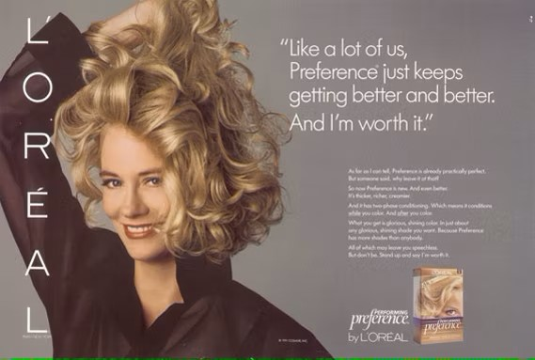
History of L’Oréal Paris
A young pharmacist with ambitious enthusiasm by the name of Eugene Schueller establish the L’Oréal Group in 1909. His career as a successful businessman in the hair dye market started with a hair dye he created, manufactured, and provided to Paris hair stylists.
On July 31, 1919, Schueller founded the French business Société Française de Teintures Inoffensive pour Cheveux, a Safe Hair Dye Company in France. The company’s fundamental ideals were creativity and investigation in the beauty industry until it ultimately changed its name to L’Oréal. In 1920, only three chemists were working at the company. Currently, more than 2,000 teams are working globally. In 1973, L’Oréal acquired Synthelabo to further its goals in the pharmaceutical industry. In 1999, Sanofi and Synthelabo joined to form Sanofi-Synthelabo. Sanofi-Aventis was formed in 2004 as a merger of Sanofi-Synthelabo and Aventis. L’Oréal Paris’s slogan, “Because you’re worth it” came to represent the organization’s emphasis on women in 2009 when it comes to beauty and cosmetics.
Currently, L’Oréal has 20 research centres across the world moreover L’Oréal has transformed into a real tech powerhouse serving personalized, sustainable beauty for everybody in a very short period. L’Oréal has achieved EDGE - The Global Business Accreditation Standard for Gender Equality and GEEIS - Gender Equality European and International Standard awards in almost 30 nations.

COMMUNICATION
The Latin term “Communicare”, which means to impart, participate in, or transmit, is the source of the English word “communication”. The root of the term is the Latin word “communis”, which means “to make accessible or to share”. In the word of common people communication is just in the form of Talking and listening but according to Newstrom & Keith Davis, it is an exchange of information from one person to another. It is a means of communicating with people and conveying beliefs, ideas, and facts showing that strong interpersonal interaction is the most essential ability managers should acquire(1985).
BUSINESS COMMUNICATION can be defined as a method of communicating that includes transferring and accurately reproducing ideas ensured by feedback for motivating actions which will accomplish organizational goals (William G. Scott). Mikael Krogerus and Roman Tschappeler’s “The Communication Book: 44 Ideas for Better Conversations Every Day” Provides straightforward advice for enhancing communication abilities in a range of settings, including meetings, presentations, emails, and social media.
SHANNON-WEAVER COMMUNICATION MODEL
Based on mathematical principles associated with the sending and receiving of signals with the greatest possible telephone line capacity and the least amount of distortion, Shannon designed the Shannon-Weaver model in 1949. “The fundamental problem of communication is that of reproducing a message sent from one point, either exactly or approximately, to another point” (Shannon, 1948, p. 379). To differentiate between signals that indicate information and those that are just noise, Shannon invented his information theory. In his work on the mathematical foundations of human communication, Weaver improved it for use in various types of communication. Here are the seven main parts of the communication model proposed by Shannon and Weaver.
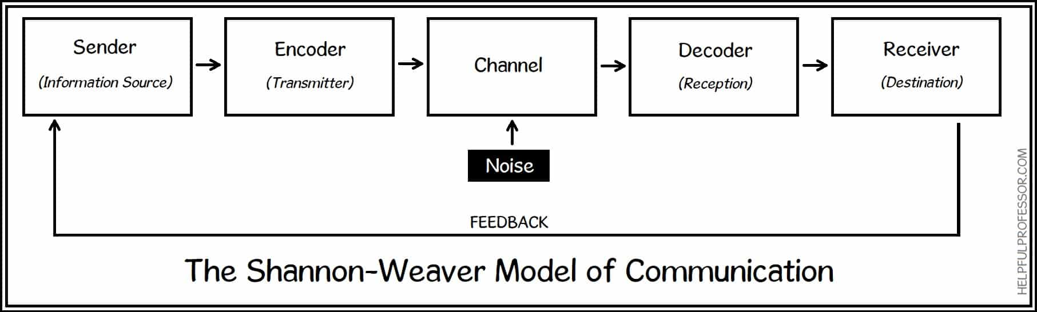 SOURCE OF IMAGE: https://helpfulprofessor.com

EXPLANATION OF THE SHANNON-WEAVER COMMUNICATION MODEL
SENDER (Information source): The person who formed the communication or the information source chooses the desired message. The sender wants the person receiving it to be aware of the information. It is generally believed that the message’s sender bears major blame for the communication’s success or failure. This is because, the fact that the sender has much more influence over the variables of the communication process than the message’s recipient.
ENCODER(Transmitter): Encoder is a person or device that converts a message into a signal that is sent to the receiver telephones and computers are examples of encoding which encode our words sometimes a person also turns an idea into spoken words or signals to communicate with other.
CHANNEL: The network of equipment that carries information from the transmitter and encoder to the decoder and receiver is known as the communication channel. The internet, landlines, and voice echoes used while conversing face-to-face are some examples.
DECODER (RECEPTION): Previous to the communication’s departure, it must be fully understood. This section specifies how the person who receives it will understand and translate the message. Once more, a machine may carry out this operation using binary information, or it might be a human catching up on all of the language and communication data such as sentences, illustrations, word pronunciation, and many on that form a communication transaction.
RECEIVER: The receiver is the person who receives the decoded message and tries to understand the message. The effect that the message has on the receiver indicates if he or she has received and was able to properly understand the message. Effective communication takes place when the consequence of the receiver fulfils the sender’s expectations (Kitson et al., 2013).
NOISE: Certain distortions are introduced during transmission that is not part of the sender’s original message. For instance, if there is a communication process by telephone, the telephone is the channel and the data is transmitted by wires. If the person who is on the other side of the telephone won’t able to hear clear information is noise in the communication process.
FEEDBACK: Feedback is the recipient’s response; it can be positive or negative, verbal or nonverbal, or occasionally even have no response at all. It ensures that the message has been properly comprehended by the recipient. You may recall that one of the primary goals of corporate communication is to obtain an acceptable receiver response. A person can Inquire directly or indirectly for a response.

INTEGRATED MARKET COMMUNICATION
IMC may be defined as the planning and execution of all types of advertising and promotions but based on Kotler (2003), IMC is the technique of seeing all aspects of marketing from the standpoint of the customers. IMC is an organizational strategy that is used to formulate, develop, execute, examine, and manage brand marketing activities with customers, vendors, consumers, and other targeted, relevant global as well as internal audiences (Schultz & Schultz 2003, p. 21)
L’Oréal Paris has an effective advertising strategy that uses a variety of platforms, including print and digital advertisements, social media campaigns, influencer collaborations, television commercials, and print ads, celebrity endorsement. To expand its awareness and audience, the company also supports several prestigious events, like the Cannes Film Festival. There are several other sub-brands under L’Oréal Paris, including L’Oréal Paris Men Expert, L’Oréal Paris Revitalift, and L’Oréal Paris True Match. Each sub-brand has a distinct marketing plan to advertise its items and a focused audience to reach. The target market audience of L’Oréal Paris is approximately 40% male and 60% of female in all sizes, shapes, lifestyles, ethnicity, and race. CÉLINE DION is the brand ambassador of L’Oréal Paris in the UK. An official partner of Paris Fashion Week is L’Oréal Paris.
NEW PROMOTIONAL STRATEGIES TO RAISE THE BRAND AWARENESS
Online marketing is necessary for increasing broad public awareness of a brand. Potential customers can connect with the business through paid advertisements on social media or create any kind of marketing material. Geographic and hobby-specific offline marketing options include taking part in events and festivities, receiving gifts, referring advertising, direct mail, printed materials, outdoor marketing, and television and broadcast adverts. It is a fantastic chance for the business to grow.
NEW ONLINE PROMOTION STRATEGIES
Short films: A short film with universal appeal has a good chance of becoming viral and being shared widely on social media. A short film can help to stand out among the noise in this information-overloaded digital age. With the help of a focused key massage that the brand wants to deliver, a great story that performs by great actors, and good visuality will help to raise brand awareness.
In the past, shampoo, shower gel, and sometimes a moisturizer was all that most guys used to groom themselves but now social media turn ‘Why’ to ‘Why Not’. L’Oréal Paris can create and post a short film on YouTube related to make-up for everyone. Creating a short film which shows a movie where a guy loves to do makeup but everyone making fun of him for putting on makeup, without thinking about society that guy breaks all the limits and openly shows his love for makeup and wearing it confidently that creates a new mindset where everyone has a right wear makeup irrespective of any gender, caste, race, religion and age. So that it can increase brand awareness in the mind of people.
Online Competition: L’Oréal Paris can announce an online competition on the digital platform where everyone can take part and upload their makeup look video and the few selected winners get a chance to be the face of the next L’Oréal Paris advertisement.
Campaign for cancer patients: L’Oréal Paris doing great in creating awareness about skin cancer more than 280,000 dermatological consultations are held every year. Hair care is also rapidly raising and creating a good number of shares in the market with the help of which L’Oréal Paris can start a campaign for cancer patients who lost their hair while battling cancer and makes a special human hair wig for them.
NEW OFFLINE PROMOTIONAL STRATEGIES
Gift with purchase: L’Oréal Paris offers freebies on hair care in this promotion strategy L’Oréal put an offer in which the customer who bought a full hair care package can win a new tool like a head massager, hair straighteners, and hair curling machines as a gift.
Allowing customers to create their own preferences products: nowadays there is a lot of awareness among people about racism. In this type of promotion, L’Oréal Paris can allow its in-store customer in which the customer can create their skin colour-matching foundation. In fragrances, they can make their perfume with their favourite ingredients. For instance, if a customer is allergic to some ingredient, they can create it according to their preference.
Collaboration with fitness influence: In this promotion, L’Oréal Paris makes collaboration with a well-known male fitness influencer who promotes a hair care range. Moreover, L’Oréal Paris can hold an event at the store in which the customers get a chance to meet that male fitness influencer and create brand awareness among the people.
BRANDING AND BRAND EQUITY
Branding: Incorporating a brand’s power into goods and services is branding, as defined by Kotler and Keller. The creators of Principles of Marketing, Philip Kotler and Gary Amstrong, offer the following straightforward definition of a brand: The verb “brand” indicates an identification term, advertisement, symbol, or a combination of these that represents the product’s creator or seller. According to the oxford dictionary the process of providing products and services with a specific name and image to attract customers and make sales. Branding helps to identify and recognize your products and service; different branding makes you different from competitors and easily connects with customers emotionally, attracting top-quality talent.
Brand equity: Brand equity can be considered a measure of a brand’s value. When a product has a brand name, its value is greater than when it does not said Rosenbaum Elliott(2015). Brand equity is approached differently by Winters (1991), who believes that it is a supplementary benefit that gives consumers less opportunity for interpretation because of the connections and impressions the brand engenders. Brand equity is important for several factors, including improved consumer loyalty and higher perceived value. In addition, businesses with strong equity usually have a solid reputation and may provide high-quality goods or services, which can boost customer satisfaction.
Here are some of L’Oréal Pari’s brand awareness campaigns to promote the brand

StandUp campaign: L’Oréal discovered that street harassment is the most serious issue affecting women and girls, and through its Stand Up Against Street Harassment training program, it is strengthening its commitment to defending individual self-worth. By 2021, L’Oréal Paris intends to have trained 1 million people in the 5D technique, enabling both men and women to take a stance and start a movement of upstanders. Stand Up has trained 150,000 people as of this writing. Beginning on March 8th, 2021, the program will be extended to ten additional nations: the UK, Germany, the Netherlands, Greece, Ukraine, Israel, Turkey, Indonesia, Thailand, and the Caribbean.
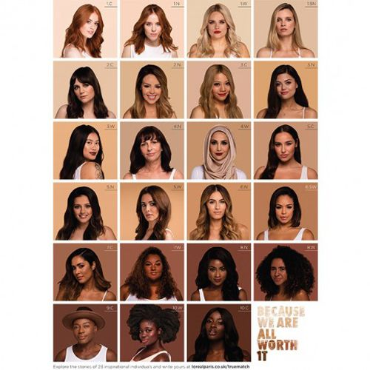
YoursTruly campaign: L’Oréal Paris #YoursTruly campaign, which highlights 23 of the most inspirational and powerful people in the UK, aims to draw attention to the spectrum of colours available in the True Match Foundation line. Gary Thompson, the first male model for the company, has learned to embrace putting foundation rather than escaping it as well as British beauty blogger Jane Cunningham and fitness instructor AJ Odudu are the ambassadors.
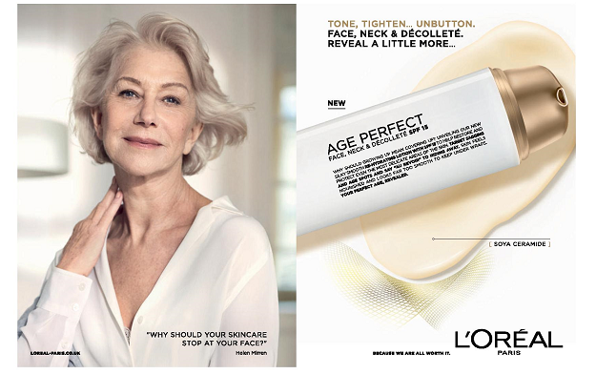
Mature Creator-led campaign: For the first time, L’Oréal Paris has launched a campaign to market its Age Perfect Golden Age Rosy Oil Serum, for elderly skin. The oldest influencer in the campaign, Anita, is 84 years old, and there are ten of them in total. The campaign, which is active on Instagram, aims to inform customers about the ingredients in the serum’s benefits for aged skin, increase brand awareness, and encourage purchases. The campaign is backed by a sponsored media boosting approach to increase sales, which includes Stories from some authors with a call-to-action to shop. The campaign honours and promotes the self-assurance, optimism, and self-love that come with advancing years, according to Gabriella Ostrenius, Nordic Social Brand Manager for L’Oréal Paris.
KELLER’S BRAND EQUITY MODEL
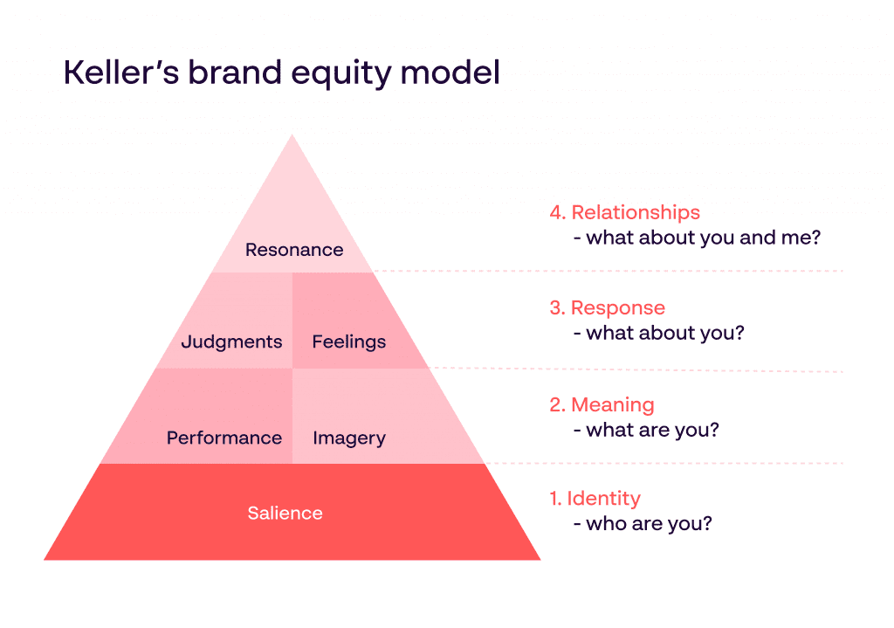
Keller’s brand equity model is a customer-based approach that emphasizes the importance of having an impact on how consumers think about and choose products. It was created for his textbook on strategic brand management. A business should create an environment where its clients would think positively of the brand and see it as reputable. a company’s brand identity, brand meaning, brand perceptions, brand attitudes, brand sentiments, brand judgments, and brand connections are among the components of the Keller model. The Pyramid of Brand Salience is a model used to measure the awareness of a brand. Kerri-Ann et al 2008 established the second stage, which is associated with brand performance and image. The third stage of brand response is divided into brand judgment and brand feeling. At the top of the pyramid, Brand Resonance is the relationship between the customer and the company, which helps to increase the number of customers.
Source: - https://www.papirfly.com

Customer Base Brand Equity Model of L’Oréal Paris
BRAND IDENTITY: The way a brand delivers its significance, personality traits, and features to its target audience is through its brand identity. With over a century of technology and perfection under its umbrella, L’Oréal Paris is the most prominent cosmetics company worldwide Loreal Paris set up its “Because I’m worth it” was formed in 1973, illustrating the brand’s goal of womanhood and confidence. L’Oréal Paris displays its identity through celebs and other fashion bloggers in addition to having a brand ambassador who represents the company’s identity.
BRAND MEANING: L’Oréal Paris creates a strong brand image and performance all around the world Because it provides a wide range of options for different customer requirements, like makeup, skincare, hair care products, and perfumes. L’Oréal Paris has a straightforward and enduring brand image that expresses its values of empowerment, variety, and outstanding performance. The brand additionally maintains an excellent reputation in the cosmetics industry.
BRAND RESPONSE: The purpose here is to generate positive thoughts and attitudes from customers. As a result of maintaining its promises about excellence, security, and performance, Loreal Paris has an outstanding level of customer loyalty. The company additionally promotes its consumers to experience emotions beneficial, like pride, confidence, and ambition. The business also gains rewards from its environmental and social responsibility programs, which include promoting causes for women, encouraging long-term viability, and banning the use of animals for research.
BRAND RESONANCE: L’Oréal Luxe-trained beauty specialists provide individualized attention and advice to meet customer needs. All distribution channels are expected to offer special experiences, custom offers, and personalized amenities. Technology implemented in indirect distribution is also seen in digital services offered on the company’s websites, such as the ModiFace technology, which allows customers to virtually try out cosmetics products through augmented reality.
ADVANTAGES OF THE KEELER’S MODEL
- L’Oréal Paris has a strong customer base brand equity model. The company has a significant brand image among its targeted audience. Buyers may immediately recognize products from brands.
- L’Oréal Paris continually innovates by investing significantly in research and development. This keeps your business current with industry trends and competition. Loreal Paris has successfully established a favourable connection with the brand via effective advertising and promotional methods, which helps foster trust and validity with customers.
- L’Oréal Paris continually innovates by investing significantly in research and development. This keeps brands current with industry trends and competition.
- With a wide range of campaigns that Loreal Paris is launching helps customers easily aware of the brand’s products. This approach promotes the brand’s value and forges a unified brand identity.
- By charging higher prices and expanding client lifetime value, it may raise brand revenue and value.

DISADVANTAGES OF KELLER’S MODEL

- When operating in such a cutthroat market and competing against other well-known cosmetic companies such as Estee Lauder, Revlon, and Nivea, it may be very difficult to maintain brand identity.
- It may be costly when using promotional strategies like celebrity Endorsement, and influencer promotions. Sometimes technology also can be expensive.
- When a brand fails to fulfill the customer’s need and its promise it may affect the customer’s loyalty.

CUSTOMER JOURNEY MAP
The series of experiences a consumer has with a brand while buying a service or goods is known as the customer journey. It is used to determine and evaluate how well a business assists its clients and improves the experience. Businesses may increase brand loyalty by enhancing the consumer experience at each touchpoint. grasp what drives brand loyalty requires a grasp of how market factors operate.
There are mainly four stages of the customer journey map Awareness (Wanting) where the customer knows about his/her need and try to find out the solution. In the second stage Consideration (Research) this stage customers try to do some research and look for other alternative options. In the Conversion (Experiencing) stage the customer takes action regarding the product. The last stage shows customer loyalty toward the brand if the customer is happy with the product or service, he/she becomes loyal to the company.
Here is a customer journey map of who wants to buy a Loreal Paris product the steps in the map are wanting, researching, experiencing, and wanting more.

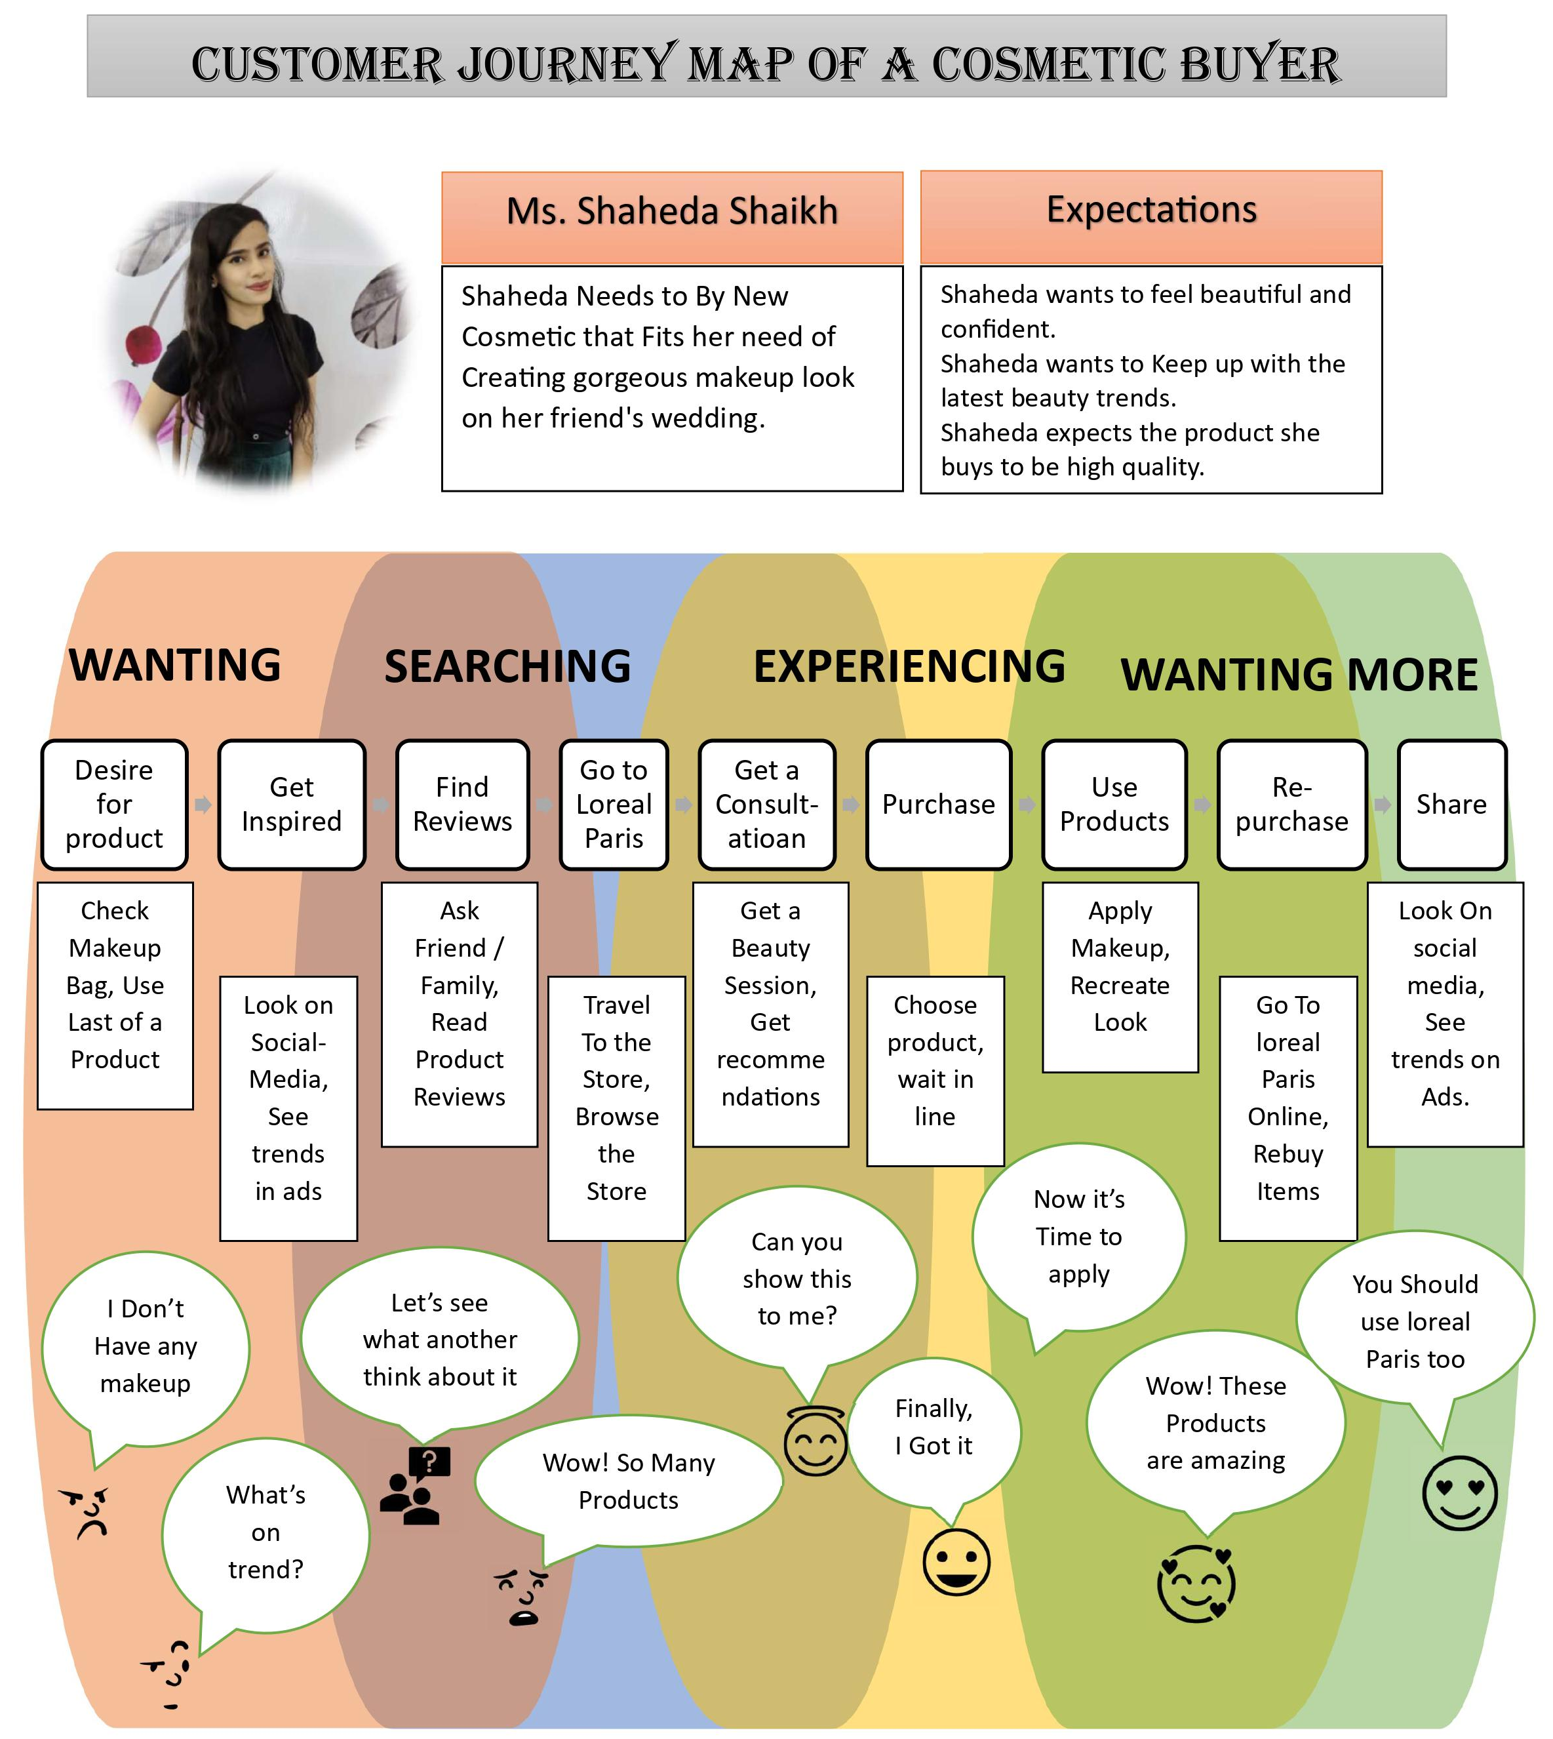
SOURCE: AUTHOR OF THIS REPORT
Pre-Purchases:
The period before the customer makes a purchase When a client first recognizes a need or problem and begins to seek for a potential solution, that is the stage of the customer journey map. The customer’s interactions with the brand up until the time of purchase are included in this stage. The following are examples of touchpoints: advertising, word-of-mouth, social media, websites, emails, and stores.
In the above customer journey map Shaheda comes to know about that she wants to look gorgeous at her friend’s wedding when she checks her makeup, she becomes aware that she doesn’t have makeup products. The customer still doesn’t have a goal for her purchase. After that in the consideration or searching stage, she uses to search on social media to get some information about current trends in makeup here, she might use Instagram, YouTube, or TikTok. Moreover, she uses word of mouth by getting references from her family and friends and tries to get some reviews regarding the product.

Purchase:
In the purchase stage, she makes up her mind to purchase the product. She enters the L’Oréal Paris store freely. She already knows what she wants to buy but as she never purchases before from L’Oréal Paris, she looking for someone who can guide her in the right way. As L’Oréal Paris provides high-technology consultation in which they offer the dermatologist consultant about your skin and its problem. Further, there was a manager who saw Shaheda is quite confused about the products then after he immediately called his co-worker and tell to guide her. Then she had a session with the consultant and she recommends to Shaheda which products will work best for her. Now Shaheda can get exactly what she wants and waits in line to make her last move to get the product when she reaches the counter the cashier welcomes her will a pleasant smile and as she was a new customer, she gets 20% off her first order as a new customer.

Post-Purchase:
Now Shaheda finally gets her product in her hand as she goes to her home, she immediately tries all the products excitedly as L’Oréal Paris launched a new range of foundation for every skin tone, she gets the exact shade of foundation and when she wears it, she looks the most beautiful and happiest after buying the product and gives positive feedback on the L’Oréal Paris website. Now whenever she wants a cosmetic product she always rebuys from L’Oréal Paris and recommends everyone on social media to use L’Oréal Paris products and become a loyal customer of the brand.

TOTAL Engagement MODEL

Roberts and Alpert (2010) state that a company needs to establish a cooperative and strategic relationship between loyal customers and engaged employees of the company to achieve success over the long term. The total engagement model refers to the customer value proposition, which is defined from different viewpoints in marketing. Brand advertising promotes a brand stronger in comparison with other brands by expanding its target market, boosting awareness of its goods and services, and establishing close bonds with its customers. A high-performance culture defines the actions and attitudes that are helpful and encouraging, and employee engagement is influenced by how pleased and satisfied they are with their organizational culture. Building connections with customers necessitates being conscious of their requirements, desires, and ideals, and it extends beyond simply using the goods or services.
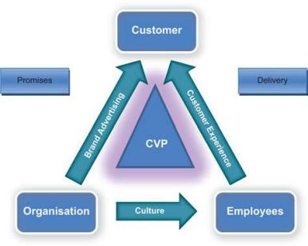

Source: The total engagement model of Robert and Alpert (2010)

L’Oréal Paris demonstrates its empathy for its staff by giving them opportunities for growth, variety, and health. To encourage its growth and provide a stake in its success, L’Oréal Paris offers its employees an ownership plan. In addition, L’Oréal Paris provides wellness packages based on recommendations from its staff. Moreover, L’Oréal Paris offers Citizens Week plans for staff members to volunteer their time to one of more than 50 charitable organizations to give back to the neighbourhood. The following characteristics are offered by L’Oréal Paris to its customers. The business provides a sale-wide 100% responsive programme that ensures timely and relevant dialogues with clients via social media and other channels. They employ a smart gadget with artificial intelligence to make personalised lipstick that matches consumer preferences or needs. In addition, a virtual try-on tool is available so users can examine how various items appear on their skin and hair. A seamless 24-hour assistance and guidance system is provided by a team that combines consumer e-care with marketing and e-commerce teams. Based on Hofstede, the culture of an organisation is a collective psychological structure that sets its members aside from those of other organisations. L’Oréal Paris engages leaders from a variety of ethnic backgrounds in its most competitive activities. creation of new products since the late 1990s. Typically, they have 40 creation groups, each focused on an individual concepts group of three or more individuals, two of whom may be multicultural

RECOMMENDATION:
LOREAL PARIS could focus on creating unique propositions of value for its goods and services that respond to the desires, requirements, and ambitions of the consumer.
It has a knack to diversify sources of income, reduce costs, increase efficiency, and evaluate trends and adjust plans accordingly. It might look into fresh opportunities and growth potential in developing and untapped regions, adjust its products and services to meet regional customs, preferences, and cultural norms, and use its worldwide network of partners and distribution channels to broaden its reach and visibility.

Conclusion:
In summary, I can state that Loreal Paris has employed effective marketing techniques and has been able to grow its customer base internationally. However, I believe that Loreal Paris ought to concentrate more on marketing its products on social media platforms. Additionally, Loreal Paris had been successful in raising awareness of the brand. Loreal Paris has several distribution networks, which enable them to have an important market share. The business prioritises cutting costs while raising perceived value. Successful brand identity for Loreal Paris. To explore and study the demands for cosmetics of local consumers, Loreal Paris maintains research and development platforms in every worldwide area.

LIST OF REFERENCES:

Pierce, J.L., Newstrom, J.W. and Davis, K. (1985). Study guide to accompany Davis and Newstrom: Human behavior at work: Organizational Behavior, 7th ed. New York; Sydney: Mcgraw-Hill.

Lynne, E. (1986). Nursing leadership and management: an experiential approach. Boston: Jones and Bartlett Publishers Inc.

Shannon, C.E., Weaver, W. and Wiener, N. (1950). The Mathematical Theory of Communication. Physics Today, 3(9), pp.31–32. doi https://doi.org/10.1063/1.3067010.

Keiling, Hanne (n.d.). communication type.

American Psychological Association (2014). APA Dictionary of Psychology. [online] American psychological association. Available at: https://dictionary.apa.org/.

businesstopia (2018). Shannon and Weaver Model of Communication - Businesstopia. [online] Businesstopia. Available at: https://www.businesstopia.net/communication/shannon-and-weaver-model-communication.

Chandler, D. (n.d.). Dictionary Of Media And Communication. Oxford.

Goot, M. (2010). ‘A worse importation than chewing gum’: American Influences on The Australian Press and Their Limits—The Australian Gallup Poll, 1941–1973. Historical Journal of Film, Radio and Television, 30(3), pp.269–302.
doi https://doi.org/10.1080/01439685.2010.505020.

Fiske, J. (2010). Introduction to Communication Studies. Routledge.

Hoopla Digital (2006). Britannica concise encyclopedia. United States: Britannica Digital Learning.

Percy, L. (2018). Strategic integrated marketing communications. New York: Routledge.

Stuart, B.E., Sarow, M.S. and Stuart, L.P. (2007). Integrated business communication in a global marketplace. Chichester, England; Hoboken, Nj: John Wiley & Sons.

Loreal.com. (2018). L’Oréal - L’Oréal Group. [online] Available at: https://www.loreal.com/.

www.greenbiz.com. (n.d.). GreenBiz. [online] Available at: https://www.greenbiz.com/article.

Anon, (n.d.). ‘L’ORÉAL and CARBIOS sign agreement to jointly found consortium for bio-recycling of plastic on an industrial scale’.

Salesforce (2018). Logiciel CRM - Gestion de la Relation Client (GRC). [online] Salesforce.com. Available at: https://www.salesforce.com/.

Anon, (n.d.). The Titan Who Founded L’Oréal Prospered Under the Nazis.

i95business.com. (n.d.). Brand Awareness Online and Offline: I95 Business. [online] Available at: https://i95business.com/articles/content/brand-awareness-online-and-offline-1852 [Accessed 28 Apr. 2023]

The Branding Journal. (n.d.). Homepage. [online] Available at: https://www.thebrandingjournal.com.

Neumeier, M. (2004). The dictionary of the brand. New York: Aiga Center for Brand Experience.

Aaker, D.A. (1991). Managing Brand Equity. New York: Free Press.

Customer Loyalty And Brand Management. (2019). S.L.: Mdpi Ag.

Dhaliwal, D.S., Radhakrishnan, S., Tsang, A. and Yang, Y.G. (2012). Nonfinancial Disclosure and Analyst Forecast Accuracy: International Evidence on Corporate Social Responsibility Disclosure. The Accounting Review, [online] 87(3), pp.723 doi: https://doi.org/10.2308/accr-10218.

Kotler, P. and Armstrong, G. (2016). Principles of marketing. 16th ed. Boston: Pearson.

L'Oréal Paris. (n.d.). L'Oréal Paris history. Retrieved from https://www.lorealparisusa.com/about-loreal-paris/about-loreal-paris.aspx

Newstrom, J. W., & Davis, K. (1985). Organizational behavior: Human behavior at work. McGraw-Hill Education.

‌

‌

‌

‌

‌

‌

‌

‌

‌

‌

‌

‌

‌

‌

‌

‌

‌

‌

‌

‌

‌

‌

‌
‌

