Ways of perceiving

Student ID; 1901920
Course; Automotive design
Word Count; 1664
Tutor name; Gwenllian Beynon

As an automotive design student and a future lorry driver, I am hoping to achieve a more luxury lifestyle for those forgotten. Those who keep the country running, those who don’t stop until the job are done, those risking their lives on a daily basis to deliver goods to our supermarkets and hospitals so the rest of us don’t suffer without our basic essentials.
The impact of my idea has been inspired by the worlds recent pandemic, however it has always been to my attention that drivers don’t get the recognition they truly deserve.

I want to create a strong impact that affects my audience for the better as I am determined to create change. My reason for this is because I have come across many articles in the past few months reporting how heavy goods drivers are not been treat fairly during this critical time.
These men and women are being refused basic facilities at service stations, pick up and drop off points.
These articles are revealing the truth about how some companies, suppliers and customers are using the pandemic as an excuse to build hostility and intolerance towards truck drivers.

Due to the basic facilities being closed it forces drivers to degrade themselves by having to carry carrier bags and plastic bottle to relieve themselves in the cab of the truck, not only is this extremely unhygienic its demeaning.

There is absolutely no excuse to deny drivers toilets or water.
What has the world come to if this is how we treat the men and women that are trying to keep this country together at such a difficult time. There are many more articles just like this, coming from drivers themselves, one in fact truly made me realise how bad these situations are, a female trucker aged 56 who has been working in the haulage industry for over 30 years has had to beg the government to make the necessary changes to allow drivers to use the facilities that should be a basic human right. This one female, Ruth Copeland, tells us she has not showered for two weeks due to been on the road and the facilities been closed. This article is sickening.
I want situations like this to never happen again!
Imagine the elderly be refused the basic facilities in care homes there would be uproar everyone would jump on board and fight to make change… so why should truck drivers have be treat like this?

It shocks me that after all these hard-working people do they are been treat this way. It’s not right and I feel strongly about creating change.
Elaborating on change, back in 2009 there was already a modification in the industry. They allowed younger people to learn to drive heavy goods vehicles. The age was dropped to 18 from 21 years of age. This was to entice more people in to the commercial HGV industry. This is what makes me confident that more change is possible. That is what I want my audience to see. I want them to realise how much drivers of this country do for us. However, while getting the truth across I want to create an exciting event. I want it to be memorable, an exhibition to be enjoyed by the whole family.

I want to reach out to the working-class people of this country, the ones who work tirelessly to provide us food in our supermarkets and medicines in our hospitals.
With a slight bit of passion and the right intentions we will make the trucking industry a whole lot more appreciated and respected and if it is done right it will hopefully make people get more involved in the haulage industry.

My vision for presenting this body of work is to use all the information I have gathered about all the disrespected truck drivers. I will put it all in the spot light make people see what they go through day and night.
Using my practice and the issues brought to my attention, I want to redesign elements of the interior of a class 1 tractor unit to incorporate luxury and comfort for the driver as they are the ones that will be spending weeks at a time in the cab. Not only including high end technology but my main focus will be to make it homely, cosy, a place where the driver can relax put his or her feet up after a long day. A home away from home.

As I expect a lot of people who are not interested in the haulage industry will not have been in a HGV cab, so they will not really know what it is like. For many men and women these metal cabs are where they eat, sleep and work a large portion of the time. This is why it is important for these cabs to be decent, you wouldn’t want to be stuck in some dark, dingy and dirty box 15 or more hours a day. That would have a very poor impact on drivers.

Most cabs these days are nicely designed, in my opinion I think the representation of the vehicle reflects on the company. nevertheless, most company’s and designers will always choose not to create the cab with the actual drivers in mind which is disappointing. Researching this I found an article telling me all about the interior “they don’t need to be fancy, just functional” I’d like to improve this way of thinking I understand from a business angle that they need things to be functional for the driver to have everything they need while on the job although I believe the drivers cabs should feel more like home especially if they are spending more than 50% of the week on the road.

Thankfully I am not the only designer with the drivers in mind. Carina Bystrorm is a female designer who led the redesign of the Volvo FM. This has inspired me more as it makes it real to me that change is possible in the industry. She had created a more spacious feel within the cab which is great for the drivers. This wise and thoughtful woman has added more space and newer technology and new and improved non-slip mats as a safety precaution in to the interior. This is definably a start in the right direction.

With my designs not only do I want to improve on Carinas ideas because I think they are fantastic, but they don’t reach out to the kind of point I wanted to get across. I want to make the cab as homely as possible.

By taking away the passenger seat it creates more roaming space within the cab this also allows more space to let the bed extend further. This is perfect because then we can add a larger, a better-quality mattress. The drivers need their sleep, so a quality mattress is essential.

Above the windscreen I have added a lot more storage, I really like this idea because it gives drivers space to bring home to work with them, they now have space for blankets, more clothes, photos of loved ones and much more personal items. This will obviously vary depending on the driver.

I have also added a high-quality navigation system this is for peace of mind for the driver these systems know the dimensions of your tractor and trailer, so it will not take you down routes that don’t comply with your vehicle.

Now my favourite is the back massager built in to the driver’s seat this is made to relax the driver, loosen any strained muscles from sitting with their back straight for hours.

And of course, a larger fridge this will encourage drivers to eat healthier as they can buy more for their fridges instead of eating fast food all the time.

These are only small changes however they will make a huge difference.

I want to exhibit my work at a public show so many from across Britain can come and visit the exhibition.

It will be a reveal of a new and improved tractor unit the main focus will be the interior. I want the concept of the improvements to be a surprise to the audience. I want my audience to be lorry drivers and family of, many lorry drivers take pride in their trucks so having them at this event will be exciting as I will get to hear their views on my lorry design it will also be a lovely day out for them and their families. The driver’s family are used to not having them around especially if they are long haul drivers, so bringing them together will create the perfect environment for my work.

My exhibition will be in an outdoor open area in Bridlington, Bridlington is a beautiful little seaside town in Yorkshire, popular with tourists. It is also a very accessible place for HGVs.

There is a large car park usually used by PCVs however it would be a perfect spot for the public exhibition. The layout would create a sense of exhilaration and unity with having 6-7 brand new tractor units stood together each side of the car park, with the bold and beautiful coloured trucks standing strong together.

There will also be a large marquee in the centre of the car park.
The interior of the marquee will have the latest reveal, which will of course be my design focusing on my new homely interior. There will also be stands in and around the marquee to bring people in, these will be also creating interest as there will be merchandise, free and for sale. The merchandise will tie the whole exhibition together as it would support the HGV industry and support the fight to appreciate everything these drivers do for the country. I feel this exhibition could be something special. I feel strongly that it could make my audience proud and learn that there are people who will support truckers all the way.

EXHIBITION LAYOUT
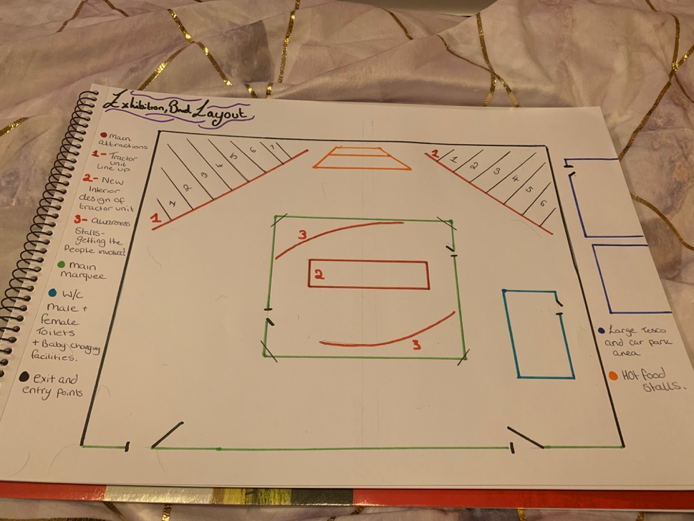

DESIGN IDEAS
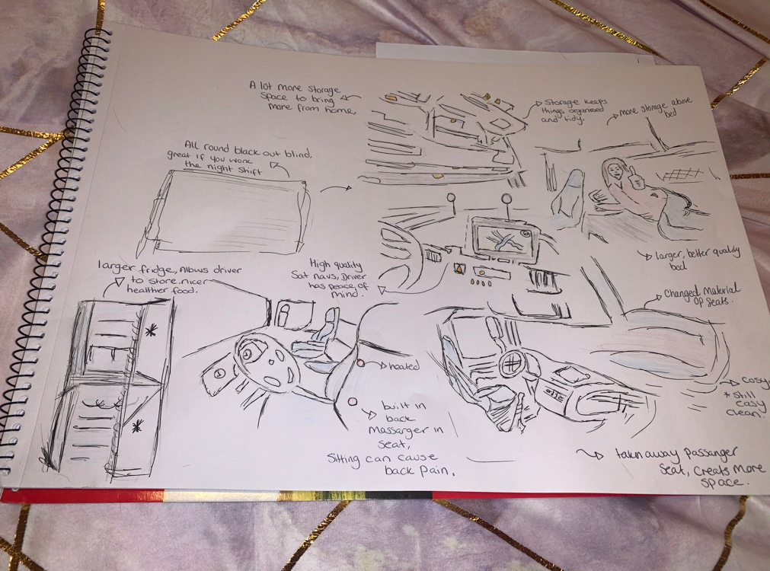

Links I have used…
https://www.easyashgv.co.uk/news/whats-in-your-cab/

magazine
https://www.truckanddriver.co.uk/latest-stories/hgv-drivers-being-denied-access-to-facilities-during-the-covid-19-outbreak-what-were-doing-and-what-we-need-from-you/
asked drivers about changes
https://www.volvotrucks.com/en-en/news-stories/magazine-online/2020/feb/transport-improvements-fh-cab.html
similar designers
https://www.volvotrucks.com/en-en/news-stories/magazine-online/2020/feb/design-story-volvo-fm-cab.html
inside a cab
https://www.vice.com/en_uk/article/xd77gq/photos-from-inside-the-cabs-of-long-distance-truckers-001

(news link) magazine
https://www.truckanddriver.co.uk/latest-stories/hgv-drivers-being-denied-access-to-facilities-during-the-covid-19-outbreak-what-were-doing-and-what-we-need-from-you/

https://www.dailyrecord.co.uk/news/scottish-news/scots-trucker-begs-government-extend-21823831https://www.easyashgv.co.uk/news/whats-in-your-cab/

https://www.nolgvbrokers.co.uk/faq/whats-the-minimum-age-for-driving-a-lorry/

