L5 - Changemakers: Creativity and Value Creation (ACCA5033)

Student Name:Samantha Oddie
Student Number: 1911261
BA Course Title: Computer Game Design
Tutors Name: James Williams

Contents

- E-Portfolio

- Task 1: Mind Map

- Task 2: Image Based Video Presentation

- Task 3: Video Presentation

- Task 4: Academic Poster

- References

E-Portfolio

A link to my e-portfolio:
https://samanthaoddi3.wixsite.com/website

Screenshot of my e-portfolio home page:
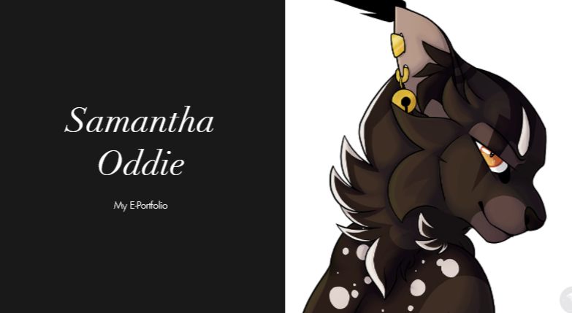

Task 1: Mind Map

Link to the task answer in the e-portfolio:
https://samanthaoddi3.wixsite.com/website

Link to the mind map:
https://drive.google.com/file/d/1debfbV17Qac82bl7emK3AccdijwKciRD/view?usp=sharing

Screenshot of the mind map:
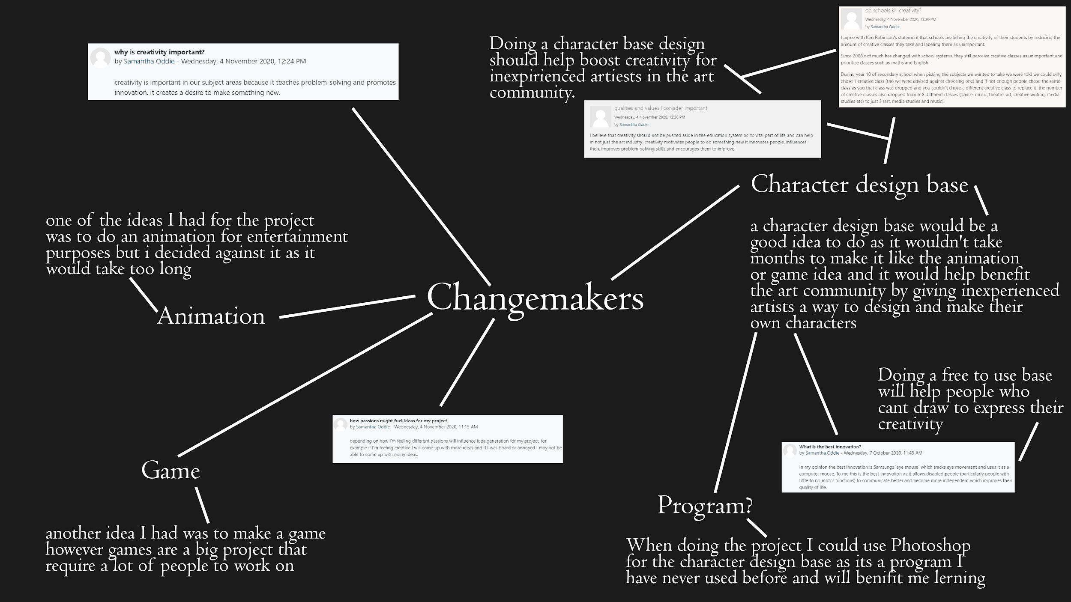

Task 2: Image Based Video Presentation

Link to the image based presentation in the e-portfolio:
https://samanthaoddi3.wixsite.com/website

Link to the image based presentation:
https://docs.google.com/presentation/d/1FeJE8wQ5BCY6vfTynS7ChoqWXnZI0ZhZ0z-4dWFuXPw/edit?usp=sharing

Link to the image based presentation on youtube:
https://www.youtube.com/watch?v=ycHl_4AREGg&feature=youtu.be

Link to the image based video presentation:
https://drive.google.com/file/d/1rQX-5JbV5T-_VOVKtMvlzSMcgncP3cr8/view?usp=sharing

Screenshot of the image based presentation in the e-portfolio:
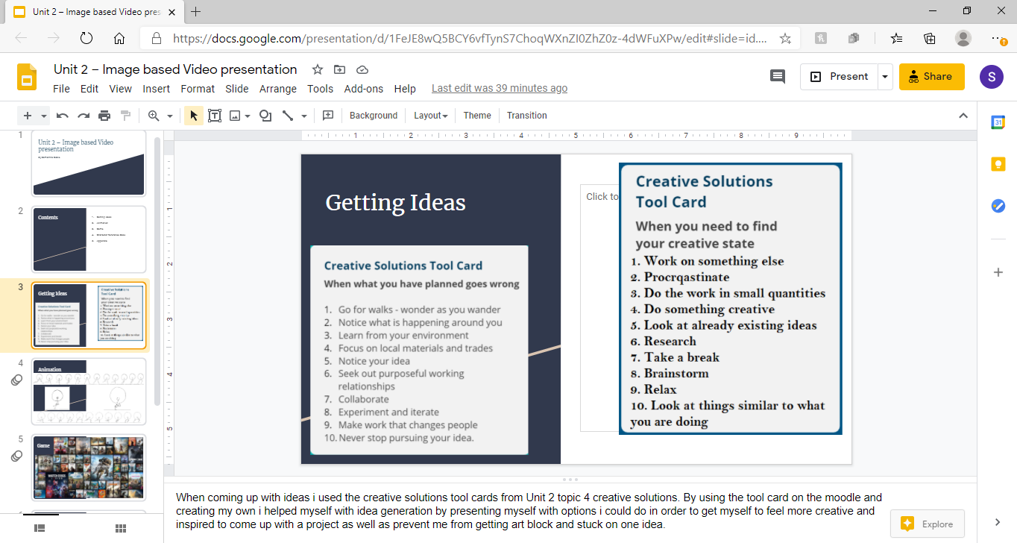
Task 3: Video Presentation

Link to the video presentation in the e-portfolio:
https://samanthaoddi3.wixsite.com/website

Link to presentation:
https://docs.google.com/presentation/d/120f0XGRTpx2Jz7m8RGCGMLNy1QfpkVBZndjtxiEU6D0/edit?usp=sharing

Link to the video presentation on youtube:
https://youtu.be/yO0XREmtdYQ

Link to video presentation:
https://drive.google.com/file/d/1gs_sp-8KZRJU7yx-I1OUaRbY9XWC9vE7/view?usp=sharing

Link to questionnaire:
What species do you think is the best for a original character? - Google Forms

Screenshot of the video presentation on the e-portfolio:
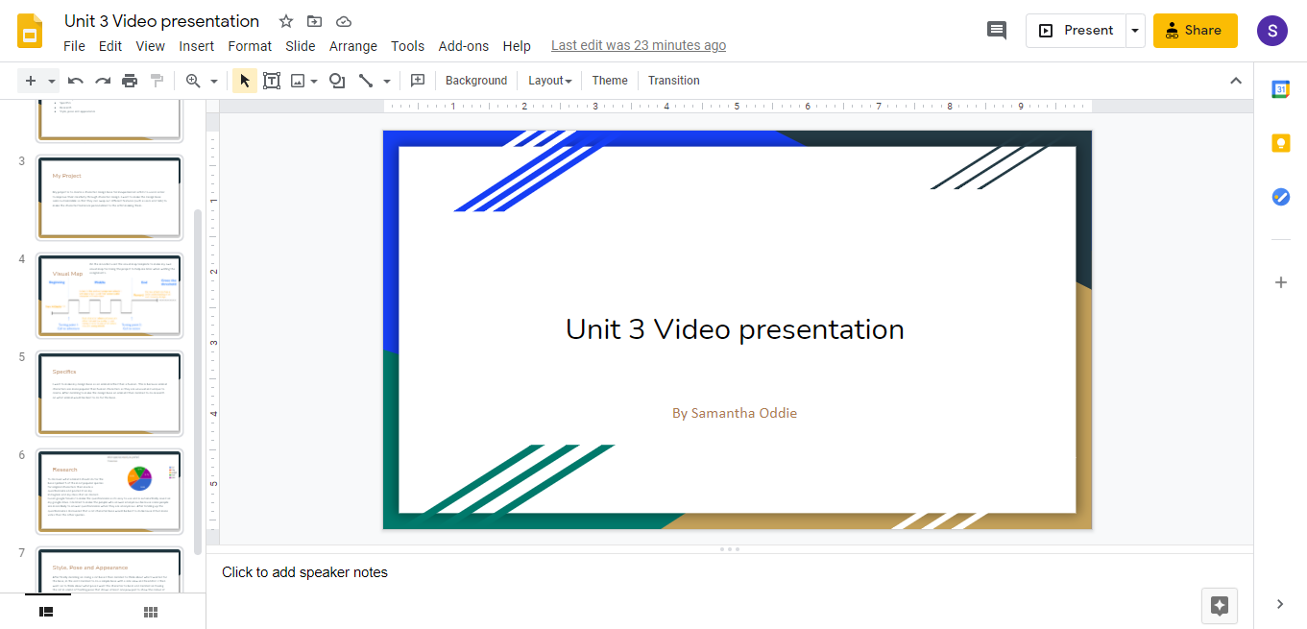Task 4: Academic Poster

Link to the academic poster in the e-portfolio:
https://samanthaoddi3.wixsite.com/website

Link to the academic poster:
https://drive.google.com/file/d/13GUQ3XRQdY-qhi8JQmFTKpzcRmsK0v6G/view?usp=sharing

Screenshot of the academic poster:
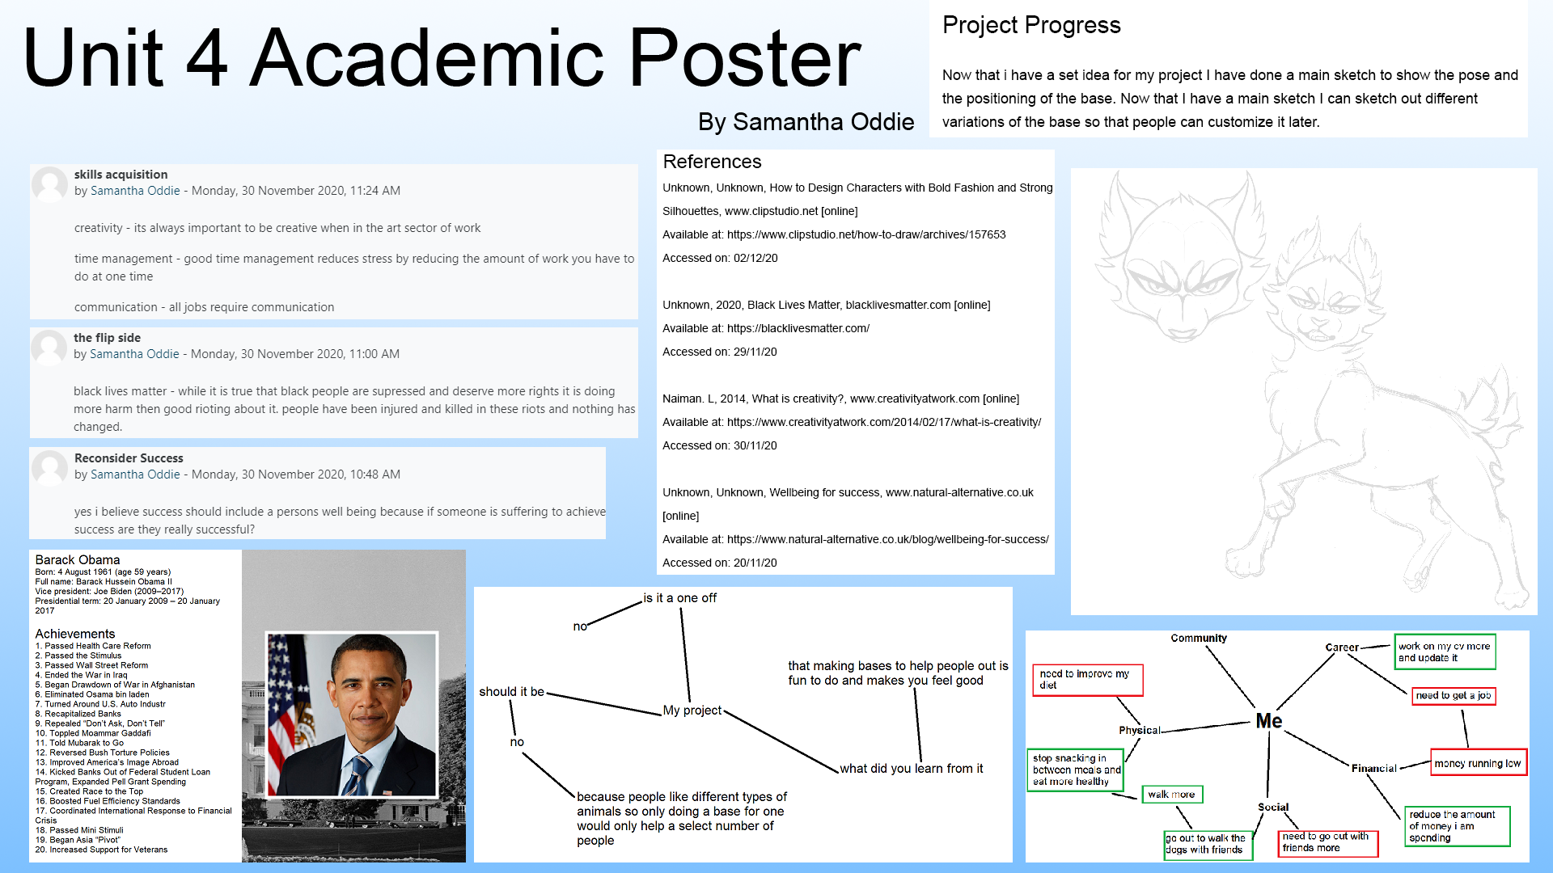

References
Unknown, Unknown, How to Design Characters with Bold Fashion and Strong Silhouettes,
www.clipstudio.net [online]
Available at: https://www.clipstudio.net/how-to-draw/archives/157653
Accessed on: 02/12/20

Unknown, 2020, Black Lives Matter, blacklivesmatter.com [online]
Available at: https://blacklivesmatter.com/
Accessed on: 29/11/20

Naiman. L, 2014, What is creativity?, www.creativityatwork.com [online]
Available at: https://www.creativityatwork.com/2014/02/17/what-is-creativity/
Accessed on: 30/11/20

Unknown, Unknown, Wellbeing for success, www.natural-alternative.co.uk [online]
Available at: https://www.natural-alternative.co.uk/blog/wellbeing-for-success/
Accessed on: 20/11/20

Harris. W, 2013, Top 40 character design tips - Part 1: Animal based characters,
www.creativebloq.com [online]
Available at: https://www.creativebloq.com/animation/top-40-character-design-tips-part-1-animal-based-characters-5132659
Accessed on: 19/11/20

Cooper. R, Glastris. P, Hu. S, 2012, Obama’s Top 50 Accomplishments, washingtonmonthly.com [online]
Available at: https://washingtonmonthly.com/magazine/marchapril-2012/obamas-top-50-accomplishments/
Accessed on: 30/11/20

Unknown, 2020, Barack Obama Biography, www.biography.com [online]
Available at: https://www.biography.com/us-president/barack-obama
Accessed on: 29/11/20

